Overview 2

Components 2

Money Management 2

Risk 2

Strategies 2

Intra-Day 2

Forex Trading 2

Stock Trading 2

PlayBook 2

Strategies: 2

Gap Openings: 2

Basis Trade: 3

Reversal Plays: 3

ABCD Pattern: 3

Bull Flag Momentum 4

Short Term – Over Night 4

Good Night Gold 4

Short Term 4

Position Sizing 4

Strategies: 4

Breakouts 4

Long Term 4

Trade Journal 4

# Overview

What 20% of my daily routines are responsible for 80% of my successes?

-> What 80% of activities are a waste of time?

Personal power, believe in it.

You don’t need to know what is going to happen next to make money.

“The consistency you seek is in your mind, not in the markets” – Mark Douglas

Think like a trader

* Confidence in their trades & trust in themselves
* No longer fear the crazy market (because it really is crazy)
* Focused on identifying opportunities instead of on information that reinforces fear

Three Critical Truths – Mark Douglas

1. Anything can happen
2. You don’t need to know what is going to happen next in order to make money
3. Every moment in the market is unique

It is how you think when you are trading.

It’s not what you think about trading.

Flawlessly execute the trading system.

Build self trust to operate in an unlimited environment

Train my mind to think in probabilities

Strong, unshakeable belief in my consistency as a trader

Manage myself, become ruthless in eliminating the low pay-off distractions/activities I have unwittingly tolerated as a trader.

Most of what I do as a trader is a waste of time.

Where should I focus my time? What activities produce the best results, most consistently? -> Stop most of what I am doing.

Price Action

If its not happening now, it is not happening.

The struggles I have endured and how I overcame them make me who I am today.

Qualities: detachment, acceptance, wisdom, patience, persistence, discipline

Mindfulness to balance and temper thoughts and emotions

Confident in ability to adapt to change

Inquisitive. Mistakes lead to growth.

Celebrate other people’s succeses.

Trust my rules

Understand and manage risk

Learn. CANEI.

Losses lead to improvement

Self-worth regardless of winning or losing day.

Tolerate short-term pain for long-term gain

Feel and express gratitude.

Focus on what I can control

Principles of Consistency

1. Objectively identify my edges
2. Pre-define the risk of every trade
3. Accept the risk or late the trade go
4. Act on my edges without hesitation or reservation
5. Pay myself as the market makes money available to me
6. Monitor my susceptibility for making errors

## Components

### Money Management

### Risk

* Do not average down
* Making money trumps being right

# Strategies

## Intra-Day

### Forex Trading

Trade Journal: what when why tax records

* Review
* PATI January 27, 2016 – Trader Psychology – keeping a trade journal

Red News Alert:

* February 24, 2016 webinar – technical training – red news trading
* FMOC, non-farm payrolls – wacky spreads
* Plans before the news release – range, or direction

Previous High / Previous Low

* Entry:
  + Distance from entry to previous H/L is <= 1R
    - Move entry to half the distance to previous H/L
    - Recalc stop loss from new entry level
* Exit Target:
  + If at a level, use it for exit
  + Use level as a target
  + Choose level over the previous H/L

Risk Management

* Daily max drawdown: 50 pips

Best Times to Trade

* February 10, 2016 webinar – members Q&A (8mins in)
* NY session 9:30 am
* 8:30 am for NY Red News
* London session 8:00 am (GMT)
* 9:30 am (GMT) for London Red News
* trade 1st 2-3 hours of NYSE and LSE open (optional)

Asian Session Trading

* Red News trading only
* AUD, NZD, CNY, JPY

Range BreakOut

* Re-entry
  + Break within a level
    - Long: breaking price is below the next level and the highest price reached after the break is above the next level up, the re-entry is just above the highest price reached

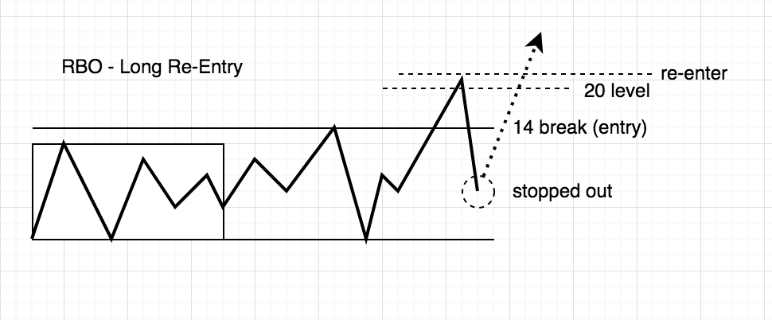

* + - Short: breaking price is above the next level and the lowest price reached after the break is below the next level down, the re-entry is just below the lowest price reached.

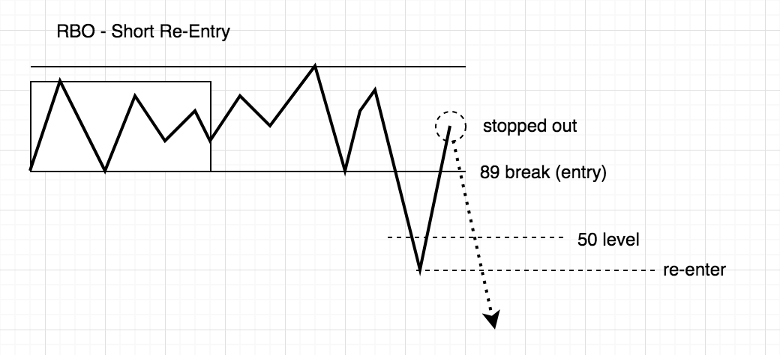

* + Break at a level
    - Long: breaking price is at a level or above a level, the re-entry will be up at the next level.
    - Short: breaking price is at a level or below a level, the re-entry will be down at the next level.
* Exits:
  + Take loss if closes back in range

Summary of my trading times

* Asian Red News Alerts
* NYSE open, 1st 2-3 hours
* LSE open, 1st 2-3 hours

PreOpen Routing:

Entries : yellow line, reentry, rbo, red news

* Clear Direction Movement (CDM)
  + After Asian session, forex pairs shows clear direction
  + Set yellow level
  + Enter on pullback to yellow yellow
  + Use stop loss for pair
  + Exit at level
* Range BreakOut (RBO)
  + After Asian session, forex pair trading in a range
  + Do not trade within this range
  + Enter on breakout of range
    - Try a stop entry, i.e. 2-3 pips away from the breakout
    - Enter immediate upon seeing the breakout
  + Set stop loss for pair
  + Exit at level
  + If breakout is missed
    - Use yellow
* Asian Session Trading
  + Trade on Red News only
  + Trade: AUD, NZD, CNY, JPY

Exits:

* With small loss
  + Late in session, no follow thru apparent, no price action
  + Free up margin for other opportunities
* Initial stop loss
  + Fixed number of pips, base on ccy pair
  + When + 25 pips in the money, move to breakeven + 5 pips

### Stock Trading

### PlayBook

* High Relative Volume

### Strategies:

#### Gap Openings:

* Targets:
  + x% at ½ gap
  + x% at full gap fill
  + x% trailing stop
* Days of week:

|  |  |
| --- | --- |
| Monday | 65% |
| Tuesday | 77% |
| Wednesday | 79% |
| Thursday | 82% |
| Friday | 78% |

* Size vs probability

|  |  |  |  |
| --- | --- | --- | --- |
| Points | Half Gap | Full Gap |  |
| 1 | 77% | 50% |  |
| 2 | 79% | 50% |  |
| 3 | 82% | 50% |  |
| 4 | 78% | 50% |  |

* Observations
  + Monday after
* Markets: research high probability ETF gap fillers (DIA,SPY)
* Pre-market volume determines when to fade the gap open
  + High pre-market volume (professional gap) less likely to fill gap
  + Low-moderate pre-market volume, smaller gaps – more likely to fill
  + Measure at 9:20 and compare to historical relative values
  + Track volume in movers & shakers

|  |  |  |  |
| --- | --- | --- | --- |
| Shares | Probability | Size |  |
| > 30,000 & < 50,000 | 85% | Full | Target gap fill |
| > 30,000, < 50,000 | 60% | 2/3 | 85% to mid-gap. Take ½ at ½ fill, ½ and gap fill. |
| > 50,000 | 30% | 0 | Do Not Take Trade |

* + Research and set volume levels to gap fill probability

* + Idea: use VIX to dynamical set volume levels

#### Basis Trade:

#### Reversal Plays:

* At least 4 consecutive down bars (5min)
* Extreme RSI (90/10)
* Doji candle or strong bull candle for bullish reversal, strong bear candle for bearish reversal

#### ABCD Pattern:

* A->B surge to new day highs
* Wait for support higher than A (C)
* Watch consolidation, set size, stop-loss, and target
* Confirm consolidation or momo, enter near C
* Sell ½ at D, raise stop-loss to break-even
* Sell remaining at target, or new low on 5 minute bar.

#### Bull Flag Momentum

* Low float stocks
* Price < $10

## Short Term – Over Night

### Good Night Gold

* Record 1:30pm gold settlement on COMEX
* Gold is trending on daily chart
  + If ADX > 20, tradeable
  + If ADX < 20, do not trade
* Gold direction on daily chart
  + If direction is up, focus on long
  + If direction is down, focus on short
* E
* 11:30pm entry
  + Long gold if
    - price – settlement price >= $3 & < $20 & direction is up

## Short Term

### Position Sizing

### Strategies:

#### Breakouts

## Long Term

# Trade Journal

What when why

Keep honest

Maintain integrity

## Trading Sheets

Bottom Reversal

* Scan:
  + 4 or more consecutive candlesticks going down in an extreme manner
  + RSI < 10
  + relative volume ?
* Check if good candidate: high volume and near support level
* Waite for confirmation: bullish doji, indecision candle or bullish candlestick
* Entry: new 1-minute or 5-minute high
* Stop Loss: low of previous red candlestick or the low of the day
* Profit Target:
  + Next level f support
  + VWAP
  + 9/20 EMA
  + new 5-minute low

Top Reversal

* Scan:
  + 4 or more consecutive candlesticks going up in an extreme manner
  + RSI > 90
  + relative volume ?
* Check if good candidate:
  + high volume
  + near resistance level
* Waite for confirmation:
  + bearish doji
  + indecision candle
  + very bearish candlestick
* Entry: new 1-minute or 5-minute low
* Stop Loss: high of previous candlestick or the high of the day
* Profit Target:
  + Next level f resistance
  + VWAP
  + 9/20 EMA
  + new 5-minute high

## Journal

* Benjamin Franklin
  + What good shall I do this today?
  + What good have I done today?
* Steve Jobs
  + If today were the last day of my life, would I want to do what I am about to do?
* Count my blessings
* Oprah Winfrey
  + Gratitude Journal. Note five things for which she’s thankful
* Reid Hoffman
  + What are the kind of things that might be constraints in a solution, or might be the attributes of a solution?
  + What are the tools or assets I might have?
  + What are the key things that I want to think about?
  + What do I want to solve creatively?

## Nap

* Productivity and creativity
* Induce hypnagogia
* 1-1 ½ hours
* Wake up to cup of tea
* Albert Einstein, Thomas Edison (3), Winston Churchill, JFK, Leonardo Da Vinci (12x10m), Ronald Reagan, John D. Rockefeller, Margaret Thatcher, Arnold Schwarzenegger, Bill Clinton

## Exercise

* Walking

## Reading