pruebanumerouno
2025-06-18

R Markdown
This is an R Markdown document. Markdown is a simple formatting syntax for authoring HTML, PDF, and MS Word documents. For more details on using R Markdown see http://rmarkdown.rstudio.com.
When you click the Knit button a document will be generated that includes both content as well as the output of any embedded R code chunks within the document. You can embed an R code chunk like this:
## speed dist
## Min. : 4.0 Min. : 2.00
## 1st Qu.:12.0 1st Qu.: 26.00
## Median :15.0 Median : 36.00
## Mean :15.4 Mean : 42.98
## 3rd Qu.:19.0 3rd Qu.: 56.00
## Max. :25.0 Max. :120.00
## ── Attaching core tidyverse packages ──────────────────────── tidyverse 2.0.0 ──
## ✔ dplyr 1.1.4 ✔ readr 2.1.5
## ✔ forcats 1.0.0 ✔ stringr 1.5.1
## ✔ lubridate 1.9.4 ✔ tibble 3.2.1
## ✔ purrr 1.0.4 ✔ tidyr 1.3.1
## ── Conflicts ────────────────────────────────────────── tidyverse_conflicts() ──
## ✖ dplyr::filter() masks stats::filter()
## ✖ dplyr::lag() masks stats::lag()
## ℹ Use the conflicted package (<http://conflicted.r-lib.org/>) to force all conflicts to become errors
## [1] 4.257292
## [1] 7.354308
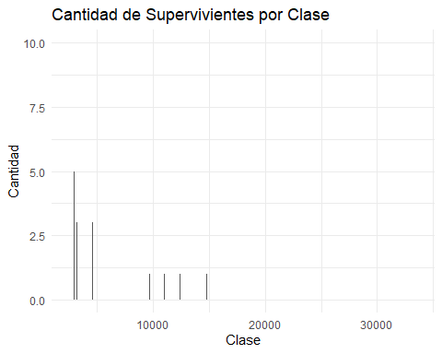
## star magnitude temp type
## 1 Sun 4.8 5840 G
## 2 SiriusA 1.4 9620 A
## 3 Canopus -3.1 7400 F
## 4 Arcturus -0.4 4590 K
## 5 AlphaCentauriA 4.3 5840 G
## 6 Vega 0.5 9900 A
## 7 Capella -0.6 5150 G
## 8 Rigel -7.2 12140 B
## 9 ProcyonA 2.6 6580 F
## 10 Betelgeuse -5.7 3200 M
## 11 Achemar -2.4 20500 B
## 12 Hadar -5.3 25500 B
## 13 Altair 2.2 8060 A
## 14 Aldebaran -0.8 4130 K
## 15 Spica -3.4 25500 B
## 16 Antares -5.2 3340 M
## 17 Fomalhaut 2.0 9060 A
## 18 Pollux 1.0 4900 K
## 19 Deneb -7.2 9340 A
## 20 BetaCrucis -4.7 28000 B
## 21 Regulus -0.8 13260 B
## 22 Acrux -4.0 28000 B
## 23 Adhara -5.2 23000 B
## 24 Shaula -3.4 25500 B
## 25 Bellatrix -4.3 23000 B
## 26 Castor 1.2 9620 A
## 27 Gacrux -0.5 3750 M
## 28 BetaCentauri -5.1 25500 B
## 29 AlphaCentauriB 5.8 4730 K
## 30 AlNa'ir -1.1 15550 B
## 31 Miaplacidus -0.6 9300 A
## 32 Elnath -1.6 12400 B
## 33 Alnilam -6.2 26950 B
## 34 Mirfak -4.6 7700 F
## 35 Alnitak -5.9 33600 O
## 36 Dubhe 0.2 4900 K
## 37 Alioth 0.4 9900 A
## 38 Peacock -2.3 20500 B
## 39 KausAustralis -0.3 11000 B
## 40 ThetaScorpii -5.6 7400 F
## 41 Atria -0.1 4590 K
## 42 Alkaid -1.7 20500 B
## 43 AlphaCrucisB -3.3 20500 B
## 44 Avior -2.1 4900 K
## 45 DeltaCanisMajoris -8.0 6100 F
## 46 Alhena 0.0 9900 A
## 47 Menkalinan 0.6 9340 A
## 48 Polaris -4.6 6100 F
## 49 Mirzam -4.8 25500 B
## 50 DeltaVulpeculae 0.6 9900 A
## 51 *ProximaCentauri 15.5 2670 M
## 52 *AlphaCentauriB 5.8 4900 K
## 53 Barnard'sStar 13.2 2800 M
## 54 Wolf359 16.7 2670 M
## 55 HD93735 10.5 3200 M
## 56 *L726-8 15.5 2670 M
## 57 *UVCeti 16.0 2670 M
## 58 *SiriusA 1.4 9620 A
## 59 *SiriusB 11.2 14800 DA
## 60 Ross154 13.1 2800 M
## 61 Ross248 14.8 2670 M
## 62 EpsilonEridani 6.1 4590 K
## 63 Ross128 13.5 2800 M
## 64 L789-6 14.5 2670 M
## 65 *GXAndromedae 10.4 3340 M
## 66 *GQAndromedae 13.4 2670 M
## 67 EpsilonIndi 7.0 4130 K
## 68 *61CygniA 7.6 4130 K
## 69 *61CygniB 8.4 3870 K
## 70 *Struve2398A 11.2 3070 M
## 71 *Struve2398B 11.9 2940 M
## 72 TauCeti 5.7 5150 G
## 73 *ProcyonA 2.6 6600 F
## 74 *ProcyonB 13.0 9700 DF
## 75 Lacaille9352 9.6 3340 M
## 76 G51-I5 17.0 2500 M
## 77 YZCeti 14.1 2670 M
## 78 BD+051668 11.9 2800 M
## 79 Lacaille8760 8.7 3340 K
## 80 KapteynsStar 10.9 3480 M
## 81 *Kruger60A 11.9 2940 M
## 82 *Kruger60B 13.3 2670 M
## 83 BD-124523 12.1 2940 M
## 84 Ross614A 13.1 2800 M
## 85 Wolf424A 15.0 2670 M
## 86 vanMaanen'sStar 14.2 13000 DB
## 87 TZArietis 14.0 2800 M
## 88 HD225213 10.3 3200 M
## 89 Altair 2.2 8060 A
## 90 ADLeonis 11.0 2940 M
## 91 *40EridaniA 6.0 4900 K
## 92 *40EridaniB 11.1 10000 DA
## 93 *40EridaniC 12.8 2940 M
## 94 *70OphiuchiA 5.8 4950 K
## 95 *70OphiuchiB 7.5 3870 K
## 96 EVLacertae 11.7 2800 M
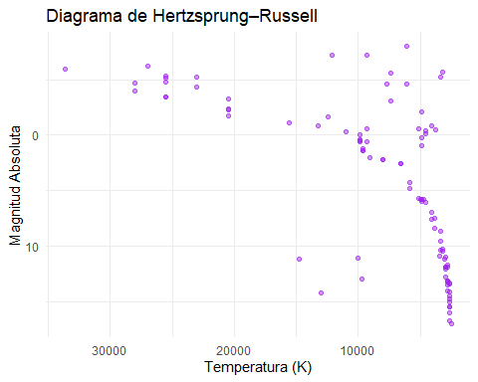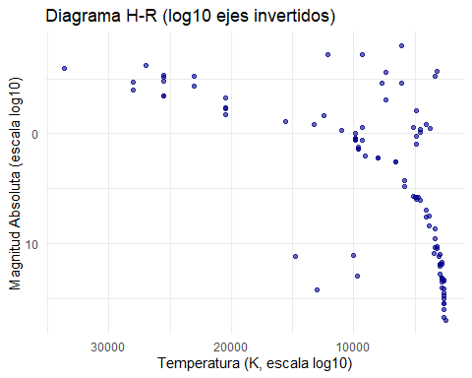

Including Plots
You can also embed plots, for example:
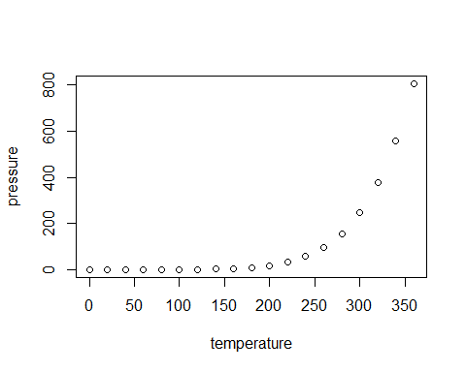
Note that the echo = FALSE parameter was added to the code chunk to prevent printing of the R code that generated the plot.

