HTTP, SOAP, WebDAV, FTP, DNS

CENG-0031 Higher Layer Network Protocols

**by**

Mehmet Harun Gülen

Department of Computer Engineering

Cukurova University

hgulen@cu.edu.tr

Advised by

Assoc. Prof. Dr. Fatih Abut

October 11, 2023

**ABSTRACT**

In the OSI model, which consists of 7 layers, there are many protocols in the Application layer, which is closest to the users. Most of these protocols have developed as a result of the needs arising from the use of the internet. If we examine the ones that have been widely used until today, we can talk about DNS, HTTP, FTP, SOAP, WEBDAV protocols.

There are reference fields among these protocols. For example, SOAP is a protocol that can be implemented with http or ftp. Another example is WEBDAV uses the http protocol on the back side.

As you can see, there are many protocols in the application layer, and they can have close relationships with each other, sometimes very tight and sometimes not.

1 Introduction

Let's examine these protocols in the application layer as http, ftp, soap, dns, webdav, respectively.

2 HTTP

The protocol that contains the rules that allow us to access resources such as files, pictures, websites on the Internet is called Hyper-Text Transfer Protocol (http).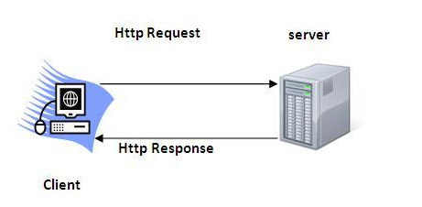

Http is a TCP/IP-based communication protocol. It provides communication between client and server using port 80. Since this port comes by default in many Firewalls, many applications and protocols are built on http.

We can list the general characteristics of http as follows.

• Defines commands that enable data exchange with the web server thanks to browsers.

• It is a protocol based on request and response.

• Uses TCP and port 80

• It is a stateless protocol. Every request is evaluated as if it never came from the server.

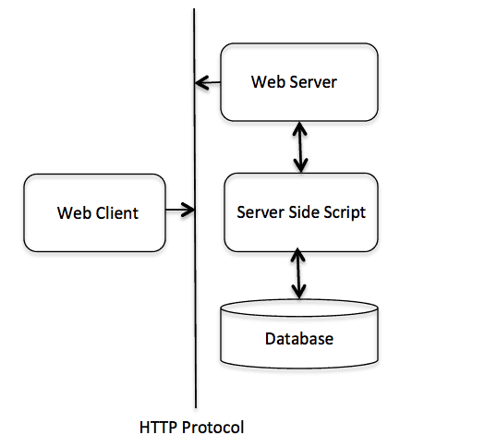**The Basic Architecture of HTTP**

The diagram on the right shows that http acts as a carrier between Client and Server.

Here, it carries out the migration process with commands. Each command represents a request and the response from the server as a result. Each client request and the response returned from the server can contain head and head-body.

The commands are sent to the server by being processed in the Head part, and the server decides to perform the operations according to this command. As a result of these operations, a response containing the head and head-body is returned to the client.

Most used commands

GET: Requesting a specific resource

HEAD: Message header of a specific resource

POST/PUT: Sending a resource to a specified location on the server

3 FTP

FTP dosyaların bir yerden bir yere taşınmasını sağlayan standart bir internet protolüdür.Http de bulunmayan transfer hızı ve kullanıcı doğrulama işlemleri sayesinde uzun yıllar boyunca kullanılmıştır ve hala geçerliliğini korumaktadır.

Mechanism of FTP

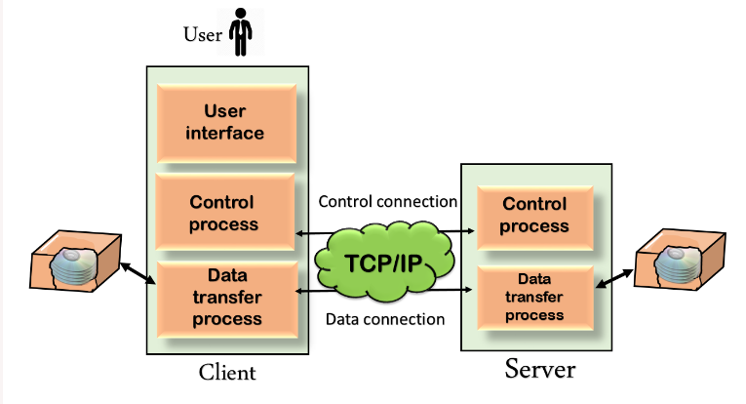

* FTP is also built on a client–server model
* The FTP client has three components: the user interface, control process, and data transfer process.
* The server has two components: the server control process and the server data transfer process.

Here, when the user wants to connect to an ftp server, an ftp session is opened. As long as this session remains open, Control connection does not close, but a separate data connection is opened for each file transfer. All file data goes over the data connection. Information such as user authentications or other communication speed are sent from the Control connection.

4 SOAP

6 Conclusion

He iki protokolünde yazılım geliştiriciler için artı ve eksileri vardır. Git, SVN den sonra çıkan bir protokol olduğu için SNV de kullanılırken yaşanan tecrübeler ve ortaya çıkan yeni ihtiyaçlar sonucunda Git protokolü ortaya çıkmıştır. Fakat en başta ofline çalışma ihtiyacını çözmek için yerelde daha fazla alan tutmamız gerekmektedir.Burada proje yöneticisinin kararı çok önemlidir.Yinede günümüzde bu platformlar aslında geçiş kolay olması nedeniyle geliştiriciler kendi ihtiyaçlarına göre karar verebilirler.

Refence

<https://git-scm.com/>

https://en.wikipedia.org/wiki/Git