**Book Proposal Form**

## Proposal Information

This information is crucial for us to discuss your proposed book. Please complete this document in as much detail as possible. If needed, feel free to use additional sheets.

1. **Book Details**

* **Title:**
* **Subtitle (if applicable):**
* **Series (if applicable):**

**Author(s) / Editor(s)**

Please provide the following information for each author or editor:

* **Full Name:**
* **Contact Information:**
  + Telephone Number:
  + Email Address:
* **Author/Editor Bio:** Briefly describe your background and experience. Please also send your CV highlighting your recent publications.

**II ABOUT THE MANUSCRIPT**

Please let us have the details requested below.

1. **Brief Synopsis: 200–400 words** which will be a statement of aims outlining the rationale behind the manuscript.
2. What is your manuscript about? (list the USPs; key arguments)
3. **Table of Contents** with chapter titles
4. **Chapter abstracts** (of 150 sharp, words at least per chapter) and **key words**
5. What are the recent **competing books** in the area?

**Technical details:**

1. How many tables, maps, figures, photographs if any?
2. Has **permission** been taken for use of copyrighted material (including essays, photographs, maps, visuals, etc.)? *The* *Publishers will not do so on your behalf nor finance the fee, if any.*

* Please Note: Maps cannot be used as downloaded from the Internet. Proper permission has to be taken to reproduce them. It is best to have these redrawn in B/W.
* Please **specifically** mention if you are using reprint/pre-published material – chapters/essays – in this volume.

1. What is the word count inclusive of everything – notes, references etc. *We prefer 80,000–90,000 words (for authored volumes), or 100,000 words (for edited volumes) at the outside. This includes Notes and References. Authors will be expected to prune their manuscripts if the word limit is exceeded*.
   * There are special specifications for different categories/formats. Please check with your editor regarding this.
2. When will the complete manuscript be ready for submission?
3. Are you planning to submit it to more than one publisher at the same time?
   1. EDITED VOLUMES

For these, please let us know:

1. If it is based on a Seminar/Workshop/Conference, please provide details (venue, sponsors, dates, etc.)?
2. Have the papers been suitably revised and updated for publication?
3. Have any of the essays in the volume been published elsewhere? If yes, has written permission been obtained from the copyright-holder/author in each case?
4. In all other cases, has written permission been obtained from the authors of the essays to include their papers in your volume?

1. RESEARCH REPORTS

If yours is a research report, please indicate for whom the research was undertaken; the year in which the research was initiated; the year in which the primary research was completed; the date on which the report was submitted:

1. DOCTORAL DISSERTATIONS

If yours is a thesis, please let us know the name of the University where the thesis was submitted and the year in which the degree was awarded.

Please enclose/attach the reports of the examiners in case you have them.

**III MARKET & READERSHIP**

**Target Audience**

**Who will benefit most from your book?**

* **Is your book aimed at students?** If so, is it appropriate for undergraduate or postgraduate studies? Can you specify the specific course or area of study it would complement?
* **Do you envision a broader readership?** If your book has international appeal, please explain why you think so.

**Open Access Options**

**Are you interested in making your book openly accessible?**

There are several options to consider:

* **Funder Requirement:** Does your funding require open access publication?
* **Exploring Open Access:** If open access is not mandatory, but you'd like to explore this option, we can discuss partial or chapter-by-chapter open access with associated fees.
* **Not Possible for Open Access:** If open access is not feasible for your book, please let us know.

**The reason of choosing TRC-Sapphire?**

Declaration

## Subject: Book Proposal Submission - [Your Book Title: please giev us three option]

Dear [Name of Editor/Acquisitions Manager],

I am writing to submit a proposal for my book, "[Your Book Title]," for your consideration.

This email includes the following information:

* **Proposal Document:** Attached you will find the completed proposal document outlining the book's target audience, market appeal, synopsis, and author information.
* **Author Biographies:** My CV and a brief bio for each author/editor are included in the proposal document.

**Additionally:**

* **Rationale for Choosing TRC-Sapphire:** [ Briefly explain why you chose TRC-Sapphire to publish your book. This could be their expertise in your genre, their reach in the target market, etc.]

**Submission:**

* Please find the author/editor signatures at the bottom of the proposal document. (If using a digital form, you can remove this line)
* You can reply to this email if you have any questions or require further information.

For thesis: Thesis Orioginal Title

Supervisor name

Institution:

Thank you for your time and consideration. I look forward to hearing from you soon.

Sincerely,

[……Your Name(s)………..]

Sign of all Authors/Editor

Send at below

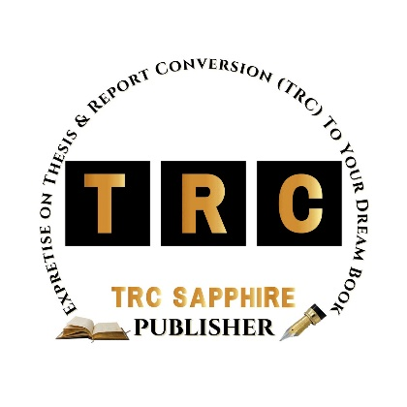**TRC Sapphire**

info@trc-sapphirepublisher.com

[www.trc-sapphirepublisher.com](http://www.trc-sapphirepublisher.com)

Kuala Lumpur, Malaysia