**Project Documentation**

**Introduction**

The Materials List Estimation Application is a software project aimed at assisting a construction  
company in estimating materials costs for building homes. The primary objectives of this  
project are to develop a user-friendly GUI application that allows users to input item details,  
calculate costs, and generate materials lists with estimated expenses. However, there are  
certain constraints to be considered:

* The project should be completed within an 8-week timeframe.
* The development team consists of seven members with varying levels of experience.
* The application should run on Windows operating systems (Windows 7 or later).
* The application must be developed using C# and the .NET Framework.

**Project Organization**

**Team Members:**

**1. Matthew Hildebrand**  
**Role: Project Manager**  
**Responsibilities: Overall project coordination, task assignment, and timeline**  
**management.**  
**2. Donovan Atkins**  
**Role: GUI Designer**  
**Responsibilities: Designing the graphical user interface, including forms, buttons,**  
**and layouts.**  
**3. Ben Vuko**  
**Role: Programmer**

**Responsibilities: Writing the code for the application, handling data input and**  
**calculations.**  
**4. Tyler Disneau**  
**Role: Tester and Documentation Specialist**

**Responsibilities: Ensuring the application is thoroughly tested, identifying and**  
**reporting bugs. Creating project documentation, including user manuals and**  
**help guides.**

**Hardware and Software Requirements**  
**Software Requirements:**

* Windows 7 or later operating system.
* Microsoft Visual Studio (2019 or later) for development.
* C# programming language.
* .NET Framework for Windows Forms development.

**Hardware Requirements:**

* A Windows-compatible computer with sufficient processing power and memory to run the development environment.

**Work Breakdown**  
The project will be broken down into the following activities:  
1. Project Planning and Scope Definition  
2. GUI Design and Prototyping  
3. Database Schema Design  
4. Programming and Implementation  
5. Testing and Quality Assurance  
6. Documentation and User Manual

7. File Management Integration  
8. Additional Features Development  
9. Final Testing and Bug Fixing  
10. User Training and Support

**Process Flow Diagram**

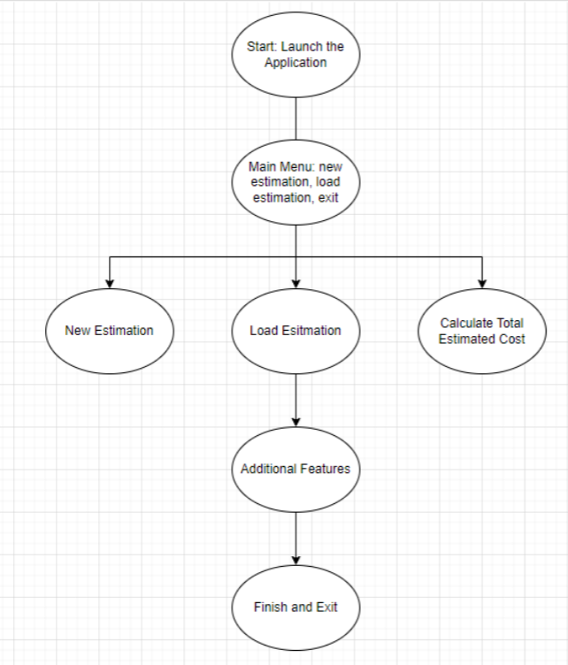

**Project Schedule**

Week 1-2: Project Planning and Scope Definition (Duration: 1 week)

* Define project objectives, scope, and constraints.
* Formulate a project plan, including roles and responsibilities.
* Develop a brief project timeline and milestones.

Week 3-4: GUI Design and Prototyping (Duration: 2 weeks)

* Create mockups and wireframes for the application's user interface.
* Gather feedback from stakeholders and make necessary revisions.
* Finalize the graphical design elements.

Week 5-6: Programming and Implementation (Duration: 2 weeks)

* Begin coding the application based on the approved design.
* Develop functionality for data input, calculations, and user interface.
* Continuously test and debug the application as features are developed.

Week 7: Testing and Quality Assurance (Duration: 2 weeks)

* Conduct thorough testing of the application to identify and resolve any defects or issues.
* Ensure that the application meets user requirements and functions correctly.

Week 8: Documentation, Deployment, and Conclusion (Duration: 1 week)

* Create user documentation, including manuals and help guides.
* Prepare for the final project presentation.
* Deploy the application for use within the organization.
* Address any remaining issues or concerns.  
  **Monitoring and Reporting Mechanisms**  
  The project will be monitored and reported through regular status meetings held every week.  
  During these meetings, team members will provide updates on the progress of their respective  
  tasks, discuss any issues or roadblocks encountered, and identify potential solutions.  
  Additionally, an online project management tool will be used to track task completion and milestones.

**Appendix**  
**Summary of Project Activities:**  
Activity # Description Estimated Duration Dependencies  
1 Project Planning and Scope Definition 1 week None  
2 GUI Design and Prototyping 2 week Activity 1  
3 Programming and Implementation 2 week Activity 2  
4 Testing and Quality Assurance 2 week Activity 3  
5 Documentation, Deployment, and Conclusion 1 week Activity 4  
6-8 Monitoring and Reporting Ongoing Activities 1-5