Exam_1_Analysis.R

hirsc

Wed Oct 24 20:56:31 2018

#16  
bat <- read_csv("BatteryLife.csv")

bat$Material <- as.factor(bat$Material)  
bat_aov <- aov(FailureTime~Material, data = bat)  
  
bat %>%   
 ggplot(aes(x = Material, y = FailureTime))+  
 geom_boxplot()+  
 geom_point()

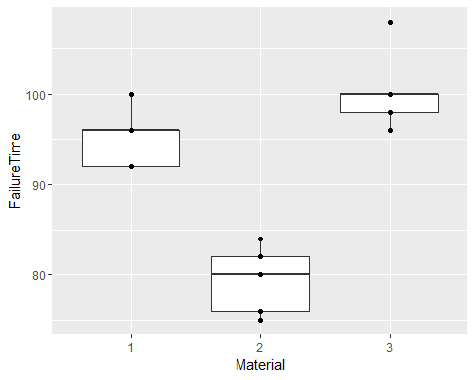

bat %>%   
 ggplot(aes(sample = FailureTime))+  
 geom_qq()+  
 geom_qq_line()

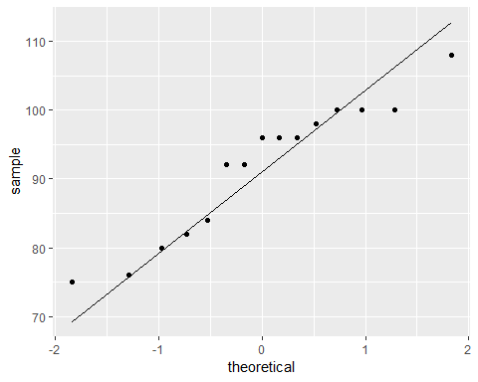

plotmeans(FailureTime ~ Material, data = bat)

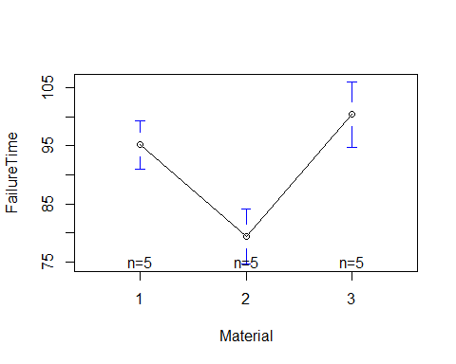

plot(bat_aov)

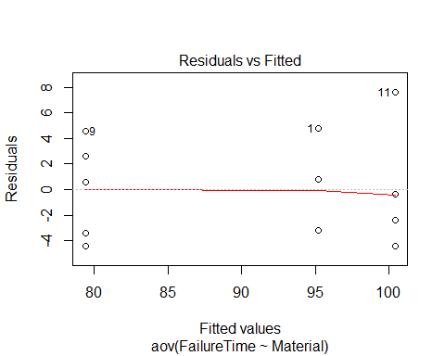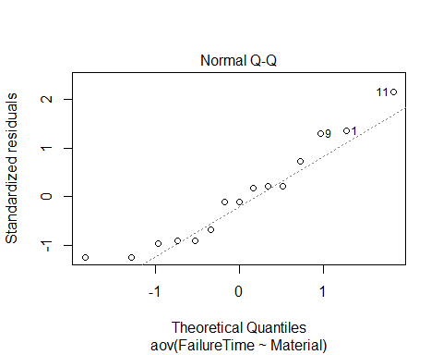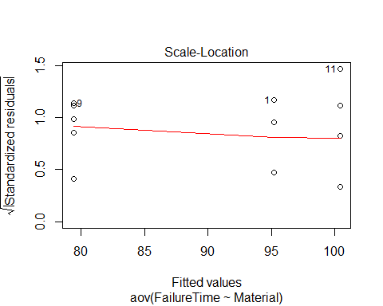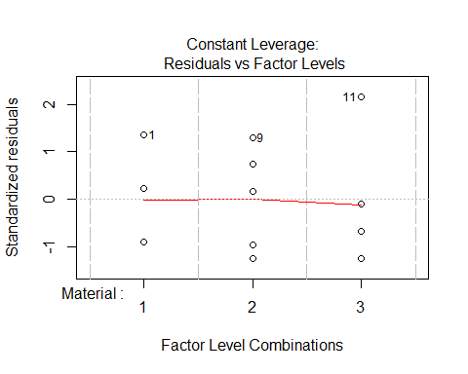

anova(bat_aov)

## Analysis of Variance Table  
##   
## Response: FailureTime  
## Df Sum Sq Mean Sq F value Pr(>F)   
## Material 2 1196.1 598.07 38.338 6.141e-06 ***  
## Residuals 12 187.2 15.60   
## ---  
## Signif. codes: 0 '***' 0.001 '**' 0.01 '*' 0.05 '.' 0.1 ' ' 1

summary(bat_aov)

## Df Sum Sq Mean Sq F value Pr(>F)   
## Material 2 1196.1 598.1 38.34 6.14e-06 ***  
## Residuals 12 187.2 15.6   
## ---  
## Signif. codes: 0 '***' 0.001 '**' 0.01 '*' 0.05 '.' 0.1 ' ' 1

#17  
  
fin <- read_csv("SurfaceFinish.csv")

fin$Feedrate <- as.factor(fin$Feedrate)  
fin$DepthofCut <- as.factor(fin$DepthofCut)  
fin_aov <- aov(SurfaceFinish~DepthofCut*Feedrate, data = fin)  
  
fin %>%   
 ggplot(aes(x = Feedrate, y = SurfaceFinish))+  
 geom_boxplot()+  
 geom_point()

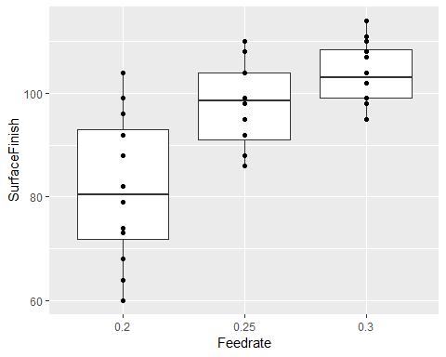

fin %>%   
 ggplot(aes(x = DepthofCut, y = SurfaceFinish))+  
 geom_boxplot()+  
 geom_point()

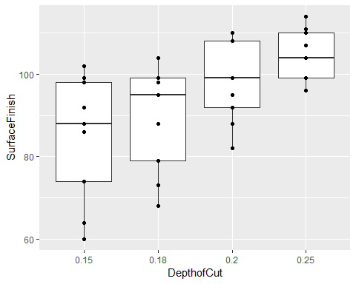

plotmeans(SurfaceFinish~Feedrate, data = fin)

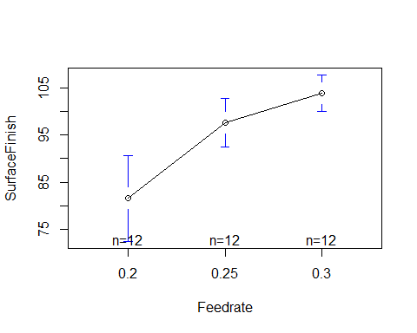

plotmeans(SurfaceFinish~DepthofCut, data = fin)

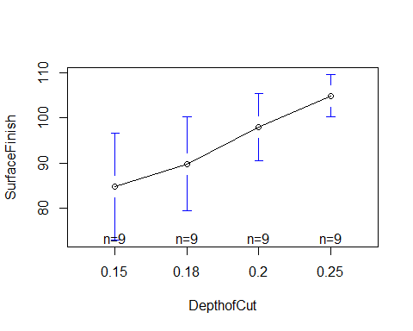

interaction.plot(fin$Feedrate, fin$DepthofCut, fin$SurfaceFinish)

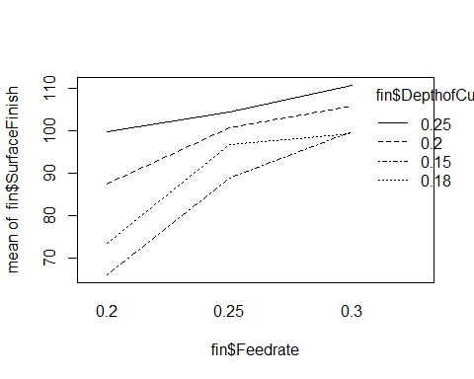

interaction.plot(fin$DepthofCut,fin$Feedrate, fin$SurfaceFinish)

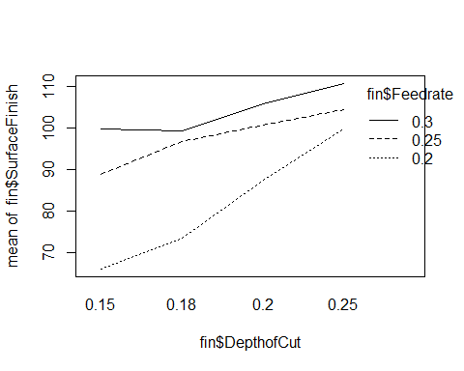

plot(fin_aov, which = 1:2)

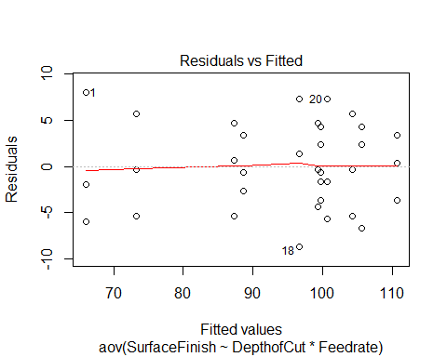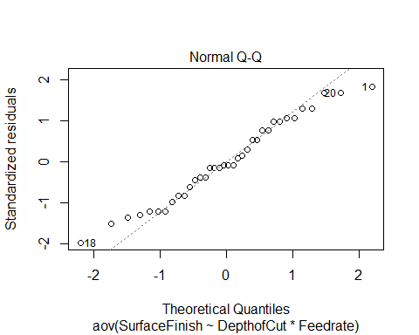

anova(fin_aov)

## Analysis of Variance Table  
##   
## Response: SurfaceFinish  
## Df Sum Sq Mean Sq F value Pr(>F)   
## DepthofCut 3 2125.11 708.37 24.6628 1.652e-07 ***  
## Feedrate 2 3160.50 1580.25 55.0184 1.086e-09 ***  
## DepthofCut:Feedrate 6 557.06 92.84 3.2324 0.01797 *   
## Residuals 24 689.33 28.72   
## ---  
## Signif. codes: 0 '***' 0.001 '**' 0.01 '*' 0.05 '.' 0.1 ' ' 1