Color Response Group

**Proposal**:

We would like to see if staring at a specific color will impact a person’s reaction time/cognitive ability.

**Method**:

We are going to have a monitor and present people with one of two colors, blue and red, and have one control group that doesn’t have a color shown. We will show them said color for 30 seconds. The color will be a full-screen picture of a color (red or blue) pulled from google images. The color red that we are using is at the link described at the end of our intro.4 The color blue likewise has a link.5 After that, we will apply a test of either reflexes or cognitive ability (Shapesplosion) and see how they perform by measuring their test time. If they are in the control group, we will have them play the game directly. We will record the time within the game’s timer function. All participants will use a wireless mouse in order to interact with the game.

**Factors**:

We’ll be testing two factors; color applied to the person and gender. We are going to shoot for a sample size of about 60, we want to have 10 observations in each of the possible combinations (male/female and color 1/color 2/no color).

**Hypothesis**:

We will be using an alpha level of .05 for our test and we will have three different hypothesis.

H10: Gender doesn’t have an affect on the outcome (betaj = 0 for  j= Male, Female)

H1A: At least one gender affect is different.

H20: The color shown before hand doesn’t affect the outcome (betai = 0 for i=color 1, color 2, control)

H2A: At least one color affect is different.

H30: The effect of the interaction of gender and color is 0.

H3A: At least one interaction term affect is different.

**Data Collection**:

For collecting out data we intend to set up on campus in a few locations and simply ask people to participate. As people do, we will randomize what they are exposed to before they play the game shapesplosion. We will assign each condition a number, and use a random number generator in order to determine which color conditions a person receives.

We will use the game’s built in recording functionality to record the results and collect our data.

For those people that are exposed to a color, we will have that color on a screen for them to look at before they play the game. Again, we will use shapesplosion to record which color they were exposed to or if they are a part of the control group.

Our experiment will be randomized in that we will assign the before game exposure randomly until one group has been sampled 10 times (i.e. 10 females viewing color 1) at which point in time we will stop adding people to that group. We do run the risk of having our experiment be a little unbalanced in terms of gender, however we should be able to get adequate sampling for all the color applications.

A sample survey of what we will be saying to people as we recruit them and introduce ourselves has been provided at the end of this document.

**Schedule:**

We plan on meeting at least once a week on Thursdays in order to start obtaining observations. We will generally meet at 2 p.m., and continue our experiments for a while.

**Previous Studies**:

It is well known that colors an impact on the mind and its processing ability. In the 1964 Journal of Psychology, a study was cited in which participants are given a test where the names of colors are given in different colors than the ones they describe. Participants were observed to falter, stutter, or name incorrectly the colors written.1 Furthermore, in more recent studies, scientists 2 observe a phenomena called Stimulus Onset Asynchrony and the effect of equiluminant colors coupled with reflex tests based on metacontrast experiments, testing to see if exposure to different hues of colors affects the perception of small dots while being subsequently masked by a different object at different time intervals. Red usually has been shown to have a stronger positive effect on perception in these trials.

What we wish to discover in our test is to see if different color hues affect the combined reaction time and cognitive-spatial capacity to fit shapes into corresponded places in Shapesplosion. We also wish to see the effects of gender, and see if more men or women are affected by this phenomenon.

1. Klein, George S. "Semantic power measured through the interference of words with color-naming." *The American journal of psychology* 77.4 (1964): 576-588.

2. Breitmeyer, Bruno G., and Joshua I. Breier. "Effects of background color on reaction time to stimuli varying in size and contrast: Inferences about human M channels." *Vision Research* 34.8 (1994): 1039-1045.

3. Breitmeyer, Bruno G., and Haluk Ogmen. "Recent models and findings in visual backward masking: A comparison, review, and update." *Perception & psychophysics* 62.8 (2000): 1572-1595.

**Sample Survey**:

Would you be willing to help us in a study testing response time and colors?

You will be asked to stare at a color for 30 seconds then complete a response game called Shapesplosion. It is to help us gather some data for an experiment for class. It will only take about 2 minutes or so.

You will be asked to stare at a computer screen for about one minute. This screen will display a randomly selected color. Thereafter, you will be asked to play a small computer game to put shapes into the correctly and correspondingly shaped holes.

We have some quick questions to ask you before we start.

Are you color blind?

Do certain colors cause any eye pain or headaches?

Have you recently been sitting at a computer or staring at a screen?

Did you get plenty of sleep last night?

Do you regularly work at your computer for homework and how many hours?

Additionally, before we start, we would like you to know that have a right to opt out of this research at any time. We do not expect any risks from this experiment, but if you feel uncomfortable at any time, you may opt to stop.

We will only record your reaction time of the game, as well as your gender. All other identifying information will be anonymous.

We have approval from the IRB, as is shown below.

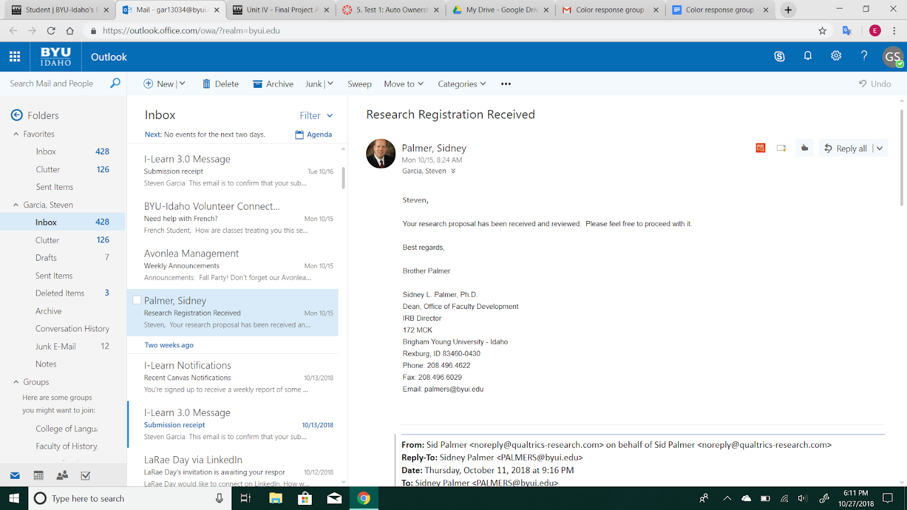

4. <https://www.google.com/imgres?imgurl=https%3A%2F%2Fi5.walmartimages.com%2Fasr%2F1c26a355-f40c-4309-aaa4-5cbf952b2158_1.ede2d65a57a1580e181a607f1ba7078e.jpeg&imgrefurl=https%3A%2F%2Fwww.walmart.com%2Fip%2FSiser-EasyWeed-Heat-Transfer-Material-Bright-Red%2F367797580&docid=ga5u4DEmEL7P1M&tbnid=x7j10F0sgFPuFM%3A&vet=10ahUKEwjiptiY9KfeAhXVIjQIHTrFBp4QMwhsKAEwAQ..i&w=2047&h=2048&bih=754&biw=1536&q=red&ved=0ahUKEwjiptiY9KfeAhXVIjQIHTrFBp4QMwhsKAEwAQ&iact=mrc&uact=8>

5. <https://www.google.com/imgres?imgurl=https%3A%2F%2Fupload.wikimedia.org%2Fwikipedia%2Fcommons%2Fthumb%2Ff%2Fff%2FSolid_blue.svg%2F225px-Solid_blue.svg.png&imgrefurl=https%3A%2F%2Fen.wikipedia.org%2Fwiki%2FBlue&docid=d1t6B7ZtoP8azM&tbnid=D4ed44lkuJWilM%3A&vet=10ahUKEwj6j7TU9KfeAhVQIjQIHcSjD-8QMwhrKAAwAA..i&w=225&h=225&bih=754&biw=1536&q=blue&ved=0ahUKEwj6j7TU9KfeAhVQIjQIHcSjD-8QMwhrKAAwAA&iact=mrc&uact=8>