bf_2.R

hirsc

Wed Oct 17 13:38:10 2018

dat$type <- as.factor(dat$type)  
dat$gender <- as.factor(dat$gender)  
dat1 <- read_csv("wear_no_rep.csv")

dat1$filler <- as.factor(dat1$filler)  
dat1$proportion <- as.factor(dat1$proportion)  
  
aov2 <- aov(dat1$wear~dat1$filler*dat1$proportion)  
anova(aov2)

## Warning in anova.lm(aov2): ANOVA F-tests on an essentially perfect fit are  
## unreliable

## Analysis of Variance Table  
##   
## Response: dat1$wear  
## Df Sum Sq Mean Sq F value Pr(>F)  
## dat1$filler 1 5280.7 5280.7   
## dat1$proportion 2 1608.6 804.3   
## dat1$filler:dat1$proportion 2 1493.6 746.8   
## Residuals 0 0.0

aov1 <- aov(dat1$wear~dat1$filler+dat1$proportion)  
anova(aov1)

## Analysis of Variance Table  
##   
## Response: dat1$wear  
## Df Sum Sq Mean Sq F value Pr(>F)  
## dat1$filler 1 5280.7 5280.7 7.0711 0.1171  
## dat1$proportion 2 1608.6 804.3 1.0770 0.4815  
## Residuals 2 1493.6 746.8

interaction.plot(dat1$filler, dat1$proportion, dat1$wear)

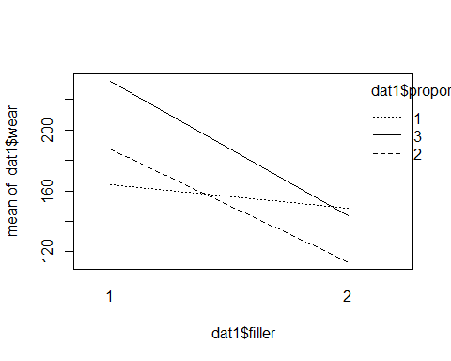

favstats(days~type+gender, data = dat)

## type.gender min Q1 median Q3 max mean sd n  
## 1 bladder.1 548 1483.00 2418.0 3353.00 4288 2418.0000 2644.57936 2  
## 2 bronchus.1 20 66.00 144.5 208.75 461 166.1429 139.59604 14  
## 3 colon.1 20 176.00 283.0 462.50 1843 489.0000 619.10931 7  
## 4 kidney.1 296 322.25 600.5 1073.75 1685 795.5000 648.59361 4  
## 5 rectum.1 115 209.50 301.5 815.25 2175 723.2500 973.07292 4  
## 6 stomach.1 42 49.75 124.5 358.00 1112 281.5000 363.78094 8  
## 7 bladder.2 51 164.50 278.0 1968.00 3658 1329.0000 2020.16410 3  
## 8 bronchus.2 166 186.00 206.0 226.00 246 206.0000 56.56854 2  
## 9 colon.2 101 248.00 372.0 455.00 942 397.4444 244.67893 9  
## 10 kidney.2 203 204.00 205.0 371.50 538 315.3333 192.83758 3  
## 11 rectum.2 185 332.00 479.0 677.00 875 513.0000 346.25424 3  
## 12 stomach.2 25 40.00 84.5 192.00 396 147.5000 171.09159 4  
## missing  
## 1 0  
## 2 0  
## 3 0  
## 4 0  
## 5 0  
## 6 0  
## 7 0  
## 8 0  
## 9 0  
## 10 0  
## 11 0  
## 12 0

model <- aov(days~type*gender, data = dat, contrasts = list(gender = contr.sum, type = contr.sum))  
Anova(model,type = 3)

## Anova Table (Type III tests)  
##   
## Response: days  
## Sum Sq Df F value Pr(>F)   
## (Intercept) 18920903 1 40.8501 4.975e-08 ***  
## type 10729871 5 4.6331 0.001462 **   
## gender 1206625 1 2.6051 0.112692   
## type:gender 1219108 5 0.5264 0.755172   
## Residuals 23622141 51   
## ---  
## Signif. codes: 0 '***' 0.001 '**' 0.01 '*' 0.05 '.' 0.1 ' ' 1