bf_project_2.R

hirsc

Sat Oct 20 19:46:33 2018

dat <- read_csv("basketball.csv")

## Parsed with column specification:  
## cols(  
## basket_type = col_character(),  
## location_feet = col_integer(),  
## shots_made = col_integer()  
## )

dat$basket_type <- as.factor(dat$basket_type)  
dat$location_feet <- as.factor(dat$location_feet)  
favstats(shots_made~location_feet+basket_type, data = dat)

## location_feet.basket_type min Q1 median Q3 max mean sd n missing  
## 1 10.blocks holder 6 7 8 8 10 7.8 1.483240 5 0  
## 2 15.blocks holder 2 2 4 5 6 3.8 1.788854 5 0  
## 3 10.garbage can 5 5 7 9 9 7.0 2.000000 5 0  
## 4 15.garbage can 2 5 8 8 8 6.2 2.683282 5 0  
## 5 10.laundry basket 2 6 6 8 8 6.0 2.449490 5 0  
## 6 15.laundry basket 1 2 4 7 8 4.4 3.049590 5 0

dat %>%   
 ggplot(aes(x = basket_type, y = shots_made))+  
 geom_boxplot()+  
 geom_point()

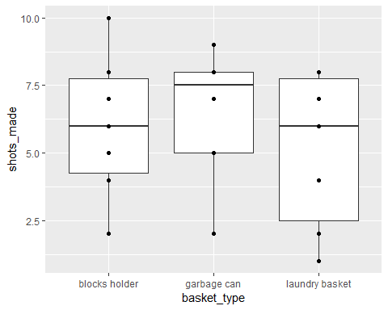

dat %>%   
 ggplot(aes(x = location_feet, y = shots_made))+  
 geom_boxplot()+  
 geom_point()

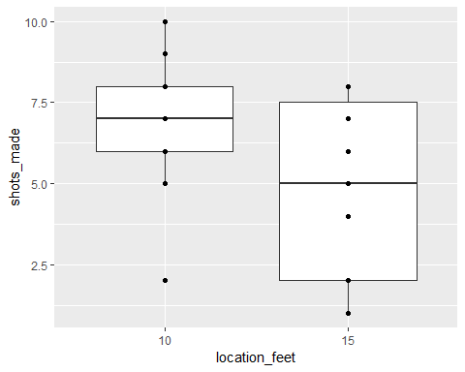

my_aov <- aov(shots_made~basket_type*location_feet, data = dat)  
anova(my_aov)

## Analysis of Variance Table  
##   
## Response: shots_made  
## Df Sum Sq Mean Sq F value Pr(>F)   
## basket_type 2 9.867 4.933 0.9279 0.40911   
## location_feet 1 34.133 34.133 6.4201 0.01823 *  
## basket_type:location_feet 2 13.867 6.933 1.3041 0.28997   
## Residuals 24 127.600 5.317   
## ---  
## Signif. codes: 0 '***' 0.001 '**' 0.01 '*' 0.05 '.' 0.1 ' ' 1

interaction.plot(dat$basket_type, dat$location_feet, dat$shots_made)

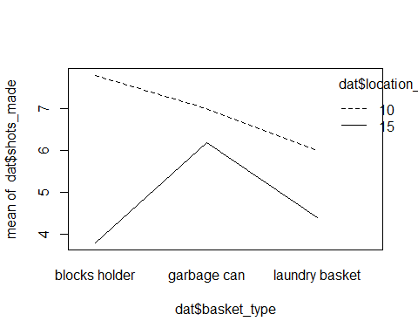

interaction.plot(dat$location_feet,dat$basket_type, dat$shots_made)

