wear_model.R

hirsc

Mon Oct 15 13:35:19 2018

dat$prop <- as.factor(dat$prop)  
dat$filler <- as.factor(dat$filler)  
  
  
dat %>%   
 ggplot(aes(x = prop, y = wear1))+  
 geom_boxplot()+  
 geom_point()

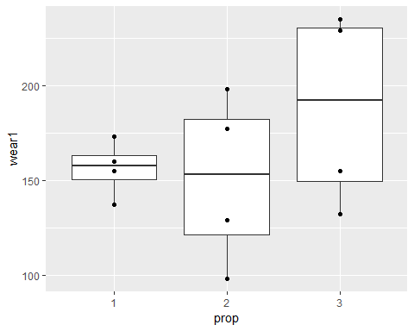

dat %>%   
 ggplot(aes(x = filler, y = wear1))+  
 geom_boxplot()+  
 geom_point()

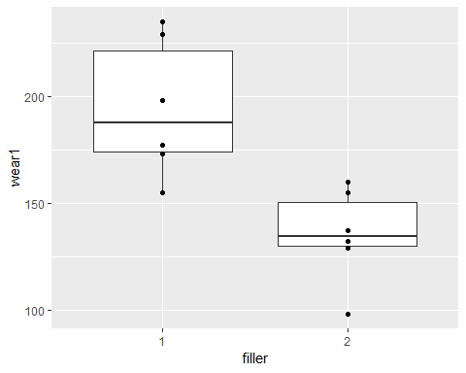

interaction.plot(dat$prop, dat$filler, dat$wear1)

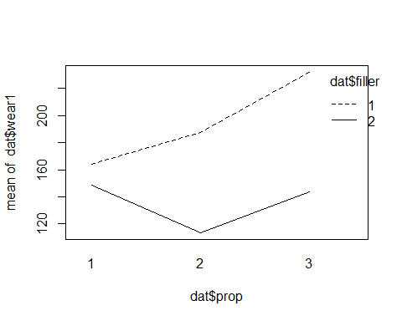

favstats(dat$wear1~dat$prop+dat$filler)

## dat$prop.dat$filler min Q1 median Q3 max mean sd n  
## 1 1.1 155 159.50 164.0 168.50 173 164.0 12.727922 2  
## 2 2.1 177 182.25 187.5 192.75 198 187.5 14.849242 2  
## 3 3.1 229 230.50 232.0 233.50 235 232.0 4.242641 2  
## 4 1.2 137 142.75 148.5 154.25 160 148.5 16.263456 2  
## 5 2.2 98 105.75 113.5 121.25 129 113.5 21.920310 2  
## 6 3.2 132 137.75 143.5 149.25 155 143.5 16.263456 2  
## missing  
## 1 0  
## 2 0  
## 3 0  
## 4 0  
## 5 0  
## 6 0

my_aov <- aov(log(dat$wear1) ~ dat$filler * dat$prop)  
anova(my_aov)

## Analysis of Variance Table  
##   
## Response: log(dat$wear1)  
## Df Sum Sq Mean Sq F value Pr(>F)   
## dat$filler 1 0.39905 0.39905 31.7683 0.001336 **  
## dat$prop 2 0.10855 0.05427 4.3208 0.068816 .   
## dat$filler:dat$prop 2 0.10484 0.05242 4.1730 0.073158 .   
## Residuals 6 0.07537 0.01256   
## ---  
## Signif. codes: 0 '***' 0.001 '**' 0.01 '*' 0.05 '.' 0.1 ' ' 1

plot(my_aov)

