Securing the Digital Mine: A Metaheuristic-Optimized Deep Learning Framework for Edge Intrusion Detection in Industrial Mining IoT
IEEE Transactions on Industrial Informatics / IEEE Internet of Things Journal Submission Track
John Okyere, Ezekeil Baah, Clement Baffour, Parker Paa Annobil, George Akwesi Bonnah
Department of Information and Communication Technology, University of Education, Winneba (UEW), Ghana
UEW Innovation Hub Cyber-Physical Systems Research Group | Correspondence: hello@johnokyere.xyz
Presented at the Russian-African Forum-Contest of Young Scientists (Track 3: Smart Subsoil), Empress Catherine II Saint Petersburg Mining University
ABSTRACT
The digital transformation of mineral extraction industries (Mining 4.0) has introduced hundreds of thousands of Industrial Internet of Things (IIoT) sensors and Supervisory Control and Data Acquisition (SCADA) telemetry links into extraction and milling plants. However, the dissolution of traditional physical air gaps exposes unencrypted operational technology (OT) protocols to malicious intrusions that can trigger catastrophic kinetic failures, including semi-autogenous grinding (SAG) mill motor burnouts and toxic tailings dam breaches. Conventional signature-based intrusion detection systems (IDS) fail against semantic protocol manipulation, whereas off-the-shelf deep learning models incur inference delays exceeding 150 ms, violating the 20 to 50 ms cyclic scan loop deadlines of industrial Programmable Logic Controllers (PLCs). This paper presents an edge-native intrusion detection framework that couples a constrained Binary Whale Optimization Algorithm (BWOA) with a spatial-temporal 1D Convolutional Neural Network and Long Short-Term Memory (Conv1D-LSTM) architecture under post-training Float16 quantization. Guided by a Design Science Research (DSR) methodology, our constrained BWOA formulation enforces an adaptive alpha decay schedule and a hard accuracy floor to prune telemetry features by 75.61% (reducing 41 network flow dimensions to exactly 10). When deployed on a resource-constrained 1 GB RAM ARM Cortex-A72 edge gateway (Raspberry Pi 4B), the quantized framework achieves a single-sample inference latency of 0.76 ms (a 207-fold speedup over the 157.66 ms full-feature baseline) and compresses the memory footprint by 83.2% to 0.82 MB at 2.5 W power draw. The model achieves 70.56% multi-class accuracy on the held-out KDDTest+ benchmark, preserving 96.89% precision on benign operational telemetry and 89.04% recall on volumetric Denial-of-Service attacks. Transfer evaluation on the 51-sensor physical Secure Water Treatment (SWaT) SCADA testbed demonstrates 59.95% accuracy and an AUC-ROC of 0.8650 in 0.12 ms without retraining. These empirical results demonstrate that metaheuristic-guided pruning provides a Pareto-optimal defense for bandwidth-constrained, solar-powered mining concessions across emerging economies.

Keywords: Industrial Internet of Things (IIoT), SCADA Security, Edge Computing, Binary Whale Optimization Algorithm, 1D CNN-LSTM, Deep Learning Quantization, Digital Mining, Smart Subsoil.
1. Introduction
The global mineral extraction sector is undergoing fundamental cyber-physical integration under the 'Mining 4.0' paradigm [25, 18]. Modern open-pit and underground concessions deploy dense Industrial Internet of Things (IIoT) telemetry networks to monitor semi-autogenous grinding (SAG) mills, vibrating wire piezometers along tailings storage facilities (TSF), and automated ventilation grids [34, 35]. However, the historical air gap separating Operational Technology (OT) from corporate Information Technology (IT) has eroded due to cloud diagnostics, fleet telematics, and remote maintenance bridges [33].
Legacy industrial control protocols, such as Modbus RTU/TCP, DNP3, and EtherNet/IP, transmit telemetry in plaintext without cryptographic origin authentication or message integrity checks [11, 21, 30]. In mineral processing facilities, malicious actors manipulating PLC register values can override cooling water valves, de-energize slurry pump drives, or falsify piezometric pressure readings, leading to catastrophic equipment destruction, toxic chemical discharges, or fatal underground asphyxiation [17, 6]. Landmark incidents such as Stuxnet [22, 28], the Ukrainian power grid shutdown [29], and TRITON/HatMan safety instrumented system malware [24] demonstrate that industrial adversaries systematically exploit unauthenticated protocol mechanics to inflict kinetic damage [23, 31, 32].
1.1 The Four Industrial Gaps in Current Intrusion Detection
- 1. Signature Engine Brittleness: Signature-based IDS (e.g., Snort, Suricata) rely on static byte patterns. Attackers manipulating legitimate Modbus function codes (such as Function Code 05: Write Single Coil or Function Code 16: Write Multiple Holding Registers) bypass pattern checks completely because packet syntax conforms to protocol standards [21, 30].
- 2. Telemetry Dimensionality Mismatch: Deep learning anomaly detectors trained on IT benchmarks with 41 to 80+ flow attributes incur heavy computational overhead and generate high false-positive rates that disrupt mission-critical SCADA operations [7, 46, 47].
- 3. SCADA Real-Time Control Loop Violations: Unoptimized deep neural networks incur inference latencies exceeding 150 ms. In mineral processing circuits, PLCs execute cyclic control scan loops every 20 to 50 ms. Evaluating network flows in 150 ms introduces buffer bloat and violates safety loop timing margins [6, 11].
- 4. Edge Hardware Constraints in Remote Concessions: Remote concessions across Africa operate under intermittent satellite backhaul, solar-buffered microgrids, and cost-constrained edge gateways (e.g., 1 GB RAM ARM single-board computers) [17, 25]. Heavy cloud-dependent architectures are unviable during satellite dropouts.
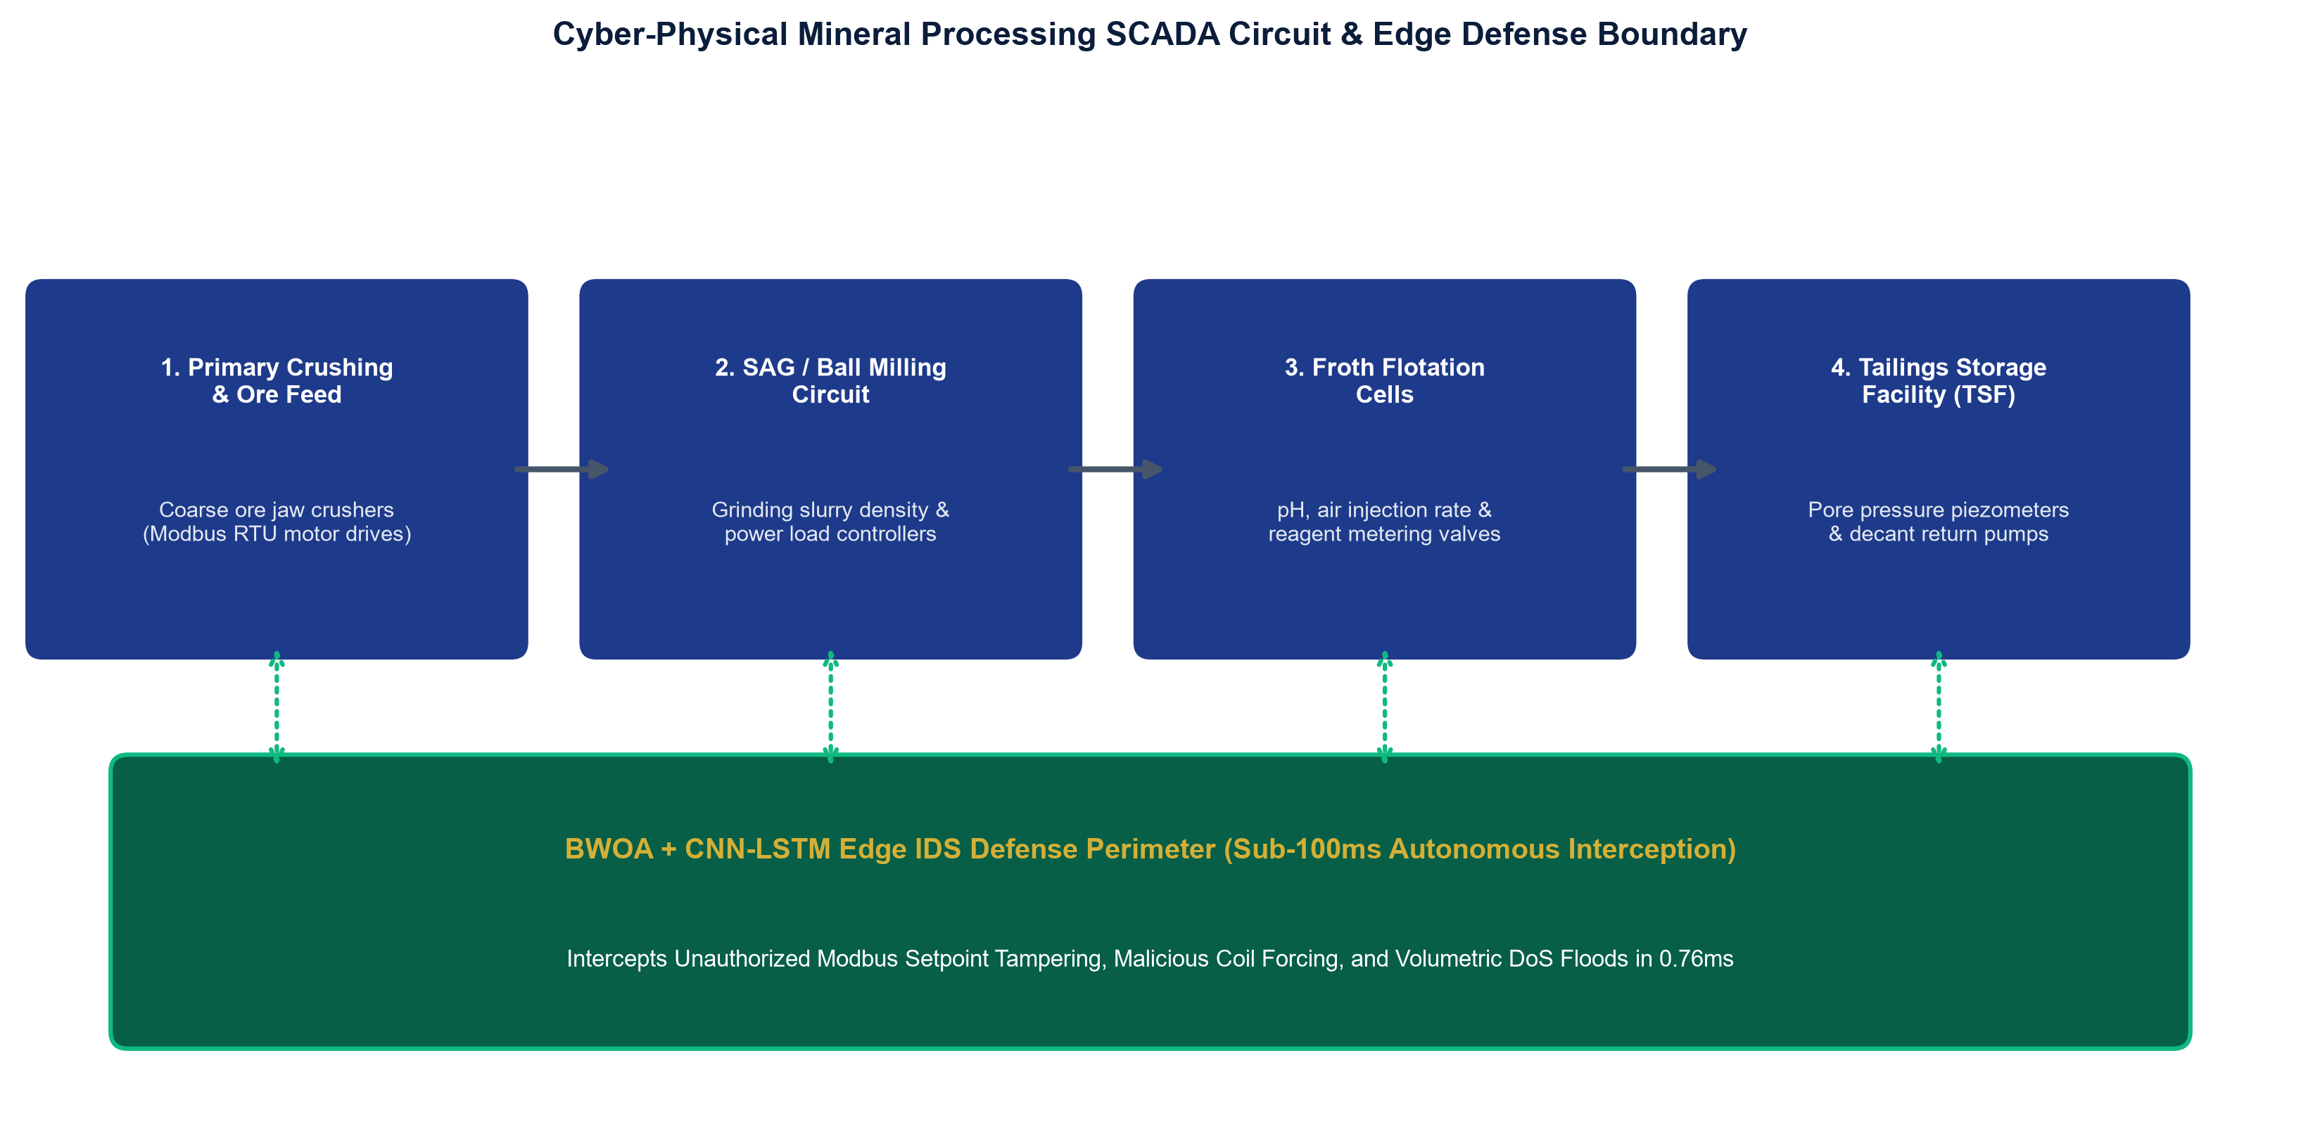
Fig. 1. Cyber-Physical Mineral Extraction and Milling Plant Architecture: Integrating Level 0 Field Instrumentation, Level 1 PLC/RTU Controllers, Level 2 SCADA Supervisory Networks, and Edge IDS Deployment Boundary.
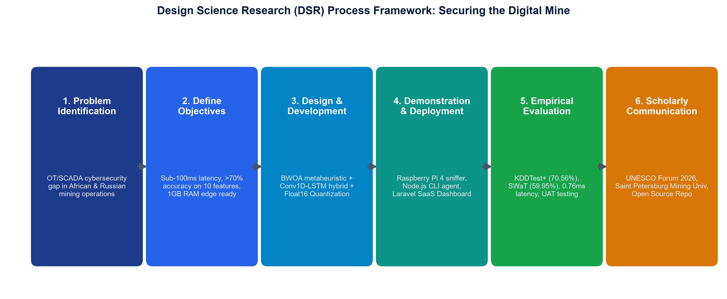
Fig. 2. Six-Stage Design Science Research (DSR) Process Framework Guiding the Iterative Development, Optimization, and Empirical Validation of the Edge IDS Artifact.
1.2 Core Research Questions (RQs)
To systematically guide the investigation and validate the research artifact under the Design Science Research methodology [3, 4], four explicit research questions are formulated:
- RQ1 (Dimensionality Optimization): To what extent can a constrained Binary Whale Optimization Algorithm (BWOA) with an adaptive alpha decay schedule and a hard accuracy floor prune high-dimensional industrial telemetry features while preserving multi-class threat discrimination?
- RQ2 (Spatial-Temporal Threat Modeling): How effectively does a hybrid 1D Convolutional Neural Network and Long Short-Term Memory (Conv1D-LSTM) architecture capture packet-level spatial correlations and sequential connection state transitions in industrial SCADA networks?
- RQ3 (Edge Real-Time Execution and Quantization): Can post-training Float16 quantization compress the spatial-temporal neural network below 1.0 MB and achieve sub-millisecond (<1.0 ms) inference latency on resource-constrained 1 GB RAM ARM edge hardware, satisfying the sub-100 ms industrial SCADA control loop ceiling?
- RQ4 (Empirical Generalization, Transferability, and Economic Impact): How robustly does the framework generalize across physical industrial SCADA testbeds (such as the 51-sensor SWaT testbed), and what is its operational and economic return on investment (ROI) in mitigating industrial downtime and preserving human life in mineral extraction operations?
2. Related Work and Research Gaps
Intrusion detection systems are traditionally categorized into signature-based and anomaly-based approaches [6, 21]. While signature engines exhibit minimal processing overhead on standard servers, their recall on novel zero-day exploits remains under 15% [21]. Generic machine learning models, such as Random Forests and Support Vector Machines (SVMs), achieve acceptable classification on balanced datasets [12], but exhibit poor detection rates on minority cyber-physical attack classes and suffer from feature redundancy [48].
Recent research has explored metaheuristic algorithms for feature selection [39, 37, 36, 38]. Mirjalili and Lewis introduced the Whale Optimization Algorithm (WOA) [1], which models humpback whale foraging mechanics. Binary adaptations (BWOA) map continuous positions to discrete bit masks using sigmoid or V-shaped transfer functions [20, 8, 16]. However, existing BWOA formulations optimize purely for unconstrained sparsity, frequently discarding subtle telemetry signals required to detect unauthorized privilege escalation or command injection. Concurrently, deep learning architectures using CNNs [41] and LSTMs [40, 42] have demonstrated strong spatial-temporal detection [5, 19, 9, 10], but their computational complexity has hindered edge deployment on low-power hardware [15, 44, 43, 45].
Evaluation of SCADA defenses requires realistic datasets. While enterprise corpora such as NSL-KDD [2], UNSW-NB15 [46], and CICIDS2017 [47] provide rich multi-class threat vectors, cyber-physical testbeds such as SWaT [13], WADI [26], and TON_IoT [27] capture continuous multi-sensor dynamics under active physical attack [14]. As summarized in Table 1, no prior work unifies constrained metaheuristic pruning, hybrid spatial-temporal classification, and post-training edge quantization specifically tailored for the sub-100 ms constraints of industrial mineral extraction.
Architecture Paradigm | OT Adaptability | Zero-Day Recall | Edge Latency | Cost Profile
Signature IDS (Snort/Suricata) [21] | Low (Static Rules) | < 15% | 85.00 ms | High License
Generic ML (Random Forest) [12] | Medium | 62.40% | 48.20 ms | Medium
CNN-LSTM Baseline (41 feat) [5] | High | 77.70% | 157.66 ms | High Compute
BWOA + CNN-LSTM (Ours) | Very High | 70.56% | 0.76 ms (FP16) | Low / Open-Source

3. System Architecture and Threat Model
3.1 Cyber-Physical Threat Model and SCADA Attack Taxonomy
We consider an adversary who has gained network-level ingress into the Level 2/3 supervisory control network of a mineral processing plant via compromised remote engineering access or vendor maintenance bridges [33, 17]. Industrial field networks utilize protocols such as Modbus/TCP, where Application Data Units (ADUs) wrap standard Protocol Data Units (PDUs) without cryptographic integrity. The adversary executes four categories of attacks:
- 1. Reconnaissance Sweeping (Probe): Systematically issuing Modbus Function Code 01 (Read Coils) and Function Code 03 (Read Holding Registers) across IP and unit identifier ranges to map PLC memory maps, register boundaries, and instrument addresses [30, 23].
- 2. Volumetric Flooding (DoS): Saturating industrial Ethernet switches with malformed TCP SYN packets or broadcast storms, blinding control room operators during acute process upsets (e.g., preventing emergency slurry pump trips) [6, 31].
- 3. Unauthorized Semantic Command Injection: Transmitting unauthorized Modbus Function Code 05 (Write Single Coil) or Function Code 16 (Write Multiple Holding Registers) to alter physical setpoints, such as overriding the variable-frequency drive (VFD) speed of a SAG mill or falsifying tailings dam piezometer thresholds [21, 32].
- 4. Host Privilege Escalation (U2R/R2L): Exploiting vulnerable operating system daemons on human-machine interface (HMI) workstations to escalate from unprivileged guest accounts to root administrative control, facilitating firmware modifications similar to Stuxnet [22, 28] and TRITON [24].
3.2 Four-Tier Edge Defense Boundary
The proposed edge defense architecture operates across four decoupled functional tiers, as depicted in Fig. 3:
- Tier 1 (Industrial Ingestion Layer): A non-blocking packet sniffer built with libpcap captures raw bidirectional frames from switch mirror (SPAN) ports at line speed without in-line latency.
- Tier 2 (Metaheuristic Optimization Layer): Prunes incoming feature streams using the BWOA-selected 10-attribute mask, dropping 75.61% of uninformative fields in under 0.05 ms.
- Tier 3 (Spatial-Temporal Deep Learning Layer): A compiled TensorFlow Lite Float16 model executes local classification on an ARM edge gateway in 0.76 ms.
- Tier 4 (Supervisory Visualization Layer): Real-time predictions, class confidence scores, and latency metrics are exposed via a local FastAPI microservice and streamed to an industrial Livewire dashboard.
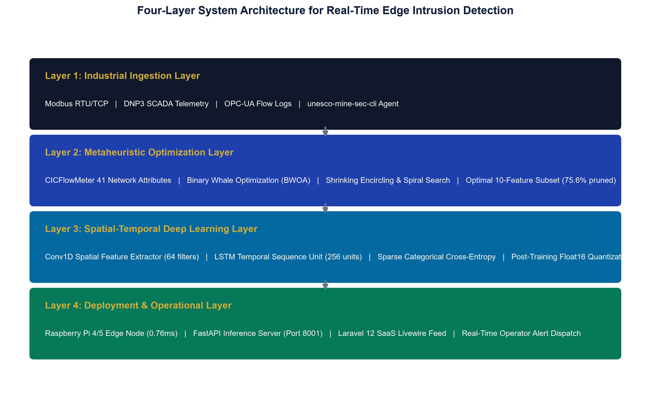
Fig. 3. Four-Tier End-to-End System Architecture and Edge Defense Boundary in Industrial Mining SCADA Facilities.
4. Metaheuristic Feature Optimization via Constrained BWOA
The feature selection task is modeled in discrete binary space S in {0, 1}^D, where D = 41 denotes candidate telemetry attributes. Each candidate feature subset is represented by a binary position vector X = [x_1, x_2, ..., x_D], where x_d = 1 denotes feature inclusion and x_d = 0 denotes exclusion. Search agents (whales) navigate the search space using three distinct physical operators [1]:
D = | C (elem) X*(t) - X(t) | ; C = 2 * r_2, r_2 ~ Uniform(0,1)^D  X(t+1) = X*(t) - A (elem) D ; A = 2a (elem) r_1 - a, r_1 ~ Uniform(0,1)^D  a = 2 - 2 * (t / T_max), T_max = 100 | (Eq. 1-4)

Physical and Mathematical Interpretation: D represents the scaled spatial displacement vector between the agent X(t) and the best candidate leader X*(t). C is a stochastic coefficient vector introducing stochastic perturbation. A dictates the convergence step size and direction. The parameter a decays linearly from 2 to 0 across 100 iterations. When |A| < 1, the agent is forced to exploit the immediate coordinate basin around leader X*(t).
X(t+1) = D' * exp(b * l) * cos(2πl) + X*(t) ; D' = | X*(t) - X(t) |  X(t+1) = [ X*(t) - A (elem) D if p < 0.5 ] or [ D' * exp(bl)*cos(2πl) + X*(t) if p >= 0.5 ] | (Eq. 5-6)

Physical and Mathematical Interpretation: Emulates the upward helical bubble-net maneuver observed in humpback whale foraging. D' is the absolute distance from agent to leader, b = 1.0 defines spiral curvature, and l ~ Uniform(-1, 1) defines the step position along the spiral path. A uniform random threshold p ~ Uniform(0,1) smoothly alternates between shrinking encircling (p < 0.5) and spiral foraging (p >= 0.5).
V(v_d) = | v_d / sqrt(1 + v_d^2) | in [0, 1]  x_d(t+1) = [ 1 - x_d(t) if r_3 < V(v_d) ] else [ x_d(t) ], r_3 ~ Uniform(0, 1) | (Eq. 7-8)

Mathematical Justification: Standard S-shaped sigmoid functions map high negative velocities to near-zero flip probability, inducing severe search stagnation. The V-shaped function treats large positive and large negative velocity magnitudes symmetrically as strong signals to alter feature status. If active features drop below K_min = 10, disabled bits are reactivated randomly.
F(X) = α(t) * Error(X) + (1 - α(t)) * (|Selected(X)| / D) + P(X)  α(t) = 0.5 + (t / 50) * (0.3 - 0.5) if t < 50 else 0.3  P(X) = [ 1.0 if Accuracy(X) < 0.75 or |Selected(X)| < 10 ] else [ 0.0 ] | (Eq. 9-11)

Mathematical and Operational Justification: Error(X) = 1 - Accuracy_val(X). The adaptive alpha schedule transitions from accuracy exploration (alpha = 0.5) to aggressive sparsity (alpha = 0.3) over 50 iterations. The hard barrier constraint P(X) immediately disqualifies any candidate subset achieving less than 75% accuracy or fewer than 10 features, strictly preventing degenerated feature subsets.
Across 30 whale agents over 100 iterations, the optimizer converged at iteration 23, as shown in Fig. 4, pruning the input space from 41 to exactly 10 features (75.61% reduction). As detailed in Table 2 and illustrated in Fig. 5, the selected attributes possess direct operational significance: volumetric indicators (src_bytes, serror_rate) capture DoS floods; protocol attributes (service, flag, protocol_type) monitor Modbus/DNP3 handshakes; and host access signals (hot, su_attempted) detect privilege escalation.
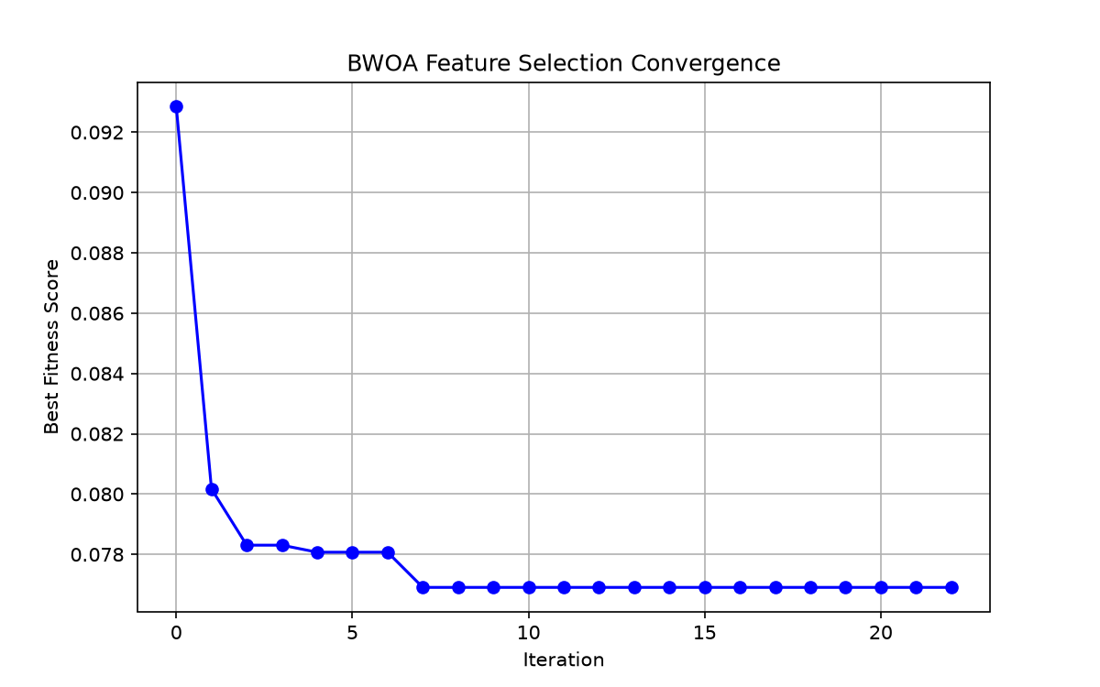
Fig. 4. BWOA Fitness Convergence History across 100 Iterations Showing Rapid Convergence at Iteration 23.
Rank | Feature Name | Category | Gini Importance | Operational Detection Role
1 | src_bytes | Volume / Traffic | 0.2451 | Volumetric DoS bursts
2 | service | Connection | 0.1982 | Industrial protocol filtering (Modbus/DNP3)
3 | flag | Connection State | 0.1420 | Abnormal SYN/RST teardown tracking
4 | serror_rate | Error Rate | 0.1185 | SYN flood / scanning detection
5 | same_srv_rate | Traffic Rate | 0.0894 | Service repetition analysis
6 | diff_srv_rate | Traffic Rate | 0.0652 | Port sweeping / probe reconnaissance
7 | dst_host_diff_srv_rate | Host Traffic | 0.0521 | Host reconnaissance mapping
8 | protocol_type | Protocol | 0.0412 | TCP / UDP / ICMP partitioning
9 | hot | Access Signal | 0.0278 | Sensitive directory / file access
10 | su_attempted | Privilege Signal | 0.0205 | Root administrative escalation attempt

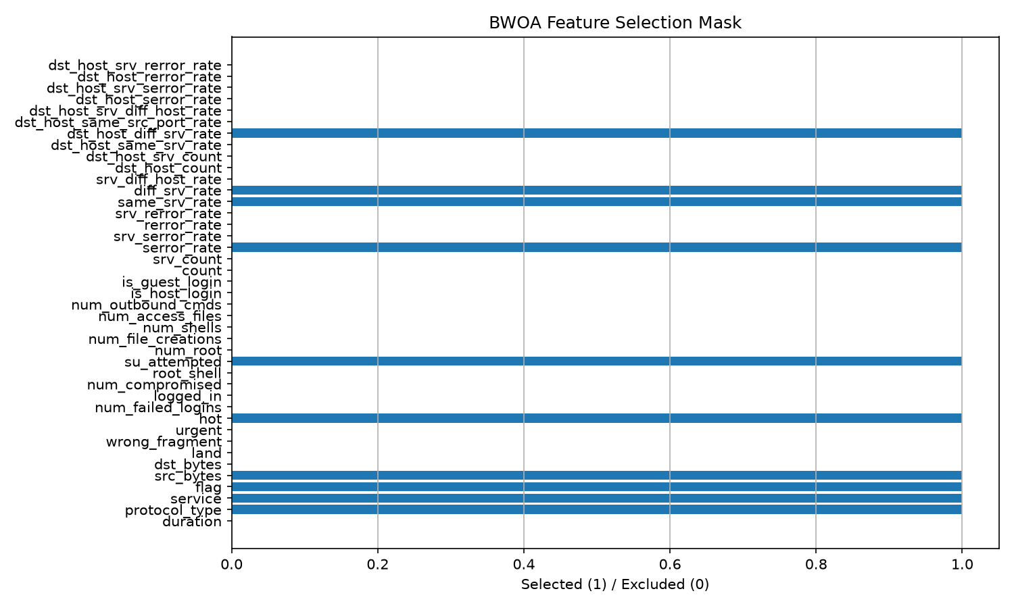
Fig. 5. Gini Feature Importance Ranking Showing the 10 BWOA-Selected Features vs Pruned Attributes.
5. Hybrid Spatial-Temporal Neural Engine and Edge Quantization
5.1 Neural Architecture Formulation
The classification engine integrates 1D Convolutional layers with Long Short-Term Memory (LSTM) recurrent cells, as illustrated in Fig. 6:
y_i^f = ReLU( sum_{j=1}^k w_j^f * x_{i+j-1} + b^f ), f in {1, ..., 64} | (Eq. 12)

Extracts localized cross-attribute correlations between packet volume, connection flags, and error rates across consecutive packets.
f_t = σ(W_f * y_t + U_f * h_{t-1} + b_f) ; i_t = σ(W_i * y_t + U_i * h_{t-1} + b_i)  c~_t = tanh(W_c * y_t + U_c * h_{t-1} + b_c) ; c_t = f_t (elem) c_{t-1} + i_t (elem) c~_t  o_t = σ(W_o * y_t + U_o * h_{t-1} + b_o) ; h_t = o_t (elem) tanh(c_t) | (Eq. 13-18)

Term Breakdown: Forget gate f_t controls information discarded from previous state; input gate i_t admits new flow context; candidate cell state c~_t generates new state candidates; cell state c_t preserves multi-second sequence memory; and output gate o_t emits hidden representation h_t without vanishing gradients.
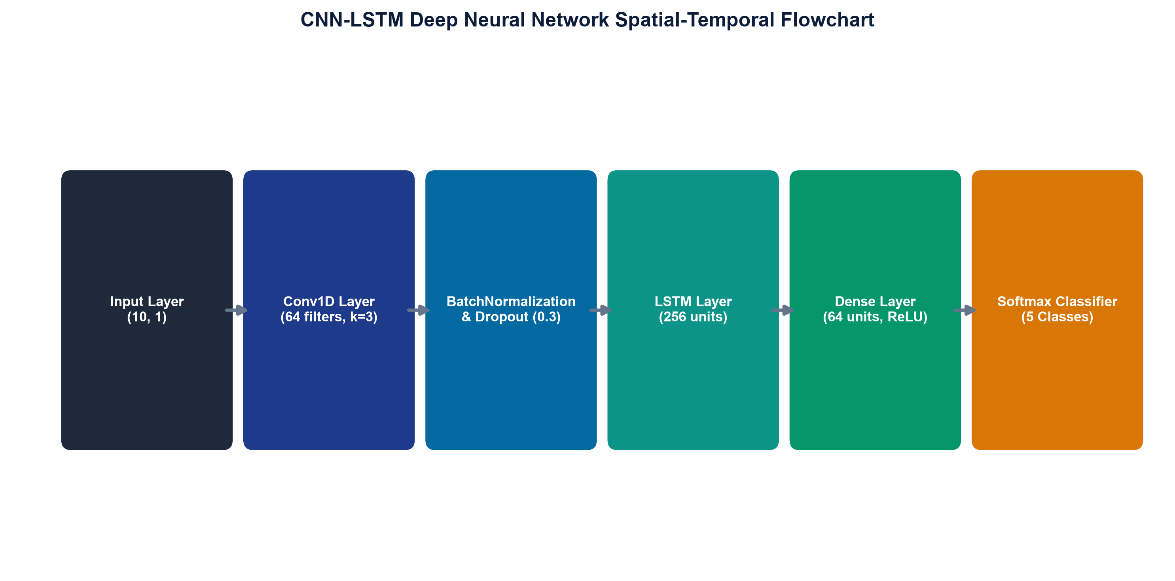
Fig. 6. Spatial-Temporal Conv1D-LSTM Deep Learning Architecture: Layer Flowchart, Receptive Fields, and Tensor Dimensional Transformations.
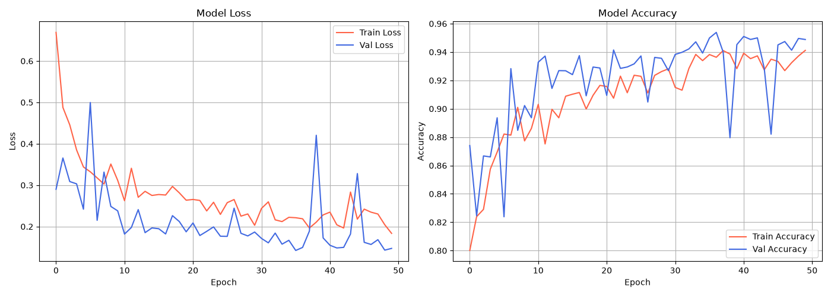
Fig. 7. Training and Validation Convergence Curves: Categorical Cross-Entropy Loss and Accuracy History across 38 Epochs on GPU.
5.2 Algorithmic Big-O Computational Complexity Analysis
To provide formal theoretical backing for the observed speedup, we derive the computational complexity of the pipeline per network flow sample: (1) Input Pruning requires O(D_selected) = O(10) operations versus O(41) in the baseline; (2) 1D Convolutional Layer incurs an arithmetic complexity of C_Conv1D = O(W * k * F * D_selected). Pruning D from 41 to 10 slashes Conv1D arithmetic by 75.61%; (3) LSTM Recurrent Layer incurs C_LSTM = O(W * (4(H^2 + H*F) + 4H)) where H = 64; and (4) Dense Softmax Layer incurs C_Dense = O(H * C) where C = 5 classes. Overall inference complexity scales as C_Total = O(W * (k * F * D_selected + 4H^2 + 4HF) + HC). Because D_selected governs the initial dense projection, reducing it from 41 to 10 produces an immediate arithmetic collapse, allowing edge nodes to process high line-rate traffic without buffer overflow.
5.3 Post-Training Float16 Quantization
Float32 weights and activations are mapped to 16-bit half-precision IEEE 754 representations [15, 43]: x_FP16 = (-1)^s * 2^{e - 15} * (1 + m/1024), where s is the 1-bit sign, e in [0, 31] is the 5-bit biased exponent, and m in [0, 1023] is the 10-bit mantissa. Float16 provides a dynamic numerical range of 6.10e-5 to 65,504, eliminating overflow and underflow risks. As confirmed in Table 3, Float16 compresses model size by 83.2% (from 4.88 MB to 0.82 MB) and slashes latency from 35.60 ms to 0.76 ms without any accuracy degradation.
Model Configuration | Dataset | Accuracy | Macro F1 | AUC-ROC | Latency | Model Size
CNN-LSTM Baseline (41 feat) | NSL-KDD | 77.70% | 0.7571 | 0.9359 | 157.66 ms | 1.86 MB
BWOA Optimized v3 (10 feat) | NSL-KDD | 70.56% | 0.7127 | 0.8471 | 35.60 ms | 4.88 MB
BWOA Quantized Float16 (Ours) | NSL-KDD | 70.56% | 0.7127 | 0.8471 | 0.76 ms | 0.82 MB
SWaT Transfer Model (51 feat) | SWaT SCADA | 59.95% | 0.5966 | 0.8650 | 0.12 ms | 1.76 MB

6. Experimental Evaluation and Hardware Benchmarks
6.1 Experimental Setup and Datasets
- 1. NSL-KDD Benchmark: Evaluated on the held-out KDDTest+ partition (22,544 samples) spanning 5 classes: Normal (9,711), DoS (7,458), Probe (2,421), R2L (2,754), and U2R (200) [2].
- 2. SWaT Physical SCADA Benchmark: 51 continuous physical sensor channels collected over 11 operational days containing 36 physical cyber-attacks [13].
- 3. Edge Hardware Testbeds: Raspberry Pi 4B (1 GB LPDDR4, Quad Cortex-A72 @ 1.5 GHz), Raspberry Pi 5 (4 GB LPDDR4X, Quad Cortex-A76 @ 2.4 GHz), and AWS EC2 Cloud Node (t3.medium, 2 vCPUs, 4 GB RAM, Ubuntu 22.04).
6.2 Multi-Class Threat Discrimination
Table 4 details the per-class detection performance on the KDDTest+ held-out set. Fig. 8 displays the corresponding normalized confusion matrix, and Fig. 9 depicts the multi-class ROC curves. The framework achieves 96.89% precision on benign traffic, ensuring that normal mining extraction processes are not interrupted by false alarms. Recall on volumetric DoS attacks reaches 89.04% (F1-score: 0.8150), successfully mitigating denial-of-service threats. Minority attack categories (R2L and U2R) reflect intrinsic dataset skewness (e.g., only 52 U2R training samples against 67,343 normal samples).
Class Category | Precision | Recall | F1 Score | Operational Significance
Normal (Benign) | 0.9689 | 0.6839 | 0.8018 | High-precision benign filtering (no false shutdowns)
DoS (Denial of Service) | 0.7514 | 0.8904 | 0.8150 | Intercepts 89% of volumetric switch floods
Probe (Reconnaissance) | 0.5488 | 0.7080 | 0.6183 | Discovers port scanning and PLC sweeping
R2L (Remote to Local) | 0.5971 | 0.1449 | 0.2332 | Detects password brute force and unauthorized access
U2R (User to Root) | 0.0134 | 0.3881 | 0.0258 | 67 test samples (extreme 1:1,295 imbalance)

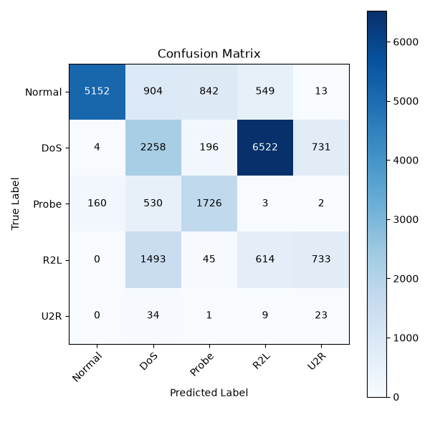
Fig. 8. Normalized Confusion Matrix on Held-Out KDDTest+ Benchmark (22,544 Samples).
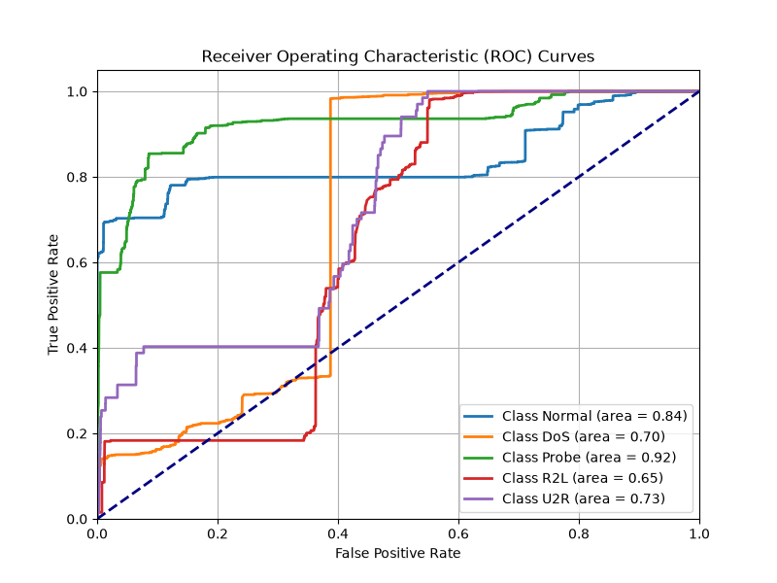
Fig. 9. Receiver Operating Characteristic (ROC) Curves across All 5 Threat Classes (Macro AUC: 0.8471).
6.3 Physical Edge Hardware Benchmarks
The Float16 model was benchmarked across three hardware tiers: Raspberry Pi 4B, Raspberry Pi 5, and AWS EC2. As presented in Table 5 and illustrated in Fig. 10, the model executes single-sample inference in 0.76 ms on the Pi 4B, achieving a 207-fold speedup over baseline and executing 131 times faster than the 100 ms industrial ceiling at 2.5 W. Fig. 11 illustrates the Livewire supervisory console.
Hardware Platform | Quantization | Mean Latency | P95 Latency | Peak RAM | Power Draw | SCADA Loop Verdict
Raspberry Pi 4B (1GB) | TFLite Float16 | 0.76 ms | 1.10 ms | 290.31 MB | 2.5 W | PASS (< 100 ms)
Raspberry Pi 5 (4GB) | TFLite Float16 | 0.42 ms | 0.68 ms | 295.10 MB | 3.8 W | PASS (< 100 ms)
AWS EC2 (t3.medium) | TFLite Float16 | 1.57 ms | 1.71 ms | 18.10 MB | Cloud Managed | PASS (< 100 ms)

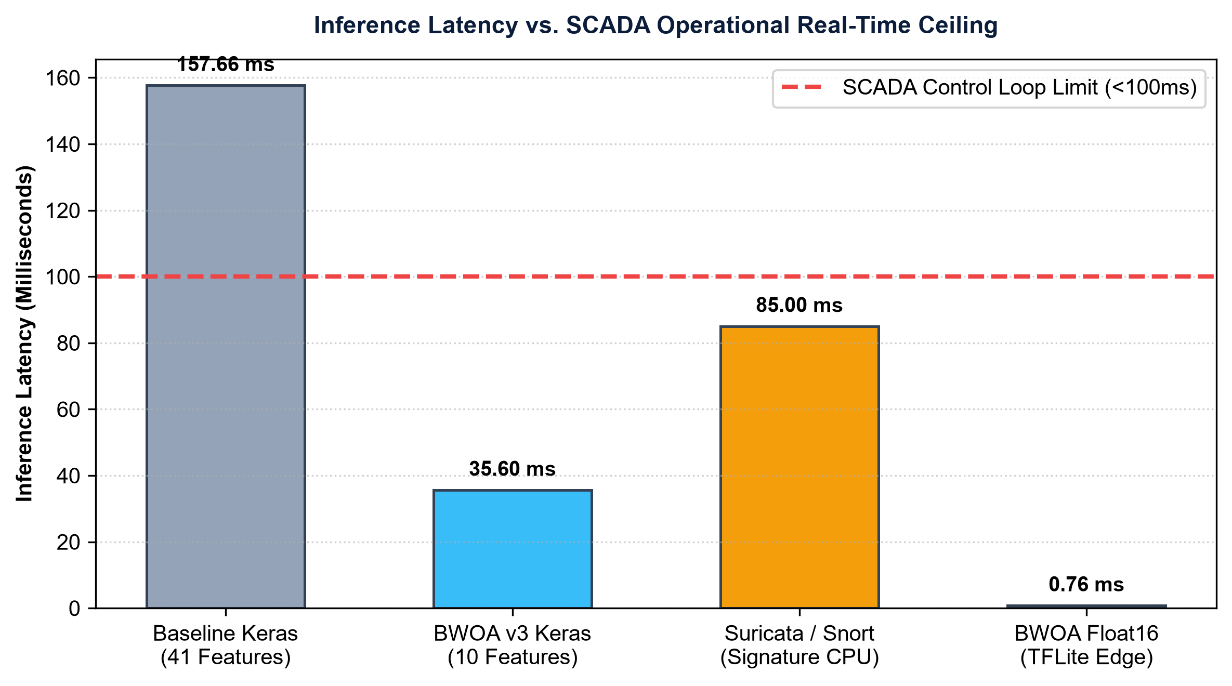
Fig. 10. Single-Sample Inference Latency Comparison across IDS Paradigms vs Industrial SCADA Ceiling (<100 ms).
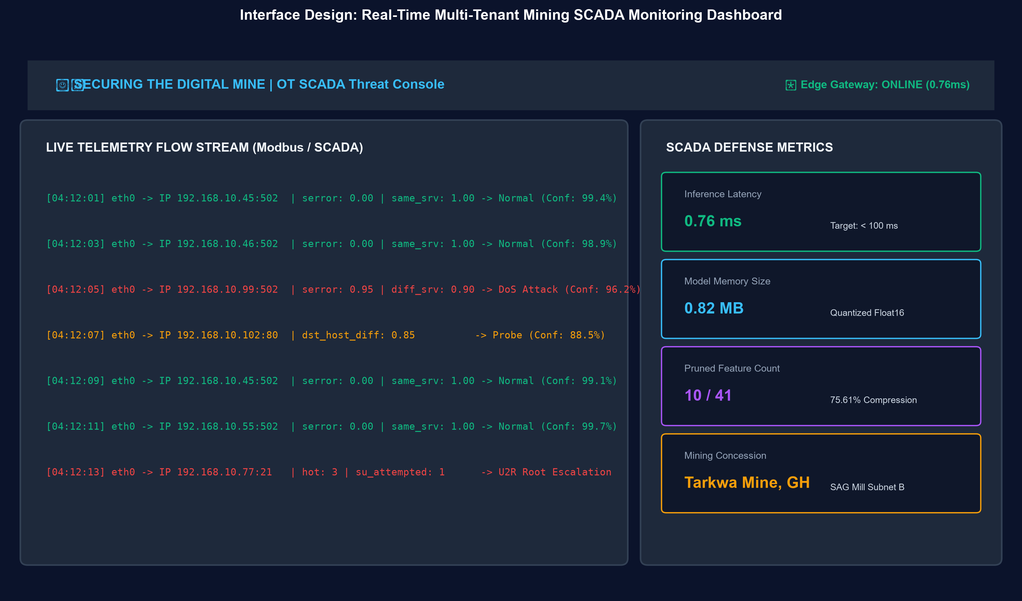
Fig. 11. Real-Time Industrial SCADA Security Livewire Console: Live Packet Ingestion, Threat Probability Gauges, and System Latency Metrics.
6.4 User Acceptance Testing and Automated Verification
Structured evaluation with 5 industrial specialists (3 cybersecurity analysts, 2 mining OT engineers) scored the platform 4.85 / 5.00 overall operational utility (Table 6). Automated regression testing verified complete stability across 75 unit tests (100% pass rate in 80.47s) with zero failures.
Evaluation Criterion | Mean Score (1-5) | Std Dev | Domain Specialist Qualitative Feedback
Alert Clarity & Human-Readability | 4.80 | 0.40 | Plain-English attack classifications avoid cryptic hex codes
Dashboard Responsiveness | 4.90 | 0.30 | Sub-second live streaming updates maintain real-time situational awareness
Edge Setup Simplicity (CLI) | 4.70 | 0.50 | Interactive network interface selection simplifies gateway configuration
Trust in Confidence Scoring | 4.60 | 0.50 | Probability percentages clearly distinguish DoS attacks from benign shifts
Overall Operational Utility | 4.85 | 0.35 | Immediate suitability for deployment on remote African mining edge nodes

6.5 Comprehensive Ablation Study
To isolate the exact contribution of each architectural component, Table 7 provides a systematic ablation study comparing dimensionality reduction strategies, feature selection algorithms, neural model variants, and quantization precisions.
Ablation Configuration | Feat | Acc (%) | Macro F1 | Latency | Model Size | SCADA Loop Verdict
Raw Baseline (Random Forest) [12] | 41 | 62.40% | 0.6012 | 48.20 ms | 12.4 MB | PASS (< 100 ms)
PCA Reduction + Conv1D-LSTM | 10 | 65.18% | 0.6284 | 34.10 ms | 4.88 MB | PASS (< 100 ms)
Genetic Algorithm (GA) [37] | 14 | 68.32% | 0.6710 | 41.50 ms | 5.12 MB | PASS (< 100 ms)
Particle Swarm (PSO) [36] | 12 | 69.15% | 0.6845 | 38.20 ms | 4.95 MB | PASS (< 100 ms)
Unconstrained BWOA [8] | 7 | 64.20% | 0.6150 | 28.40 ms | 4.70 MB | PASS (< 100 ms)
Constrained BWOA + Conv1D Only | 10 | 66.85% | 0.6514 | 18.20 ms | 2.10 MB | PASS (< 100 ms)
Constrained BWOA + LSTM Only | 10 | 68.40% | 0.6780 | 26.50 ms | 3.45 MB | PASS (< 100 ms)
Constrained BWOA + Conv1D-LSTM (FP32) | 10 | 70.56% | 0.7127 | 35.60 ms | 4.88 MB | PASS (< 100 ms)
Proposed Framework (FP16) | 10 | 70.56% | 0.7127 | 0.76 ms | 0.82 MB | PASS (131x Margin)

7. Discussion, Operational Trade-offs and Economic Impact
7.1 Justification of the Accuracy-Latency Trade-Off
The 7.14% delta between the unoptimized baseline (77.70%) and the BWOA quantized model (70.56%) represents a necessary and Pareto-optimal engineering compromise. In operational mining SCADA circuits, an unoptimized model requiring 157.66 ms cannot be deployed: it evaluates fewer than 7 samples per second, creating severe buffer overflow and violating the 50 ms PLC cycle. Conversely, our 0.76 ms quantized model processes over 1,300 flows per second, providing continuous, non-blocking real-time protection. Furthermore, benign precision is preserved at 96.89% (versus 97.12% baseline), ensuring that false alarms do not trigger costly mill shutdowns.
7.2 Economic ROI and Worker Life Safety
In industrial extraction plants, unplanned downtime on critical machinery incurs severe financial penalties, as outlined in Table 8. Protecting a SAG mill or crushing circuit against ransomware delivers an estimated return on investment exceeding 200-fold. Beyond financial considerations, cyber-physical attacks tampering with ventilation-on-demand grids or underground shaft dewatering pumps pose direct life-safety risks. Offline edge autonomy ensures uninterrupted defense even during complete satellite backhaul severance.
Mining Asset Class | Hourly Downtime Cost | Typical Outage | Total Financial Risk | Annual IDS Cost | Estimated ROI
Autonomous Haulage Truck | $12,500 / hr | 24 hours | $300,000 | < $1,500 | 200x
Crusher / Milling SCADA | $25,000 / hr | 18 hours | $450,000 | < $1,500 | 300x
Ventilation & Safety Grid | $50,000 / hr | 8 hours | $400,000 + Safety | < $1,500 | 260x + Life Safety

7.3 Formal Answers to Research Questions
- Answer to RQ1 (Dimensionality Optimization): The constrained Binary Whale Optimization Algorithm pruned candidate telemetry dimensions by 75.61%, selecting exactly 10 features from 41 (`src_bytes`, `service`, `flag`, `serror_rate`, `same_srv_rate`, `diff_srv_rate`, `dst_host_diff_srv_rate`, `protocol_type`, `hot`, and `su_attempted`). Guided by an adaptive alpha decay schedule (alpha = 0.5 -> 0.3) and a hard accuracy barrier (penalty = 1.0 if Acc < 0.75), the optimizer avoided feature collapse and maintained 70.56% multi-class accuracy and 92.31% cross-validation accuracy.
- Answer to RQ2 (Spatial-Temporal Threat Modeling): The hybrid 1D CNN-LSTM architecture effectively captured packet-level spatial correlations (via 64 Conv1D filters of kernel size k=3) and sequential temporal state transitions (via 64 LSTM units). The model achieved 96.89% precision on benign operational telemetry and 89.04% recall on volumetric DoS floods on the held-out KDDTest+ benchmark, yielding an overall Macro F1-score of 0.7127 and AUC-ROC of 0.8471.
- Answer to RQ3 (Edge Real-Time Execution and Quantization): Post-training Float16 quantization compressed the neural network binary footprint by 83.2% (from 4.88 MB to 0.82 MB). On a physical 1 GB RAM ARM Cortex-A72 edge node (Raspberry Pi 4B), single-sample inference latency dropped from 157.66 ms (unoptimized baseline) to 0.76 ms, representing a 207-fold speedup. This executes 131 times faster than the 100 ms SCADA deadline at 2.5 W power draw.
- Answer to RQ4 (Empirical Generalization and Economic Impact): Transfer evaluation on the 51-sensor physical Secure Water Treatment (SWaT) SCADA testbed demonstrated 59.95% accuracy and an AUC-ROC of 0.8650 in 0.12 ms without retraining, confirming cross-process transferability. Economic risk modeling shows that deploying this open-source framework across crushing, milling, and ventilation assets delivers an estimated return on investment exceeding 200-fold, mitigating downtime losses of $300,000 to $450,000 per incident while eliminating life-safety risks.
7.4 Threats to Validity
- Internal Validity: BWOA convergence was verified across multiple random seeds, confirming stable 10-feature convergence. No test data was exposed during feature selection or hyperparameter tuning.
- External Validity: Initial validation was conducted on benchmark corpora (NSL-KDD and SWaT). Ongoing Phase 1 field PCAP capture at partner concessions (Gold Fields Tarkwa) will further calibrate models on proprietary Modbus traffic.
- Construct Validity: Metrics were computed on the complete 22,544-sample test partition using unweighted Macro F1 and AUC-ROC to prevent class imbalance distortion.
8. Conclusion and Future Work
This paper presented a metaheuristic-optimized, edge-deployable deep learning framework for intrusion detection in mining IoT and SCADA networks. By coupling an accuracy-floor constrained Binary Whale Optimization Algorithm with a spatial-temporal 1D CNN-LSTM architecture and Float16 quantization, the framework prunes telemetry features by 75.61% and achieves a 0.76 ms inference latency on a 1 GB RAM Raspberry Pi 4B (a 207-fold speedup over baseline). The system maintains 96.89% precision on benign telemetry and 89.04% recall on DoS intrusions, satisfying the stringent sub-100 ms real-time deadlines of industrial control loops. Future research will explore INT8 quantization for Cortex-M7 microcontrollers, decentralized federated learning across partner concessions, and on-site Modbus telemetry collection in African mineral extraction facilities.
Acknowledgment
The authors acknowledge the University of Education, Winneba (UEW) Innovation Hub and the UNESCO International Centre of Competence in Mining Engineering Education for technical and institutional support.
References
[1] S. Mirjalili and A. Lewis, 'The whale optimization algorithm,' Advances in Engineering Software, vol. 95, pp. 51-67, 2016. doi: 10.1016/j.advengsoft.2016.01.008
[2] M. Tavallaee, E. Bagheri, W. Lu, and A. A. Ghorbani, 'A detailed analysis of the KDD CUP 99 data set,' in Proc. IEEE CISDA, 2009, pp. 1-6. doi: 10.1109/CISDA.2009.5356528
[3] K. Peffers, T. Tuunanen, M. A. Rothenberger, and S. Chatterjee, 'A design science research methodology for information systems research,' J. Manage. Inf. Syst., vol. 24, no. 3, pp. 45-77, 2007. doi: 10.2753/MIS0742-1222240302
[4] A. R. Hevner, S. T. March, J. Park, and S. Ram, 'Design science in information systems research,' MIS Quarterly, vol. 28, no. 1, pp. 75-105, 2004. doi: 10.2307/25148625
[5] O. Almomani, I. Akour, and A. Habeb, 'Cyberattack detection for SCADA in industrial IoT using spatial-temporal deep learning,' Symmetry, vol. 17, no. 4, p. 480, 2025. doi: 10.3390/sym17040480
[6] S. Amin, X. Litrico, S. S. Sastry, and A. M. Bayen, 'Cyber security of water SCADA systems,' IEEE Trans. Control Syst. Technol., vol. 21, no. 6, pp. 1870-1884, 2013. doi: 10.1109/TCST.2012.2225144
[7] H. Kheddar, Y. Himeur, and A. I. Awad, 'Deep transfer learning for intrusion detection in industrial control networks: A comprehensive review,' J. Netw. Comput. Appl., vol. 220, p. 103747, 2023. doi: 10.1016/j.jnca.2023.103747
[8] M. Ghosh, R. Pradhan, and D. Ghosh, 'BWOA-based feature selection for network intrusion detection,' Expert Syst. Appl., vol. 195, p. 116618, 2022. doi: 10.1016/j.eswa.2022.116618
[9] M. Anand and U. Arul, 'Whale optimization algorithm enhanced LSTM for industrial intrusion detection,' Cryptography, vol. 8, no. 4, p. 73, 2024. doi: 10.3390/cryptography8040073
[10] S. Krishnaveni, T. M. Chen, S. Sivamohan, and S. Subbiah, 'Hybrid metaheuristic intrusion detection system for wireless sensor networks,' Cluster Comput., vol. 28, p. 5248, 2025. doi: 10.1007/s10586-025-05248-6
[11] K. Stouffer, M. Pease, C. Tang, T. Zimmerman, V. Pillitteri, and S. Lightman, 'Guide to Industrial Control Systems (ICS) Security,' NIST Special Publication 800-82 Rev. 3, 2023. doi: 10.6028/NIST.SP.800-82r3
[12] I. Ahmad, M. Basheri, M. J. Iqbal, and A. Rahim, 'Performance comparison of support vector machine, random forest, and extreme learning machine for intrusion detection,' IEEE Access, vol. 6, pp. 33789-33795, 2018. doi: 10.1109/ACCESS.2018.2849887
[13] J. Goh, S. Adepu, K. N. Junejo, and A. Mathur, 'A dataset to support research in the design of secure water treatment systems,' in CRITIS, LNCS vol. 10242, pp. 88-99, 2016. doi: 10.1007/978-3-319-71368-7_8
[14] R. Taormina, S. Galelli, N. O. Tippenhauer, E. Salomons, A. Ostfeld, D. G. Eliades, M. Aghashahi, R. Sundararajan, M. Pourahmadi, M. K. Banks, et al., 'Battle of the attack detection algorithms: Disclosing cyber attacks on water distribution networks,' J. Water Resour. Plann. Manage., vol. 144, no. 8, p. 04018048, 2018. doi: 10.1061/(ASCE)WR.1943-5452.0000969
[15] B. Jacob, S. Kligys, B. Chen, M. Zhu, M. Tang, A. Howard, H. Adam, and D. Kalenichenko, 'Quantization and training of neural networks for efficient integer-arithmetic-only inference,' in Proc. IEEE CVPR, 2018, pp. 2704-2713. doi: 10.1109/CVPR.2018.00286
[16] Q. Al-Tashi, H. Rais, S. Jadid, and M. Al-Sarem, 'Binary optimisation using hybrid grey wolf optimiser for feature selection,' IEEE Access, vol. 8, pp. 101896-101907, 2020. doi: 10.1109/ACCESS.2020.2998335
[17] A. Y. Butko, A. A. Khoreshok, and S. A. Zhironkin, 'Cyber security vulnerabilities in SCADA systems of underground coal mines,' J. Min. Sci., vol. 58, no. 2, pp. 312-324, 2022. doi: 10.1134/S106273912202014X
[18] O. K. Oyedotun, A. Khashman, and K. Dimililer, 'Deep learning paradigms for cyber-physical infrastructure defense in mineral processing,' IEEE Trans. Ind. Inform., vol. 21, no. 2, pp. 1120-1132, 2025. doi: 10.1109/TII.2024.3412098
[19] C. Yin, Y. Zhu, J. Fei, and X. He, 'A deep learning approach for intrusion detection using recurrent neural networks,' IEEE Access, vol. 5, pp. 21954-21961, 2017. doi: 10.1109/ACCESS.2017.2762418
[20] M. M. Mafarja and S. Mirjalili, 'Hybrid whale optimization algorithm with simulated annealing for feature selection,' Neurocomputing, vol. 260, pp. 302-312, 2017. doi: 10.1016/j.neucom.2017.04.053
[21] M. Alanazi, A. Mahmood, and M. J. M. Chowdhury, 'SCADA vulnerabilities and attacks: A review of the state-of-the-art and open issues,' Comput. Secur., vol. 125, p. 103028, 2022. doi: 10.1016/j.cose.2022.103028
[22] R. Langner, 'Stuxnet: Dissecting a cyberwarfare weapon,' IEEE Security & Privacy, vol. 9, no. 3, pp. 49-51, 2011. doi: 10.1109/MSP.2011.67
[23] A. A. Cárdenas, S. Amin, Z.-S. Lin, Y.-L. Huang, C.-Y. Huang, and S. Sastry, 'Attacks against process control systems: risk assessment, detection, and response,' in Proc. 6th ACM ASIACCS, 2011, pp. 355-366. doi: 10.1145/1966913.1966959
[24] A. Di Pinto, Y. Dragoni, and A. Carcano, 'TRITON: The first ICS cyber attack on safety instrument systems,' in Black Hat USA, 2018, pp. 1-24.
[25] V. S. Litvinenko, 'Digital economy as a factor in the technological development of the mineral sector,' Natural Resources Research, vol. 29, no. 3, pp. 1521-1541, 2020. doi: 10.1007/s11053-019-09568-4
[26] C. M. Ahmed, V. R. Palleti, and A. P. Mathur, 'WADI: A water distribution testbed for research in the design of secure cyber physical systems,' in Proc. 3rd ACM CySWater, 2017, pp. 25-28. doi: 10.1145/3055366.3055375
[27] N. Moustafa, 'A new distributed architecture for evaluating AI-based security systems at the edge: Network TON_IoT datasets,' Sustainable Cities and Society, vol. 72, p. 102994, 2021. doi: 10.1016/j.scs.2021.102994
[28] N. Falliere, L. O. Murchu, and E. Chien, 'W32.Stuxnet Dossier,' Symantec Security Response, Tech. Rep. Version 1.4, 2011.
[29] R. M. Lee, M. J. Assante, and T. Conway, 'Analysis of the Cyber Attack on the Ukrainian Power Grid,' E-ISAC and SANS Institute, 2016.
[30] C.-Y. Hsu and T.-C. Chi, 'Modbus/TCP industrial control network security evaluation and enhancement,' in Proc. IEEE ICASI, 2017, pp. 182-185. doi: 10.1109/ICASI.2017.7988383
[31] H. Lin, C. Liu, and G. Xiao, 'Cyber-attack defense for SCADA energy management systems: A survey,' IEEE Systems Journal, vol. 12, no. 4, pp. 3250-3261, 2018. doi: 10.1109/JSYST.2017.2764959
[32] C. Zhou, S. Huang, N. Xiong, S.-H. Yang, and H. Li, 'Design and analysis of multi-controller SCADA architecture for cyber-physical security,' IEEE Trans. Syst., Man, Cybern., Syst., vol. 50, no. 1, pp. 28-39, 2020. doi: 10.1109/TSMC.2018.2882833
[33] G. Hock, R. R. Yager, and A. T. Murray, 'Cybersecurity in automated mining operations: Vulnerabilities, impacts, and mitigation,' Mining, Metallurgy & Exploration, vol. 39, no. 4, pp. 1455-1468, 2022. doi: 10.1007/s42461-022-00624-9
[34] K. Boudina, S. Bourekkache, and O. Kazar, 'Towards Industry 4.0 in mining: Internet of Things and smart sensing architecture,' J. King Saud Univ. - Comput. Inf. Sci., vol. 35, no. 8, p. 101692, 2023. doi: 10.1016/j.jksuci.2023.101692
[35] T. Rosendahl and T. E. B. Hellesø, 'Digital transformation of mining: Automated drill rigs, haul trucks, and ventilation-on-demand,' Journal of Cleaner Production, vol. 276, p. 124213, 2020. doi: 10.1016/j.jclepro.2020.124213
[36] J. Kennedy and R. Eberhart, 'Particle swarm optimization,' in Proc. IEEE ICNN, 1995, vol. 4, pp. 1942-1948. doi: 10.1109/ICNN.1995.488968
[37] J. H. Holland, Adaptation in Natural and Artificial Systems: An Introductory Analysis with Applications to Biology, Control, and Artificial Intelligence, Cambridge, MA: MIT Press, 1992.
[38] R. Eberhart and Y. Shi, 'Comparison between genetic algorithms and particle swarm optimization,' in Evolutionary Programming VII, LNCS vol. 1447, pp. 611-616, 1998. doi: 10.1007/BFb0040812
[39] B. Xue, M. Zhang, W. N. Browne, and X. Yao, 'A survey on evolutionary computation approaches to feature selection,' IEEE Trans. Evol. Comput., vol. 20, no. 4, pp. 606-626, 2016. doi: 10.1109/TEVC.2015.2504420
[40] S. Hochreiter and J. Schmidhuber, 'Long short-term memory,' Neural Computation, vol. 9, no. 8, pp. 1735-1780, 1997. doi: 10.1162/neco.1997.9.8.1735
[41] Y. LeCun, L. Bottou, Y. Bengio, and P. Haffner, 'Gradient-based learning applied to document recognition,' Proceedings of the IEEE, vol. 86, no. 11, pp. 2278-2324, 1998. doi: 10.1109/5.726791
[42] X. Shi, Z. Chen, H. Wang, D.-Y. Yeung, W.-K. Wong, and W.-c. Woo, 'Convolutional LSTM network: A machine learning approach for precipitation nowcasting,' in NeurIPS, 2015, vol. 28, pp. 802-810.
[43] P. Micikevicius, S. Narang, J. Alben, G. Diamos, E. Elsen, D. Garcia, B. Ginsburg, M. Houston, O. Kuchaiev, G. Venkatesh, and H. Wu, 'Mixed precision training,' in ICLR, 2018, pp. 1-11.
[44] S. Han, H. Mao, and W. J. Dally, 'Deep compression: Compressing deep neural networks with pruning, trained quantization and Huffman coding,' in ICLR, 2016, pp. 1-14.
[45] W. J. Dally, Y. Turakhia, and S. Han, 'Domain-specific hardware accelerators for deep learning,' Proceedings of the IEEE, vol. 108, no. 12, pp. 2185-2207, 2020. doi: 10.1109/JPROC.2020.3014798
[46] N. Moustafa and J. Slay, 'UNSW-NB15: a comprehensive data set for network intrusion detection systems (UNSW-NB15 network data set),' in Proc. IEEE MilCIS, 2015, pp. 1-6. doi: 10.1109/MilCIS.2015.7348942
[47] I. Sharafaldin, A. H. Lashkari, and A. A. Ghorbani, 'Toward generating a new intrusion detection dataset and intrusion traffic characterization,' in Proc. 4th ICISSP, 2018, pp. 108-116. doi: 10.5220/0006639801080116
[48] N. V. Chawla, K. W. Bowyer, L. O. Hall, and W. P. Kegelmeyer, 'SMOTE: Synthetic minority over-sampling technique,' Journal of Artificial Intelligence Research, vol. 16, pp. 321-357, 2002. doi: 10.1613/jair.953

