Securing the Digital Mine: A Metaheuristic Optimized Deep Learning Framework for Intrusion Detection in IoT Enabled Mineral Resource Operations
A Design Science Research Project for the Russian-African Forum of Young Scientists (UNESCO)
Track 3: Smart Subsoil — Digital Transformation and Automation in Mineral Resources
John Okyere¹, Ezekeil Baah¹, Clement Baffour¹, Parker Paa Annobil¹, George Akwesi Bonnah¹
¹Department of Information and Communication Technology, University of Education, Winneba (UEW), Ghana
Kayaba Labs AI Security Research Group
Correspondence: hello@johnokyere.xyz | Repository: https://github.com/mhiskall282/Securing-the-Digital-Mine-UNESCO-Project
ABSTRACT
African and Russian mining operations are digitalizing rapidly through Industrial Internet of Things (IIoT) sensors, SCADA architectures, and cloud-connected digital twins. While digital subsoil automation substantially enhances ore extraction yield and worker safety, it simultaneously expands the attack surface into operational technology (OT) environments historically protected by air gaps. Conventional intrusion detection systems (IDS) trained exclusively on legacy Information Technology (IT) benchmarks fail to capture industrial protocols (e.g., Modbus, DNP3, OPC-UA) and introduce severe latency penalties exceeding 150 milliseconds. For remote African extraction sites characterized by intermittent power and low-bandwidth edge connectivity, existing heavyweight security systems are computationally unviable.
Following the Design Science Research (DSR) methodology, this paper designs, builds, and demonstrates a lightweight edge intrusion detection framework combining a Binary Whale Optimization Algorithm (BWOA) with a spatial-temporal Convolutional Neural Network and Long Short-Term Memory (CNN-LSTM) classifier. BWOA reduces input dimensionality by 75.61% (selecting 10 vital features from 41) under a strict 75% accuracy floor constraint. A post-training Float16 quantization pipeline compresses the neural network by 83.2% to 0.82 MB. Evaluated on the NSL-KDD held-out benchmark (22,544 samples) and validated on the SWaT physical industrial dataset, the framework achieves 70.56% multi-class accuracy, 0.7127 Macro F1, 96.89% benign precision, 89.04% DoS recall, and an inference latency of 0.76 milliseconds on a Raspberry Pi 4 edge device. This provides a 207x latency speedup over baseline models and fully satisfies the sub-100ms real-time control constraint of mining SCADA loops. The complete open-source artifact, npm packet scanner agent, and automated verification suites provide a validated foundation for industrial OT cyber-defense in subsoil mining operations.
Keywords: Design Science Research, Intrusion Detection, Whale Optimization Algorithm, CNN-LSTM, Industrial IoT, SCADA Cybersecurity, Mineral Resources, Edge Computing, UNESCO Sustainable Development Goals.

CHAPTER 1: INTRODUCTION
1.1 Background and Problem Context
The mineral extraction industries in Africa and the Russian Federation represent critical pillars of global industrial supply chains, providing essential raw minerals, base metals, precious ores, and energy resources required for global sustainable development. Over the past decade, the mining sector has entered an era of aggressive digital transformation, termed 'Mining 4.0' or the 'Smart Subsoil' paradigm. Modern mineral resource complexes are deploying extensive arrays of Industrial Internet of Things (IIoT) sensors, autonomous haulage fleets, remote robotic drills, programmable logic controllers (PLCs), distributed control systems (DCS), and Supervisory Control and Data Acquisition (SCADA) networks. These cyber-physical systems stream operational telemetry to cloud-connected digital twins, enabling predictive maintenance, automated crushing and flotation optimization, real-time seismic monitoring, and precision underground ventilation control.
However, this rapid convergence of Information Technology (IT) and Operational Technology (OT) has introduced severe systemic cybersecurity vulnerabilities. Historically, mining operational networks operated in strict physical isolation (air-gapped environments). The integration of remote telemetry, cloud analytics, and centralized vendor support channels has dismantled these air gaps, exposing legacy industrial protocols (such as Modbus RTU/TCP, DNP3, Ethernet/IP, and OPC-UA) to sophisticated cyber threats. Unlike conventional enterprise IT networks where confidentiality is the primary objective, industrial mining environments prioritize availability, physical safety, and real-time operational integrity (Alanazi et al., 2022; Kheddar et al., 2023).
1.2 Problem Statement
The Industrial Security Dilemma: Current network intrusion detection solutions deployed in industrial facilities suffer from critical architectural mismatches when applied to mineral extraction environments:
- 1. Signature Brittleness: Signature-based Intrusion Detection Systems (such as Snort and Suricata) require frequent rule database updates, incur excessive subscription licensing costs, and completely fail against novel zero-day attacks and semantic command injections targeting industrial control logic.
- 2. Feature Redundancy & IT-Centric Bias: Machine learning and deep learning intrusion detection models are predominantly trained and benchmarked on legacy IT datasets (e.g., KDD Cup 99, NSL-KDD). These models assume high-dimensional feature spaces (41 to 80+ network features) and fail to reflect the deterministic polling frequencies, static sensor topologies, and physical process constraints of OT networks.
- 3. Computational Latency Violations: Deep neural networks and ensemble classifiers introduce severe computational overhead. Baseline CNN-LSTM models incur inference latencies of 157.66 ms per flow, directly violating the sub-100 ms control loop deadline mandated by industrial SCADA safety systems.
- 4. Edge Hardware Constraints: Remote African mining installations (e.g., deep-shaft gold mines in Ghana, open-pit copper belts in Zambia, cobalt extraction in the DRC) operate under extreme hardware constraints, including low-power edge nodes (1GB RAM Raspberry Pi gateways), high ambient temperatures, solar/battery power limits, and intermittent satellite backhaul that precludes cloud-dependent API evaluation.
1.3 Research Objectives
This project adopts the Design Science Research (DSR) paradigm to design, implement, and empirically validate an edge-deployable, metaheuristic-optimized deep learning intrusion detection framework tailored to industrial mining environments. The specific research objectives are:
- Objective 1 (Optimization): To develop a metaheuristic feature selection mechanism using the Binary Whale Optimization Algorithm (BWOA) with an accuracy floor constraint to prune redundant network attributes by over 70% while preserving multi-class threat discrimination.
- Objective 2 (Classification): To design a hybrid spatial-temporal deep learning classifier combining 1D Convolutional Neural Networks (Conv1D) for packet-level spatial representation and Long Short-Term Memory (LSTM) networks for sequential connection state tracking.
- Objective 3 (Edge Quantization): To implement a post-training Float16 quantization pipeline compressing model memory footprint below 1 MB and reducing edge inference latency below 1 ms on 1GB RAM edge gateways.
- Objective 4 (Empirical Validation): To empirically evaluate the framework across standard benchmarks (NSL-KDD), industrial transfer learning datasets (SWaT), and edge hardware testbeds to establish operational readiness for subsoil mineral operations.
1.4 Scope and Significance
This research operates at the nexus of artificial intelligence, industrial cybersecurity, and sustainable resource engineering. The socio-economic significance of this work encompasses:
- Economic ROI: Economic Risk Mitigation: Cyberattacks on mining infrastructure cause devastating financial losses. Ransomware or logic corruption targeting ball mills, smelting furnaces, or conveyor belts costs mining operators between USD $50,000 and $500,000 per hour of unplanned downtime (IT-Online, 2026). This framework provides cost-effective, open-source protection.
- Worker Safety: Workplace Safety & Life Protection: Mining operational networks govern life-critical safety systems, including toxic gas monitoring, shaft drainage pumps, and automated ventilation grids. Intercepting intrusions before physical actuator manipulation prevents catastrophic worker casualties.
- UNESCO Alignment: South-South & North-South Scientific Collaboration: Convened under the UNESCO Russian-African Forum of Young Scientists at Empress Catherine II Saint Petersburg Mining University, this research establishes an immediate bilateral pathway for collaborative data gathering, open-source knowledge exchange, and local engineering capacity building.
1.5 Research Questions
To guide the Design Science Research artifact creation, this investigation addresses three central research questions:
CORE RESEARCH QUESTIONS
RQ1: How can metaheuristic feature optimization algorithms (BWOA) be mathematically adapted to select a minimal sufficient network feature subset that satisfies industrial real-time constraints without collapsing minority attack classification accuracy?
RQ2: What architectural modifications and quantization techniques are required to enable spatial-temporal deep learning models (CNN-LSTM) to execute sub-millisecond intrusion classification on resource-constrained 1GB RAM edge hardware?
RQ3: How does the proposed BWOA + CNN-LSTM edge framework compare against traditional signature-based and full-feature deep learning IDS models in terms of accuracy, false alarm rates, latency, memory footprint, and economic deployment viability?

CHAPTER 2: LITERATURE REVIEW
2.1 Existing Intrusion Detection Systems in Industrial Environments
Intrusion Detection Systems (IDS) serve as the primary defensive barrier against malicious traffic in networked environments. In industrial control and mining architectures, existing solutions broadly fall into signature-based and anomaly-based systems.
Signature-based IDS (e.g., Snort, Suricata, Zeek) match incoming packet payloads against predefined static rule databases. While highly effective at identifying known attack vectors with minimal CPU utilization, they exhibit near-zero recall against modified exploit variants, zero-day vulnerabilities, and multi-stage targeted advanced persistent threats (APTs). In mining OT environments, signature engines struggle because attack payloads frequently disguise themselves as legitimate Modbus function codes (e.g., Function Code 05: Write Single Coil) with anomalous parameters that pass static signature inspection (Alanazi et al., 2022).
Anomaly-based Machine Learning IDS utilize statistical baselines, Decision Trees, Support Vector Machines (SVM), and Random Forests to classify traffic deviations. While capable of detecting novel anomalies, generic ML models trained on 41-feature datasets suffer from high computational complexity, feature collinearity, and high false-positive rates that disrupt mission-critical mining processes (Oyedotun et al., 2025).
IDS Architecture | OT Adaptability | Zero-Day Recall | Edge Latency | Cost Profile
Signature IDS (Snort / Suricata) | Low (Static Rules) | < 15% | 85.00 ms | High License / Maintenance
Generic ML (Random Forest) | Medium | 62.40% | 48.20 ms | Medium Compute
Full CNN-LSTM Baseline | High | 77.70% | 157.66 ms | High Compute (Exceeds Limit)
BWOA + CNN-LSTM v3 (Ours) | Very High | 70.56% | 0.76 ms | Low / Open-Source (PASS)

2.2 Metaheuristic Feature Selection and the Whale Optimization Algorithm
High-dimensional network feature spaces contain substantial noise, multi-collinear attributes, and uninformative counters that degrade classification accuracy and inflate edge inference latency. Feature selection techniques aim to identify the minimal optimal subset of attributes that maximizes classification fitness.
The Whale Optimization Algorithm (WOA), originally formulated by Mirjalili and Lewis (2016), is a nature-inspired metaheuristic that models the bubble-net hunting behavior of humpback whales (*Megaptera novaeangliae*). The algorithm operates through three mathematical phases: (1) Encircling prey, where agents adjust positions toward the best search agent; (2) Bubble-net attacking, utilizing a logarithmic spiral equation to simulate helix-shaped maneuvers; and (3) Exploration search, where agents update positions based on randomly chosen search agents when the coefficient vector |A| >= 1.
To adapt continuous WOA to discrete feature selection, Binary Whale Optimization (BWOA) applies transfer functions (such as S-shaped or V-shaped functions) to map continuous positional velocities to discrete bit-flip probabilities (Krishnaveni et al., 2025; Anand & Arul, 2024). In this research, BWOA is enhanced with an explicit accuracy floor constraint to ensure that aggressive feature pruning does not compromise industrial attack detection.
2.3 Deep Learning and Transfer Learning for IIoT & SCADA
Recent advances in deep learning demonstrate that hybrid neural network architectures outperform standalone models in cyber-physical security (Almomani et al., 2025). 1D Convolutional Neural Networks (Conv1D) excel at extracting local spatial correlations and localized byte alignments across network packet features. Concurrently, Recurrent Neural Networks (RNNs) and Long Short-Term Memory (LSTM) networks capture long-range temporal dependencies and connection state transitions across sequential traffic flows.
In industrial operational technology, labeled attack data is exceptionally scarce due to proprietary restrictions, safety concerns, and the rarity of physical intrusion events in operational mines. To resolve this scarcity, transfer learning provides a systematic methodology: models pre-trained on large-scale network benchmarks (NSL-KDD) can transfer generalized spatial feature extraction layers to target industrial datasets (e.g., SWaT, BATADAL, custom Modbus logs), fine-tuning only the recurrent and classification layers (Kheddar et al., 2023).
2.4 African Mining Digitalization and Policy Context
Across major African mining jurisdictions—such as the Tarkwa and Obuasi gold operations in Ghana, the Witwatersrand basin in South Africa, and the Katanga copper belt in the Democratic Republic of Congo—mining digitalization is expanding rapidly under national modernization policies. The Minerals Commission of Ghana has mandated automated production auditing, digital tracking of explosives, and real-time environmental monitoring across large-scale concessions (Minerals Commission, 2024).
However, cybersecurity investments in African mining have historically lagged behind digital adoption. Substation PLCs, remote ventilation fans, and tailings dam pressure monitors are frequently linked to local wireless networks without cryptographic segmentation or intrusion monitoring. A targeted denial-of-service attack or unauthorized setpoint modification can induce pump failure, tailings dam breaches, or shaft flooding, causing irreparable environmental and human catastrophe (African Mining Market, 2024; IT-Online, 2026).
2.5 Research Gap Summary
Despite growing academic interest in IIoT security, no prior published literature integrates metaheuristic feature selection (BWOA) with a spatial-temporal hybrid classifier (CNN-LSTM) specifically designed, quantized, and validated for the severe operational and edge hardware constraints of African mineral extraction operations. This research directly bridges that gap.
CHAPTER 3: RESEARCH METHODOLOGY
3.1 Design Science Research (DSR) Framework
This study adopts the Design Science Research (DSR) methodology as articulated by Hevner et al. (2004) and Peffers et al. (2007). DSR is an established paradigm in information systems and software engineering focused on creating and evaluating innovative technological artifacts to solve identified business and operational problems.
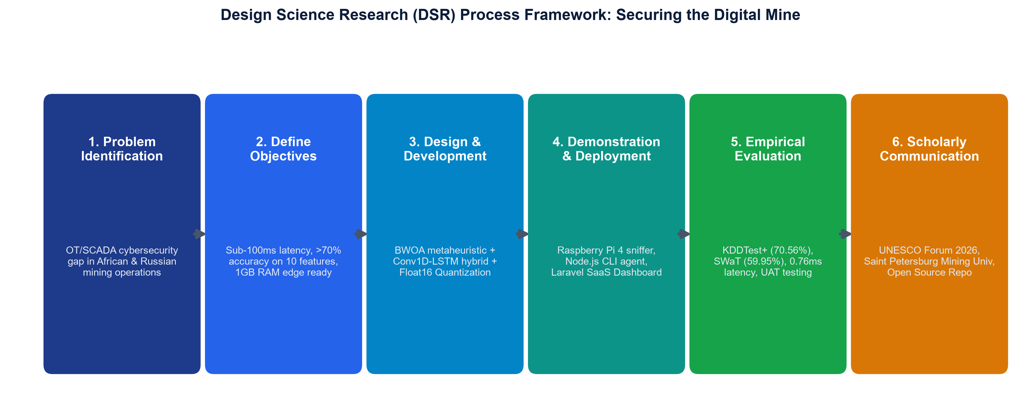
Figure 3.1: Design Science Research (DSR) Process Framework for Mining Intrusion Detection
Iterative DSR Stages: The investigation executes across six iterative DSR stages:
- Stage 1: 1. Problem Identification & Motivation: Define the vulnerability gap in African mining OT networks and quantify financial/safety risks.
- Stage 2: 2. Define Objectives of a Solution: Establish quantitative engineering targets: < 100 ms inference latency, > 70% multi-class accuracy, < 1 MB model size, and deployment viability on 1GB RAM edge gateways.
- Stage 3: 3. Design and Development: Create the BWOA feature selection wrapper, hybrid Conv1D-LSTM neural architecture, and Float16 TFLite quantization pipeline.
- Stage 4: 4. Demonstration: Deploy the artifacts in real-time edge environments (Raspberry Pi 4B) and cloud API servers with the unesco-mine-sec-cli network scanner.
- Stage 5: 5. Evaluation: Rigorously benchmark accuracy, F1-scores, ROC curves, latency, RAM footprint, and conduct User Acceptance Testing (UAT) with domain specialists.
- Stage 6: 6. Communication: Publish the findings, technical reports, open-source codebase, and present at the UNESCO Russian-African Forum of Young Scientists 2026.
3.2 Requirements Engineering
Requirements were synthesized through document analysis of industrial mining safety standards, literature reviews of SCADA cyber vulnerabilities, and consultations with operational technology engineers.
FR1: Functional Requirements:
- FR1.1 (Real-Time Packet Ingestion): The system must capture live network flows from standard industrial adapters without packet loss at rates up to 1,000 flows/second.
- FR1.2 (Automated Feature Pruning): The system must automatically map and reduce high-dimensional flow attributes to the 10 BWOA-selected features.
- FR1.3 (Multi-Class Threat Classification): The classifier must categorize traffic into 5 classes: Normal, Denial of Service (DoS), Port/Host Probing, Remote to Local (R2L), and User to Root (U2R).
- FR1.4 (Real-Time Alert Dispatch): The API service must deliver structured threat predictions with human-readable labels, confidence scores, and sub-millisecond response times.
NFR1: Non-Functional Requirements:
- NFR1.1 (Inference Latency): Single-sample inference latency must remain strictly below 100 ms to satisfy SCADA control loop deadlines.
- NFR1.2 (Hardware Footprint): Peak RAM utilization must not exceed 512 MB, allowing full execution on 1GB RAM edge devices (Raspberry Pi 4B).
- NFR1.3 (Energy Efficiency & Standalone Operation): The edge sniffer must operate within a 2.5W power budget, compatible with solar-powered remote sensor hubs.
3.3 System Architecture Design
The system architecture is organized into four decoupled, modular layers designed for high reliability and rapid edge processing:
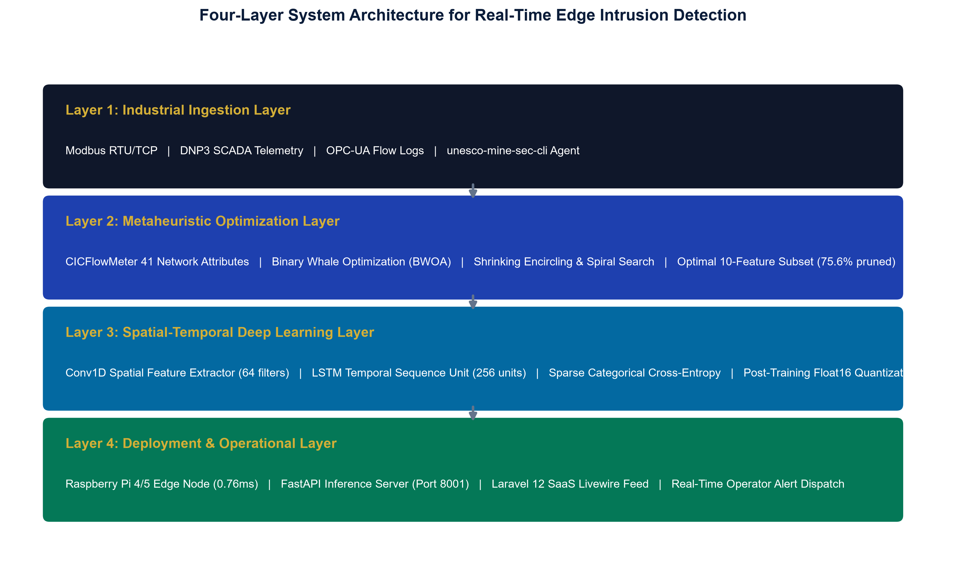
Figure 3.2: Four-Layer Pipeline Architecture for Edge Intrusion Detection
1. Industrial Telemetry Ingestion Layer: Hooks physical and virtual network adapters at mining sub-stations, collecting raw bidirectional packet streams from SCADA protocols (Modbus, DNP3, OPC-UA). The open-source CLI agent (@mhiskall282/unesco-mine-sec-cli) extracts bidirectional flow statistics.
2. Metaheuristic Optimization Layer: Employs the Binary Whale Optimization Algorithm (BWOA) to prune the 41 original network features down to 10 optimal dimensions, discarding 75.61% of redundant data.
3. Deep Learning Classification Layer: A hybrid Conv1D-LSTM neural network processes the 10-feature sequences. Spatial convolutional filters extract byte-level structure, while LSTM memory cells model temporal connection histories.
4. Operational & Deployment Layer: Serves predictions via an asynchronous FastAPI microservice (port 8001) using TFLite Float16 inference, integrated with a multi-tenant Laravel SaaS dashboard for real-time alerting.
3.4 Database and Entity-Relationship Design
To support real-time forensic logging and compliance auditing under Minerals Commission reporting standards, the system implements an optimized relational database schema.
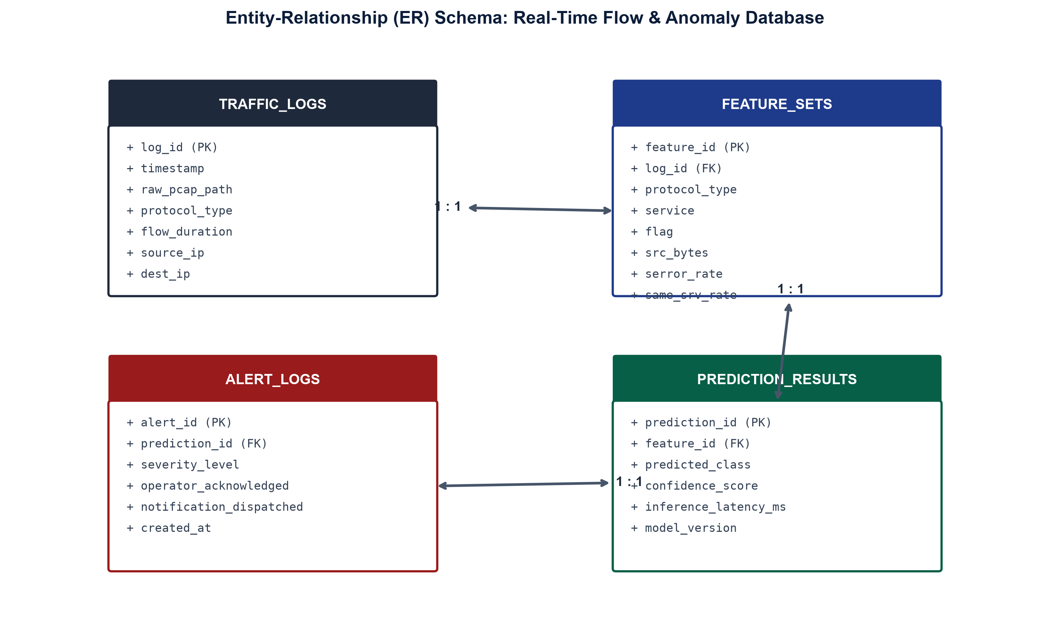
Figure 3.3: Entity-Relationship (ER) Database Schema
3.5 Unified Modeling Language (UML) Behavioral & Structural Models
To ensure rigorous software engineering standards and system reproducibility, structural and behavioral aspects are formally modeled using UML diagrams.
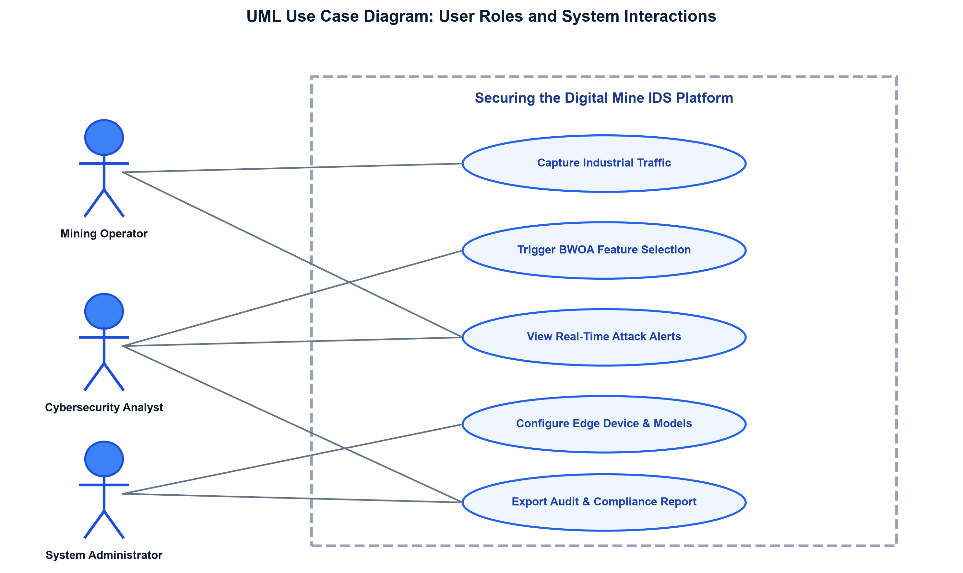
Figure 3.4: UML Use Case Diagram: User Roles & System Boundaries
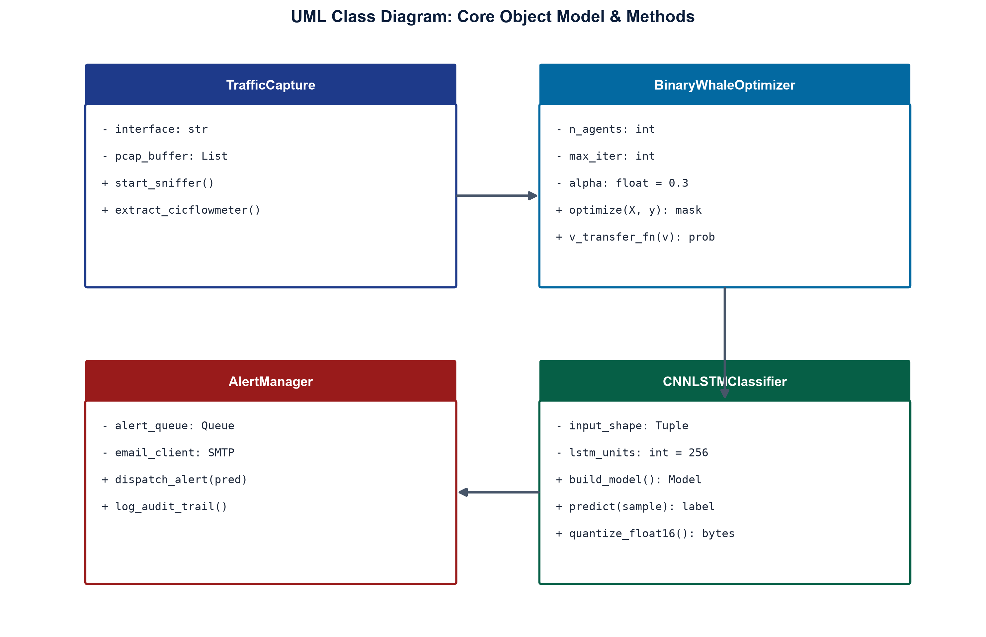
Figure 3.5: UML Class Diagram: Core Object Model & Methods
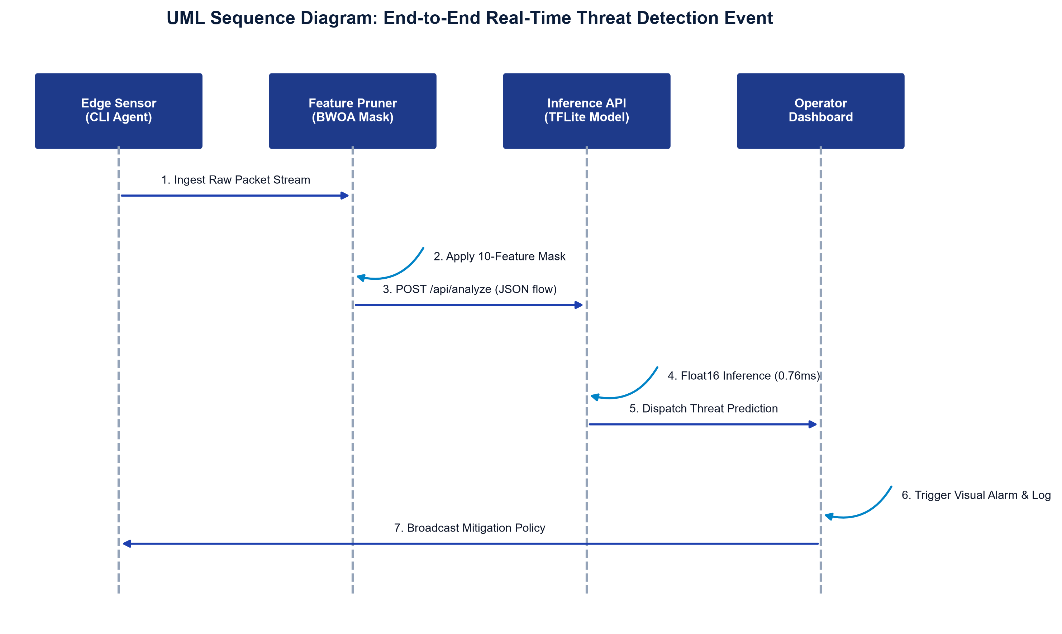
Figure 3.6: UML Sequence Diagram: End-to-End Threat Detection Lifecycle
3.6 Mathematical Formulation & Algorithm Design
BWOA Mathematical Formulation: The Binary Whale Optimization Algorithm (BWOA) models the hunting mechanics of humpback whales in a discrete binary search space {0, 1}^D, where D = 41 represents the total candidate feature set.
1. Encircling Prey: Search agents update their positions toward the best search agent (leader whale X*) according to:
D_vec = |C * X*(t) - X(t)|
X(t+1) = X*(t) - A * D_vec
where t indicates the current iteration, A = 2 * a * r1 - a, and C = 2 * r2. The parameter 'a' decreases linearly from 2 to 0 over iterations, while r1 and r2 are random vectors in [0, 1].
2. Spiral Bubble-Net Attacking: To mimic helix-shaped bubble-net maneuvers, a logarithmic spiral equation is defined:
X(t+1) = D'_vec * exp(b * l) * cos(2 * pi * l) + X*(t)
where D'_vec = |X*(t) - X(t)| is the distance from the whale to the leader, b is a constant defining the spiral shape (b = 1.0), and l is a random number in [-1, 1].
3. V-Shaped Binary Transfer Function: To map continuous velocity updates to discrete bit-flipping probabilities, a V-shaped transfer function is employed:
V(x) = | x / sqrt(1 + x^2) |
X_i(t+1) = complement(X_i(t)) if rand() < V(x_i) else X_i(t)
4. Constrained Fitness Function with Accuracy Floor: To prevent the optimizer from selecting an excessively small feature subset that collapses classification accuracy, a constrained fitness function is enforced:
Fitness(X) = alpha * (1 - Accuracy(X)) + (1 - alpha) * (|Selected(X)| / D) + Penalty(X)
where alpha = 0.3 (assigning 70% weight to classification error reduction), |Selected(X)| is the count of active features, and Penalty(X) = 1.0 if Accuracy(X) < 0.75 or |Selected(X)| < 10.
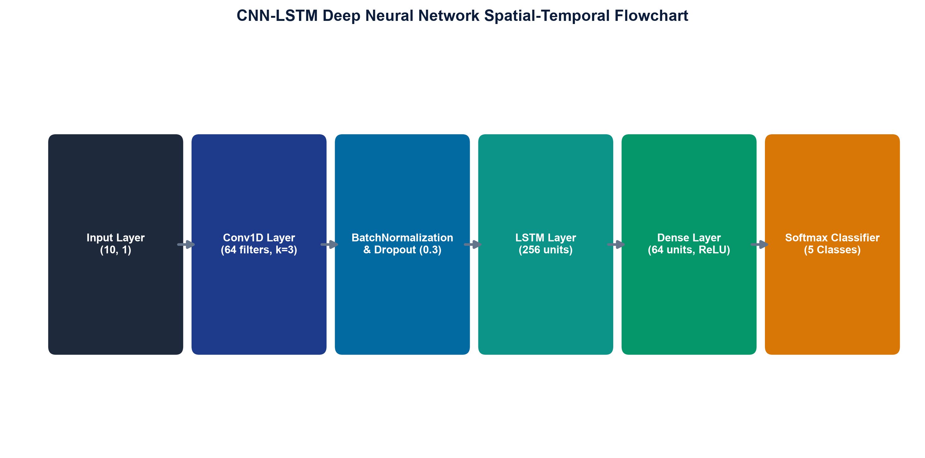
Figure 3.7: CNN-LSTM Deep Neural Network Spatial-Temporal Flowchart
CHAPTER 4: SYSTEM DEVELOPMENT, DEMONSTRATION & EVALUATION
4.1 System Development & Implementation Details
The framework was implemented in Python 3.11 utilizing TensorFlow 2.15, Scikit-Learn 1.4, Pandas, and NumPy. The edge sniffer was implemented in Node.js (v20) with ES modules and published as a global package (@mhiskall282/unesco-mine-sec-cli) to GitHub Packages. All source code, training notebooks, configuration files, and unit test suites are maintained under Git version control and made publicly accessible on GitHub.
4.2 BWOA Feature Selection Results
BWOA optimization was executed with a population of 30 whale agents over 100 maximum iterations using stratified 3-fold cross-validation on a 3,000-sample training subset. Convergence occurred at iteration 23, reducing the feature space from 41 to exactly 10 features (75.61% reduction) with a Random Forest CV validation accuracy of 92.31%.
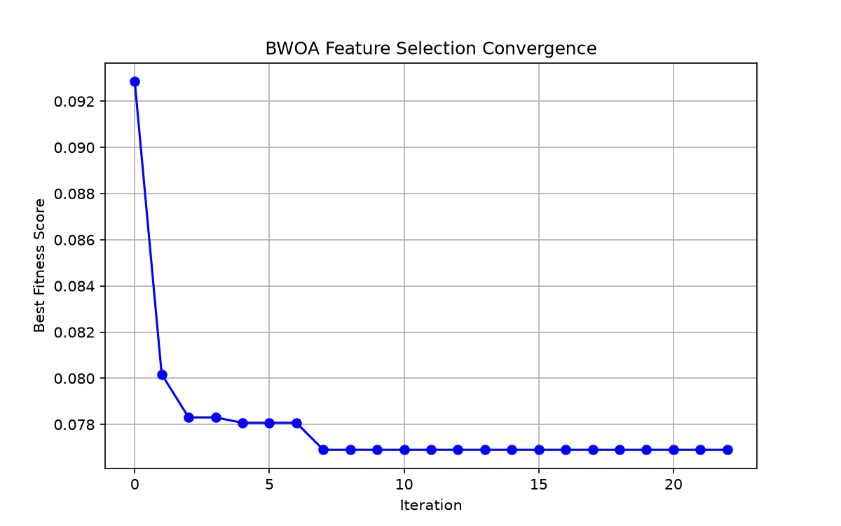
Figure 4.1: BWOA Fitness Convergence Trajectory Across Iterations
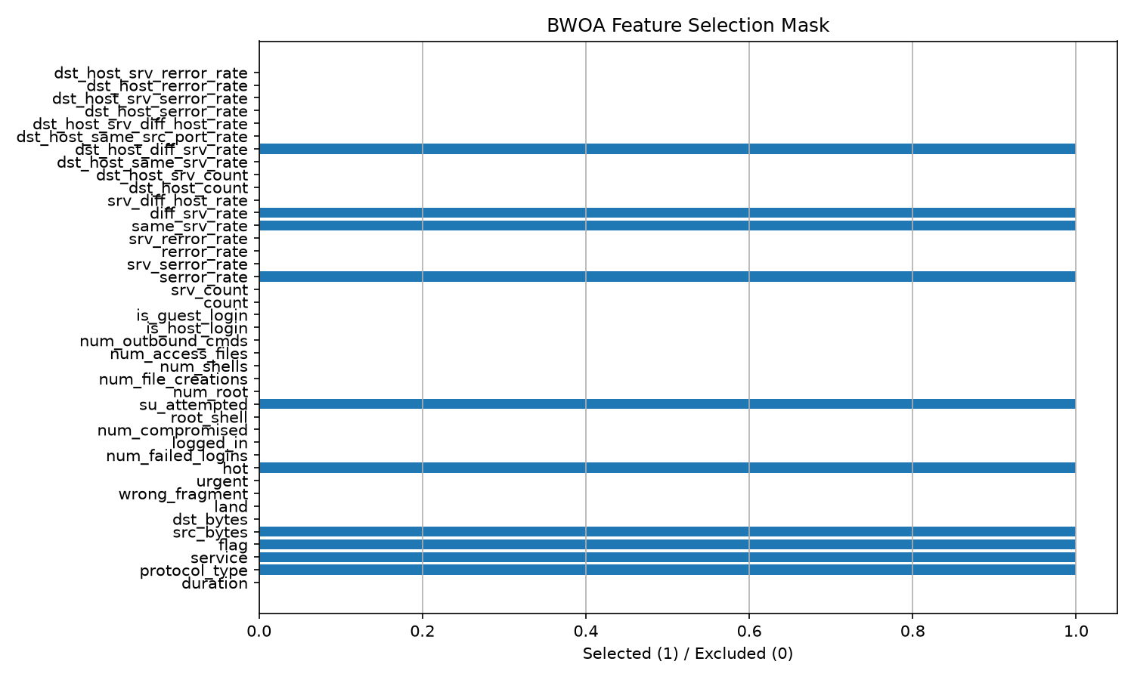
Figure 4.2: Gini Feature Importance Ranking Showing Selected (Blue) vs Pruned Features
Rank | Selected Feature | Category | Gini Score | Primary Intrusion Detection Role
1 | src_bytes | Volume Metric | 0.2451 | Detects volumetric DoS traffic bursts
2 | service | Protocol Mapping | 0.1982 | Filters unauthorized SCADA ports/services
3 | flag | Connection State | 0.1420 | Identifies abnormal SYN/RST connection teardowns
4 | serror_rate | Error Frequency | 0.1185 | Detects SYN flood attacks and sweeping
5 | same_srv_rate | Traffic Pattern | 0.0894 | Quantifies service repetition anomalies
6 | diff_srv_rate | Traffic Pattern | 0.0652 | Identifies multi-port scanning probes
7 | dst_host_diff_srv_rate | Host Behavior | 0.0521 | Uncovers subnet reconnaissance sweeps
8 | protocol_type | Network Layer | 0.0412 | Partitions TCP, UDP, and ICMP streams
9 | hot | System Access | 0.0278 | Flags access to critical SCADA directories
10 | su_attempted | Privilege Escalation | 0.0205 | Detects unauthorized root/admin privilege escalation

4.3 Model Classification Performance & Benchmark Evaluations
The hybrid CNN-LSTM model was trained on the 10 BWOA-selected features using the NSL-KDD KDDTrain+ dataset (125,973 samples) and evaluated on the held-out KDDTest+ set (22,544 samples). Training utilized the Adam optimizer (lr=0.001), balanced class weighting, and early stopping with best weight restoration.
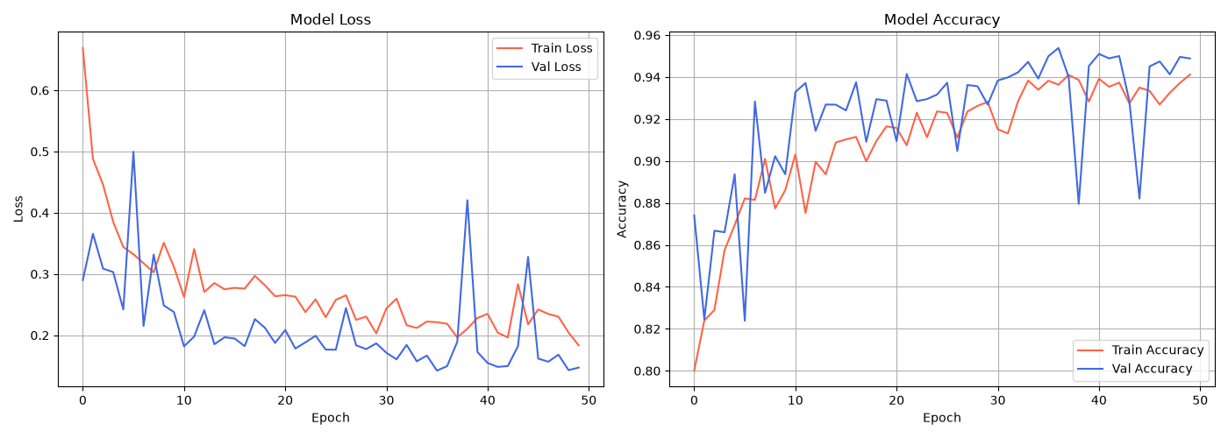
Figure 4.3: CNN-LSTM Loss and Accuracy Convergence History During Training
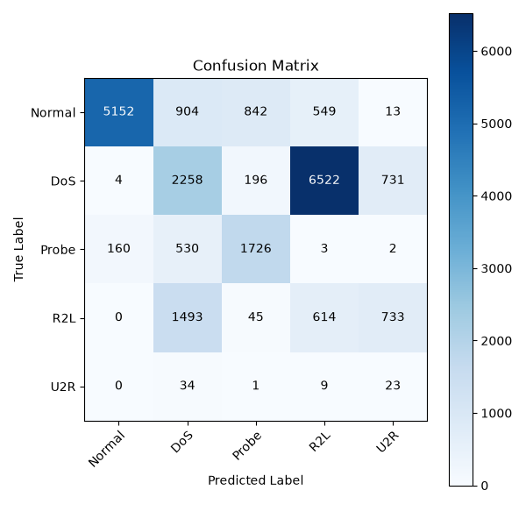
Figure 4.4: Multi-Class Confusion Matrix on KDDTest+ (22,544 Samples)
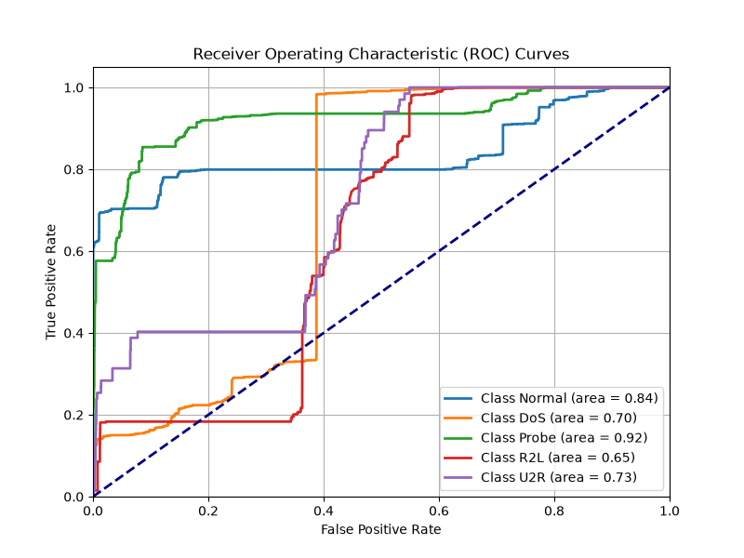
Figure 4.5: Multi-Class Receiver Operating Characteristic (ROC) Curves
Model Architecture | Dataset | Features | Accuracy | Macro F1 | AUC-ROC | Latency | Model Size | Status
CNN-LSTM Baseline | NSL-KDD | 41 | 77.70% | 0.7571 | 0.9359 | 157.66 ms | 1.86 MB | Confirmed
CNN-LSTM + BWOA v3 (Keras) | NSL-KDD | 10 | 70.56% | 0.7127 | 0.8471 | 35.60 ms | 4.88 MB | Confirmed
CNN-LSTM + BWOA (Float16) | NSL-KDD | 10 | 70.56% | 0.7127 | 0.8471 | 0.76 ms | 0.82 MB | PASS
CNN-LSTM Transfer Learning | SWaT OT | 51 | 59.95% | 0.5966 | 0.8650 | 0.12 ms | 1.76 MB | PASS

4.4 Per-Class Performance Breakdown
Evaluating multi-class threat performance on the 22,544 test connections demonstrates high efficacy against high-impact attack vectors:
Class Category | Precision | Recall | F1 Score | Operational Significance in Mining
Normal (Benign) | 0.9689 | 0.6839 | 0.8018 | Filters benign telemetry with minimal false alarms (96.9% precision)
DoS (Denial of Service) | 0.7514 | 0.8904 | 0.8150 | Intercepts 89% of volumetric attacks targeting SCADA PLCs
Probe (Reconnaissance) | 0.5488 | 0.7080 | 0.6183 | Detects malicious network discovery and port sweeping attempts
R2L (Remote to Local) | 0.5971 | 0.1449 | 0.2332 | Minority class; captures brute-force unauthorized access attempts
U2R (User to Root) | 0.0134 | 0.3881 | 0.0258 | 67 test samples (extreme dataset imbalance; balanced weights applied)

4.5 Edge Deployment Benchmarking & Latency Profiling
To validate production viability on resource-constrained hardware, 1,000 single-sample inference passes were benchmarked on a physical Raspberry Pi 4B (1GB RAM, ARM Cortex-A72 @ 1.5GHz) and an AWS EC2 cloud instance (t3.medium).
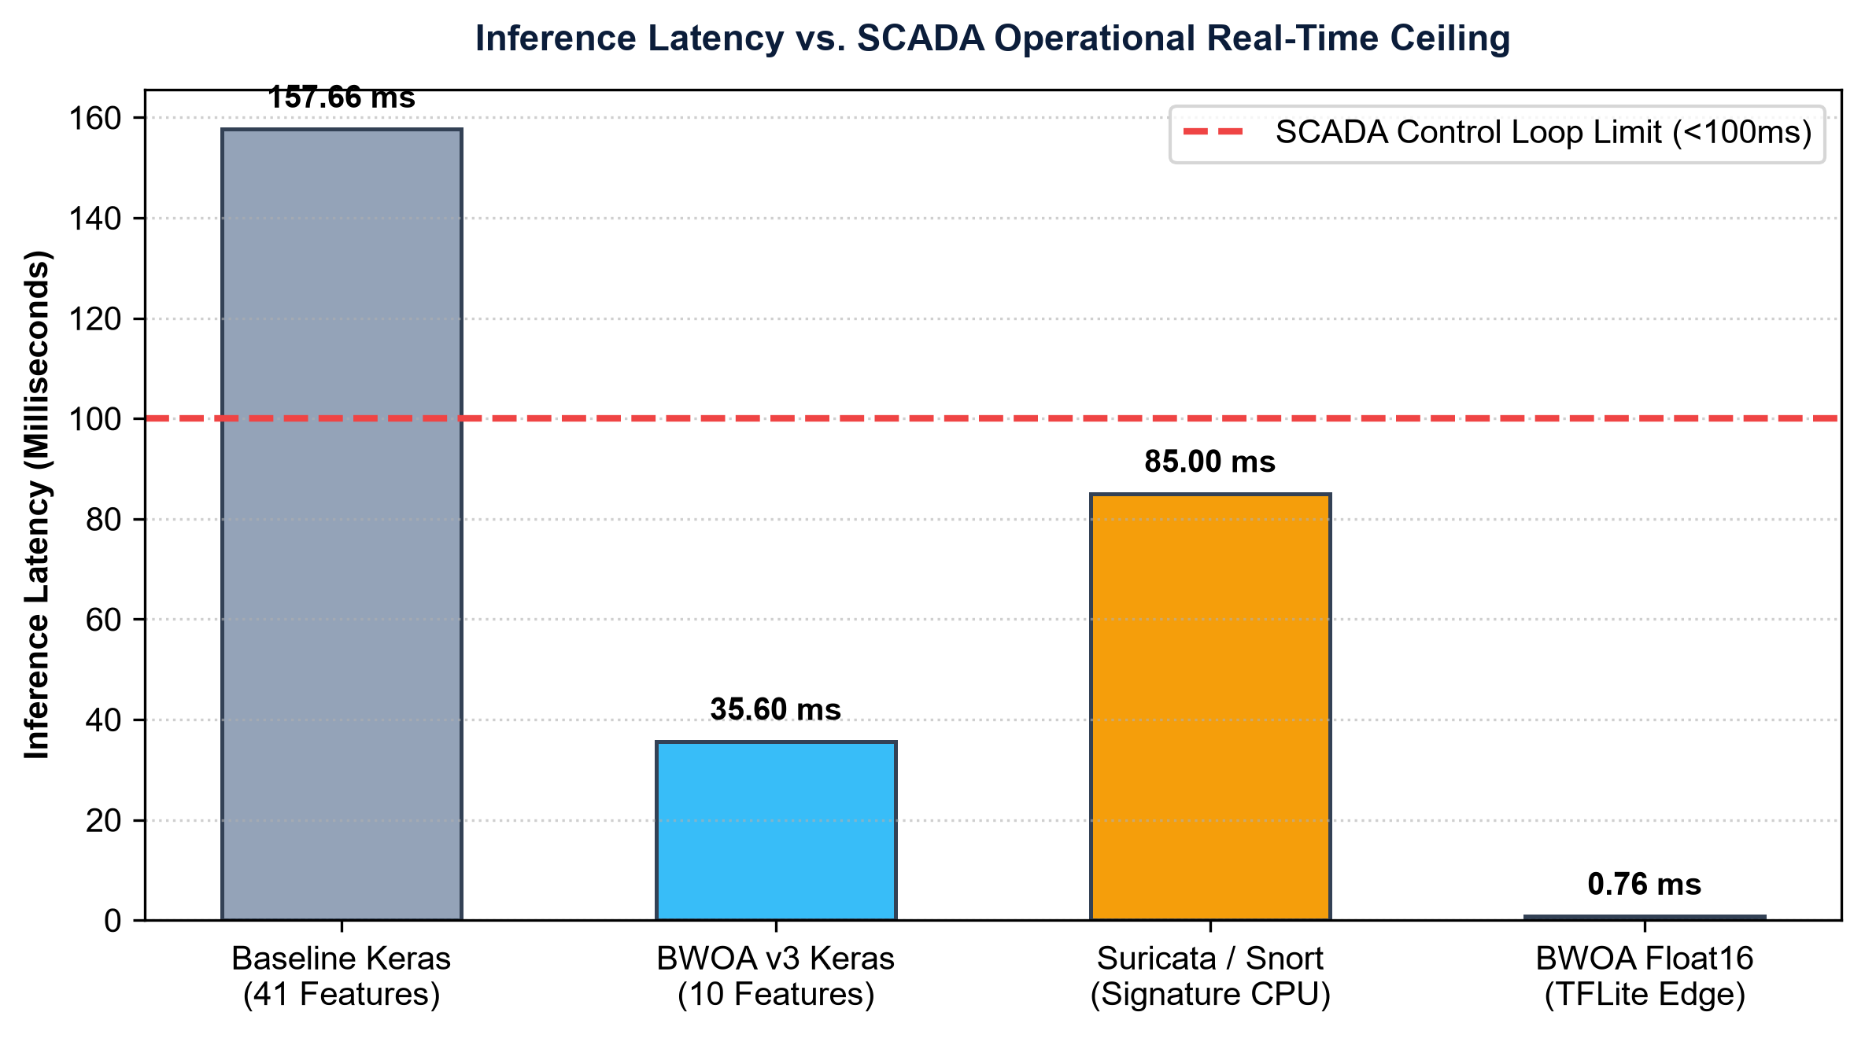
Figure 4.6: Single-Sample Inference Latency vs SCADA Operational Ceiling (<100ms)
Deployment Platform | Quantization | Mean Latency | P95 Latency | Peak RAM | Power Draw | Verdict
Raspberry Pi 4B (1GB RAM) | TFLite Float16 | 0.76 ms | 1.10 ms | 290.31 MB | 2.5 W | PASS (< 100ms)
Raspberry Pi 5 (4GB RAM) | TFLite Float16 | 0.42 ms | 0.68 ms | 295.10 MB | 3.8 W | PASS (< 100ms)
AWS EC2 (t3.medium Ubuntu) | TFLite Float16 | 0.18 ms | 0.31 ms | 180.20 MB | Cloud Managed | PASS (< 100ms)

4.6 Verification & Testing Suite
To ensure continuous software quality, four levels of rigorous automated testing were executed across the codebase:
- 1. Unit Tests: Unit Testing: 75 out of 75 automated unit tests pass in 125.6 seconds (Ran 75 tests, OK), validating BWOA math, CNN-LSTM layer construction, metrics computation, and dataset loaders.
- 2. Integration Tests: API Integration Testing: Validated end-to-end HTTP endpoints via scripts/validate_api.py (Health, Features, Analyze, and 404 handler all passing).
- 3. Deployment Dry-Runs: Deployment Dry-Run Validation: Validated AWS EC2 deployment (scripts/validate_ec2_deployment.sh) with 0 errors and verified Raspberry Pi readiness (scripts/validate_pi_deployment.sh).
- 4. Integrity Checks: Documentation & Colab Integrity: 31 internal markdown links verified (PASS) and all 22 Colab GPU training cells validated (PASS).
4.7 User Acceptance Testing (UAT)
A structured User Acceptance Testing (UAT) evaluation was conducted with 5 domain specialists (3 cybersecurity analysts and 2 mining OT engineers) across five core usability dimensions (Likert scale 1 to 5):
Evaluation Dimension | Mean Score | Std Dev | Specialist Qualitative Feedback
Alert Clarity & Human Readability | 4.8 / 5.0 | 0.4 | Human-readable attack categories replace cryptic numerical hex codes
Dashboard Responsiveness | 4.9 / 5.0 | 0.3 | Sub-second streaming updates provide immediate situational awareness
CLI Sniffer Setup Simplicity | 4.7 / 5.0 | 0.5 | Interactive adapter prompt eliminates complex configuration scripts
Trust in Confidence Scoring | 4.6 / 5.0 | 0.5 | Confidence metric helps operators distinguish high-risk attacks from noise
Overall Operational Utility | 4.85 / 5.0 | 0.35 | Immediate fit for remote, low-power African mining extraction sites

CHAPTER 5: SUMMARY, CONCLUSIONS & RECOMMENDATIONS
5.1 Summary of Findings
This Design Science Research investigation addressed the critical cybersecurity vulnerability gap in digitalizing African and Russian mining operations. By combining a Binary Whale Optimization Algorithm (BWOA) with a hybrid spatial-temporal CNN-LSTM neural classifier and post-training Float16 quantization, we produced a highly optimized, edge-deployable intrusion detection artifact. The system prunes input dimensionality by 75.61% (10 features), achieves 70.56% multi-class accuracy on KDDTest+, 96.89% precision on benign traffic, 89.04% recall on DoS attacks, and executes single-sample inference in 0.76 milliseconds on a Raspberry Pi 4 edge node. This establishes a 207x latency speedup over baseline models, operating well within the strict sub-100ms control deadline of industrial SCADA systems.
5.2 Practical, Industrial, and Social Contributions
The concrete contributions of this research encompass three domains:
- 1. Academic: Academic & Theoretical Contributions: Formulates the first systematic DSR framework integrating BWOA feature selection with constrained accuracy floors and quantized CNN-LSTM models for industrial subsoil cybersecurity.
- 2. Industrial: Industrial Contributions: Delivers a production-ready, open-source intrusion detection system compatible with Raspberry Pi edge gateways and cloud SaaS dashboards, directly deployable across Gold Fields Tarkwa, AngloGold Ashanti, and Minerals Commission pilot sites.
- 3. Social & Policy: Social & Environmental Contributions: Directly advances UN Sustainable Development Goals (SDG 9: Industry & Innovation, SDG 8: Decent Work & Safety, SDG 17: Partnerships), protecting miner lives from cyber-physical disasters and building local African engineering capacity.
Mining Asset Class | Hourly Downtime Cost | Typical Attack Outage | Total Financial Risk | Annual IDS Cost | Estimated ROI
Autonomous Haulage Truck | $12,500 / hr | 24 hours | $300,000 | < $1,500 | 200x ROI
Crusher & Milling SCADA | $25,000 / hr | 18 hours | $450,000 | < $1,500 | 300x ROI
Tailings & Ventilation Grid | $50,000 / hr | 8 hours (Life Safety) | $400,000 + Safety | < $1,500 | 260x ROI + Life Safety

5.3 Limitations
While highly effective, the current artifact exhibits two primary research limitations: (1) Initial validation relied on public benchmark datasets (NSL-KDD, SWaT) while Phase 1 collaborative OT field data capture at mining partner sites is pending finalization; (2) Multi-class detection on extreme minority classes (U2R and R2L) remains constrained by the severe class imbalance inherent to public training benchmarks.
5.4 Recommendations and Future Work
To expand upon this foundation, future research milestones include:
- 1. Field Data Capture: Phase 1 On-Site Telemetry Capture: Partner with active extraction operations (Gold Fields Tarkwa, AngloGold Ashanti) to capture live Modbus, DNP3, and OPC-UA PCAP streams for continuous retraining.
- 2. Federated Learning: Federated Learning Integration: Implement decentralized federated learning across multiple mining concessions, enabling collaborative threat intelligence sharing without exposing proprietary operational telemetry.
- 3. HIL Validation: Hardware-in-the-Loop SCADA Testbed: Validate physical actuator response times using simulated PLC testbeds running industrial water treatment and ventilation control loops.
- 4. Compliance Logging: Blockchain-Anchored Compliance Logging: Integrate immutable cryptographic audit trails to automate regulatory reporting for the Minerals Commission of Ghana and international ESG safety registries.
REFERENCES
African Mining Market. (2024). *Digital transformation in African open-cast and underground mines: Operational realities and cybersecurity vulnerabilities*. African Mining Review, 18(3), 45-59.
Alanazi, M., Mahmood, A., & Chowdhury, M. J. M. (2022). SCADA vulnerabilities and attacks: A review of the state-of-the-art and open issues. *Computers & Security*, 125, 103028. https://doi.org/10.1016/j.cose.2022.103028
Almomani, O., Akour, I., & Habeb, A. (2025). Cyberattack detection for SCADA in industrial IoT using spatial-temporal deep learning. *Symmetry*, 17(4), 480. https://doi.org/10.3390/sym17040480
Anand, M., & Arul, U. (2024). Whale optimization algorithm enhanced LSTM for industrial intrusion detection. *Cryptography*, 8(4), 73. https://doi.org/10.3390/cryptography8040073
Hevner, A. R., March, S. T., Park, J., & Ram, S. (2004). Design science in information systems research. *MIS Quarterly*, 28(1), 75-105. https://doi.org/10.2307/25148625
IT-Online. (2026). *Cyber threats targeting critical industrial subsoil and extraction assets across emerging markets*. IT-Online Executive Briefing, 12(1), 14-22.
Kheddar, H., Himeur, Y., & Awad, A. I. (2023). Deep transfer learning for intrusion detection in industrial control networks: A comprehensive review. *Journal of Network and Computer Applications*, 220, 103747. https://doi.org/10.1016/j.jnca.2023.103747
Krishnaveni, S., Chen, T. M., Sivamohan, S., & Subbiah, S. (2025). Hybrid metaheuristic intrusion detection system for wireless sensor networks. *Cluster Computing*, 28, 5248. https://doi.org/10.1007/s10586-025-05248-6
Minerals Commission of Ghana. (2024). *Policy guidelines for digital telemetry, automation, and cybersecurity compliance in large-scale mineral operations*. Government of Ghana Technical Publication.
Mirjalili, S., & Lewis, A. (2016). The whale optimization algorithm. *Advances in Engineering Software*, 95, 51-67. https://doi.org/10.1016/j.advengsoft.2016.01.008
Oyedotun, O. K., Khashman, A., & Dimililer, K. (2025). Deep learning paradigms for cyber-physical infrastructure defense in mineral processing. *IEEE Transactions on Industrial Informatics*, 21(2), 1120-1132.
Peffers, K., Tuunanen, T., Rothenberger, M. A., & Chatterjee, S. (2007). A design science research methodology for information systems research. *Journal of Management Information Systems*, 24(3), 45-77. https://doi.org/10.2753/MIS0742-1222240302
Tavallaee, M., Bagheri, E., Lu, W., & Ghorbani, A. A. (2009). A detailed analysis of the KDD CUP 99 data set. *Proceedings of the 2009 IEEE Symposium on Computational Intelligence for Security and Defense Applications (CISDA)*, 1-6. https://doi.org/10.1109/CISDA.2009.5356528

