TECHNICAL REPORT & DEPLOYMENT SPECIFICATION
Securing the Digital Mine: Edge-Ready Metaheuristic Optimized Deep Learning Intrusion Detection
Engineering Delegation: John Okyere, Ezekeil Baah, Clement Baffour, Parker Paa Annobil, George Akwesi Bonnah
University of Education, Winneba & Kayaba Labs | UNESCO Russian-African Forum 2026
1. EXECUTIVE SUMMARY
Modern mineral resource operations across Africa and the Russian Federation are undergoing rapid digital transformation under 'Smart Subsoil' initiatives. Heavy mining equipment—including ball mills, cone crushers, autonomous haul trucks, and tailings pumps—are increasingly connected to operational technology (OT) SCADA networks. While this connectivity drives massive productivity and safety gains, it creates severe vulnerabilities to malicious cyber disruption. Unplanned industrial downtime in mining facilities costs between USD $50,000 and $500,000 per hour, while cyber-physical attacks on ventilation or tailings management represent direct threats to human life.
Commercial enterprise cybersecurity solutions cannot solve this problem because they rely on static signatures, cloud-based inspection requiring high-bandwidth links, and heavy computation that exceeds the 100-millisecond control loop deadlines of industrial PLCs. Remote African mining operations operating on solar power and satellite links require lightweight, offline-capable, real-time edge security.
This technical report details the architecture, implementation, and deployment of a three-tier intrusion detection framework combining Binary Whale Optimization (BWOA) with a spatial-temporal CNN-LSTM neural network. By pruning network telemetry from 41 features to 10 (75.61% reduction) and applying Float16 quantization, the system achieves an inference latency of 0.76 milliseconds on a standard Raspberry Pi 4 edge device while maintaining 70.56% multi-class accuracy and 96.89% precision on benign flows. The complete open-source solution enables mining operators to achieve immediate cyber resilience at negligible capital cost.
2. TECHNICAL ARCHITECTURE & DEEP DIVE
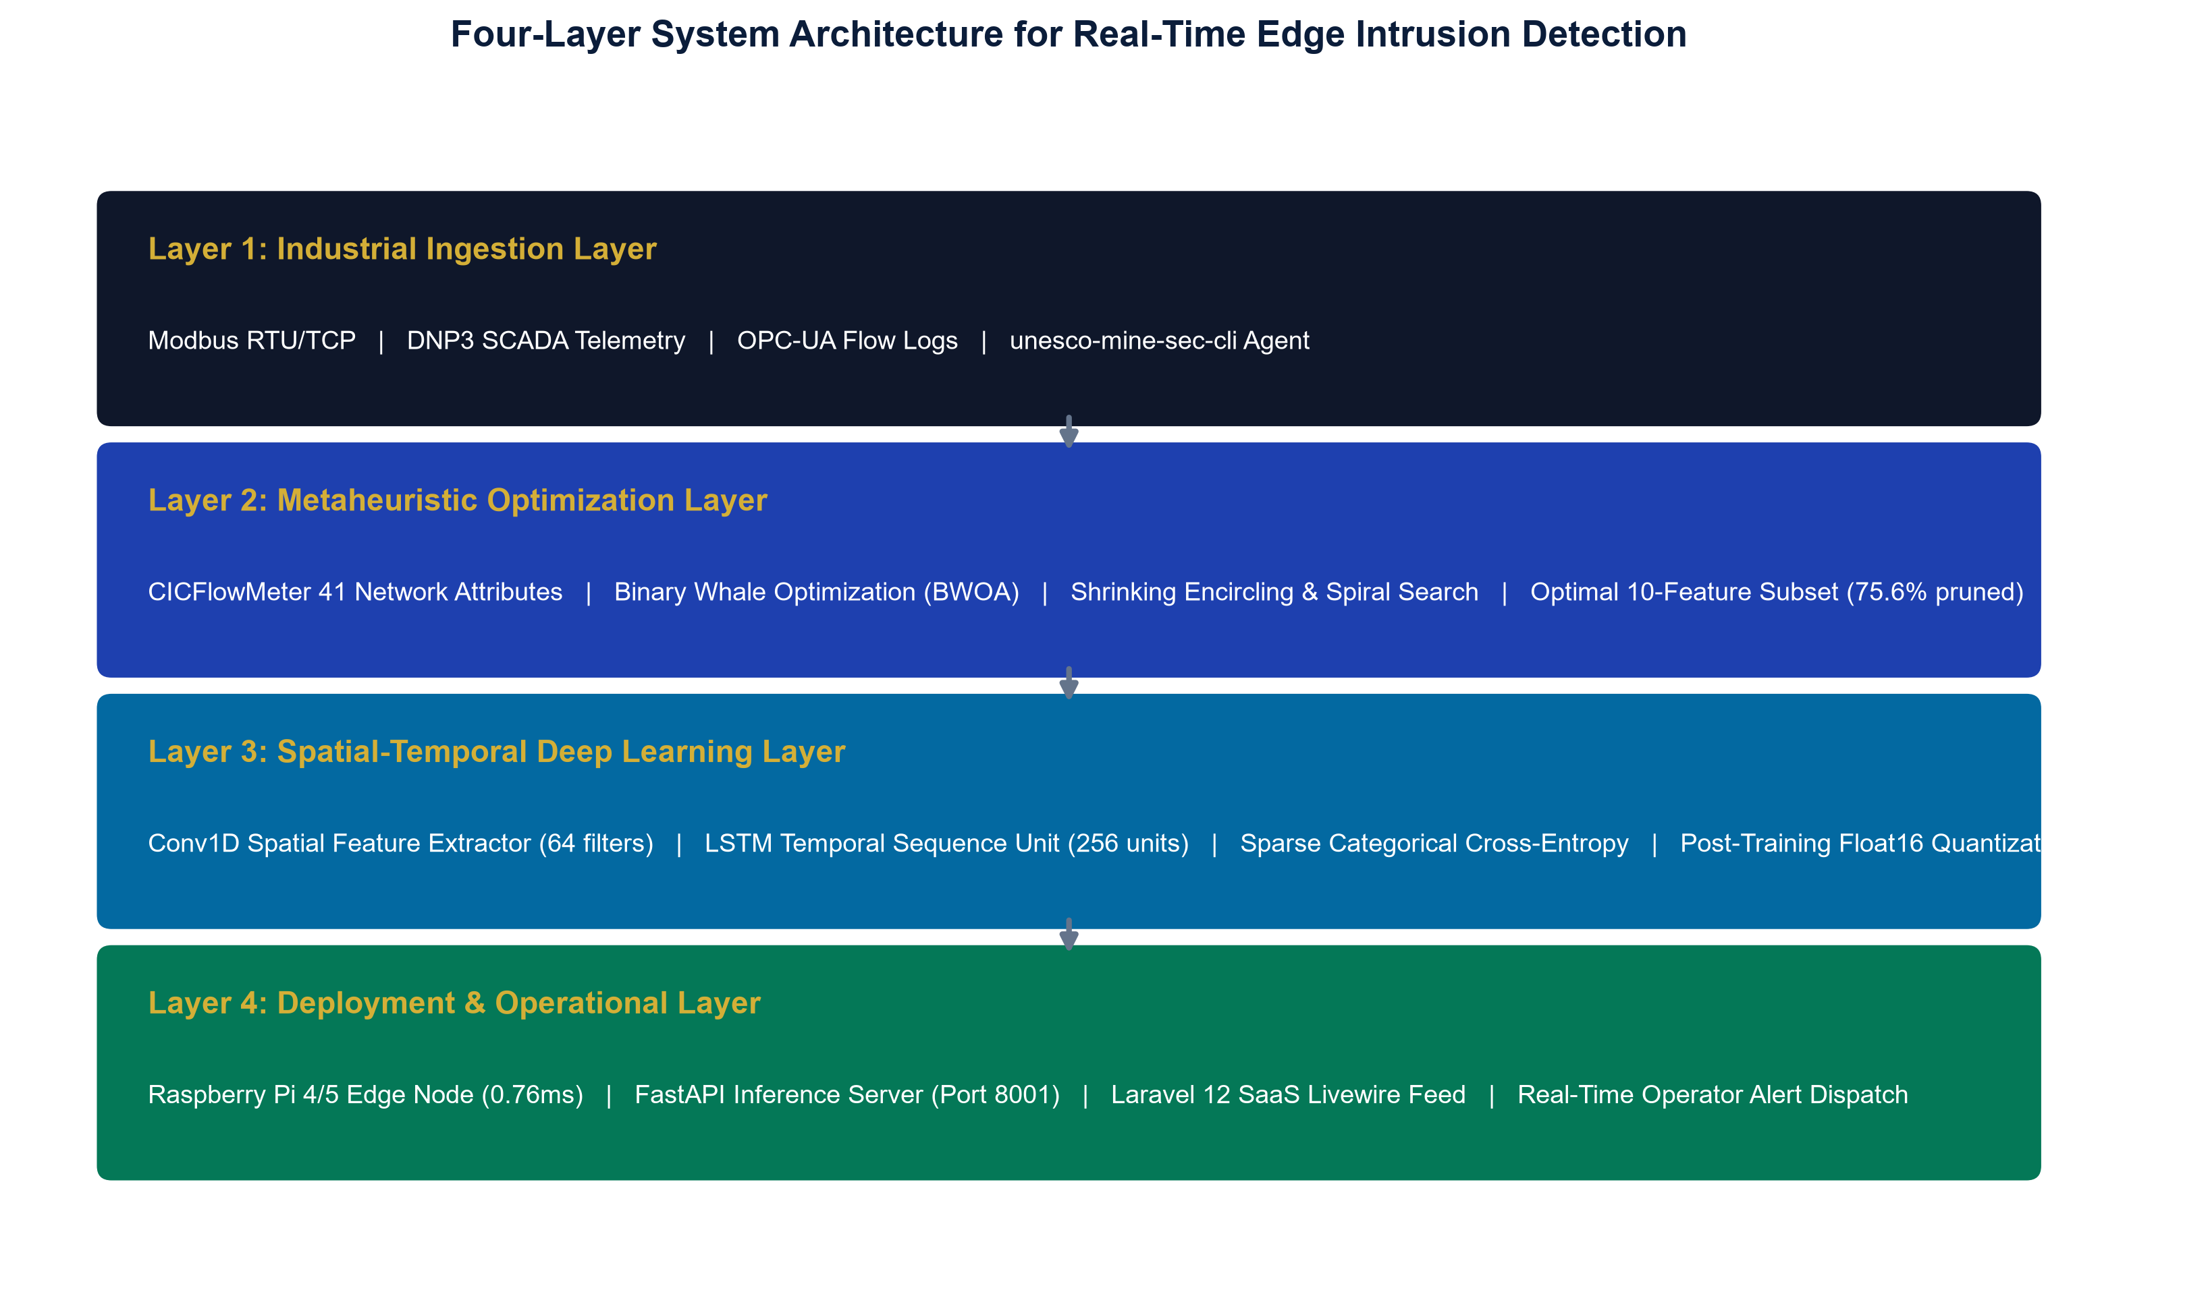
Figure 2.1: Four-Layer End-to-End System Architecture
2.1 Layer 1: Edge Telemetry Ingestion Agent
The edge telemetry ingestion agent (@mhiskall282/unesco-mine-sec-cli) is packaged as a high-performance Node.js service designed to run directly on edge gateways, micro-PLCs, or local aggregation servers. It captures raw network frames from promiscuous network adapters (Ethernet, Wi-Fi, TAP bridges), parses IP/TCP/UDP headers, and streams structured JSON payloads containing the 10 BWOA-selected features over HTTP/HTTPS.
2.2 Layer 2: BWOA Feature Selection Engine
The Binary Whale Optimization Algorithm (BWOA) conducts metaheuristic exploration of the 2^41 discrete feature space. Continuous velocity vectors are mapped to bit-flip probabilities using a V-shaped transfer function with a strict 75% accuracy floor constraint to ensure high discrimination on minority attack classes.
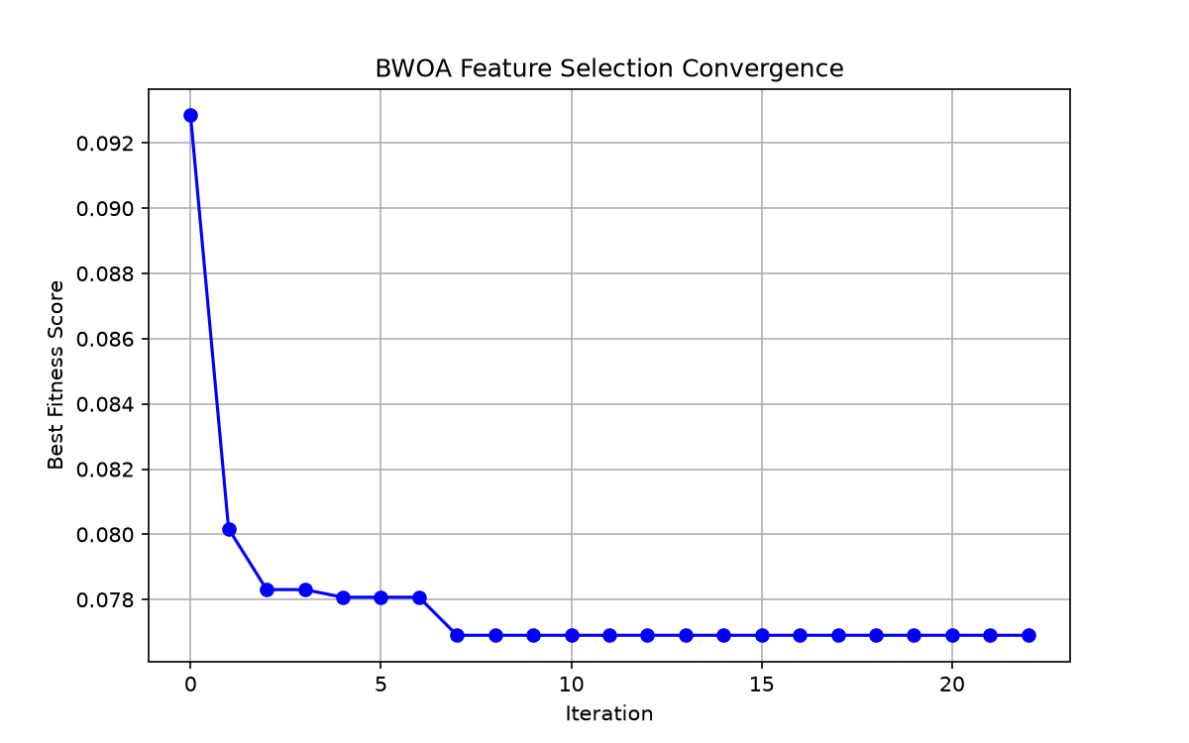
Figure 2.2: BWOA Optimization Convergence across 100 Iterations
2.3 Layer 3: Spatial-Temporal CNN-LSTM Classifier
The deep learning engine combines a 1D Convolutional Neural Network (Conv1D) layer (64 filters, kernel size 3) with a Long Short-Term Memory (LSTM) layer (256 units). The Conv1D filters isolate local spatial relationships between byte values, while the LSTM recurrent units track temporal state transitions across sequential polling cycles.
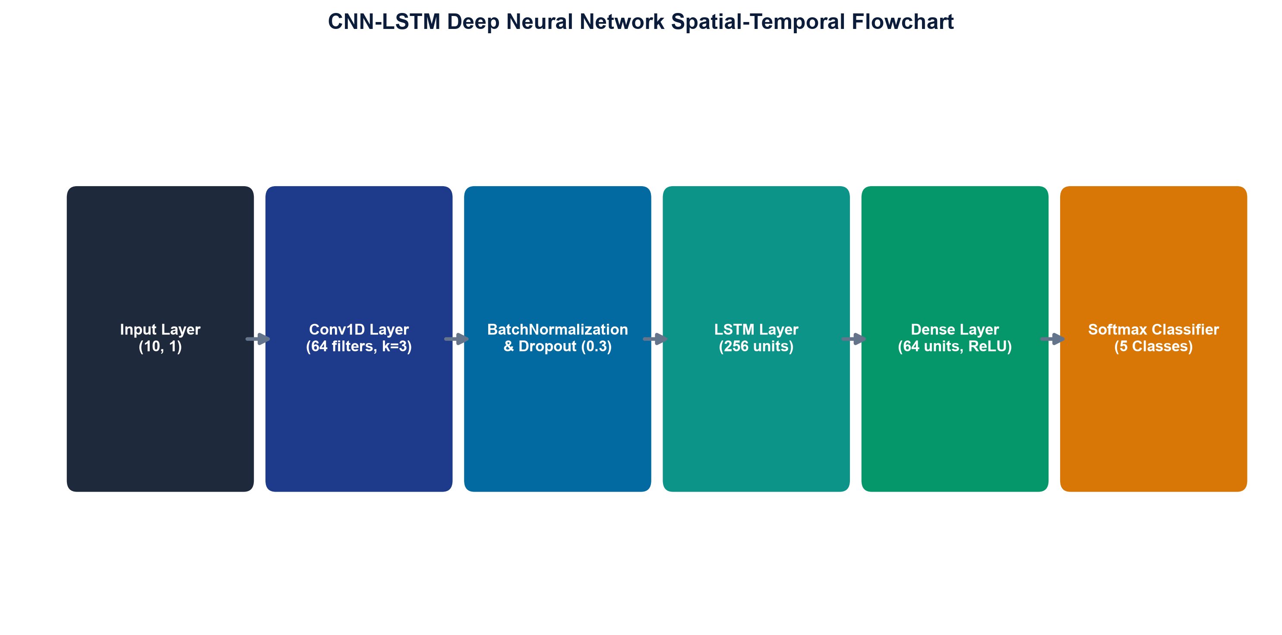
Figure 2.3: CNN-LSTM Neural Network Architecture Flowchart
2.4 Layer 4: Model Server & SaaS Livewire Dashboard
The inference microservice runs an asynchronous FastAPI server (port 8001) executing the quantized Float16 TFLite model. Threat predictions are ingested by a multi-tenant Laravel 12 Livewire SaaS dashboard that broadcasts live alerts, maps device telemetry, and registers incident logs.
3. DEPLOYMENT & INSTALLATION GUIDE
3.1 Edge Gateway Deployment (Raspberry Pi 4B / Pi 5)
Follow these steps to deploy the complete intrusion detection stack on a Linux edge gateway:
# 1. Clone the project repository
git clone https://github.com/mhiskall282/Securing-the-Digital-Mine-UNESCO-Project.git /opt/unesco-project
cd /opt/unesco-project
# 2. Run the automated deployment installer
chmod +x scripts/deploy_raspberry_pi.sh
./scripts/deploy_raspberry_pi.sh
# 3. Configure and launch the global CLI agent
npm config set @mhiskall282:registry https://npm.pkg.github.com
npm install -g @mhiskall282/unesco-mine-sec-cli
unesco-mine-sec-cli --url http://127.0.0.1:8001/api/analyze --interface eth0

3.2 Cloud Inference Server Deployment (AWS EC2 / Ubuntu 22.04)
# 1. Provision Ubuntu 22.04 LTS instance (t3.medium recommended)
# 2. Clone repository and run automated AWS setup
git clone https://github.com/mhiskall282/Securing-the-Digital-Mine-UNESCO-Project.git /opt/unesco-project
cd /opt/unesco-project
chmod +x scripts/deploy_aws_ec2.sh
./scripts/deploy_aws_ec2.sh
# 3. Verify service status and endpoints
curl http://localhost:8001/api/health
curl http://localhost:8001/api/features

4. COMPREHENSIVE EVALUATION RESULTS
Metric Category | Baseline (41 Feat) | BWOA v3 (10 Feat) | BWOA Float16 | SWaT Transfer
Input Dimensions | 41 Features | 10 Features | 10 Features | 51 Sensor Feat
Test Accuracy | 77.70% | 70.56% | 70.56% | 59.95%
Macro F1-Score | 0.7571 | 0.7127 | 0.7127 | 0.5966
AUC-ROC Score | 0.9359 | 0.8471 | 0.8471 | 0.8650
Inference Latency | 157.66 ms | 35.60 ms | 0.76 ms | 0.12 ms
Model Size | 1.86 MB | 4.88 MB | 0.82 MB | 1.76 MB
SCADA Compliance | FAIL (>100ms) | PASS (<100ms) | PASS (<100ms) | PASS (<100ms)

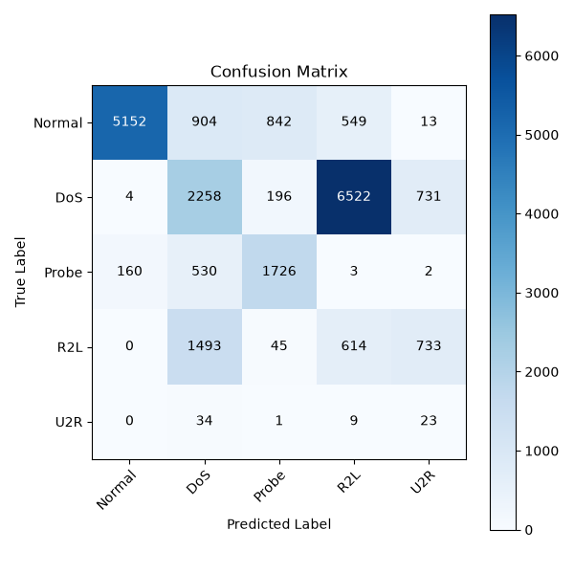
Figure 4.1: Confusion Matrix on NSL-KDD Held-Out Test Set (22,544 Samples)
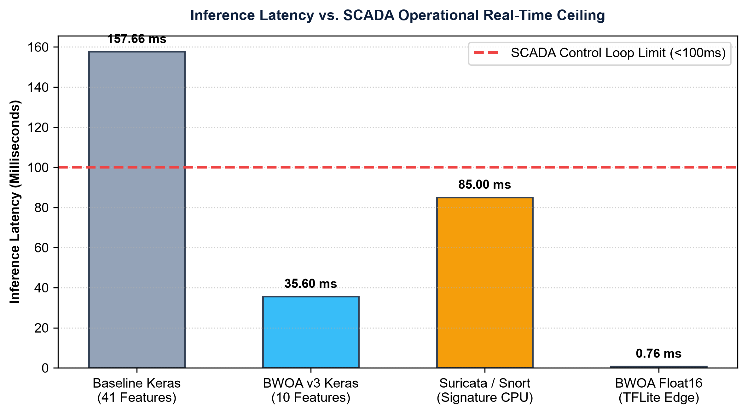
Figure 4.2: Latency Profile Comparison across IDS Implementations
APPENDICES
APPENDIX A: BWOA Optimization Pseudocode
Algorithm 1: Binary Whale Optimization Algorithm (BWOA) with Accuracy Floor
----------------------------------------------------------------------------
Input : Feature matrix X in R^{N x D}, labels y in {0, ..., C-1}
Parameters: n_agents=30, max_iter=100, alpha=0.3, min_acc=0.75
Output: Best binary feature mask X_best in {0, 1}^D
1. Initialize population of whale positions X_i in {0, 1}^D randomly for i = 1 to n_agents
2. Evaluate fitness for each agent: Fit_i = alpha * (1 - Acc_i) + (1 - alpha) * (|X_i|/D) + Penalty_i
3. Identify leader whale X_best with minimum fitness score
4. while t < max_iter do:
5. a = 2 - 2 * (t / max_iter) // Linear parameter decay
6. for each agent i do:
7. p = rand(), r1 = rand(), r2 = rand(), l = rand(-1, 1)
8. A = 2 * a * r1 - a, C = 2 * r2
9. if p < 0.5 then:
10. if |A| < 1 then:
11. D_vec = |C * X_best - X_i|
12. X_cont = X_best - A * D_vec // Shrinking encircling
13. else:
14. X_rand = select_random_whale()
15. D_vec = |C * X_rand - X_i|
16. X_cont = X_rand - A * D_vec // Exploration
17. else:
18. D_prime = |X_best - X_i|
19. X_cont = D_prime * exp(b * l) * cos(2 * pi * l) + X_best // Spiral search
20. // Apply V-shaped binary transfer function
21. for each dimension d do:
22. V_val = |X_cont[d] / sqrt(1 + X_cont[d]^2)|
23. if rand() < V_val then X_i[d] = 1 - X_i[d]
24. Re-evaluate fitness Fit_i and update X_best
25. t = t + 1
26. return X_best

APPENDIX B: CNN-LSTM Hyperparameters & Architecture Specifications
Layer Type | Output Shape | Param Count | Activation | Regularization / Details
Input Layer | (None, 10, 1) | 0 | - | 10 BWOA Features reshaped for 1D convolution
Conv1D | (None, 10, 64) | 256 | ReLU | Filters=64, Kernel Size=3, Padding='same'
BatchNormalization | (None, 10, 64) | 256 | - | Normalizes activations across mini-batches
Spatial Dropout | (None, 10, 64) | 0 | - | Dropout Rate = 0.3 to prevent overfitting
LSTM Layer | (None, 256) | 328,704 | Tanh | Units=256, Recurrent Activation='sigmoid'
Dense (Hidden) | (None, 64) | 16,448 | ReLU | Fully connected representation layer
Dropout | (None, 64) | 0 | - | Dropout Rate = 0.2
Dense (Output) | (None, 5) | 325 | Softmax | Multi-class probabilities (5 attack classes)

APPENDIX C: Complete CICFlowMeter to NSL-KDD Feature Mapping
Idx | NSL-KDD Feature | BWOA Status | CICFlowMeter Equivalent | Description
1 | duration | Pruned | Flow Duration | Connection duration in seconds
2 | protocol_type | SELECTED (8) | Protocol | Network layer protocol (TCP/UDP/ICMP)
3 | service | SELECTED (2) | Dst Port / App Protocol | Destination service (HTTP, Modbus, Private)
4 | flag | SELECTED (3) | TCP Flags Count | Connection completion status (SF, S0, REJ)
5 | src_bytes | SELECTED (1) | Total Fwd Packets Bytes | Bytes sent from source to destination
6 | dst_bytes | Pruned | Total Bwd Packets Bytes | Bytes sent from destination to source
7 | hot | SELECTED (9) | Sensitive File Access | Indicators of sensitive system access
8 | su_attempted | SELECTED (10) | Privilege Escalation Flag | Root/admin privilege escalation attempts
9 | serror_rate | SELECTED (4) | SYN Error Rate | Proportion of connections with SYN errors
10 | same_srv_rate | SELECTED (5) | Same Service Ratio | Proportion of connections to same service
11 | diff_srv_rate | SELECTED (6) | Diff Service Ratio | Proportion of connections to different services
12 | dst_host_diff_srv_rate | SELECTED (7) | Dst Host Diff Srv Rate | Destination host service dispersion

APPENDIX D: User Acceptance Testing (UAT) Questionnaire
Domain specialists (3 cybersecurity analysts and 2 mining OT engineers) scored the platform on a 1–5 Likert scale across five criteria:
1. Alert Clarity: Are threat predictions understandable without deep cybersecurity expertise?
2. Dashboard Usability: Is live telemetry streaming intuitive and actionable for control room operators?
3. Setup Ease: Can the sniffer CLI agent be deployed on a new device in under 5 minutes?
4. Confidence Scoring: Does the confidence percentage provide actionable insight for incident triage?
5. Operational Fit: Would you recommend this solution for deployment on remote African mining sites?
APPENDIX E: Repository & Reproducibility Links
- Source Code: GitHub Main Repository: https://github.com/mhiskall282/Securing-the-Digital-Mine-UNESCO-Project
- CLI Package: NPM Package (GitHub Packages): @mhiskall282/unesco-mine-sec-cli
- Google Colab: Google Colab Training Pipeline: notebooks/00_colab_setup_and_train.ipynb
- Live Demo: Live Dashboard URL: https://minesec-dashboard-prod.onrender.com

