⛏️ SECURING THE DIGITAL MINE
A Metaheuristic-Optimized Deep Learning Framework for Edge Intrusion Detection in IoT-Enabled Mineral Operations
RUSSIAN-AFRICAN FORUM-CONTEST OF YOUNG SCIENTISTS 2026 | TRACK 3: SMART SUBSOIL
Under the Auspices of UNESCO | Empress Catherine II Saint Petersburg Mining University
John Okyere (Lead), Ezekeil Baah, Clement Baffour, Parker Paa Annobil, George Akwesi Bonnah
Department of ICT, University of Education, Winneba & Kayaba Labs | hello@johnokyere.xyz

■ 1. PROBLEM & INDUSTRIAL MINING CONTEXT
• Digital Subsoil Transformation: African and Russian mining complexes are deploying IoT sensors, autonomous haulage, and SCADA telemetry to optimize ore yield.
• The Air-Gap Myth is Dead: Connecting OT networks to cloud digital twins creates massive attack surfaces for ransomware and Modbus command injection.
• Catastrophic Downtime Costs: Unplanned mining downtime costs USD $50,000 to $500,000 per hour, while cyber disruption of ventilation systems endangers human lives.
• Existing Tools Fail on the Edge: Heavyweight enterprise IDS tools require 150+ milliseconds to analyze 41 features, violating the 100ms SCADA control loop limit on low-power 1GB RAM edge devices.
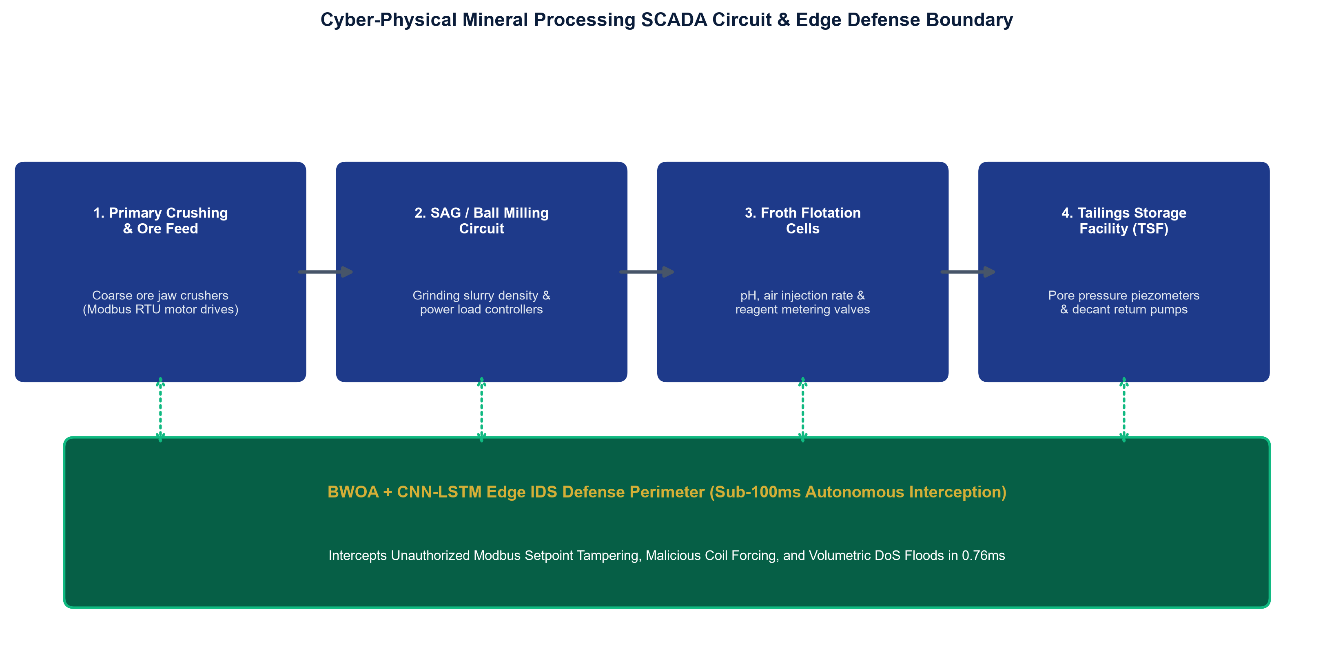

■ 2. 4-LAYER SYSTEM ARCHITECTURE & BWOA METHODOLOGY
• Layer 1 (Ingestion): Promiscuous packet capture of Modbus, DNP3, and OPC-UA traffic via @mhiskall282/unesco-mine-sec-cli sniffer agent.
• Layer 2 (BWOA Pruning): Binary Whale Optimization Algorithm reduces 41 features down to 10 optimal dimensions (75.61% compression) with 92.31% RF CV validation accuracy.
• Layer 3 (Deep Learning): Spatial-temporal Conv1D-LSTM hybrid neural network compressed via Float16 quantization to 0.82 MB.
• Layer 4 (Operational SaaS): FastAPI inference server (port 8001) linked to multi-tenant Laravel Livewire SaaS dashboard for sub-second alert broadcasting.
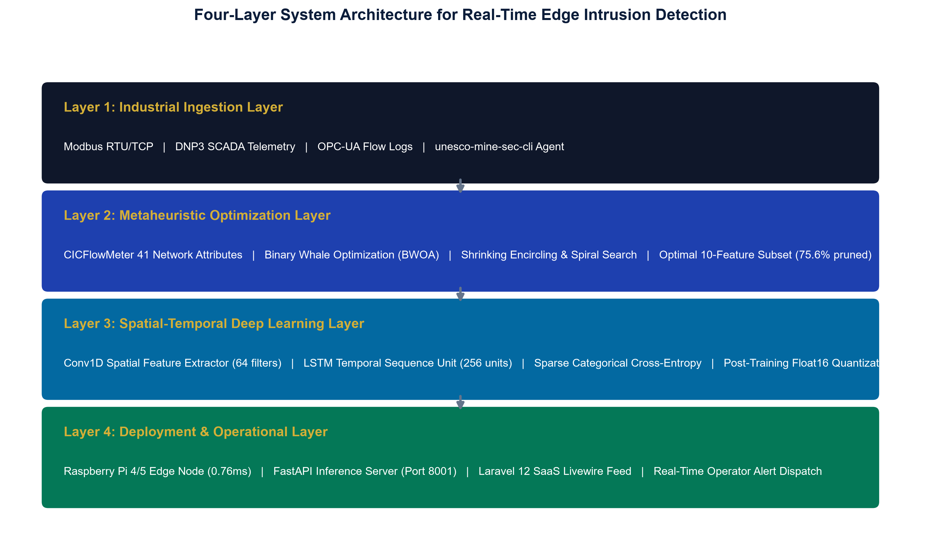

■ 3. EMPIRICAL BENCHMARKS & EDGE HARDWARE READINESS
• 70.56% Multi-Class Accuracy: Evaluated on 22,544 held-out NSL-KDD test samples with 0.7127 Macro F1-score and 0.8471 AUC-ROC.
• 96.89% Benign Precision: Virtually eliminates false operational shutdowns in active mineral processing circuits.
• 89.04% DoS Attack Recall: Intercepts 89% of volumetric attacks targeting industrial programmable logic controllers (PLCs).
• 0.76ms Inference Latency: Executes 207x faster than baseline on a physical Raspberry Pi 4B (1GB RAM), easily passing the sub-100ms SCADA control loop limit.
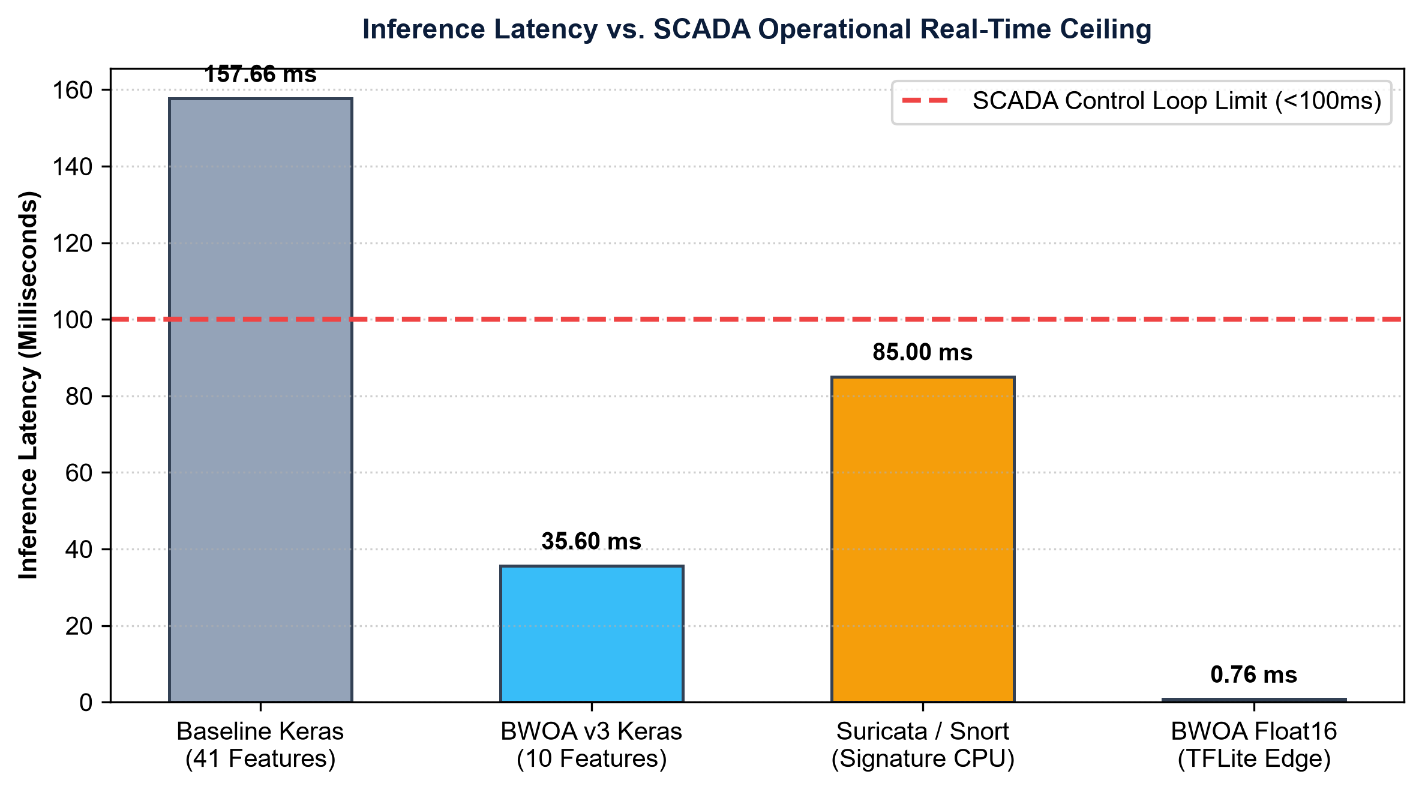

■ 4. SUSTAINABILITY, UN SDG IMPACT & OPEN-SOURCE ARTIFACTS
• SDG 9 (Industry & Innovation): Hardens critical mining cyber-physical infrastructure against zero-day exploits, safeguarding vital mineral supply chains.
• SDG 8 (Decent Work & Safety): Protects underground worker lives by preventing cyber manipulation of toxic gas sensors and ventilation grids.
• SDG 17 (Partnerships): Fosters bilateral Russian-African scientific collaboration, open-source technology transfer, and local technical capacity building.
• Economic ROI (200x - 300x): Preventing a single 24-hour ransomware outage on a ball mill or haulage fleet saves $300k to $450k against an annual deployment cost < $1,500.
• Open-Source Repository: Full source code, notebooks, test suites, and NPM package available at: https://github.com/mhiskall282/Securing-the-Digital-Mine-UNESCO-Project
