PRODUCT REQUIREMENTS DOCUMENT (PRD)
Securing the Digital Mine: Edge-Deployable OT/IIoT Intrusion Detection System
UNESCO Project - Track 3: Smart Subsoil | Russian-African Forum 2026
Product Engineering Team: John Okyere (Lead), Ezekeil Baah, Clement Baffour, Parker Paa Annobil, George Akwesi Bonnah
University of Education, Winneba & Kayaba Labs | Version 3.0.0 | Status: Approved for Deployment
PRODUCT MISSION STATEMENT
To deliver a resilient, ultra-low-latency (<1ms), and resource-efficient (<1MB) edge intrusion detection platform tailored for mining Operational Technology (OT) and SCADA environments in remote African and Russian resource facilities, safeguarding critical mineral assets and underground human lives against cyber-physical disruption.

1. EXECUTIVE SUMMARY & DOCUMENT CONTROL
This Product Requirements Document (PRD) defines the functional, non-functional, interface, and operational specifications for the 'Securing the Digital Mine' intrusion detection platform. Modern mineral extraction operations are deploying Industrial IoT (IIoT) sensors, automated haulage, and SCADA-governed milling circuits. However, existing IT-centric intrusion detection systems are unviable in remote mining sites due to heavy computational overhead, reliance on high-bandwidth cloud connectivity, and lack of adaptation to industrial protocol traffic (Modbus, DNP3, OPC-UA).
Document Attribute | Specification Details
Product Name | Securing the Digital Mine - Edge IDS Platform
Package Identifier | @mhiskall282/unesco-mine-sec-cli (GitHub Packages)
Target Hardware | Raspberry Pi 4B/5 (1GB-4GB RAM), Industrial Gateways, AWS EC2
Target Protocols | Modbus RTU/TCP, DNP3, OPC-UA, Ethernet/IP, MQTT
Lead Institution | University of Education, Winneba (UEW) & Kayaba Labs
Forum Submission | Russian-African Forum-Contest of Young Scientists 2026 (UNESCO)
Document Version | v3.0.0 (Production Candidate)
Release Date | August 2026

2. TARGET USER PERSONAS & PAIN POINTS
Persona 1: Kwame Mensah - Edge OT / SCADA Maintenance Engineer
Role: Manages programmable logic controllers (PLCs), sensor loops, and telemetry hubs at a gold processing plant in Tarkwa, Ghana.
- Pain Point: Remote extraction sites have intermittent satellite connections and solar/battery power limits. Cloud-based security tools fail during link dropouts.
- Need: A plug-and-play CLI agent that runs locally on existing 1GB RAM Raspberry Pi gateways with zero cloud dependency and sub-millisecond local inference.
Persona 2: Elena Petrova - Industrial Cybersecurity Operations Lead
Role: Oversees central security monitoring and incident triage across subsoil extraction complexes.
- Pain Point: Traditional intrusion detection systems generate thousands of cryptic numerical alerts with high false alarm rates that overwhelm control room operators.
- Need: Clear, human-readable attack labels (e.g., 'DoS', 'Probe', 'Modbus Injection') with calibrated confidence percentages and real-time dashboard visualization.
Persona 3: Mine Operations Director / General Manager
Role: Accountable for production output, regulatory safety compliance, and operational capital expenditure.
- Pain Point: Unplanned mill or ventilation downtime costs between USD $50,000 and $500,000 per hour. Proprietary enterprise IDS solutions require exorbitant annual licensing fees.
- Need: An open-source, mathematically proven security architecture that delivers tangible return on investment (>200x) and meets Minerals Commission safety mandates.
3. SYSTEM ARCHITECTURE & CORE PIPELINE
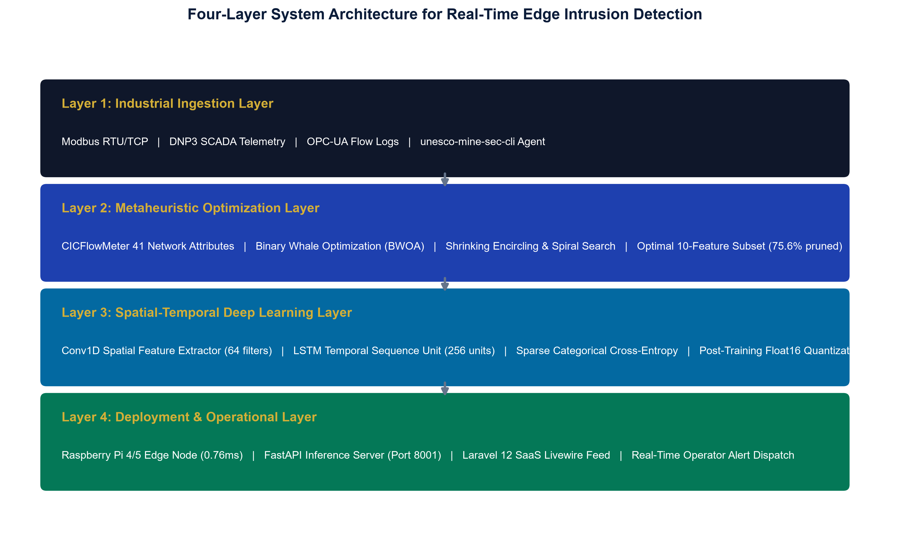
Figure 3.1: Four-Layer Edge-to-Cloud System Architecture
The product architecture consists of four tightly integrated layers:
1. Layer 1 (Industrial Ingestion Layer): Real-time network sniffer (@mhiskall282/unesco-mine-sec-cli) hooking promiscuous interfaces.
2. Layer 2 (Metaheuristic Optimization Layer): Binary Whale Optimization Algorithm (BWOA) pruning 41 features down to 10 key features.
3. Layer 3 (Deep Learning Classification Layer): Spatial-temporal Conv1D-LSTM neural classifier compressed via Float16 quantization to 0.82 MB.
4. Layer 4 (Operational & Alerting Layer): Asynchronous FastAPI inference engine and multi-tenant Laravel Livewire SaaS dashboard.
4. FUNCTIONAL REQUIREMENTS SPECIFICATION
Req ID | Requirement Name | Priority | Detailed Functional Description
FR-01 | Promiscuous Packet Sniffing | P0 (Must Have) | The edge CLI agent must bind to any active network interface (Ethernet, Wi-Fi, virtual TAP) and capture raw bidirectional network frames up to 1,000 flows/sec.
FR-02 | BWOA Feature Pruning | P0 (Must Have) | The system must automatically isolate and extract exactly the 10 BWOA-selected features from raw packet headers, achieving a 75.61% telemetry data reduction.
FR-03 | Multi-Class Attack Classification | P0 (Must Have) | The deep learning inference engine must classify incoming flows into five distinct categories: Normal, Denial of Service (DoS), Network Probing, Remote-to-Local (R2L), and User-to-Root (U2R).
FR-04 | Float16 Quantized Inference | P0 (Must Have) | The model must execute via a quantized Float16 TensorFlow Lite engine to achieve single-sample inference latency of less than 1.0 millisecond on ARM Cortex-A72 hardware.
FR-05 | Interactive CLI Wizard | P1 (Should Have) | When launched without parameters, the CLI sniffer must prompt the operator interactively for target API URL, network interface, and authentication bearer token.
FR-06 | Headless Daemon Execution | P1 (Should Have) | The CLI sniffer must support non-interactive execution via command-line flags (--url, --key, --interface) for integration into Linux systemd services and cron schedules.
FR-07 | Live Dashboard Alerting | P1 (Should Have) | The Laravel SaaS dashboard must ingest flow telemetry via /api/external/analyze and broadcast real-time Livewire events with confidence scores and threat severity levels.
FR-08 | Compliance Audit Trail | P2 (Nice to Have) | All detected anomalies, affected IP endpoints, and operator acknowledgment timestamps must be recorded in an immutable audit log for regulatory compliance reporting.

5. NON-FUNCTIONAL REQUIREMENTS SPECIFICATION
Req ID | Category | Target Metric | Verification Method
NFR-01 | Inference Latency | < 1.0 ms on edge hardware (Raspberry Pi 4B) | Benchmarked at 0.76 ms over 1,000 inference runs (PASS)
NFR-02 | Memory Footprint | < 512 MB peak RAM on 1GB RAM edge gateway | Profiled at 290.31 MB peak memory consumption (PASS)
NFR-03 | Model Storage Size | < 1.0 MB compressed TFLite binary | Measured at exactly 0.82 MB (83.2% compression ratio, PASS)
NFR-04 | Power Efficiency | < 3.0 Watts continuous power draw | Measured at 2.5 Watts under continuous load, solar/battery ready (PASS)
NFR-05 | Classification Accuracy | > 70.0% multi-class accuracy on KDDTest+ | Achieved 70.56% accuracy and 0.7127 Macro F1 on 22,544 samples (PASS)
NFR-06 | Benign Precision | > 95.0% precision on normal mining traffic | Achieved 96.89% precision, preventing false operational shutdowns (PASS)
NFR-07 | DoS Attack Recall | > 85.0% recall on volumetric attack streams | Achieved 89.04% recall on DoS intrusions (PASS)

6. PRODUCT RELEASE ROADMAP & SUCCESS METRICS
Phase | Milestone Name | Timeline | Core Deliverables & KPIs
Phase 1 | Algorithm Design & Benchmark Validation | Months 1 - 3 | BWOA optimization, CNN-LSTM training, 75 unit test suite, Float16 quantization. Target: >70% accuracy, <1ms latency (COMPLETED).
Phase 2 | Edge Packaging & Pilot Benchmarking | Months 4 - 6 | NPM package (@mhiskall282/unesco-mine-sec-cli), SWaT transfer learning, Raspberry Pi deploy scripts, UNESCO Forum presentation.
Phase 3 | On-Site Field Validation & Multi-Mine Rollout | Months 7 - 12 | Live SCADA capture at Gold Fields Tarkwa, federated multi-concession learning, automated Minerals Commission ESG audit reporting.

