Cover Page



Time-Adjusted Cluster Load Allocation with Error Correction in Sparsely Metered Distribution Networks

BY
PAUL CHINONSO IREM

U19EE1013

A FINAL YEAR PROJECT SUBMITTED TO THE DEPARTMENT OF ELECTRICAL ENGINEERING, AHMADU BELLO UNIVERSITY, ZARIA IN PARTIAL FULFILMENT OF THE REQUIREMENT FOR THE AWARD OF BACHELOR OF ENGINEERING (B.ENG) DEGREE IN ELECTRICAL ENGINEERING.

OCTOBER, 2026

DECLARATION

I hereby declare that this project entitled “Time-Adjusted Cluster Load Allocation with Error Correction in Sparsely Metered Distribution Networks” has been carried out by me in the Department of Electrical Engineering. The information derived from literature has been duly acknowledged in the text and a list of references provided. No part of this work has been submitted anywhere else for the award of degree or diploma at this or any other institution.

_________________________ ____________________
PAUL CHINONSO IREM Date

CERTIFICATION

This project work titled “Time-Adjusted Cluster Load Allocation with Error Correction in Sparsely Metered Distribution Networks” by Paul Chinonso Irem meets the regulations governing the award of Degree of Bachelor of Engineering (B.Eng) in Electrical Engineering of the Ahmadu Bello University, Zaria and is approved for its contribution to knowledge and literary presentation.

Prof. GBENGA. A. OLARINOYE _________________ ________________

Supervisor Signature Date

Dr. I. A. Shehu ________________ _________________
Project Coordinator Signature Date

Dr. Adamu . S. Abubakar ________________ _________________
Head of Department Signature Date

DEDICATION
This work is dedicated first and foremost to God Almighty, whose grace, wisdom, strength, and guidance have sustained me throughout the course of my studies and this research journey.
I dedicate this work to my beloved family, who have stood by me with unwavering love, encouragement, sacrifice, and support. I express my deepest gratitude to my sister, Gift, who has almost single-handedly sponsored my education and made significant sacrifices to ensure that I had the opportunity to pursue my studies. Her selflessness, generosity, and belief in me have been an invaluable source of strength, and this achievement would not have been possible without her immense support.
I also dedicate this work to Nigeria, where persistent and challenging electricity supply conditions, compounded by funding constraints for metering consumers and distribution companies, have motivated this research. It is my hope that this work contributes, however modestly, to the broader effort to address Nigeria’s energy challenges.
Finally, I dedicate this work to my lecturer, Prof. Engr. Gbenga Abidemi Olarinoye, whose lectures, insights, and intellectual guidance provided many of the foundational ideas that shaped this research. His teaching stimulated my interest in the subject and provided much of the conceptual foundation required to undertake this work.

ACKNOWLEDGEMENT
I would like to express my profound gratitude to everyone whose support, guidance, encouragement, and contributions made the completion of this research work possible.
My sincere appreciation goes to the staff and lecturers of the Department of Electrical Engineering, whose teaching, technical guidance, academic support, and access to departmental resources provided an important foundation for the development of this work. Their dedication to teaching and research greatly contributed to my understanding of the concepts and methods required to undertake this research.
I am also grateful to Kaggle for providing access to valuable computational and cloud-based resources. The availability of these computing facilities made it possible to carry out the simulations, data processing, analysis, and computational experiments required for this research.
I extend my appreciation to my colleagues and fellow students for their support, encouragement, discussions, and willingness to share ideas throughout the course of this work. Their contributions, whether through technical discussions or simply through encouragement during challenging periods, were greatly appreciated.

ABSTRACT
This paper presents a unified, physics-constrained framework combining Time-Adjusted Cluster Load Allocation (CLA) and transient-assisted error correction to resolve low-voltage distribution network state estimation challenges under severe Advanced Metering Infrastructure (AMI) sparsity (<40% smart meter coverage). The primary research goal is reconstructing individual consumer load shapes with high fidelity without requiring full physical metering. Methodologically, the framework constructs live, the non-parametric empirical cumulative distribution function (ECDF) curve, from metered customer subset (36% sampling fraction) and performs quantile mapping to infer unmetered consumer demand, applying a power-law suppression exponent ($β$* = 0.3962) to minimize allocation bias toward below-mean consumers. Upstream SCADA telemetry enforces physical boundary transformer energy conservation constraints, while high-frequency secondary transient waveform analytics, co-simulated via OpenDSS and ATP-EMTP, capture discrete load-switching and fault event indicators. Statistical testing across multi-event datasets yields a mean waveform correlation (S = 0.3974), deriving a transient-assisted error reduction factor (D = 0.6345). Findings demonstrate that Time-Adjusted CLA reduces individual consumer Mean Absolute Percentage Error (MAPE) from 61.10% under baseline CLA down to 50.17% (38.93% at optimal $β$*). Furthermore, integrating high-frequency transient dissimilarity metrics reduces total aggregate load allocation estimation error from 7.77% down to 2.84%. Ultimately, coupling dynamic ECDF quantile mapping, physical conservation boundaries, and secondary transient analytics establishes a scalable, robust architecture for state estimation in sparsely metered grids.
Index Terms— Time-Adjusted Cluster Load Allocation (CLA), Distribution System State Estimation (DSSE), Advanced Metering Infrastructure (AMI) sparsity, transient-assisted error correction, empirical quantile mapping (EQM), physical boundary energy conservation, pseudomeasurement generation, low-voltage distribution networks, transformer secondary boundary telemetry, secondary transformer waveform analytics, discrete switching event indicators, Thévenin network equivalent extraction, OpenDSS, ATP-EMTP, BCTRAN transformer modeling, latent network realization.
TABLE OF CONTENTS
List of Figures .................................................................................................................... ix
List of Tables ...................................................................................................................... x
List of Acronyms ................................................................................................................ x

CHAPTER ONE: INTRODUCTION
1.1 Background of the Study ................................................................................................ 1
1.2 Statement of the Problem ............................................................................................... 3
1.3 Aim and Objectives ......................................................................................................... 5
1.4 Significance of the Study ................................................................................................ 6
1.5 Scope and Limitations .................................................................................................... 7
1.6 Project Outline ................................................................................................................ 8

CHAPTER TWO: LITERATURE REVIEW
2.1 Introduction ..................................................................................................................... 9
2.2 Review of Fundamental Concepts ................................................................................ 10
2.2.1 Distribution System State Estimation (DSSE) and AMI Sparsity ........................... 10
2.2.2 Pseudomeasurement Generation and Allocation Techniques .............................. 12
2.2.3 Feeder Power Conservation and Line Loss Accounting ........................................ 15
2.3 Review of Similar Works ............................................................................................... 18

CHAPTER THREE: METHODOLOGY
3.1 Introduction ................................................................................................................... 22
3.2 Network Model and Latent Realization Architecture ..................................................... 23
3.3 Time-Adjusted Cluster Load Allocation (CLA) Framework ........................................... 26
3.3.1 Live Metered Class ECDF Construction and Empirical Quantile Mapping ............ 26
3.3.2 Power-Law Suppression Exponent (\(\beta^* = 0.3962\)) Calibratio..................... 29
3.3.3 Physical Boundary Energy Conservation Balancing ............................................. 31
3.4 Transformer Transient-Assisted Error Correction ........................................................ 34
3.4.1 Thévenin Equivalent Network Extraction in OpenDSS .......................................... 34
3.4.2 BCTRAN Transformer Matrix Modeling in ATP-EMTP .......................................... 36
3.4.3 Co-Event Simulation and Multiphase Waveform Extraction .................................. 38

CHAPTER FOUR: RESULTS AND DISCUSSION
4.1 Introduction ................................................................................................................... 42
4.2 Statistical Validation and Cluster Load Allocation Error ............................................... 43
4.2.1 Individual Consumer MAE, MAPE, and MSE Improvements ................................ 43
4.2.2 Optimization of Time-Adjustment Exponent (\(\beta^*\)) ....................................... 46
4.3 Transformer Terminal Waveform Observability Analysis ............................................. 49
4.3.1 Event Pair Response in Dataset 2 (Nominal Conditions) ...................................... 49
4.3.2 Time-Shift Sensitivity in Dataset 3 ......................................................................... 52
4.3.3 Transformer Specification Variation in Dataset 4 .................................................. 55
4.4 Derivation of Transient-Assisted Error Reduction Factor (\(D = 0.6345\)) .................... 58

CHAPTER FIVE: CONCLUSION AND RECOMMENDATION(S)
5.1 Conclusion .................................................................................................................... 61
5.1.1 Summary of Physical Boundary Aggregation and Observability ........................... 61
5.1.2 Transformer Domain-Shift and Superposition Findings ......................................... 63
5.2 Recommendation(s) ..................................................................................................... 65
5.2.1 Noise-Robust Hybrid Time–Frequency Signal Processing Architecture ............... 65
5.2.2 Controlled Transformer Signature Acquisition and Field Deployment ................... 68

REFERENCES ................................................................................................................ 71

APPENDICES .................................................................................................................... 76

LIST OF FIGURES
Figure No. | Title / Description | Page
Figure 3.1 | Single-Line Diagram and Bus Topology of the 20-Bus Radial Low-Voltage (LV1) Test Feeder | 25
Figure 4.1 | Three-Phase Secondary Transient Waveform Responses: No-Load Baseline vs. Equipment 1 (AC Motor) | 48
Figure 4.2 | Three-Phase Secondary Transient Waveform Responses: No-Load Baseline vs. Equipment 2 (Compressor) | 49
Figure  4.3 | Subtracted Residual Load Waveforms ($\Delta V_1$, $\Delta V_2$, and $\Delta V_{1,2}$) for Individual Loads and Co-Event Pair 1,2 | 51
Figure  4.4 | 5-Component Waveform Decomposition of RAW Three-Phase Current ($I_{a,b,c}$) for Load Pair Co-Event | 54
Figure  4.5 | Transient Waveform Residual Voltage and Current Scaling Curve versus Simultaneous Co-Events ($K = 2 \text{ to } 25$) | 56
Figure  4.6 | 5-Component Waveform Decomposition of RAW Three-Phase Voltage ($V_{a,b,c}$) for Load Pair Co-Event | 53

LIST OF TABLES
Table No. | Title / Description | Page
Table 3.1 | Consumer Class Weights, Primary Load Types, and Population Distribution in the 20-Bus Radial Low-Voltage Feeder | 27
Table 4.1 | Statistical Comparison of Allocation Errors Across Baseline, Default Time-Adjusted, and Optimized Cluster Load Allocation Configurations | 44
Table 4.2 | Phase-Specific Waveform Correlation Vectors and Residual-to-Composed Magnitude Ratios Across Co-Event Datasets | 52
Table 4.3 | Summary of Overall Waveform Dissimilarity Metrics and Transient-Assisted Load Allocation Error Reduction | 58

LIST OF ACRONYMS
Acronym | Definition / Full Meaning
ADC | Analog-to-Digital Converter
AMI | Advanced Metering Infrastructure
API | Application Programming Interface
ATP-EMTP | Alternative Transients Program – Electromagnetic Transients Program
BCSE | Branch-Current State Estimation
BiLSTM | Bidirectional Long Short-Term Memory
CDF | Cumulative Distribution Function
CIGRE | Conseil International des Grands Réseaux Électriques (International Council on Large Electric Systems)
CLA | Cluster Load Allocation
CNN | Convolutional Neural Network
DSO | Distribution System Operator
DSSE | Distribution System State Estimation
DWT | Discrete Wavelet Transform
ECDF | Empirical Cumulative Distribution Function
EQM | Empirical Quantile Mapping
FFT | Fast Fourier Transform
GASF | Gramian Angular Summation Field
GEFCom | Global Energy Forecasting Competition
HV | High Voltage
IEC | International Electrotechnical Commission
MV | Medium Voltage
NERC | Nigerian Electricity Regulatory Commission
NILM | Non-Intrusive Load Monitoring
OpenDSS | Open Distribution System Simulator
PWM | Pulse-Width Modulation
QDM | Quantile Delta Mapping
RLP | Representative Load Profile
RMSE | Root Mean Square Error
RTU | Remote Terminal Unit
SCADA | Supervisory Control and Data Acquisition
SFRA | Sweep Frequency Response Analysis
SOM | Self-Organizing Map
STFT | Short-Time Fourier Transform
SWT | Stationary Wavelet Transform
TAC-ERF | Transient-Assisted CLA Error Reduction Factor
THD | Total Harmonic Distortion
TTU | Transformer Terminal Unit
UPS | Uninterruptible Power Supply
V-I | Voltage-Current (Trajectory)
WLS | Weighted Least Squares
WPT | Wavelet Packet Transform

CHAPTER ONE

INTRODUCTION
1.1 Background of the study
Distribution system state estimation (DSSE) has become an important component of modern distribution system operation because it provides estimates of electrical states that are not directly available from the measurement infrastructure. Such estimates support voltage monitoring, loss assessment, congestion management, network control, distributed energy resource integration, fault management, and other distribution-level applications.
State estimation originated primarily in the transmission-system environment. The classical formulation developed by Schweppe and colleagues in the early 1970s established state estimation as a measurement-processing problem in which redundant measurements are combined with a mathematical network model to estimate bus voltage magnitudes and phase angles. Iterative weighted least-squares methods subsequently became an important foundation for practical power-system state estimation. The transmission-oriented formulation was developed for systems with relatively extensive measurement infrastructure and network characteristics that differ substantially from those of distribution systems.
The need for a distinct distribution-system formulation became apparent because distribution networks possess characteristics that make direct application of transmission-system estimators problematic. Distribution feeders are typically unbalanced, have comparatively high resistance-to-reactance ratios, contain many sparsely instrumented buses, and commonly operate with limited real-time measurements. The first DSSE formulations emerged in the 1990s, with Wu's work in 1990 generally identified as an early formal distribution-state-estimation formulation, followed by subsequent developments addressing three-phase operation, current-based measurements, and other distribution-specific characteristics.
The development of advanced metering infrastructure subsequently changed the measurement environment. Smart meters introduced the possibility of obtaining voltage, current, energy, power, and related measurements over large numbers of customer connections, although their temporal resolution and available measurement quantities remain substantially different from those of phasor measurement units and micro-phasor measurement units. As a consequence, DSSE research has increasingly focused on combining heterogeneous measurements, pseudo-measurements, network models, and statistical information to overcome limited measurement coverage. Reviews of LV DSSE have identified measurement sparsity, pseudo-measurement uncertainty, network-model uncertainty, and observability as persistent practical limitations.
This development represents an important change in the understanding of distribution-system observability. The problem is no longer simply whether sufficient measurements are available to estimate a known state vector. Recent work has demonstrated joint or coupled estimation of distribution states and line parameters, including approaches designed for unbalanced three-phase networks and noisy measurement conditions. Nevertheless, these approaches have predominantly relied on steady-state electrical relationships and measurements such as voltage magnitude, current, active power, and reactive power. This leaves an opportunity to investigate whether additional information contained in short-duration transient responses can assist the estimation of latent distribution-system quantities and non-intrusive load monitoring and energy disaggregation.
The field was pioneered by Hart's event-based approach and subsequently developed using steady-state changes, transient signatures, harmonic characteristics, statistical models, optimization techniques, and machine-learning methods.
Transient-based load identification is particularly relevant to sparsely metered distribution networks because the transient response may contain information that is not apparent from low-frequency energy measurements. A switching operation can modify the instantaneous voltage and current response and may generate transient characteristics related to event duration, waveform shape, harmonic content, and frequency-domain behaviour. Earlier load-monitoring studies showed that such transient characteristics can improve discrimination between loads with similar steady-state signatures, although they also highlighted the need for sufficiently high sampling rates and the sensitivity of transient signatures to noise and repeatability.
Wavelet analysis has consequently become relevant to transient-based electrical signal analysis because it provides a representation that preserves information in both time and frequency. Unlike a conventional Fourier representation, which provides a global spectral description, wavelet methods can localize short-duration features at multiple temporal scales. This property is particularly useful for distribution-system disturbances and load-transition events whose spectral content changes rapidly in time. The use of wavelet coefficients as load-monitoring features is established in non-intrusive monitoring research, where wavelet transforms have been used alongside RMS quantities, harmonic features, and other characteristics for event detection and appliance identification.
The present study is situated at the intersection of four related areas of research. The first is conventional and dynamic DSSE, which seeks to estimate electrical states from heterogeneous and incomplete measurements. The second is distribution-network parameter estimation, which addresses the fact that line parameters may be unavailable or inaccurate. The third is non-intrusive load monitoring and energy disaggregation, which seeks to infer individual or grouped consumer behaviour from aggregate measurements. The fourth is power-system transient and wavelet analysis, which seeks to exploit non-stationary electrical signals for disturbance and event identification. Each area has developed substantially, but they have largely evolved as separate research streams. Reviews of DSSE emphasize observability, pseudo-measurement uncertainty, bad data, meter placement, model uncertainty, and the distinction between model-based and data-driven estimation. Research on line-parameter estimation similarly focuses primarily on extracting impedance information from steady-state smart-meter or phasor measurements. Conversely, transient-based load monitoring has mainly focused on load or appliance identification rather than integrating transient information with distribution-network state estimation and energy allocation.
The unresolved research opportunity lies in combining these developments into a unified estimation framework for a known LV network in which selected line parameters and consumer loads are latent. Existing studies have established that line parameters can be inferred from smart-meter or phasor measurements and that transient signatures can assist load identification.
The framework uses synchronized transformer-boundary measurements, steady-state electrical information, and time–frequency features extracted from transient responses to estimate latent line parameters and consumer-load behaviour. The study further investigates the physical and statistical structure of residual transient energy, develops a noise-aware event-signature detection mechanism, and evaluates how the resulting transient information can be incorporated into Cluster Load Allocation without violating feeder-level energy conservation.

1.2 Aim of the Study
The aim of this study is to develop a transient-assisted distributed system state-estimation framework for sparsely metered low-voltage distribution networks that jointly exploits steady-state measurements and transformer-boundary time–frequency transient information to estimate latent line parameters and consumer loads and to reduce aggregate load-allocation error.

1.3 Objectives of the Study
The objectives of the study are to:
- characterize the uncertainty introduced by sparse measurements, measurement noise, pseudo-measurements, and latent line parameters in the estimation of LV network states;
- investigate the relationship between transformer-boundary transient responses and downstream consumer events under varying co-event density, event timing, operating conditions, and transformer characteristics;
- develop a noise-aware signature-detection mechanism that distinguishes reproducible transient signatures from measurement noise, persistent harmonic content, electromagnetic interference, and unmodelled background response;
- investigate the use of transient-derived information as an additional observation for estimating latent line parameters and consumer-load characteristics;
- develop a probable transient-assisted error-reduction factor that converts measured transient discrimination and event confidence into a calibrated estimate of the reduction achievable in aggregate Cluster Load Allocation error;
- integrate the transient-derived information into the CLA framework while preserving the feeder-level energy-balance constraint;
- compare the resulting estimation accuracy and aggregate allocation error against the corresponding steady-state and time-adjusted CLA approaches.

1.4 Scope of the Study
The study focuses on low-voltage distribution networks with a known network topology and known electrical connectivity, while allowing selected line parameters and consumer-load quantities to remain latent. The measurement architecture is centered on synchronized transformer-boundary voltage and current measurements supplemented by conventional electrical measurements. The transient-analysis component considers event-oriented voltage and current responses and extracts time–frequency information using spectral and wavelet techniques.
The investigation covers steady-state and transient conditions, including multiple downstream consumer events, changes in relative event timing, transformer operating-condition variation, and controlled measurement-noise conditions. The study does not assume that the transformer transient uniquely identifies a consumer independently of the network and transformer through which the signal propagates. Instead, transformer characteristics and operating conditions are treated as conditioning variables within the estimation framework.
The resulting methodology is evaluated within the defined simulation and measurement environment. Consequently, the resulting error-reduction factor represents a model- and experiment-dependent quantity that requires independent validation before generalization to physical distribution networks. This is consistent with the broader practical literature, which identifies the gap between theoretically effective DSSE methods and field deployment under sparse measurements, uncertain models, and heterogeneous sensing systems.
1.5 Statement of the Problem
Standard state estimation frameworks is fixed diagonal measurement error covariance matrices or uniform percentage error bounds around a mean pseudo-measurement. Advanced probabilistic methods represent variance via continuous probability density functions or multi-quantile prediction intervals $\left[q_{α},q_{1-α}\right]$. Unobserved events—such as occupancy changes, new appliances, travel, outages, downtime, or behavioral shifts—create unmodeled structural residual offsets $η_{i}\left(t\right)$. Existing point-estimation algorithms typically ignore these shifts or treat them as random noise, which biases state estimation results unless corrected by real-time boundary energy constraints or adaptive residual error routines.
Individual customer behavioral variations $η_{i}\left(t\right)$ that lack corresponding local sensors remain fundamentally irreducible. Transient or event-based measurements at boundary transformers can detect discrete macro-state transitions, such as electric vehicle charger initiation or major switching events, providing event indicators that can recalibrate class profile assignments or trigger real-time error correction routines. A clear methodological gap remains between existing isolated load allocation or profiling methods and a fully integrated framework. Existing studies evaluate dynamic profile clustering, probabilistic quantile mapping, boundary physical constraints, or transient event sensing separately. No unified framework integrates dynamic metered-class empirical cumulative distribution function matching, assigned customer percentile weighting, physical boundary constraint balancing, and transient-assisted error correction under severe Advanced Metering Infrastructure sparsity
The specific research gap is formally defined as the lack of a unified, physics-constrained allocation methodology capable of accurately reconstructing individual customer load shapes in real time when Advanced Metering Infrastructure penetration is below fourty percent.
1.6 The significance of the study
The significance of this study lies in its potential to improve the observability, monitoring, and estimation of low-voltage distribution networks in situations where measurement coverage is limited and some electrical parameters and consumer loads cannot be directly observed. As distribution systems become more complex and the number and diversity of connected loads increase, accurate knowledge of network states and consumer demand becomes increasingly important for effective planning, operation, energy accounting, and system control. The study addresses this problem by investigating whether transient information measured at the distribution-transformer boundary can provide additional information beyond that available from conventional steady-state measurements.
Scientific Significance
Scientifically, the study contributes to the development of distribution system state estimation by extending the information used for estimation beyond conventional steady-state electrical quantities. Whereas conventional DSSE primarily exploits relationships among measured voltage, current, active power, reactive power, and network parameters, this study investigates the use of the time–frequency structure of transformer transient responses as an additional source of observability.
A further scientific contribution is the integration of three related areas of investigation: latent line-parameter estimation, consumer-load estimation, and transient event characterization. The resulting framework provides a basis for investigating whether transient information can reduce uncertainty in estimation when steady-state observations alone do not provide sufficient information to distinguish between competing combinations of network parameters and consumer loading.
Significance to Distribution Network Operators
For distribution network operators, the study may provide a means of obtaining additional operational information without requiring high-resolution sensing equipment to be installed at every consumer connection. The distribution transformer represents an aggregation point through which the electrical response of downstream consumers is observed. A reliable transient-analysis framework could therefore complement existing smart-meter and transformer measurements by providing information about short-duration changes in downstream consumption.
Such information could support improved feeder monitoring, identification of significant switching activity, investigation of abnormal operating conditions, and estimation of network conditions where direct measurements are unavailable. The proposed methodology is not intended to replace existing metering infrastructure; rather, it provides an additional information layer that can be combined with existing measurements.
Significance to Energy Accounting and Load Allocation
The study is also relevant to electricity energy accounting and the estimation of unmetered or sparsely measured consumer demand. Aggregate feeder energy may be available even when the individual contribution of consumers cannot be directly determined with the same accuracy. Under these circumstances, Cluster Load Allocation can distribute the unsampled energy among consumers, but uncertainty in the allocation remains.
The proposed transient-assisted approach addresses this problem by using detected transient events as additional evidence about the temporal and relative distribution of downstream consumption. The transient measurement is therefore not treated as an alternative measurement of total energy. Instead, it provides information for improving the allocation of the energy already constrained by aggregate feeder measurements.
Significance to Consumers and Electricity Service
Improved estimation of distribution-network states and consumer demand can potentially contribute to better electricity service by providing distribution operators with more accurate information about feeder loading and downstream demand behaviour. Better information can support earlier identification of abnormal conditions, improved load assessment, and more informed operational decisions.
The study may also contribute to improved energy-accounting transparency where measured aggregate supply and individual consumer measurements do not provide sufficiently detailed information to determine the distribution of consumption. Any such benefit would depend on successful validation of the proposed transient-identification and estimation framework under realistic field conditions.
Significance to Future Research
The study also establishes a foundation for further research into dynamic and transient-assisted DSSE. The proposed framework can be extended to investigate different transformer designs, feeder configurations, consumer-event classes, noise environments, sampling rates, and sensor technologies. It can also provide a basis for experimental validation using physical distribution transformers and field measurements.
1.5 Project Outline
The proposed research framework—provisionally titled Time-Adjusted Cluster Load Allocation (CLA) with Error Correction—is situated at the structural intersection of dynamic class load profiling, empirical quantile mapping, physical boundary power balancing, and transient event assistance. The operational workflow of the proposed estimator progresses systematically through four functional stages:
- Live Metered Class Cumulative Distribution Function Construction: The framework leverages the available metered customer subset to build live, time-adjusted empirical cumulative distribution functions $F_{Y\left(t\right)∣C}\left(y\right)$ for each customer class $C$ at time $t$. This captures intra-day variability, skewness, and class variance dynamically without imposing rigid parametric assumptions.
- Relative Percentile Rank Allocation: Each unmetered customer is assigned an ordinal position or percentile rank $w_{i}∈\left[0,1\right]$ within their assigned class based on premise attributes. Individual demand estimates are generated by inverting the live metered class distribution: ${\overset{ˆ}{P}}_{i}\left(t\right)=F_{Y\left(t\right)∣C}^{-1}\left(w_{i}\right)$.
- Physical Boundary Energy Conservation: Raw percentile allocations are scaled using real-time SCADA telemetry collected at distribution transformer boundaries. Enforcing total power conservation ensures that the sum of metered loads, allocated unmetered loads, and calculated technical line losses exactly matches aggregate transformer intake.
- Transient-Assisted Residual Error Correction: High-frequency boundary waveform analytics at the distribution transformer detect discrete macro-state switching events (such as major motor starts or electric vehicle charger activations). These event indicators dynamically adjust assigned customer percentile weights $w_{i}$ or trigger localized residual error recalibrations.
By combining empirical non-parametric quantile mapping with physical conservation boundaries and boundary event indicators, the proposed framework generates high-fidelity pseudo-measurements for distribution state estimation tools operating in sparsely metered grids.

CHAPTER TWO

LITERATURE REVIEW

Despite extensive Advanced Metering Infrastructure (AMI) rollouts, universal, real-time customer-level metering remains economically and logistically unachievable across many distribution systems. High capital expenditures, legacy communication limitations, data packet loss, non-standardized hardware adapters, and privacy regulations prevent ubiquitous, sub-hourly smart meter deployments at every low-voltage customer connection point. Consequently, distribution system operators (DSOs) operate under conditions of persistent metering sparsity, where customer telemetry is partially observed, intermittently transmitted, or entirely absent.
Substation transformers, feeder heads, and low-voltage secondary busbars are increasingly instrumented with real-time SCADA systems, Remote Terminal Units (RTUs), or Transformer Terminal Units (TTUs) that deliver continuous measurements of voltage, current, active power, reactive power, and high-frequency waveforms. Conversely, downstream individual customer connection points remain largely unmonitored in real time, leaving individual consumption profiles unobserved. To bridge this gap without full physical instrumentation, power system analytical tools rely on pseudomeasurements—synthesized estimates of downstream customer demand derived from historical billing, customer class curves, or statistical disaggregation.
Customer Load Estimation focuses purely on consumer demand modeling without considering network connectivity or electrical power flow constraints. Load Allocation disaggregates an observed aggregate feeder measurement across downstream buses using physical heuristics or billing proportions, producing node-level demand estimates. Distribution System State Estimation processes these allocated loads as input pseudomeasurements alongside physical network impedance matrices ($Y_{\text{bus}}$) to solve non-linear power flow equations and estimate complex bus voltage vectors. Confusing these analytical levels risks misattributing physical transmission losses to estimation error or expecting pure load profiling algorithms to solve electrical network states.
When direct customer measurements are unavailable, load allocation disaggregates measured substation or feeder head active power across downstream distribution transformers. Established methods for estimating customer loads under incomplete metering include historical or shared-metering heuristics that allocate recorded energy using transformer ratings, billing data, or shared-meter measurements; machine-learning algorithms such as K-means clustering, image-NN spatial-temporal ratio interpolation, and weather-driven Markov models for customer load profiling; regression-based machine-learning models; and optimization-based pseudo-measurement generation for state estimation.
Customers are classified using administrative tariff structures, historical billing energy tiers, or unsupervised clustering algorithms (K-means, Self-Organizing Maps, Mean-Shift, and Hierarchical clustering) applied to sampled smart-meter time-series. Distance metrics, including Euclidean, Manhattan, and Pearson correlation distance, quantify dissimilarities between customer load profiles to support clustering based on consumption magnitude and temporal patterns. These profiles are then adjusted over time using time-indexed Load Model Factors, seasonal updates, weather-driven Markov-chain state transitions, and multi-time-scale estimation architectures in which fast-rate SCADA snapshots recalibrate slower-rate historical profiles.
In sparsely metered networks static class averages are rarely used in practise as it erases individual coincident peak timing, eliminates intra-class variance, underpredicts localized voltage drops and branch thermal overloads, and imposes artificial demand correlation across diverse customer premises. A customer's relative position within a class can be used to infer expected demand by assigning an unmetered customer a relative ordinal rank or percentile weight $w_{i}∈\left[0,1\right]$ within their assigned cluster. Instantaneous demand is inferred by evaluating the inverse cumulative distribution function of the live metered customer population: ${\overset{ˆ}{E}}_{i}\left(t\right)=F_{Y\left(t\right)∣C}^{-1}\left(w_{i}\right)$. This empirical percentile and quantile-based approach is consistent with established methods for probabilistic load forecasting, where conditional quantiles are used to represent the distribution and uncertainty of future demand. This is reflected in the Global Energy Forecasting Competition (GEFCom), particularly its probabilistic load-forecasting tasks, which evaluated forecasts across multiple quantiles rather than relying solely on point estimates. Related applications of quantile-based modelling also appear in density forecasting and spatial-temporal downscaling.
Foundational studies operationalized proportional load allocation in radial feeders, calculating the estimated demand $P_{j}\left(t\right)$ at a downstream transformer bus $j$ according to:
$$P_{j}\left(t\right)=P_{\text{feeder}}\left(t\right)⋅\frac{S_{T,j}⋅{\text{DF}}_{j}}{\sum_{k=1}^{N}{\left(S_{T,k}⋅{\text{DF}}_{k}\right)}}$$
where $S_{T,j}$ represents the rated capacity of transformer $j$, and ${\text{DF}}_{j}$ denotes the coincident diversity factor derived from historical customer class surveys.
Failure Modes of Proportional Allocation
While computationally lightweight, proportional allocation rules exhibit critical empirical failure modes during peak operational periods in modern active distribution networks:
- Reverse Power Flow Distortion: High penetrations of rooftop photovoltaics can cause net demand at individual nodes to become negative during midday hours. Proportional scaling factors based on nameplate kVA or gross historical energy consumption cannot represent these directional power reversals, resulting in substantial over-allocation of demand on unmetered branches.
- Non-Coincident Peak Shifts: Unmonitored residential loads driven by electric-vehicle charging, heat pumps, and other high-power appliances can introduce localized, non-coincident demand peaks. Proportional disaggregation implicitly transfers aggregate demand according to fixed allocation factors, smoothing or suppressing localized peaks and potentially underestimating branch currents and thermal loading.
- Non-Technical Losses: Electricity theft, illegal connections, meter bypass, and other non-technical losses introduce demand that is not reliably represented in historical customer measurements. Where these losses are unmetered or unidentified, proportional allocation cannot distinguish legitimate consumption from unaccounted demand, producing persistent and potentially irreducible estimation errors in affected network sections.
- Phase Unbalance Degradation: Uneven distribution of single-phase customers across low-voltage phases can produce substantial phase-dependent demand and voltage differences. Proportional allocation based primarily on aggregate transformer or customer energy cannot recover this phase-specific variation, which may lead to excessive voltage unbalance, increased neutral currents and losses, transformer or conductor thermal stress, and incorrect assessment of voltage compliance and protection performance.
To overcome the limitations of static allocation, published studies have investigated unsupervised clustering methods that group smart-meter consumption time-series into Representative Load Profiles (RLPs). Key algorithmic paradigms include:
- $K$-Means Clustering: Minimizes the within-cluster sum of squared Euclidean distances. However, it is highly sensitive to initial centroid selection and outlier spikes in spiky low-voltage demand data.
- Self-Organizing Maps (SOM): Implements competitive unsupervised learning to map high-dimensional load time-series onto a lower-dimensional topological grid. The neuron weight vector $C_{i,t}$ is updated for winning neuron $i^{*}$ and its neighbors using:
$$C_{i,t}^{\left(\text{new}\right)}=C_{i,t}^{\left(\text{old}\right)}+α⋅\exp\left(-\frac{‖i^{*}-i‖​^{2}}{2σ^{2}}\right)\left(M_{j,t}-C_{i,t}\right)$$
where $α$ is the learning rate, $σ$ is the neighborhood radius, and $M_{j,t}$ is customer $j$'s consumption time-series.
- Mean-Shift with Epanechnikov Kernels: A non-parametric density-based clustering algorithm that identifies cluster centers at the modes of a kernel density estimate without requiring prior specification of cluster count $K$. The Epanechnikov kernel $K_{E}\left(D_{ij}\right)$ evaluated over correlation distance $D_{ij}$ with bandwidth $h$ is formulated as:
$$K_{E}\left(D_{ij}\right)=\left\{\begin{matrix}\frac{3}{4h}\left(1-{\left(\frac{D_{ij}}{h}\right)}^{2}\right), & \text{if }|D_{ij}|≤h \\ 0, & \text{otherwise}\end{matrix}\right.$$
$$\boxed{K_{E}\left(D_{ij}\right)=0, d_{ij}≥h}$$
where $d_{ij}$is the distance between load profiles $i$and $j$, and $h$is the kernel bandwidth controlling the neighbourhood over which profiles contribute to the local density estimate.

When clustering load shapes, Euclidean distance ($L_{2}$ norm) and Manhattan distance ($L_{1}$ norm) measure magnitude differences rather than structural temporal patterns. Consequently, two customers with identical diurnal consumption shapes but different peak magnitudes are incorrectly assigned to separate clusters under Euclidean metrics. Pearson correlation distance $D_{ij}$ isolates shape morphology by normalizing for mean magnitude and variance:
$$D_{ij}=1-ρ\left(M_{j,t},C_{i,t}\right)=1-\frac{\sum_{k=1}^{T}{\left(M_{j,k}-{\overline{M}}_{j}\right)}\left(C_{i,k}-{\overline{C}}_{i}\right)}{\sqrt{\sum_{k=1}^{T}{{\left(M_{j,k}-{\overline{M}}_{j}\right)}^{2}}\sum_{k=1}^{T}{{\left(C_{i,k}-{\overline{C}}_{i}\right)}^{2}}}}$$
Pearson correlation distance is preferred for shape matching because it ensures that load profiles sharing coincident timing for peaks and troughs are grouped into the same representative customer class, regardless of overall energy scale.

Spatial-Temporal Interpolation
For partially metered feeders, k-Nearest Neighbors (k-NN) spatial-temporal interpolation estimates unmetered customer demand by identifying nearby metered customers and weighting their observed load profiles according to their proximity. Neighbors may be defined using electrical distance, derived from network impedance or path impedance, or topological distance, such as the feeder path length between customers. The estimated demand is then obtained from a distance-weighted combination of the selected metered profiles, with temporal observations providing the corresponding load state at the estimation instant.

Feeder Power Conservation and Loss Accounting
Consider a radial feeder or transformer secondary zone servicing $N$ downstream customer connection points. Real-time active power flow measured at the transformer secondary terminal or feeder head $P_{\text{boundary}}\left(t\right)$ satisfies:
$$P_{\text{boundary}}\left(t\right)=\sum_{i=1}^{N}{P_{i,t}}+P_{\text{loss}}\left(t\right)$$
where $P_{i,t}$ is the actual demand of customer $i$, and $P_{\text{loss}}\left(t\right)$ denotes total technical line and transformer load losses across the boundary zone. Accurate load allocation requires separating technical line losses $P_{\text{loss}}\left(t\right)$ from customer demand estimates. Technical losses vary nonlinearly with line current flow ($I^{2}R$) and must be calculated using physical branch impedance parameters ($Y_{\text{bus}}$) or loss sensitivity matrices.
In asymmetric three-phase low-voltage networks, power conservation must be enforced independently on each phase $ϕ∈\left\{A,B,C\right\}$:
$$P_{\text{boundary},ϕ}\left(t\right)=\sum_{i∈N_{ϕ}}{P_{i,t,ϕ}}+P_{\text{loss},ϕ}\left(t\right)$$
where $N_{ϕ}$ represents the set of single-phase customers connected to phase $ϕ$, because physical telemetry in distribution grids is under-determined, Distribution System State Estimation (DSSE) algorithms—including Weighted Least Squares (WLS) and Branch-Current State Estimation (BCSE)—depend on pseudomeasurements to maintain numerical observability. Allocated customer loads serve directly as real and reactive power injection pseudomeasurements (${\overset{ˆ}{P}}_{i},{\overset{ˆ}{Q}}_{i}$) at network nodes.

Algorithm Divergence and Estimation Bias from Uncorrected Pseudomeasurements
When uncorrected pseudomeasurements containing uncalibrated systematic errors or incorrect variance assumptions are injected into DSSE engines, severe numerical and operational errors occur:
- Gain Matrix Ill-Conditioning and Algorithm Divergence: WLS state estimation minimizes the weighted sum of squared residuals using the gain matrix $G=H^{T}R^{-1}H$, where $R$ is the measurement error covariance matrix and $H$ is the measurement Jacobian. Uncorrected pseudomeasurement errors lead to ill-conditioned gain matrices, causing Gauss-Newton iterative solver divergence.
- Large Normalized Residuals and False Bad-Data Flagging: Large pseudomeasurement errors yield high normalized residual vectors. Standard Chi-square bad-data detection routines routinely misidentify valid real-time SCADA current measurements as corrupted data due to severe underlying pseudomeasurement errors.
- Systemic Voltage Magnitude and Angle Estimation Bias: Pseudomeasurement over-estimation at unmetered nodes depresses calculated bus voltage magnitudes $|V_{i}|$ across downstream branches, causing DSSE to report false low-voltage violations and trigger unnecessary tap-changer operations.

Advanced Observability via Boundary Waveform Analytics
Beyond steady-state telemetry ($P,Q$), modern transformer terminal units (TTUs) sample voltage and current waveforms at high sampling frequencies (kHz to MHz range). High-frequency sampling captures transient switching signatures, providing an additional source of observability for downstream customer operations.

Non-Intrusive Load Monitoring (NILM) and Deep Learning Feature Architectures
Transformer-side NILM disaggregates total boundary waveforms into constituent downstream appliance or customer switching states. Advanced feature extraction and machine learning pipelines include:
- Gramian Angular Summation Fields (GASF) and Recursive Patterns (RP): Algorithms that convert one-dimensional current transient time-series into two-dimensional image matrices, preserving spatial-temporal correlation structures.
- CNN-Transformer Hybrid Networks: Convolutional layers extract localized spatial features from 2D GASF images, while Transformer self-attention modules capture long-range temporal dependencies across switching sequences.
- Bidirectional LSTM (BiLSTM) Feature Fusion: BiLSTM networks process multidimensional transient feature vectors in forward and reverse time directions, enabling feature fusion for load state classification.
- Voltage-Current ($V$-$I$) Trajectory Mapping and SFRA: $V$-$I$ trajectory plots extract phase-shift and harmonic admittance signatures. Sweep Frequency Response Analysis (SFRA) monitors high-frequency transformer admittance spectrums up to 1.2 MHz to characterize transient propagation paths.

Physical Boundary Sensing Limits
While transient waveform analysis provides dynamic information, its inference capabilities at distribution transformer boundaries are constrained by physical laws:
- High-Frequency Signal Attenuation: High-frequency transient harmonics attenuate rapidly as they propagate along low-voltage service drop lines due to series line inductance and phase dispersion, smoothing out sharp switching edges.
- Concurrent Event Masking and Signal Superposition: When multiple downstream appliances or customer loads switch simultaneously, overlapping transient waveforms obscure individual signal signatures.
- Unknown Appliance Inventories and Non-Stationary Loads: Consumer adoption of novel, uncatalogued power-electronic loads creates non-stationary switching signatures that evade pre-trained machine learning classifiers.
- Background Thermal and Harmonic Interference: Sub-threshold background total harmonic distortion (THD $≤5\%$) and thermal ambient noise absorb low-power resistive load switching transients ($<100$W).

A rigorous critical review of the literature reveals a structural gap in distribution network observability methods under severe metering sparsity, current methods remain siloed:
- High-accuracy probabilistic models require dense smart meter coverage ($≥80\%$) and perform poorly when metering sparsity drops below $20\%$.
- Sparse-data allocation methods revert to static proportional scaling rules that ignore time-varying quantile shifts, localized peaks, and phase unbalance.
- Statistical pseudomeasurement generators fail to enforce physical multi-phase feeder power conservation and technical line loss disaggregation.
- High-frequency boundary waveform processors operate independently of baseline customer weight distributions and statistical quantile mapping models.

Review of similar works

1. Primadianto and Lu (2017)
- What was done by the authors: The authors conducted a comprehensive review and formulation of Distribution System State Estimation (DSSE) under conditions of severe measurement sparsity, evaluating how pseudomeasurement injections support network observability.
- Method used: Formulated Weighted Least Squares (WLS) state estimation incorporating fixed diagonal measurement error covariance matrices (\(\mathbf{R}\)) and static percentage error bounds around historical mean pseudomeasurements.
- Achievements / Results: Established fundamental baseline observability criteria for radial distribution networks and demonstrated the numerical mechanics of pseudomeasurement integration into iterative WLS gain matrices (\(\mathbf{G} = \mathbf{H}^T \mathbf{R}^{-1} \mathbf{H}\)).

2. Chicco et al., (2006)
- What was done by the authors: Executed a comparative benchmark evaluation of unsupervised clustering algorithms for disaggregating smart meter time-series into Representative Load Profiles (RLPs) for customer load profiling.
- Method used: Implemented \(K\)-Means, Hierarchical, and Fuzzy C-Means clustering algorithms applied to customer consumption time-series evaluated over Euclidean (\(L_2\) norm) and Manhattan (\(L_1\) norm) distance metrics.
- Achievements / Results: Demonstrated that grouping smart meter time-series into representative clusters effectively captures class-level diurnal load shapes across residential and commercial customer categories.

3. Piani et al., (2010)
- What was done by the authors: Developed non-parametric statistical bias-correction and cumulative distribution function matching techniques for distributed variables.
- Method used: Formulated Empirical Quantile Mapping (EQM) by evaluating the inverse cumulative distribution function (\(F_{Y_t | C}^{-1}\)) across continuous distribution percentiles.
- Achievements / Results: Proved that non-parametric EQM successfully removes systematic statistical bias and preserves non-Gaussian distributional variance, skewness, and multimodal structures without imposing rigid parametric normal assumptions.

4. Ledva and Mathieu (2018)
- What was done by the authors: Investigated feeder-head SCADA power disaggregation to estimate downstream customer class demand profiles using physical boundary observations.
- Method used: Implemented boundary power-balance equality constraints that scaled downstream historical customer load curves proportionally based on total feeder head active power measurements.
- Achievements / Results: Successfully enforced aggregate active power conservation at the feeder boundary, preventing global energy estimation drift across the feeder zone.

5. Zheng et al., (2023)
- What was done by the authors: Developed secondary boundary sensing and Non-Intrusive Load Monitoring (NILM) frameworks using high-frequency waveform analytics at distribution secondary boundaries.
- Method used: Sampled secondary voltage and current waveforms in the kHz-to-MHz range and extracted spatial-temporal features using Gramian Angular Summation Fields (GASF), Short-Time Fourier Transforms (STFT), and CNN-Transformer deep learning pipelines.
- Achievements / Results: Demonstrated that high-frequency electromagnetic transient signatures captured at transformer secondary terminals contain unique spectral features capable of identifying downstream switching operations.

6. Pang et al., (2026)
- What was done by the authors: Developed and validated load pseudomeasurement generation frameworks for distribution state estimation under partial smart meter observability using the Low-Carbon London smart meter dataset.
- Method used: Evaluated probabilistic quantile prediction intervals (\(q_\alpha, q_{1-\alpha}\)) and profile disaggregation across varying smart meter sampling fractions.
- Achievements / Results: Proved that replacing static load profiles with conditional quantiles improves individual customer estimation accuracy under partial metering coverage.

Gaps / Limitations: The existing studies address important but largely separate aspects of distribution-system estimation and load characterization. Primadianto and Lu focus on sparse-measurement DSSE and pseudomeasurements but assume that the network model and measurement formulation are sufficiently known for conventional WLS estimation, leaving limited treatment of partially observable LV networks and dynamically changing downstream states. Chicco et al. demonstrate that clustering can represent customer load profiles effectively, but their approach is based primarily on time-series consumption patterns and does not provide a physical mechanism for identifying unmetered loads from transformer-boundary electrical measurements. Piani et al. establish the value of empirical quantile mapping for correcting distributional bias, but the method itself does not determine the physical origin of the variable being mapped or provide event-level information from electrical transients. Ledva and Mathieu enforce feeder-head power-balance constraints for downstream demand estimation, but proportional scaling of historical customer profiles does not explicitly resolve individual switching events, latent consumer states, or changes in the composition of the downstream load. Zheng et al. demonstrate that high-frequency secondary-boundary waveforms can contain distinctive switching information, but transient signatures are highly dependent on event timing, transformer characteristics, network loading, attenuation, waveform superposition, and measurement noise, making them unsuitable as a standalone continuous power profiler. Pang et al. improve pseudomeasurement estimation through conditional quantiles under partial metering, but the approach remains primarily statistical and does not exploit transient event information as an independent observation channel for identifying changes in downstream consumer activity. Collectively, these limitations reveal a missing framework that connects sparse steady-state measurements, distributional calibration, physical network constraints, and transient event observability within a single LV state-estimation process.
What this work will do to fill the gap: This research integrates these complementary requirements into a hybrid state-estimation framework for a partially observable LV network in which the upstream transformer and available boundary measurements are known while downstream consumer states are only partially observed. The steady-state power-flow solution establishes the aggregate electrical operating state and provides the basis for inferring the downstream load population, while the Time-Adjusted CLA provides the initial allocation of the unmetered energy among latent consumers. Transformer-boundary voltage and current measurements are then analysed using a noise-robust hybrid time–frequency transient representation so that switching and other discrete downstream events are detected and identified without requiring transients to function as continuous energy measurements. The transient response is therefore treated as an additional event-observation channel whose information is integrated with the time-adjusted allocation rather than replacing the energy-balance model. The empirical quantile-mapping is retained to transform transient-derived consumer evidence onto a consistent distributional scale, while the calibrated beta value controls its influence on the underlying CLA allocation. The resulting framework can compare the consumer population inferred from steady-state operation with the population indicated by observable load-switch activity at the transformer boundary, enabling discrepancies to be used for premises and consumer evaluation, reconciliation of connected or inactive loads, identification of unaccounted demand, and prioritisation of revenue-recovery actions.

CHAPTER THREE

METHODOLOGY
The methodology is divided into two complementary sections. The first section focuses on reducing Cluster Load Allocation (CLA) estimation error by improving the allocation of unknown consumer energy using information observed from the metered customer group, including time-adjusted consumption behaviour. This stage establishes the baseline and time-adjusted CLA estimates and evaluates their estimation errors.
The second section investigates whether transformer transient responses can provide additional information for correcting the remaining CLA error. It evaluates the observability of simulated load and load-fault events and derives a transient-assisted error reduction factor for correcting the time-adjusted CLA estimate.
Metered-Group-Assisted Cluster Load Allocation
The distribution network is partially known and partially observed. Only 36% of consumer units are metered, while the remaining consumer units are unmetered. Each consumer unit contain multiple individual load units. In addition, the simulated network contains latent consumer units that are not registered in the available network model and therefore remain unknown to the distribution network operator. These latent and unmetered units constitute the unobserved portion of the customer-load population.
The network consists of:
- Utility Source (Swing Bus): Represents the steady connection to the transmission grid.
- Distribution Substation Transformer: Supplies the medium-voltage distribution bus.
- Main Feeder: Feeder lines extending from the substation, each characterized by known line lengths and impedances.
- Fixed Set of Three Transformers: Step-down distribution transformers whose primary-side terminals serve as boundary measurement interfaces.
- Measurement and Monitoring Devices: Electrical sensors capturing voltage, current, active and reactive power, and sequence components at available consumer meters and transformer primary terminals (TTUs).
- Consumer Load Circuits: Residential, commercial, and industrial end-use circuits are implemented with compatible representations in OpenDSS and ATP-EMTP:
- AC Motor (ac_motor): Three-phase induction motor with stator resistance and inductance, magnetizing branch, rotor resistance and inductance, and mechanical inertia.
- DC Motor + Inverter (dc_motor_inverter): Rectifier stage, DC-link capacitor, PWM H-bridge inverter, and DC motor armature with speed-dependent back-EMF.
- Microwave (microwave): Input rectifier, power-factor-correction stage, DC-link capacitor, high-voltage transformer, diode voltage doubler, and nonlinear magnetron load.
- Induction Plate (induction_plate): Input rectifier, DC-link capacitor, high-frequency resonant inverter, resonant capacitor, and induction coil.
- Compressor (compressor): Single-phase AC induction motor driving a reciprocating or scroll compressor load with corresponding mechanical torque.
- Audio Amplifier (audio_amplifier): AC rectifier, DC-link supply capacitor bank, Class-D switching H-bridge, LC output filter, and speaker impedance.
- Uninterruptible Power Supply / UPS (ups): Battery-bank equivalent circuit, DC-link, bidirectional converter, and AC-side filter interface.
- Fan (industrial_fan / residential): Induction motor driving a fan load with speed-squared aerodynamic torque.
- Residential and Commercial Lighting (lighting): Representative lighting circuits incorporating common resistive and power-electronic lighting loads, including incandescent, and LED-type loads.
The research employs a radial distribution network architecture with the distinct LV feeders supplied from the upstream distribution station. Each feeder operates at 415 V (line-to-line) / 240 V (line-to-neutral) with 50 Hz base frequency and 3-phase, 4-wire solidly grounded configuration.
LV1 Network (Primary Test Case):
• Topology: Radial with 20 buses and 19 branches
• Base Power: 1.5 MVA
• Network Structure: Root bus (feeder1_sec) branches into two primary nodes (f1_node1, f1_node2), from which further branches extend to nodes f1_node3 through f1_node19
• Line Parameters: Standardized impedance across all branches with 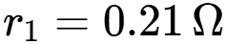/km, 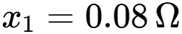/km, 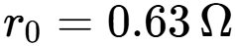/km, 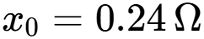/km, and nominal ampacity of 350 A
The MV feeder supplying LV1 operates at 11 kV over a length of 4.5 km, with identical positive- and zero-sequence line impedances. At the LV1 boundary, an 11/0.415-kV distribution transformer steps the voltage down to 415 V. The transformer model represents both its series leakage impedance and shunt excitation characteristics, including winding resistance and leakage reactance, as well as core loss through the core-loss resistance $R_{c}$and magnetization through the magnetizing reactance $X_{m}$. These correspond to the transformer’s no-load loss and magnetizing-current characteristics.

Consumer Units, Load Classes, and Weighting Structure
The network incorporates four distinct consumer classes with assigned class weights used as the foundation for allocation:

Load Class | Class Weight | Primary Load Types | Distribution
Residential | 1.0 | Microwave, induction plate, audio amplifier, residential fan, residential bulb | 60% of consumers
Commercial | 2.2 | Compressor, AC motor, UPS, industrial bulb, residential fan | 25% of consumers
Industrial | 3.5 | AC motor, industrial fan, DC motor inverter, industrial bulb | 10% of consumers
Agricultural | 1.5 | AC motor, compressor, industrial bulb, residential fan | 5% of consumers

Each consumer unit is registered with:
• A unique bus connection on the LV network
• An assigned load class determined either explicitly or probabilistically (60:25:10:5 split for residential:commercial:industrial:agricultural)
• Service line impedance calculated from the bus-to-line topology mapping: 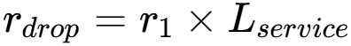 and 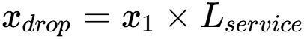
Each consumer unit receives 3–5 base load circuits selected randomly from the class-specific primary load types. For example, a residential consumer draws from {microwave, induction plate, audio amplifier, residential fan, residential bulb}, while industrial consumers draw from {AC motor, industrial fan, DC motor inverter, industrial bulb}. For unmetered consumers, 0–2 extra load circuits are assigned with probability distribution [0.35, 0.45, 0.20] for [0, 1, 2] extra loads respectively. The weight contribution from extra loads is computed as:
where the rated power is obtained from the equipment model for each load type. This 5% scaling factor introduces a heterogeneous weighting component across the unmetered population, biasing allocation toward consumers with larger auxiliary equipment.

Metered Sample Selection and Bias for Below-Mean Consumers
The critical bias toward below-mean consumption consumers is embedded in the percentile mapping process of the Time-Adjusted CLA estimator, which operates on the metered group's observed energy distribution:
1. Metered Consumer Energy Distribution: For each load class , the set of metered consumers in that class produces an observed energy distribution over the 5-minute steady-state measurement window.
2. Unmetered Consumer Percentile Ranking: Each unmetered consumer is ranked within their assigned load class by their assigned weight 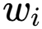. This rank is converted to a percentile 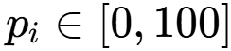 within the unmetered population of that class:
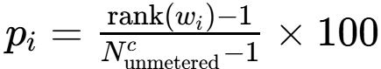
where  is the number of unmetered consumers in class . For single unmetered units in a class, 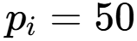 (median).
3. Cross-Mapping to Metered Energy Percentiles: The percentile 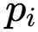 is mapped directly to the metered consumers' observed energy distribution for the same class, yielding a proxy consumption 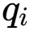:
4. Bias Coefficient via Exponent: A power-law adjustment with exponent $β$is applied to the percentile-mapped proxy consumption
$$s_{i}=w_{i}q_{i}^{β}, W_{i}=\frac{w_{i}q_{i}^{β}}{\sum_{j∈U}{w_{j}}q_{j}^{β}},$$
where $q_{i}$is the metered-consumption quantile mapped to unmetered consumer $i$, $w_{i}$is the assigned baseline weight, and $0<β<1$controls the degree of compression.
Because $β<1$, the transformation $q_{i}^{β}$reduces the relative separation between low- and high-consumption proxies. Consequently, consumers mapped to higher consumption percentiles receive a smaller relative share of the estimated unsampled energy pool than under a linear mapping, while lower-consumption consumers receive a comparatively larger share. For example, with $β=0.2$, proxy consumptions of 10 kWh and 2 kWh become
$${10}^{0.2}≈1.585, 2^{0.2}≈1.149.$$
Although the original consumption ratio is $10/2=5$, the transformed ratio is
$$\frac{1.585}{1.149}≈1.38.$$
Thus, the exponent acts as a concentration-control parameter, moderating the dominance of high-consumption proxies in the allocation of the unsampled energy pool while preserving their relative ordering.
- L1 Normalization Over Unmetered Population: The adjusted scores are L1-normalized to produce final allocation weights:
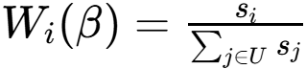

Energy Pool and Allocation Computation
Feeder Energy Balance Formulation:
The unmetered energy pool is derived from the fundamental balance equation:
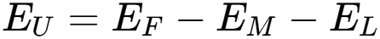
where:
• 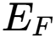: Total feeder supply energy (queried from the OpenDSS utility source over the 5-minute interval)
• 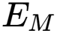: Measured (metered) consumer energy, computed by summing instantaneous load power over all metered units and integrating• 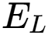: Technical loss energy, comprising transformer losses and line losses
Technical Loss Calculation:
Transformer Losses: Extracted directly from the OpenDSS transformer element via the Losses() API:
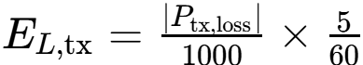
Feeder Line Losses: Computed from the MV feeder line element:
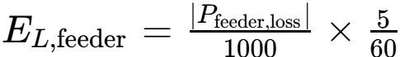
Consumer Service Line Losses: For each consumer unit connected at bus , the service drop loss is calculated using OpenDSS bus voltage magnitudes and load currents:
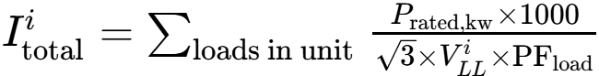
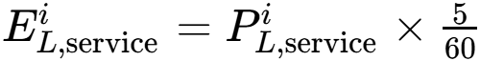
The total technical loss is:
The Time-Adjusted CLA methodology achieves allocation reduction bias toward below-mean consumers through two mechanisms:
1. Percentile Mapping: Unmetered consumers with lower assigned weights map to lower percentiles of the metered energy distribution, capturing genuinely lower consumption patterns observed in the sparse meter data.
2. Power-Law Suppression (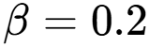): The exponent 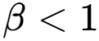 compresses high energy values more aggressively than low values.
This design ensures that the unmetered energy pool 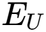 is preferentially allocated to consumers whose weight-based class profiles and observed metered behavior together indicate lower consumption, thereby reducing estimation error for the large population of below-mean consumers that dominate sparsely metered networks.

Transformer Transient-Assisted CLA Error Correction
After the first section allocates energy to unmetered consumers using the Time-Adjusted CLA method, residual estimation error may remain due to non-technical losses and other unobserved demand. This second section examines whether sudden electrical events, such as equipment switching, can provide additional information at the transformer to reduce this residual error.
The key insight is that network events produce transient changes in voltage and current at the transformer terminal. These high-frequency signatures propagate through the network and may remain observable even when the originating consumer is not directly metered. The research therefore asks: to what extent can switching events be detected from transformer-terminal measurements in the presence of faults and simultaneous co-occurring events?
The methodology uses a two-stage simulation because no single tool captures both the feeder operating state and the detailed electromagnetic transients required for event analysis. OpenDSS first solves the complete distribution network and establishes the pre-event operating condition. The relevant test branch is then selected, and the network is reduced around the target transformer to a reduced-order equivalent. This reduced model is subsequently transferred to ATP-EMTP, where the switching, fault, and simultaneous-event transients are simulated at electromagnetic-transient resolution.
Before any transient event is tested, the network is reduced to Thévenin equivalents at the two sides of the target transformer:
- Upstream (HV) side: represents the network looking back toward the utility source, including its source strength and impedance as seen from the transformer primary.
- Downstream (LV) side: represents the network looking forward into the low-voltage feeder, including the connected consumer loads and lines as seen from the transformer secondary.
The purpose is to replace the portions of the OpenDSS network that are not explicitly simulated in ATP-EMTP with equivalent voltage and impedance characteristics while preserving their electrical influence at the transformer terminals.
Extraction procedure: The pre-event bus voltages are obtained from the solved OpenDSS operating state. OpenDSS is then placed in FaultStudy mode to compute the multiphase short-circuit impedance matrix $Z_{sc}$at each bus. This matrix represents the Thévenin impedance seen at the bus and captures the network's electrical stiffness, including the resistance and reactance presented by the connected network. OpenDSS computes the corresponding open-circuit voltage and $Z_{sc}$using its network admittance model.
Thus, for a selected transformer terminal,
$$\boxed{V_{th}=V_{oc}, Z_{th}=Z_{sc}}$$
where $V_{oc}$is the open-circuit voltage vector and $Z_{sc}$is the multiphase short-circuit impedance matrix. OpenDSS exposes this matrix directly through ZscMatrix (and sequence-domain quantities such as Zsc1 and Zsc0).
The fault-study $Z_{sc}$is a network short-circuit/Thévenin equivalent. OpenDSS forms it from the system $Y$-matrix, with loads represented as admittances during the fault-study calculation.

BCTRAN Transformer Model Generation
The transformer is the central device in the transient model. Rather than representing it as a simple lumped impedance, the research uses BCTRAN, ATP-EMTP's transformer matrix model, to represent the coupled behaviour of the three phases and windings. BCTRAN is generated from transformer factory-test data, including rated voltages and power, winding connections, excitation data, winding losses, and short-circuit impedance.

ATP-EMTP Simulation
ATP-EMTP assembles the reduced transient circuit as:
$$\left[\text{Utility Grid}\right]→\left[\text{HV Th}\overset{ˊ}{\text{e}}\text{venin Equivalent}\right]→\left[\text{Transformer + BCTRAN Matrix}\right]→\left[\text{LV Th}\overset{ˊ}{\text{e}}\text{venin Equivalent}\right]→\left[\text{Test Branch/Event}\right]$$
The test branch is appended to the reduced LV network to represent the equipment switching condition, fault, or simultaneous co-event under investigation. ATP-EMTP then solves the resulting electromagnetic transient differential-algebraic system at a fixed time step of 0.1 ms (100 $μ$s).
The simulation records three-phase voltage and current waveforms at the transformer terminals, capturing:
- the transient voltage oscillations produced by the event;
- current surges, decay, and settling behaviour; and
- phase-specific responses in phases A, B, and C.
Each case is simulated for 2 s, provide
ng sufficient time to capture both the initial transient and the subsequent settling behaviour.

Transformer Transient Response Extraction Under Varying Conditions
Three datasets evaluate transient observability under different scenarios:

Dataset 2: 108 Unique Co-Events at Nominal Conditions
What's a co-event? It's two electrical events happening at the transformer secondary simultaneously or in close sequence. The research generates:
• 28 Load-Load pairs: Two different appliances switching on at the same time (e.g., AC motor + microwave)
• 80 Load-Fault pairs: An appliance switching on while a fault occurs on the line (e.g., AC motor + single-line-to-ground fault)
Total: 108 unique co-events.
Why co-events? In reality, multiple things happen at once on a distribution network. By testing pairs, the research asks: "Can we distinguish two simultaneous events from the transformer's perspective?" If we observe strange voltage/current patterns at the transformer, can we separate them back to their original causes?
Fault configurations tested:
• LG (Line-to-Ground) faults on phases A, B, C separately (3 configurations)
• LL (Line-to-Line) faults on phases AB, BC, CA separately (3 configurations)
• LLG (Line-to-Line-to-Ground) on phases AB/ground, BC/ground, CA/ground (3 configurations)
• LLL (Three-phase) fault (1 configuration)
Total: 10 fault configurations × 8 equipment types = 80 load-fault pairs.
Duration: Appliances run for 0.5–1.5 seconds (depending on type), starting at 20 ms into the simulation. Faults last 0.5 seconds.

Dataset 3: Time-Shift Variation Testing
Same 108 co-events, but with varying time offsets between the two events. Instead of both events starting at the same moment:
• Event 1 starts at time = 20 ms
• Event 2 starts at time = 20 + offset ms, where offset ranges from 5 ms to 50 ms
Why this matters: In the field, events don't happen in perfect synchrony. This test reveals: "If event 2 happens slightly after event 1, can we still tell them apart?"
The offset is varied across the 108 pairs to sample the sensitivity landscape.

Dataset 4: Transformer Specification Variation Testing
Same 108 co-events at nominal conditions, but using different transformer models. The three transformers tested have different:
• Physical sizes and core designs
• Impedance levels (how much they resist transient currents)
• Frequency response (how they behave at different timescales)
Why this matters: Real-world transformers come in many specifications. This test shows: "Does the observability of events depend on which transformer is installed?" This guides practitioners on whether to invest in better transformers for state estimation.

Signal Processing: From Transient Waveforms to Observability Metrics
Once ATP-EMTP generates the transient waveforms, they undergo careful processing:

Fundamental-Frequency Band-Pass Filtering
Raw waveforms contain the grid fundamental component and its harmonic content. In the preprocessing stage, a fourth-order Butterworth band-pass filter is applied to isolate the 50 Hz fundamental component rather than using a high-pass filter.
- Center frequency: $50\text{ Hz}$
- Passband: $45\text{–}55\text{ Hz}$, corresponding to a $10\text{ Hz}$bandwidth
- Filter order: 4
- Sampling rate: $10\text{ kHz}$, corresponding to a sampling interval of $0.1\text{ ms}$
- Implementation: Butterworth filter in second-order-sections (SOS) form with zero-phase filtering using sosfiltfilt
The normalized passband is defined by
$$f_{L}=50-\frac{10}{2}=45\text{ Hz}, f_{H}=50+\frac{10}{2}=55\text{ Hz}.$$
Thus, the filter retains the dominant 50 Hz fundamental component while attenuating DC and lower-frequency components below $45\text{ Hz}$, as well as higher-frequency harmonics above $55\text{ Hz}$.
This filtering stage therefore does not isolate transient signatures directly. Rather, it extracts the fundamental-frequency component from the waveform. Any subsequent transient analysis must operate on an appropriately derived residual or on a separate high-pass/band-pass representation designed specifically to retain the transient frequency range.

Residual vs. Composed Waveform Analysis
For each co-event, three versions of the voltage and current waveforms are recorded:
• Single Event 1 waveform: Voltage/current response if only event 1 occurred in isolation
• Single Event 2 waveform: Voltage/current response if only event 2 occurred in isolation
• Joint (Composed) waveform: Voltage/current when both events occur together
• Composed voltage/current: 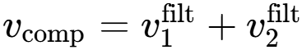 (superposition of single-event waveforms)
Residual magnitudes directly quantify the observability of co-events; discounted correlations account for noise floor via:
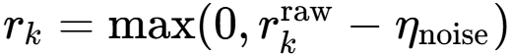
If the network behaves linearly (which it mostly does for small transients), the composed waveform should equal event 1 + event 2. However, in reality, there are deviations due to:
• Transformer saturation (nonlinearity when magnetic flux is high)
• Interaction effects between the two events
• Measurement noise and digitization artifacts
The residual is defined as:
• Magnitude: 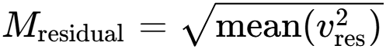 (root-mean-square scalar magnitude)A large residual means the two events interact in complex ways—they're distinguishable. A small residual means they're hard to separate.

Pearson Correlation Coefficient
For each pair of phases (e.g., phase A of event 1 vs. phase A of event 2), the algorithm computes the Pearson correlation between the filtered single-event waveforms:
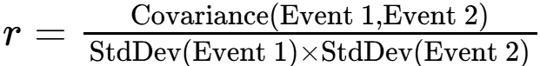
• 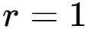 means the waveforms are identical (events are identical, hard to distinguish)
• 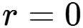 means uncorrelated (events are very different, easy to distinguish)
• 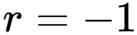 means opposite waveforms (opposite but equally distinguishable)
The correlation is computed for all 6 waveform pairs (3 phases × 2 types: voltage and current), then averaged.

Magnitude Ratio Penalty
Raw correlation values are adjusted by a penalty factor that accounts for:
• Noise floor: The simulation assumes ambient noise at SNR = 35 dB, which is typical for real sensor measurements. This noise amplitude is:
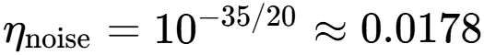
• Residual magnitude: How much the composed waveform deviates from linear superposition
This penalty is subtracted from the raw correlation:

Deriving the Error Reduction Factor
Aggregate results across all 108 co-events in each dataset.
For each dataset, compute:
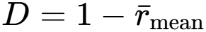
where 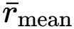 is the average adjusted correlation across all 108 pairs.
•  near 0 = events are very distinguishable (mean correlation is high)
• near 1 = events are very similar (mean correlation is low)
This dissimilarity metric from Dataset 2 (baseline), Dataset 3 (time shift), and Dataset 4 (transformer variations) are averaged to obtain an overall Overall Mean Dissimilarity:
$$D_{overall}=\frac{D_{2}+D_{3}+D_{4}}{3},$$The Transient-Assisted CLA Error Reduction Factor (TAC-ERF) is defined from the measured change in aggregate error:
$$TAC\text{-}ERF=1-\frac{E_{after}}{E_{before}},$$
where $E_{before }$is the aggregate error of the CLA method before transient-assisted correction and $E_{after}$is the aggregate error after incorporating transient information, the aggregate CLA error is defined as
$$E_{CLA}=\frac{∣\sum_{i∈U}{{\hat{E}}_{i}}-\sum_{i∈U}{E_{i}^{GT}}∣}{\sum_{i∈U}{E_{i}^{GT}}}×100\%,$$
where $U$denotes the evaluated consumer population, ${\hat{E}}_{i}$is the estimated energy for consumer $i$, and $E_{i}^{GT}$is the corresponding ground-truth energy.
The transient dissimilarity index is subsequently used to parameterize or predict the expected error reduction through an empirically calibrated relationship.

Limitations: The proposed validation establishes the extent to which transient measurements at the transformer boundary can improve discrimination between simulated co-events and support correction of CLA estimates under the modeled operating conditions. The results should therefore be interpreted as evidence of feasibility within the defined simulation, network, event, transformer, and measurement assumptions. They do not by themselves establish field-level performance or universal identifiability of downstream parameters. In particular, practical performance will depend on measurement noise, sensor bandwidth and calibration, synchronization error, transformer frequency response, unmodeled feeder dynamics, variations in consumer loading, and the degree to which different downstream states produce distinguishable transient signatures at the transformer boundary. Experimental validation on physical LV networks is consequently required before generalizing the proposed transient-assisted error reduction relationship beyond the simulated environment.

CHAPTER FOUR

RESULTS AND DISCUSSION

Statistical Validation and Cluster Load Allocation Error
Dataset 1 was used to evaluate the accuracy of Cluster Load Allocation (CLA) for the unmetered consumer population by comparing the baseline CLA estimator with the time-adjusted CLA estimator. The analysis was performed at both the aggregate population level and the individual consumer-unit level. The aggregate error is 7.77% which is the total error from non technical losses, an MAE of 0.9179 kWh, a MAPE of 61.10%, and an MSE of 1.5500 kWh(^2) are allocation errors for the baseline cla. With the default time-adjusted CLA configuration, using (\beta=0.2), the aggregate error remained 7.77%, while the MAE decreased to 0.8232 kWh and the MAPE decreased to 50.17%. Relative to the baseline, this corresponds to reductions of approximately 10.32% in MAE and 17.89% in MAPE. However, the MSE increased from 1.5500 to 1.6047 kWh(^2), an increase of approximately 3.53%.
The unchanged aggregate error together with the reduction in MAE and MAPE indicates that the initial time adjustment primarily modifies the distribution of the allocated energy among individual consumers, rather than changing the aggregate energy discrepancy.

Optimization of the Time-Adjustment Exponent
The influence of the time-adjustment exponent $β$ was evaluated by optimizing it directly on the 13-unit unmetered population in Dataset 1. The exponent controls how strongly the time-adjustment term modifies the base CLA allocation. For each candidate value $β$, the estimator first determines the base CLA weight $w_{i}$for each unmetered consumer and maps the consumer's percentile within its load class to a corresponding metered-energy value $q_{i}$. The time-adjusted score is then computed as
$$s_{i}\left(β\right)=w_{i}q_{i}^{β}.$$
Thus, $β$determines the strength of the consumption-based adjustment applied to the base CLA weight. When $β=0$, the adjustment is neutral because $q_{i}^{0}=1$, so the allocation reduces to the base CLA weighting. As $β$increases, differences in the mapped metered-energy values ${q }_{i}$increasingly influence the relative allocation.
Consequently, the optimization of $β$affects only the distribution of the energy pool among unmetered consumers, while the total pool itself remains fixed.
The optimal exponent was obtained by solving
$$β^{*}= \frac{1}{∣U∣}\sum_{i∈U}{∣E_{i}^{GT}-{\hat{E}}_{i}\left(β\right)∣},$$
using bounded scalar minimization over $0≤β≤1$.
The optimization produced
$$\boxed{β^{*}=0.3962}$$for the $∣U∣=13$unmetered consumer population. This indicates that, for Dataset 1, the MAE-minimizing allocation required the consumption-based adjustment to exert a stronger influence than the estimator's default value of $β=0.2$. In particular, the optimized value increases the sensitivity of the allocation weights to the mapped metered-energy term $q_{i}$, while remaining sublinear because $0<β^{*}<1$.
At $β^{*}=0.3962$, the MAE decreased further to 0.7890 kWh, while MAPE decreased to 38.93%. Compared with the default time-adjusted configuration, this represents a further 4.15% reduction in MAE and a 22.40% reduction in MAPE. Relative to the original baseline CLA, the optimized estimator reduces MAE by approximately 14.04% and MAPE by approximately 36.28%.
The MSE at the optimized exponent was 1.6488 kWh${}^{2}$. Therefore, although the optimized exponent provides the lowest MAE and MAPE among the three configurations, it produces a higher MSE than both the baseline (1.5500 kWh${}^{2}$) and the default time-adjusted estimator (1.6047 kWh${}^{2}$). This shows that the optimization objective specifically favors reducing the average absolute allocation error rather than minimizing squared error. In other words, increasing $β$to $0.3962$improves typical allocation accuracy but does not necessarily eliminate the influence of a small number of larger deviations.
Overall, Dataset 1 demonstrates a two-stage improvement in CLA estimation. The default time-adjustment mechanism reduces individual allocation error without materially changing the aggregate error, while calibration of the exponent from $β=$0.2 to $β$* = 0.3962 produces a further reduction in MAE and MAPE. The results therefore support the use of metered-group temporal information to refine the allocation of energy among unmetered consumers. The remaining aggregate error of 7.77%, together with the persistence of larger individual deviations reflected in the MSE, provides the residual error that motivates the subsequent transient-assisted error-correction stage.

Event Pair Observability in Dataset 2
Dataset 2 was used to evaluate the observability of paired transient events at the transformer boundary. The analysis considers both load-switch/load-switch pairs ((load_load)) and mixed load-switch/fault pairs ((load_fault)). For each event pair, the three-phase co-event response is compared with the corresponding single-event responses through phase-specific voltage and current waveform correlations. The purpose is to determine whether the transient response observed at the transformer boundary contains a measurable signature of the underlying event pair.
For each of the six phase-specific waveform channels, the Pearson correlation coefficient is defined as
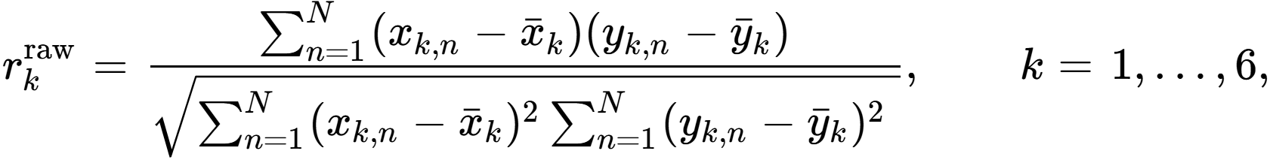
where (x_{k,n}) and (y_{k,n}) represent the corresponding single-event and residual/composed waveform samples. Because the objective is to evaluate observability under realistic measurement conditions, the raw correlation is discounted according to the assumed noise level and the relative magnitude of the residual waveform.
At an assumed signal-to-noise ratio of (35,\mathrm{dB}), the noise-amplitude ratio is
The analysis additionally obtained a residual-to-composed waveform magnitude ratio of
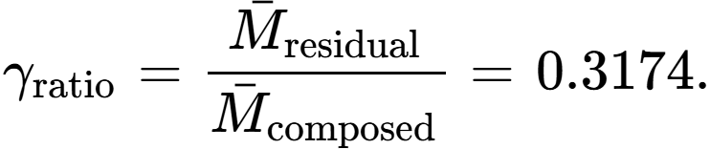
Thus, the total correlation discount used in the analysis is
The discounted correlation is therefore
The magnitude ratio is the dominant component of the discount, contributing approximately (94.7%) of the total discount, whereas the assumed measurement-noise contribution is approximately (5.3%). Consequently, the reduction in correlation is driven primarily by the magnitude of the transient residual relative to the composed event response rather than by the assumed ambient noise level.
The resulting phase-specific correlation vector was
The reported mean correlation was
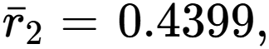
with a reported standard deviation of
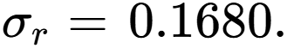
The mean correlation indicates a moderate correspondence between the evaluated event-response waveforms after the specified noise and residual-magnitude discount. Importantly, the correlation is not uniform across the six waveform channels. The largest correlations are (0.6648), occurring in the fourth and sixth channels, whereas the smallest correlations are (0.2645), occurring in the second and fifth channels. The difference between the maximum and minimum correlation is therefore
showing that the transient signature is substantially more observable in some phase-specific voltage/current channels than in others.
Dataset 2 produces a transient dissimilarity of 0.5601. This value represents the portion of the normalized correlation scale not explained by the measured waveform similarity after the prescribed discounting procedure. Within the proposed methodology, this dissimilarity is retained as the Dataset 2 contribution to the subsequent transient-assisted CLA error-correction analysis.
The numerical results therefore show three important characteristics of the transformer transient response. First, the paired events produce a measurable relationship with their corresponding event signatures, as indicated by the mean correlation of (0.4399). Second, this relationship varies substantially between waveform channels, with correlations ranging from (0.2645) to (0.6648). Third, the residual response has a substantial relative magnitude ((31.74%) of the composed response), meaning that event pairing produces a detectable deviation rather than an insignificant perturbation.

Time-Shift Operation Variation in Dataset 3
Dataset 3 evaluates how a nonzero temporal displacement between two transient events changes the observability of their combined transformer-boundary response. The waveform-correlation analysis provides a complementary measure of how temporal separation changes the similarity of the observed transformer-boundary response. For the six phase-specific voltage and current channels, the Dataset 3 per-channel discounted correlation vector is 0.1346, 0.0420, 0.1335, 0.4845, 0.0420, and 0.4845.
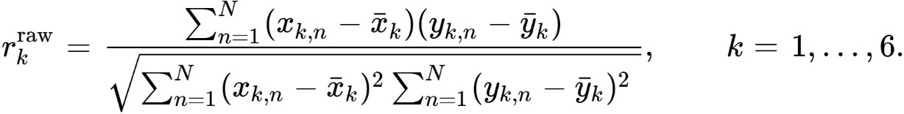

The resulting mean correlation is 0.2202 with a standard deviation of 0.1907. The residual-to-composed waveform magnitude ratio is 0.4977 and the corresponding total discount factor is 0.5155 under the prescribed 35 dB signal-to-noise assumption. Dataset 2, by comparison, has a mean correlation of 0.4399 and a standard deviation of 0.1680, with a residual-to-composed magnitude ratio of 0.3174 and a total discount factor of 0.3352. The Dataset 3 mean correlation is therefore lower by 0.2197, corresponding to an approximately 49.94% reduction relative to Dataset 2. The associated dissimilarity increases from 0.5601 in Dataset 2 to 0.7798 in Dataset 3, an absolute increase of 0.2197 or approximately 39.23% relative to the Dataset 2 dissimilarity. The residual-to-composed ratio also increases by 0.1803, equivalent to approximately 56.81% relative to the Dataset 2 value. These changes indicate that temporal separation produces a substantially less similar and more residual-dominated boundary response than the simultaneous-event configuration.
The channel-level behaviour further demonstrates that the influence of temporal separation is not uniform across the six measurement channels. The highest Dataset 3 correlations are 0.4845 in the fourth and sixth channels, while the lowest are 0.0420 in the second and fifth channels. The resulting channel range is 0.4425, compared with the Dataset 2 range of 0.4003. The standard deviation likewise rises from 0.1680 in Dataset 2 to 0.1907 in Dataset 3, an increase of 0.0227 or approximately 13.51%. The larger dispersion indicates that temporal displacement changes the relative observability of individual phase-specific voltage and current components rather than producing a uniform degradation across all channels. This supports the use of channel-aware transient features in the proposed state-estimation framework instead of relying only on a single aggregated waveform measure.

Unlike Dataset 2, Dataset 3 does not contain simultaneous-event cases with zero time offset; the executed analysis contains 108 time-shifted cases and no simultaneous cases. Consequently, Dataset 2 provides the appropriate simultaneous-event reference for comparison. Dataset 2 uses zero time offset and reports mean residual magnitudes of 11.218888 V for voltage and 8.288529 A for current, whereas Dataset 3, with the events temporally displaced, reports mean residual magnitudes of 16.751304 V and 10.331699 A. The corresponding absolute increases are therefore 5.532416 V and 2.043170 A, representing increases of approximately 49.31% and 24.65% relative to the Dataset 2 simultaneous-event reference. The evidence shows that temporal separation produces an additional non-additive residual response relative to the simultaneous-event behaviour established in Dataset 2. The larger residual, lower mean correlation, greater dissimilarity, and increased channel dispersion together indicate that event timing is a material component of the observable transformer-boundary transient signature and should therefore be explicitly represented in transient detection, event identification, and subsequent CLA assistance.

Transformer Specification Effect in Dataset 4
Dataset 4 evaluates the effect of transformer specification on the observability of paired transient events at the transformer boundary. Unlike Dataset 2, which uses a fixed transformer specification, Dataset 4 varies the physical transformer specification while maintaining the event-observation framework. The dataset therefore examines whether changes in transformer characteristics modify the voltage and current transient signatures associated with load-switch and mixed load-fault events. The observed quantities include three-phase co-event waveforms, phase-specific event responses, residual waveforms, and scalar residual magnitudes.
For each of the six phase-specific waveform channels, the Pearson correlation coefficient is calculated as
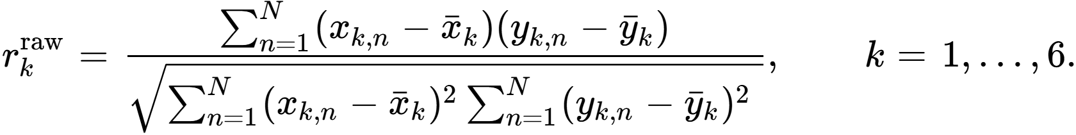
The correlation is subsequently discounted to account for the assumed waveform noise and the relative magnitude of the residual response. The Dataset 4 residual-to-composed magnitude ratio was
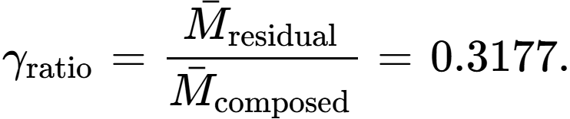
The total discount factor is therefore
The discounted correlation is consequently
The residual-magnitude component accounts for
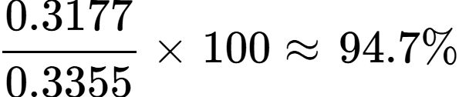
of the total discount, while the assumed noise contribution accounts for approximately (5.3%). Hence, the principal attenuation of the waveform correlation is associated with the residual-to-composed magnitude relationship rather than the assumed measurement-noise term.
The six-channel correlation vector obtained for Dataset 4 is
The mean of these six channel correlations is
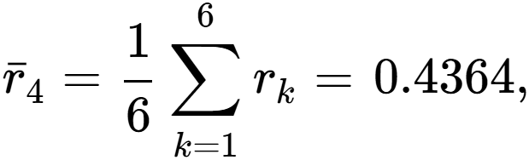
with a reported standard deviation of
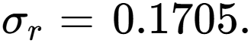
The corresponding mean dissimilarity is
The correlation vector exhibits the same general channel structure observed in the event-pair analysis. The maximum correlations occur in channels 4 and 6,
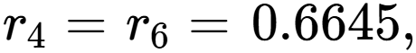
while channels 2 and 5 have the lowest values,
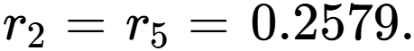
The channel range is therefore
Thus, the information conveyed by the transformer transient response remains phase/channel dependent. Some voltage/current components retain a substantially stronger relationship with the corresponding event response than others.
The reported standard deviation of (0.1705) indicates moderate dispersion across the waveform correlations. Compared with Dataset 2, where the mean correlation was (0.4399) and standard deviation (0.1680), Dataset 4 gives a slightly lower mean correlation and slightly greater dispersion. The change in mean correlation is
corresponding to only about a (0.8%) decrease relative to the Dataset 2 mean. The dissimilarity correspondingly changes from (0.5601) in Dataset 2 to (0.5636) in Dataset 4.
This indicates that transformer-specification variation does not fundamentally alter the overall correlation level of the six-channel response in the reported aggregate result. Instead, the principal effect is reflected more clearly in the magnitude of the residual transient response.

Effect on Residual Voltage and Current Response
Dataset 4 contains

transformer-specification observations. The mean residual magnitudes were
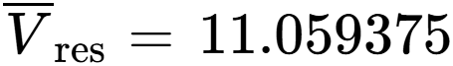
and
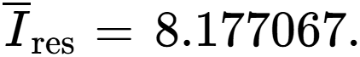
Hence, relative to the corresponding composed waveform, the average residual magnitude is approximately (31.77%), as reflected by
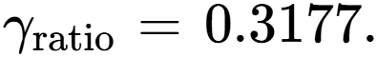
The nonzero residual voltage and current indicate that variations in transformer specification alter the boundary waveform sufficiently to produce a measurable deviation from the composed event response. In physical terms, transformer parameters influence the transfer of transient disturbances from the downstream event to the measurement boundary. Changes in transformer impedance and associated electrical characteristics therefore modify the amplitude and waveform shape observed at the transformer terminal.
The voltage and current residuals can be regarded as two complementary observability channels:
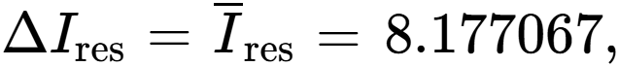
because the reported output provides the mean residual magnitudes directly rather than a separate zero-residual reference population. The two quantities demonstrate that transformer-specification variation is reflected in both voltage and current measurements rather than being confined to one measurement domain.

Transient-Assisted CLA Error Reduction Factor
The results indicate that the transient response observed at the transformer boundary contains information about downstream events that is not represented adequately by the fundamental-frequency component alone. The co-event residual is defined as the difference between the directly simulated simultaneous-event response and the response obtained by composing the corresponding individual-event responses. Thus, for a measured quantity (x),
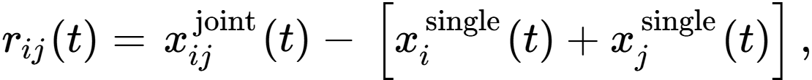
with the corresponding residual magnitude or energy evaluated over the observation interval. This residual represents the non-additive response produced by the transformer and downstream network under simultaneous excitation and should not be interpreted as a wavelet-reconstruction error. The distinction is important because the wavelet reconstruction residual is representation-dependent, whereas the co-event residual is produced by the physical response of the system.

Residual behaviour across Datasets 2–4
Datasets 2–4 establish that the magnitude of the co-event residual changes systematically when the event arrangement, temporal alignment, and transformer representation are changed. In Dataset 2, representing event-pair observability, the mean residual magnitudes were (11.2189) for voltage and (8.2885) for current. Dataset 4, which varies the transformer specification while retaining the fixed time alignment, produced comparable values of (11.0594) and (8.1771), respectively. Dataset 3 produced the largest residual response under time displacement, with mean voltage and current residual magnitudes of (16.7513) and (10.3317). The simultaneous-event cases in Dataset 3, by construction, produced zero residual before time displacement. These results demonstrate that the transient residual is sensitive to both event interaction and the relative temporal/physical conditions under which the events are observed.

Dataset | Experimental variation | Mean voltage residual | Mean current residual
Dataset 2 | Event-pair observability | 11.2189 | 8.2885
Dataset 3 | Time-shift operation | 16.7513 | 10.3317
Dataset 4 | Transformer specification | 11.0594 | 8.1771

The corresponding mean waveform correlations were (0.4399), (0.2202), and (0.4364) for Datasets 2, 3, and 4, respectively. The lower correlation obtained under time shifting is consistent with the larger residual observed in Dataset 3 and shows that event timing is an important source of transient-response differentiation. These results support the use of transient information as an additional observation channel for CLA rather than treating the transformer-boundary waveform as an invariant representation of downstream load behaviour.

Exponential growth of the fundamental-component residual
To determine whether the non-additive response increases systematically with event density, simultaneous co-events were generated for
$$K=2,…,25.$$For each $K$, the individual event responses were first obtained separately and then composed to form the corresponding linear-superposition reference. The composed response was compared with the directly simulated joint $K$-event response, and the residual energy was evaluated using the definition above.
The resulting empirical relationships are represented by quadratic functions. For the voltage response,
$$\boxed{E_{res,V}\left(K\right)=0.004843K^{2}-0.004813K+0.002399}$$
and for the current response,
$$\boxed{E_{res,I}\left(K\right)=0.022047K^{2}-0.022038K+0.014454.}$$The fitted curves reproduce the simulated points with $R^{2}=1.0000$over the evaluated range. This exact fit should, however, be interpreted as a property of the current synthetic realization and fitting procedure rather than as evidence that the quadratic relationship is a universal physical law. Independent operating conditions and held-out co-event combinations are required to establish the validity and uncertainty of the proposed scaling law.
The quadratic expressions can be rewritten in a more physically informative pair-interaction form:
$$\boxed{E_{res,V}\left(K\right)=0.002399+0.000030K+0.004843K\left(K-1\right)}$$
and
$$\boxed{E_{res,I}\left(K\right)=0.014454+0.000009K+0.022047K\left(K-1\right).}$$This representation is significant because
$$\frac{K\left(K-1\right)}{2}$$
is the number of distinct event pairs in a $K$-event configuration. The empirical residual therefore has the structure expected when the dominant contribution arises from pairwise interaction among simultaneous events rather than from an independent fixed contribution from each event. Further analysis of the fundamental-component residual power magnitude shows that this growth is better represented by an exponential relationship than by the previously used quadratic approximation. The fundamental residual can therefore be represented phenomenologically as
where (K) denotes the number of simultaneous co-events, (P_{0,f}) is the initial residual-power scale, (\alpha_f) describes the rate of growth with increasing co-event density, and (P_{b,f}) represents the residual baseline.
The significance of this result is that additional simultaneous events do not merely add a fixed amount of distinguishable information to the transformer-boundary fundamental response. Instead, the residual magnitude increasingly separates from the simple superposition reference as the number of interacting events increases. The exponential form is consequently interpreted as an empirical description of increasing co-event complexity rather than as a universal physical law. Independent operating conditions and held-out co-event combinations remain necessary to establish the stability of the fitted exponential parameters.
The exponential behaviour also changes the interpretation of residual growth. A quadratic law is naturally associated with pair-count scaling, whereas an exponential trend indicates that the observable residual may evolve through repeated interaction among event-dependent states, transformer operating conditions, and downstream network dynamics. The residual should therefore be regarded as a response of a state-dependent electromagnetic system rather than simply as a sum of isolated pairwise corrections. This is consistent with the earlier observation that the transformer and downstream feeder should be treated as a dynamic transfer system in which loading, frequency-dependent behaviour, magnetisation, and feeder coupling modify the observed waveform.

Limitation of the fundamental component
Despite its increasing residual magnitude, the fundamental component does not preserve the complete transient waveform. The current analysis indicates that approximately 60% of the waveform is recognizable through the fundamental-dominated channel. Thus, the fundamental component provides a substantial but incomplete representation of the information required for transient-assisted CLA.
This observation is important for the definition of an error-reduction factor. The approximately (60%) recognizable fraction should not be interpreted as a (60%) reduction in CLA estimation error. It represents an observability fraction for one signal component. A waveform may remain partially recognizable without providing an equivalent reduction in the error of the latent consumer-energy allocation. Therefore,
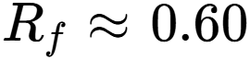
should be interpreted as a fundamental-channel recognition fraction, not as the transient-assisted CLA error-reduction factor itself.
This distinction is consistent with the earlier formulation that waveform dissimilarity measures transient differentiation but does not by itself demonstrate that an equivalent percentage of CLA estimation error can be removed.

Information retained in harmonics and the slowly varying/DC component
The approximately (60%) fundamental-channel observability led to a second-stage decomposition of the waveform into physically interpretable components: the fundamental component, harmonic bands, localized transient, oscillatory transient, and slowly varying/DC component. The decomposition shows that information excluded from the fundamental channel is not necessarily lost from the transformer-boundary measurement.
In particular, the harmonic component (H(t)) and the slowly varying component (S(t)) provide persistent information about the underlying load condition. The two-channel representation is defined as
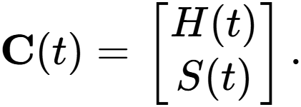
For two co-events containing a common base load but different secondary event equipment, the harmonic and slowly varying channels remain highly correlated. In the shared-base experiment, the harmonic-channel correlation was
while the slowly varying component gave
With equal weighting of the two channels,
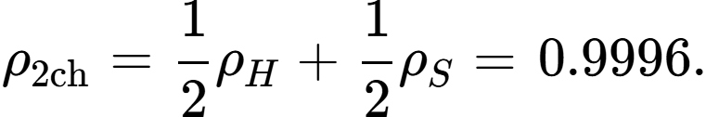
The result is significant because the two co-events were deliberately constructed with different event-specific transient components while sharing the same base equipment. The high correlation therefore indicates that the harmonic and slowly varying channels retain a stable component associated with the common underlying load. The transient signature is consequently not restricted to the visually dominant switching or oscillatory component.
The observation provides experimental support for separating the event-specific transient signature from the persistent base-load signature. A useful conceptual representation is
where (B(t)) denotes the base-load signature, (E(t)) represents the additional event contribution, (T(t)) represents localized and oscillatory transient behaviour, and (\epsilon(t)) contains measurement, numerical, and unmodelled effects. The second-stage result suggests that (B(t)) can survive changes in the secondary event through the harmonic and slowly varying channels, even when (T(t)) changes substantially. This finding changes the role assigned to the transient in CLA. The objective to reconstruct the entire waveform depends on the useful information consisting of a combination of transient differentiation and persistent load-dependent signatures. The transformer-boundary measurement therefore provides two complementary forms of information: transient features that distinguish co-events and spectral/slow-varying features that preserve information about a common underlying load.
This interpretation is also consistent with the earlier decomposition of the residual into nonlinear interaction, transformer loading effects, magnetisation behaviour, feeder coupling, and measurement or unmodelled terms. Those contributions should be interpreted as components of a state-dependent transfer function rather than as independently identifiable physical losses.

Formulation of the transient-assisted CLA reduction factor
The preceding results require the transient-assisted CLA reduction factor to be defined more carefully than a simple waveform-dissimilarity measure. Three levels of quantity should be distinguished.
First, the fundamental recognition fraction is
with the present analysis giving approximately
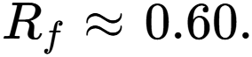
Second, the multi-component transient information is represented by the feature vector
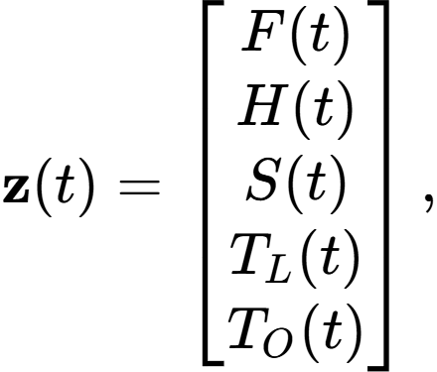
where (F(t)) is the fundamental component, (H(t)) the harmonic component, (S(t)) the slowly varying/DC component, (T_L(t)) the localized transient, and (T_O(t)) the oscillatory transient. The second-stage results show that (H(t)) and (S(t)) contain information that is not represented completely by (F(t)). Consequently, the total recoverable transient information cannot be approximated by (R_f) alone.
Third, the transient-assisted CLA error-reduction factor must be defined from the actual estimation error:
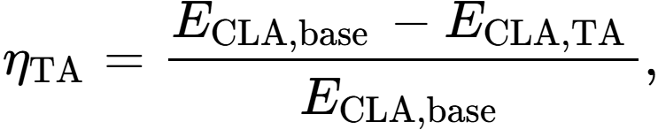
where (E_{\mathrm{CLA,base}}) is the aggregate CLA error without transient assistance and (E_{\mathrm{CLA,TA}}) is the aggregate error after the transient-assisted correction is applied.
This definition deliberately separates observability from estimation performance. The experimentally measured value of (\eta_{\mathrm{TA}}) can only be obtained by applying the proposed correction procedure to independent validation cases and measuring the resulting reduction in CLA error.

Resulting interpretation for CLA
The implication for the proposed CLA method is that transient assistance should operate through a multi-component representation of transformer-boundary measurements, rather than through the fundamental waveform alone. The transient channel contributes event-specific differentiation, while harmonic and slowly varying components contribute persistent information associated with the underlying load. The resulting estimator can therefore exploit both transient interaction information and cross-event-stable signatures to improve allocation of latent consumer energy.

CHAPTER FIVE
CONCLUSION AND RECOMMENDATIONS
The results demonstrate that transformer-boundary transient measurements contain information about downstream consumer events, but that this information is observed through an inherently aggregated and transformer-dependent measurement point. This aggregation can be substantial in practical distribution systems. The transformer observes the combined electrical response of all connected customers, the LV network, the transformer itself, and any disturbances occurring on the network.
An Australian distribution-system planning report describes approximately 50–200 customers being supplied from a distribution transformer through LV lines, while a Nigerian study reports that the number of end-users per distribution transformer can exceed 200 in the Nigerian context. NERC material also demonstrates that Nigerian distribution transformers operate under substantially different customer configurations; for example, its classification of high-voltage distribution systems identifies 25–100 kVA transformers with customer populations of approximately 1–10 for that particular configuration, illustrating that the number of connected customers is highly architecture-dependent.

What “Consumer Load Identification” Means under Downstream Network
Because the downstream feeder topology and line parameters are not fully observed, the transformer-boundary signal cannot by itself be treated as a direct physical locator of an individual consumer.
The estimator therefore produces two different identification levels:

Event-class identification
This is determined by the hybrid transient signature classifier.

Consumer allocation identification
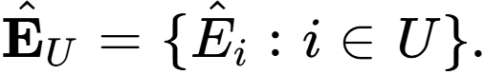
This is determined by the β-based CLA prior modified by transient evidence.
Consequently,
The transient observation provides evidence about which type of downstream activity occurred and when it occurred, while the CLA state estimator determines the corresponding probabilistic distribution of latent energy among candidate consumers.
This distinction prevents the method from claiming spatial localization that is not identifiable from the available measurements.

Consequently, a transformer measurement can be represented conceptually as an aggregate observation,
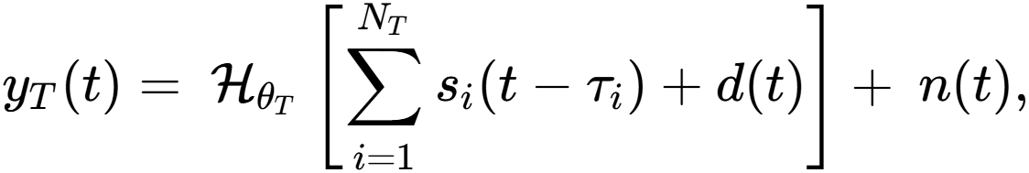
where (N_T) is the number of consumers connected to transformer (T), (s_i(t)) is the transient signature of consumer (i), (\tau_i) is its event time, (d(t)) represents other network disturbances such as faults or switching operations, (\mathcal{H}_{\theta_T}) is the electrical transfer characteristic of the transformer and connected network parameterized by (\theta_T), and (n(t)) represents measurement and environmental noise. As (N_T) increases, the probability that multiple consumers or network events contribute to the same measurement window also increases
This has an important consequence for signature extraction. If a consumer signature is extracted directly from transformer observations without accounting for other simultaneous or temporally adjacent events, the extracted signature may contain residual components that do not originate from the target consumer. A line fault, another customer switching a motor, transformer energization, capacitor switching, or another transient disturbance can appear in the same observation window. The extracted signature can therefore be expressed more realistically as
where (e_{\mathrm{other}}) represents unrelated consumer or network events, (e_{\mathrm{transformer}}) represents distortion introduced by the transformer/network transfer characteristics, and (e_{\mathrm{noise}}) represents measurement noise.
Dataset 4 demonstrates that the transformer itself is an additional source of variability. This indicates that the same underlying event cannot be assumed to generate an identical boundary signature when the transformer through which it is observed changes.
The implication is that consumer transient signatures should preferably be obtained using a reference transformer representative of the intended deployment transformer, rather than relying exclusively on signatures obtained from an unrelated laboratory transformer. Where the deployment transformer is already known, its rated capacity, winding configuration, impedance, frequency characteristics, and relevant network parameters should be incorporated into the signature-generation process. Alternatively, a test transformer can be selected to reproduce the electrical characteristics of the target deployment transformer.
This requirement can also be interpreted as a domain-shift problem. Let
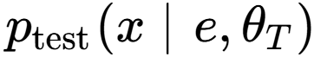
represent the distribution of observed signatures generated during testing for event (e) and transformer specification (\theta_T), and let
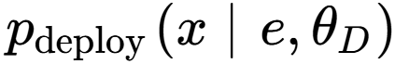
represent the corresponding deployment distribution. If
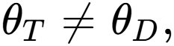
then, in general,
Consequently, a signature classifier or estimator calibrated on one transformer may exhibit systematic mismatch when transferred to another transformer, even when the underlying consumer event is unchanged.
This separation is particularly important because the proposed methodology uses transient residuals as additional information for CLA correction. A line fault mistakenly classified as a consumer signature could introduce a systematic bias into the inferred customer-level energy allocation. Conversely, suppressing genuine consumer transients as network disturbances would discard useful information.
The combined results therefore suggest that deployment should use a controlled signature-acquisition stage before applying transformer transient information to operational CLA estimation. The preferred arrangement is to characterize representative consumer units under a transformer specification matching the intended deployment environment, acquire signatures under controlled switching conditions, and subsequently validate those signatures against naturally occurring network disturbances. This creates a reference signature library conditioned on transformer and network characteristics rather than a transformer-independent library.

Noise-Robust Hybrid Time–Frequency Signature Detection and Transient-Assisted State Estimation and CLA Error Reduction

The transient-processing stage is to determine whether the synchronized transformer-boundary measurements contain statistically reproducible evidence of one or more downstream consumer events and, when that evidence is sufficiently reliable, use it to refine the allocation of the latent consumer-energy state. This is consistent with the observation that the transformer response is a noise-contaminated, transformer-conditioned signature whose information is distributed across time, frequency, phase, event timing, and operating condition.
The estimation problem is therefore formulated as a partially observable downstream state-estimation problem rather than conventional fully known-topology DSSE.
Let the synchronized transformer-boundary observation at time (t) be
Let the known upstream measurements and operating variables be collected in
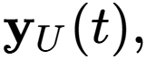
and let the latent downstream state be represented by
where
• (E_U(t)) is the total unsampled consumer-energy pool,
• (\mathcal A(t)) is the set of downstream event classes active in the observation window,
• (\Delta t(t)) contains event-relative timing information,
• (\mathbf W_U(t)={W_i(t):i\in U}) contains the normalized allocation weights for candidate unmetered consumers.
The transformer boundary is represented conceptually by
where (\boldsymbol{\theta}_T) represents transformer/network transfer characteristics, (\mathbf q_T(t)) represents the observable transformer operating state, and (\mathbf n(t)) represents measurement and electromagnetic noise.
The objective is therefore
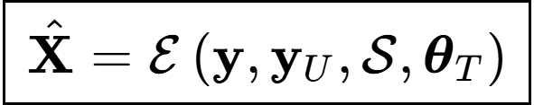
where (\mathcal S) is a saved transformer-boundary event-signature library.
The estimator does not claim to reconstruct the complete hidden downstream network state. It estimates the latent consumer-energy allocation and the event information that can be inferred from the transformer boundary.

Measurement and Channel Definition
The core observation channels are the synchronized three-phase transformer voltage and current channels:
These six channels are retained because the notebook experiments explicitly operate on three-phase transformer voltage and current waveforms, while the transient methodology identifies both voltage and current as observation channels.
The estimator does not assign equal diagnostic importance to every raw channel. Instead, each channel is weighted according to its pre-event noise covariance and its repeatability within the saved signature library. A noisy channel is therefore prevented from dominating the classifier simply because its waveform amplitude is large.
The channel hierarchy is:
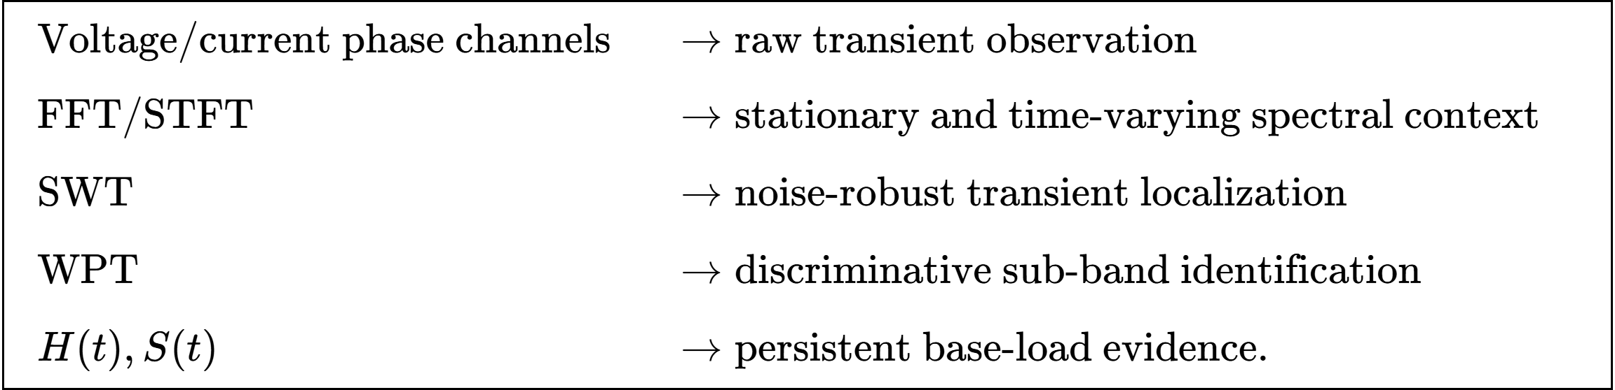
The harmonic (H(t)) and slowly varying (S(t)) channels are particularly important for estimating the persistent base-load component.

Event-Centred Baseline and Residual Construction
For each measurement channel (c), a pre-event window (W_0) is retained. The baseline is estimated from the preceding steady-state cycles:
The event-oriented residual is
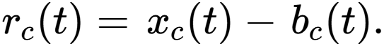
When persistent spectral components have already been explicitly separated, the corresponding residual may instead be written as
The important restriction is that event-induced harmonic changes must not be removed automatically. They may form part of the event signature, particularly for nonlinear and converter-fed loads.
The residual is normalized relative to the pre-event operating state:
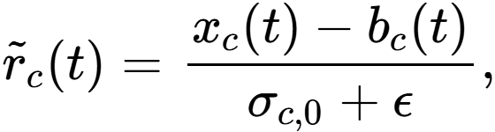
where (\sigma_{c,0}) is the channel's pre-event scale parameter.
This makes the signature less sensitive to the absolute transformer loading level and allows two otherwise similar downstream events to be compared under different transformer operating points.

Spectral Conditioning: FFT and STFT
The FFT is used first to characterize the stationary spectral environment before the transient detector is applied.
For channel (c),
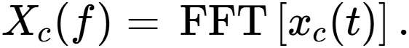
The principal spectral descriptors are
together with associated phase descriptors.
The FFT therefore identifies:
1. the fundamental component,
2. persistent harmonic/interharmonic structure,
3. the broadband spectral floor.
The STFT is subsequently applied to the residual:
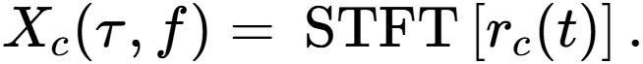
The event-to-baseline spectral departure is
The STFT does not constitute the final event classifier. It supplies a time-frequency localization map that identifies the approximate event interval and separates persistent spectral content from components that appear or change during the event. FFT and STFT therefore provide spectral conditioning, while SWT performs the principal transient localization.

Noise-Robust Preprocessing
Two noise mechanisms are treated separately.
Isolated anomalous samples are detected by a Hampel or short-window median detector:
Only identified outliers are corrected. A long low-pass filter is not used for this purpose because genuine switching transients can be attenuated by conventional low-pass smoothing.
The pre-event SWT coefficients estimate the channel- and scale-specific background noise:
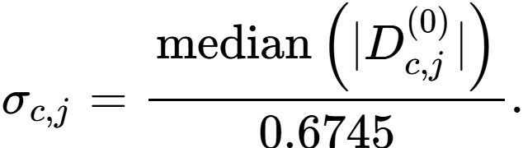
A scale-dependent threshold is then applied:
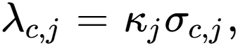
with soft shrinkage
Thresholds are calibrated against detection performance rather than adopted as universal fixed values. This avoids the failure mode in which legitimate high-frequency event information is incorrectly classified as noise.
A saved signature is therefore not a single waveform. For event class (m), the library contains multiple realizations:
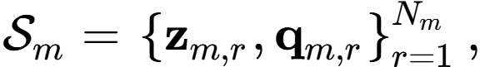
from which robust class statistics are estimated:
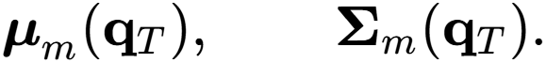
This is essential because Dataset 4 shows that the same downstream event does not produce an invariant transformer-boundary waveform when transformer specifications change.

Noise-Whitened Event Detection
The pre-event covariance is used to account for channel- and feature-dependent noise:
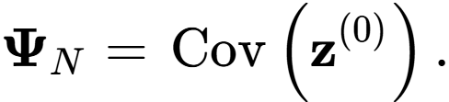
For candidate event class (m), define the covariance-weighted distance
The classifier score is
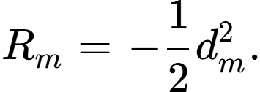
A raw similarity value is therefore obtained without interpreting it prematurely as a probability.
The identified event class is
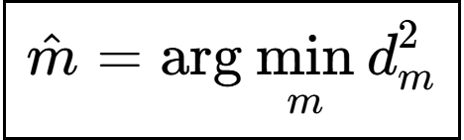
provided the observation also satisfies the independent transient-energy detection criterion.
This prevents a large but noisy high-frequency coefficient from dominating the classification merely because its amplitude is high.

Multi-Event Identification
When more than one downstream event may be active, single-class classification is insufficient.
Let

be a candidate event set.
The identified co-event set is obtained from
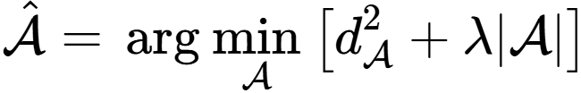
subject to the observed residual-magnitude consistency.
For (K=|\mathcal A|), the expected residual voltage/current magnitude can be represented as
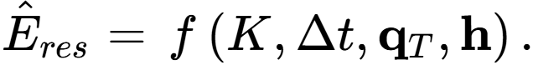

Transformer-Conditioned Signature Matching
The signature distance must be conditioned on the transformer and operating state:
where the entries describe transformer specification and pre-event operating state.
The event model becomes
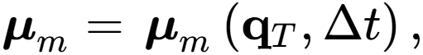
and
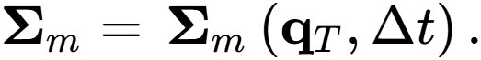
The objective is to compare a new observation against signatures generated under a comparable transformer operating condition rather than assuming that an event waveform is invariant across transformers.
The transformer is consequently treated as a state-dependent transfer system, not merely as a fixed amplitude multiplier.
Composite Event Confidence
Three evidence classes are retained:
and
R_r = residual magnitude consistency
These features are combined using a calibrated function:
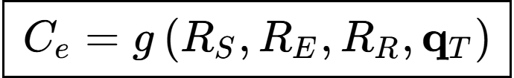
where (g) is learned using labelled validation cases.
A logistic, isotonic, or equivalent monotonic calibration model may be used. The output (C_e) is then an experimentally interpretable confidence rather than an arbitrary product of uncalibrated scores.
The distinction is important:
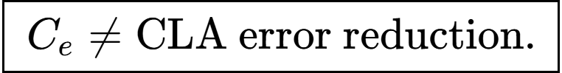
It is the confidence that the transformer-boundary observation contains usable event evidence.
The proposed state-estimation framework begins with a synchronized observation window containing the three-phase transformer-boundary voltages and currents. The estimator first establishes the transformer operating background from a pre-event reference interval and removes this background from the observed signals to obtain a normalized event residual. The residual is conditioned in both the time and frequency domains: spectral analysis is used to characterize persistent and evolving frequency content, while impulsive outliers are suppressed using robust local statistics. The signal is then denoised and localized with a shift-invariant wavelet decomposition, followed by wavelet-packet analysis to isolate frequency bands that are most discriminative for transient events. The resulting representation is therefore a hybrid signature containing multiresolution wavelet features, selected frequency-band features, event amplitude information, onset and duration characteristics, fundamental, harmonic content and slowly varying or DC behaviour indicators.
Event detection is performed from the consistency of these hybrid features rather than from a single waveform component. A transient is accepted only when its time-domain and spectral evidence exceed the established detection threshold and remain consistent across the relevant voltage and current channels. The detected signature is then compared with the library of admissible downstream event classes to determine the most compatible event type and, where the available information permits, the event identity and temporal displacement. Classification is constrained by residual-magnitude consistency so that an apparently similar signature cannot be accepted when its associated residual magnitude is incompatible with the observed transformer response. The estimator then combines signature similarity, energy consistency, cross-channel agreement, and transient-quality measures to produce an event-confidence value.

The transient evidence is incorporated into the time-adjusted consumer allocation as an additional source of information for estimating the composition of the aggregate load observed at the transformer boundary. The steady-state power-flow solution provides the baseline electrical state of the low-voltage network and, from the estimated total active and reactive demand together with the known network configuration and consumer classes, provides an estimate of the number and loading contribution of connected consumer loads. This estimate represents the steady-state interpretation of the aggregate demand. The transformer terminal unit then provides an independent dynamic observation: load-switch operations produce transient signatures at the transformer boundary that can be detected, separated, and associated with changes in downstream loading. By counting and identifying these observable switching responses over an observation period, the system obtains a second estimate of the number of active or responsive loads. The two estimates need not be identical because steady-state power flow represents the electrical load present at a particular operating condition, whereas TTU transient observations reveal only loads whose switching activity is observable within the measurement interval.
The difference between the steady-state-derived load estimate and the TTU-derived observable load estimate can therefore be used as a diagnostic for premises-level and consumer-level evaluation. Where the estimates are consistent, the observed transient activity provides supporting evidence that the inferred consumer population and the time-adjusted allocation are representative of the actual downstream configuration. Where they differ materially, the discrepancy can identify premises requiring further investigation, such as consumers that are connected but inactive during the observation period, loads that are electrically aggregated and therefore produce weak or overlapping switching signatures, incorrectly classified consumer types, newly connected or disconnected premises, or unmodelled demand. The time-adjusted CLA can then use the transient information to refine the allocation of the aggregate unmetered energy across the inferred consumer population while the feeder or transformer energy balance remains the governing constraint. In an operational setting, repeated comparison of steady-state load counts, TTU-observed switching events, and subsequent premises-level verification creates a feedback process: the network model is progressively refined, consumer records can be reconciled with observed electrical behaviour, anomalous or unaccounted premises can be targeted for inspection, and commercial actions can be prioritised toward locations where the discrepancy between expected and observed consumption is persistent. This provides a direct pathway from transformer-boundary state estimation to premises evaluation, improved consumer visibility, loss identification, and ultimately improved revenue recovery.

REFERENCES
Primadianto & Lu (2017): Comprehensive review of distribution system state estimation, detailing measurement sparsity, pseudomeasurement injection mechanics, and WLS formulation limitations.
Pang et al. (2026): Development and validation of load pseudomeasurement generation frameworks under partial smart meter observability using Low-Carbon London data.
Kotsonias et al. (2021): Experimental deployment and field validation of low-voltage distribution grid monitoring applications under sparse AMI infrastructure.
Vanin et al. (2023): Systematization of knowledge clarifying formal theoretical boundaries between load allocation, state estimation, power flow, and parameter identification.

Customer Classification, Clustering, and Profile-Based Allocation
Chicco et al. (2006): Benchmark comparative assessment of clustering algorithms ($K$-Means, Hierarchical, Fuzzy $C$) for electricity customer load profiling.
Mutanen et al. / Rautiainen et al. (2015/2016): Smart meter data-driven customer load profiling and its quantifiable accuracy impacts on distribution state estimation.
Luan et al. (2015): Modeling distribution feeders using smart meter data and aggregate feeder-level load allocation.
Aoki et al. (1987): Foundational mathematical formulation of optimal load allocation in normal operating distribution systems.
Civanlar et al. (1988): Feeder reconfiguration and load allocation principles based on physical feeder characteristics.
Broadwater et al. (1997): Time-series load allocation methodology in distribution networks utilizing transformer nameplate ratings and billing determinants.

Temporal Dynamics, Dynamic Tariffs, and Probabilistic Forecasting
MDPI Energy Simulation / Tariff Study (2026): Systematic evaluation of dynamic weather-driven real-time pricing (RTP) tariffs, ToU structures, and diurnal load variations.
Sobol et al. / Quasi-Monte Carlo Study (2025): Non-parametric quantile forecasting integrated with Quasi-Monte Carlo Simulation for probabilistic power flow under demand uncertainty.
Haben et al. (2016): Analysis of residential customer behavior, peak demand variability, and finite mixture models using smart meter time-series.

Quantile Mapping and Distribution Matching Precedents
Piani et al. (2010): Mathematical formulation and statistical proof of empirical quantile mapping (EQM) for bias-correcting distributed variables.
Gudmundsson et al. (2012): Comparative evaluation of parametric versus non-parametric statistical transformations for empirical cumulative distribution function matching.
Cannon et al. (2015): Quantile Delta Mapping (QDM) formulation preserving distribution shifts and non-stationary quantile trends.

Uncertainty Decomposition and Irreducible Error Bounds
OAPEN / Low-Voltage Load Forecasting Treatise (2023): Mathematical definition of irreducible stochastic estimation error ($σ_{\text{irred}}^{2}$) driven by unobserved exogenous variables in low-voltage networks.
Kong (2020): Analysis of single-phase load allocation asymmetry, dynamic customer behavior variations, and physical phase unbalance in LV networks.

Network Boundary Constraints, Multi-Phase Flow, and Loss Modeling
Ledva & Mathieu (2018): Statistical disaggregation of aggregate feeder demand into constituent customer class components using boundary measurements.
Saleh & Wadoud (2026): Multi-phase power flow, loss minimization, and branch current constraint modeling in radial distribution networks.
Siti et al. (2005): Load balancing, phase reconfiguration, and feeder current constraint management in distribution systems.

High-Frequency Waveforms, Transient Analysis, and Secondary Boundary Sensing
Zheng et al. (2023): Non-Intrusive Load Monitoring (NILM) and Sweep Frequency Response Analysis (SFRA) at distribution secondary boundaries.
MDPI Energies NILM Review (2026): Comprehensive survey of event-based and state-based NILM workflows, feature extraction methods (GASF, wavelets), and deep learning architectures.
Direct Comparison Method Waveform Thesis (2023): Waveform anomaly detection, high-frequency boundary sampling, and clustering limitations in distribution network condition monitoring.
Code: https://github.com/mhizterpaul/dsse/

Tables and figures
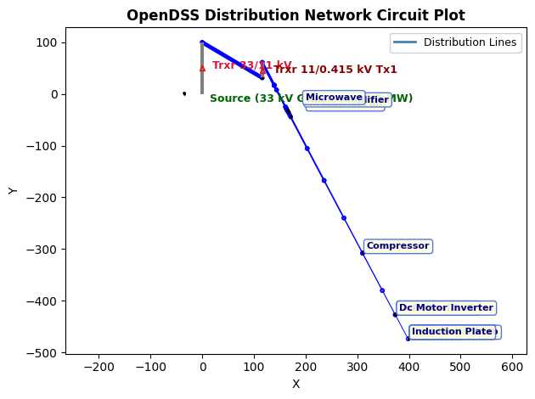
Single-Line Diagram and Bus Topology of the 20-Bus Radial Low-Voltage (LV1) Test Feeder

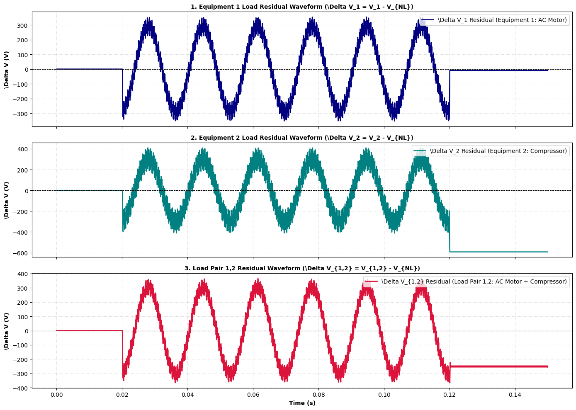
Subtracted Residual Load Waveforms ($\Delta V_1$, $\Delta V_2$, and $\Delta V_{1,2}$) for Individual Loads and Co-Event Pair 1,2
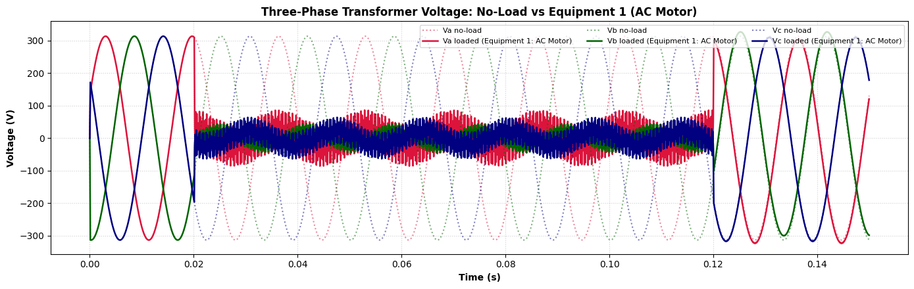
Three-Phase Secondary Transient Waveform Responses: No-Load Baseline vs. Equipment 1 (AC Motor)

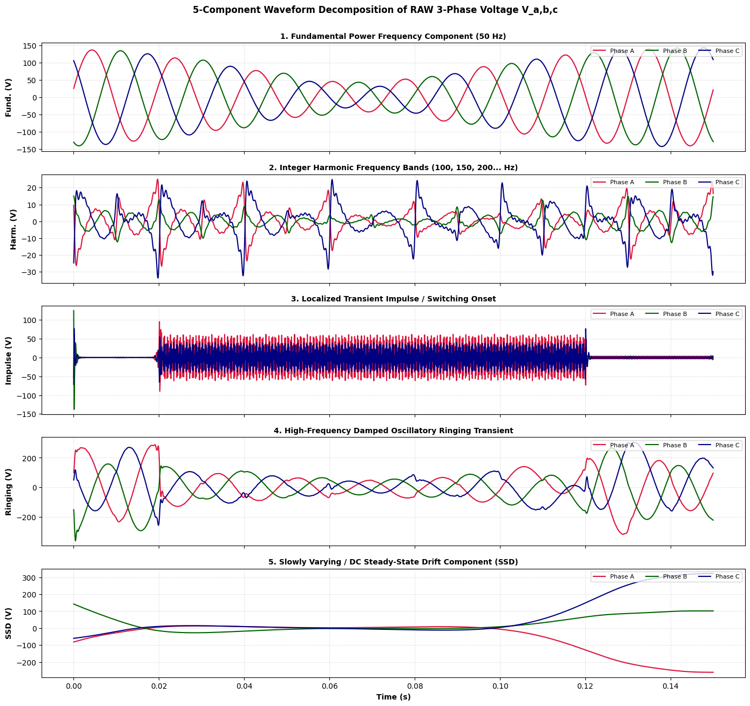
5-Component Waveform Decomposition of RAW Three-Phase Voltage ($V_{a,b,c}$) for Load Pair Co-Event
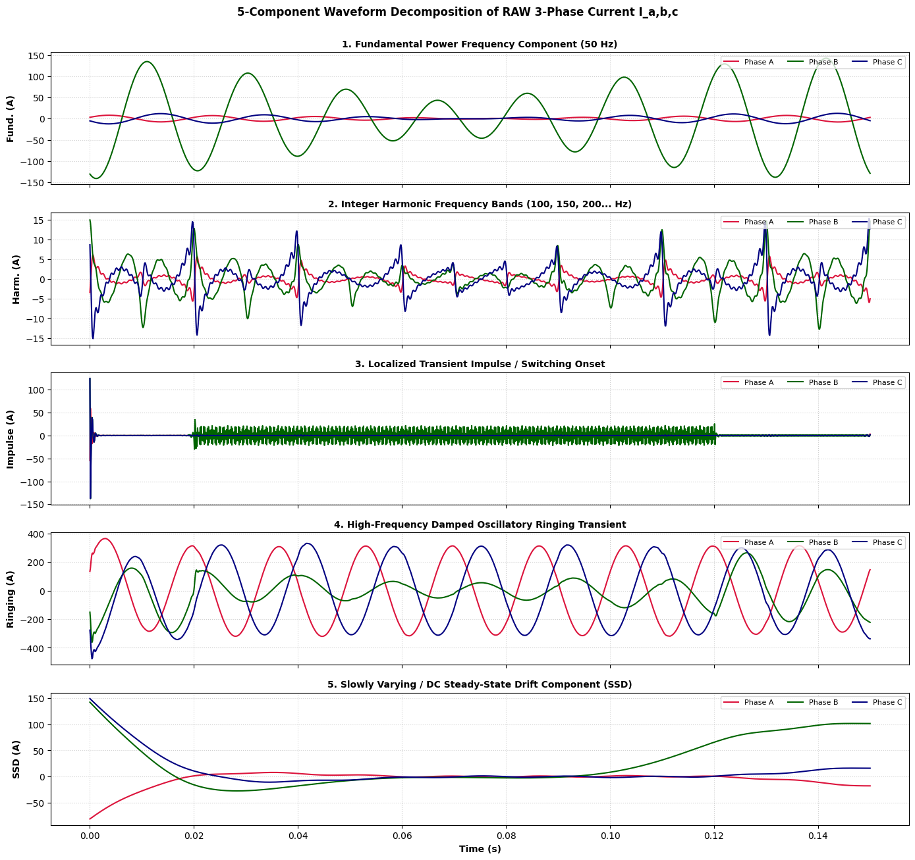
5-Component Waveform Decomposition of RAW Three-Phase Current ($I_{a,b,c}$) for Load Pair Co-Event
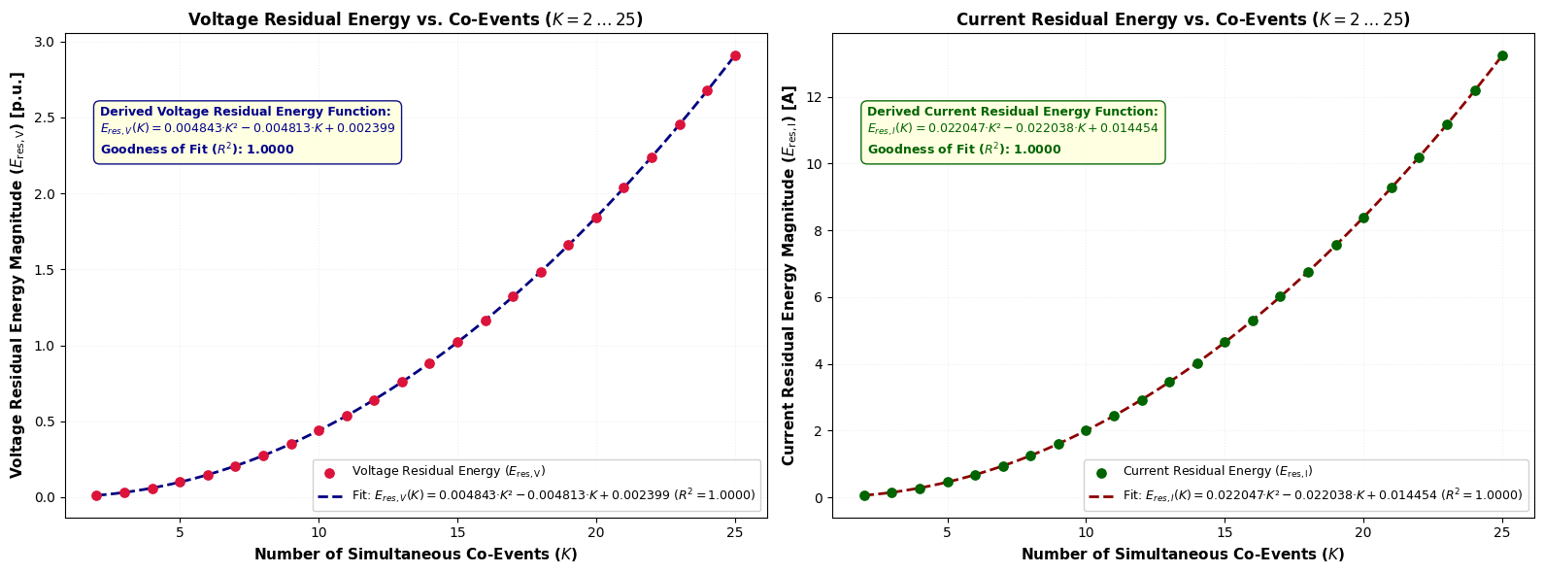
Transient Waveform Residual Voltage and Current Scaling Curve versus Simultaneous Co-Events ($K = 2 \text{ to } 25$)
Transient Waveform Residual Voltage and Current Scaling Curve versus Simultaneous Co-Events (\(K = 2 \text{ to } 25\))
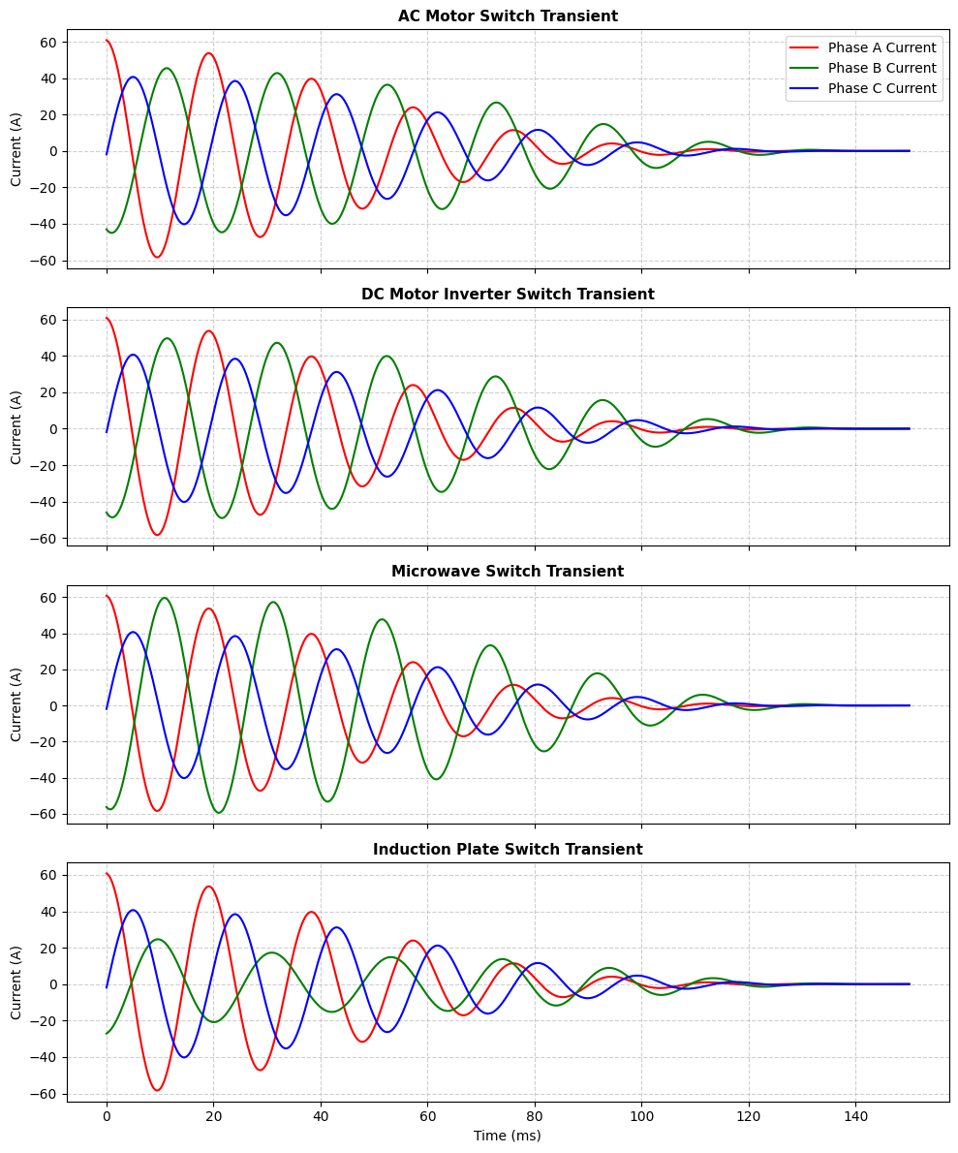
Three-Phase Secondary Transient Waveform Responses for Load Equipment Group 1 (AC Motor, DC Motor Inverter, Microwave, Induction Plate)

Appendix: Technical Terms and Methodological Concepts

1. Empirical Quantile Mapping (EQM)
• Definition: A non-parametric cumulative distribution function (CDF) matching technique that maps an unmetered consumer's percentile rank into a live metered class consumption value.
• Mathematical Formulation: For a given load class (C) at time (t), the live metered group forms an empirical cumulative distribution function (F_{Y_t\mid C}). An unmetered consumer (i) with ordinal percentile rank (w_i\in[0,1]) receives an estimated active-power demand through empirical distribution inversion:
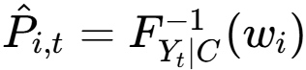

2. High-Frequency Secondary Transient Waveform Analytics
• Definition: Sub-millisecond voltage and current waveform sampling, operating in the kHz-to-MHz frequency range, captured at the distribution-transformer secondary boundary to detect discrete load-switching and fault events.
• Physical Context: Captures fast electromagnetic-transient signatures caused by motor starts, appliance switching, power-electronic converter operation, or line faults propagating through the distribution transformer.

3. Thévenin Network Equivalent Extraction
• Definition: An automated circuit-reduction procedure performed in OpenDSS using short-circuit studies to condense complex upstream and downstream networks into simplified equivalent sources and impedance matrices.
• Mathematical Formulation: Extracts open-circuit Thévenin voltage vectors (\mathbf{V}_{\mathrm{Th}}) and equivalent impedance matrices:
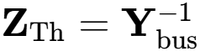
at the transformer high-voltage (HV) and low-voltage (LV) terminals.

4. BCTRAN Transformer Modeling
• Definition: A three-phase coupled electromagnetic-transformer modeling routine in ATP-EMTP that represents transformer windings and their electromagnetic coupling using matrix-based parameters.
• Physical Context: Utilizes physical nameplate and test parameters, including rated voltage, rated power, excitation current, no-load losses, and short-circuit impedances, to generate frequency-dependent transformer matrices or punch data.

5. Pearson Correlation Distance ((D_{ij}))
• Definition: A normalized shape-matching distance metric used to group consumer load profiles according to temporal demand morphology rather than absolute magnitude.
• Mathematical Formulation: Given consumer time series (M_{j,t}) and class centroid (C_{i,t}) over a time horizon (T):
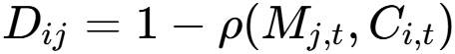
where
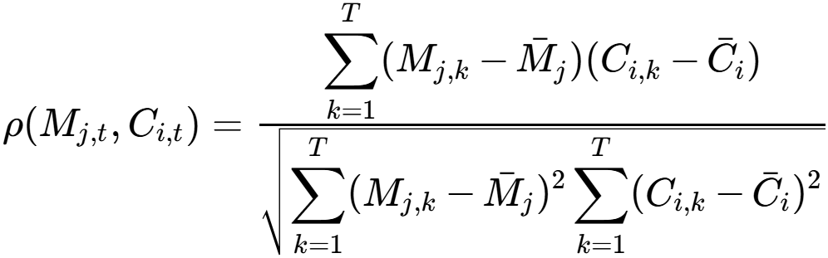

6. Distribution System State Estimation (DSSE) & Pseudomeasurement Generation
• Definition: State-estimation algorithms, such as Weighted Least Squares (WLS) or Branch-Current State Estimation (BCSE), that estimate complex bus-voltage states across partially observed distribution networks using synthesized load-injection estimates, or pseudomeasurements.
• Mathematical Context: The state vector (\mathbf{x}) is obtained by minimizing the weighted measurement residual:
where (\mathbf{z}) is the measurement vector, (h(\mathbf{x})) is the nonlinear measurement model, and (\mathbf{R}) is the measurement-error covariance matrix.

7. Stationary Wavelet Transform (SWT)
• Definition: A translation-invariant, non-decimated multiresolution time-frequency decomposition used to localize transient-energy features.
• Mathematical Context: Unlike the standard Discrete Wavelet Transform (DWT), SWT omits downsampling at successive decomposition levels while appropriately dilating the analysis filters. Consequently, each decomposition level retains the original signal length and full temporal alignment.

I. Statistical Error & Performance Metrics

1. Mean Absolute Error (MAE)
• Mathematical Definition: The average magnitude of absolute allocation errors across the unmetered consumer population (U):
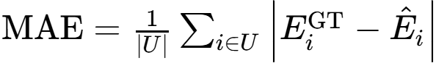
where (E_i^{\mathrm{GT}}) is ground-truth consumption and (\hat{E}_i) is the allocated energy estimate.
• Paper Context & Role: Measures individual consumer allocation error in absolute physical energy units (kWh). In the paper's dataset, baseline CLA produced an MAE of 0.9179 kWh, which decreased to 0.8232 kWh under default Time-Adjusted CLA ((\beta=0.2)), and was further minimized to 0.7890 kWh at the optimal power-law exponent ((\beta^{*}=0.3962)).

2. Mean Absolute Percentage Error (MAPE)
• Mathematical Definition: The average relative percentage error across individual unmetered consumers:
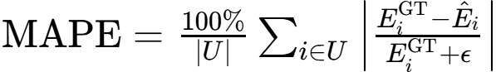
where (\epsilon=10^{-6}) prevents division by zero.
• Paper Context & Role: Evaluates typical relative error per customer. The baseline CLA MAPE of 61.10% was reduced to 50.17% with default time adjustment, and reached 38.93% under optimized power-law scaling ((\beta^{*}=0.3962)), representing a total 36.28% relative error reduction.

3. Mean Squared Error (MSE)
• Mathematical Definition: The average squared difference between ground-truth demand and allocated load estimates:
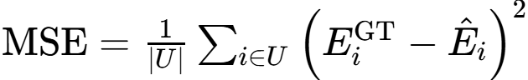
• Paper Context & Role: MSE severely penalizes larger individual deviations because of its quadratic formulation. While time adjustment significantly reduced MAE and MAPE, MSE rose slightly from (1.5500\ \mathrm{kWh}^2) for the baseline to (1.6047\ \mathrm{kWh}^2) under the default configuration and (1.6488\ \mathrm{kWh}^2) at (\beta^{*}). This demonstrates that power-law exponent optimization improves typical allocation accuracy across the majority of consumers without completely eliminating a small number of large tail deviations.

II. Probabilistic Distribution & Allocation Concepts

4. Cumulative Distribution Function (CDF)
• Mathematical Definition: A function
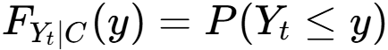
representing the probability that consumption (Y_t) of load class (C) at time (t) is less than or equal to active power magnitude (y).
• Paper Context & Role: Live empirical CDFs (ECDFs) are constructed in real time from the 36% metered customer subset to reflect intra-day class demand shifts without imposing rigid parametric assumptions such as Gaussian distributions.

5. Percentile Rank ((w_i))
• Mathematical Definition: An ordinal scalar value (w_i\in[0,1]) representing the relative position of unmetered consumer (i) within their assigned load class, calculated from historical billing ratios or equipment-load weights.
• Paper Context & Role: For an unmetered consumer (i) ranked by weight in a class containing (|U_c|) unmetered units, the percentile rank is:
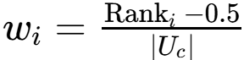

6. Non-Parametric Quantile Inversion
• Mathematical Definition: Evaluation of the inverse CDF of the metered population at an unmetered consumer's percentile rank:
• Paper Context & Role: Maps unmetered consumers directly to live metered consumption percentiles. This preserves real-time distribution variance, skewness, and multimodal structure without assuming normal or Gaussian error distributions.

III. Unsupervised Load Profiling & Clustering Terminology

8. Mean-Shift Clustering
• Mathematical Definition: A non-parametric, density-based clustering algorithm that iteratively shifts data points toward the modes of a kernel-density surface without requiring pre-specification of the cluster count (K).
• Paper Context & Role: Used in the literature for smart-meter time-series disaggregation to group customer profiles dynamically without forcing artificial cluster boundaries.

9. Epanechnikov Kernel
• Mathematical Definition: A parabolic, bounded kernel function used within density estimation to weight neighboring profiles smoothly:
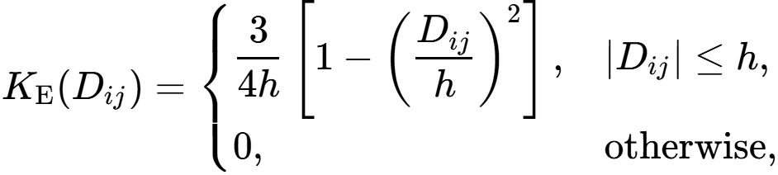
where (D_{ij}) is the Pearson correlation distance and (h) is the bandwidth.
• Paper Context & Role: Provides an efficient bounded kernel for non-parametric load-density profiling over the selected distance metric (D_{ij}).

III. Wavelet Signal Processing & Transient Analytics

1. Undecimated Discrete Wavelet Transform (UDWT / Stationary Wavelet Transform — SWT)
• Mathematical Definition: A translation-invariant multiresolution wavelet decomposition that omits the downsampling (decimation) step at successive levels.
• Paper Context & Role: Prevents sample-alignment sensitivity during transient analysis. Because switching events can occur at arbitrary times within an observation window, SWT ensures that wavelet detail coefficients (D_j(t)) are substantially less sensitive to event translation than those produced by a decimated DWT, allowing transient morphology to be characterized more consistently.

2. Decimated Discrete Wavelet Transform (DWT)
• Mathematical Definition: A standard wavelet decomposition that applies a factor-of-two downsampling step after filtering at each level.
• Paper Context & Role: Standard DWT is not shift-invariant. In transient waveform feature extraction, subtle shifts in event-onset timing can produce significant changes in DWT coefficient amplitudes, making it less suitable than SWT for consistent load-event localization.

3. Signal-to-Noise Ratio (SNR)
• Mathematical Definition: The power ratio between a true physical signal and background sensor or channel noise, expressed in decibels:
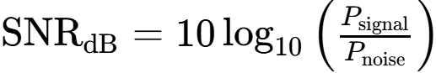
In amplitude terms, a 35 dB SNR corresponds to a noise-to-signal amplitude ratio of
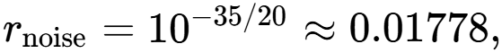
or approximately 1.78%.
• Paper Context & Role: Used in the paper's ATP-EMTP simulations to inject controlled measurement noise into transformer secondary voltage/current waveforms prior to computing correlation discounts.

IV. Cross-Referenced Primary Appendix Terms
(Detailed extensively in the primary technical appendix document in your Studio panel.)
• Time-Adjusted Cluster Load Allocation (Time-Adjusted CLA): Reconstructs individual customer load shapes under (<30%) smart-meter coverage by combining dynamic class profiles, percentile-rank mapping, and transformer energy-balance constraints.
• Physical Boundary Energy Conservation: SCADA/TTU transformer-balance matching that constrains boundary intake using metered demand, allocated unmetered demand, and calculated technical losses, including (I^2R) line losses and core losses.

V. Load Profile, Clustering & Mathematical Concepts

1. Demand Skewness
• Definition & Context: The asymmetry in the probability distribution of power consumption across a customer population. Low-voltage residential and commercial feeders typically exhibit a heavily right-skewed distribution, characterized by a dense population of below-mean consumers and a long upper tail of high-energy users.

2. Diurnal Shape
• Definition & Context: The recurring 24-hour demand profile reflecting human and operational activity patterns, such as morning and evening residential peaks, midday commercial plateaus, and overnight troughs.
• Operational Relevance: Time-Adjusted CLA captures time-indexed diurnal variations by constructing live empirical cumulative distribution functions (ECDFs) at 5-minute intervals, preserving intra-day peak and trough timing across different consumer classes.

3. Euclidean Distance ((L_2) Norm)
• Mathematical Definition: The standard geometric distance between two consumption time-series vectors (M_{j,t}) and (C_{i,t}):
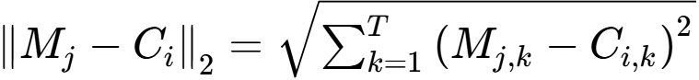

4. Load Morphology
• Definition & Context: The structural, shape-based characteristics of a time-series load profile, particularly the relative timing and progression of demand ramps, peaks, and troughs, independent of absolute energy magnitude.
• Operational Relevance: Isolating load morphology using Pearson correlation distance,
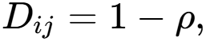
allows consumers with coincident temporal demand patterns to be grouped within the same load class even when their absolute consumption magnitudes differ.

VI. Power Quality & Simulation Modeling

1. Total Harmonic Distortion (THD)
• Mathematical Definition: The ratio of the RMS magnitude of harmonic components to the RMS magnitude of the fundamental component:
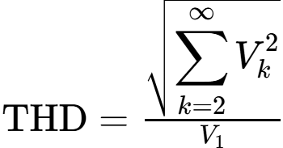
where (V_1) is the fundamental RMS voltage and (V_k) is the RMS magnitude of the (k)-th harmonic.
• Operational Relevance: In LV distribution networks, nonlinear consumer equipment contributes background harmonic distortion. A specified THD level can therefore form part of the simulated sensing environment when evaluating whether low-amplitude switching transients can be distinguished from background waveform distortion.

