 | NSSF800CM1K2ESAG
 | N-Channel Silicon Carbide Power MOSFET
 | Rev.01 - 2 October 2026 | Product datasheet

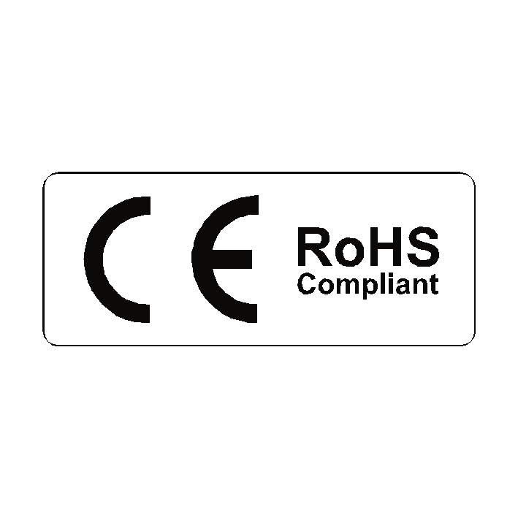


1. General description
 |  | NMIS NASPIC Generation 1 N-Channel Silicon Carbide Power MOSFET in a TO247-4L package, designed for high frequency, high eﬀciency systems.
2. Features and beneﬁts
- Kelvin source conﬁguration
- Low speciﬁc On State resistance
- Optimized dynamic performance
- Robust gate design
- 0V turn-oﬀ V_{GS} for simple gate driving
- 100% UIS Tested
- Easy to parallel
3. Applications
- PC/server/telecom power supplies
- UPS & Energy storage system
- Battery formation instrument
- PV MPPT and inverters
- EV Chargers
- Motor Drives
4. Quick reference data
Table 1. Quick reference data
Symbol |  |  | Parameter |  | Conditions |  | Notes |  |  |  | Values |  |  |  |  | Unit
Absolute maximum rating
V_{DS} |  |  | Drain-source voltage |  | 25 °C ≤ T_{j} ≤ 175 °C |  |  |  |  |  | 1200 |  |  |  |  | V
I_{D} |  |  | Drain current |  | V_{GS} = 18 V; T_{mb} = 25 °C |  |  |  |  |  | 120 |  |  |  |  | A
P_{tot} |  |  | Total power dissipation |  | T_{mb} = 25 °C; T_{j} = 175 °C |  |  |  |  |  | 625 |  |  |  |  | W
T_{j} |  |  | Junction temperature |  |  |  |  |  |  |  | -55 to 175 |  |  |  |  | °C
 | Symbol |  |  | Parameter | Conditions | Notes |  |  |  | Min |  | Typ |  | Max |  |  | Unit
 | Static characteristics
 | R_{DS(on)} |  |  | drain-source on-state  resistance | V_{GS}=15V; I_{D}=90A; T_{j}=25°C |  |  |  |  | - |  |  | 800 |  | - |  | V
 |  |  |  | drain-source on-state  resistance | V_{GS}=18V; I_{D}=90A; T_{j}=25°C |  |  |  |  | - |  |  | 65 |  | 85 |  | A
 | Dynamic characteristics
 | C_{g(total)} |  |  | total gate charge | I_{D}=90 A; V_{DS}=400V;  V_{GS}=-4V/18V; T_{j} =25°C |  |  |  |  | - |  |  | 256 |  | - |  | nC
 | C_{gd} |  |  | gate-drain charge | I_{D}=90 A; V_{DS}=400V;  V_{GS}=-4V/18V; T_{j} =25°C |  |  |  |  | - |  |  | 28 |  | - |  | nC
 | Source-drain diode
 | Q_{rr} |  |  | Reverse recovered charge | I_{D}=90 A; V_{DS}=400V;  V_{GS}=-4V/18V; T_{j} =25°C |  |  |  |  | - |  |  | 306 |  | - |  | nC

5. Pinning information
Table 2. Pinning information
Pin | Symbol | Description | Simpliﬁed outline | Graphic symbol
1 | D | drain | 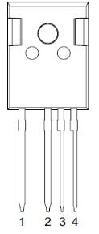 | 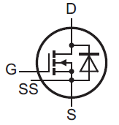
2 | S | source
3 | SS | source sense
4 | G | gate
mb | D | mounting base; connected to drain

6. Ordering information
Table 3. Ordering information
Type number | Package Name | Orderable part no. | Package  method | Min packing quantity | Package version | Issue date
NSSF080CM1K2ESAF | TO247-4L NL | - | Tube | 30 | 1.0 | 2-Oct-26

7. Marking
Table 4. Marking codes
Type number | Marking codes
NSSF080CM1K2ESAF | NSSF080CM  1K2ESAF

8. Limiting values
Table 5. Limiting values
In accordance with the Absolute Maximum Rating System (IEC 60134)
Symbol | Parameter | Conditions | Notes | Values | Unit
Absolute maximum rating
V_{DS} | Drain-source voltage | 25 °C ≤ T_{j} ≤ 175 °C |  | 1200 | V
V_{GS(max)} | Gate-source voltage | Absolute maximum values |  | -10 to 22 | V
V_{GS(max)} | Gate-source voltage | Recommended operational values |  | -4 to 18 | V
P_{tot} | Total power dissipation | T_{mb} = 25 °C; T_{j} = 175 °C |  | 625 | W
I_{D} | Drain current | V_{GS} = 18 V; T_{mb} = 25 °C |  | 218 | A
I_{D} | Drain current | V_{GS} = 18 V; T_{mb} = 100 °C |  | 154 | A
I_{DM} | Peak Drain current | Pulse width t_{p} limited by T_{jmax} |  | 435 | A
I_{S} | Continuous diode current | V_{GS} = -4 V; T_{mb} = 25 °C |  | 118 | A
I_{SM} | Pulse diode current | V_{GS}=-4 V; pulse width t_{p} limited by T_{jmax} |  | 435 | A
E_{AS} | Single pulse drain-to-source avalanche | I_{AS}=37.8 A; L=1 mH; V_{DD}=100V; T_{j} = 25 °C |  | 714
T_{stg} | Storage temperature |  |  | -55 to 175 | °C
T_{j} | Junction temperature |  |  | -55 to 175 | °C
T_{sold(M)} | Peak soldering temperature |  |  | 260 | °C

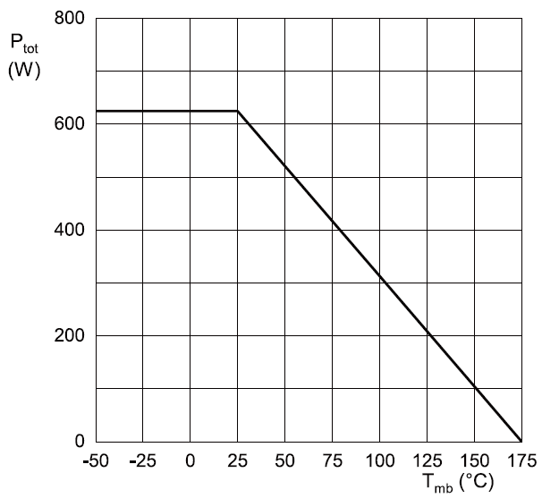 | 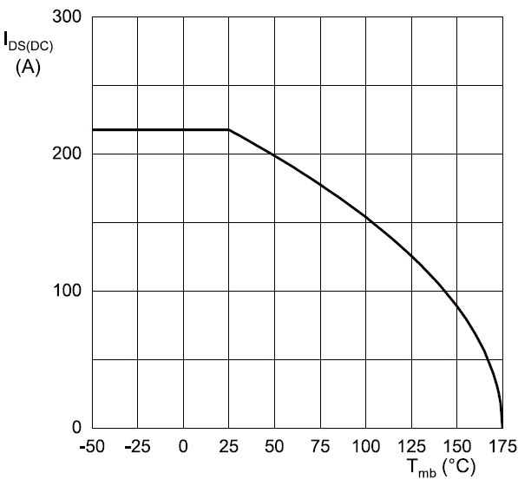
Fig. 1. Total power dissipation as a function of mounting base temperature; maximum values | Fig. 2. Continuous Drain Current as a function of mounting base temperature

9. Thermal & Mechanical characteristics
Table 6. Thermal & Mechanical characteristics
 | Symbol | Parameter | Conditions | Notes | Min | Typ |  | Max |  | Unit
 | R_{th(j-mb)} | thermal resistance from junction to mounting base |  |  | - |  | 0.24 |  | - | K/W
 | Rth(j-a) | thermal resistance  from junction to ambient | in free air |  | - |  | 40 |  | - | K/W
 | Md | Mounting torque | M3 or 6 - 32 screw |  | - |  | - |  | 0.6 | Nm
 | Note: | It is recommended that a metal washer is inserted between screw head and mounting tab.  Do not use self-tapping screws.  Device is ESD sensitive and handling precautions are recommended.
 | 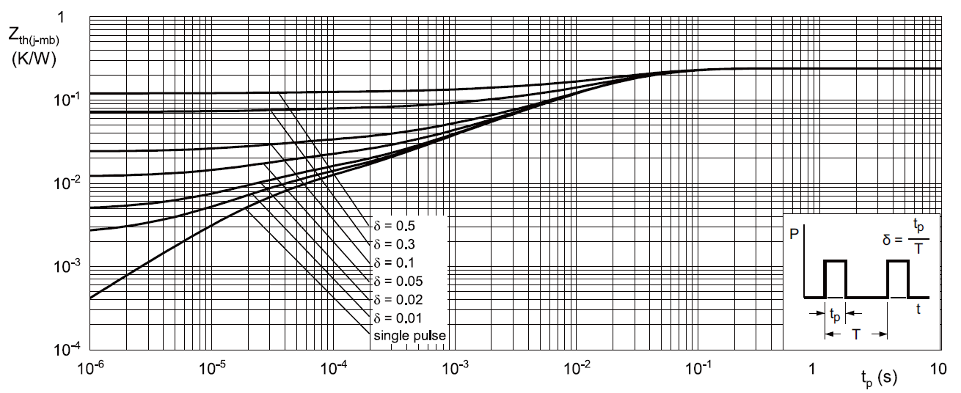
 | Fig. 3. Transient thermal impedance from junction to mounting base as a function of pulse duration

10. Package outline
Plastic single-ended through-hole package; headsink mounted; 1 mounting hole; 4 leads TO-247 Narrow Leads TO247-4L NL
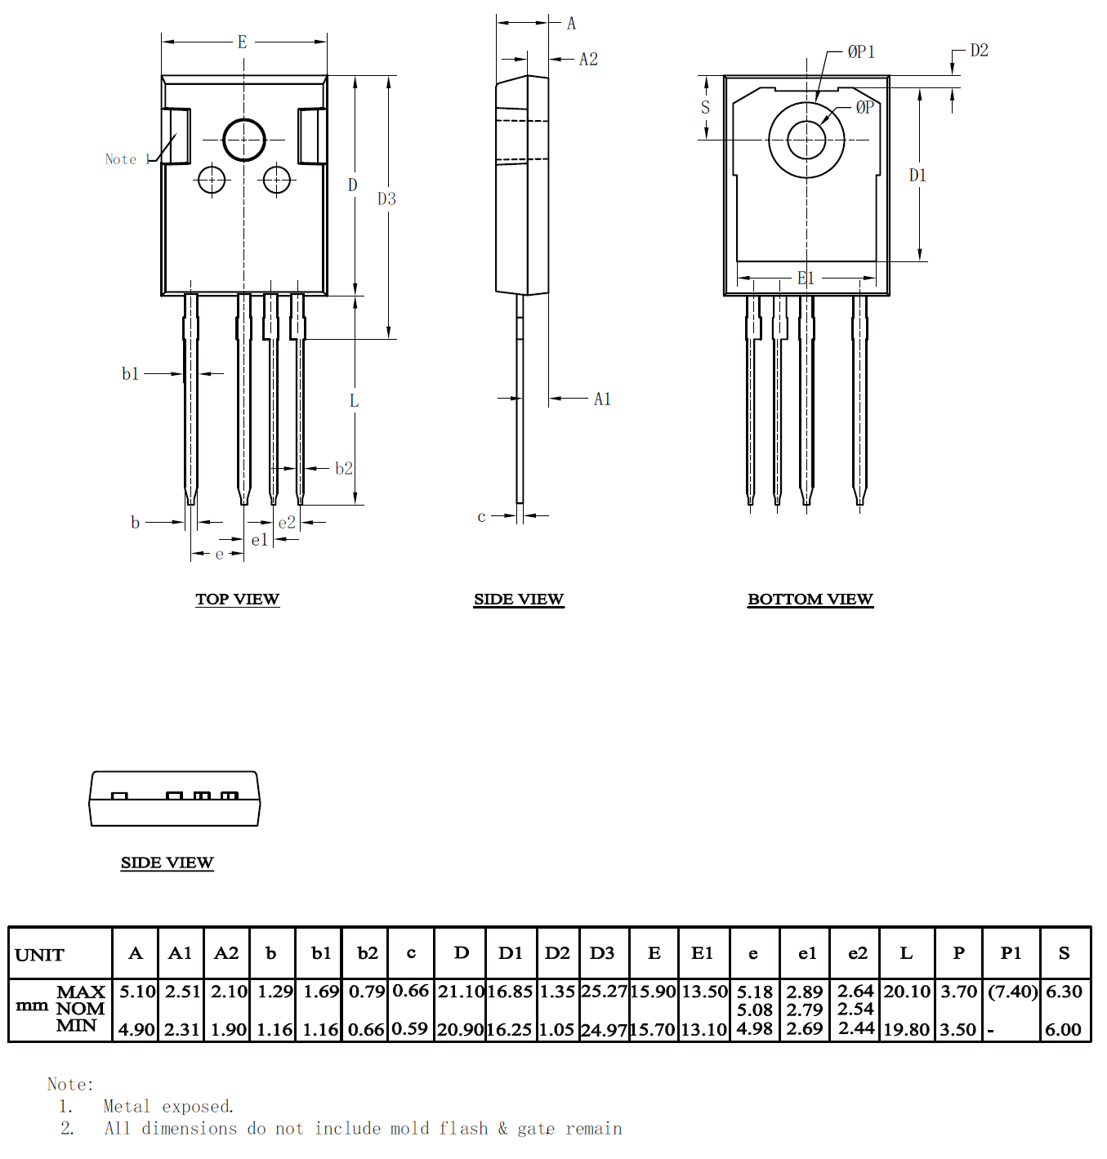

12. Legal information |  |  | Right to make changes — NMIS NASPIC reserves the right to make changes to information published in this document, including without limitation specifications and product descriptions, at any time and without notice. This document supersedes and replaces all information supplied prior to the publication hereof.  Suitability for use — NMIS NASPIC products are not designed, authorized or warranted to be suitable for use in life support, life-critical or safety-critical systems or equipment, nor in applications where failure or malfunction of an NMIS NASPIC product can reasonably be expected to result in personal injury, death or severe property or environmental damage. NMIS NASPIC and its suppliers accept no liability for inclusion and/or use of NMIS NASPIC products in such equipment or applications and therefore such inclusion and/or use is at the customer’s own risk.  Quick reference data — The Quick reference data is an extract of the product data given in the Limiting values and Characteristics sections of this document, and as such is not complete, exhaustive or legally binding.  Applications — Applications that are described herein for any of these products are for illustrative purposes only. NMIS NASPIC makes no representation or warranty that such applications will be suitable for the specified use without further testing or modification. Customers are responsible for the design and operation of their applications and products using NMIS NASPIC products, and NMIS NASPIC accepts no liability for any assistance with applications or customer product design. It is customer’s sole responsibility to determine whether the NMIS NASPIC product is suitable and fit for the customer’s applications and products planned, as well as for the planned application and use of customer’s third-party customer(s). Customers should provide appropriate design and operating safeguards to minimize the risks associated with their applications and products. NMIS NASPIC does not accept any liability related to any default, damage, costs or problem which is based on any weakness or default in the customer’s applications or products, or the application or use by customer’s third-party customer(s). Customer is responsible for doing all necessary testing for the customer’s applications and products using NMIS NASPIC products in order to avoid a default of the applications and the products or of the application or use by customer’s third-party customer(s). NMIS does not accept any liability in this respect.  Limiting values — Stress above one or more limiting values (as defined in the Absolute Maximum Ratings System of IEC 60134) will cause permanent damage to the device. Limiting values are stress ratings only and (proper) operation of the device at these or any other conditions above those given in the Recommended operating conditions section (if present) or the Characteristics sections of this document is not warranted. Constant or repeated exposure to limiting values will permanently and irreversibly affect the quality and reliability of the device.  No offer to sell or license — Nothing in this document may be interpreted or construed as an offer to sell products that is open for acceptance or the grant, conveyance or implication of any license under any copyrights, patents or other industrial or intellectual property rights.  Export control — This document as well as the item(s) described herein may be subject to export control regulations. Export might require a prior authorization from competent authorities.  Non-automotive qualified products — Unless this data sheet expressly states that this specific NMIS NASPIC product is automotive qualified, the product is not suitable for automotive use. It is neither qualified nor tested in accordance with automotive testing or application requirements. NMIS NASPIC accepts no liability for inclusion and/or use of non-automotive qualified products in automotive equipment or applications. In the event that customer uses the product for design-in and use in automotive applications to automotive specifications and standards, customer (a) shall use the product without NMIS NASPIC’ warranty of the product for such automotive applications, use and specifications, and (b) whenever customer uses the product for automotive applications beyond NMIS NASPIC’ specifications such use shall be solely at customer’s own risk, and (c) customer fully indemnifies NMIS NASPIC for any liability, damages or failed product claims resulting from customer design and use of the product for automotive applications beyond NMIS NASPIC’ standard warranty and NMIS NASPIC’ product specifications.
Data sheet status
Document Status | Product Status | Definition
Objective data sheet | Development | This document contains data from the objective specification for product development.
Preliminary data sheet | Qualification | This document contains data from the preliminary specification.
Product data sheet | Production | This document contains the product specification.
- Please consult the most recently issued document before initiating or completing a design.
- The term 'short data sheet' is explained in section "Definitions".
- The product status of device(s) described in this document may have changed since this document was published and may differ in case of multiple devices. The latest product status information is available on the NMIS website
Definitions
Draft — The document is a draft version only. The content is still under internal review and subject to formal approval, which may result in modifications or additions. NMIS NASPIC does not give any representations or warranties as to the accuracy or completeness of information included herein and shall have no liability for the consequences of use of such information.
data sheet — A short data sheet is an extract from a full data sheet with the same product type number(s) and title. A short data sheet is intended for quick reference only and should not be relied upon to contain detailed and full information. For detailed and full information see the relevant full data sheet, which is available on request via the local NMIS NASPIC sales office. In case of any inconsistency or conflict with the short data sheet, the full data sheet shall prevail.
Product specification — The information and data provided in a Product data sheet shall define the specification of the product as agreed between NMIS NASPIC and its customer, unless NMIS NASPIC and customer have explicitly agreed otherwise in writing. In no event, however, shall an agreement be valid in which the NMIS NASPIC product is deemed to offer functions and qualities beyond those described in the Product data sheet.
Disclaimers
Limited warranty and liability — Information in this document is believed to be accurate and reliable. However, NMIS NASPIC does not give any representations or warranties, expressed or implied, as to the accuracy or completeness of such information and shall have no liability for the consequences of use of such information. NMIS NASPIC takes no responsibility for the content in this document if provided by an information source outside of NMIS NASPIC. In no event shall NMIS NASPIC be liable for any indirect, incidental, punitive, special or consequential damages (including - without limitation - lost profits, lost savings, business interruption, costs related to the removal or replacement of any products or rework charges) whether or not such damages are based on tort (including negligence), warranty, breach of contract or any other legal theory. Notwithstanding any damages that customer might incur for any reason whatsoever, NMIS NASPIC’ aggregate and cumulative liability towards customer for the products described herein shall be limited in accordance with the Terms and conditions of commercial sale of NMIS NASPIC.

