 | AEC-Q101 Qualification Report
 | {{Product_Name}} {{Device_Description}}
 | Rev.01 - 20 October 2026 | IATF 16949:2016 Qualification Report


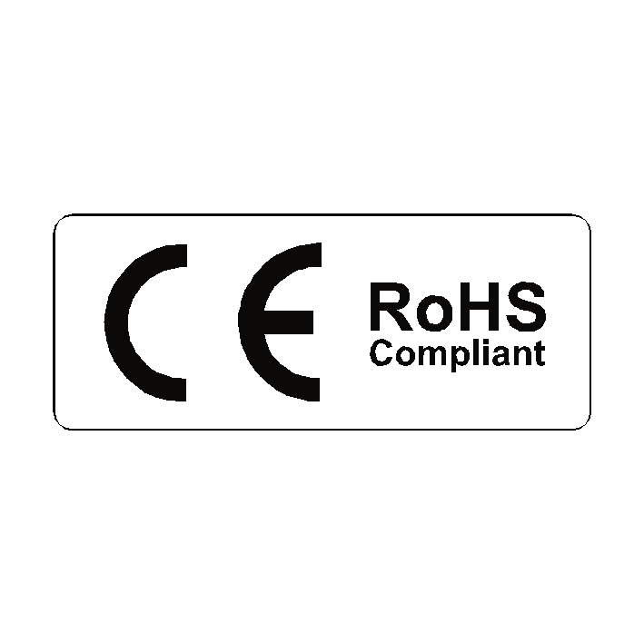


1. General description
 | NMIS NASPIC {{ Revision_Text }} {{Device_Description}} in a {{ Package_Type_Text }} package, designed for high frequency, high eﬀciency systems.
2. Revision history
Revision |  | Description | Author |  |  |  | Date
0 |  | Initial release | Prof. Matt Boyle |  |  |  | 2-Sep-2025
3. References
- Bonding diagram of {{Product_Name}}
- Bonding diagram of NSSF080CM1K2ESAH
- Datasheet of {{Product_Name}}
- Datasheet of NSSF080CM1K2ESAH

4. Summary
4.1 Scope of Qualification
☐New Technology |  | ☒New Package |  | ☐Derivative | ☐Design change
☐NPI |  | ☐Process Change |  | ☐New Subcon
☐Others, please specify:

 | 4.2 Qualification Summary
 | Qualificaiton Vehicle |  | {{Product_Name}} (Q1)  NSSF080CM1K2ESAH (Q2)
 | Part Number(s) covered |  | ALL applicable {{Device_Description}}
 | Max Junction Temperature |  | +175°C
 | Max Rating Voltage |  | {{V_rate}}
 | Max Rating Current |  | {{I_rate}}
 | Target Package Type |  | {{ Package_Type_Text }}
 | Target Assembly Site |  | ABB Taiwan
4.3 Qualification Conclusions
This qualification report documents the qualification and reliability test results for the NMIS {{Device_Description}} product family.
Upon successful completion of all predefined qualification requirements, this report certifies that the subject {{Device_Description}} devices are qualified in accordance with the requirements of the Automotive Electronics Council (AEC-Q101) standard.
A comprehensive qualification program was conducted to evaluate the quality, robustness, and long-term reliability performance of the devices throughout their intended service life. The qualification assessment covered a wide range of operating life, environmental, mechanical, and electrical stress tests representative of the intended application conditions.
More than 1,000 test units from multiple product variants within the {{Device_Description}} family were subjected to qualification stress and subsequent electrical verification. All devices were evaluated against the applicable datasheet specifications, and zero failures were observed throughout the qualification program.
In addition, drift analysis was performed on critical electrical parameters throughout the qualification testing. No significant parameter drift was detected following stress exposure, and the devices demonstrated stable electrical performance with promising process capability (Cpk) results.
In summary, the qualification results demonstrate that the NMIS {{Device_Description}} product family meets the applicable reliability requirements and exhibits robust performance, stable parametric behavior, and excellent reliability characteristics suitable for its intended applications.

5. Pinning information
Pin | Symbol | Description | Simpliﬁed outline | Graphic symbol
1 | D | drain | 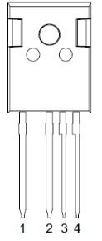 | 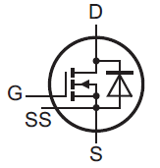
2 | S | source
3 | SS | source sense
4 | G | gate
mb | D | mounting base; connected to drain

6. Ordering information
Type number | Package Name | Orderable part no. | Package  method | Min packing quantity | Package version | Issue date
{{Product_Name}} | TO247-4L NL | - | Tube | 30 | 1.0 | 20-Oct-26

7. Qualification Device Attribute Information
The following tables capture the important information about the SiC die and packaging attributes for the product(s) under the scope of this qualification study.
7.1 Die Attributes
Product |  |  | {{Product_Name}} (Q1) |  | NSSF080CM1K2ESAH (Q2)
Die Code / Mask ID |  |  | ASD-1801A |  | V10-0827
Foundry |  |  | Texas Instrument
Substrate |  |  | DC |  | II-VI
Die Size |  |  | 2550umx2550um |  | 2780umx2780um
Die Thickness |  |  | 200um-250um
Metallization und Thickness |  |  | Al 4um
Passivation Type |  |  | PSG + Polyimide
Backside Metallization |  |  | Ti/Ni/Ag
7.2 Package Attributes
Package Type |  | TO-247 (JEDEC)
Assembly Site |  | ABB Taiwan
MSL @ Tpeak |  | ---
Lead Temperature |  | 260°C
Mold Compound |  | KTMC-5400GV
Wire Bond |  | Aluminum
Die Bond |  | Soft Solder
Terminal Finish |  | Pure Matte Tin
Leadframe Base Material |  | Copper
Leadframe Paddle Size |  | 12.50mm x 7.40mm
Flammability Rating |  | UL-V0
7.3 Qualification Lot Information
Qual Lot ID | Device |  |  | Wafer Lot Number
Q1 | {{Product_Name}} |  |  | 170215PTQ0102
Q2 | NSSF080CM1K2ESAH |  |  | 170215PTQZSO3

8. Qualification Test Results
Product Level Qualification Test Results
In accordance with the Joint Electron Device Engineering Council (JESD22 / IEC 60749) standard
Test Items |  | Lot no. | Sample Size per lot | Total units | Results (Fail rate) | Qual point | Summary
External Visual Inspection (EVI)  JESD22-B101 |  | Q1, Q2 | 100% | 100% | 0% | --- | PASSED
High Temperature Reverse Bias (HTRB) JESD22-A108 @Tj=175°C, 100% rated voltage |  Readpoints: 500hrs, 1000hrs |  | Q1, Q2 | 85 | 255 | 0/255 | 1000hrs | PASSED
Intermittent Operating Life (IOL) MIL-STD-750 Method 1037 @ΔTj=125°C |  Readpoint: 2K, 5K, 7.5Kcyc |  | Q1, Q2 | 85 | 255 | 0/255 | 7.5K cycle | PASSED
Parameter Verification (PV) (please refer to Appendix I) |  | Q1, Q2 | 30 | 30 | 0/30 | --- | PASSED
Temperature Cycling Test (TCT)  JESD22-A104 @+150°C/-55°C Readpoint: 1000cyc |  | Q1, Q2 | 85 | 255 | 0/255 | 1000 cycle | PASSED
Highly Accelerated Stress Test (HAST)  JESD22-A110 @42V, Ta=130°C 33.5psia, 85%RH Readpoint: 96hrs |  | Q1, Q2 | 85 | 255 | 0/255 | 96hrs | PASSED
Autoclave (PTH)  JESD22-A110 @121°C, 15psig, 100%RH Readpoint: 96hrs |  | Q1, Q2 | 85 | 255 | 0/255 | 96hrs | PASSED
ESD | Human Body Model (HBM)  JS-001/Q101-001 | Q1, Q2 | 30 | 90 | 0/90 | 8kV  Class: H3B | PASSED
ESD | Charged Device Model (CDM)  JS-002/Q101-005 | Q1, Q2 | 30 | 90 | 0/90 | 1.25kV  Class: C5 | PASSED

9. Appendix I
9.1 Parameter Verification Summary
A thorough assessment for critical electrical parameters Vgst (threshold voltage), Idss (leakage current) and BVdss (breakdown voltage) was conducted with promising capability demonstrated.
The following table shows the data at 25°C from sample before and after reliability stresses HTRB and IOL for reference:
 | {{Product_Name}} (Q1) |  |  |  |  | 1000hrs HTRB
 |  |  |  |  |  | Vor |  |  |  |  | Nach
 | Parameter | LCL | UCL | Unit | Mean |  | Max | Min | Delta | Cpk | Mean |  | Max | Min | Delta | Cpk
 | Vgst | - | 1.8 | V | 1.436 |  | 1.636 | 1.348 | 0.0592 | 2.05 |  | 1.434 | 1.635 | 1.347 | 0.0597 | 2.04
 | Idss | - | 200 | uA | 10.42 |  | 127 | 1.8 | 19.712 | 3.21 |  | 7.61 | 116.8 | 1.6 | 16.56 | 3.87
 | BVdss | 1200 | - | V | 1610 |  | 1671 | 1301 | 64.039 | 2.13 |  | 1613 | 1671 | 1301 | 60.044 | 2.29

 |  |  |  |  | 7.5K IOL
 |  |  |  |  | Vor |  |  |  |  | Nach
Parameter | LCL | UCL | Unit | Mean |  | Max | Min | Delta | Cpk | Mean |  | Max | Min | Delta | Cpk
Vgst | - | 1.8 | V | 1.447 |  | 1.624 | 1.341 | 0.0553 | 2.13 |  | 1.449 | 1.624 | 1.342 | 0.0551 | 2.12
Idss | - | 200 | uA | 7.69 |  | 150.6 | 1.7 | 13.57 | 4.72 |  | 7.764 | 144.3 | 1.7 | 13.153 | 4.87
BVdss | 1200 | - | V | 1615 |  | 1674 | 1325 | 51.036 | 2.71 |  | 1611 | 1670 | 1322 | 49.787 | 2.75

NSSF080CM1K2ESAH (Q2) |  |  |  |  | 1000hrs HTRB
 |  |  |  |  | Vor |  |  |  |  | Nach
Parameter | LCL | UCL | Unit | Mean |  | Max | Min | Delta | Cpk | Mean |  | Max | Min | Delta | Cpk
Vgst | - | 1.8 | V | 1.353 |  | 1.446 | 1.29 | 0.0324 | 4.6 |  | 1.3471 | 1.442 | 0.5933 | 0.0674 | 2.24
Idss | - | 200 | uA | 2.433 |  | 12.513 | 0.477 | 2.063 | 31.93 |  | 2.196 | 10.241 | 0.307 | 1.781 | 37.02
BVdss | 1200 | - | V | 2329 |  | 2945 | 2069 | 115.712 | 1.81 |  | 2326 | 2410 | 2083 | 60.3 | 3.46

 |  |  |  |  | 7.5K IOL
 |  |  |  |  | Vor |  |  |  |  | Nach
Parameter | LCL | UCL | Unit | Mean |  | Max | Min | Delta | Cpk | Mean |  | Max | Min | Delta | Cpk
Vgst | - | 1.8 | V | 1.356 |  | 1.459 | 1.285 | 0.0346 | 4.28 |  | 1.355 | 1.458 | 1.285 | 0.0347 | 4.28
Idss | - | 200 | uA | 2.73 |  | 19.3 | 0.3 | 3.063 | 21.47 |  | 2.728 | 19.6 | 0.3 | 3.16 | 20.81
BVdss | 1200 | - | V | 2354 |  | 2416 | 2085 | 45.49 | 4.79 |  | 2351 | 2414 | 2106 | 44.821 | 4.84

9.2 Parameter Shift Summary
Following charts show the critical electrical parameters Vgst (threshold voltage), Idss (leakage current) and BVdss (breakdown voltage) across operation temperatures (Hi Temp 175°C, Rm Temp typical 25°C, and Cold Temp).
Vgst (threshold voltage)
{{Product_Name}} (Q1) | NSSF080CM1K2ESAH (Q2)
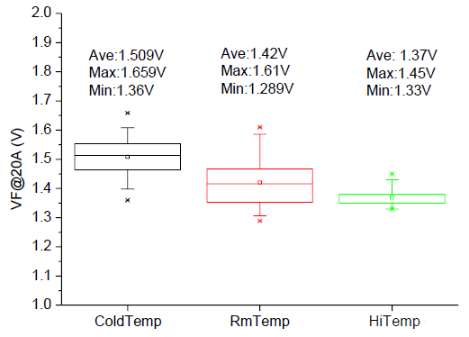 | 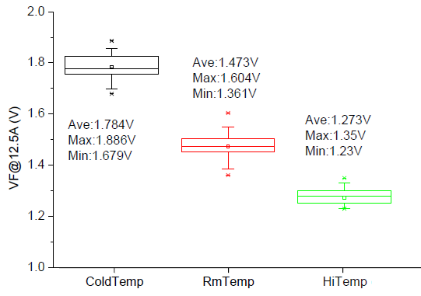
Idss (leakage current)
{{Product_Name}} (Q1) | NSSF080CM1K2ESAH (Q2)
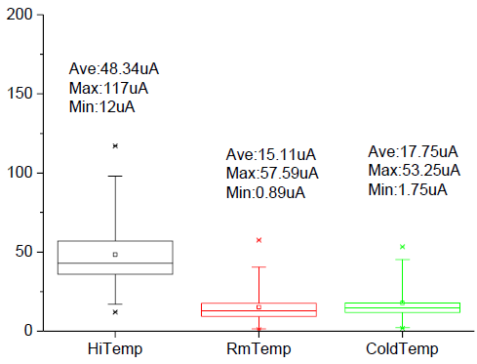 | 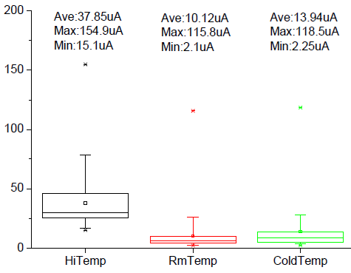
BVdss (breakdown voltage)
{{Product_Name}} (Q1) | NSSF080CM1K2ESAH (Q2)
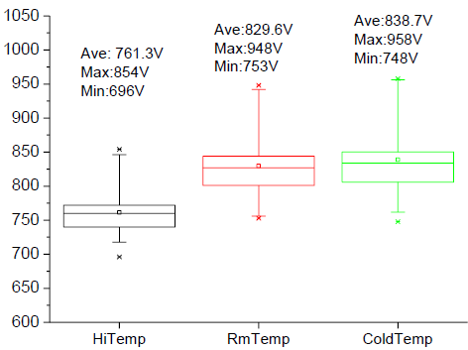 | 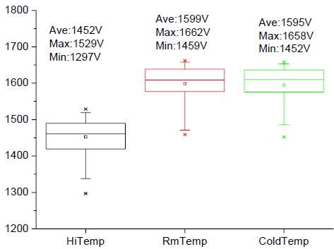
- End of Report -

