A Formal Verification Framework for Secure Key
Exchange Protocol using Atomicity Decomposition
in Event- B

Abstract. Complex systems are modelled and verified in Event-B through a step-by-step refinement process. An abstract model is gradually transformed into a more detailed one. This work shows how atomicity decomposition breaks one abstract event into smaller, manageable actions. Since Event-B does not directly show how events are linked or the order in which they occur, this study applies the approach to the Diffie–Hellman Key Exchange algorithm to clearly outline each communication step. Key actions such as generating keys, sharing values, and computing the shared secret key are represented through refined events, supported by Event Refinement Diagrams that show how the events are connected. The refinements are then checked using the Rodin tool to ensure correctness and security, showing that atomicity decomposition is an effective way to formally model such systems.
Keywords: Formal Verification · Event- B · Atomicity Decomposition · Diffie Hellman Key Exchange · Cryptograph· RODIN
- Introduction
With rapid technological growth, modern systems and software have become more complex. Traditional testing and debugging methods are no longer enough to find errors in such systems. That’s why the tech industry started adopting formal verification methods to check system correctness more effectively [1]. One of the formal verification techniques, Event-B, is an enhanced version of the traditional B approach for step-by-step system design. It starts with an abstract model that is gradually refined to meet system requirements. The context contains the static elements of the system, and the machine deals with the elements that may change while Events describe the steps through which these changes occur [2][3].
RODIN is a software tool that is used to develop Event-B models and check whether they are correct. It provides an easy-to-use interface that enables users to progressively create, up-date, and enhance models one step at a time. The tool is flexible and can be adapted for different project requirements, which makes it helpful for both academic work and real-world applications [4]. The Rodin tool makes it easier to use Event-B by letting you develop complex system models step by step, starting from basic ideas and refining them into detailed designs. However, Event-B does not clearly define the flow or connection between events during refinement. This issue is resolved by atomicity decomposition, which employs diagrams to make the connections between events and the flow of control between them evident. [5].
Cryptography is a key component of information security and makes use of ideas from computer science and mathematics. Over time, cryptography has evolved from basic techniques like the Caesar cipher to more sophisticated ones like shared keys, public-private keys, hash functions, and digital signatures. This study examines the development of cryptography and demonstrates how new technologies, such as artificial intelligence, can improve data security and encryption [6].
The study demonstrates how cryptographic algorithms can be clearly and systematically designed and verified using Event-B. Using the Diffie–Hellman key exchange as an example, the study breaks the process down into simple, easy-to-follow steps, making it much easier to understand and manage. The Rodin tool is used to ensure that the model functions properly and remains safe throughout. Overall, this work proves that Event-B and atomicity decomposition can help build and verify secure communication systems more effectively.
- An Overview of Atomicity Decomposition
Atomicity decomposition is a method used in Event-B to break one big event into smaller steps that are easier to understand and manage. In normal Event-B refinement, a concrete event typically refines an abstract event, but other new events are regarded as skip refinements and have no obvious connection to the original event [5]. This makes it hard to see how the whole process actually works. Atomicity decomposition addresses this by using a simple diagram to show the sequence and connections between all the smaller events. It makes the sequence of actions easy to follow and shows how each step plays a part in the overall process [7].
Let’s understand this idea using an easy example of withdrawing money from a bank. At the abstract level, there might be a single event:
E1: Withdraw Money
Balance = Balance – Amount
It seems simple, but in reality, withdrawing money involves several steps. While refined, this one event can be split into three smaller events:
E21: Verify the user’s PIN.
E22: Check ATM cash availability.
E23: Dispense money and update the account balance.
In the usual Event-B refinement process, only E23 would refine the abstract event E1, while E21 and E22 would just refine skip. Atomicity decomposition, on the other hand, shows all three steps clearly in a diagram called Event Refinement Structure (ERS) [8], with arrows connecting them in order (E21 → E22 → E23). A solid line shows the main refinement (E23), while dashed lines show helping events (E21, E22). Together, these smaller events achieve the same effect as the single abstract withdrawal event and make the whole process easier to understand. Figure 1 given below depicts the bank withdrawal process represented through an Event Refinement Structure.
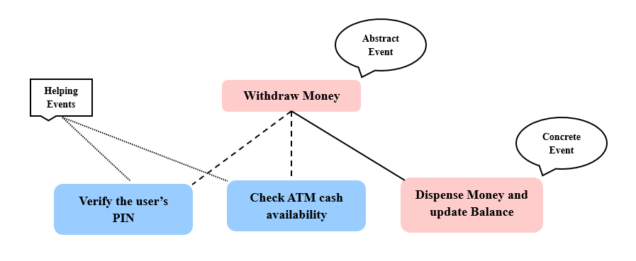
Fig. 1. ERS illustrating the Bank Withdrawal process
- Related Works
Several researchers have explored atomicity decomposition to improve clarity, structure, and refinement in Event-B models. This section reviews the key studies, methods, and tools developed to support explicit control flow and event decomposition within the Event-B framework. Michael Butler’s research [8] introduces two effective ways to make Event-B refinement easier and manageable. He explains how event refinement diagrams can show the steps of breaking a big event into smaller parts, and how dividing a model into sub-models allows different parts to be refined separately. In another study, Asieh Salehi Fathabadi and colleagues point out that while Event-B allows for gradual, step-by-step refinement, it often doesn’t clearly show the sequence of events or how the detailed events relate back to the original abstract ones. They tested this method on large case studies and developed a tool to support it based on their results. They tested this method on large case studies and developed a tool to support it based on their results. Additionally, in [9], the authors use a multimedia communication system as a case study to assess how the atomicity decomposition approach works in Event-B. Their study shows that using diagrams makes it simpler to model complex refinements and also offers suggestions for improving the existing notation. The authors have also applied these techniques to a spacecraft system [10], demonstrating how they help make refinements clearer in bigger and more complex models. Their findings offer practical guidance for applying these techniques in future Event-B work. Further, Rahul Karmakar et al. show that Event-B can model the Stop-and-Wait ARQ protocol but often struggles to clearly represent control flow between refined events [7]. Their work uses graphical atomicity decomposition and Rodin validation to make these event relationships easier to understand and verify. Thai Son Hoang et al. in another research [11] explain how combining refinement and decomposition in Event-B can simplify the design of parallel programs. Their approach makes designing and verifying the system easier by dividing it into smaller parts that can be refined one at a time. The author also shared practical guidelines for Event-B decomposition in [12], high-lighting that thoughtful design and planning are key to creating sub-models that can be refined on their own. They also note that existing tools and methods aren’t sufficient, emphasizing the need for improved approaches and further research on combining decomposition techniques and automating decomposability checks. Renato Silva et al. explains how Event-B models can be divided into smaller parts using the Rodin toolset, making it easier to manage and refine large systems. Their work highlights two decomposition styles, shared variables and shared events, showing how each supports modular development and smoother proof handling in complex projects. Overall, the reviewed studies show how Event-B refinement and decomposition help build complex systems in a clear, structured, and manageable way.
- A Case Study on Diffie Hellman Key Exchange Algorithm
This case study uses the Diffie–Hellman Key Exchange method to demonstrate how atomicity decomposition can be applied in a real-world system. First, we explained how the algorithm works and outlined the requirements necessary for secure key generation and communication. Next, we demonstrated how the system can be modeled in Event-B by breaking the key exchange process into smaller, detailed events using atomicity decomposition. Breaking the process into smaller steps makes the design easier to follow and ensures the system is developed clearly, accurately, and in an organized way.
  - System Description and Key Requirements
The Diffie–Hellman Key Exchange algorithm lets two parties securely establish a shared secret key without ever transmitting the key over the network. Each participant shares only public information and keeps their private data hidden, making it extremely hard for anyone else to figure out the shared secret. This subsection gives a brief and straightforward explanation of how the algorithm works, followed by a list of the system requirements.
- REQ1: The system needs to have two parties who want to securely generate a shared secret key. (ENV)
- REQ2: The system must give both parties a common public prime number p and a public base value g. (ENV)
- REQ3: Each participant needs to create their own private key and keep it secret. (FUN)
- REQ4: Each participant uses their private key together with the shared values to compute a public key. (FUN)
- REQ5: The system should allow both parties to exchange their public keys, even over an insecure communication channel. (FUN)
- REQ6: Each party must combine its private key with the other party’s public key to compute the shared secret key. (FUN)
- REQ7: Both parties need to generate the same shared secret key in the end. (FUN)
These requirements provide a clear framework of the steps and conditions necessary for modeling the Diffie–Hellman Key Exchange in Event-B. They offer a framework to model the key exchange process in a structured, clear, and easily manageable way through atomicity decomposition.

  - System Modelling with Event- B using Atomicity Decomposition
The base Event-B model is designed to capture the core behavior of the Diffie–Hellman key exchange process in a clear and structured way. This model focuses on the essential steps required to generate private keys, compute public keys, exchange public information, and finally derive a shared secret key between two users. By keeping the model abstract, it becomes easier to understand the overall flow of the protocol while ensuring that the fundamental security constraints are preserved. The invariant properties defined for this base model describe the key consistency and dependency rules that must always hold during execution, and these invariant properties are summarized in Table 1.
Table 1. The invariant properties of the Basic Model
Invariants | Properties
INV1 | privatekey ∈ USER ⇸ ℕ
INV2 | publickey ∈ USER ⇸ ℕ
INV3 | sharedkey ∈ USER ⇸ ℕ
INV4 | dom(publickey) ⊆ dom(privatekey)
INV5 | dom(sharedkey) ⊆ dom(privatekey)
INV6 | dom(sharedkey) ⊆ dom(publickey)
INV7 | ran(privatekey) ⊆ ℕ1
INV8 | ran(publickey) ⊆ ℕ1
INV9 | ran(sharedkey) ⊆ ℕ1
INV10 | ∀u· u ∈ dom(sharedkey) ⇒ dom(publickey) ≠ ∅
INV11 | ∀u· u ∈ dom(privatekey) ⇒ privatekey(u) < p
INV12 | ∀u· u ∈ dom(publickey) ⇒ publickey(u) < p
INV13 | ∀u· (u ∈ dom(sharedkey) ⇒ sharedkey(u) ∈ 1‥ (p − 1))
The events in the base model represent the main steps involved in the Diffie–Hellman key exchange process and describe how the system state changes during execution. The Generate_PrivateKey event creates a private key for a user, followed by the Compute_PublicKey event, which computes the corresponding public value. Another event Exchange_PublicKey manages the exchange of public keys between users so that both parties have the necessary information. The ultimate event Compute_SharedKey derives the shared secret key using the private key and the received public key. Together, these events explain how the protocol moves from initial key creation to secure key agreement, and they are summarized in Table 2.
Table 2. The Events of the Basic Model
Generate_PrivateKey
ANY
u
n
WHERE
grd1: u ∈ USER
grd2: n ∈ ℕ1
grd3: u ∉ dom(privatekey)
THEN
act1: privatekey(u) ≔ n
END
Compute_PublicKey
ANY
u
WHERE
grd1: u ∈ dom(privatekey)
grd2: u ∉ dom(publickey)
THEN
act1: publickey(u) ≔ (g ^ privatekey(u)) mod p
END
Exchange_PublicKey
ANY
u
v
WHERE
grd1: u ∈ dom(publickey)
grd2: v ∈ dom(publickey)
grd3: u ≠ v
THEN
act1: publickey ≔ publickey
END
Compute_SharedKey
ANY
u
v
WHERE
grd1: u ∈ dom(privatekey)
grd2: v ∈ dom(publickey)
grd3: u ≠ v
grd4: u ∉ dom(sharedkey)
THEN
act1: sharedkey(u) ≔ (publickey(v) ^ privatekey(u)) mod p
END
The advanced model refines the basic model by describing the Diffie–Hellman key exchange in a more detailed and structured way. In this refinement, the abstract steps are expanded into concrete actions such as generating a private key, validating it, computing the public key, exchanging public keys, and finally computing the shared key. A key purpose of this refinement is to introduce clear flow control, ensuring that each user follows the protocol in the correct order and cannot skip or repeat steps. This is achieved by using state variables and invariant relationships that control when an event can occur. As a result, the model becomes easier to understand, analyze, and verify, while still remaining consistent with the behavior defined in the basic model. The properties of the variables used in this advanced model are listed in Table 3.
Table 3. Variable and Event Relationship Properties of the Advanced Model
VARIABLES | EVENT RELATIPNSHIP PROPERTIES
Generate_PrivateKey | P1: Generate_PrivateKey ⊆ USER
Generate_RandomKey | P2: Generate_RandomKey ⊆ Generate_PrivateKey
Validate_PrivateKey | P3: Validate_PrivateKey ⊆ Generate_RandomKey
Compute_PublicKey | P4: Compute_PublicKey ⊆ Validate_PrivateKey
Exchange_PublicKey | P5: Exchange_PublicKey ⊆ USER × USER
Compute_SharedKey | P6: Compute_SharedKey ⊆ Compute_PublicKey
-- | P7: Generate_RandomKey ∩ Validate_PrivateKey = ∅
-- | P8: Generate_PrivateKey ∩ Compute_PublicKey = ∅
The advanced model explains the key exchange process in small and clear steps so that the movement of each user through the system can be easily followed. The process begins with Generate_PrivateKey, where a user is selected to start the key generation process. After that, Generate_RandomKey assigns a valid random number as the user’s private key. The Validate_PrivateKey step checks whether this private key is acceptable before moving forward. Once the key is validated, Compute_PublicKey creates the public key using the private key and system values. The Exchange_PublicKey step represents users sharing their public keys with each other. In the last step, Compute_SharedKey, each user computes the final shared secret using the received public key and their own private key. All these are normal events and they follow a fixed order, which helps control the flow of the system and prevents steps from happening too early. The events of the advanced model are shown in Table 4.

Table 4. The Events of the Advanced Model
Generate_PrivateKey
REFINES
Generate_PrivateKey
ANY
u
n
WHERE
grd1: u ∈ USER
grd2: n ∈ ℕ1
grd3: u ∉ Generate_PrivateKey
THEN
act1: Generate_PrivateKey ≔ Generate_PrivateKey ∪ {u}
END
Generate_RandomKey
ANY
u
n
WHERE
grd1: u ∈ Generate_PrivateKey
grd2: u ∉ Generate_RandomKey
grd3: n ∈ 1‥(p−1)
THEN
act1: Generate_RandomKey ≔ Generate_RandomKey ∪ {u}
act2: privateKey(u) ≔ n
END
Validate_PrivateKey
ANY
u
WHERE
grd1: u ∈ Generate_RandomKey
grd2: u ∉ Validate_PrivateKey
THEN
act1: Validate_PrivateKey ≔ Validate_PrivateKey ∪ {u}
END
Compute_PublicKey
REFINES
Compute_PublicKey
ANY
u
WHERE
grd1: u ∈ Validate_PrivateKey
grd2: u ∉ Compute_PublicKey
THEN
act1: Compute_PublicKey ≔ Compute_PublicKey ∪ {u}
act2: publicKey(u) ≔ (g ^ privateKey(u)) mod p
END
Exchange_PublicKey
REFINES
Exchange_PublicKey
ANY
u
v
WHERE
grd1: u ∈ Compute_PublicKey
grd2: v ∈ Compute_PublicKey
grd3: u ≠ v
grd4: (u ↦ v) ∉ Exchange_PublicKey
THEN
act1: Exchange_PublicKey ≔ Exchange_PublicKey ∪ {u ↦ v}
END
Compute_SharedKey
REFINES
Compute_SharedKey
ANY
u
v
WHERE
grd1: u ∈ Compute_PublicKey
grd2: v ∈ Compute_PublicKey
grd3: u ≠ v
grd4: u ∉ Compute_SharedKey
THEN
act1: Compute_SharedKey ≔ Compute_SharedKey ∪ {u}
act2: sharedKey(u) ≔ (publicKey(v) ^ privateKey(u)) mod p
END
  - RODIN Based System Visualization and Event Refinement Overview
The major events in the Diffie–Hellman key exchange model have been carefully identified and organized to make the overall structure and flow of the system easier to understand. This clear structure also shows how each abstract action is divided into concrete and supporting events, keeping the modeling process well organized and easy to understand. Figure 2 shows a snapshot from the Rodin tool, highlighting how the algorithm is modeled using Event-B.

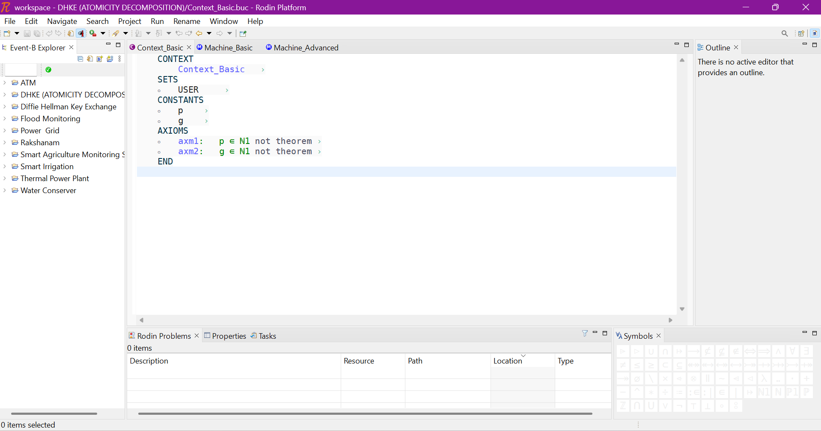 | 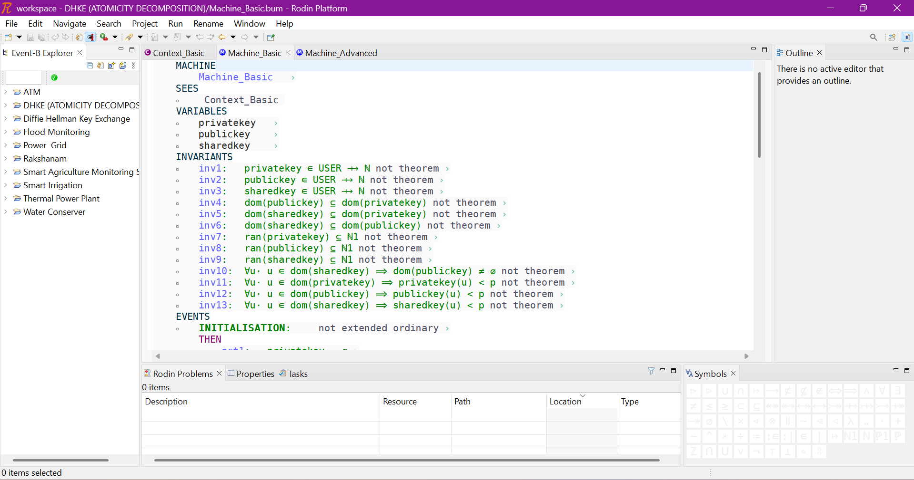
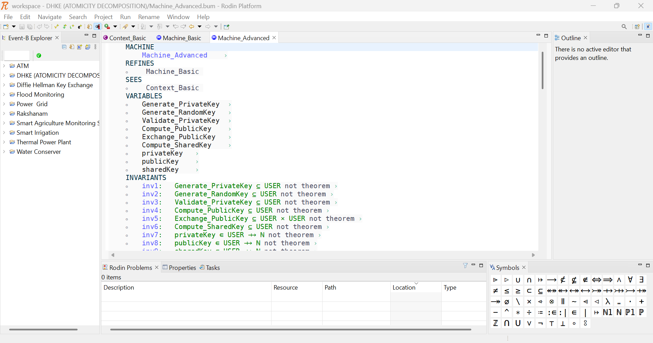 | 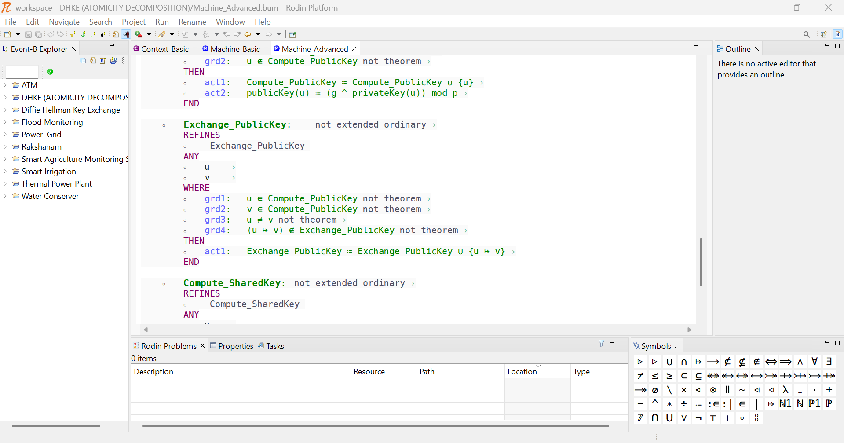
Fig. 2. RODIN Workspace showing Event- B Modelling of the Key Exchange Algorithm
The event refinement diagram for the Diffie–Hellman key exchange model shown in Figure 3 clearly illustrates how the system is refined step by step. It shows how abstract events are divided into concrete and supporting events using atomicity decomposition. In the diagram, the pink states represent the abstract events, the blue states show the concrete events, and the green states indicate the additional events that assist in refining the abstract events. This diagram makes it easier to see how events depend on and interact with each other, showing how the system develops step by step. Overall, it helps make the modeling process simpler to understand and verify.
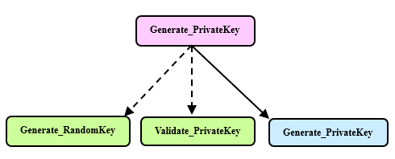 | 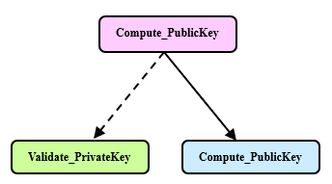
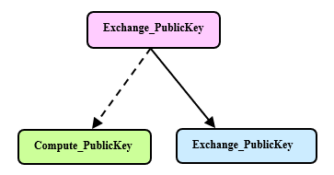 | 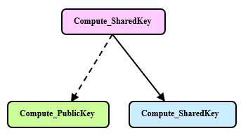
Fig. 3. ERS for the Diffie–Hellman Key Exchange Model
- Model Analysis and Discussion
This section explains and discusses the developed models in a clear way. It describes how the Diffie–Hellman key exchange system is built and checked using Event-B. Both the base model and the advanced model are examined to understand their structure and working. The flow of events and the generated proof obligations are also discussed. This helps to show how the model becomes clearer and more detailed through refinement.
  - Comparative Analysis: Direct Modelling vs. Atomicity Decomposition
The base model shows the Diffie–Hellman key exchange in a simple way. Each main step of the protocol is written as one single event. The order of execution is controlled using guards and conditions, which check whether the required values are available before moving to the next step. This keeps the model short and easy to follow. However, it does not clearly show the small internal steps that happen in between. The flow of events is controlled, but it is not shown in a detailed or structured manner. Because of this, the internal progression of the system is not very visible. The ERS for the base model is depicted below in figure 4.
Fig. 4. ERS for the Base Model
The advanced model improves this by breaking big events into smaller steps using atomicity decomposition. Instead of doing everything in one event, the process is divided into stages like generating the key, validating it, and then computing other values. This makes the flow of control clearer and more organized. The subset conditions help maintain the correct order of events, and the separation between stages avoids confusion. As a result, the behavior of the system becomes easier to understand and verify step by step. The detailed ERS for the advanced model is shown in figure 5.
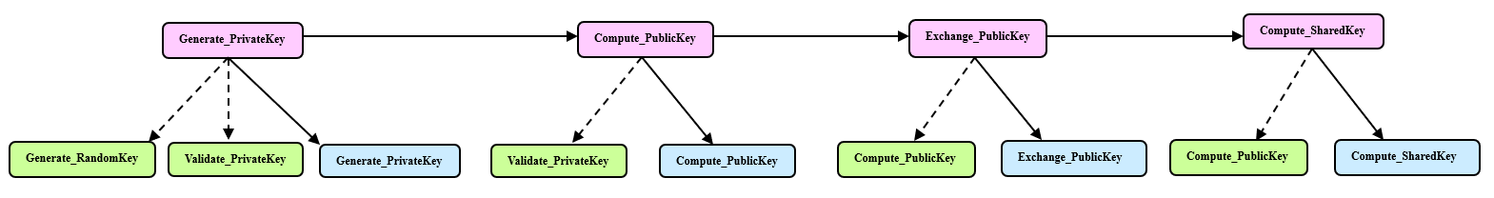
Fig. 5. Detailed ERS for the Advanced Model
  - Formal Analysis and Evaluation of the Proposed Model
This section analyzes and discusses the proof obligations generated using the RODIN tool, as summarized in Table 7. The basic model, Machine_Basic, introduces the system and produces a total of 15 proof obligations, out of which 12 are successfully discharged automatically. The refined model, Machine_Advanced, builds on Machine_Basic and produces 27 proof obligations, out of which 25 are automatically verified.
Some of the proof obligations that were not proved automatically highlights the complexity of the Event-B model and indicates that some parts need careful manual verification. Most of the proofs completed automatically shows that the formal verification process is reliable and effective. However, these results also indicate that some parts of the model’s structure or underlying assumptions might need improvement. Further refinement and continuous validation are therefore essential to achieve a fully verified system, especially in safety-critical applications where high accuracy is required.
Table 7. Proof Statistics based on RODIN Tool

MACHINE | TOTAL | AUTOMATIC | MANUAL | REVERSE | UNDISCHARGED
Machine_Basic  Events 4  Invariants 8 | 27 | 25 | 0 | 0 | 2
Machine_Advanced  Events 6  Invariants 4 | 54 | 49 | 0 | 0 | 5

Formal verification is applied to the Diffie–Hellman key exchange algorithm to ensure that every step of key generation and exchange is performed correctly and securely. Because the algorithm includes several calculations and message exchanges over an insecure channel, even a minor design error can create security vulnerabilities. Modeling the system in Event-B allows the actions of both parties and the key ex-change process to be represented clearly and accurately. Atomicity decomposition assists by dividing a complex operation, like private key generation, into smaller, more manageable steps that are easier to verify. This approach simplifies the model and lowers the risk of hidden errors. Using formal proofs in the Rodin tool further guarantees that all security requirements are satisfied at each stage of refinement. Overall, this approach increases confidence in the correctness, reliability, and security of the Diffie–Hellman key exchange process.
- Conclusion
In this study, we demonstrated how every stage of the Diffie–Hellman key exchange process can be modeled clearly and systematically in Event-B using atomicity de-composition. By breaking a single abstract event into smaller refined events, we were able to model key generation, value exchange, and shared-secret calculation more precisely. Event Refinement diagrams also helped show how events are linked during the refinement process, making the system’s overall behavior easier to understand.
The Rodin tool was used to check the refined Event-B models, ensuring that each step of the key exchange works correctly and securely. This study showed that atomicity decomposition is a practical and effective way to model cryptographic protocols, offering both a clear structure and robust verification. This work emphasizes that combining formal verification with atomicity decomposition can help ensure the reliability, correctness, and clear step-by-step organization of secure communication systems.

References
[1] J.-R. Abrial, Modeling in Event-B: System and Software Engineering. Cambridge, U.K.: Cambridge University Press, 2010.
[2] T. S. Hoang, “An Introduction to the Event-B Modelling Method,” in Industrial Deployment of System Engineering Methods, A. Romanovsky and M. Thomas, Eds., Springer-Verlag, 2013, pp. 211–236.
[3] R. Karmakar, B. Biman Sarkar, and N. Chaki, “System modeling using Event-B: an insight,” in Proceedings of the 2nd International Conference on Information Systems & Management Science (ISMS), 2019. Accessed: Aug. 08, 2025. [Online]. Available: https://papers.ssrn.com/sol3/papers.cfm?abstract_id=3511455
[4] M. Butler and S. Hallerstede, “The Rodin Formal Modelling Tool,” BCS-FACS Christmas 2007 Meeting - Formal Methods In Industry, London, Dec. 2007.
[5] A. S. Fathabadi, M. Butler, and A. Rezazadeh, “A Systematic Approach to Atomicity Decomposition in Event-B,” in Lecture Notes in Computer Science, vol. 7504, 2012, pp. 78–93, doi: 10.1007/978-3-642-33826-7_6.
[6] M. Tarawneh, “Cryptography: Recent Advances and Research Perspectives,” in Cryptography – Recent Advances and Research Perspectives, IntechOpen, 2023, doi: 10.5772/intechopen.111847.
[7] R. Karmakar, B. B. Sarkar, and N. Chaki, “Event Ordering Using Graphical Notation for Event-B Models,” in Computer Information Systems and Industrial Management, vol. 12133, K. Saeed and J. Dvorský, Eds., in Lecture Notes in Computer Science, vol.12133, Cham: Springer International Publishing, 2020, pp. 377–389. doi: 10.1007/978-3-030-47679-3_32.
[8] M. Butler, “Decomposition Structures for Event-B,” in Integrated Formal Methods, vol. 5423, M. Leuschel and H. Wehrheim, Eds., in Lecture Notes in Computer Science, vol. 5423., Berlin, Heidelberg: Springer Berlin Heidelberg, 2009, pp. 20–38. doi: 10.1007/978-3-642-00255-7_2.
[9] A. Salehi Fathabadi and M. Butler, “Applying Event-B Atomicity Decomposition to a Multi Media Protocol,” in Formal Methods for Components and Objects, F. S. de Boer, M. M. Bonsangue, S. Hallerstede, and M. Leuschel, Eds., Berlin, Heidelberg: Springer, 2010, pp. 89–104. doi: 10.1007/978-3-642-17071-3_5.
[10] A. S. Fathabadi, A. Rezazadeh, and M. Butler, “Applying Atomicity and Model Decomposition to a Space Craft System in Event-B,” in Proceedings of the Third NASA Formal Methods Symposium, NASA Formal Methods (NFM) ’11, Pasadena, CA, USA, Apr. 18–20, 2011, Lecture Notes in Computer Science, vol. 6617, pp. 328–342, Springer, 2011, doi: 10.1007/978-3-642-20398-5_24.
[11] T. S. Hoang and J.-R. Abrial, “Event-B Decomposition for Parallel Programs,” in Proc. 2nd International Conference on ASM, Alloy, B and Z (ABZ’10), Orford, QC, Canada, Feb. 22–25, 2010, Lecture Notes in Computer Science, vol. 5977, pp. 319–333, Springer, 2010, doi: 10.1007/978-3-642-11811-1_24.
[12] T. S. Hoang, A. Illiasov, R. Silva, and W. Wei, “A Survey on Event-B Decomposition,” Electronic Communications of the EASST, vol. 46, 2011, doi: 10.14279/tuj.eceasst.46.688.
[13] R. Silva, C. Pascal, T. S. Hoang, and M. Butler, “Decomposition tool for event‐B,” Software: Practice and Experience, vol. 41, no. 2, p. 199, 2011, doi: 10.1002/SPE.1002.

