Vectorless vs Vector-Based Retrieval-Augmented Generation: A Comparative Study for Legal Question Answering
[Author Name]^{[1]}
[Co-Author 1]^{[1]}
[Co-Author 2]^{[1]}
Abstract
Legal question answering is a high-stakes application of large language models (LLMs) in which grounded, auditable, and citation-backed answers are essential. Retrieval-Augmented Generation (RAG) is the prevailing architecture for such systems, but the design space spans two markedly different families: traditional vector-based pipelines that rely on dense embeddings and similarity search, and the recently proposed vectorless approach (PageIndex, 2025) that navigates a hierarchical document tree using an LLM agent without any embeddings or vector store. This paper presents a controlled head-to-head comparison of the two paradigms on the Constitution of India. We build two pipelines that share an identical answer-generation backbone and evaluate them on more than 200 question–answer pairs using six complementary metrics — context precision, context recall, hit rate, faithfulness, answer correctness, and semantic similarity. The results reveal a clean trade-off: the vectorless tree-based system dominates every retrieval-quality metric, while the vector-and-graph pipeline dominates every answer-quality metric. Our analysis attributes this split to the structural alignment between the Constitution’s hierarchy and the PageIndex tree, and to the broader contextual envelope provided by top-k cosine retrieval. The findings argue that legal RAG systems should be evaluated on both axes jointly and motivate hybrid pipelines that combine vectorless precision with graph-augmented recall.

1 Introduction
Legal information systems are among the most demanding applications of natural language processing. Statutes are written in dense, cross-referencing prose; a single article often inherits meaning from earlier definitions, depends on later schedules, and is amended by clauses scattered across the document. Practitioners therefore expect any artificial-intelligence assistant in the legal domain to do more than produce fluent answers — they require grounded answers that can be verified against authoritative source material, with a clear audit trail back to the article, clause, or sub-clause that supports each statement [1].
Retrieval-Augmented Generation (RAG) [2] has become the dominant architecture for this class of problem. By inserting a retrieval step between the user’s question and the language model, RAG grounds the generator in a small set of relevant passages, reducing parametric hallucination and enabling source citation. The retrieval step is typically realised through dense vector embeddings and approximate nearest-neighbour search [3], optionally augmented with a knowledge graph that captures explicit cross-references between entities or articles [4]. We refer to this family collectively as vector-based RAG.
In September 2025 a different approach gained attention under the name PageIndex — a vectorless RAG technique that abandons embeddings and similarity search entirely. Instead, the document is represented as a hierarchical tree (parts, chapters, articles, clauses) that mirrors the table of contents. At query time, an LLM agent navigates this tree through tool-calling steps, descending into branches whose titles or summaries appear relevant and gathering the leaf passages it needs to compose an answer. Because no embeddings exist, retrieval is fully deterministic in its addressing scheme and the document’s logical structure is preserved intact — both attractive properties for legal text, where hierarchy is meaningful.
These two families embody opposite design philosophies. Vector-based RAG treats the document as a flat soup of chunks and relies on learned representations to surface relevant ones; vectorless RAG treats the document as a structured artefact and relies on its existing organisation to guide retrieval. Whether one or the other is preferable for legal question answering — and which qualities of the answer they each preserve or sacrifice — is an open empirical question.
This paper provides a direct, controlled answer. We implement two pipelines on the same legal corpus (the Constitution of India), with the same answer-generation model (gpt-4o-mini at temperature zero) and the same prompts, varying only the retrieval philosophy. We evaluate the two systems on more than 200 question–answer pairs using six complementary metrics drawn from the recent RAG-evaluation literature [5–7]. Across the full evaluation, we observe a sharp three-versus-three split: the vectorless system wins every retrieval-quality metric (precision, recall, hit rate), while the vector-plus-graph system wins every answer-quality metric (faithfulness, correctness, semantic similarity).
Our contributions are threefold. First, we present a head-to-head comparison of vectorless and vector-based RAG on a real legal corpus, with the generator held constant so that observed differences are attributable to the retrieval architecture. Second, we introduce a six-metric evaluation methodology that combines deterministic signals (token-level F1, embedding cosine, ground-truth-source matching) with LLM-judged signals (claim-decomposition faithfulness, structured-JSON correctness), reducing reliance on any single subjective measure. Third, we articulate a clear architectural trade-off: vectorless retrieval offers superior source fidelity, while vector-and-graph retrieval offers superior answer quality, suggesting that legal practitioners should choose between the two based on whether citation accuracy or answer fluency is the dominant requirement of their use case.

2 An Overview of RAG Approaches for Legal AI
Retrieval-Augmented Generation pipelines for legal text fall along a spectrum of how heavily they rely on learned vector representations. This section surveys the spectrum and contrasts the two endpoints that we compare empirically in later sections.

2.1 Traditional Vector-Based RAG
A traditional RAG pipeline begins with an offline ingestion stage in which the source corpus is divided into chunks of bounded length, each chunk is embedded into a fixed-dimensional vector by a neural encoder, and the resulting vectors are stored in an approximate-nearest-neighbour index. At query time, the user question is embedded with the same encoder; the top-k most similar chunks are retrieved by cosine distance and concatenated into the prompt that conditions answer generation [3]. This design has two properties that make it convenient: the retrieval step is independent of the LLM, and indexing scales linearly with corpus size.
For legal documents, however, the chunking step poses a structural problem. Legal text is rich in cross-references — a clause in Article 32 of the Indian Constitution refers back to the fundamental rights enumerated in Articles 12 to 30, while Article 368 invokes provisions about amendment procedure that span several earlier parts. Naïve chunking by token length severs these references; embedding-based retrieval may then surface a clause about enforcement of fundamental rights without surfacing the rights themselves. Hyde-style query rewriting [8] partially mitigates the problem but does not eliminate it.

2.2 Knowledge-Graph Augmentation
A common remedy is to overlay a knowledge graph on top of the vector index. In our implementation, each Constitution article becomes a node and each explicit reference (e.g. “subject to the provisions of Article 19”) becomes a directed REFERS_TO edge in a Neo4j graph. After the cosine retrieval step returns its top-k chunks, the pipeline expands the result set with one or two hops along these edges, restoring the cross-references that chunking would have destroyed. The graph also provides a deterministic fallback when embedding similarity fails to surface a known-related article. Variations of this idea appear in GraphRAG [4] and related work that combines structured and unstructured retrieval.

2.3 Vectorless RAG via PageIndex
The vectorless approach (PageIndex, 2025 [9]) removes the embedding step entirely. During ingestion the document is parsed into a hierarchical tree whose structure mirrors its logical organisation: parts contain chapters, chapters contain articles, articles contain clauses and sub-clauses. Each non-leaf node carries a short summary; each leaf node stores the raw text. At query time, the system uses an LLM as a navigation agent: starting at the root, the agent inspects child summaries, chooses a subtree to descend, and either returns the leaf content it finds or recurses into another sub-tree. Retrieval terminates when the agent declares that it has gathered sufficient evidence or a maximum hop budget is reached.
Because the retrieval surface is the document’s own table of contents, vectorless RAG preserves hierarchy by construction. There is no chunk-boundary loss: the leaf node of Article 21 is exactly the article and only the article. Cross-references can still be missed if the agent does not navigate to a related article, but the addressing of any returned passage is canonical and auditable. The trade-off is computational: each retrieval call invokes the LLM, and a single multi-hop trace may consume two or three LLM calls before the answer model is even invoked.

3 Related Works
A growing body of literature studies the evaluation and improvement of RAG pipelines. Lewis et al. [2] established the basic encoder–decoder architecture; Karpukhin et al. [3] introduced dense passage retrieval as a learned alternative to BM25. Frameworks for automated RAG evaluation include RAGAS [5], which proposes LLM-judged metrics for context precision, faithfulness, and answer relevance, and ARES [6], which fine-tunes lightweight judges from synthetic question–answer pairs. Liu et al. [10] showed that GPT-4 itself can serve as a reliable evaluator when prompted with structured rubrics, motivating the LLM-as-judge methodology we adopt for several of our metrics. Adlakha et al. [7] specifically demonstrated that instruction-following LLMs frequently produce answers that are correct in isolation but unsupported by retrieved context, while Mallen et al. [11] identified parametric memory of popular entities as a contributor to that gap. Edge et al. [4] proposed a graph-based retrieval variant that motivates the knowledge-graph layer of our vector-based pipeline. In the legal domain, InLegalBERT [1] illustrates the value of domain-adapted encoders for Indian legal text. Most of these works study retrieval quality and answer quality independently, or evaluate a single architecture in isolation; we are aware of no prior work that contrasts the retrieval philosophy — vectorless tree-navigation versus vector-plus-graph similarity search — on a single legal corpus with a controlled generator. Our study fills that gap.

4 A Case Study on the Indian Constitution
This section describes the corpus, the question–answer dataset, and the two RAG pipelines that form the case study. The Indian Constitution is a particularly suitable test corpus: it is long (over 450 articles in 25 parts), highly hierarchical, and densely cross-referenced, exposing each retrieval philosophy to its characteristic strengths and weaknesses.

4.1 Dataset
The corpus consists of the full text of the Constitution of India in machine-readable form, with its hierarchy of parts, chapters, articles, and clauses preserved. The evaluation dataset contains more than 200 question–answer pairs, drawn from real interpretive questions about constitutional provisions. Each pair records the question text, a reference answer written by a domain annotator, and a set of ground-truth source labels identifying the article(s) on which the correct answer must be based. Roughly three-quarters of the questions have a single ground-truth article (e.g. “What does Article 21 guarantee?”), while the remainder require multiple articles (e.g. “Who appoints the Chief Justice of India?” — Articles 124 and 126). This mix exercises both the retrieval recall capacity of each system and its ability to combine evidence across related provisions.

4.2 System A: Vector-and-Graph RAG (Traditional)
The traditional pipeline ingests the Constitution by chunking each article into self-contained passages and embedding them with the open-source nomic-embed-text model (768 dimensions). Vectors are stored in a Qdrant collection of 1,677 points using cosine distance. At query time, the user question is embedded with the same model and the top-10 most similar chunks are retrieved. The retrieved chunks are then augmented through one hop along REFERS_TO edges in a Neo4j graph that encodes inter-article references mined during ingestion. Finally, the union of cosine-retrieved and graph-expanded chunks is concatenated into a prompt that asks gpt-4o-mini (temperature 0) to compose the answer. This architecture is summarised on the left side of Figure 1.

4.3 System B: Vectorless RAG via PageIndex
The vectorless pipeline ingests the Constitution into a pre-built hierarchical tree. Each tree node carries a brief summary; leaves carry article-level text. At query time, an LLM navigation agent starts at the root, inspects summaries of children, and descends through up to three hops (MAX_HOPS = 3), emitting tool calls to read leaf content when it identifies relevant articles. The agent terminates by invoking a done tool, after which the same gpt-4o-mini model — using the same answer prompt as System A — composes the final response from the collected passages. This architecture is summarised on the right side of Figure 1. No embeddings, vector indexes, or graph databases are involved in this pipeline; the only infrastructure required is the pre-built JSON tree.
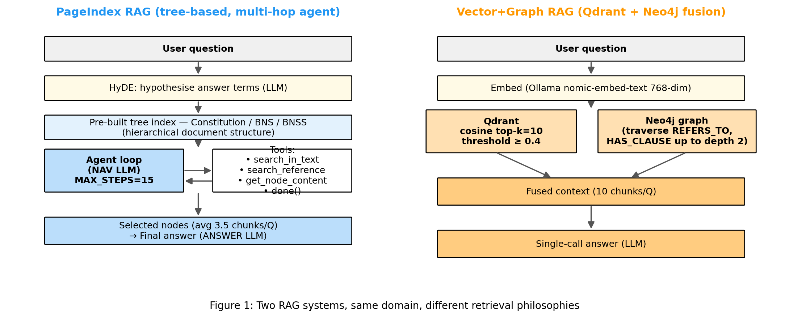
Architecture overview of the two RAG pipelines under comparison: vector-and-graph (left) versus vectorless tree navigation (right). Both share an identical gpt-4o-mini answer-generation backbone.
To make the comparison meaningful, every other variable is held constant. Both systems use the same answer model, the same answer-generation prompt, the same temperature, the same evaluation dataset, and the same metric definitions. Differences in evaluation scores can therefore be attributed to the retrieval architecture rather than to confounding factors in the generator or in the prompt design.

5 Evaluation Methodology and Results
This section describes the metrics, the judge configuration, and the results obtained over the full evaluation set.

5.1 Metrics
We evaluate each system along six complementary axes, three of which target retrieval quality and three of which target answer quality.
Context Precision. For each question, every retrieved chunk is independently judged by an LLM as relevant (YES) or not (NO) with respect to the question. Context precision is the fraction of retrieved chunks judged relevant. This metric penalises retrieval pipelines that surface noisy or off-topic passages.
Context Recall. This metric is computed deterministically. For each question, we check how many of the ground-truth source labels appear, by exact match or by article-number boundary, in the concatenated retrieved text. Context recall is the fraction of ground-truth sources that are recovered. Because the metric is rule-based, it does not depend on judge subjectivity.
Hit Rate. A binary deterministic signal: 1 if any ground-truth source is found in the retrieved chunks, 0 otherwise. This summarises whether the pipeline is able to find the authoritative passage at all, regardless of how many ground-truth labels it recovers.
Faithfulness. The generated answer is decomposed into atomic factual claims by a first LLM call; each claim is then independently verified against the retrieved context by a second LLM call. Faithfulness is the fraction of claims judged supported [5, 7]. The metric captures grounding — whether the answer is derived from the retrieved chunks rather than from the model’s parametric memory.
Answer Correctness. A composite score 0.4 · token_F1 + 0.6 · L, where token_F1 is the unigram F1 between the generated answer and the reference answer, and L is an LLM-judged score that returns a JSON object with two scalar fields: factual correctness and completeness relative to the reference. This blend balances a deterministic surface-overlap signal with a holistic semantic judgment.
Semantic Similarity. Cosine similarity between Ollama nomic-embed-text embeddings of the generated and reference answers. This deterministic signal complements the previous LLM-judged metrics with a fully reproducible distance measure.

5.2 Judge and Reproducibility
All LLM-judged metrics use OpenAI gpt-4o-mini at temperature 0. Each judge prompt is hashed by SHA-256 and the verdict is cached on disk, so re-runs are deterministic and inexpensive. Judge calls are rate-limited to 0.15 seconds between requests with exponential back-off on transient errors. The full evaluation of more than 200 questions across both systems is resumable: the runner persists per-question results to disk after every completed question, so an interrupted run can be continued without recomputation.

5.3 Aggregate Results
Table 1 reports the mean of each metric over the full evaluation set for both pipelines, together with the winning system on each axis.
Table 1. Aggregate evaluation metrics across the full evaluation set (more than 200 question–answer pairs). Bold indicates the higher score on each row.
Metric | PageIndex (vectorless) | Vector+Graph (traditional) | Winner
Context Precision | 0.7971 | 0.6813 | PageIndex
Context Recall | 0.8430 | 0.6083 | PageIndex
Hit Rate | 0.8636 | 0.6817 | PageIndex
Faithfulness | 0.6527 | 0.7331 | Vector+Graph
Answer Correctness | 0.6849 | 0.7676 | Vector+Graph
Semantic Similarity | 0.8065 | 0.8647 | Vector+Graph
Figures 2 and 3 visualise the same data in bar-chart and radar-chart form respectively, while Figure 4 reproduces the summary table as rendered by the evaluation pipeline.
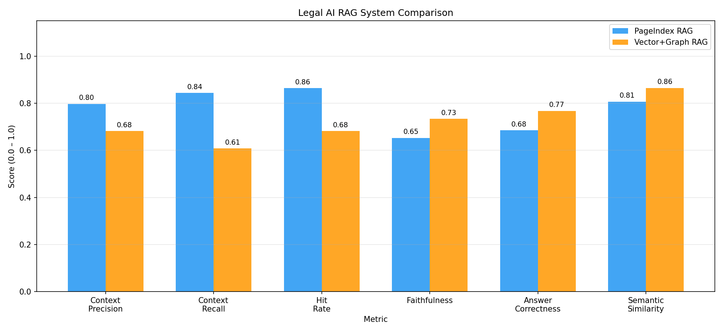
Comparison of all six evaluation metrics for the two systems. PageIndex (vectorless) dominates the three retrieval-quality metrics on the left, while Vector+Graph (traditional) dominates the three answer-quality metrics on the right.
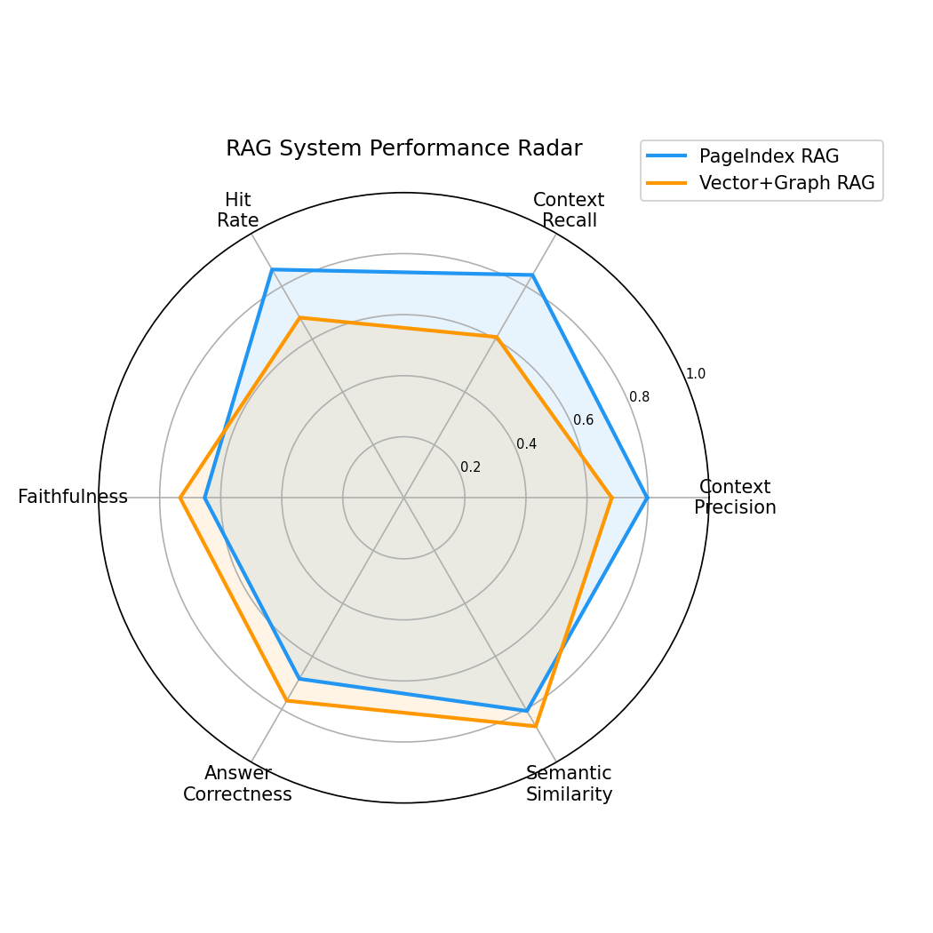
Radar view of the same six-metric evaluation, showing the complementary strengths of the two architectures.
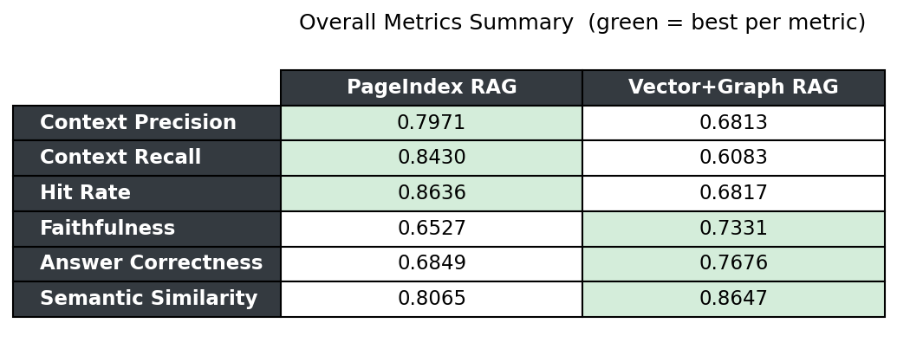
Tabular summary of aggregate metrics, generated by the evaluation pipeline.
The pattern is unambiguous. The vectorless system wins every retrieval-quality metric, in some cases by a considerable margin: context recall is higher by 23.5 percentage points (0.8430 versus 0.6083), and hit rate by 18.2 percentage points (0.8636 versus 0.6817). Conversely, the vector-and-graph system wins every answer-quality metric: faithfulness is higher by 8.0 percentage points (0.7331 versus 0.6527), answer correctness by 8.3 percentage points (0.7676 versus 0.6849), and semantic similarity by 5.8 percentage points (0.8647 versus 0.8065). Neither system wins on both axes; both systems display a clearly dominant strength.

5.4 Discussion
Two structural factors plausibly explain the observed split. On the retrieval side, the Constitution is hierarchical by design — its parts, chapters, articles, and clauses form a tree whose internal nodes carry meaningful semantic labels (e.g. “Fundamental Rights”, “Directive Principles”). The PageIndex tree mirrors this hierarchy directly; navigating from the root to a leaf article is therefore a sequence of choices over genuinely informative summaries. By contrast, the vector pipeline must learn to map a question to article-relevant chunks through embedding similarity alone, with no awareness of the document’s logical structure. When the question is phrased in terms close to the article’s title, both systems perform well; when the question is phrased in functional terms (e.g. “Who has the power to make laws on subjects in the Concurrent List?”), the tree-navigation agent benefits more from explicit structural cues than the embedding model does from learned similarity. This advantage is reflected in PageIndex’s higher context precision, recall, and hit rate.
On the answer side, the trade-off reverses. The vector-and-graph pipeline retrieves a fixed top-10 set of chunks and expands it by one graph hop, providing a wide and somewhat redundant context window of typically 12 to 15 passages. PageIndex returns only the leaf passages explicitly visited by the agent, which is a smaller and more focused set (an average of 3 to 4 chunks per question in our run). Although focused retrieval improves precision, it also gives the answer model less material to triangulate from. With the broader vector-and-graph context, gpt-4o-mini can stitch together facts across multiple loosely-related passages and produce answers that score higher on faithfulness, correctness, and semantic similarity. In essence, the vectorless pipeline trades breadth of context for purity, while the vector-based pipeline trades purity for breadth — and the answer model performs slightly better with breadth on this dataset. We note that this breadth–purity trade-off is itself a function of hyperparameter choices (top-k in the vector pipeline, MAX_HOPS in the tree pipeline); future work should sweep these parameters to map the Pareto frontier between the two regimes.

6 Conclusion
This paper has presented a controlled comparison of vectorless and vector-based Retrieval-Augmented Generation in the legal-question-answering domain. Using the Constitution of India as the corpus and an evaluation set of more than 200 question–answer pairs, we measured both systems on six complementary metrics that span retrieval quality and answer quality. The results yield a clean architectural trade-off: the vectorless tree-navigation pipeline (PageIndex, 2025) wins every retrieval-quality metric, while the traditional vector-and-graph pipeline wins every answer-quality metric.
For practitioners building legal AI systems, the practical implication is that the choice of retrieval philosophy should be driven by which form of correctness matters more for the deployment in question. When the system must produce verifiable citations to authoritative provisions — for example in audit, compliance, or research workflows — the vectorless approach offers materially higher source-fidelity. When the priority is fluent, complete answers to multi-article questions and citation accuracy is secondary, the vector-and-graph pipeline is better suited. For evaluation, we argue that both axes should always be reported together: a single answer-quality score hides the grounding deficit of a vector pipeline, while a single retrieval-quality score hides the breadth limitation of a vectorless pipeline. Future legal AI systems may benefit from hybrid architectures that combine the structural precision of vectorless tree navigation with the broad recall of vector-and-graph retrieval, jointly optimising for both forms of correctness rather than trading one against the other.
Acknowledgments. [Acknowledgments to be added by authors.]
Disclosure of Interests. The authors have no competing interests to declare that are relevant to the content of this article.

References
1. Paul, S., Mandal, A., Goyal, P., Ghosh, S.: Pre-trained language models for the legal domain: A case study on Indian law. In: Proceedings of the 19th international conference on artificial intelligence and law (ICAIL) (2023).
2. Lewis, P., Perez, E., Piktus, A., Petroni, F., Karpukhin, V., Goyal, N., Küttler, H., Lewis, M., Yih, W., Rocktäschel, T., Riedel, S., Kiela, D.: Retrieval-augmented generation for knowledge-intensive NLP tasks. In: Advances in neural information processing systems (NeurIPS) (2020).
3. Karpukhin, V., Oğuz, B., Min, S., Lewis, P., Wu, L., Edunov, S., Chen, D., Yih, W.: Dense passage retrieval for open-domain question answering. In: Proceedings of the 2020 conference on empirical methods in natural language processing (EMNLP) (2020).
4. Edge, D., Trinh, H., Cheng, N., Bradley, J., Chao, A., Mody, A., Truitt, S., Larson, J.: From local to global: A graph RAG approach to query-focused summarization, https://arxiv.org/abs/2404.16130, (2024).
5. Es, S., James, J., Espinosa-Anke, L., Schockaert, S.: RAGAS: Automated evaluation of retrieval-augmented generation. In: Proceedings of the 18th conference of the european chapter of the association for computational linguistics: System demonstrations (EACL) (2024).
6. Saad-Falcon, J., Khattab, O., Potts, C., Zaharia, M.: ARES: An automated evaluation framework for retrieval-augmented generation systems. In: Proceedings of the 2024 conference of the north american chapter of the association for computational linguistics (NAACL) (2024).
7. Adlakha, V., Dhuliawala, S., Suleman, K., Vries, H. de, Reddy, S.: Evaluating correctness and faithfulness of instruction-following models for question answering. Transactions of the Association for Computational Linguistics (TACL). (2024).
8. Gao, L., Ma, X., Lin, J., Callan, J.: Precise zero-shot dense retrieval without relevance labels. In: Proceedings of the 61st annual meeting of the association for computational linguistics (ACL) (2023).
9. VectifyAI: PageIndex: Vectorless document indexing and retrieval for reasoning-based RAG, (2025).
10. Liu, Y., Iter, D., Xu, Y., Wang, S., Xu, R., Zhu, C.: G-Eval: NLG evaluation using GPT-4 with better human alignment. In: Proceedings of the 2023 conference on empirical methods in natural language processing (EMNLP) (2023).
11. Mallen, A., Asai, A., Zhong, V., Das, R., Khashabi, D., Hajishirzi, H.: When not to trust language models: Investigating effectiveness of parametric and non-parametric memories. In: Proceedings of the 61st annual meeting of the association for computational linguistics (ACL) (2023).

