Nuclear structure far off stability – New results from RISING
M.Górska¹, H. Grawe¹, A. Banu¹, A. Bürger², P. Doornenbal¹, J. Gerl¹, M. Hjorth-Jensen³, H. Hübel², F. Nowacki⁴, T. Otsuka⁵, P. Reiter⁶

¹ Gesellschaft für Schwerionenforschung, Planckstr. 1, 64294 Darmstadt, Germany
² Helmholtz-Institut für Strahlen- und Kernphysik, Universität Bonn, Germany
³ Dept. of Physics and Center of Mathematics for Applications, University of Oslo, N-0316 Oslo, Norway

⁴ IReS, F-67037 Strasbourg Cedex 2, France
⁵ Department of Physics and Center for Nuclear Study, University of Tokyo, Hongo, Bunkyo-Ku, Tokyo 113-0033, Japan

⁶ Institut für Kernphysik, Universität zu Köln, Germany

M.Gorska@gsi.de
Abstract. A broad range of physics phenomena can be addressed by high-resolution in-beam γ-ray spectroscopy experiments with radioactive beams offered within the Rare ISotopes INvestigation at GSI (RISING) project. It combines the EUROBALL Ge-Cluster detectors, the MINIBALL Ge detectors, the HECTOR-BaF detectors, and the fragment separator FRS. The secondary beams produced at relativistic energies are used for Coulomb excitation or secondary fragmentation experiments to study projectile like nuclei far off the stability line by measuring de-excitation photons. The physics studied comprises the evolution of shell structure towards the drip lines and its signatures as inferred from excitation energies, mirror symmetry and electromagnetic transition strengths. The first results of the "fast beam campaign" are discussed in comparison to various shell model calculations including the structure of light Sn isotopes based on Coulomb excitation of ¹⁰⁸Sn, the discussion of the N=32,34 sub-shell closure based on neutron-rich ^{56,58}Cr isotopes, and the shell structure in light proton-rich Ca isotopes from the fragmentation of a ³⁷Ca radioactive beam.
- Introduction

The CLUSTER [1] detectors part of the EUROBALL array is presently at GSI where they are being used to explore exotic nuclei with radioactive beams within the RISING (Rare Isotope Spectroscopic INvestigation at GSI) project. The SIS/FRS [2] facility provides secondary beams of unstable rare isotopes after fragmentation reactions or fission of relativistic heavy ions with sufficient intensity for in-beam gamma-ray spectroscopy measurements. The beams can be used either i) at high energies (~100 MeV/u) for relativistic Coulomb excitation and fragmentation reactions, ii) slowed down to Coulomb barrier energies, enabling fusion, multiple Coulomb excitation and direct reactions or iii) stopped for decay studies.
The proposed experiments for the first RISING campaign, which is the main topic of this paper, exploit unique beams at relativistic energies in the range from 100 MeV/u to 400 MeV/u [3]. The RISING spectrometer is employed not only for relativistic Coulomb excitation but also for pioneering high-resolution γ-spectroscopy experiments after secondary nucleon removal reactions and secondary fragmentation. New experimental methods for spectroscopy at relativistic energies are investigated in order to obtain important nuclear structure observables for these exotic nuclei. Several of the accepted experiments focus on new methods and techniques in order to determine magnetic moments and life times of short lived states, properties of isomeric states and spectroscopic factors at relativistic energies for the first time.
The motivations to explore nuclear structure of exotic nuclei at relativistic beam energies focus on a) shell structure of unstable doubly magic nuclei and their vicinity, b) isospin symmetry along the N=Z line and mixed symmetry states, c) shapes and shape coexistence and d) collective modes and E1 strength distribution.
Spectroscopic data on the single particle structure of instable doubly magic nuclei and their nearest neighbours are indispensable for theoretical description by using and tuning effective interactions inferred from a G-matrix in large-scale shell-model calculations [4]. The studies around the N=Z doubly magic nuclei ⁵⁶Ni and ¹⁰⁰Sn provide an excellent probe for single-particle shell structure, proton-neutron interaction and the role of correlations, normally not treated in mean field approaches.
Beyond the very neutron-rich shell closures from ³⁴Si to ¹³²Sn the possible disappearance of the familiar Woods-Saxon shell closures and their reappearance as harmonic oscillator (HO) magic numbers is predicted by several mean-field calculations [5]. Alternatively, observed new shell structure in light and medium-heavy nuclei can be qualitatively understood in terms of monopole shifts of selected nucleon orbitals driven by the tensor force, with predictions for new shell gaps and spin-orbit splitting and experimental signatures deviating from the mean field predictions [6,7,8,9]. The established shell changes from N=8 to N=6 in the p-shell and from N=20 to N=16 besides N=14 in the sd shell should find their continuation in the pf shell with a changeover of the weak N=40 HO subshell to N=32,34 [7,8], which can be monitored in neutron-rich Ca-Cr isotopes. Another implication of monopole driven shell evolution is its symmetry with respect to isospin [7,8], which can be studied in N=20 isotones and their Z=20 (Ca) mirror nuclei.
Moreover, ⁷⁸Ni and ¹³²Sn are located close to the astrophysical rapid neutron capture process path and indirect evidence for an altered shell structure and shell quenching of magic gaps at N=82 and N=126 has been invoked in recent r-process network calculations [10]. The predictive power of nuclear structure theory is lacking experimental verification with respect to the most significant interaction matrix elements, the magnetic moments and the spectroscopic factors.

2. The N=32, 34 subshell closure

The experimental evidence for changing shell structure along the very neutron-rich N=8, 20 and 28 isotones can be explained by the monopole part of the nucleon-nucleon interaction [6,7]. It is traced back to the tensor interaction [8,9] which is strongly binding for nucleons in spin-flip configurations with Δl=0 (spin-orbit partners) and Δl=1,2 in adjacent major shells in the T=0 (proton-neutron) channel of the two-body interaction. It is specifically strong for optimum radial overlap, i.e. identical number of nodes in the radial wave function. The effect was first discussed for the p, sd and pf shells [6,7] with shell gaps changing from the HO magic neutron number N_{m}=8,20,40 to N_{m} - 2∙N = 6,16(14),34(32), with N counting the HO quanta. The ambiguity for N > 1 is due to the presence of j=1/2 orbits as e.g. s_{1/2} or p_{1/2} , which have a strong T=1 (pairing) monopole opening another gap when these shells are filled.
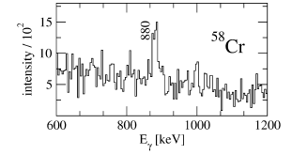
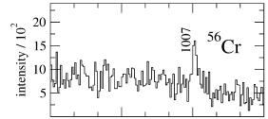
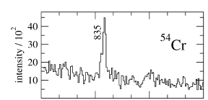
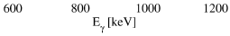
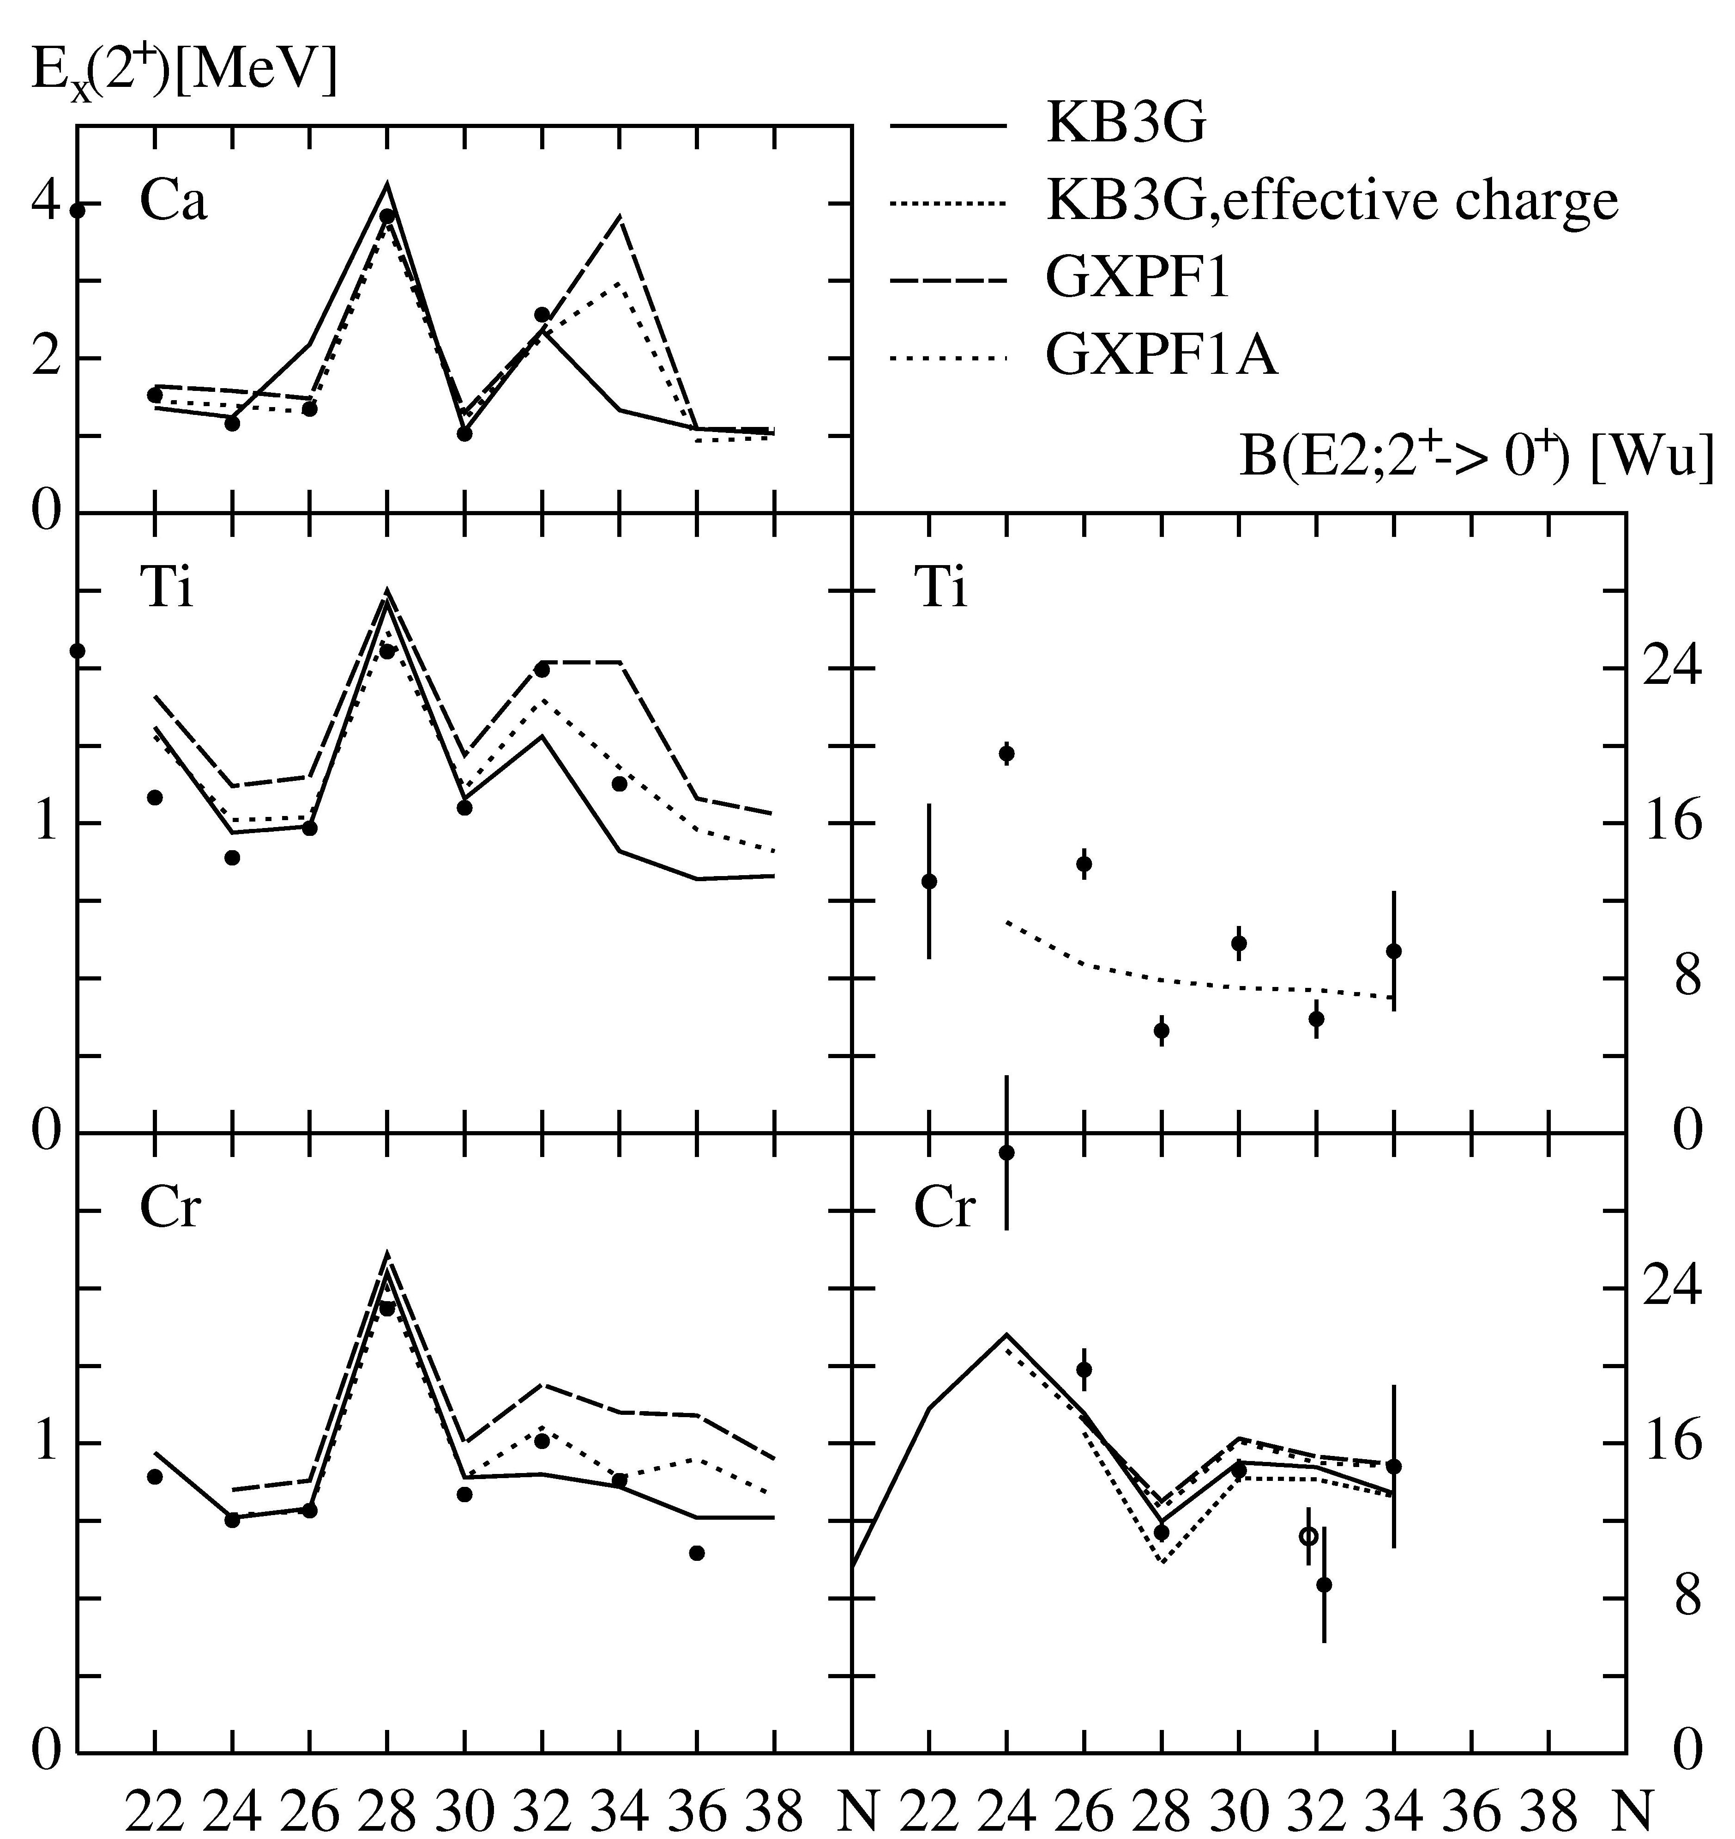
The neutron-rich Cr isotopes are located at a key point on the pathway from the N=40 subshell closure via a deformed region to spherical N=28 isotones. Experimentally a possible N=32 shell develops in the 2⁺ excitation energy of Ca isotopes and a maximum in this signature is also observed for Ti and Cr, while the Ni isotopes show constant 2⁺ energies. Three experiments were performed to measure Coulomb excitation of high-energy ⁵⁴Cr, ⁵⁶Cr and ⁵⁸Cr beams at the FRS-RISING setup at GSI, where the known B(E2;0⁺→2⁺) in ⁵⁴Cr served as normalisation and reference for possible systematic errors in the analysis. Details of the experiment are given in Ref. [11]. The Doppler corrected spectra are shown in Fig. 1 and the extracted B(E2;0⁺→2⁺) and E(2⁺) systematics of the Ti [12] and Cr [11] isotopes is shown in Fig. 2 in comparison to
Fig. 1 Doppler corrected gamma ray spectra in the coulomb excitation of ^{54,56,58}Cr isotopes.
various shell model calculations [13,14]. The local peak in the N=32 E(2⁺) seems to be confirmed by a minimum in B(E2;0⁺→2⁺) in the present experiment and two recent results for Ti isotopes and ⁵⁶Cr. For N=34 , however, the gap has not developed in Cr and Ti which leaves ^{54,56}Ca as the crucial experimental probes. Closer inspection of the shell model results, which all show a flat behaviour with respect to shell structure, indicates that the N=32 gap between p_{1/2} and p_{3/2} stays constant when moving from Ca to Cr into the proton shell while the N=34 gap between p_{3/2} and f_{5/2} reduces strongly in GXPF1/GXPF1A [13] and disappears for KB3G [14].
Fig. 2 Systematics of the energies of the first 2+ states and B(E2) values for Ca, Ti and Cr isotopes in compaison to different shell model calculations KB3G [13] and GXPF1/GXPF1A [14]. The effective charge values are given in [15].

3. Mirror symmetry in A=36, T=2 nuclei

If the new N = 14(16) shell stabilisation and the N = 20 shell quenching in ³²Mg₂₀ are dominated by the monopole part of the two-body interaction and not or little affected by the small neutron binding energy, the scenario is expected to be symmetric in isospin projection T_{z} [7,8]. The ideal site in the Segré chart where this can be verified is the N = 20 mirror region along the light Ca (Z = 20) isotopes. As the lightest Ca isotope with detailed spectroscopy is ³⁸Ca and ³⁴Ca is already unbound in the first excited state, we have chosen ³⁶Ca, the N=16 mirror of ³⁶S, which is known to show doubly-magic features. Recently the Coulomb energy difference (CED) of isobaric analogue states (IAS) and especially the mirror energy difference MED = E_{x}(I,T_{z} = -T) - E_{x} (I,T_{z} = +T) in T_{z} = ± T pairs of nuclei have been studied in extenso [16]. In connection with precise large-scale shell model calculations they have proven to be a sensitive spectroscopic probe to investigate orbital radii in excited states and reduced overlap of identical proton and neutron orbitals at the driplines [17]. Experimental information can be deduced from the MED measurement of ³⁶Ca - ³⁶S, the heaviest T = 2 mirror nuclei studied so far.
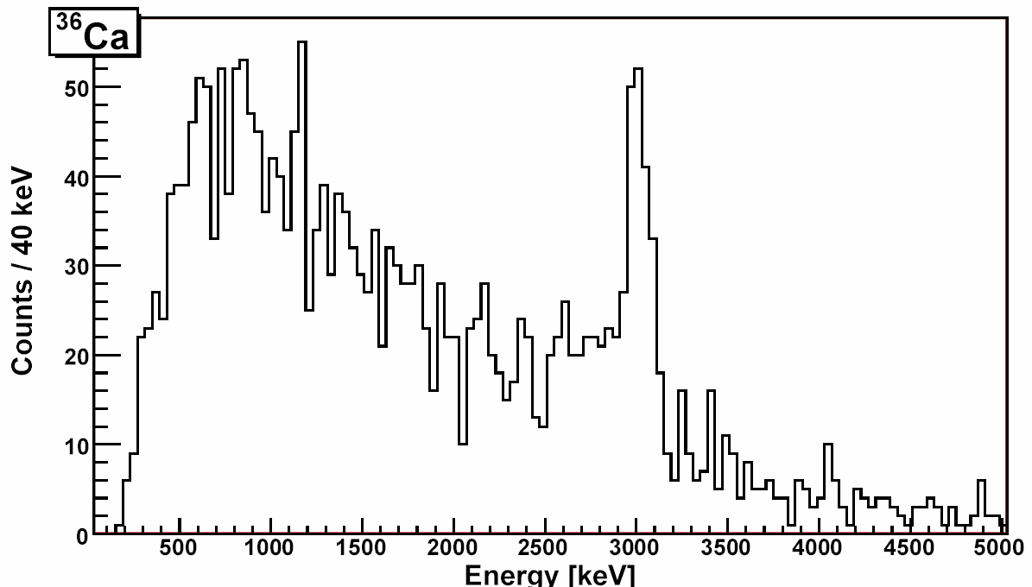
The RISING setup was used to identify excited states in ³⁶Ca, especially the 2⁺→0⁺ decay, employing the two step fragmentation technique. Experimental details will be given in a forthcoming paper [18]. In Fig. 3 Doppler corrected γ-ray spectra for ³⁶Ca fragments are shown for the Cluster and Miniball detectors. An average 2⁺→0⁺ γ-decay energy of 3015(16) keV was determined, resulting in an MED = -276(16) keV for the A=36, T=2 mirrors.
Fig. 3 Doppler corrected gamma ray spectrum of ³⁶Ca
2⁺→0⁺
3015(16) keV
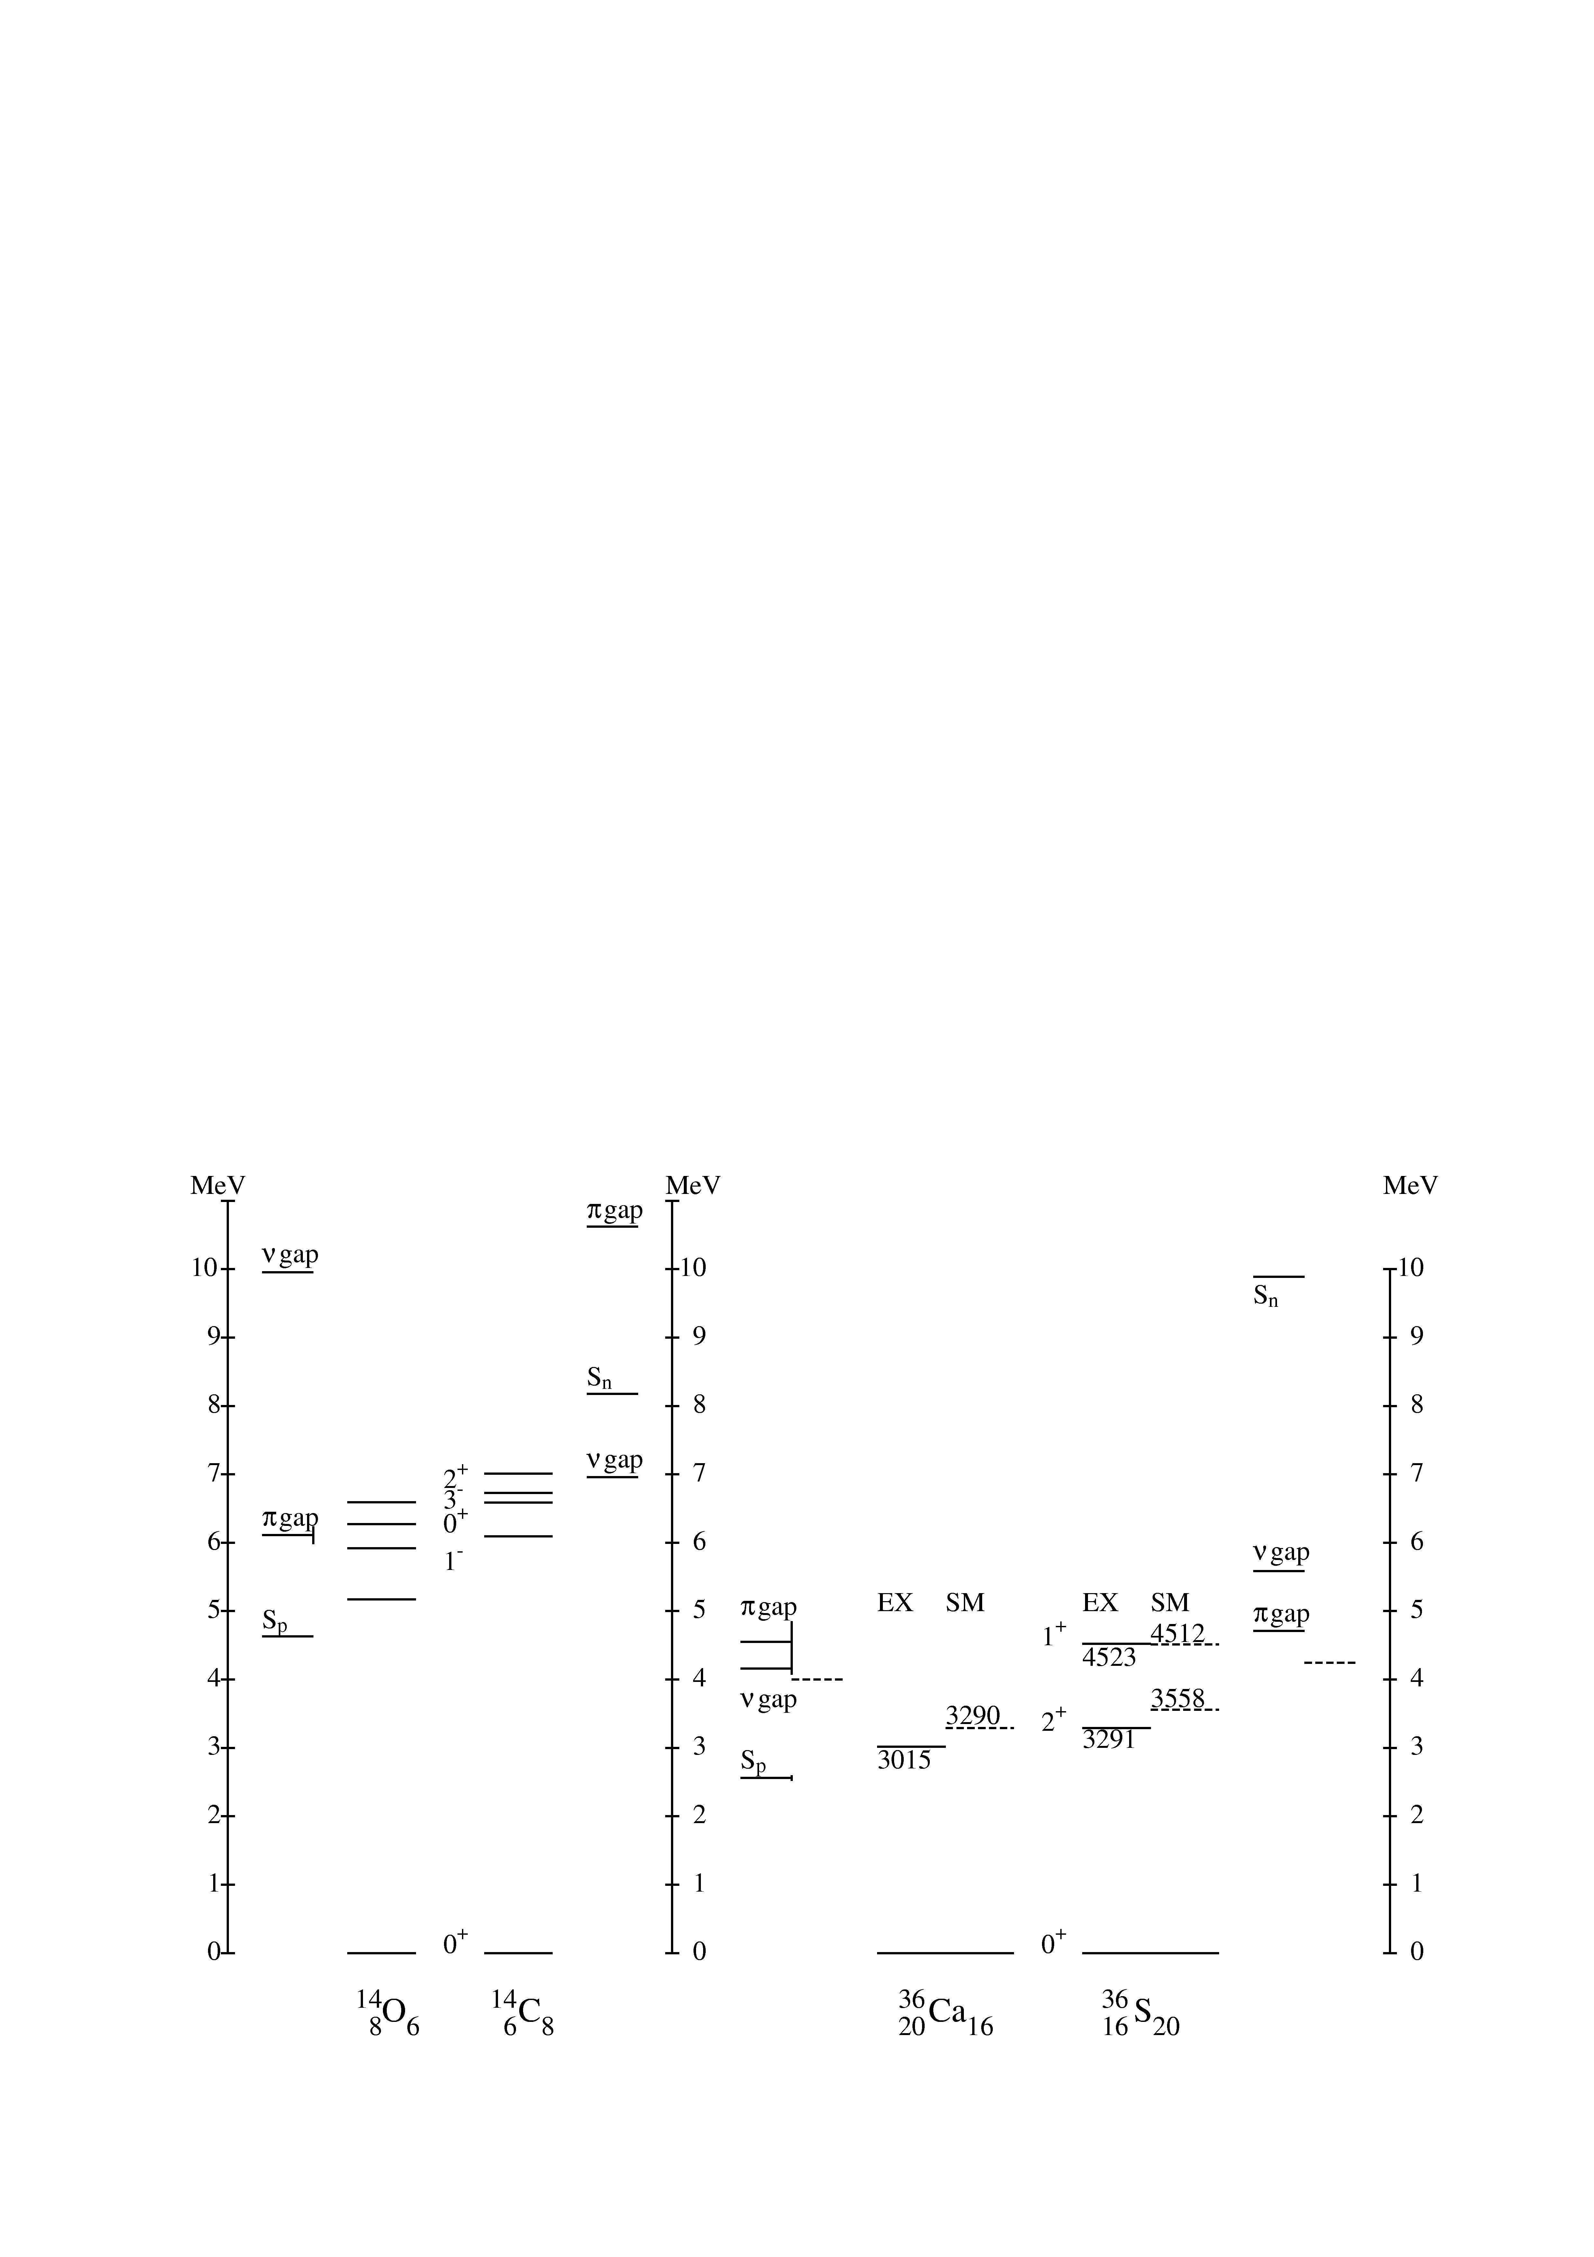
This is about a factor of 5-10 larger than MED´s observed for T=1 states in the sd shell and predominantly single-j valence T = 1 states in the f_{7/2} shell [19]. It exceeds the known sd shell T=2 mirrors for A=24,32 by a factor of three [20,21] and compares only to the T=1 mirrors of the A=14 multiplet in the p shell with MED = - 422(10) keV [19]. Though in general the T = 2 MED´s are larger than the T = 1 values, which may be due to the proton-rich partner lying closer to the dripline, the unique A = 36 and A = 14 cases are obvious. Besides being unbound, these states differ from all other cases in their leading configurations. Due to the known, respective anticipated, subshell Z,N=16 closure in the A=36 mirrors and the known Z,N=6 subshell in A=14 there is not a common particle (p) respective hole (h) valence space for the g.s. and excited state but a pure pp (hh) state for the g.s. and a ph state for the I^{π} = 2⁺ state. Therefore the large MED certainly points to an effect due to shell structure and/or coupling to the continuum for the unbound state in the proton-rich partner and not to a Coulomb effect. This is corroborated by the fact that in both, the A = 14 and A = 36 mirrors, the T_{z} =-T partner exhibits the smaller subshell and closed shell gaps as shown in Fig. 4.
Fig. 4 Spectra of the first excited states in A=14 and A=36 mirror pairs
In the hitherto first systematic attempt based on full sd shell model calculation using the USD interaction, MED´s were calculated for astrophysical application to the rp process [22]. The results fail to reproduce experimental T=2 MED´s by a large margin, yielding e.g. -30 keV for the A=36 T=2 states. In a simpler empirical approach we have used the USD [23] interaction as modified by Utsuno et al. [24] and experimental single particle energies (SPE) from the A = 17, T = 1/2 mirrors. As only the sd part of the interaction was used monopole corrections were applied to reproduce the Z,N = 14,16 shell gaps, the I^{π} = 2⁺ excitation energies and the ⁴⁰Ca single-hole energies , i.e. the semi-magic Z = 8, N=20 and Z=20 sd shell ´´borderline´´ nuclei. The result is shown in Fig. 4 for A=36 excited states and Z,N=16 shell gaps. The agreement with experiment is in view of the simple approach astonishing. Isospin symmetry is preserved in the interaction two-body matrix elements but not in the SPE, and the MED = -268 keV is well reproduced. This indicates that the experimental SPE account empirically for the one-body part of Thomas-Ehrmann and/or Coulomb effects.

4. Shell structure in Sn isotopes

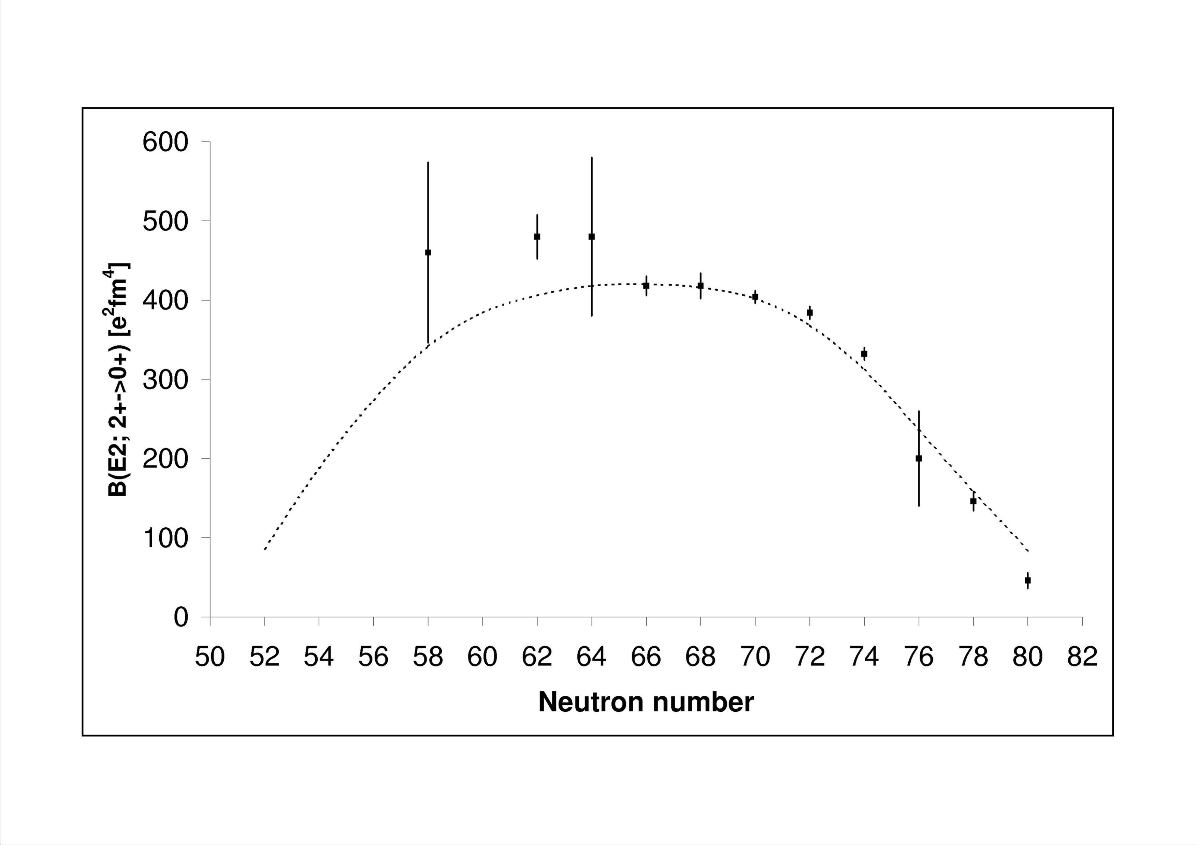
In a monopole driven shell evolution scenario the tensor interaction implies an interesting symmetry. The drifts of spin-orbit partners have opposite sign [9]. As the shell gaps beyond A=40 are determined by the spin-orbit splitting of high-l orbitals with the j> building or intruding into the lower HO shell, this should have consequences for proton cross shell excitations when filling the neutron orbitals. The Sn isotopes between the N=50 and 82 double shell closures provide the longest chain of semi-magic nuclei accessible to nuclear structure studies, both in the neutron valence space of a full
major shell and with emphasis on excitations of the Z=50 core. The B(E2;0⁺→2⁺) value is most sensitive to details of shell structure and E2 core polarization. However, the existence of higher lying isomeric states in the tin isotopes hampers a direct measurement of the lifetime of the 2⁺₁ states by using stable beams and standard Doppler methods, and the very short lifetimes of the 2⁺₁ states are not accessible to electronic timing methods. Therefore, an intermediate energy Coulomb excitation measurement is the only way to obtain this nuclear structure information for the unstable Sn isotopes.
Fig. 5 Comparison of measured B(E2↓) values in Sn isotopes with a realistic shell model calculation from Ref. [25]
In a pilot experiment the first intermediate-energy Coulomb excitation experiment was performed on the ^{108,112}Sn isotopes [25]. The B(E2;0⁺→2⁺) in ¹¹²Sn served as normalisation and reference for possible systematic errors in the analysis. Details of the experiment are given in Ref. [25]. In Fig. 5 the new result for ¹⁰⁸Sn is shown along with the systematics of known data for the stable Sn isotopes.
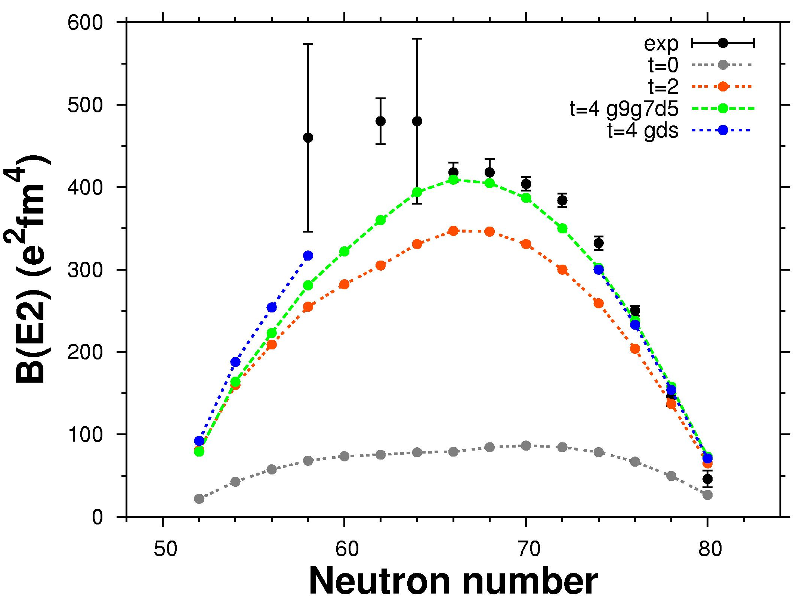
Large-scale shell model (LSSM) calculations employing a realistic interaction derived from a G-matrix for a ¹⁰⁰Sn core [26] were performed in the full neutron (s_{1/2},d_{5/2},d_{3/2,},g_{7/2},h_{11/2}) model space [25]. The results for B(E2;2⁺→0⁺) are shown in Fig. 5, too. An effective neutron charge of 1.0 e was used, yielding an overall good agreement with experiment. The large effective charge is due to the neglect of proton core excitations, and the deviations in light Sn isotopes in spite of large error bars indicate a change in character of these excitations. Therefore, in an alternative approach core excitations were explicitly included in the LSSM calculations. Protons were allowed in the (s_{1/2},d_{5/2},d_{3/2,},g_{7/2}) model space in addition to neutrons in the same model space as in the afore mentioned calculations. Up to 4p-4h proton core excitations were included, and unscreened effective charges of 1.5 e and 0.5 e were assumed for protons and neutrons, respectively. The inert core is ⁹⁰Zr, and the effective interaction, derived along the same lines as in the previous calculation was monopole adjusted to the spectroscopy of Sn isotopes and N = 82 isotones [25,27].The results are shown in Fig. 6 for different levels of truncation. The agreement at the highest level of (t=4 corresponds to inclusion of 4p-4h excitations) is equally good as before, but an inspection of the resulting proton effective single particle energy (ESPE) evolution reveals an interesting feature. To maintain the Z=50 shell gap from ¹⁰⁰Sn to ¹³²Sn the apparent proton g_{9/2} – g_{7/2} spin-orbit splitting remains essentially unchanged, which would contradict the tensor force prediction that filling of the neutron h_{11/2} shell should reduce it substantially. On the other hand the neutron g_{7/2} would cancel the effect not to forget the presence of the d_{5/2},d_{3/2,} and s_{1/2} shells which, however, due to reduced overlap should have less influence.
Fig. 6 Comparison of measured B(E2↓) values in Sn isotopes with LSSM from Ref. [27].
References

- J. Simpson, Z. Phys. A358, 139 (1997)
- H. Geissel et al., et al., Nucl. Instr. Meth. B 70, 286 (1992)
- H.J. Wollersheim et al., Nucl. Instr. Meth. A 537, 637 (2004)
- E. Caurier et al., Rev. Mod. Phys. 77, 427 (2005)
- J. Dobaczewski et al., Phys. Rev. Lett. 72, 981 (1994)
- T. Otsuka et al., Phys. Rev. Lett. 87, 082502 (2001)
- H. Grawe, Acta Phys. Pol. B34, 2277 (2003); Springer Lect. Notes Phys. 651, 33 (2004)
- H. Grawe et al., Eur. Phys. J. A 25, s01, 357 (2005) and A27, s01, 557 (2006)
- T. Otsuka et al., Phys. Rev. Lett. 95, 232502 (2005)
- B. Pfeiffer et al., Nucl. Phys. A693, 282 (2001)
- A. Bürger et al., Phys. Lett. B622, 29 (2005)
- D.C. Dinca et al., Phys. Rev. C71, 041302 (2005)
- E. Caurier et al., Eur. Phys. J. A15, 145 (2002)
- M. Honma et al., Phys. Rev. C69, 034335 (2004) and Eur. Phys. J. A25, s01, 499 (2005)
- J. Ekman et al., Eur. Phys. J. A25,363(2005)
- S.M. Lenzi et al., Phys. Rev. Lett. 87, 122501 (2002) and A.P. Zuker et al., Phys. Rev. Lett. 87,
- G. de Angelis et al., Eur. Phys. J. A 12, 51 (2001)
- P.Doornenbal et al., to be published
- ENSDF database, http://www.nndc.bnl.gov/ensdf/
- H. Schatz et al., Phys. Rev. Lett. 79, 3845 (1997)
- P.D. Cottle et al., Phys. Rev. Lett. 88, 172502 (2002)
- H. Herndl et al. Phys. Rev. C52, 1078 (1995)
- B.A. Brown, B.H. Wildenthal: Ann. Rev. of Nucl. Part. Sci. 38, 29 (1988)
- Y. Utsuno et al., Phys. Rev. C 60, 054315 (1999)
- A. Banu et al., Phys. Rev. C73, 061305(R) (2005)
- M. Hjorth-Jensen, T.T.S. Kuo, and E. Osnes, Phys. Rep. 261, 125 (1995)
- F. Nowacki, private communication

