1.

The Gill Art Gallery wishes to maintain data on their customers, artists and paintings. They may have several paintings by each artist in the gallery at one time. Paintings may be bought and sold several times. In other words, the gallery may sell a painting, then buy it back at a later date and sell it to another customer.

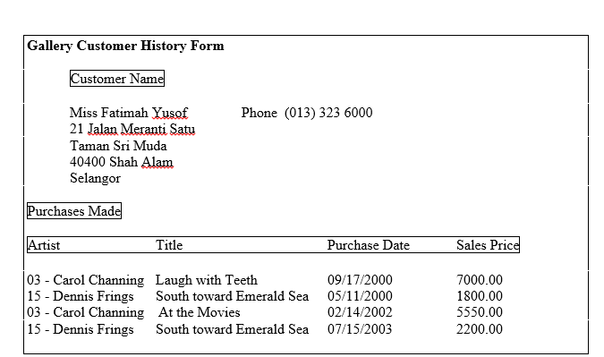

Based on the above relation structure, create a new relation structure using record layout in:

1. Create un-normalize form of relational schema
2. First Normal Form (1NF)
3. Second Normal Form (2NF)
4. Third Normal Form (3NF)

2.

