RA1811028010086

Aayush Mahajan

Aim: Write a socket program to implement a simple TCP Client-Server application, where the Client on establishing a connection with the Server, sends a string to the Server. The Server reads the String and prints it.

Objective: To establish a connection btw server and client and send a message from client to server.

Given Requirements: There are two hosts given, client and server. The client establishes a connection with server, accepts the message from the user and send it to the server. The server receives the message and prints it and echoes it back to client.

Programming Language: Python

Algorithm

Server:

1. Create a socket using the socket() function.
2. Bind the local host address to socket using the bind function.
3. Listen on the socket for the connection request from the client.
4. Accept the connection request from the client using accept function.
5. Fork the process to receive the message from the clien and pin it to the console.
6. Read the message from the console and send it to the client.

Client:

1. Include the necessary header files.
2. Get the server IP address and the Port number from console.
3. Using gethostbyname function receive it from the host and assign it.
4. Request a connection from the server using the connection function.
5. Fork the process to receive the message from the server and pit it to console.
6. Read the message, display it and send back to server.

Server Side Code:

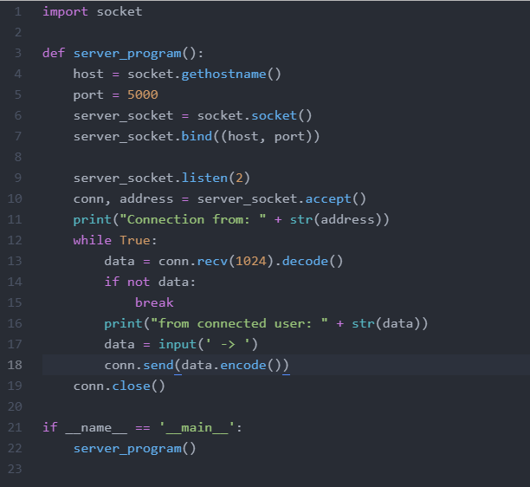

Client Side Code:

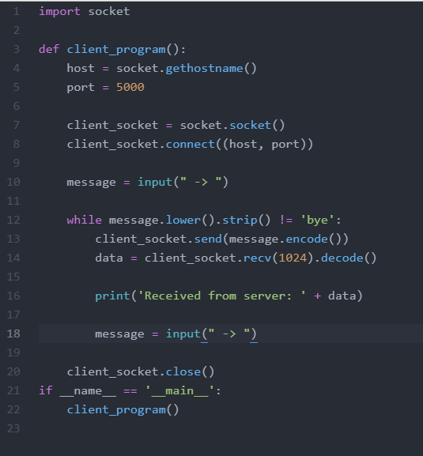

Server Side Output:

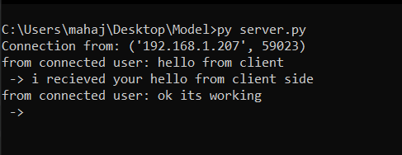

Client Side Output:

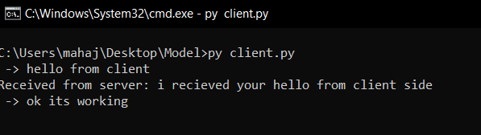

Result:

The program was executed successfully and a connection was established between the client and server using TCP/IP protocol.