
SRM INSTITUTE OF SCIENCE & TECHNOLOGY
DEPARTMENT OF COMPUTER SCIENCE AND ENGINEERING
18CSC302J-COMPUTER NETWORKS
BATCH – 2 , SEMESTER – 5
YEAR 2020-21

REGISTRATION NUMBER | RA1811028010086
NAME | Aayush Mahajan

B.tech-CSE-CC, Third Year (Section: J2)

Faculty Incharge: Vaishnavi Moorthy, Asst Prof/Dept of CSE

INDEX
Ex.no | Topic | Date of completion | Marks | Faculty signature
Assessment-1
1 | Standard Library for Socket IO | 05/08/2020
2 | TCP/IP Client-Server Communication | 12/08/2020
3 | UDP Client-Server Communication | 20/08/2020
4 | Date and time request - TCP/IP communication | 29/08/2020
5 | Half Duplex TCP/IP  Communication | 05/09/20
6 | Full Duplex TCP/IP  Communication | 12/09/20

Faculty Signature

EXPERIMENT: 1
Basic Commands for Socket Programming

Aim: To study the basic commands for socket programming

- man stdio - It is library required for input and output functions. The standard I/O library provides a simple and efficient buffered stream I/O interface. Input and output is mapped into logical data streams and the physical I/O characteristics are concealed.

- man string - library for string manipulation function. The string functions perform operations on null-terminated strings.
Eg:
int strcasecmp(const char *s1, const char *s2);
Compare the strings s1 and s2 ignoring case.

- man net db - database access methods. The supported file formats are btree, hashed and UNIX file oriented. The btree format is a representation of a sorted, balanced tree structure. The hashed format is an extensible, dynamic hashing scheme. The flat-file format is a byte stream file with fixed or variable length records.

- man time - run programs and summarize system resource usage. Time runs the program COMMAND with any given arguments. When COMMAND finishes, time displays information about resources used by COMMAND. If COMMAND exits with non-zero status, time displays a warning message and the exit status. time determines which information to display about the resources used by the COMMAND from the string FORMAT.

- man date - print or set the system date and time. Display the current time in the given FORMAT, or set the system date.

- man stat - display file or file system status,

-f, --file-system
display file system status instead of file status

- man ioctl - control device. system call manipulates the underlying device parameters of special files. In particular, many operating characteristics of character special files may be controlled with ioctl() requests. The argument fd must be an open file descriptor.

- man errno - look up errno names and descriptions, look up errno macro names, errno codes, and the corresponding descriptions. Search for errors whose description contains all the given words (case-insensitive). List all errno values.

- man pcap-filter - packet filter syntax, is used to compile a string into a filter program. The resulting filter program can then be applied to some stream of packets to determine which packets will be supplied to pcap_loop(), pcap_dispatch(), pcap_next(), or pcap_next_ex().

- man system - execute a shell command. The system() library function uses fork(2) to create a child process that executes the shell command.system() provides simplicity and convenience: it handles all of the details of calling fork(2), execl(3), and waitpid(2), as well as the necessary manipulations of signals; in addition, the shell performs the usual substitutions and I/O redirections for command. The main cost of system() is inefficiency: additional system calls are required to create the process that runs the shell and to execute the shell.

- man inet - converts the Internet host address. converts the Internet host address cp from the IPv4 numbers-and-dots notation into binary form (in network byte order) and stores it in the structure that inp points to.

- man read - read from a file descriptor. It attempts to read up to count bytes from file descriptor fd into the buffer starting at buf. On files that support seeking, the read operation commences at the file offset, and the file offset is incremented by the number of bytes read. If the file offset is at or past the end of file, no bytes are read, and read() returns zero.

- man write - send a message to another user. The write utility allows you to communicate with other users, by copying lines from your terminal to theirs.

- man gethostname - These system calls are used to access or to change the hostname of the current processor.returns the null-terminated hostname in the character array name, which has a length of len bytes. If the null-terminated hostname is too large to fit, then the name is truncated, and no error is returned. On success, zero is returned. On error, -1 is returned, and errno is set appropriately.

- man gethostbyname - It returns a structure of type hostent for the given host name. Here name is either a hostname or an IPv4 address in standard dot notation. If name is an IPv4 address, no lookup is performed and gethostbyname() simply copies name into the h_name field and its struct in_addr equivalent into the h_addr_list[0] field of the returned hostent structure.

- man htons - function converts the unsigned short integer hostshort from host byte order to network byte order.

- man htonl - function converts the unsigned integer hostlong from host byte order to network byte order.

- man bind - bind a name to a socket. bind() assigns the address specified by addr to the socket referred to by the file descriptor sockfd. addrlen specifies the size, in bytes, of the address structure pointed to by addr. Traditionally, this operation is called “assigning a name to a socket”.

- man socket - create an endpoint for communication. creates an endpoint for communication and returns a file descriptor that refers to that endpoint. The file descriptor returned by a successful call will be the lowest-numbered file descriptor not currently open for the process.

- man Ifconfig - is used to configure the kernel-resident network interfaces. Ifconfig is used to configure the kernel-resident network interfaces. It is used at boot time to set up interfaces as necessary. After that, it is usually only needed when debugging or when system tuning is needed.

- man send - send a message on a socket. The send() call may be used only when the socket is in a connected state (so that the intended recipient is known). The only difference between send() and write(2) is the presence of flags.

- man recv - receive a message from a socket. They may be used to receive data on both connectionless and connection-oriented sockets. This page first describes common features of all three system calls, and then describes the differences between the calls.

- man accept- accept jobs sent to a destination. The cupsaccept command instructs the printing system to accept print jobs to the specified destinations.

Date: 12.08.20

EXPERIMENT: 2
SOCKET PROGRAMMING USING TCP/IP

Aim: To establish a connection between TCP/IP, where the client establishes a connection with the server, sends and string to the server. The sender receives it and send a reply back.
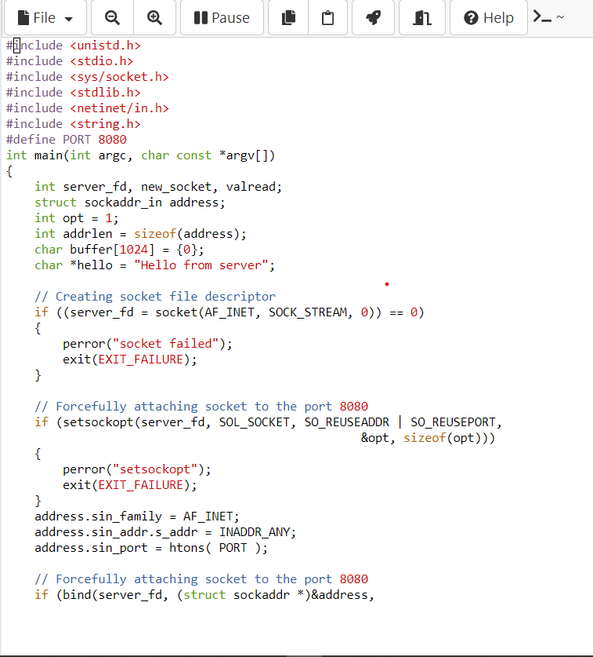
Server Side Code:
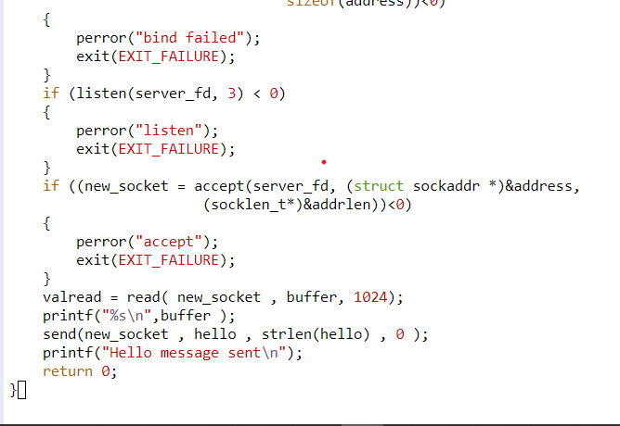

Pseudo code TCP server:
• Create socket (serverSocket)
• Bind socket to a specific port where clients can contact you
• Register with the kernel your willingness to listen that on socket for client to contact you
• Loop
Accept new connection (connectSocket)
Read and Write Data into connectSocket to Communicate with client
Close connectSocket
End Loop
• Close serverSocket

Client Side Code:
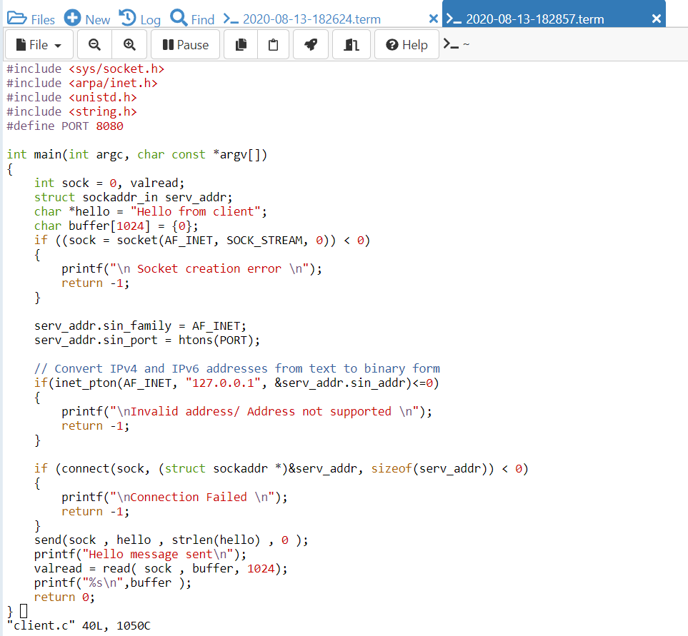
Pseudo code TCP client
• Create socket, connectSocket
• Do an active connect specifying the IP address and port number of server
• Read and Write Data Into connectSocket to Communicate with server
• Close connectSocket

Server Side Output:
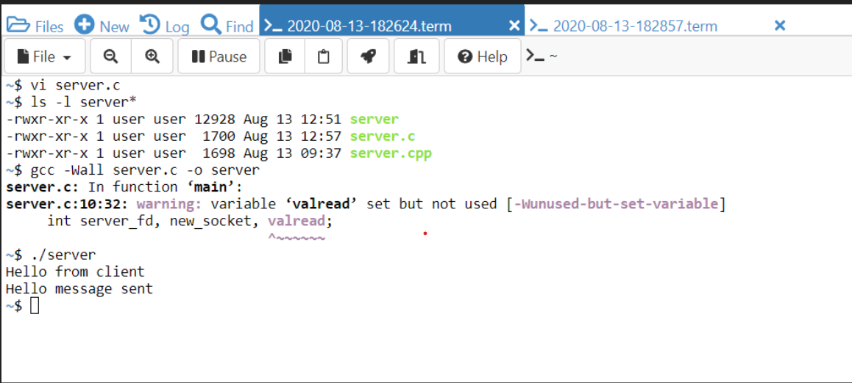

Client Side Output:
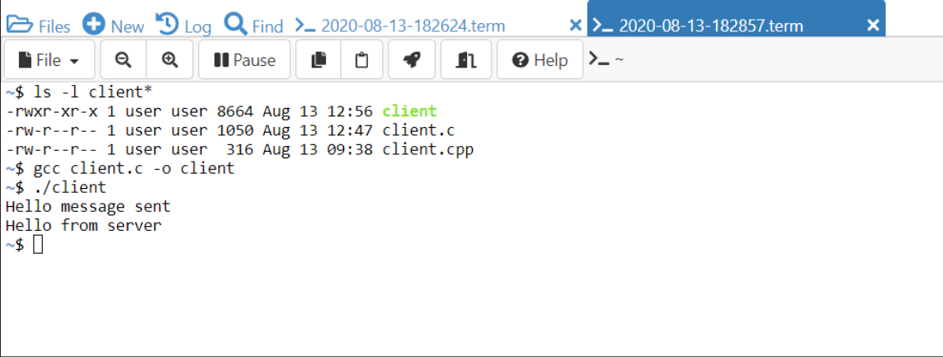

Result: The TCP/IP connection was established.

Date: 20.08.20
EXPERIMENT: 3
UDP Echo Client Server Communication

GIVEN REQUIREMENTS:
There are two hosts, client and server. The client accepts the message from the user and sends it to the server. The server receives the message, prints it and echoes the message back to the client.

TECHNICAL OBJECTIVE:
To implement an TCP/IP client-server application, where the client establishes a connection with the server, sends a string to the server. The server reads the string, prints it and echoes it back to the client and the client reads the string.

Server Side Code:
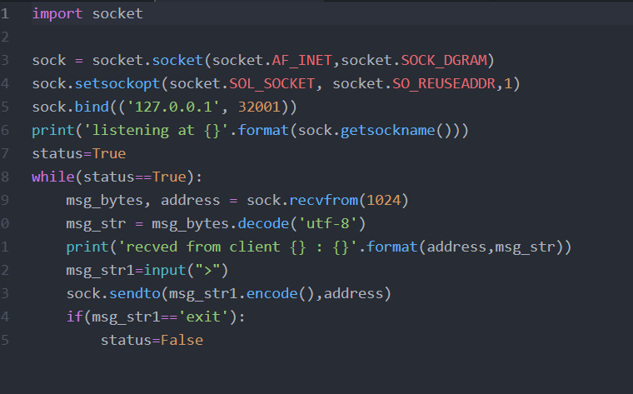

ALGORITHM:
UDP Server:
1. Create UDP socket.
2. Bind the socket to server address.
3. Wait until datagram packet arrives from client.
4. Process the datagram packet and send a reply to client.
5. Go back to Step 3.

Client Side Code:
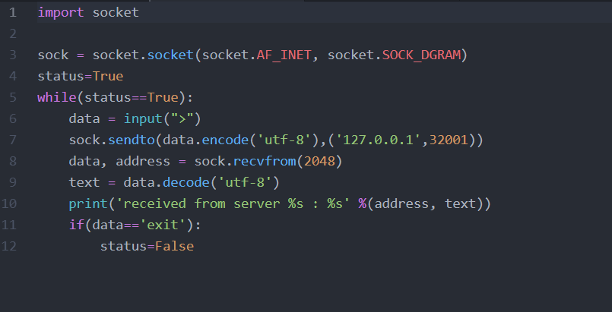
ALGORITHM:
UDP Client:
1. Create UDP socket.
2. Send message to server.
3. Wait until response from server is recieved.
4. Process reply and go back to step 2, if necessary.
5. Close socket descriptor and exit.

Server Side Output:
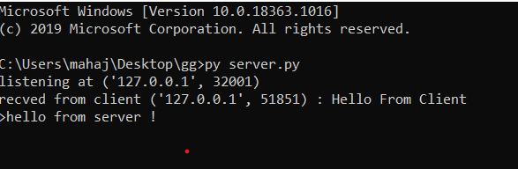

Client Side Output:
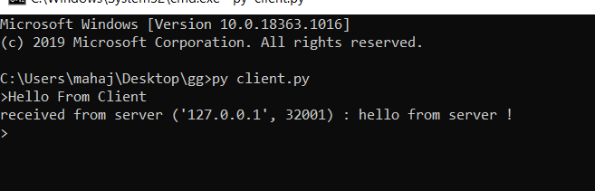

Result: The UDP Echo Client Server Communication was successfully carried out

Date: 29.08.20
EXPERIMENT: 4
Date and Time Request – TCP/IP Communication

GIVEN REQUIREMENTS:
There are two hosts, client and server. The client requests the concurrent server for the date and time. The server sends the date and time, which the client accepts and prints.

TECHNICAL OBJECTIVE:
To implement an TCP/IP day time server (concurrent server) that handles multiple client requests. Once the client establishes connection with the server, the server sends its day - time details to the client which the client prints in its console

Server Side Code:
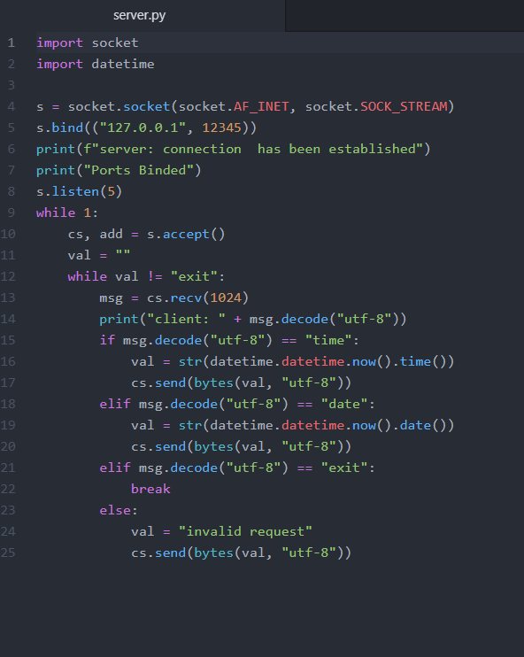

Client Side Code:
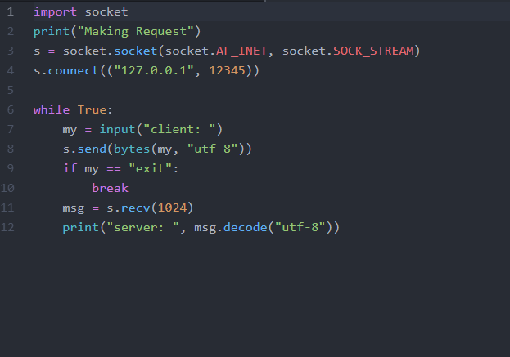

Server Side Output:
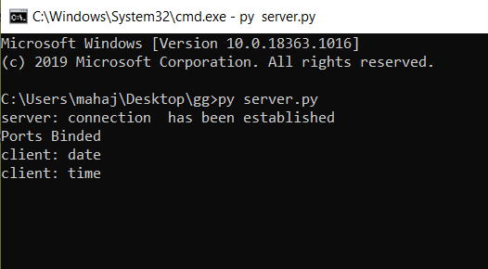

Client Side Output:
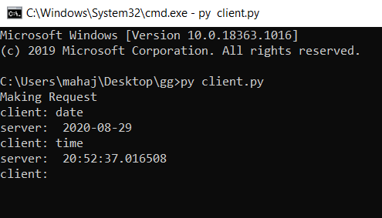

ALGORITHM:
1. Create a TCP server socket.
2. Bind the socket to a server address.
3. Start a client socket while the server socket is passive and waiting for the client to connect.
4. Once connection is established between the client and server socket, send a request for the date or time to the server.
5. Interpret the message from the client and send the required output while the client waits.

Result: The connection between the client and server was established and date and time field was noted successfully.

Date: 5.09.20
EXPERIMENT: 5
Half Duplex Chat Using TCP/IP Communication

AIM:
To implement a half-duplex application, where the Client establishes a connection with the Server. The Client can send and the server well receive messages at the same time.

GIVEN REQUIREMENTS:
There are two hosts, Client and Server. Both the Client and the Server exchange message i.e. they send messages or receive message from the other. There is only a single way communication between them.

TECHNICAL OBJECTIVE:
To implement a half-duplex application, where the Client establishes a connection with the Server. The Client can send and the server well receive messages at the same time.

ALGORITHM:
SERVER:
1. Include the necessary header files.
2. Create a socket using socket function with family AF_INET, type as SOCK_STREAM.
3. Initialize server address to 0 using the bzero function.
4. Assign the sin_family to AF_INET, sin_addr to INADDR_ANY, sin_port to dynamically assigned port number.
5. Bind the local host address to socket using the bind function.
6. Listen on the socket for connection request from the client.
7. Accept connection request from the Client using accept function.
8. Fork the process to receive message from the client and print it on the console.
9. Read message from the console and send it to the client.

CLIENT:
1. Include the necessary header files.
2. Create a socket using socket function with family AF_INET, type as SOCK_STREAM.
3. Initialize server address to 0 using the bzero function.
4. Assign the sin_family to AF_INET.
5. Get the server IP address and the Port number from the console.
6. Using gethostbyname function assign it to a hostent structure, and assign it to sin_addr of the server
address structure.
7. Request a connection from the server using the connect function.
8. Fork the process to receive message from the server and print it on the console.
9. Read message from the console and send it to the server.

Server Side Code:
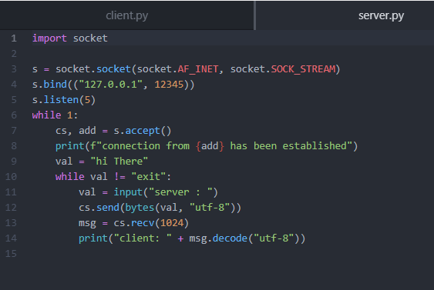
Client Side Code:
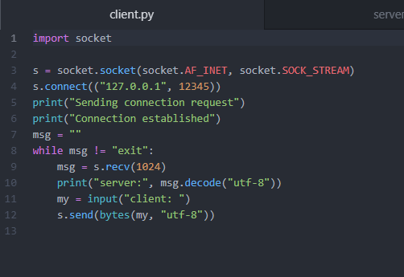

Client Side Output:
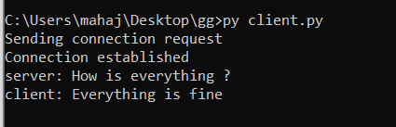

Server Side Output:
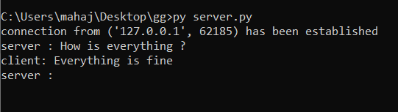

Result: The Half Duplex Chat Using TCP/IP Communication was successfully carried out.

Date: 12.09.20
EXPERIMENT: 6
Full Duplex Chat Using TCP/IP Communication

AIM:
To implement a Full duplex application, where the Client establishes a connection with the Server. The Client can send and the server well receive messages at the same time.

GIVEN REQUIREMENTS:
There are two hosts, Client and Server. Both the Client and the Server exchange message i.e. they send messages to and receive message from the other. There is a two-way communication between them.

TECHNICAL OBJECTIVE:
To implement a full duplex application, where the Client establishes a connection with the Server. The Client and Server can send as well as receive messages at the same time. Both the Client and Server exchange messages.

ALGORITHM

SERVER SIDE:
1. Include the necessary header files.
2. Create a socket using a socket function with family AF_INET, type as SOCK_STREAM.
3. Bind the local host address to the socket using the bind function.
4. Listen on the socket for connection requests from the client.
5. Accept connection requests from the Client using accept function.
6. Fork the process to receive a message from the client and print it on the console and another process to read messages from the console and send it to the client simultaneously.

CLIENT SIDE:
1. Include the necessary header files.
2. Create a socket using a socket function with family AF_INET, type as SOCK_STREAM.
3. Get the server IP address and the Port number from the console.
4. Using gethostbyname function assign it to a hostent structure, and assign it to sin_addr of
the server address structure.
5. Request a connection from the server using the connect function.
6. Fork the process to receive a message from the server and print it on the console and
another process to read messages from the console and send it to the server
simultaneously.

Server Side Code:
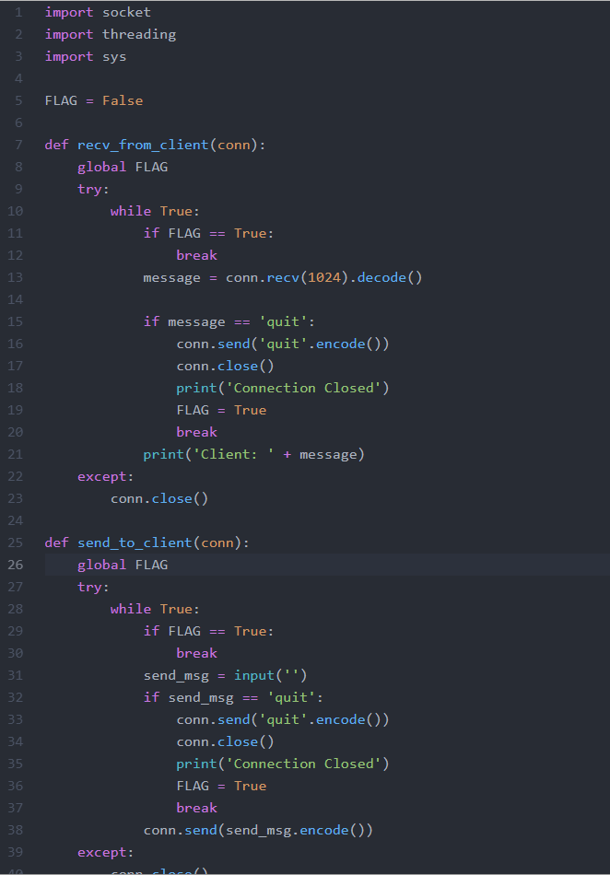
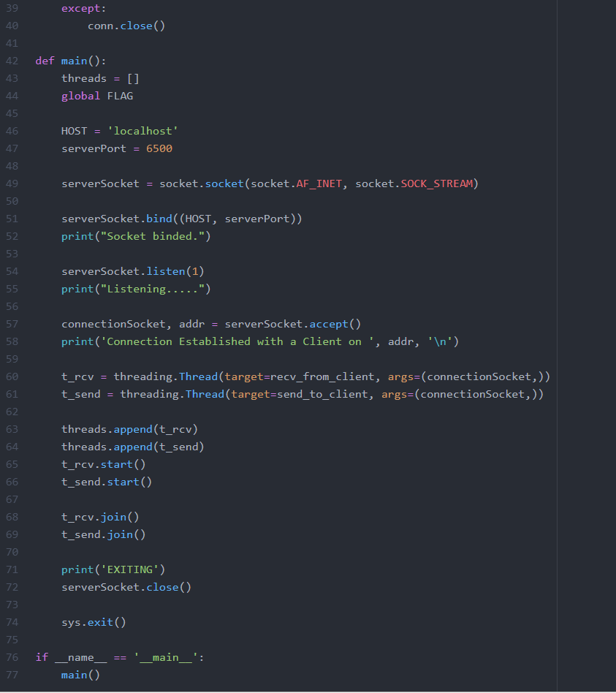

Client Side Code:
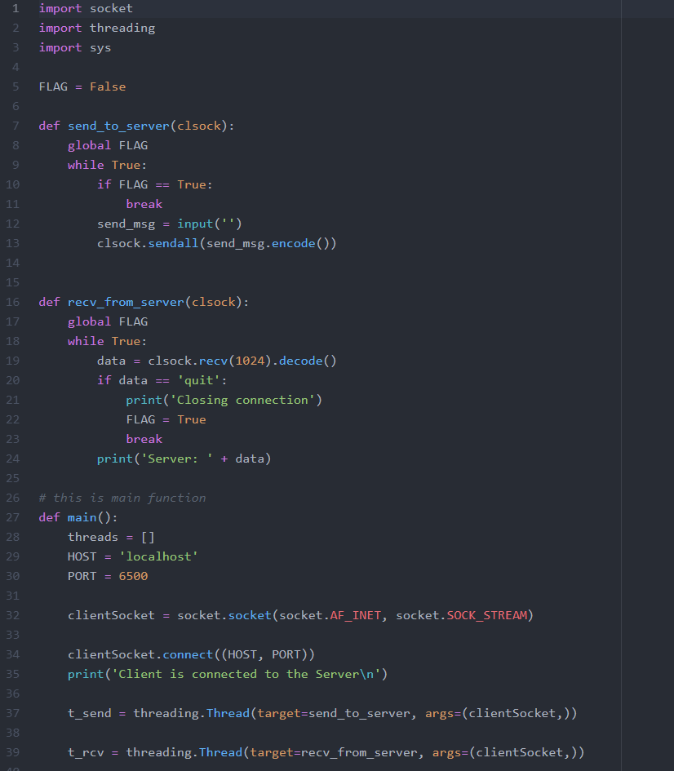
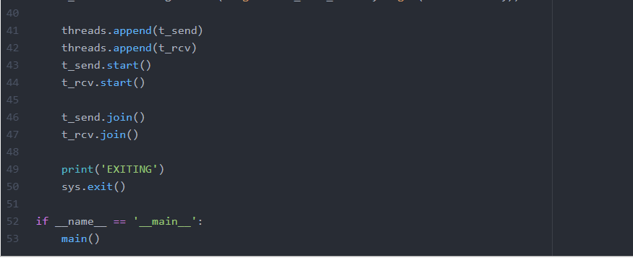

Server Side Output:
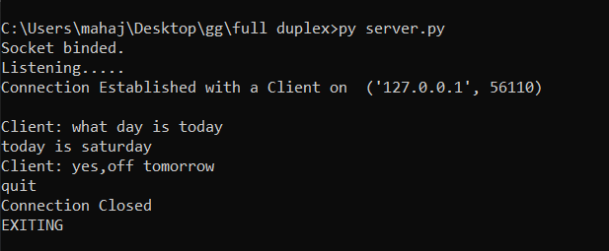

Client Side Output:
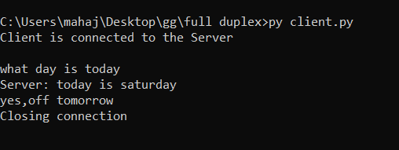
Result:
A Full duplex application, where the Client establishes a connection with the Server. The Client can send and the server well receive messages at the same time has been implemented.

