
API Documentation
Developer Reference Guide
Remote Attendance Management System (RAMS)
rumytechnologies.com/rams

Contents

1. Introduction
The Stellar API lets you integrate the Remote Attendance Management System (RAMS) directly into your own applications. Through a single JSON endpoint you can manage enrolled users, inspect connected attendance devices, and pull access logs (including GPS-tagged logs) into your own systems.
Every call is an HTTP POST request carrying a JSON body. The operation field in that body selects which action to perform, and the response is always JSON.

Conventions used in this guide
- monospaced text marks field names, values, operations, and endpoints.
- All dates use the format YYYY-MM-DD and all times use HH:mm:ss (24-hour).
- Placeholder values such as xxxxxxxx should be replaced with your real credentials.

2. Getting Started
Two things are required before you can make your first call: an account and an authentication code.

Step 1 — Create an account
Register for a RAMS account at rumytechnologies.com/rams. The username you choose here is the value you will send as auth_user in every request.

Step 2 — Obtain your auth code
Contact the device manufacturer to obtain your secret auth_code. This code authenticates every request and must be kept private.
Keep your auth code secret
Your auth_code is equivalent to a password. Do not expose it in client-side code, public repositories, or shared documents. Treat it as a secret credential at all times.

3. Making Requests

Endpoints
All operations are sent to one of the two base URLs below, depending on the operation.
Endpoint | Purpose
https://rumytechnologies.com/rams/json_api | User, device, and access-log operations
https://rumytechnologies.com/rams/service/get_gps_log | GPS-tagged access logs (fetch_gps_log)

Request format
- Method: POST
- Header: Content-Type: application/json
- Body: a JSON object containing operation, auth_user, auth_code, and any operation-specific parameters.

Rate limiting
Wait at least 5 minutes between requests
Sending requests more frequently than once every five minutes may cause the server to automatically block your IP address. Schedule your polling accordingly and use the access_id parameter (see below) to avoid re-fetching logs you already have.

4. Authentication
Every request must include two credentials in its JSON body:
Field | Description
auth_user | The username of your RAMS client account (the same one you use to log in to the web app).
auth_code | Your secret authentication code, obtained from the device manufacturer.

5. Parameter Reference
The table below lists every parameter used across the API. Not all parameters apply to every operation — see each operation's section for its specific requirements.
Parameter | Description
operation | The action to perform (for example, fetch_log). Required in every request.
registration_id | A unique identifier assigned to a user, similar to an ID or roll number.
user_name | The display name associated with the user.
signature / card | The user's unique signature to add, remove, or update. In log responses, the card field carries the RFID card value.
device_id / unit_id | The ID of the device a user is added to or removed from.
device_name / unit_name | The name of the attendance device.
auth_user | Username of your client account (used to log in to the web app).
auth_code | Your secret API authentication code from the manufacturer.
start_date | Start of the date range for logs, format YYYY-MM-DD (fetch_log / fetch_gps_log).
end_date | End of the date range for logs, format YYYY-MM-DD (fetch_log / fetch_gps_log).
start_time | Start of the time window, format HH:mm:ss (the moment a user punched a finger or card).
end_time | End of the time window, format HH:mm:ss.
access_date | The date access was granted on the device.
access_time | The time access was granted on the device.
access_id | A unique, incrementing ID for each access log (e.g. 122790737). Pass the highest access_id from your previous response to avoid re-fetching old logs.

On field-name spellings
Some responses use different spellings and key names than the request parameters. registration_id appears in the fetch_user_list and fetch_user_in_device_list responses, while registration_id is used in log responses. Likewise, the user's registration ID is sent under the username key in write requests. Parse responses using the exact keys shown in each example.

6. Operations
Each operation below shows the JSON request body to send and the response you can expect. Remember to include your auth_user and auth_code in every request.

remove_user_from_device
Removes a user from a specific device. The user remains in the system and can still be assigned to other devices.
REQUEST
{
"operation": "remove_user_from_device",
"auth_user": "John_Smith",
"auth_code": "xxxxxxxxxxxxxxxx",
"username": "asasde", // the user's registration_id
"device_id": "EM1474150"
}
RESPONSES
Message | Meaning
Successfully removed from device | The user was removed from the device.
Error finding user in device | Check the username and/or device_id and try again.

delete_permanently
Permanently deletes a user from the system across all devices. This action cannot be undone.
REQUEST
{
"operation": "delete_permanently",
"auth_user": "John_Smith",
"auth_code": "xxxxxxxxxxxxxxxx",
"username": "asasde" // the user's registration_id
}
RESPONSES
Message | Meaning
User Successfully Deleted | The user was permanently deleted.
Failed to delete | Check the username and/or device_id and try again.

fetch_user_list
Returns every user registered to your account, including registration ID, RFID card, Mifare card, and fingerprint data where available.
REQUEST
{
"operation": "fetch_user_list",
"auth_user": "John_Smith",
"auth_code": "xxxxxxxxxxxxxxxx"
}
RESPONSE
{
"user_list": [
{ "username": "Mr. Roy", "registraton_id": "roy123", "phone": "018xxxxx" },
{ "username": "Mr. Sohel", "registraton_id": "sohel123", "phone": "017xxxxx" }
]
}
Returns: a user_list array of user objects.

fetch_user_in_device_list
Returns the mapping of users to the devices they are assigned to.
REQUEST
{
"operation": "fetch_user_in_device_list",
"auth_user": "John_Smith",
"auth_code": "xxxxxxxxxxxxxxxx"
}
RESPONSE
{
"device_user": [
{ "registraton_id": "roll123", "device_id": "DS111111" },
{ "registraton_id": "roll124", "device_id": "DS111111" }
]
}
Returns: a device_user array pairing each registration ID with a device ID.

fetch_device_detail
Returns all devices registered to your account, with each device's name, ID, and the date and time it was last connected.
REQUEST
{
"operation": "fetch_device_detail",
"auth_user": "John_Smith",
"auth_code": "xxxxxxxxxxxxxxxx"
}
RESPONSE
{
"0": {
"device_name": "First Device",
"device_id": "DS111111",
"last_connected": "2022-11-27 13:14:45"
}
}
Returns: an object whose keys are numeric indices (“0”, “1”, …), each holding one device's details.

fetch_log
Returns access logs for the given date and time range. Each entry records who accessed which device, and when.
REQUEST
{
"operation": "fetch_log",
"auth_user": "John_Smith",
"auth_code": "xxxxxxxxxxxxxxxx",
"start_date": "2025-09-01",
"end_date": "2025-09-01",
"start_time": "10:49:09",
"end_time": "11:49:09",
"access_id": 122790737
}
RESPONSE
{
"log": [
{
"unit_name": "RFID DEVICE 2",
"unit_id": "DS330002",
"registration_id": "xxxxxxx",
"access_time": "11:01:41",
"access_date": "2024-01-01",
"user_name": "John Doe",
"card": "None",
"access_id": "81560849"
},
{
"unit_name": "RFID DEVICE 2",
"unit_id": "DS330002",
"registration_id": "xxxxxxxx",
"access_time": "11:17:29",
"access_date": "2024-01-01",
"user_name": "Jane Doe",
"card": "None",
"access_id": "81560850"
}
]
}
Paginating with access_id
Each log entry has a unique, incrementing access_id. On your next call, pass the highest access_id you have already received so the server returns only newer entries. On your very first call, use the example value shown above.

fetch_gps_log
Identical in shape to fetch_log, but every entry includes an additional location field with GPS coordinates. This operation is sent to the get_gps_log endpoint:
https://rumytechnologies.com/rams/service/get_gps_log
REQUEST
{
"operation": "fetch_gps_log",
"auth_user": "John_Smith",
"auth_code": "xxxxxxxxxxxxxxxx",
"start_date": "2024-01-01",
"end_date": "2024-01-01",
"start_time": "10:49:09",
"end_time": "12:49:09",
"access_id": "79180"
}
Response: the same structure as fetch_log, with each log object carrying an extra location key.

7. Postman Walkthrough
You can test any operation in Postman before writing code. Set the method to POST, enter the endpoint URL, choose raw / JSON for the body, and paste a request like the one below.
REQUEST BODY
{
"operation": "fetch_log",
"auth_user": "client_account_name",
"auth_code": "your_auth_code_from_stellar",
"start_date": "2025-09-01",
"end_date": "2025-09-01",
"start_time": "08:58:00",
"end_time": "09:47:00",
"access_id": 122790737
}
First-time use
On your first request, use the access_id value shown above as a starting point. Afterwards, carry forward the highest access_id from each response.

Sending the request
Configure the request in Postman as shown:
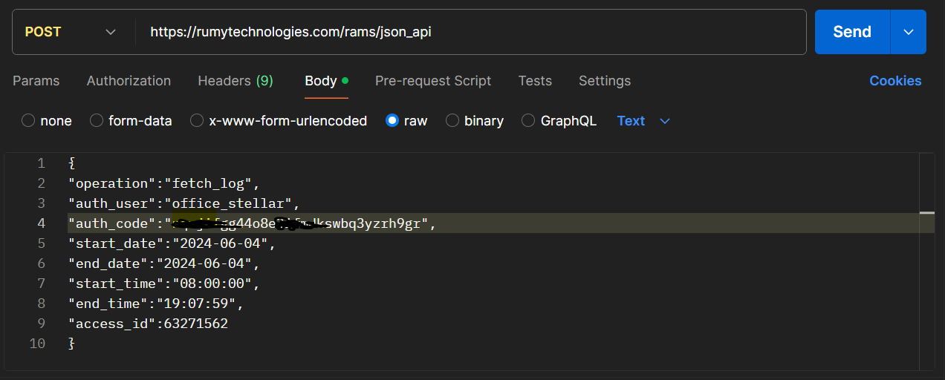

Reading the response
The response is returned as JSON and can be viewed in Postman's Pretty view:
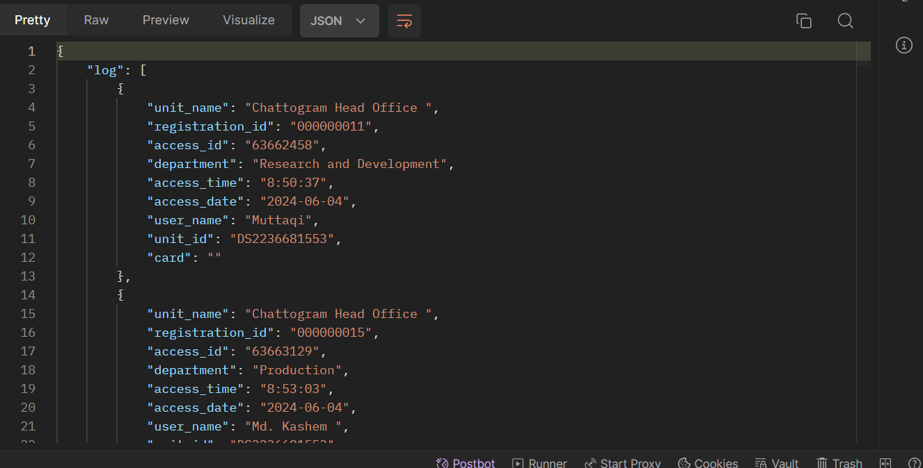

8. Code Samples
The following examples all perform a fetch_log request. Replace the placeholder credentials with your own auth_user and auth_code.

Python
Using the requests library:
import requests

url = "https://rumytechnologies.com/rams/json_api"

payload = {
"operation": "fetch_log",
"auth_user": "Account_Name",
"auth_code": "xxxxxxxxxxxxxxxxxxxxxxxxxx",
"start_date": "2025-09-01",
"end_date": "2025-09-01",
"start_time": "05:49:09",
"end_time": "08:49:09",
"access_id": 122790737,
}

response = requests.post(url, json=payload)
print(response.json())

JavaScript
Using the browser/Node fetch API:
const url = "https://rumytechnologies.com/rams/json_api";

const payload = {
operation: "fetch_log",
auth_user: "username",
auth_code: "xxxxxxxxxxxxxxxxxxxx",
start_date: "2026-01-01",
end_date: "2026-01-01",
start_time: "06:49:09",
end_time: "14:59:59",
access_id: 122790737,
};

fetch(url, {
method: "POST",
headers: { "Content-Type": "application/json" },
body: JSON.stringify(payload),
})
.then((res) => res.json())
.then((data) => console.log(data))
.catch((err) => console.error(err));

PHP
Using cURL and json_decode:
<?php

$url = "https://rumytechnologies.com/rams/json_api";

$payload = [
"operation" => "fetch_log",
"auth_user" => "xyz",
"auth_code" => "xxxxxxxxxxxxxxxxxx",
"start_date" => "2026-01-01",
"end_date" => "2026-01-01",
"start_time" => "08:49:09",
"end_time" => "15:49:09",
"access_id" => 122790737,
];

$ch = curl_init($url);
curl_setopt($ch, CURLOPT_RETURNTRANSFER, true);
curl_setopt($ch, CURLOPT_POST, true);
curl_setopt($ch, CURLOPT_POSTFIELDS, json_encode($payload));
curl_setopt($ch, CURLOPT_HTTPHEADER, ["Content-Type: application/json"]);

$response = curl_exec($ch);
curl_close($ch);

$result = json_decode($response, true);

foreach ($result["log"] as $entry) {
echo $entry["access_date"] . " " . $entry["access_time"] . PHP_EOL;
}

C#
Using HttpClient:
using System.Net.Http;
using System.Text;
using System.Text.Json;

var url = "https://rumytechnologies.com/rams/json_api";

var payload = new
{
operation = "fetch_log",
auth_user = "auth_user_name",
auth_code = "xxxxxxxxxxxxxxxxxxx",
start_date = "2025-09-01",
end_date = "2025-09-01",
start_time = "01:00:01",
end_time = "23:59:01"
};

using var client = new HttpClient();
var json = JsonSerializer.Serialize(payload);
var content = new StringContent(json, Encoding.UTF8, "application/json");

var response = await client.PostAsync(url, content);
var result = await response.Content.ReadAsStringAsync();

Console.WriteLine(result);

Oracle APEX (PL/SQL)
Using apex_web_service.make_rest_request:
DECLARE
l_response_clob CLOB;
l_request_body CLOB;
l_offset NUMBER := 1;
l_chunk VARCHAR2(32767);
BEGIN
-- 1. Build the JSON payload
l_request_body := '{
"operation":"fetch_log",
"auth_user":"your_auth_username",
"auth_code":"your_auth_code",
"start_date":"2026-01-10",
"end_date":"2026-01-10",
"start_time":"00:12:40",
"end_time":"22:12:44",
"access_id":122790737
}';

-- 2. Set the request header
apex_web_service.g_request_headers(1).name := 'Content-Type';
apex_web_service.g_request_headers(1).value := 'application/json';

-- 3. Make the REST request
l_response_clob := apex_web_service.make_rest_request(
p_url => 'https://rumytechnologies.com/rams/json_api',
p_http_method => 'POST',
p_body => l_request_body
);

-- 4. Print the response (handles large payloads in chunks)
DBMS_OUTPUT.put_line('HTTP Status: ' || apex_web_service.g_status_code);
LOOP
EXIT WHEN l_offset > DBMS_LOB.getlength(l_response_clob);
l_chunk := DBMS_LOB.substr(l_response_clob, 32767, l_offset);
DBMS_OUTPUT.put_line(l_chunk);
l_offset := l_offset + 32767;
END LOOP;

-- 5. Save the response if the request succeeded
IF apex_web_service.g_status_code = 200 THEN
INSERT INTO my_api_logs (log_clob) VALUES (l_response_clob);
DBMS_OUTPUT.put_line('Success: data saved to MY_API_LOGS.');
ELSE
DBMS_OUTPUT.put_line('Warning: not saved. HTTP status '
|| apex_web_service.g_status_code);
END IF;
EXCEPTION
WHEN OTHERS THEN
DBMS_OUTPUT.put_line('Error: ' || SQLERRM);
END;

