**Introduction:**

Finding most demanding skills for a particular category of jobs is helpful for both the recruiters and the job seekers. In this project we analyzed the best skills for particular jobs from live website and showed visually most demanding skills for each category of jobs.

**Methodology:**

The project is conducted by analyzing real and live data scraped from web. The scraped data are then cleaned and preprocessed. After that frequency of each skills are evaluated and drawn graphs based on top 10 demanding skills for the particular category of job. It is due to see the most demanding skills for a particular existing jobs.

**Dataset:**

We used live data scraped from <https://www.reed.co.uk/>. But data available in this website are not in a format of our demand. So they were cleaned and preprocessed before bring out a useful decision.

**Tools:**

1. Python
2. Requests Library
3. Beautiful Soup Library
4. Microsoft Excel

**Techniques:**

* Firstly, we have to analyze the website very carefully and see the structure and architecture of each building blocks of the website. Otherwise we may fail to achieve required data.
* Secondly, we scraped data from the website and saved it into excel sheets.
* Thirdly, the excel sheets are preprocessed and noises are cleaned.
* Fourthly, we evaluated the frequency of each skills.
* Finally, graph are drawn based to top skills in each category.

**Result:**

Here is the graphs, what we have come out finally.

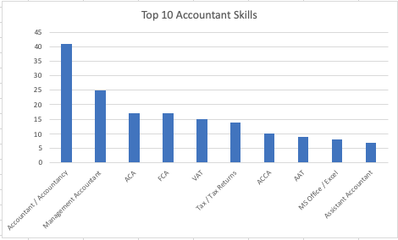

Fig 1: Top 10 Accountant Skills

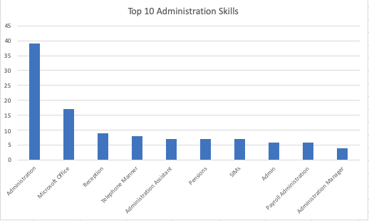

Fig 2: Top 10 Administration Skills

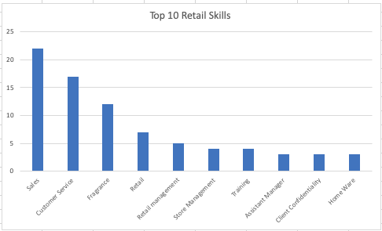

Fig 3: Top 10 Retail Skills

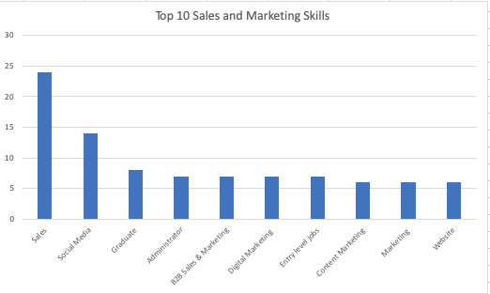

Fig 4: Top 10 Sales and Marketing Skills

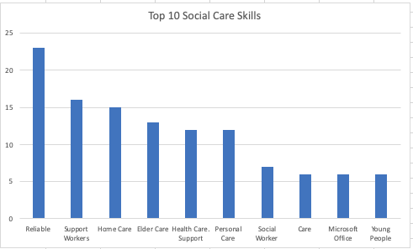

Fig 5: Top 10 Social Care Skills

**Decision:**

From the graph we can visually see the demand of skill for particular categories:

For Accountant jobs, we see there is a huge demand of Accountant, Accountancy and related skills like ACA and ACCA. Others skills like VAT, Tax, Tax Returns, MS Office, Assistant Accountant etc. also have a good demand.

Administration is the most demandable skills for administration jobs. There is no other skills that have a closer demand frequency like this. Some other skills like Microsoft Office, Reception, Telephone Manner, Administration Assistant, SIMs, Admin, Payroll Admin also a good demand.

For Retail jobs, there is a very good demand on Sales, Customer Service, Fragrance. Some other skills like Retail, Retail Management, Store Management etc. also have a good value of demand.

In Sales and Marketing jobs, there is huge demand for Sales experts. Others demanding skills are Administrator, B2B Sales & Marketing, Digital Marketing, Content Marketing etc.

For Social Care jobs, there is huge category for Reliable individuals. Other noticeable skills like Support Workers, Home Care, Elder Care, Health Care, Personal Care, Social Worker have a very good demand.