- Whenever fill-up the form, the unselected data (course, industry) are passing. (FIXED)

- Need to remove multiple “ Builder’s licenses”.

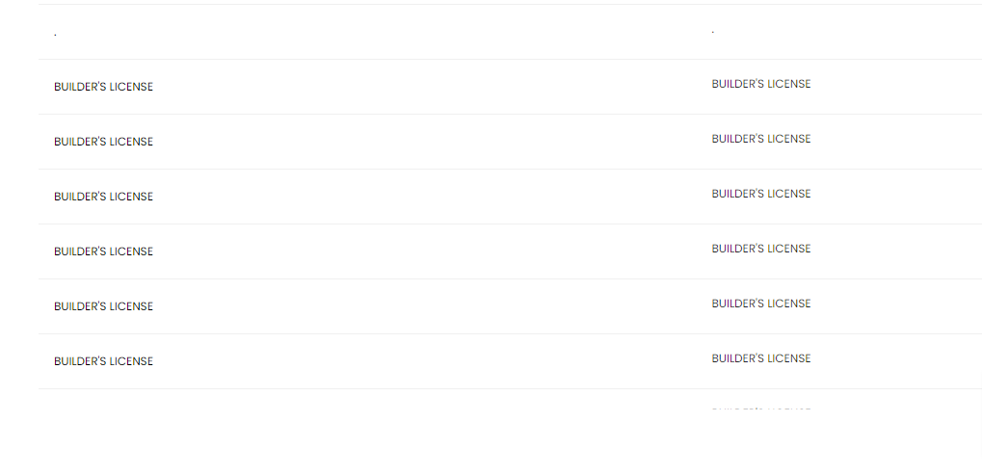
- Alignment is not okay ( Fixed)

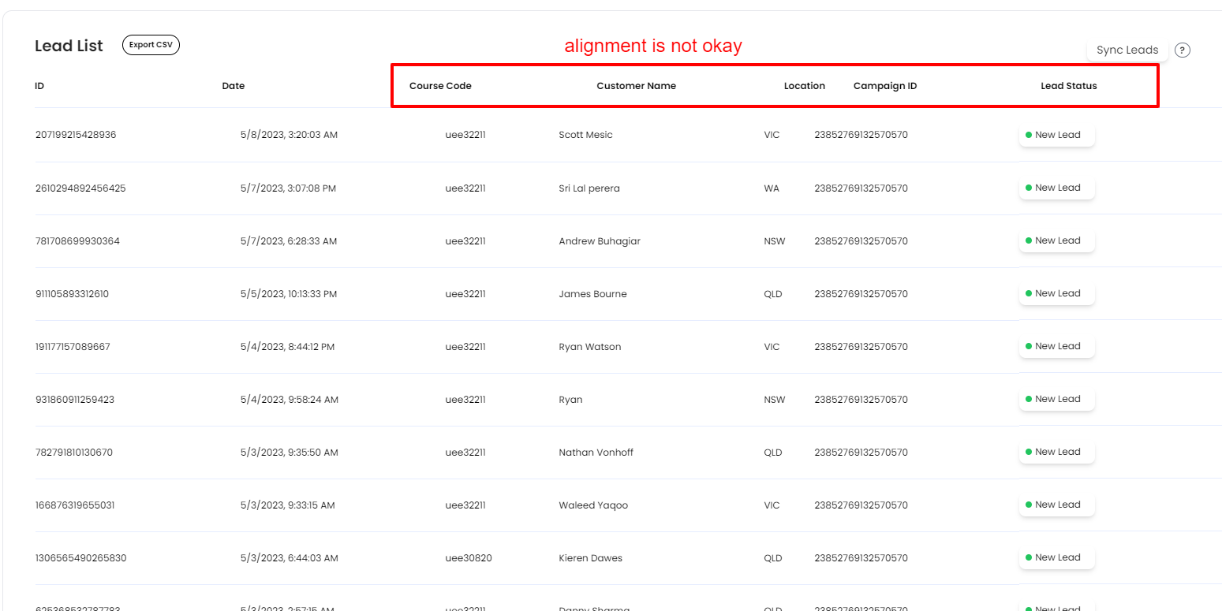

- New sales or supervisor needs to be added. The function is not working.
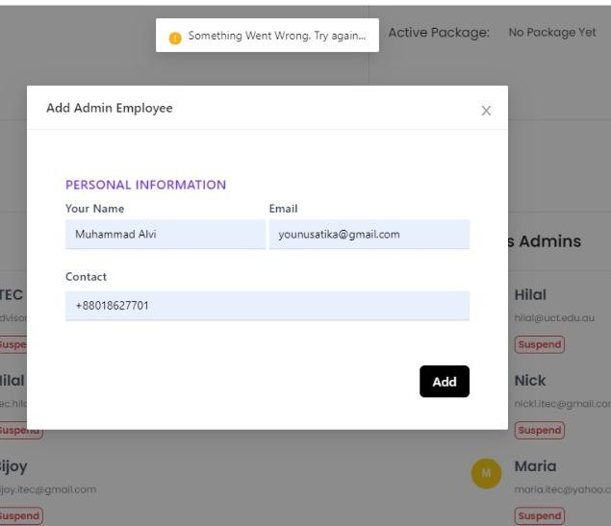

- In the dashboard, the current time and date are not showing whenever new leads are coming. (FIXED )

- Here, Visa should be stored in payment via column and the number need to be stored in the amount column.
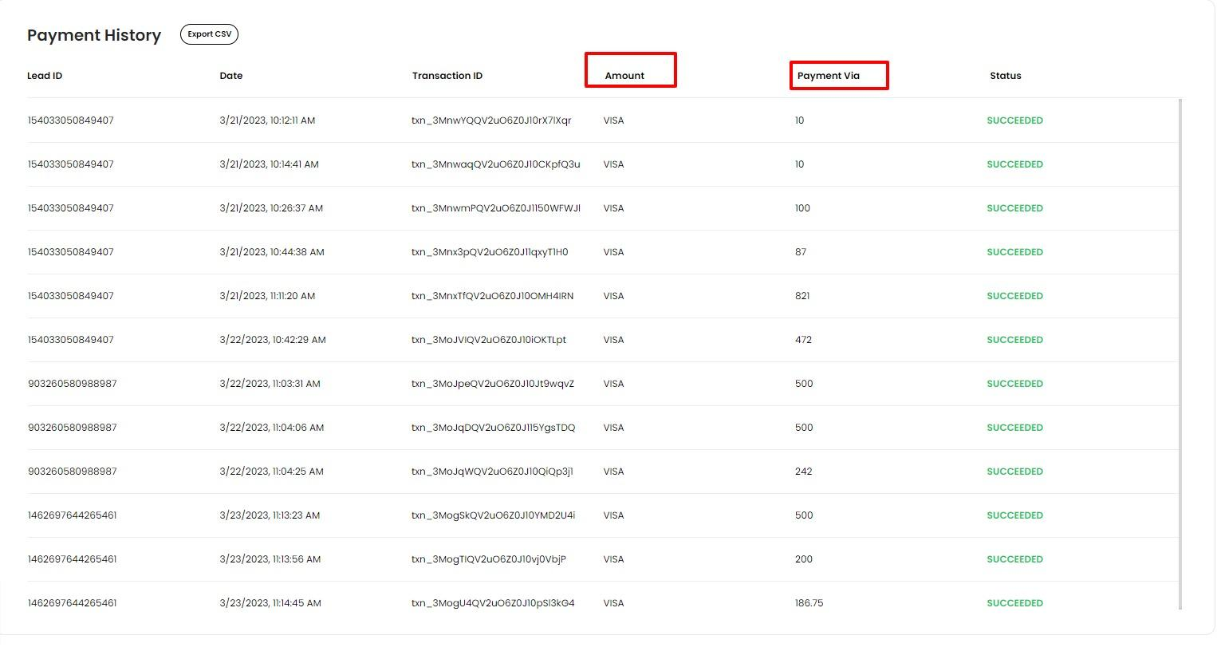

- The campaign rate is not showing here. (But whenever hover on other columns, the campaign rate is showing.)
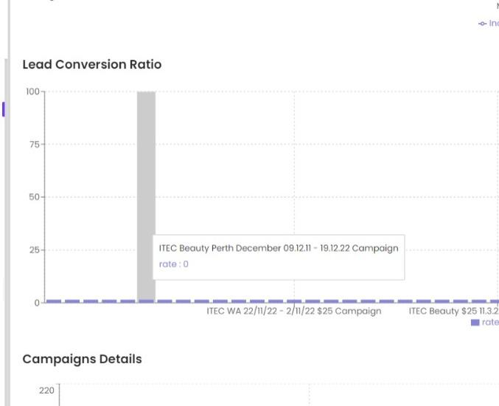

- Need to remove the dummy content.

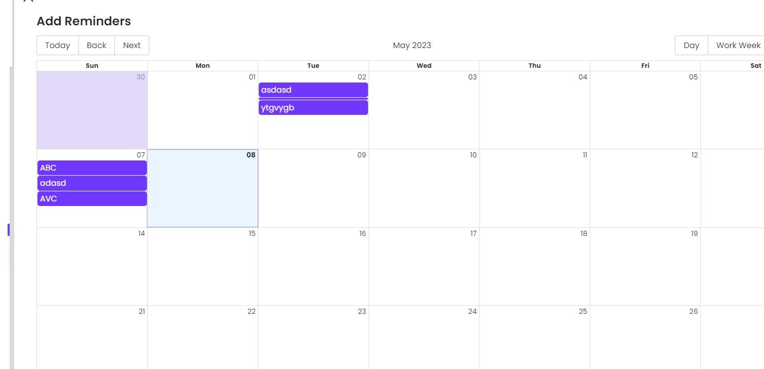

- We can add a download icon to download the certificate instead of the eye icon.

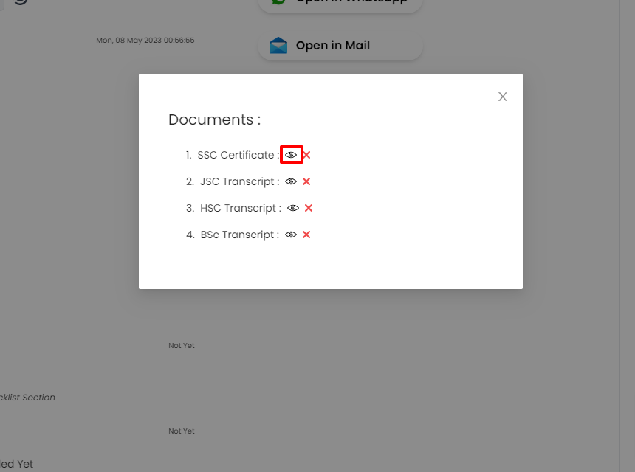

- Need to add file links.
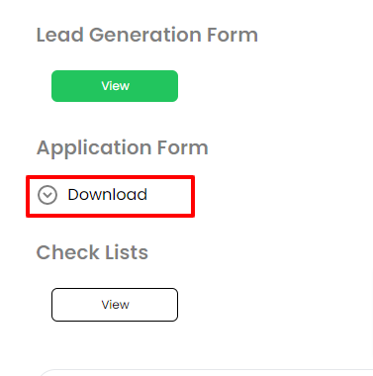

- Clicking on the checklist nothing is showing.

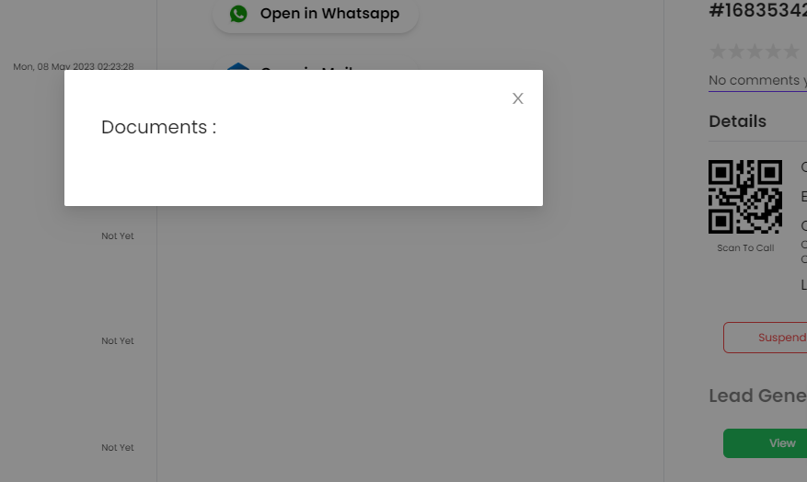

- The help center link is not working.

