**Dataset:**

Users = 500

Places = 685

Ratings = 34,500

**Features:**

**User:** age, gender, country, average user’s rating for: hotels, restaurants, shopping places, old places, natural places, and night places.

**Place:** place type, average rating, price

**Content-based filtering:**

User features

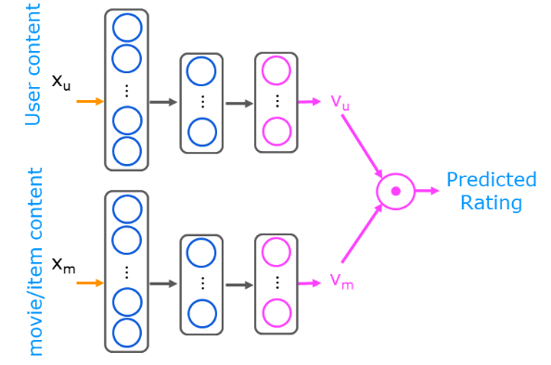

Place features

**Comparing models:**

|  |  |  |  |  |
| --- | --- | --- | --- | --- |
| Content-based Filtering | LSTM Layers | Dense Layers | Linear Regression |  |
| 20.27% | 19.66% | 19.78% | 21.15% | MAE |
| 25.66% | 28.01% | 28.31% | 27.87% | MSE |