

PingPair — LAN Characterization Report
Run ID | PingPair-sample-report
Started | 2026-06-09 14:30:00
Finished | 2026-06-09 14:45:50
Duration | 15m 50s
Server IP | 192.168.1.1
Client IP | 192.168.1.2
Protocol | UDP
Cases ok | 20 / 20
fping version | 5.5
iperf3 version | 3.21
PingPair version | 0.1.0
Technician | Demo User
Customer / Site | Example Co. (sample report)
Test environment | Two laptops · Cat6 · point-to-point
Test record ID | SAMPLE-001
Cable length (m) | 15.0

Performance Metrics
Steady-state network with no external simulated or video traffic. QoS: COS set to 0.
Payload Size  (Bytes) | Bandwidth  (MBits Per Second)  – Pushed Traffic | Throughput  (MBits Per Second)  – Received Traffic | Jitter  (msec) | Packet Loss  (%) | Minimum Latency  (msec) | Average Latency  (msec) | Maximum Latency  (msec)
200 | 10 | 9.90 | 0.105 | 0.000 | 0.13 | 0.96 | 2.60
200 | 30 | 29.70 | 0.235 | 0.000 | 0.15 | 1.08 | 3.11
200 | 50 | 49.20 | 0.365 | 0.070 | 0.17 | 1.20 | 3.62
200 | 70 | 68.00 | 0.495 | 0.540 | 0.18 | 1.32 | 4.13
200 | 90 | 85.50 | 0.625 | 1.770 | 0.20 | 1.44 | 4.64
600 | 10 | 10.00 | 0.125 | 0.000 | 0.13 | 1.01 | 2.73
600 | 30 | 29.80 | 0.255 | 0.000 | 0.15 | 1.13 | 3.24
600 | 50 | 49.50 | 0.385 | 0.060 | 0.17 | 1.25 | 3.75
600 | 70 | 68.30 | 0.515 | 0.500 | 0.18 | 1.37 | 4.26
600 | 90 | 85.90 | 0.645 | 1.610 | 0.20 | 1.49 | 4.77
1000 | 10 | 10.00 | 0.145 | 0.000 | 0.13 | 1.06 | 2.86
1000 | 30 | 29.90 | 0.275 | 0.000 | 0.15 | 1.18 | 3.37
1000 | 50 | 49.60 | 0.405 | 0.060 | 0.17 | 1.30 | 3.88
1000 | 70 | 68.60 | 0.535 | 0.450 | 0.18 | 1.42 | 4.39
1000 | 90 | 86.20 | 0.665 | 1.460 | 0.20 | 1.54 | 4.90
1300 | 10 | 10.00 | 0.165 | 0.000 | 0.13 | 1.11 | 2.99
1300 | 30 | 30.00 | 0.295 | 0.000 | 0.15 | 1.23 | 3.50
1300 | 50 | 49.90 | 0.425 | 0.050 | 0.17 | 1.35 | 4.01
1300 | 70 | 68.90 | 0.555 | 0.400 | 0.18 | 1.47 | 4.52
1300 | 90 | 86.60 | 0.685 | 1.300 | 0.20 | 1.59 | 5.03

Per-case detail
Forensics for each case: status, error notes if any, subprocess return codes, and the exact CLI strings used. Useful for re-running a single case from a terminal.

Case #01 — payload 200 B, bandwidth 10 Mbps (30 s, UDP)
Status | ok
Error | —
iperf3 client rc | 0
iperf3 server rc | —
fping rc | 0
Throughput received | 9.900 Mbps
Jitter | 0.105 ms
Loss | 0.000 %
Min / Avg / Max latency | 0.13 / 0.96 / 2.60 ms
iperf3 client cmd | iperf3.exe -c 192.168.1.1 -B 192.168.1.2 -u -i 1 -t 30 -l 200 -b 10M
iperf3 server cmd | iperf3.exe -s -i 1 -B 192.168.1.1 -1 --json
fping cmd | fping.exe 192.168.1.1 -S 192.168.1.2 -p 10 -c 3000 -s -D

Case #02 — payload 200 B, bandwidth 30 Mbps (30 s, UDP)
Status | ok
Error | —
iperf3 client rc | 0
iperf3 server rc | —
fping rc | 0
Throughput received | 29.700 Mbps
Jitter | 0.235 ms
Loss | 0.000 %
Min / Avg / Max latency | 0.15 / 1.08 / 3.11 ms
iperf3 client cmd | iperf3.exe -c 192.168.1.1 -B 192.168.1.2 -u -i 1 -t 30 -l 200 -b 30M
iperf3 server cmd | iperf3.exe -s -i 1 -B 192.168.1.1 -1 --json
fping cmd | fping.exe 192.168.1.1 -S 192.168.1.2 -p 10 -c 3000 -s -D

Case #03 — payload 200 B, bandwidth 50 Mbps (30 s, UDP)
Status | ok
Error | —
iperf3 client rc | 0
iperf3 server rc | —
fping rc | 0
Throughput received | 49.200 Mbps
Jitter | 0.365 ms
Loss | 0.070 %
Min / Avg / Max latency | 0.17 / 1.20 / 3.62 ms
iperf3 client cmd | iperf3.exe -c 192.168.1.1 -B 192.168.1.2 -u -i 1 -t 30 -l 200 -b 50M
iperf3 server cmd | iperf3.exe -s -i 1 -B 192.168.1.1 -1 --json
fping cmd | fping.exe 192.168.1.1 -S 192.168.1.2 -p 10 -c 3000 -s -D

Case #04 — payload 200 B, bandwidth 70 Mbps (30 s, UDP)
Status | ok
Error | —
iperf3 client rc | 0
iperf3 server rc | —
fping rc | 0
Throughput received | 68.000 Mbps
Jitter | 0.495 ms
Loss | 0.540 %
Min / Avg / Max latency | 0.18 / 1.32 / 4.13 ms
iperf3 client cmd | iperf3.exe -c 192.168.1.1 -B 192.168.1.2 -u -i 1 -t 30 -l 200 -b 70M
iperf3 server cmd | iperf3.exe -s -i 1 -B 192.168.1.1 -1 --json
fping cmd | fping.exe 192.168.1.1 -S 192.168.1.2 -p 10 -c 3000 -s -D

Case #05 — payload 200 B, bandwidth 90 Mbps (30 s, UDP)
Status | ok
Error | —
iperf3 client rc | 0
iperf3 server rc | —
fping rc | 0
Throughput received | 85.500 Mbps
Jitter | 0.625 ms
Loss | 1.770 %
Min / Avg / Max latency | 0.20 / 1.44 / 4.64 ms
iperf3 client cmd | iperf3.exe -c 192.168.1.1 -B 192.168.1.2 -u -i 1 -t 30 -l 200 -b 90M
iperf3 server cmd | iperf3.exe -s -i 1 -B 192.168.1.1 -1 --json
fping cmd | fping.exe 192.168.1.1 -S 192.168.1.2 -p 10 -c 3000 -s -D

Case #06 — payload 600 B, bandwidth 10 Mbps (30 s, UDP)
Status | ok
Error | —
iperf3 client rc | 0
iperf3 server rc | —
fping rc | 0
Throughput received | 10.000 Mbps
Jitter | 0.125 ms
Loss | 0.000 %
Min / Avg / Max latency | 0.13 / 1.01 / 2.73 ms
iperf3 client cmd | iperf3.exe -c 192.168.1.1 -B 192.168.1.2 -u -i 1 -t 30 -l 600 -b 10M
iperf3 server cmd | iperf3.exe -s -i 1 -B 192.168.1.1 -1 --json
fping cmd | fping.exe 192.168.1.1 -S 192.168.1.2 -p 10 -c 3000 -s -D

Case #07 — payload 600 B, bandwidth 30 Mbps (30 s, UDP)
Status | ok
Error | —
iperf3 client rc | 0
iperf3 server rc | —
fping rc | 0
Throughput received | 29.800 Mbps
Jitter | 0.255 ms
Loss | 0.000 %
Min / Avg / Max latency | 0.15 / 1.13 / 3.24 ms
iperf3 client cmd | iperf3.exe -c 192.168.1.1 -B 192.168.1.2 -u -i 1 -t 30 -l 600 -b 30M
iperf3 server cmd | iperf3.exe -s -i 1 -B 192.168.1.1 -1 --json
fping cmd | fping.exe 192.168.1.1 -S 192.168.1.2 -p 10 -c 3000 -s -D

Case #08 — payload 600 B, bandwidth 50 Mbps (30 s, UDP)
Status | ok
Error | —
iperf3 client rc | 0
iperf3 server rc | —
fping rc | 0
Throughput received | 49.500 Mbps
Jitter | 0.385 ms
Loss | 0.060 %
Min / Avg / Max latency | 0.17 / 1.25 / 3.75 ms
iperf3 client cmd | iperf3.exe -c 192.168.1.1 -B 192.168.1.2 -u -i 1 -t 30 -l 600 -b 50M
iperf3 server cmd | iperf3.exe -s -i 1 -B 192.168.1.1 -1 --json
fping cmd | fping.exe 192.168.1.1 -S 192.168.1.2 -p 10 -c 3000 -s -D

Case #09 — payload 600 B, bandwidth 70 Mbps (30 s, UDP)
Status | ok
Error | —
iperf3 client rc | 0
iperf3 server rc | —
fping rc | 0
Throughput received | 68.300 Mbps
Jitter | 0.515 ms
Loss | 0.500 %
Min / Avg / Max latency | 0.18 / 1.37 / 4.26 ms
iperf3 client cmd | iperf3.exe -c 192.168.1.1 -B 192.168.1.2 -u -i 1 -t 30 -l 600 -b 70M
iperf3 server cmd | iperf3.exe -s -i 1 -B 192.168.1.1 -1 --json
fping cmd | fping.exe 192.168.1.1 -S 192.168.1.2 -p 10 -c 3000 -s -D

Case #10 — payload 600 B, bandwidth 90 Mbps (30 s, UDP)
Status | ok
Error | —
iperf3 client rc | 0
iperf3 server rc | —
fping rc | 0
Throughput received | 85.900 Mbps
Jitter | 0.645 ms
Loss | 1.610 %
Min / Avg / Max latency | 0.20 / 1.49 / 4.77 ms
iperf3 client cmd | iperf3.exe -c 192.168.1.1 -B 192.168.1.2 -u -i 1 -t 30 -l 600 -b 90M
iperf3 server cmd | iperf3.exe -s -i 1 -B 192.168.1.1 -1 --json
fping cmd | fping.exe 192.168.1.1 -S 192.168.1.2 -p 10 -c 3000 -s -D

Case #11 — payload 1000 B, bandwidth 10 Mbps (30 s, UDP)
Status | ok
Error | —
iperf3 client rc | 0
iperf3 server rc | —
fping rc | 0
Throughput received | 10.000 Mbps
Jitter | 0.145 ms
Loss | 0.000 %
Min / Avg / Max latency | 0.13 / 1.06 / 2.86 ms
iperf3 client cmd | iperf3.exe -c 192.168.1.1 -B 192.168.1.2 -u -i 1 -t 30 -l 1000 -b 10M
iperf3 server cmd | iperf3.exe -s -i 1 -B 192.168.1.1 -1 --json
fping cmd | fping.exe 192.168.1.1 -S 192.168.1.2 -p 10 -c 3000 -s -D

Case #12 — payload 1000 B, bandwidth 30 Mbps (30 s, UDP)
Status | ok
Error | —
iperf3 client rc | 0
iperf3 server rc | —
fping rc | 0
Throughput received | 29.900 Mbps
Jitter | 0.275 ms
Loss | 0.000 %
Min / Avg / Max latency | 0.15 / 1.18 / 3.37 ms
iperf3 client cmd | iperf3.exe -c 192.168.1.1 -B 192.168.1.2 -u -i 1 -t 30 -l 1000 -b 30M
iperf3 server cmd | iperf3.exe -s -i 1 -B 192.168.1.1 -1 --json
fping cmd | fping.exe 192.168.1.1 -S 192.168.1.2 -p 10 -c 3000 -s -D

Case #13 — payload 1000 B, bandwidth 50 Mbps (30 s, UDP)
Status | ok
Error | —
iperf3 client rc | 0
iperf3 server rc | —
fping rc | 0
Throughput received | 49.600 Mbps
Jitter | 0.405 ms
Loss | 0.060 %
Min / Avg / Max latency | 0.17 / 1.30 / 3.88 ms
iperf3 client cmd | iperf3.exe -c 192.168.1.1 -B 192.168.1.2 -u -i 1 -t 30 -l 1000 -b 50M
iperf3 server cmd | iperf3.exe -s -i 1 -B 192.168.1.1 -1 --json
fping cmd | fping.exe 192.168.1.1 -S 192.168.1.2 -p 10 -c 3000 -s -D

Case #14 — payload 1000 B, bandwidth 70 Mbps (30 s, UDP)
Status | ok
Error | —
iperf3 client rc | 0
iperf3 server rc | —
fping rc | 0
Throughput received | 68.600 Mbps
Jitter | 0.535 ms
Loss | 0.450 %
Min / Avg / Max latency | 0.18 / 1.42 / 4.39 ms
iperf3 client cmd | iperf3.exe -c 192.168.1.1 -B 192.168.1.2 -u -i 1 -t 30 -l 1000 -b 70M
iperf3 server cmd | iperf3.exe -s -i 1 -B 192.168.1.1 -1 --json
fping cmd | fping.exe 192.168.1.1 -S 192.168.1.2 -p 10 -c 3000 -s -D

Case #15 — payload 1000 B, bandwidth 90 Mbps (30 s, UDP)
Status | ok
Error | —
iperf3 client rc | 0
iperf3 server rc | —
fping rc | 0
Throughput received | 86.200 Mbps
Jitter | 0.665 ms
Loss | 1.460 %
Min / Avg / Max latency | 0.20 / 1.54 / 4.90 ms
iperf3 client cmd | iperf3.exe -c 192.168.1.1 -B 192.168.1.2 -u -i 1 -t 30 -l 1000 -b 90M
iperf3 server cmd | iperf3.exe -s -i 1 -B 192.168.1.1 -1 --json
fping cmd | fping.exe 192.168.1.1 -S 192.168.1.2 -p 10 -c 3000 -s -D

Case #16 — payload 1300 B, bandwidth 10 Mbps (30 s, UDP)
Status | ok
Error | —
iperf3 client rc | 0
iperf3 server rc | —
fping rc | 0
Throughput received | 10.000 Mbps
Jitter | 0.165 ms
Loss | 0.000 %
Min / Avg / Max latency | 0.13 / 1.11 / 2.99 ms
iperf3 client cmd | iperf3.exe -c 192.168.1.1 -B 192.168.1.2 -u -i 1 -t 30 -l 1300 -b 10M
iperf3 server cmd | iperf3.exe -s -i 1 -B 192.168.1.1 -1 --json
fping cmd | fping.exe 192.168.1.1 -S 192.168.1.2 -p 10 -c 3000 -s -D

Case #17 — payload 1300 B, bandwidth 30 Mbps (30 s, UDP)
Status | ok
Error | —
iperf3 client rc | 0
iperf3 server rc | —
fping rc | 0
Throughput received | 30.000 Mbps
Jitter | 0.295 ms
Loss | 0.000 %
Min / Avg / Max latency | 0.15 / 1.23 / 3.50 ms
iperf3 client cmd | iperf3.exe -c 192.168.1.1 -B 192.168.1.2 -u -i 1 -t 30 -l 1300 -b 30M
iperf3 server cmd | iperf3.exe -s -i 1 -B 192.168.1.1 -1 --json
fping cmd | fping.exe 192.168.1.1 -S 192.168.1.2 -p 10 -c 3000 -s -D

Case #18 — payload 1300 B, bandwidth 50 Mbps (30 s, UDP)
Status | ok
Error | —
iperf3 client rc | 0
iperf3 server rc | —
fping rc | 0
Throughput received | 49.900 Mbps
Jitter | 0.425 ms
Loss | 0.050 %
Min / Avg / Max latency | 0.17 / 1.35 / 4.01 ms
iperf3 client cmd | iperf3.exe -c 192.168.1.1 -B 192.168.1.2 -u -i 1 -t 30 -l 1300 -b 50M
iperf3 server cmd | iperf3.exe -s -i 1 -B 192.168.1.1 -1 --json
fping cmd | fping.exe 192.168.1.1 -S 192.168.1.2 -p 10 -c 3000 -s -D

Case #19 — payload 1300 B, bandwidth 70 Mbps (30 s, UDP)
Status | ok
Error | —
iperf3 client rc | 0
iperf3 server rc | —
fping rc | 0
Throughput received | 68.900 Mbps
Jitter | 0.555 ms
Loss | 0.400 %
Min / Avg / Max latency | 0.18 / 1.47 / 4.52 ms
iperf3 client cmd | iperf3.exe -c 192.168.1.1 -B 192.168.1.2 -u -i 1 -t 30 -l 1300 -b 70M
iperf3 server cmd | iperf3.exe -s -i 1 -B 192.168.1.1 -1 --json
fping cmd | fping.exe 192.168.1.1 -S 192.168.1.2 -p 10 -c 3000 -s -D

Case #20 — payload 1300 B, bandwidth 90 Mbps (30 s, UDP)
Status | ok
Error | —
iperf3 client rc | 0
iperf3 server rc | —
fping rc | 0
Throughput received | 86.600 Mbps
Jitter | 0.685 ms
Loss | 1.300 %
Min / Avg / Max latency | 0.20 / 1.59 / 5.03 ms
iperf3 client cmd | iperf3.exe -c 192.168.1.1 -B 192.168.1.2 -u -i 1 -t 30 -l 1300 -b 90M
iperf3 server cmd | iperf3.exe -s -i 1 -B 192.168.1.1 -1 --json
fping cmd | fping.exe 192.168.1.1 -S 192.168.1.2 -p 10 -c 3000 -s -D

Generated by PingPair 0.1.0

Analysis appendix
Per-metric summary statistics and per-case charts for this run, plus per-payload and per-bandwidth breakdowns. Open the Analysis tab in PingPair to overlay this run against past sweeps.

Summary statistics
Metric | Samples | Min | Avg | Median | Max | Stdev
Throughput (Mbps) | 20 | 9.90 | 48.77 | 49.55 | 86.60 | 26.99
Avg latency (ms) | 20 | 0.96 | 1.27 | 1.27 | 1.59 | 0.18
Packet loss (%) | 20 | 0.000 | 0.414 | 0.060 | 1.770 | 0.594
Jitter (ms) | 20 | 0.105 | 0.395 | 0.395 | 0.685 | 0.185

Per-case charts

Throughput
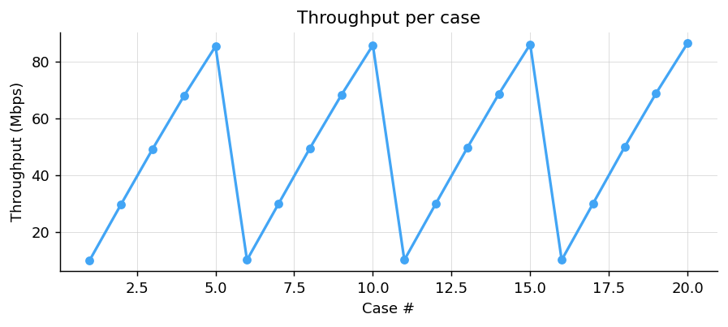

Avg latency
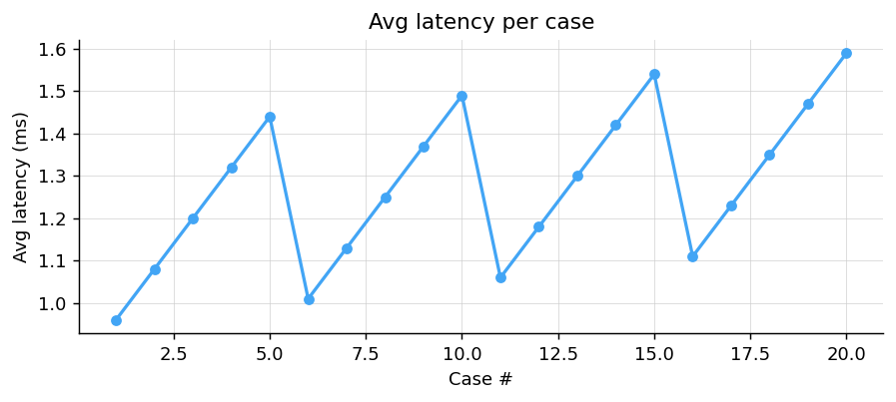

Packet loss
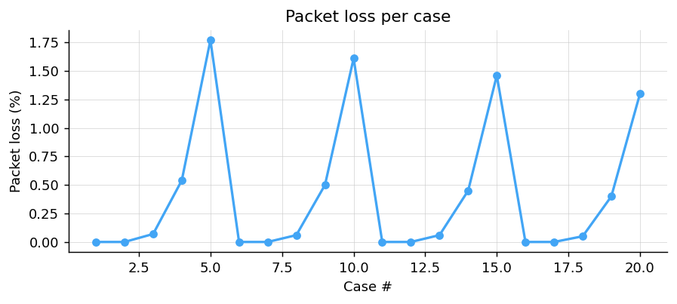

Jitter
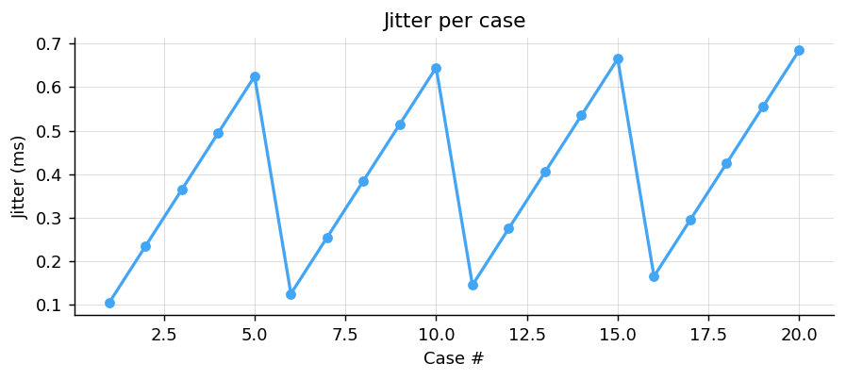

Mean metrics by payload size
Bucket | Cases | Avg Throughput (Mbps) | Avg Avg (ms) | Avg Packet (%) | Avg Jitter (ms)
200 B | 5 | 48.46 | 1.20 | 0.476 | 0.365
600 B | 5 | 48.70 | 1.25 | 0.434 | 0.385
1000 B | 5 | 48.86 | 1.30 | 0.394 | 0.405
1300 B | 5 | 49.08 | 1.35 | 0.350 | 0.425

Avg throughput by payload
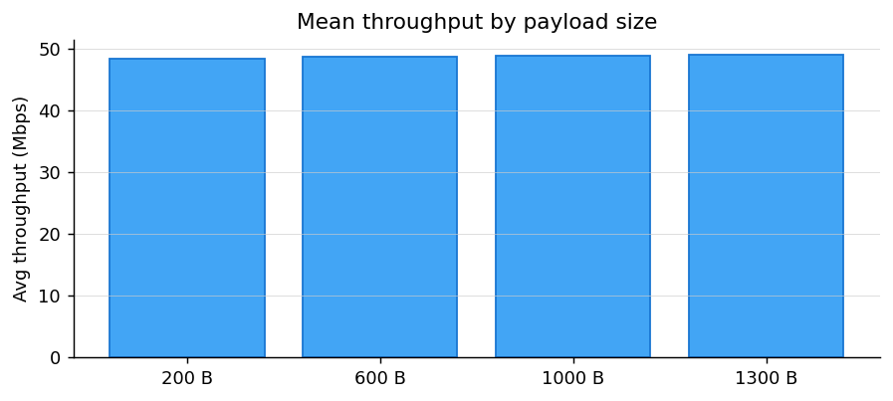

Mean metrics by bandwidth
Bucket | Cases | Avg Throughput (Mbps) | Avg Avg (ms) | Avg Packet (%) | Avg Jitter (ms)
10 Mbps | 4 | 9.97 | 1.04 | 0.000 | 0.135
30 Mbps | 4 | 29.85 | 1.16 | 0.000 | 0.265
50 Mbps | 4 | 49.55 | 1.27 | 0.060 | 0.395
70 Mbps | 4 | 68.45 | 1.40 | 0.473 | 0.525
90 Mbps | 4 | 86.05 | 1.52 | 1.535 | 0.655

Avg throughput by bandwidth
