**TASK1 (Answers)**

**// Command Line**

**Mohamed Khaled**

**1-** Print in terminal screen " **Hi, my name is..., and I’m software robotics engineer** "



**2**- open **image**, run, open **browser**, open **pdf**. **FROM** Terminal command line.

**image**

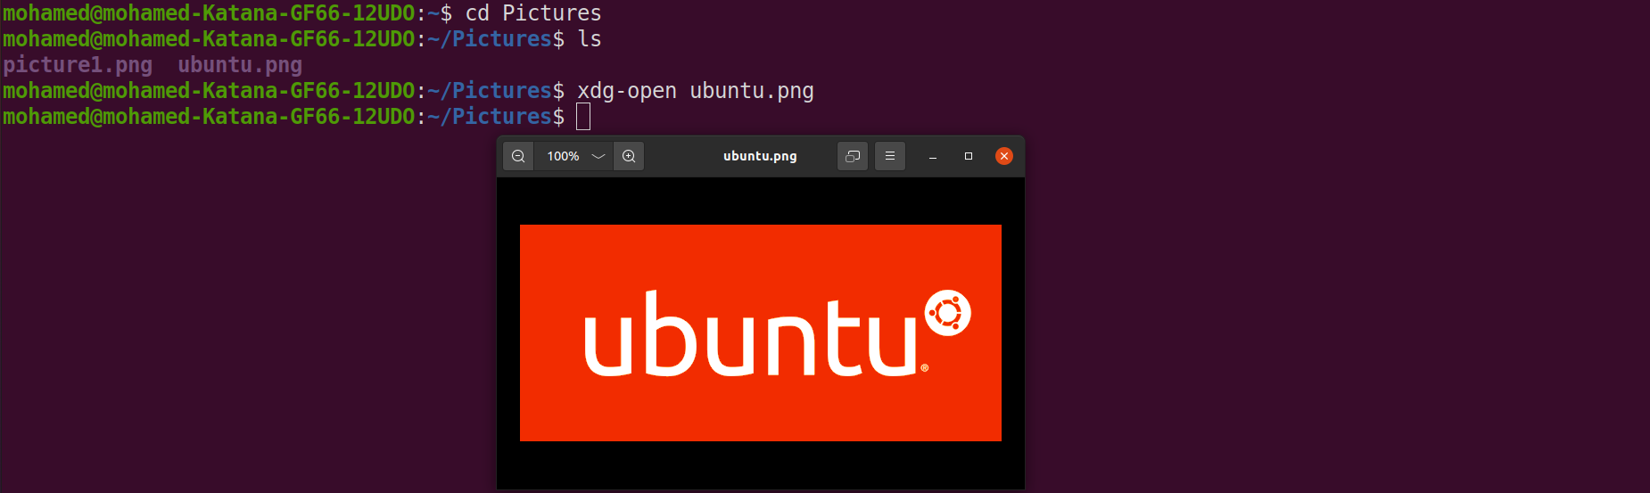**Video**

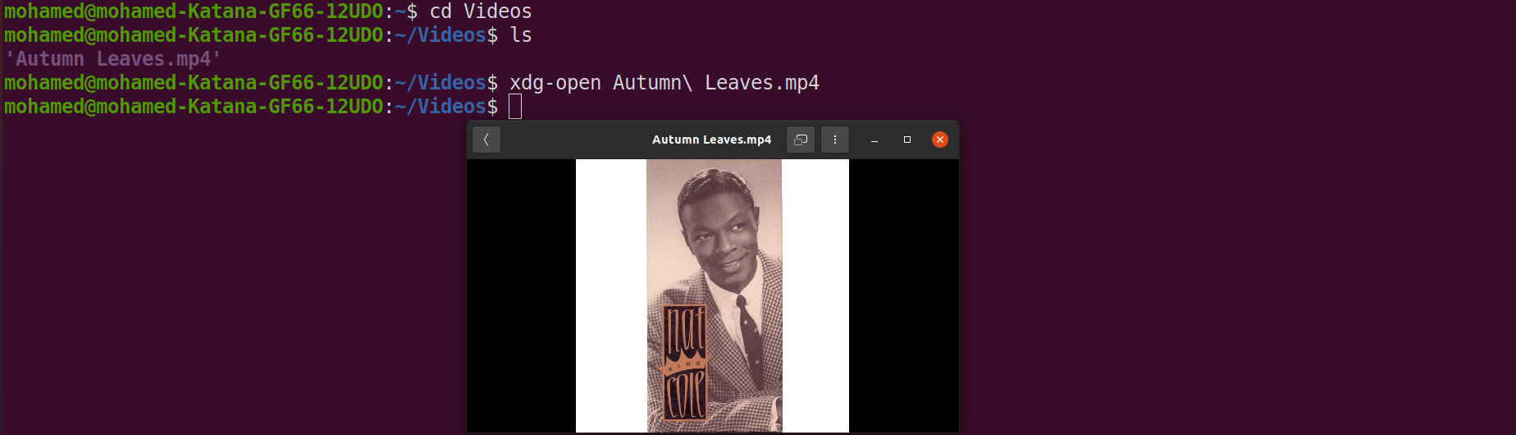**browser**

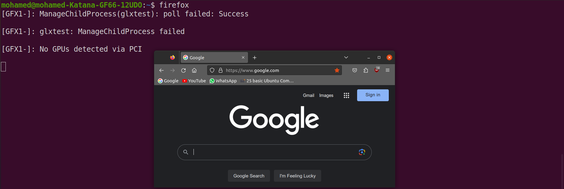

**pdf**

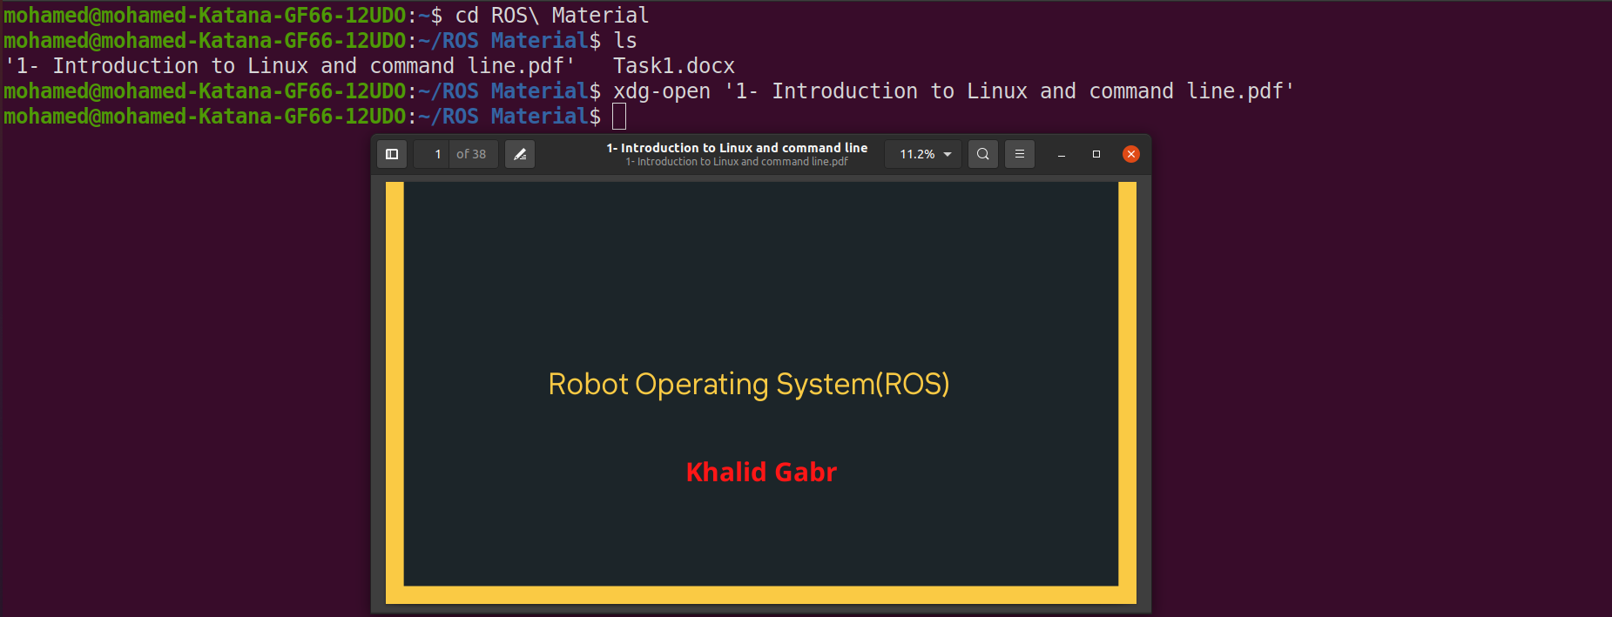

3- Create a new directory called "myproject" in your home directory.

1. Navigate into the "myproject" directory.
2. Create a new file called "test.py" using the touch command.
3. Open the "test.py" file using your favorite text editor and add some basic python code, such as a Hello World.
4. Save and close the file.
5. Use the ls command to verify that the "test.py" file has been created.
6. Create a new directory called "images" within the "myproject" directory.
7. Use the cd command to navigate into the "images" directory.
8. Use the touch command to create a new file called "logo.png".
9. Use the cp command to copy the "logo.png" file from the "images" directory to the "myproject" directory.
10. Use the ls command to verify that a copy of the "logo.png" file has been created in the "myproject" directory.
11. Use the rm command to delete the "logo.png" file from the "images" directory.
12. Use the rmdir command to delete the "images" directory.

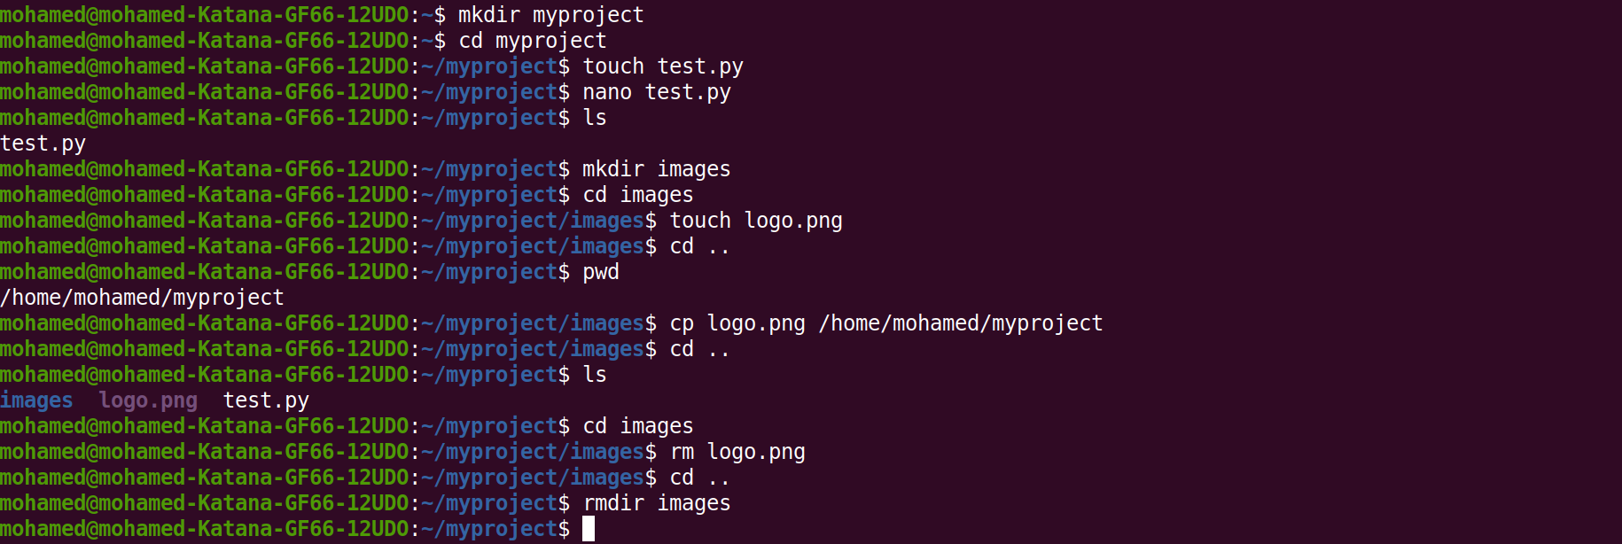



4- Open up a terminal window or console.

1. Use the pwd command to display your current working directory.
2. Use the ls command to list the contents of your current working directory.
3. Use the cd command to navigate to your home directory.
4. Use the mkdir command to create a new directory called "my_folder".
5. Use the cd command to navigate into the "my_folder" directory.
6. Use the touch command to create a new file called "my_file.txt".
7. Use the ls command to list the contents of the "my_folder" directory.
8. Use the cat command to display the contents of the "my_file.txt" file.
9. Use the echo command to write some text to the "my_file.txt" file.
10. Use the cat command again to display the updated contents of the "my_file.txt" file.
11. Use the cp command to make a copy of the "my_file.txt" file and name it "my_file_copy.txt".
12. Use the ls command to verify that the "my_file_copy.txt" file has been created.
13. Use the mv command to rename the "my_file.txt" file to "renamed_file.txt".
14. Use the ls command to verify that the file has been renamed.

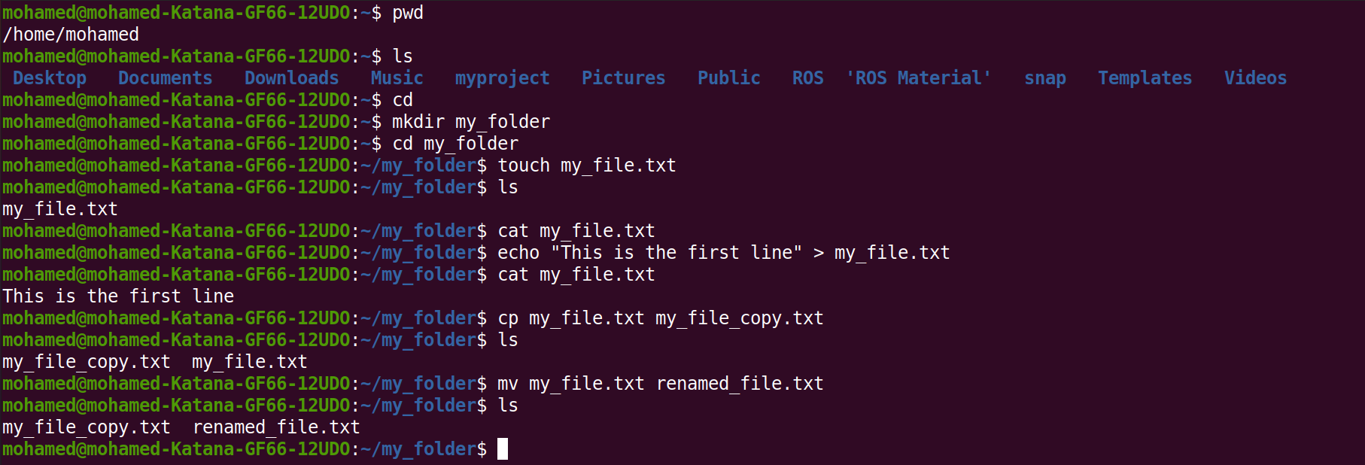

------------------------------------------------------------------------------------------------------------------

Note:

You can ask google..How i can print in terminal, How i can open image with terminal, run video,.....