Mohamed Reda Ahmed Emara
Contact Us
Address:
Dakahlia, Mansoura, Sinbillawain
Email:
m.elzero33@gmail.com
Link Portfolio:
#
Phone:
01020495108
Languages
Arabic , English
Microsoft Office
- Word
- Excel
Materials
Html5 - Css3 - Bootstrap
Tailwind - Nodejs – Nextjs- React.js
PHP – Laravel - MySQL – Github – Azuer.
Experience
- I worked at ElSewedy Cables Company from the time period 6/10/2022 to the time period 11/15/2023 (document control).
- I worked at the Mostaqbal Misr device from the period 4/29/2023 to the present time before I was accepted by the company, and I work at the device as a project technician office and a web and mobile application programmer.

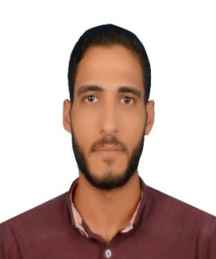
Skills
- Project Management.
- Strong Decision Maker.
- Creative Design.
- Innovative && Skilled.
Education
- Misr Higher Institute of Engineering and Technology in Mansoura.
(M.E.T Academy)
- Qualification: Management Information Systems.
- Bachelor's degree: Very Good.
- Graduation Project Degree: Excellence.
- Front-End Developer:
*- Sep2014 -Oct2018 -*
- I studied at the egyptian higher Academy of engineering and technology in mansoura.
- Cooperate with designers to create clean interfaces and simple, intuitive interactions and experiences.
- Develop project concepts and maintain optimal workflow, work with senior developer to manage large, complex design projects for corporate clients.
- Complete detailed programming and development tasks for front-end public and internal websites as well challenging back-end server code.
- Carry out Quality assurance tests to discover errors and optimize usability.
- Back-End Developer:
*- Dec2018 – Now2026-*
- Develop project concepts and maintain optimal workflow, work with senior developer to manage large, complex design projects for corporate clients.

