**Bookbank:**

**Introduction:**

Using banks can be a very exhausting and tiring experience for the customers due to how crowded it can get and time consuming, Bookbank solves this problem by making a platform that will show the available time slots and days for a certain bank, and the users can login and reserve an appointment in said bank.

[Github repository](https://github.com/mhmd3397/BookBank.git)

[Trello link](https://trello.com/b/AXlnR18p/bookbank)

**Requirements:**

1. Our platform will have a page for the user to register new accounts if he’s a staff member or a customer.

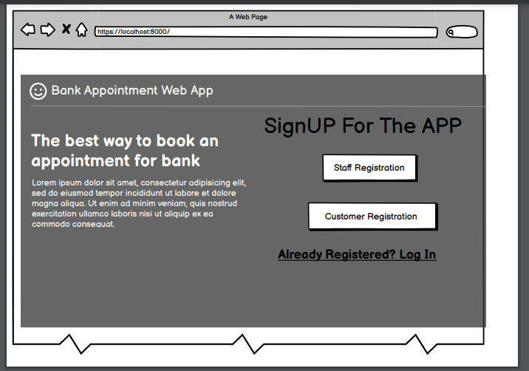

1. Clicking the staff registration will lead to a registration form for the employees,

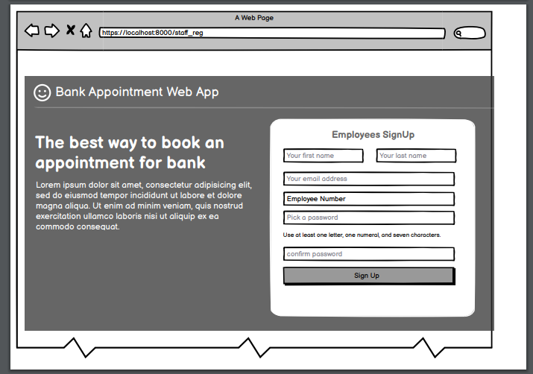

while clicking on the customer will lead to a form for registering a new customer.

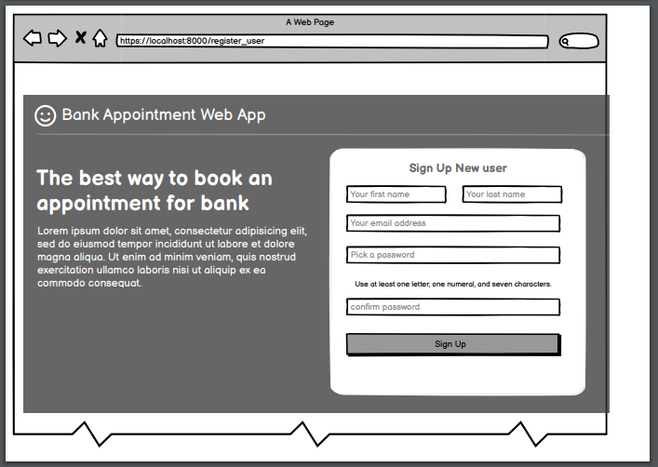

1. Clicking on the login link will lead to the login page if there is already an email.

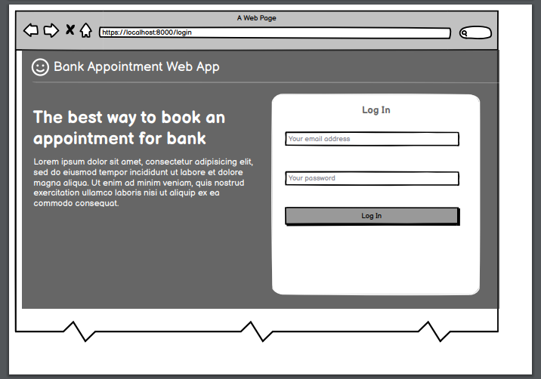

1. If the user is a customer the page shown will be a page showing all of his booked appointments with the details showing when clicking an appointment, it will also be possible to book new appointments from the page.

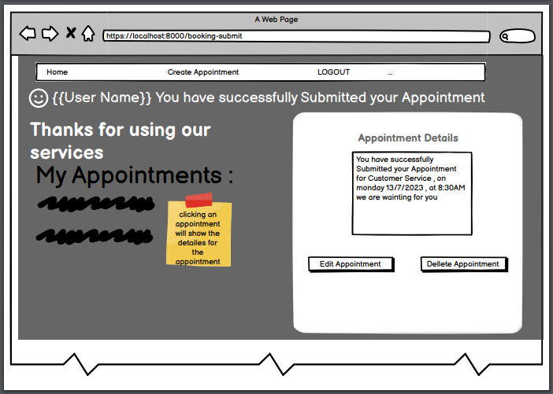

1. Going to create an appointment will take the user to a page that will let him book his appointment.

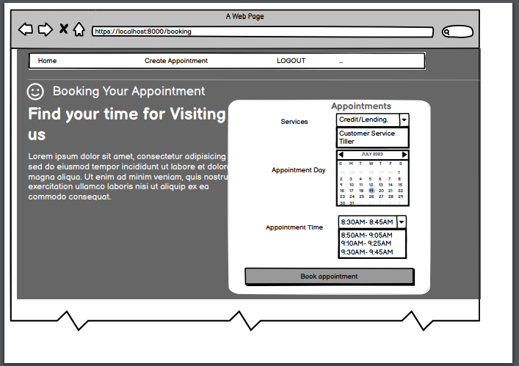

1. After booking an appointment it will show a message and the booked appointments for the user, here he can either edit or delete an appointment.

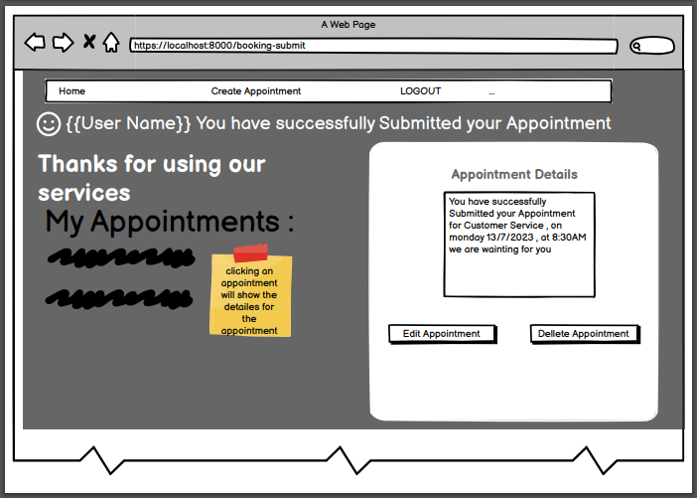

1. Logging in as an employee will take the user to a page that shows links depending on the service type.

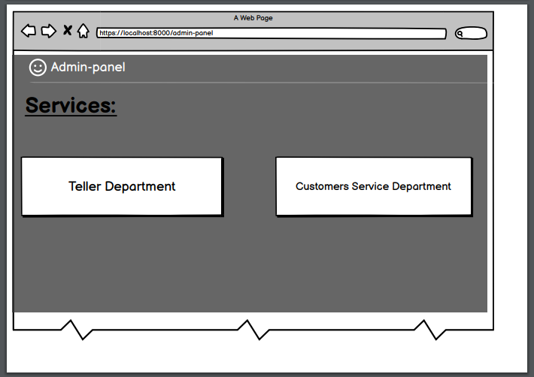

1. Clicking either link will take the employee to a page that shows all the booking for the service.
2. Clicking each appointment will show the details for the appointment along with the customer who booked the appointment.

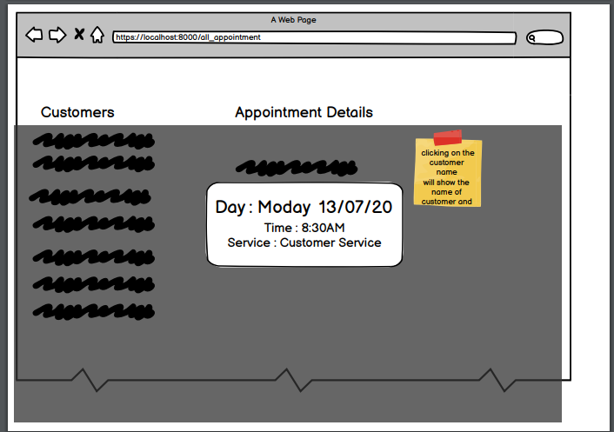

**ERD:**

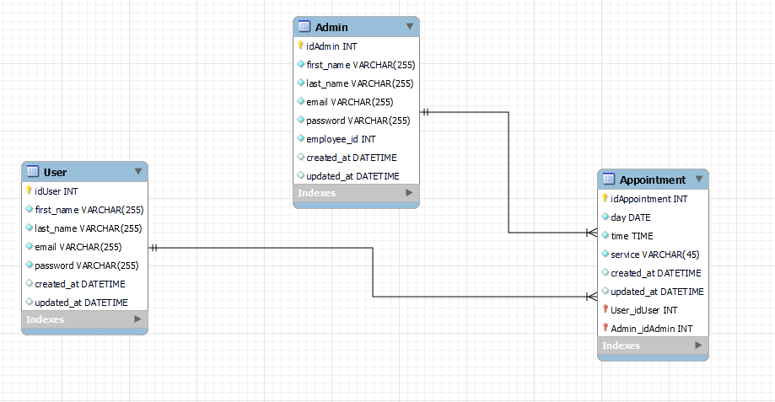

**Technologies used:**

Django framework.

Python.

HTML.

CSS.

Bootstrap.

Ajax.

**Team members:**

Azzam Ahmad

Yousef Brighith

Mohammad Elayan