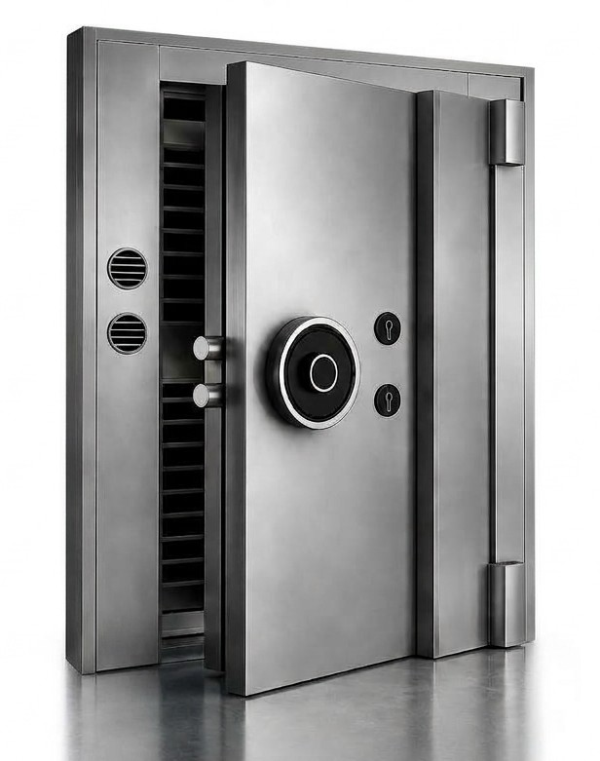

X YOUNG ANN
Outside(mm) | 2154*1386*421(MM)
Weight(kg) | 1568 Kg
Locking | S&G- KABA
Option locking | Handle / key / combination / Digital lock
Burglary Resistance | UL 608 Listed / Class 2

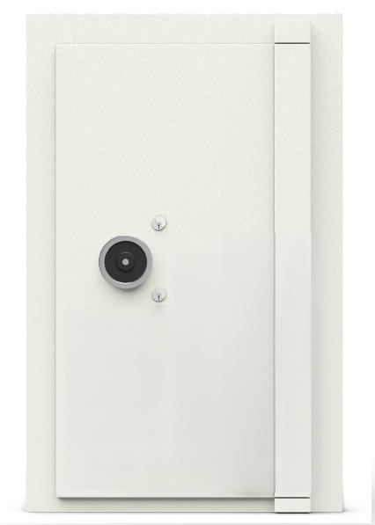

Godrej-GR-VIII
Outside(mm) | 2272*1354*320 (MM)
Weight(kg) | 1480 Kg
locking | S&G- KABA
Option locking | Handle / key / combination / Digital lock
Burglary Resistance | EN-1143-1 / GR-VIII

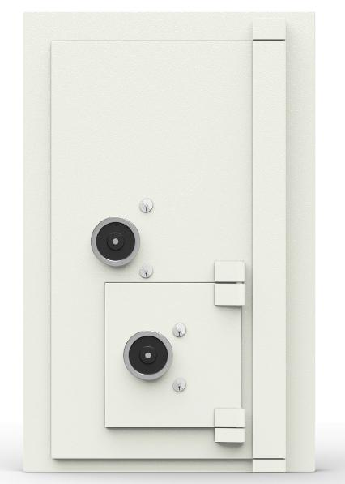

Godrej-GR-V EX
Outside(mm) | 2222*1354*420 (MM)
Weight(kg) | 1215 Kg
locking | S&G- KABA
Option locking | Handle / key / combination / Digital lock
Burglary Resistance | EN-1143-1 / GR-V EX

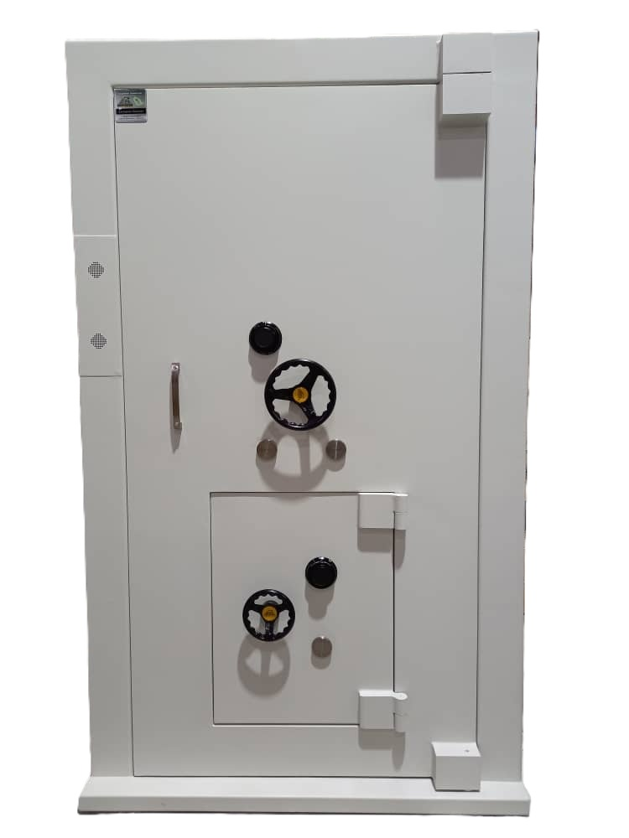

SSM130-2*1
Outside(mm) | 2175*1284*450(MM)
EMD-Outside(mm) | 697*536(MM)
Weight(kg) | 1100 Kg
locking | S&G- KABA
Option locking | Handle / key / combination / Digital lock
Certificate | SIRIM QAS

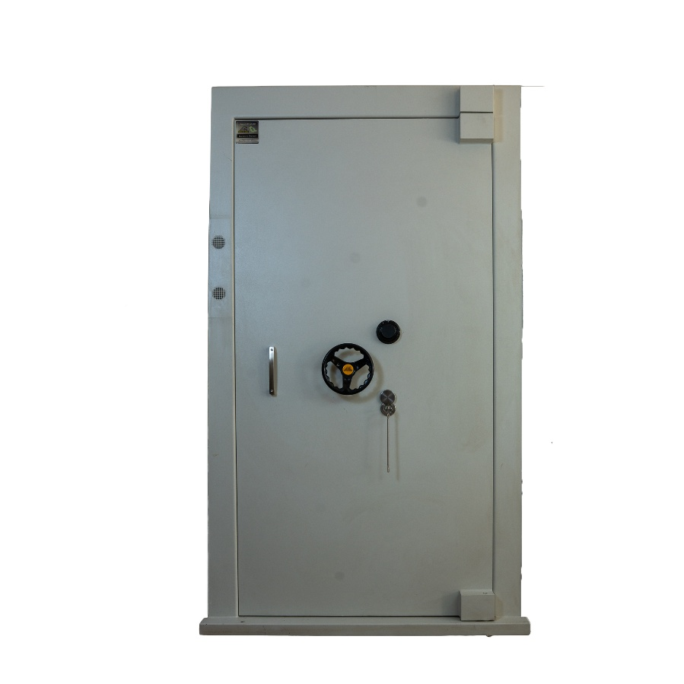

SSM130
Outside(mm) | 2180*1304*430(MM)
Weight(kg) | 1100 Kg
locking | S&G- KABA
Option locking | Handle / key / combination / Digital lock
Certificate | SIRIM QAS

SSM100-2*1
Outside(mm) | 2173*1286*330(MM)
EMD-Outside(mm) | 697*536(MM)
Weight(kg) | 1100 Kg
locking | S&G- KABA
Option locking | Handle / key / combination / Digital lock
Certificate | SIRIM QAS

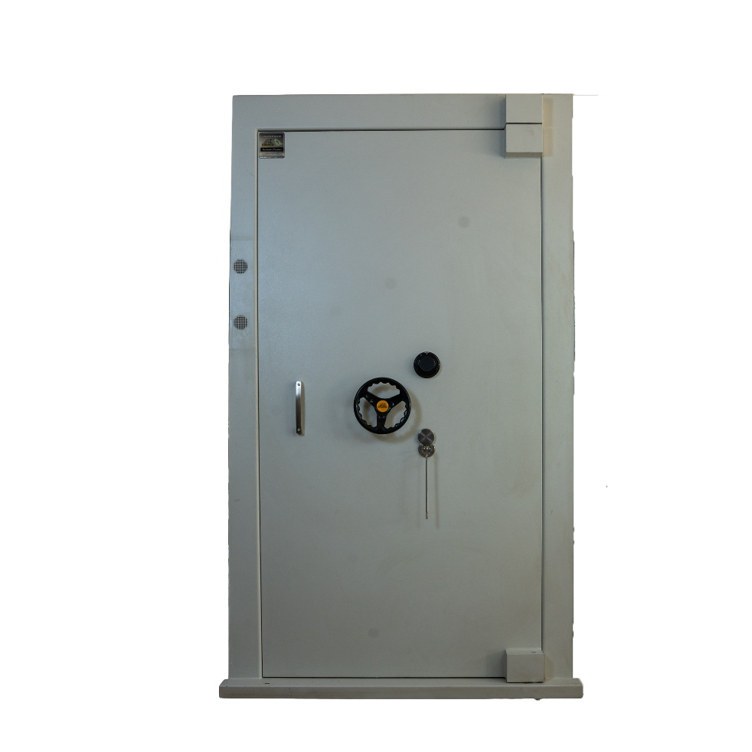

SSM100
Outside(mm) | 2180*1304*430(MM)
Weight(kg) | 1100 Kg
locking | S&G- KABA
Option locking | Handle / key / combination / Digital lock
Certificate | SIRIM QAS

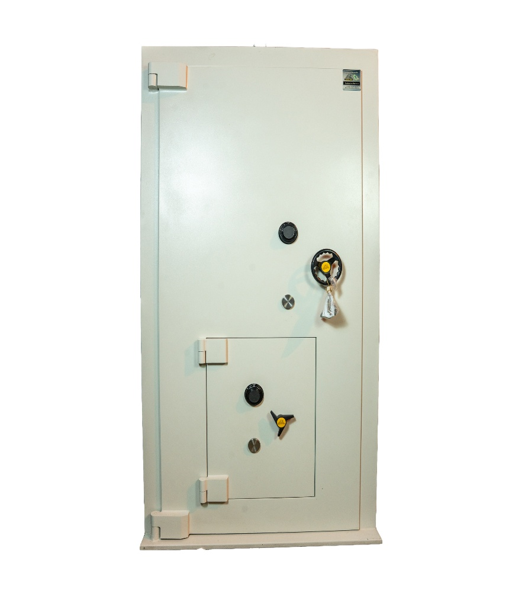

SSM50-2*1
Outside(mm) | 2125*1180*220(MM)
EMD-Outside(mm) | 700*536(MM)
Weight(kg) | 760 Kg
locking | S&G- KABA
Option locking | Handle / key / combination / Digital lock
Certificate | SIRIM QAS

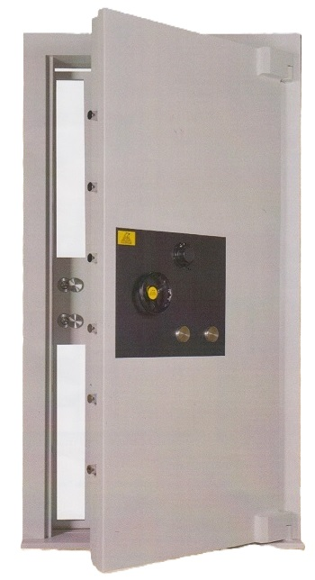

SSM50
Outside(mm) | 2046*1100*230(MM)
Weight(kg) | 750 Kg
locking | S&G- KABA
Option locking | Handle / key / combination / Digital lock
Certificate | SIRIM QAS

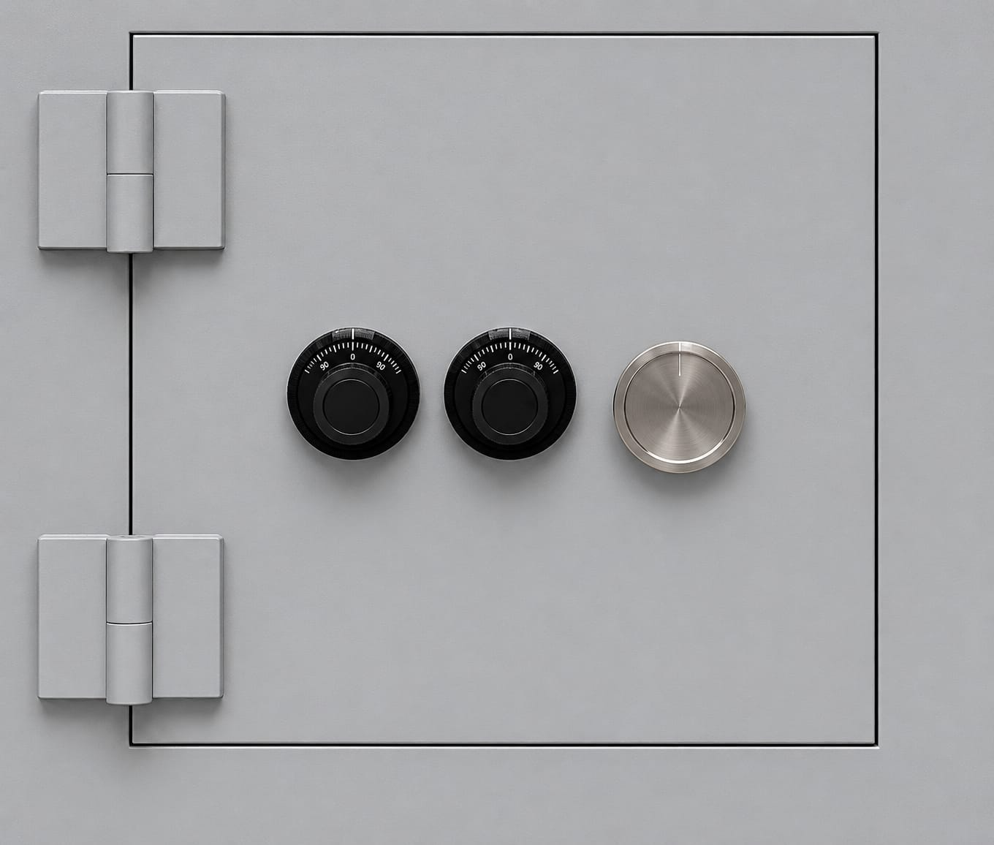

EMD JKM20606
Outside(mm) | 600*600 (MM)
Weight(kg) | 650 Kg
locking | S&G- KABA
Certificate | UL 608 Listed / Class 2

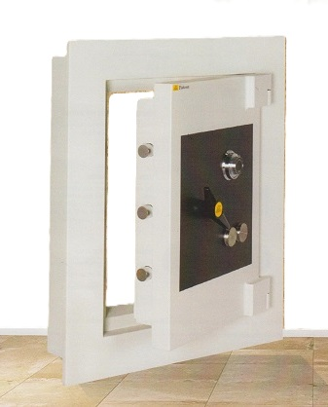

EMD 100
Outside(mm) | 600*600 (MM)
Weight(kg) | 500 Kg
locking | S&G- KABA
Certificate | SIRIM QAS

EMD 50
Outside(mm) | 1015*815*250 (MM)
Weight(kg) | 600 Kg
locking | S&G- KABA
Certificate | SIRIM QAS

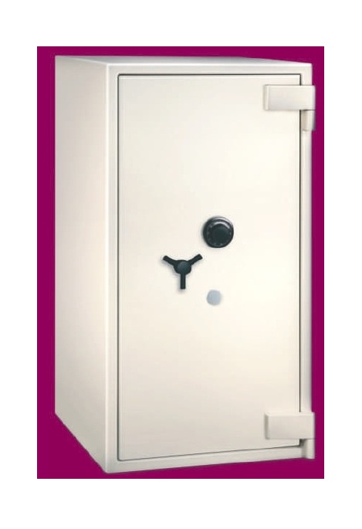

Godrej-F63
Outside(mm) | 1730*800*693
Inside (mm) | 1600*670*470
Weight(kg) | 1091 Kg
Option locking | Handle / key / combination lock
locking | S&G- KABA
Shelf(pc) | 3
Burglary Resistance | EN 1143-1 GRADE IV
Fire Class | 60 Min

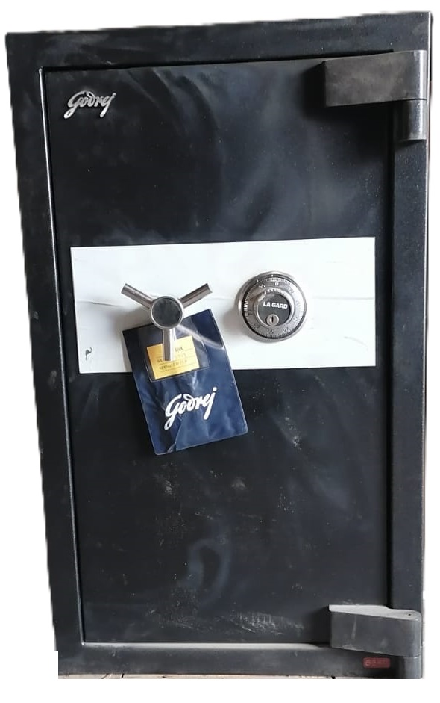

Godrej-3016-12
Outside(mm) | 895*536*510
Inside (mm) | 762*406*305
Weight(kg) | 507 Kg
Option locking | Handle / key / combination lock
locking | S&G- KABA
Shelf(pc) | 3
Fire Class | 60 Min

Godrej-2414-12
Outside(mm) | 740*486*510
Inside (mm) | 610*356*305
Weight(kg) | 407 Kg
locking | S&G- KABA
Option locking | Handle / key / combination lock
Shelf(pc) | 3
Fire Class | 60 Min

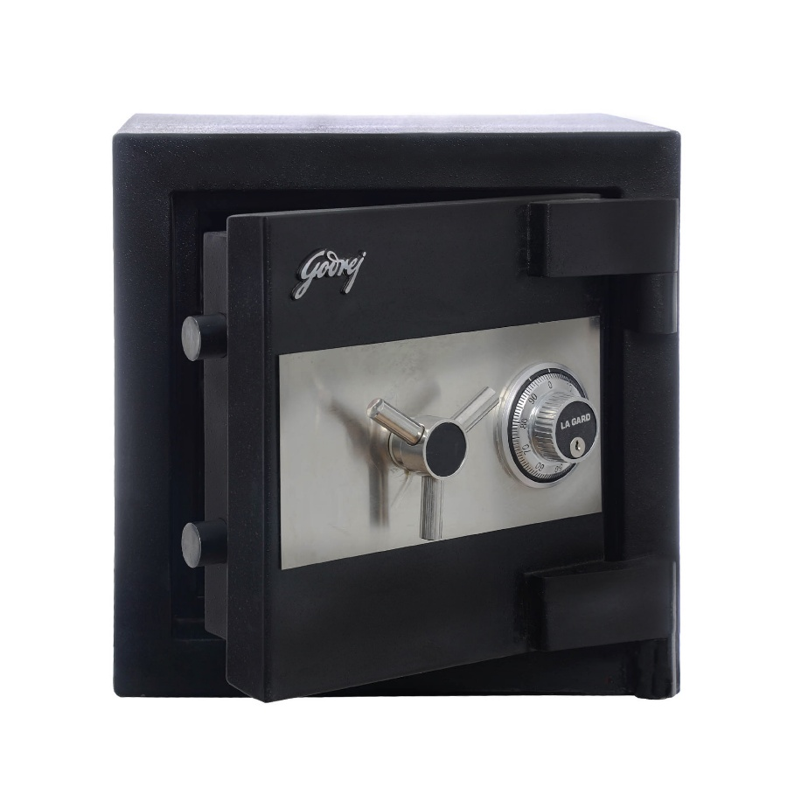

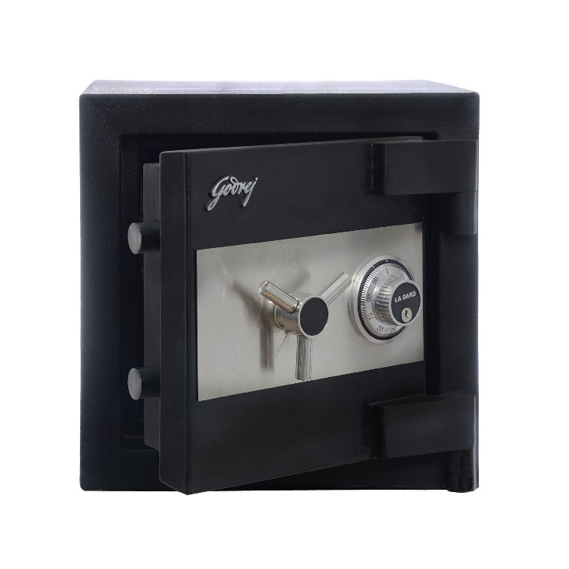

Godrej-1212-11
Outside(mm) | 435*435*485
Inside (mm) | 305*305*280
Weight(kg) | 242 Kg
Option locking | Handle / key / combination lock
Shelf(pc) | 3
Fire Class | 60 Min

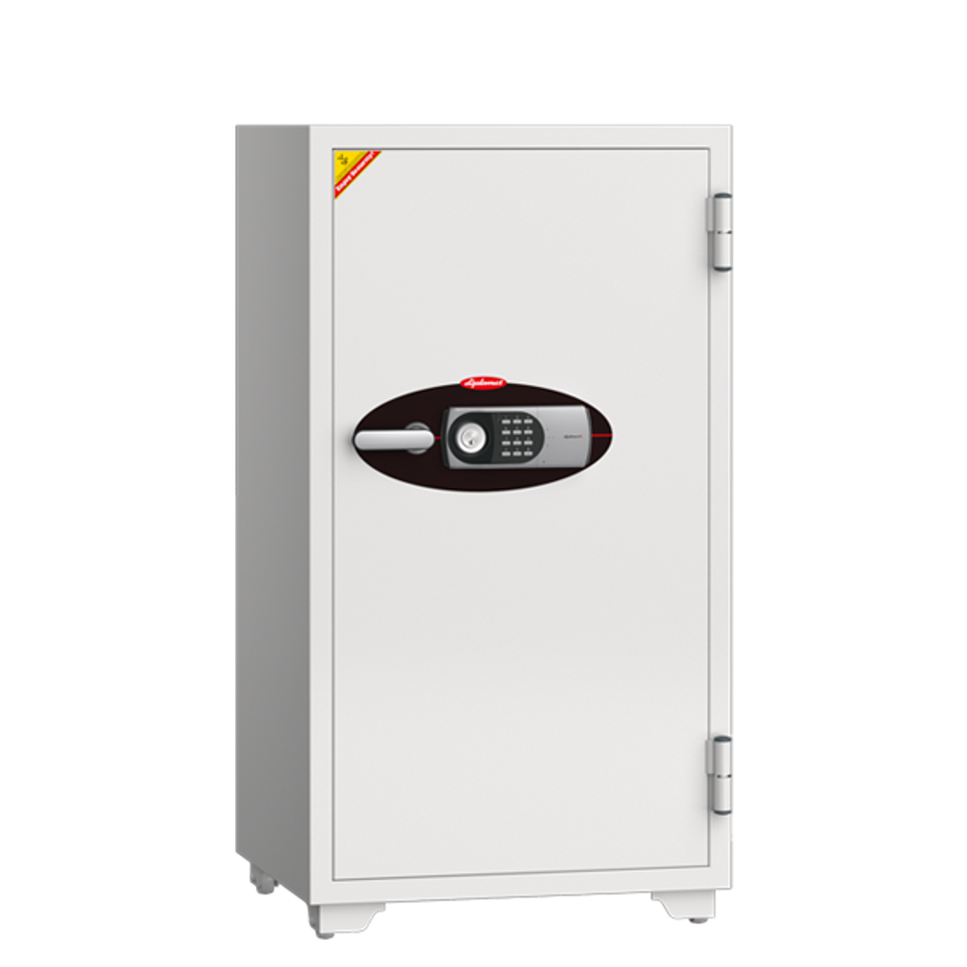

EH-100
Outside(mm) | 1020*655*560 (MM)
Inside (mm) | 780*475*350 (MM)
Option locking | Handle / key / combination lock / Digital
Weight(kg) | 201 Kg
Shelf(pc) | 2
Fire Class | 60 Min

EH-120
Outside(mm) | 1220*655*560 (MM)
Inside (mm) | 980*475*350 (MM)
Option locking | Handle / key / combination lock / Digital
Weight(kg) | 228 Kg
Shelf(pc) | 2
Fire Class | 60 Min

EH-200
Outside(mm) | 1690*655*560 (MM)
Inside (mm) | 1450*475*350 (MM)
Option locking | Handle / key / combination lock / Digital
Weight(kg) | 320 Kg
Shelf(pc) | 3
Fire Class | 60 Min

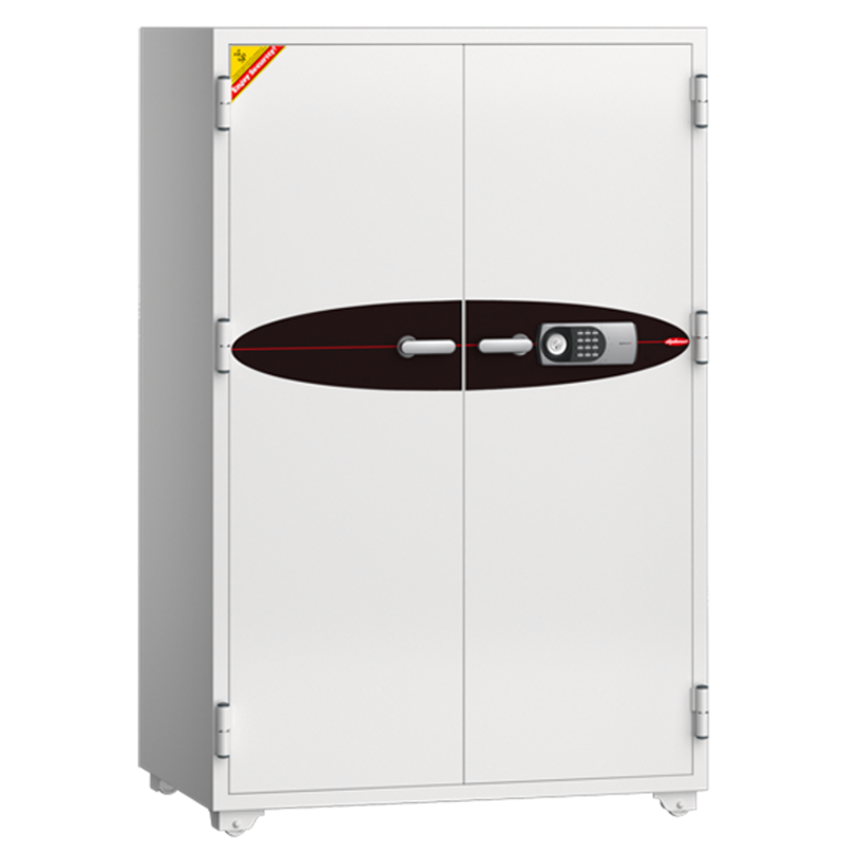

L-300
Outside(mm) | 1745*1126*700 (MM)
Inside (mm) | 1505*946*490 (MM)
locking | Handle / key / combination lock / Digital
Weight(kg) | 540 Kg
Shelf(pc) | 3
Fire Class | 60 Min

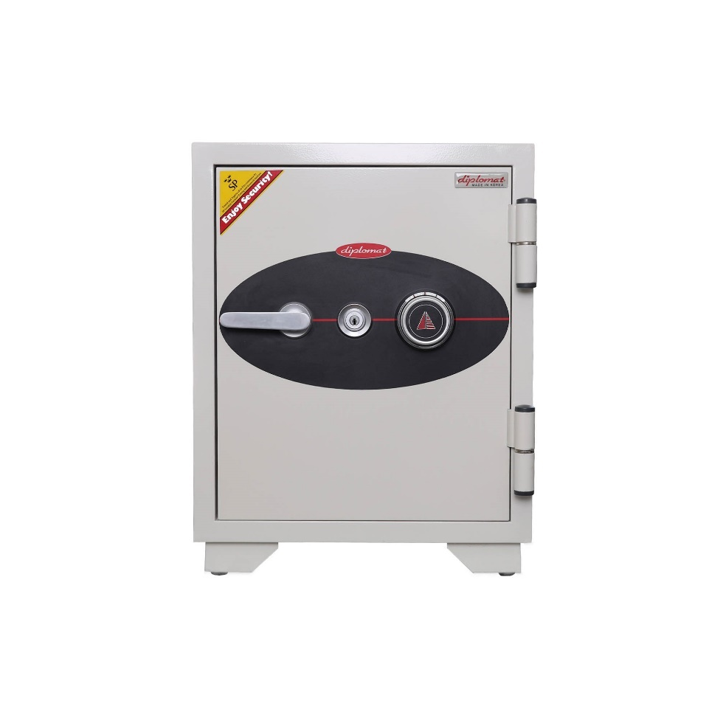

EH-006
Outside(mm) | 538*450*460
Inside (mm) | 430*350*328
locking | Handle / key / combination lock / Digital
Weight(kg) | 64 Kg
Shelf(pc) | 1
Capacity | 49
Fire Class | 60 Min

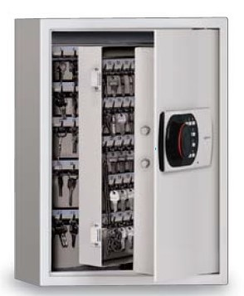

Kc-200
Outside(mm) | 555*430*179
Inside (mm) | 762*508*508
locking | Digital lock
Weight(kg) | 26 Kg
Capacity | 200 Keys

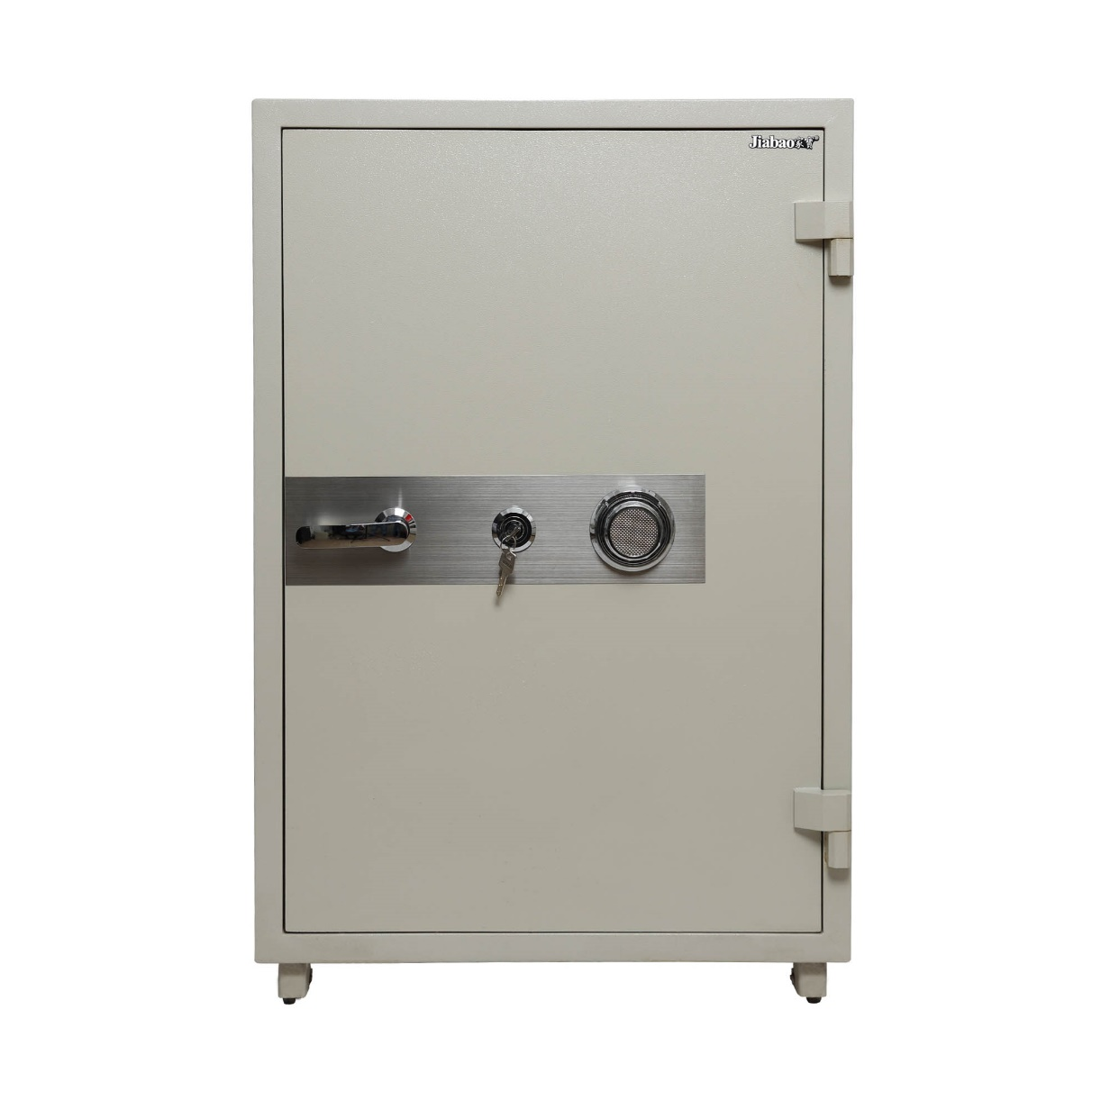
JB - 100
Outside(mm) | 1020*655*560
Inside (mm) | 780*475*350
locking | Handle / key / combination lock
Weight(kg) | 210 Kg
Capacity | 129
Shelf(pc) | 2
Fire Class | 60 Min

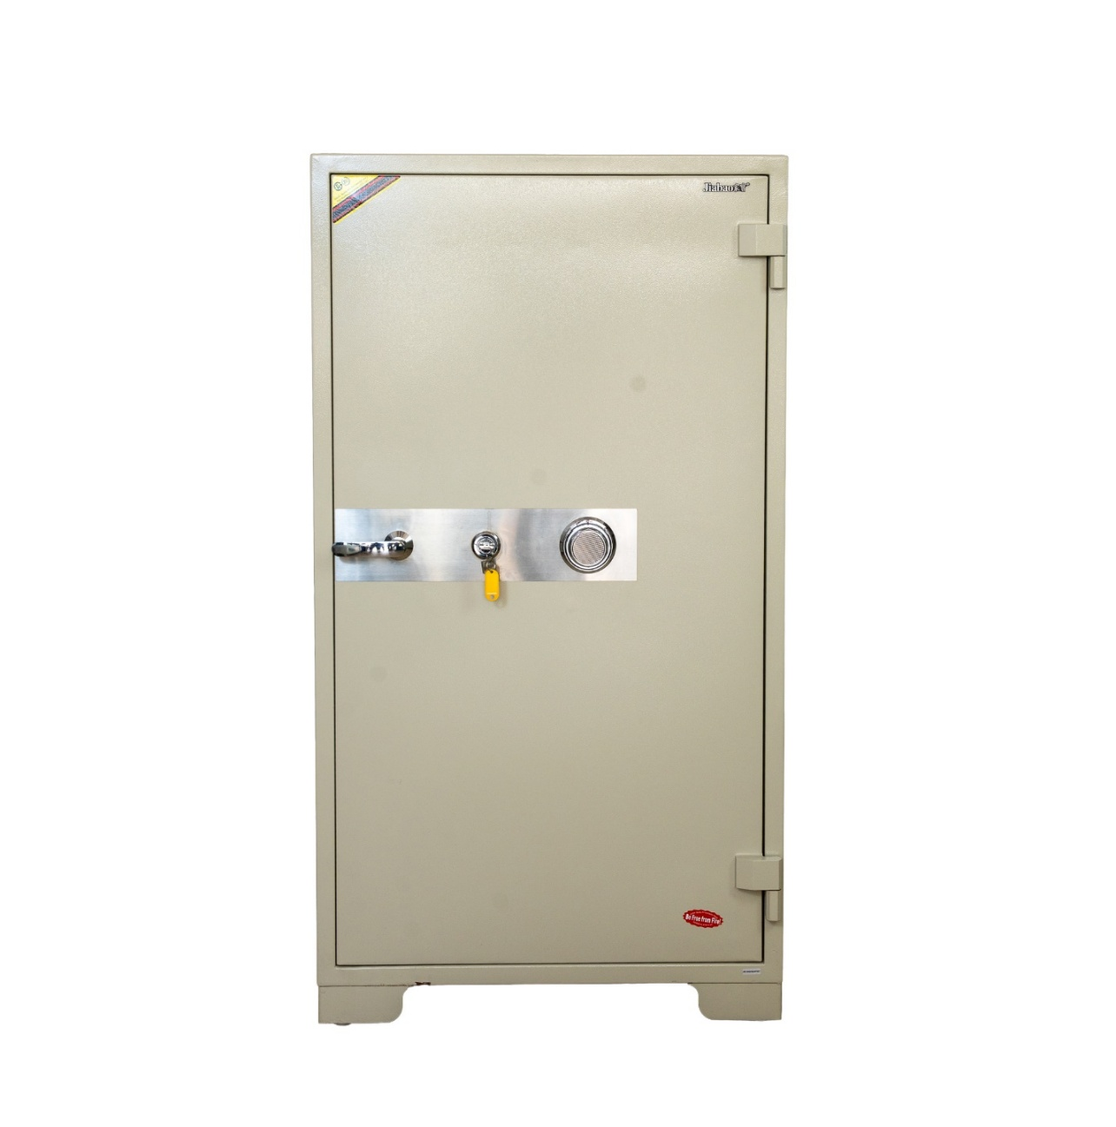

JB - 130
Outside(mm) | 1440*780*650
Inside (mm) | 125*700*560
locking | Handle / key / combination lock
Weight(kg) | 275 Kg
Capacity | 165
Shelf(pc) | 2
Fire Class | 60 Min

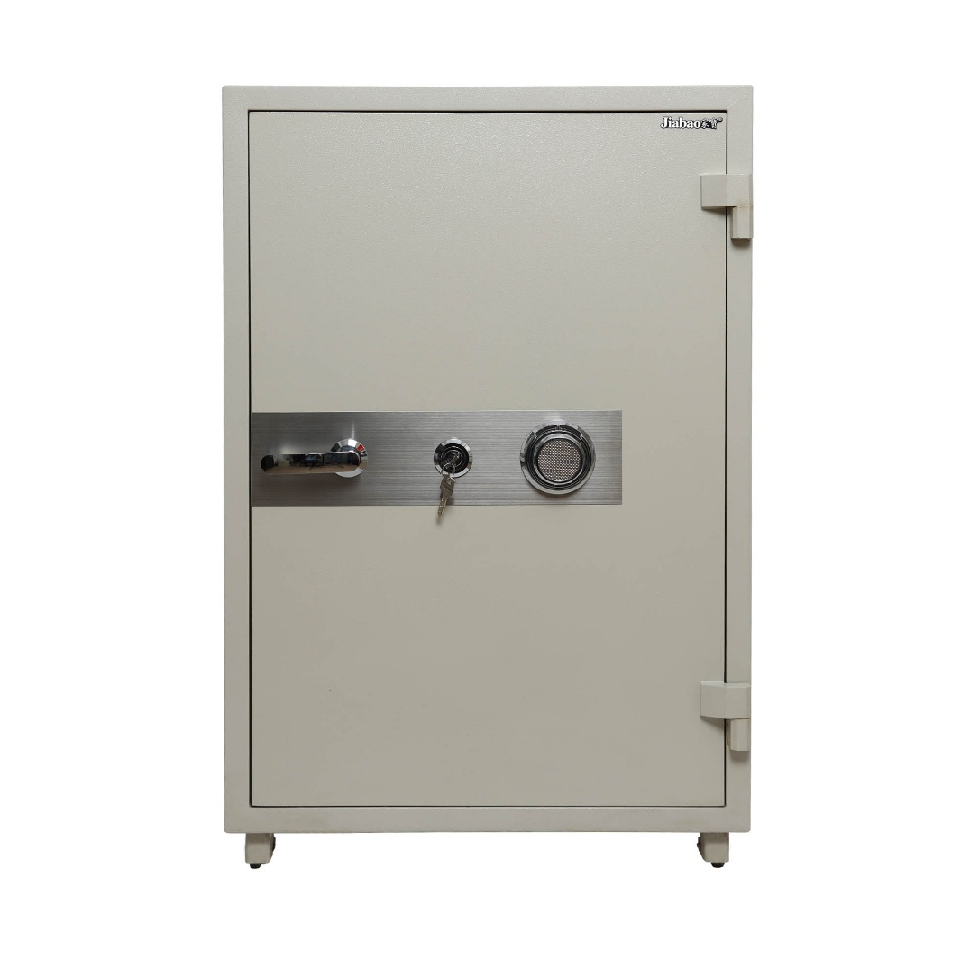

JB - 200
Outside(mm) | 1680*780*650
Inside (mm) | 1450*595*440
locking | Handle / key / combination lock
Weight(kg) | 388 Kg
Capacity | 375
Shelf(pc) | 3
Fire Class | 60 Min

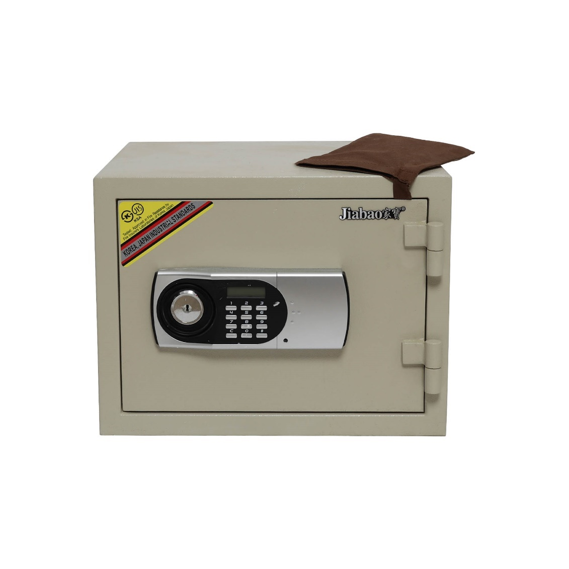

JB-001
Outside(mm) | 300*400*450
Inside (mm) | 220*320*220
locking | Handle / key lock / Digital lock
Weight(kg) | 25 Kg
Shelf(pc) | 1
Fire Class | 60 Min

EH-119
Outside(mm) | 360*412*363
Inside (mm) | 260*320*234
locking | Handle / key lock / Digital lock
Weight(kg) | 30 Kg
Shelf(pc) | 1
Fire Class | 60 Min

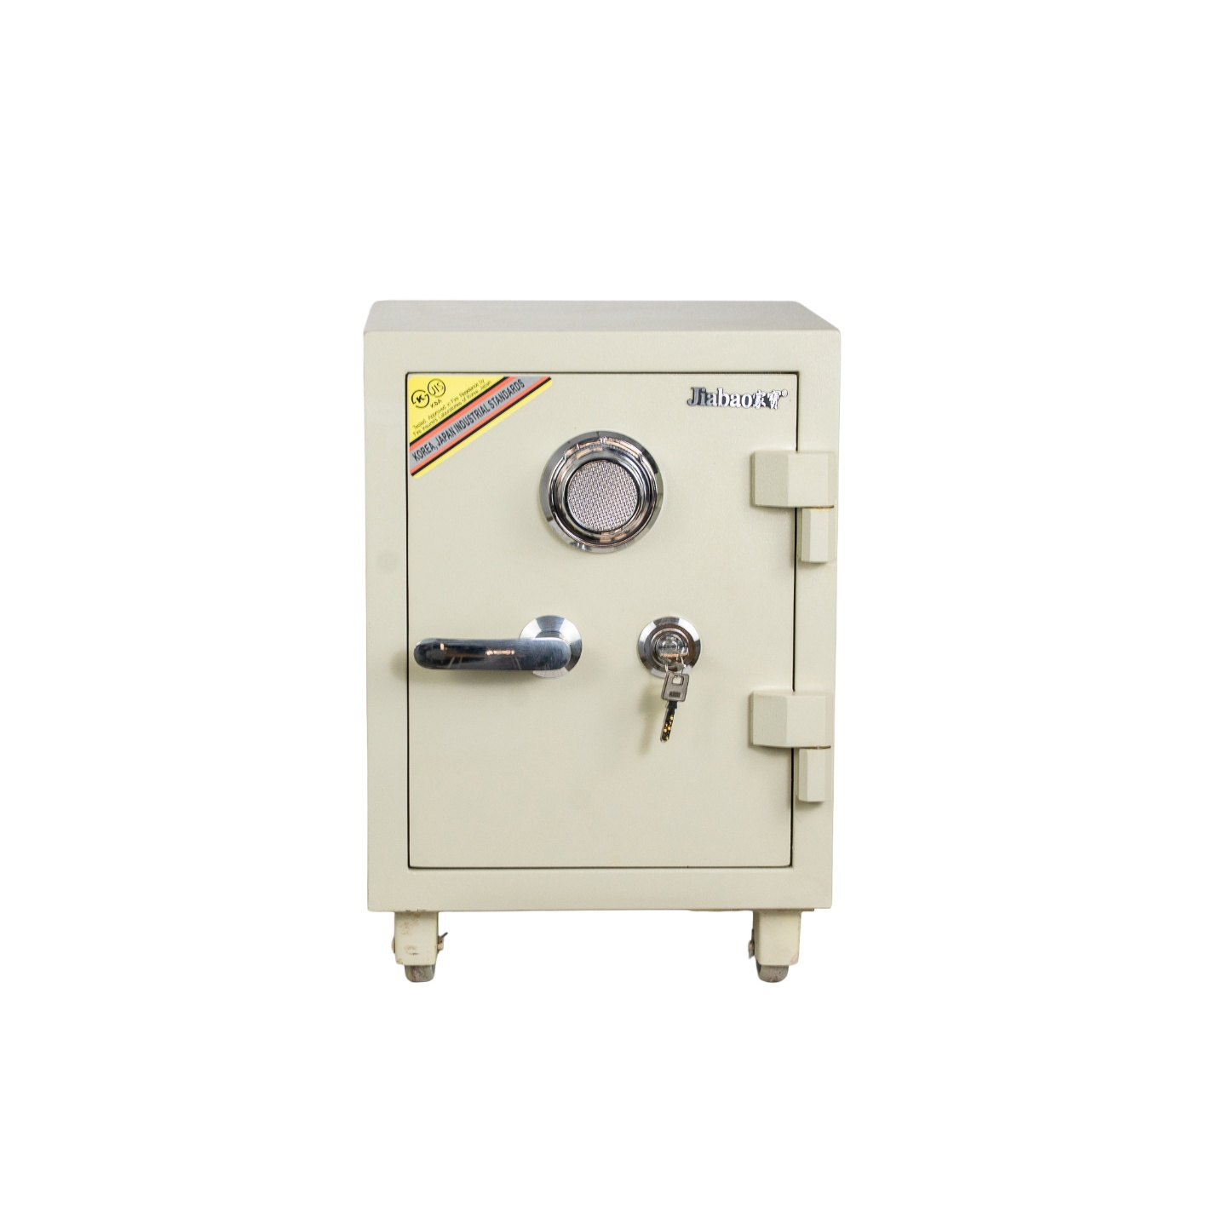

JB - 050
Outside(mm) | 520*360*360
Inside (mm) | 330*300*250
locking | Handle / key / combination lock
Weight(kg) | 25 Kg
Shelf(pc) | 1
Fire Class | 60 Min

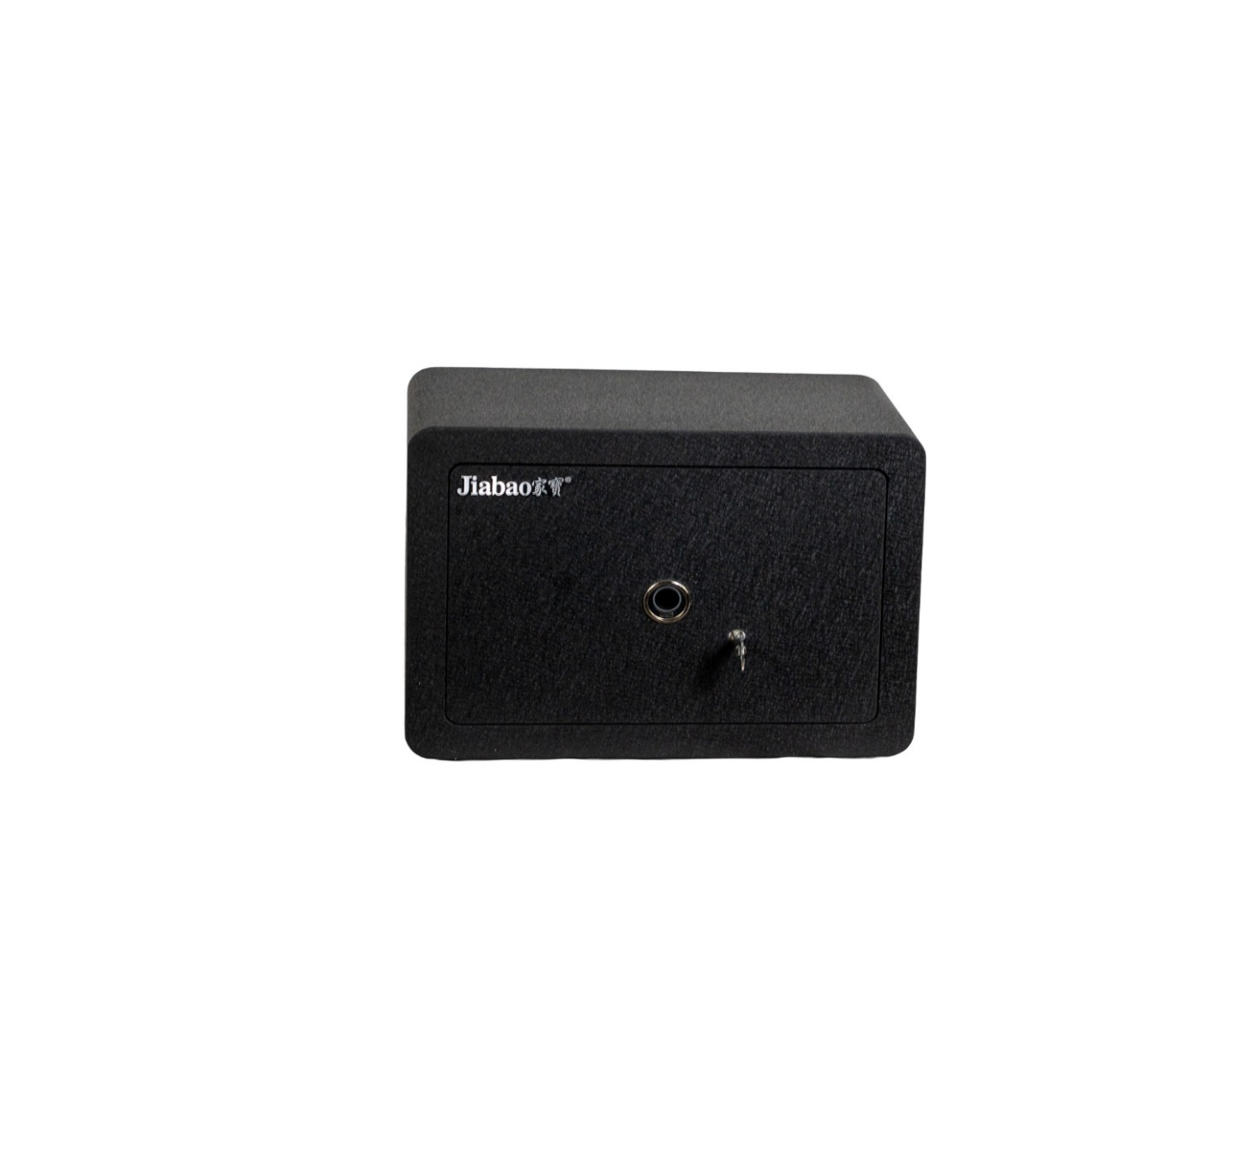

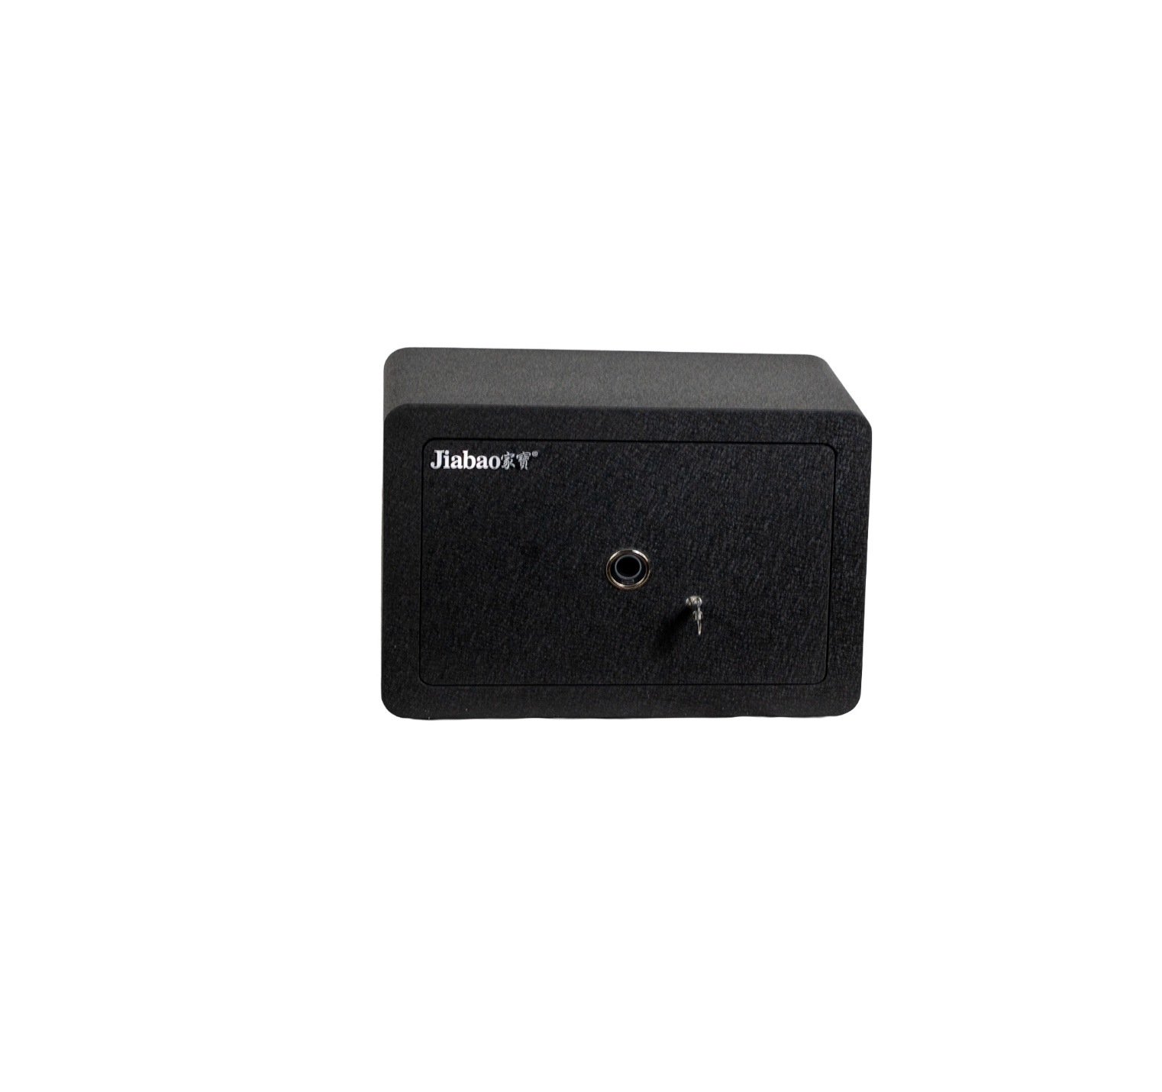

JB-TF-350
Outside(mm) | 350*250*250
Weight(kg) | 5 Kg
Shelf(pc) | 1
Lock | Finger print

JB-TF-420
Outside(mm) | 420*310*300
Weight(kg) | 7 Kg
Shelf(pc) | 1
Lock | Finger print

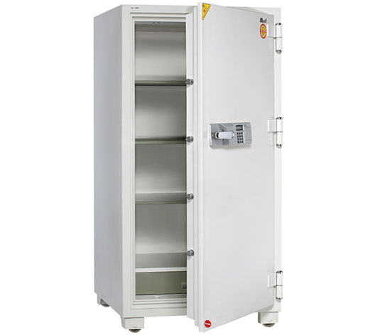

Booil Safes - 1400
Outside(mm) | 1385*700*630
Inside (mm) | 1145*530*460
locking | Handle / key / combination lock
Weight(kg) | 335 Kg
Shelf(pc) | 3

Booil Safes - 1700
Outside(mm) | 1685*800*630 (mm)
Inside (mm) | 1445*630*460 (MM)
locking | Handle / key / combination lock
Weight(kg) | 485 Kg
Shelf(pc) | 3

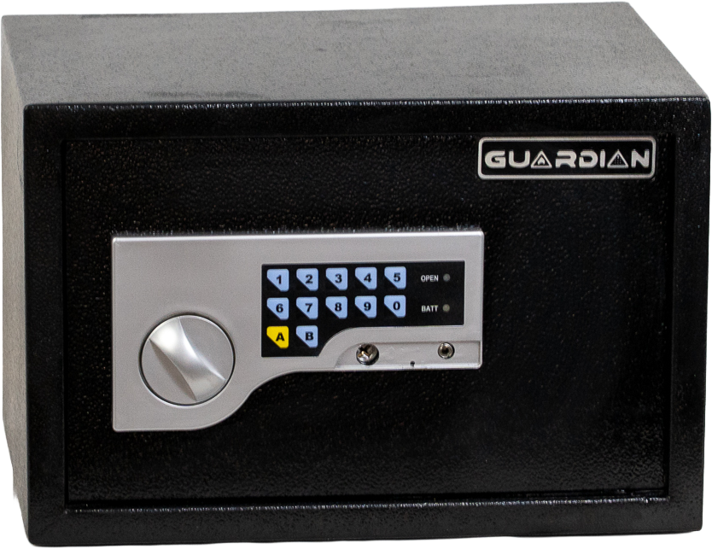

Hs-250
Outside(mm) | 250*350*250 (MM)
locking | Digital lock
Weight(kg) | 6.5 Kg
Shelf(pc) | 1

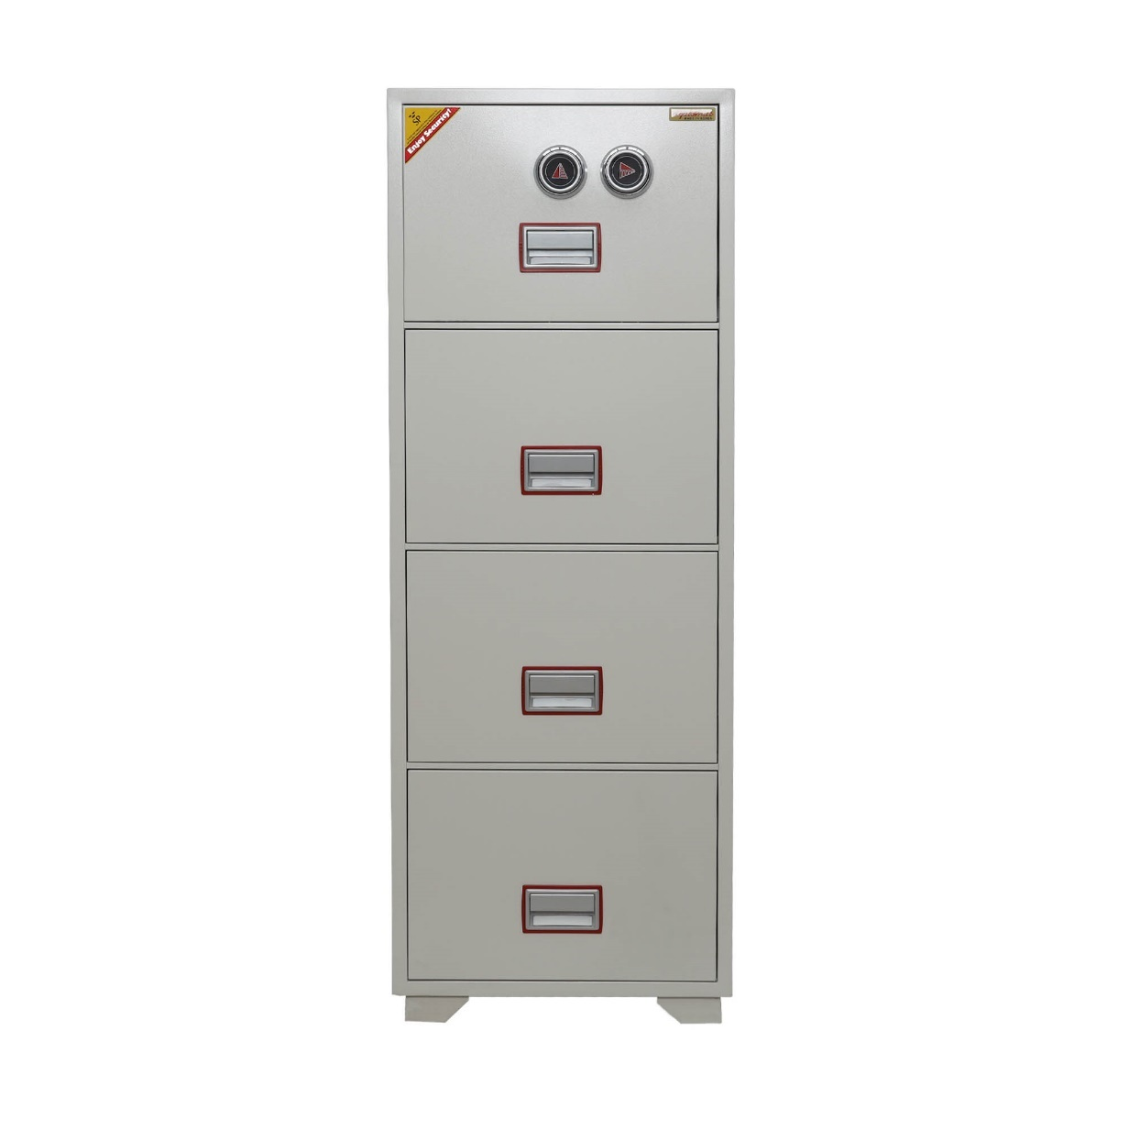

DFC-4000
Outside(mm) | 1466*528*675
Weight(kg) | 266
Shelf(pc) | 4 Drawer
locking | Handle / key / combination lock
Fire Class | 60 Min

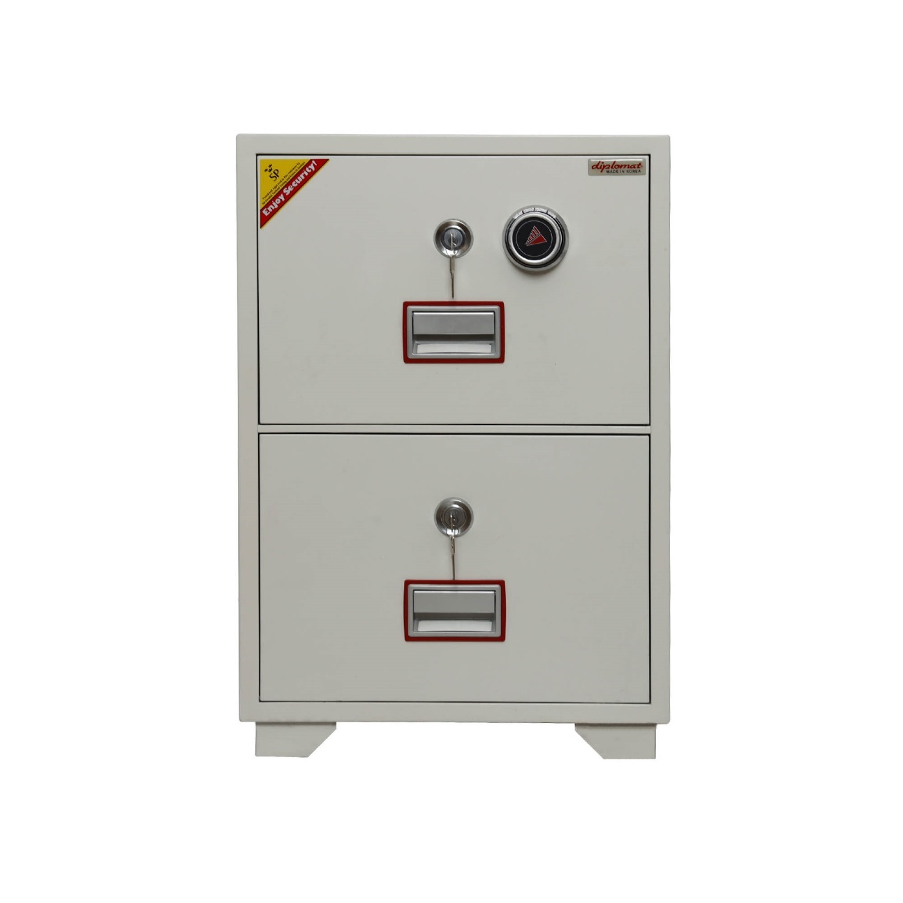
DFC- 2000
Outside(mm) | 782*528*675
Weight(kg) | 145 Kg
locking | Handle / key / combination lock
Shelf(pc) | 2 Drawer
Fire Class | 60 Min

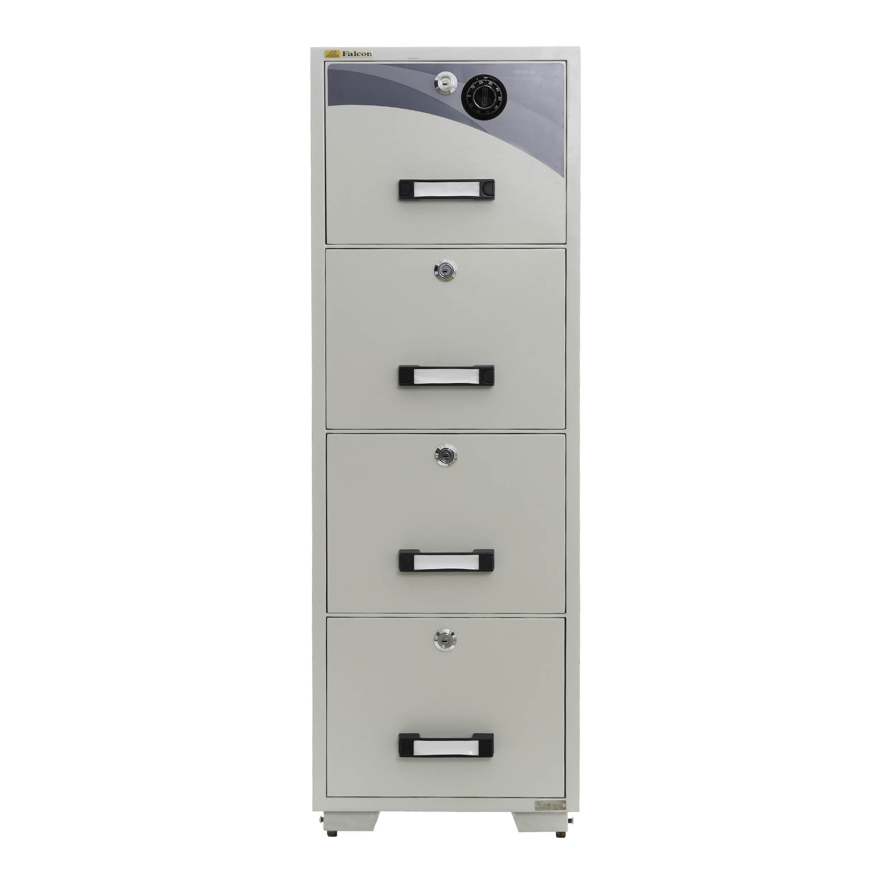

FCR- 4000
Outside(mm) | 1550*525*755
Weight(kg) | 390 Kg
locking | S&G- KABA
locking | Handle / key / combination lock
Shelf(pc) | 4 Drawer
Fire Class | 60 Min

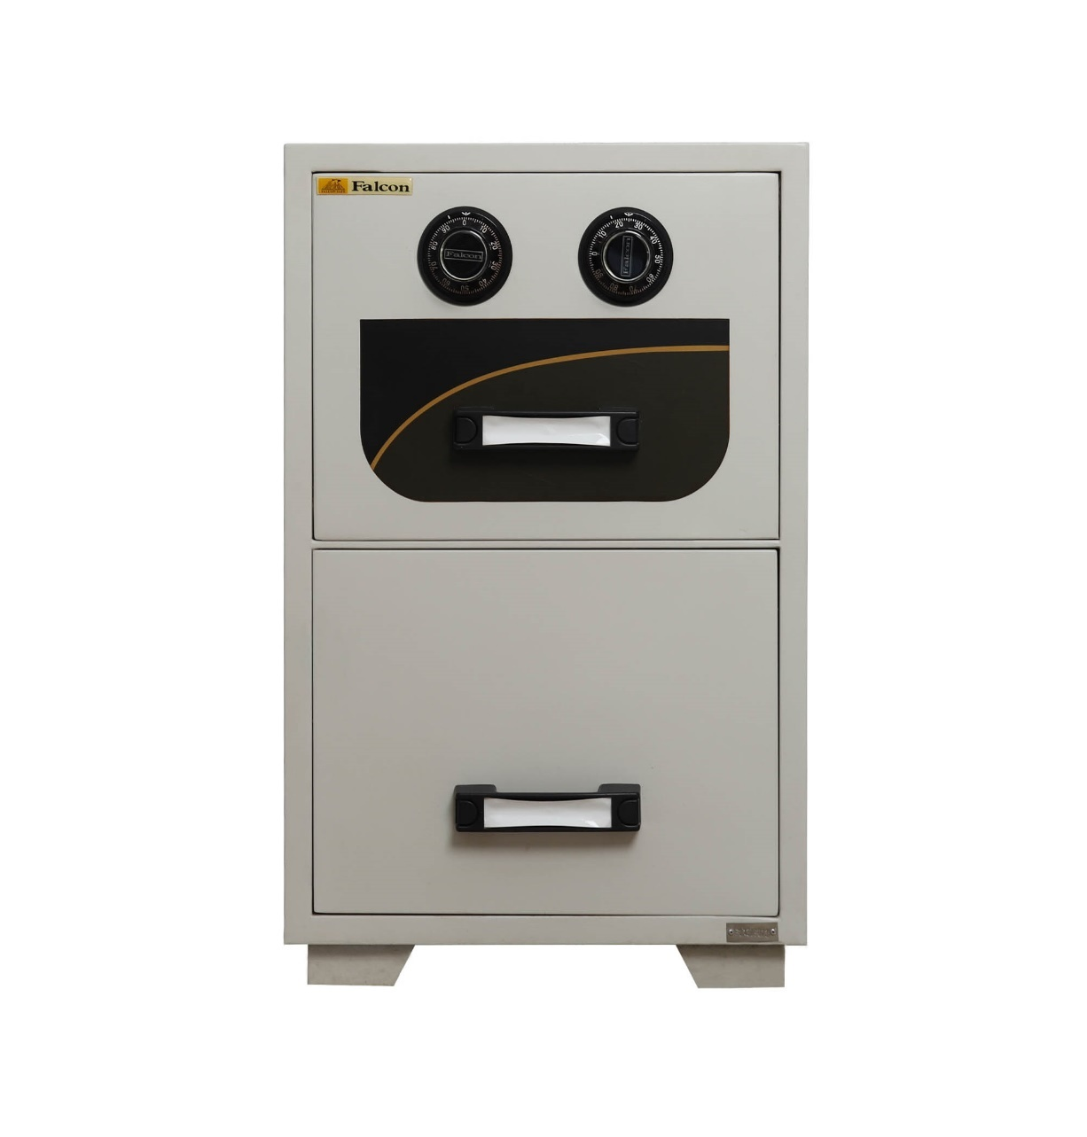
FRC – 2000
Outside(mm) | 825*525*755
Weight(kg) | 195 Kg
locking | S&G- KABA
locking | Handle / key / combination lock
Shelf(pc) | 2 Drawer
Fire Class | 60 Min

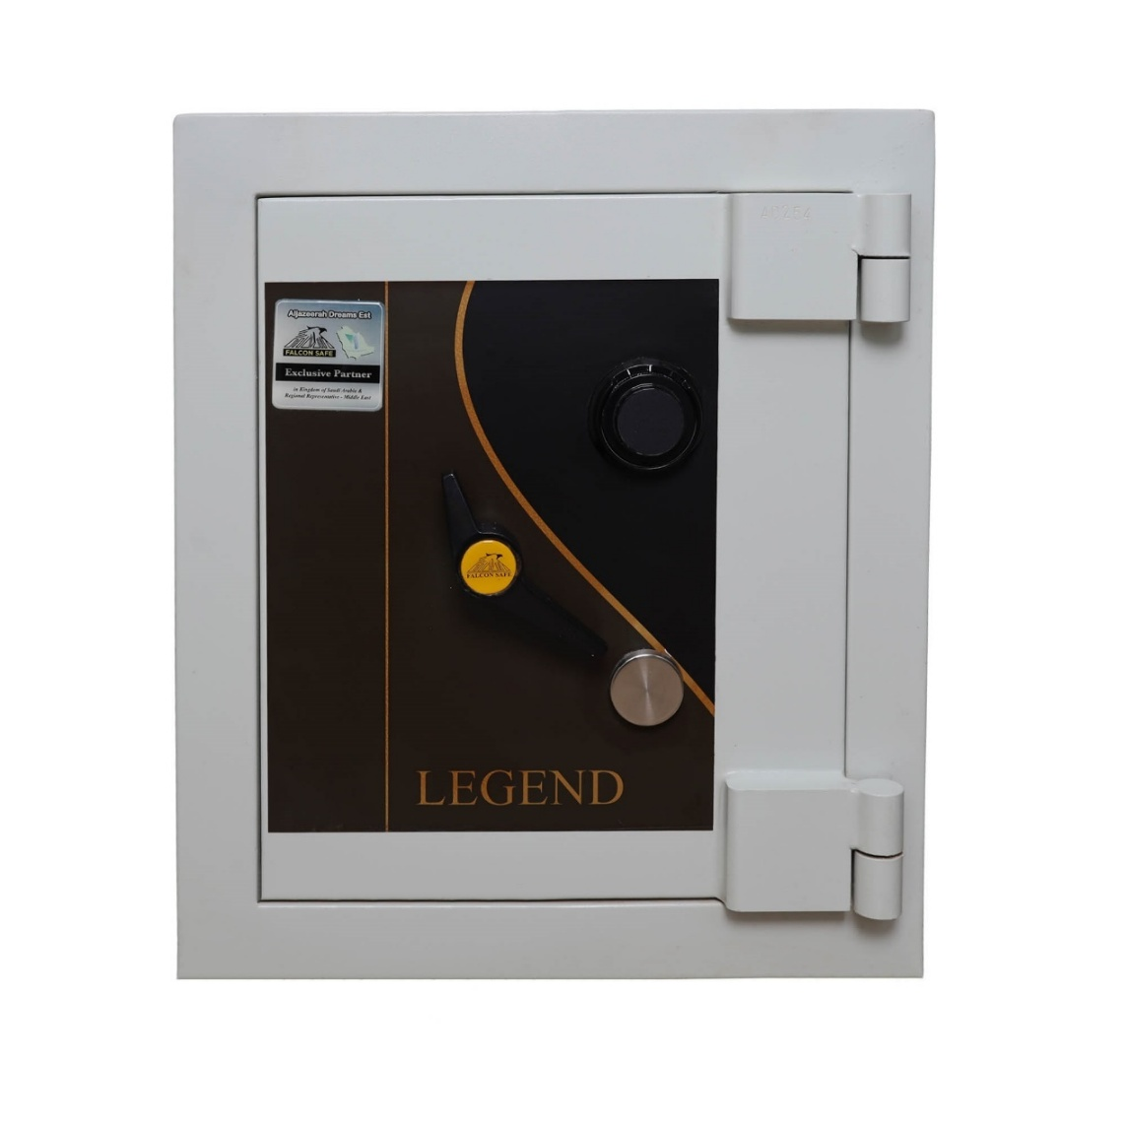
LEGEND 1
Outside(mm) | 711*685*660
Inside (mm) | 500*400*500
Weight(kg) | 538 Kg
locking | S&G- KABA
locking | Handle / key / combination lock
Shelf(pc) | 1
Fire Class | 60 Min

LEGEND 2
Outside(mm) | 890*685*735
Inside (mm) | 680*475*575
Weight(kg) | 700 Kg
locking | S&G- KABA
locking | Handle / key / combination lock
Shelf(pc) | 1
Fire Class | 60 Min
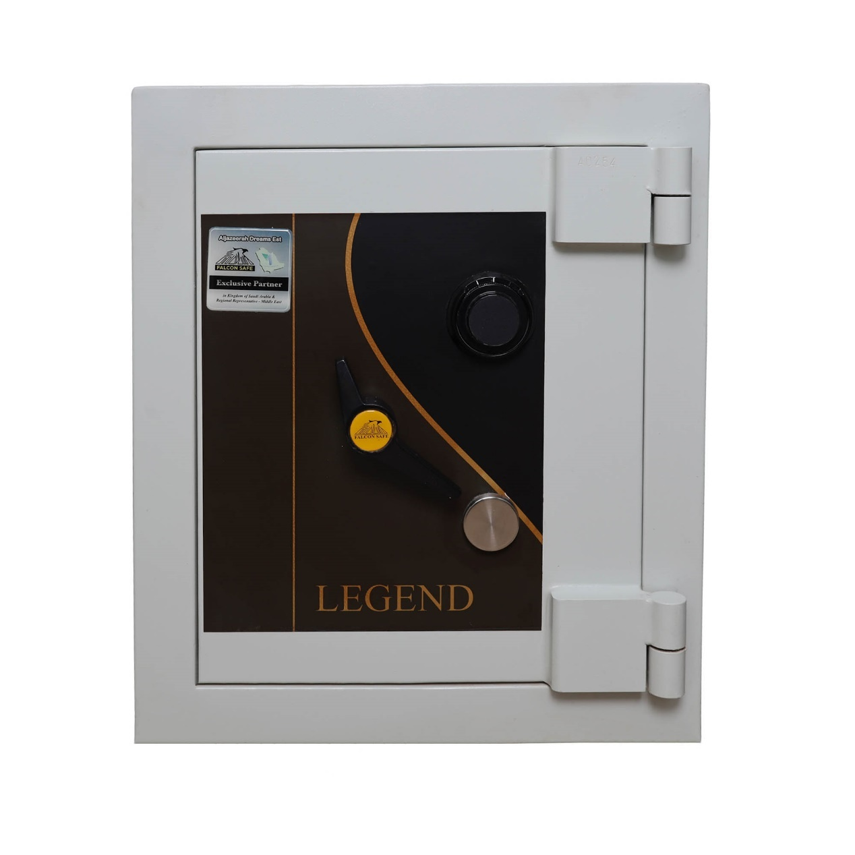

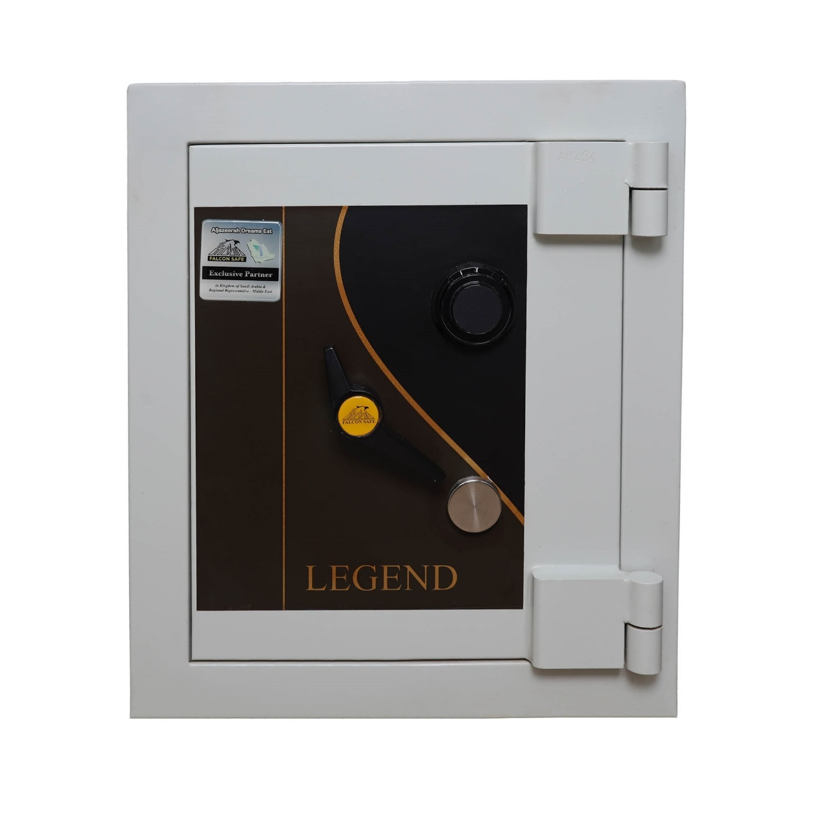

LEGEND 3
Outside(mm) | 1095*760*815
Inside (mm) | 865*535*535
Weight(kg) | 959 Kg
locking | S&G- KABA
locking | Handle / key / combination lock
Shelf(pc) | 1
Fire Class | 60 Min

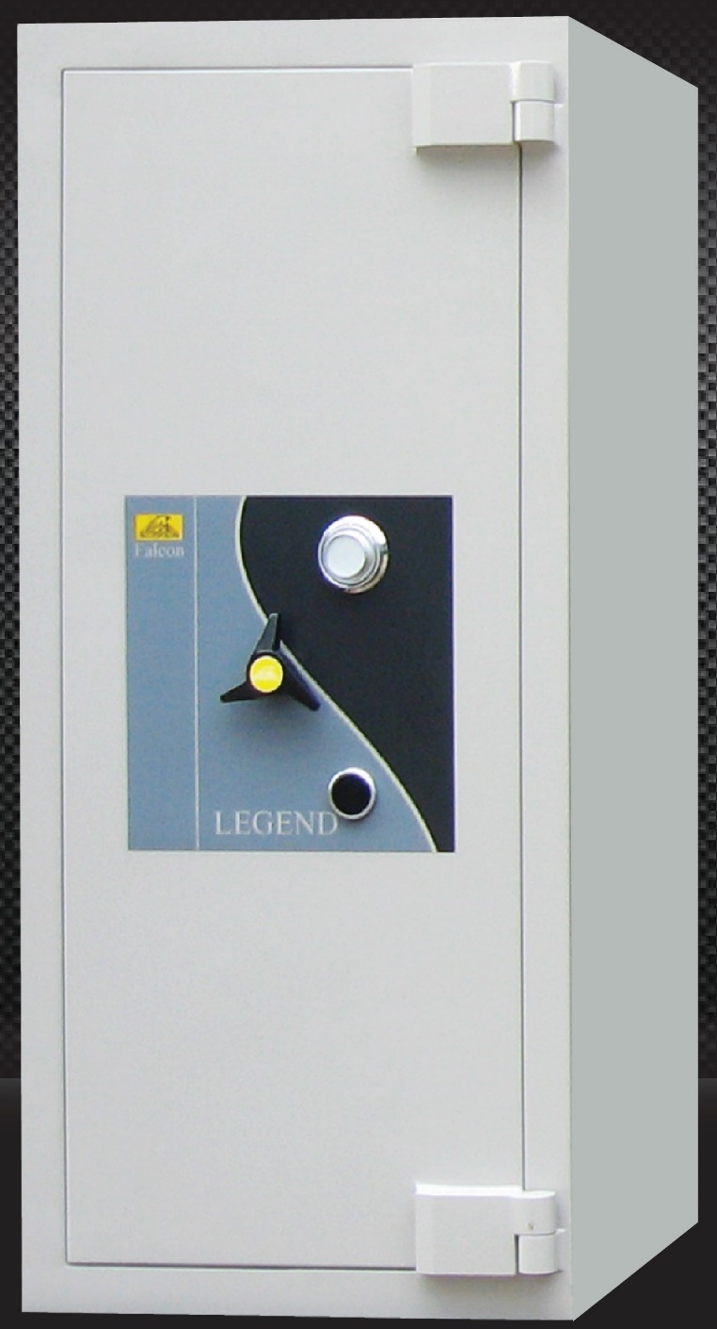

BS-2000
Outside(mm) | 1800*800*800
Inside (mm) | 1600*650*650
Weight(kg) | 1690
locking | S&G- KABA
locking | Handle / key / combination lock
Shelf(pc) | 3
Fire Class | 60 Min

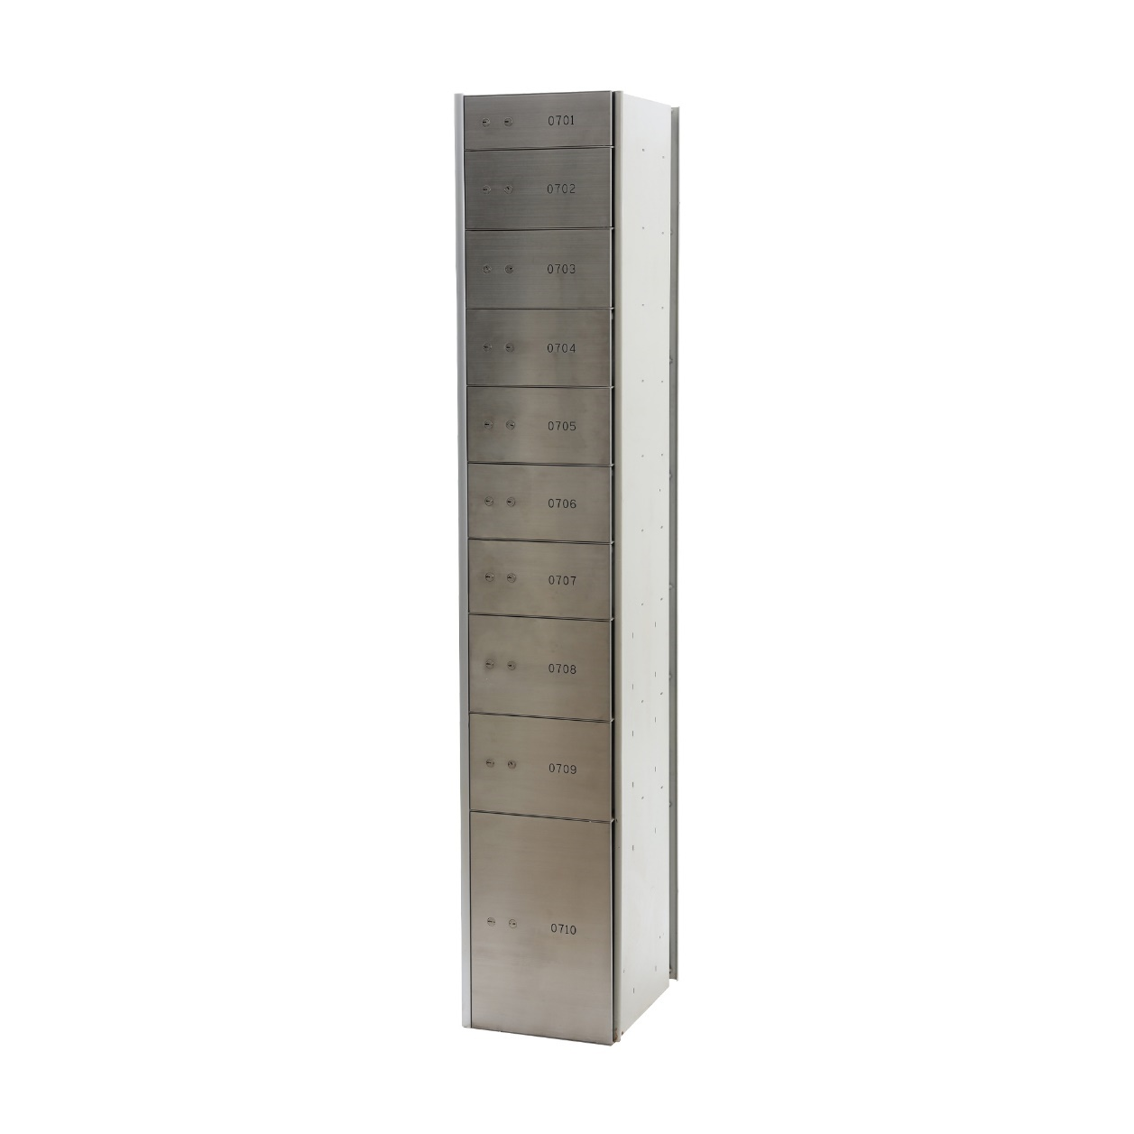
FSDL-V2000
Outside(mm) | 2000*305*435
Weight(kg) | 200 Kg
Locking | 2 KL (Customer & master)
Locker Size | 100*1  150*6  200*2  450*1
Shelf(pc) | 10 Drawer

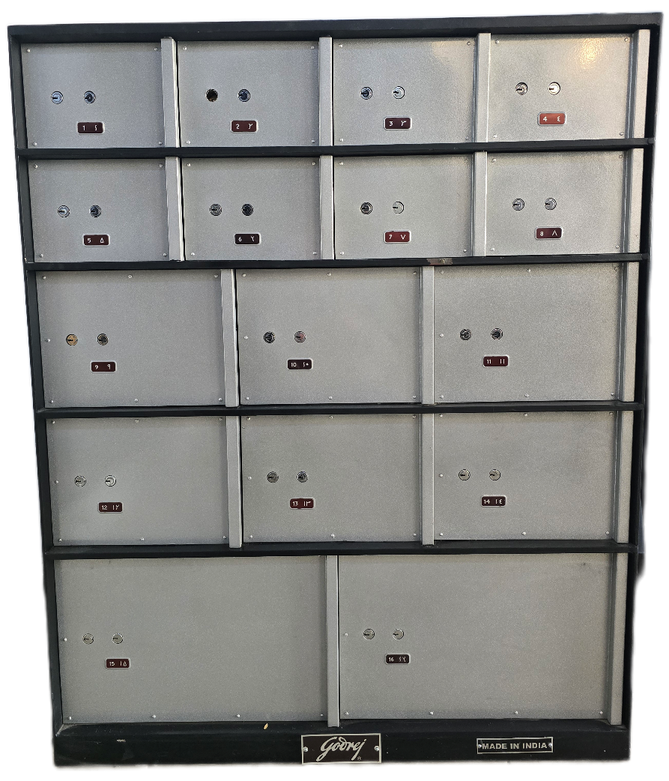

Godrej-V2000
Outside(mm) | 1140*920*570
Weight(kg) | 200 Kg
Locking | 2 KL (Customer & master)
Locker Size | H-150*W-200*8  H-200*W-280*6  H-280*W-430*2
Shelf(pc) | 16 Drawer

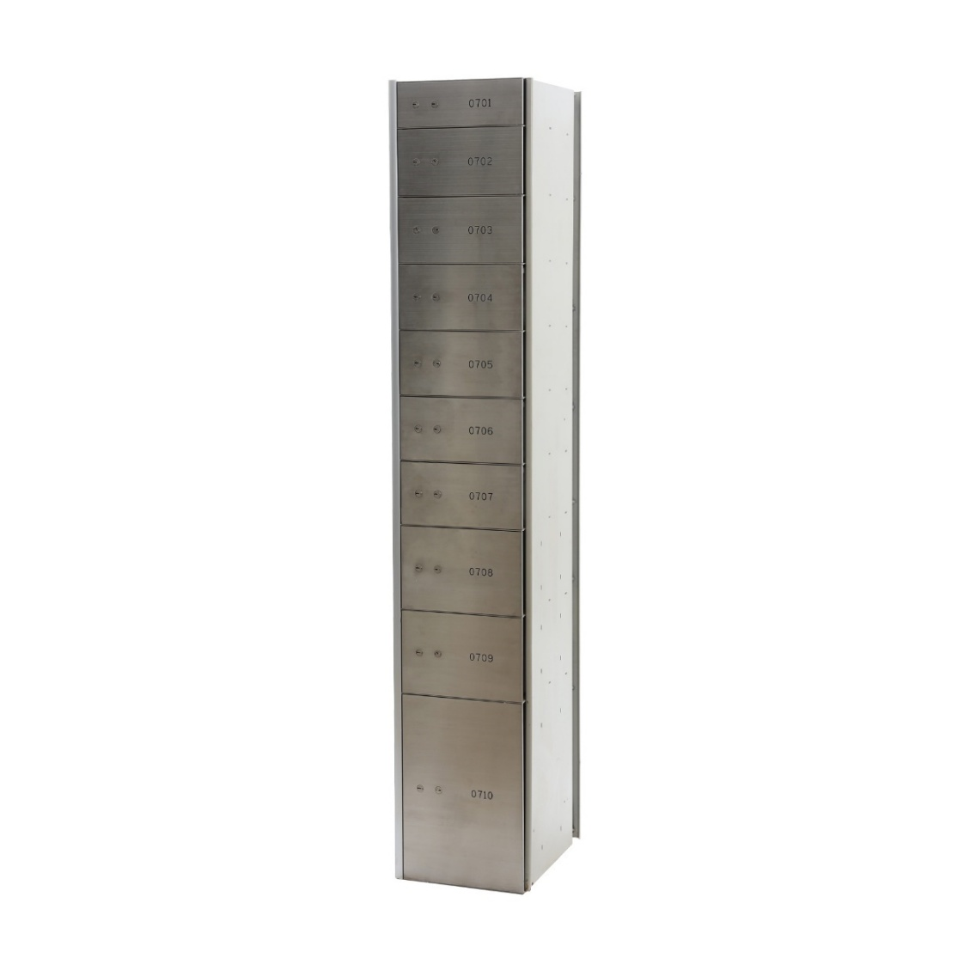

FSDL-V1750
Outside(mm) | 2000*305*435
Weight(kg) | 200 Kg
Locking | 2 KL (Customer & master)
Locker Size | 800*4  150*4  300*1  480*1
Shelf(pc) | 10 Drawer

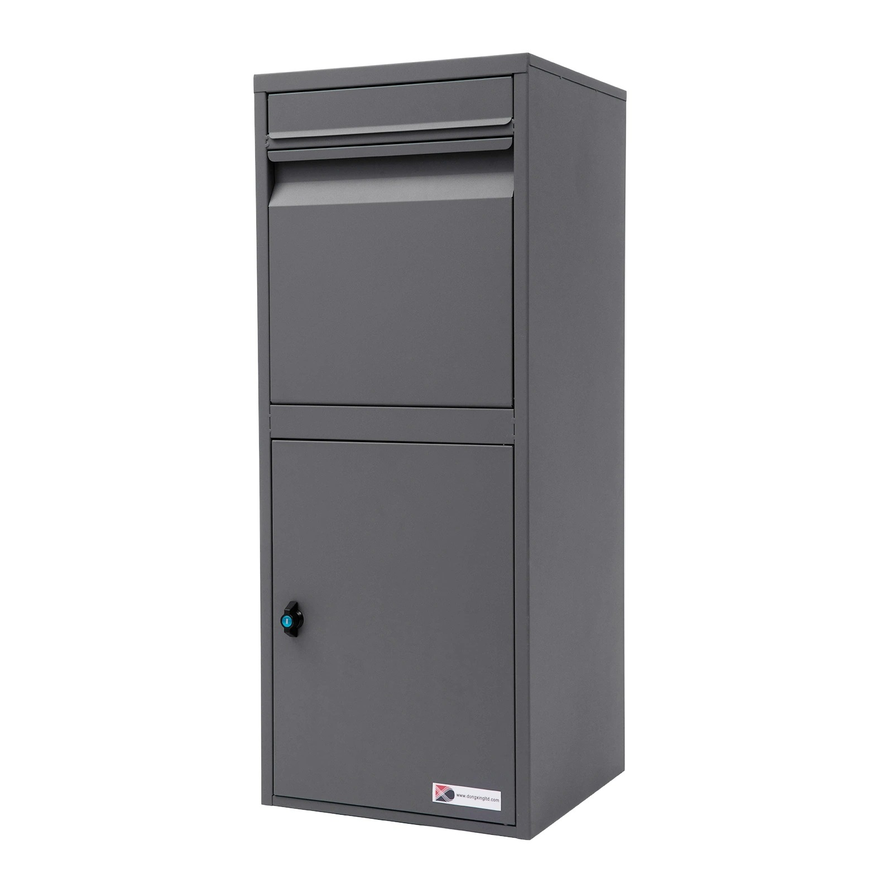

Parcel Box
Outside(mm) | 1005*600*600 (MM)
Weight(kg) | 25 Kg
Locking | 1 KL

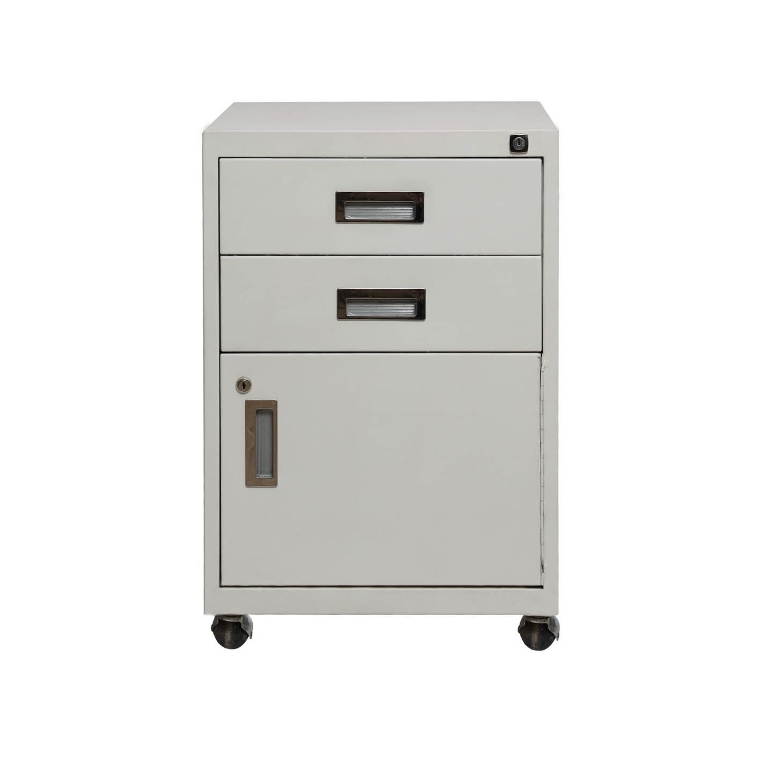
Teeler
Outside(mm) | 700*460*450
Weight(kg) | 25 Kg
Locking | 3 KL

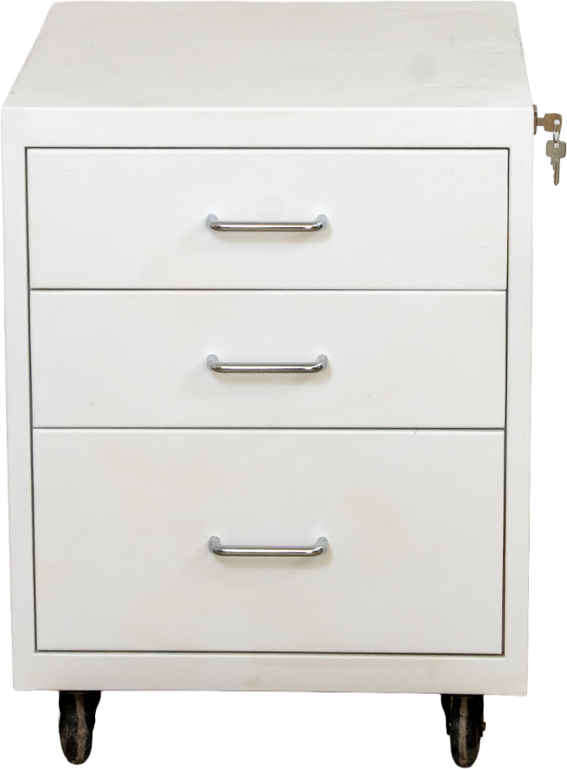

Teeler
Outside(mm) | 640*460*520
Weight(kg) | 25 Kg
Locking | 1 or 3

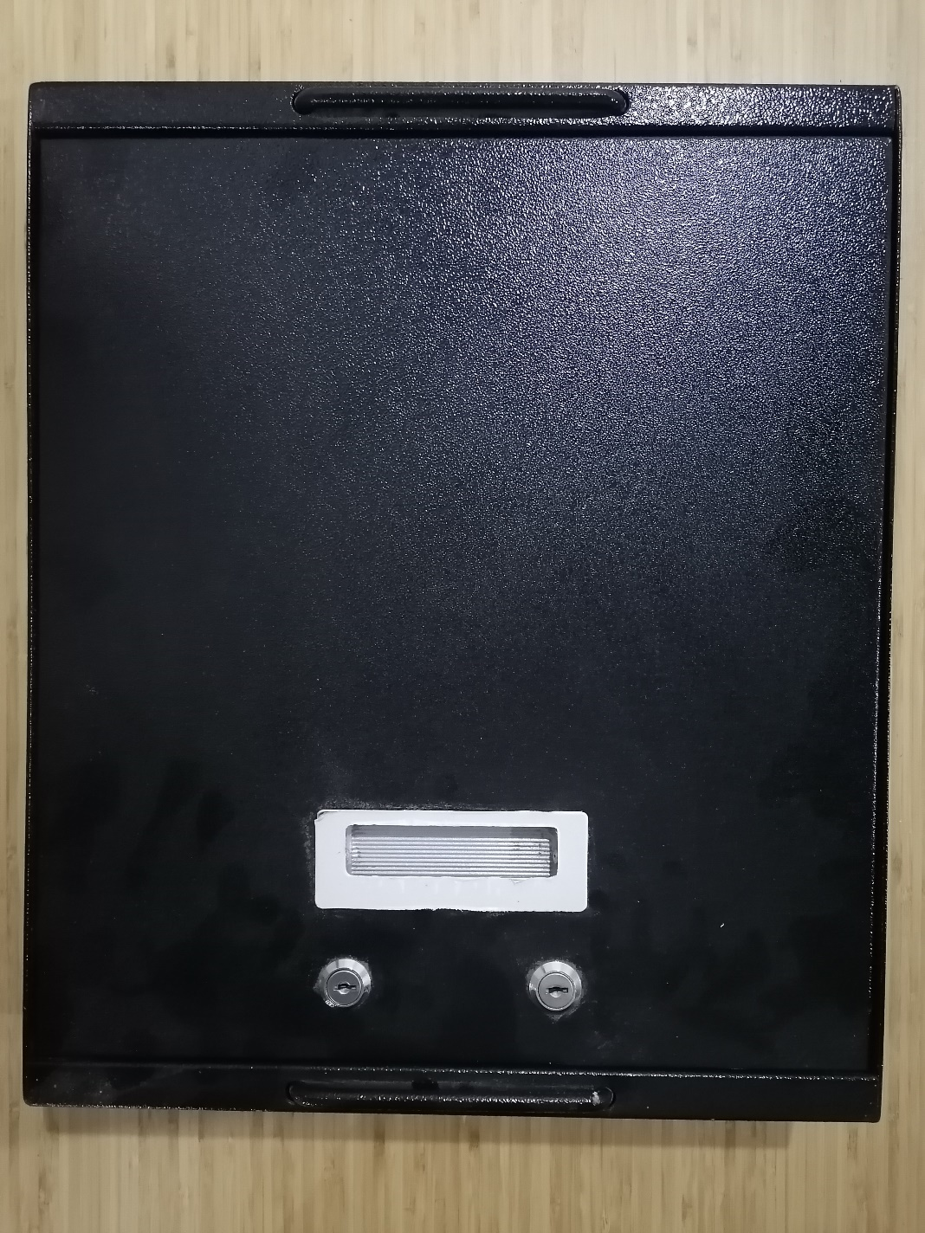

T- 102
Outside(mm) | 430*360*80
Locking | 2 KL

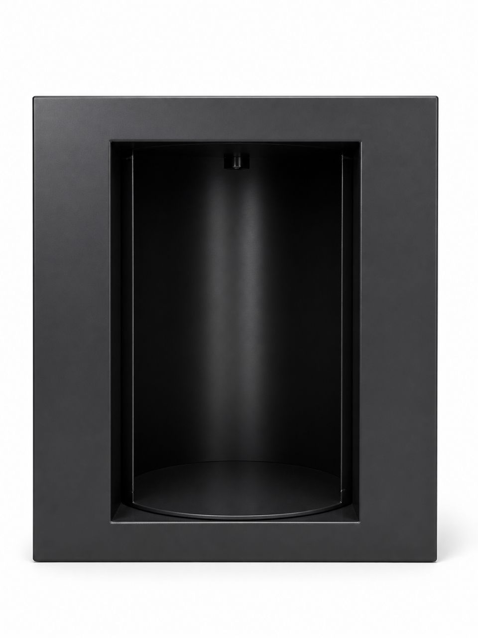

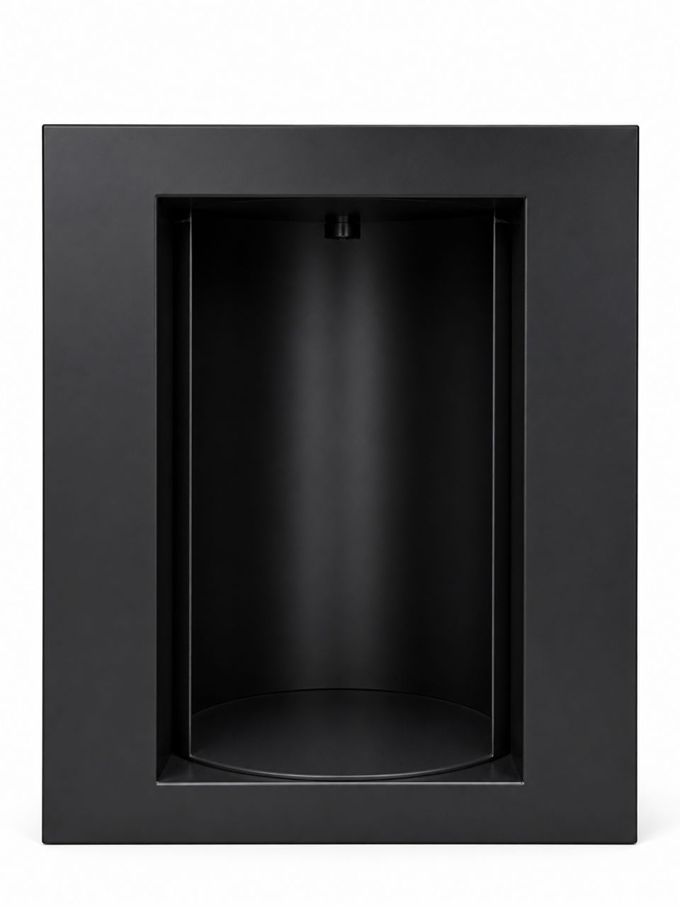

Pass Box
Outside(MM) | 1000*750*950
InSide (MM) | 820*560
Locking | 2 KL

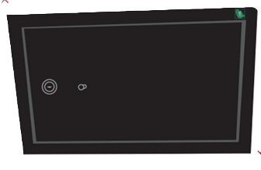

Pass Box
Outside (MM) | 300*500*300
Locking | 2 KL

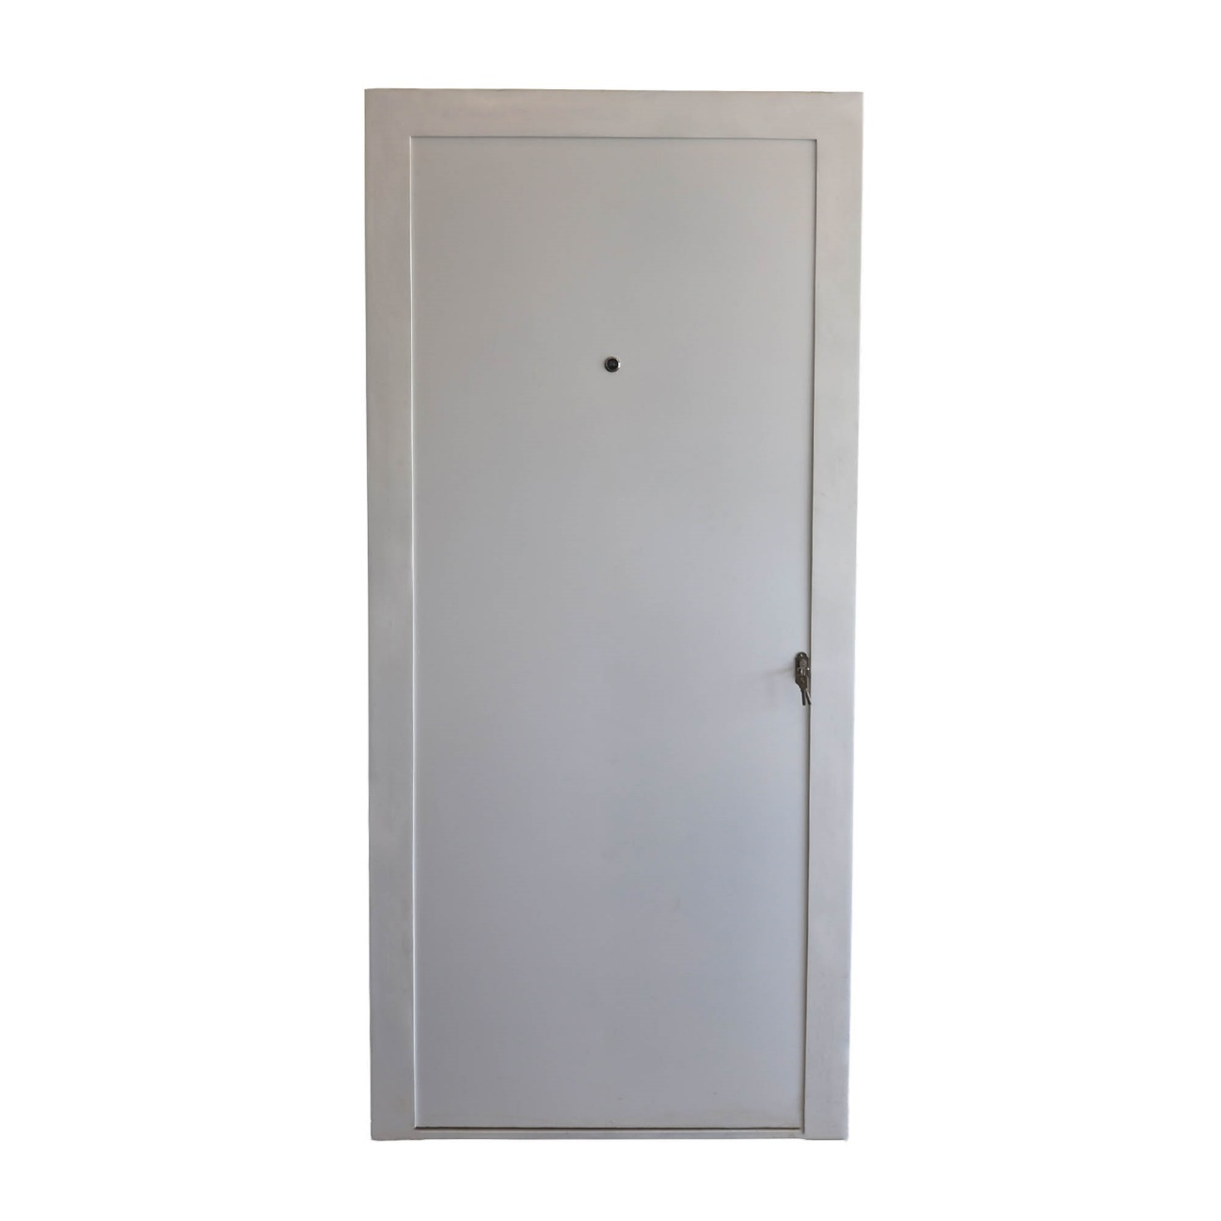

ATM Door
Outside(mm) | 220*100*23
Locking | 1 KL
Fire Class | 90 Min

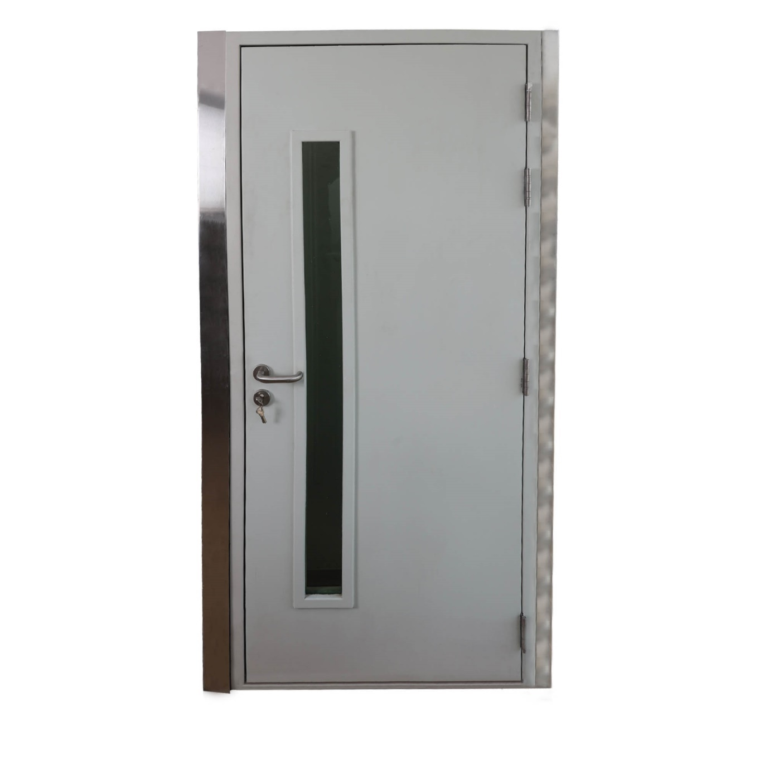
Teeler DOOR
Outside(mm) | 220*100*23
Locking | 1 KL
Fire Class | 90Min

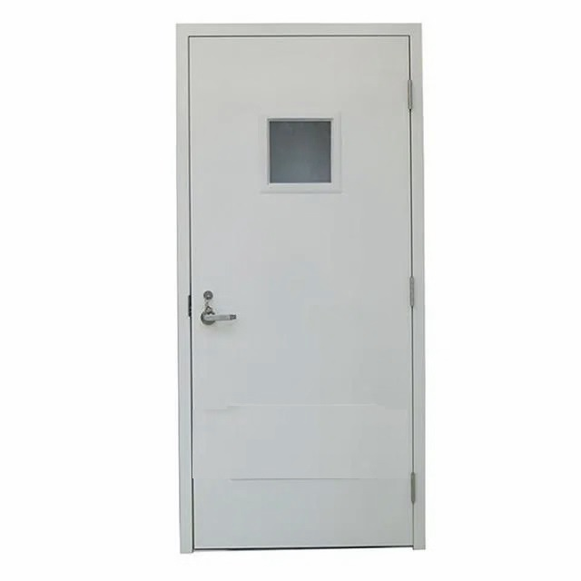

Teeler DOOR
Outside(mm) | 220*100*23
Locking | 1 KL
Fire Class | 90Min

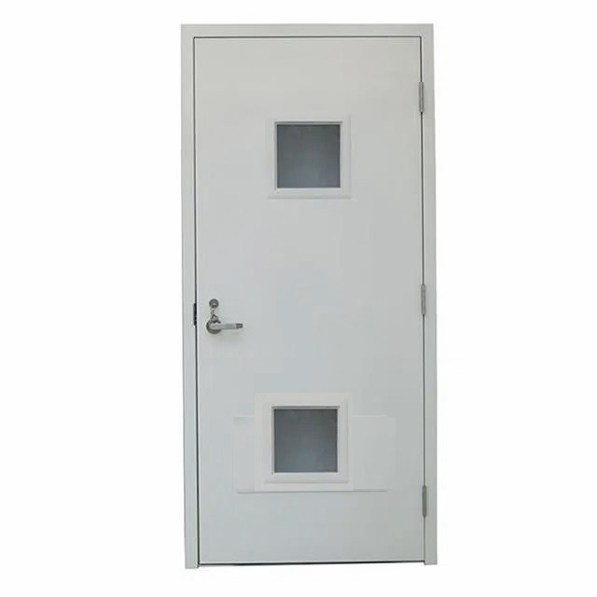

Teeler DOOR
Outside(mm) | 220*100*23
Locking | 1 KL
Fire Class | 90Min

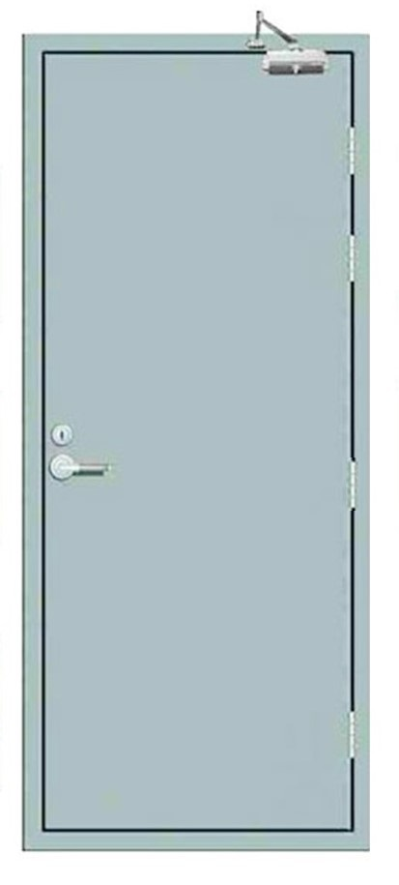

Teeler DOOR
Outside(mm) | 220*100*23
Locking | 1 KL
Fire Class | 90Min

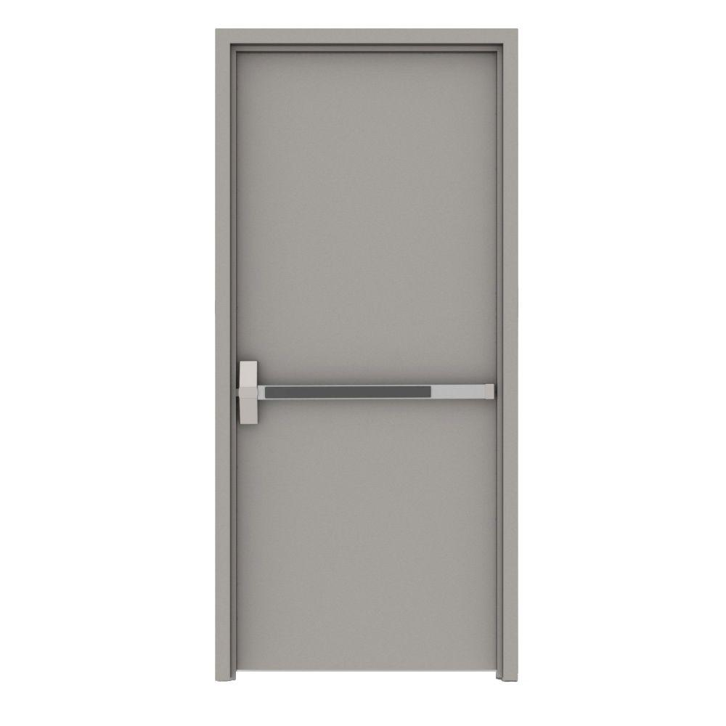

Exit Door
Outside(mm) | 220*100*23
Locking | 1 KL
Fire Class | 90Min

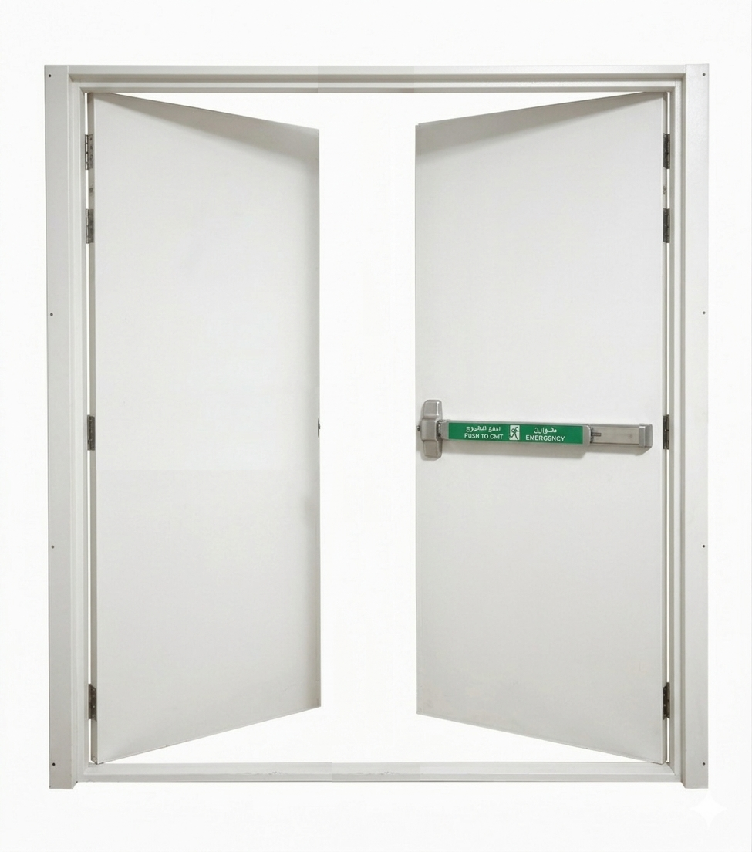

Exit Door
Outside(mm) | 220*240*23
Locking | 1 KL
Fire Class | 90Min

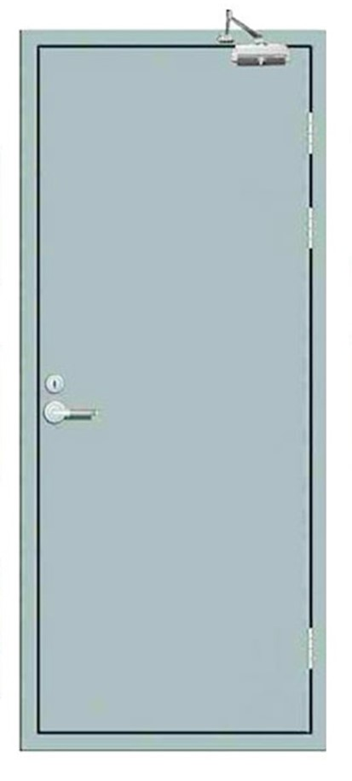

Data Door
Outside(mm) | 220*100*23
Locking | 1 KL
Fire Class | 90Min

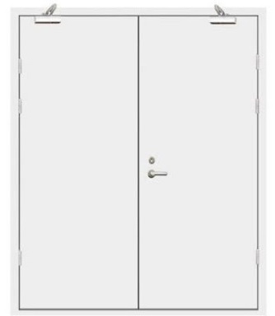

Data Door
Outside(mm) | 220*240*23
Locking | 1 KL
Fire Class | 90Min

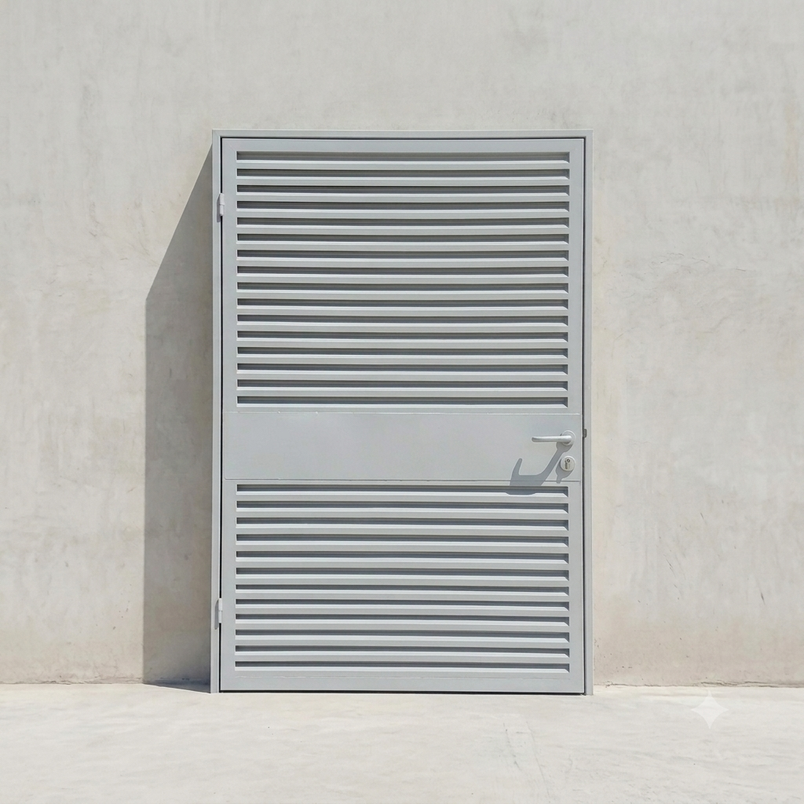

Louver Door
Outside(mm) | 220*240*23
Locking | 1 KL

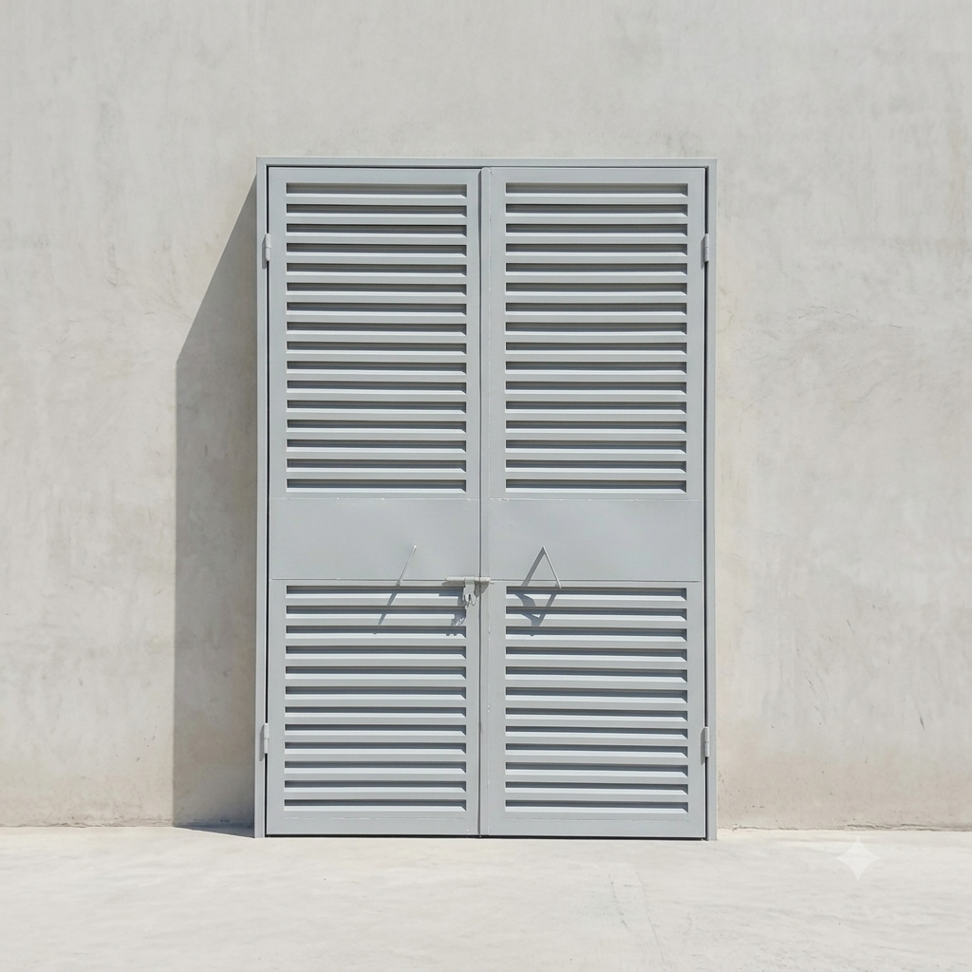

Louver Door
Outside(mm) | 220*240*23
Locking | 1 KL

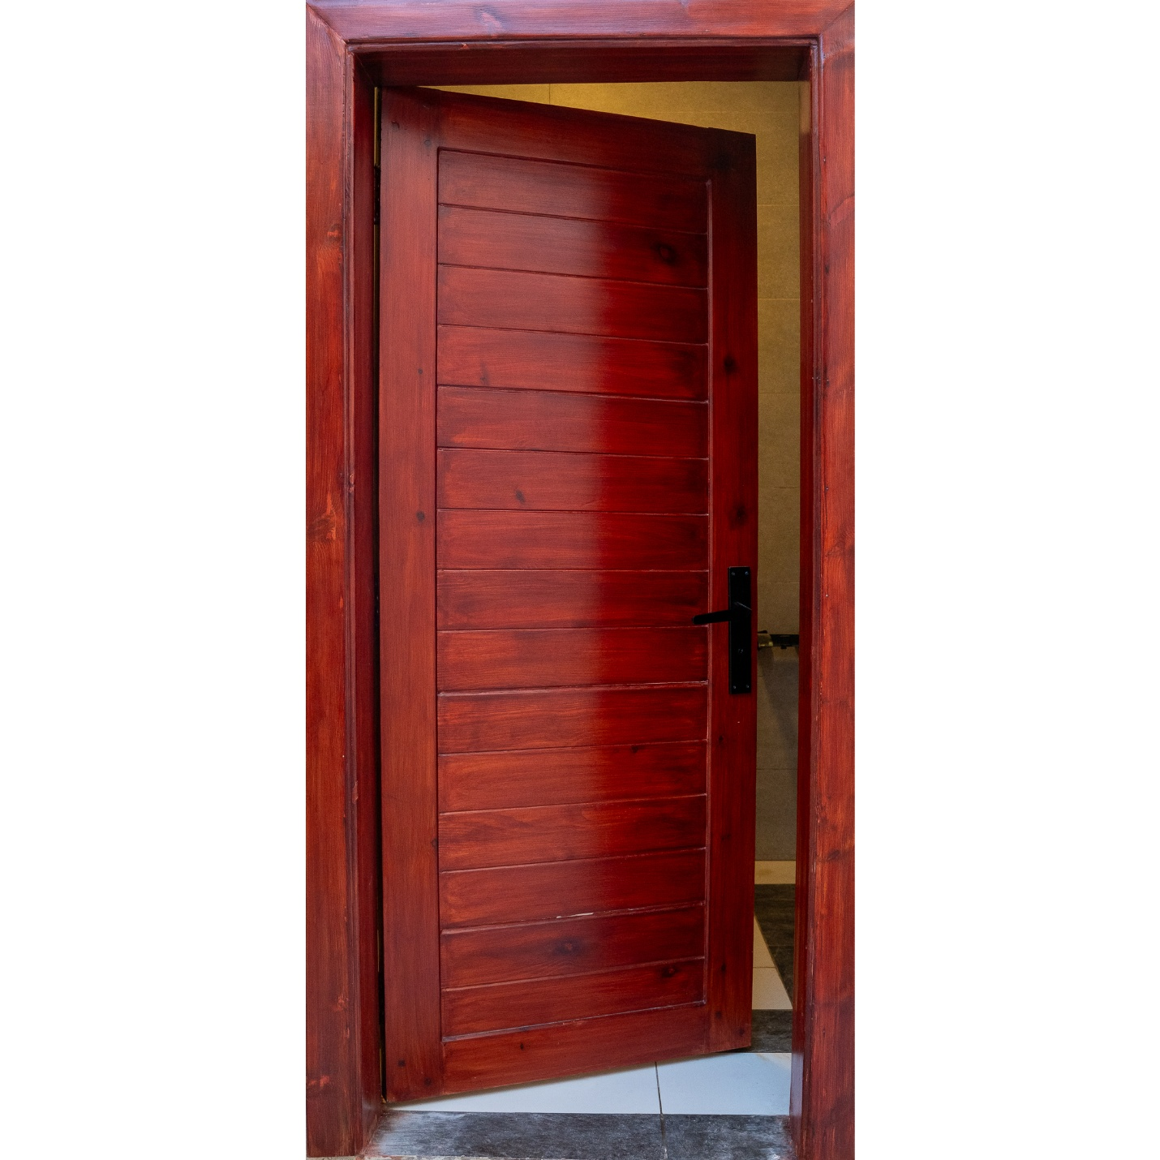

Wood Door
Outside(mm) | 220*100*23
Locking | 1 KL

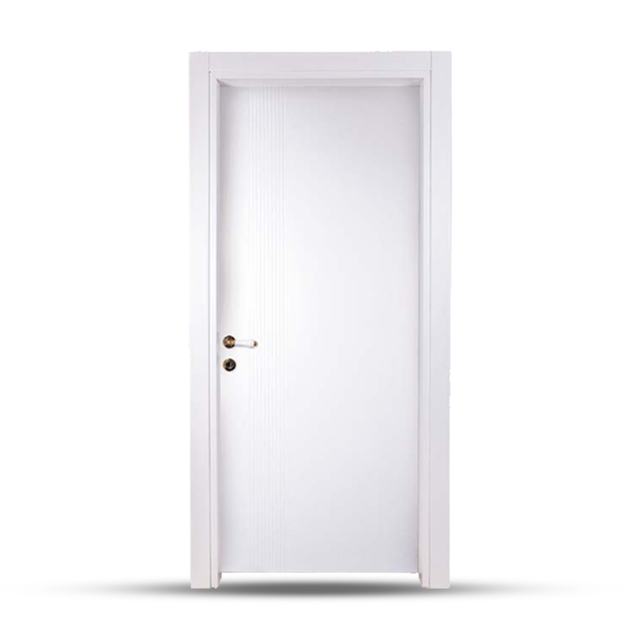

Wood Door
Outside(mm) | 220*100*23
Locking | 1 KL

Wood Door
Outside(mm) | 220*200*23
Locking | 1 KL
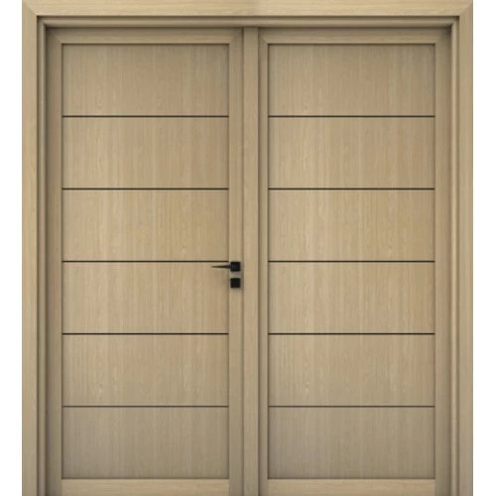

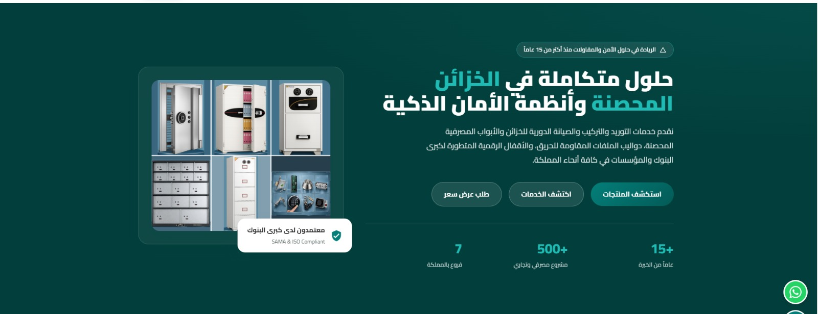

الريادة في حلول الامن والمقاولات منذ اكثر من 25 عاما
تعديل النص ابتداء من الاقفال الرقمية المتطورة الحاصلة علي شهادات الاعتماد الامريكية والاوربية لكبرى البنوك والمؤسسات والشركات في كافة انحاء المملكة

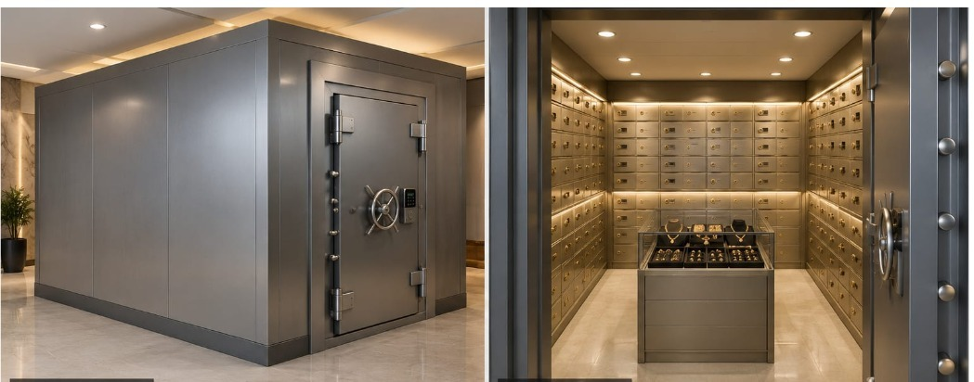

إضافة خدمه وهو تصميم وانشاء الغرف المحصنة بمقاسات مختلفة حسب طلب العميل

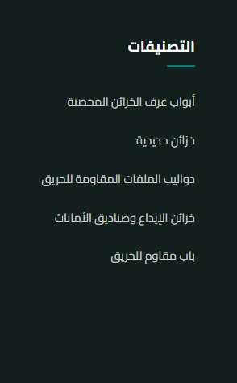

إضافة بند أبواب مقاومة للرصاص وهو للمنتجات الاتيه page here 52,53,54,55

استبدال صور باب الخزنة الاولي في الصوره التاليه

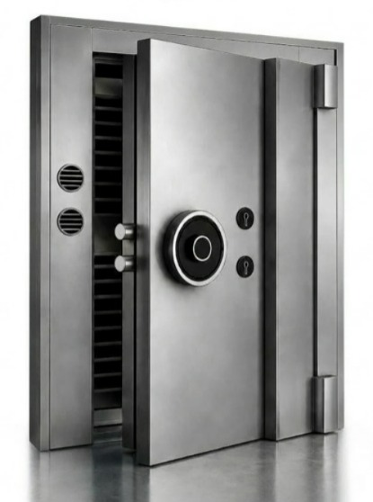

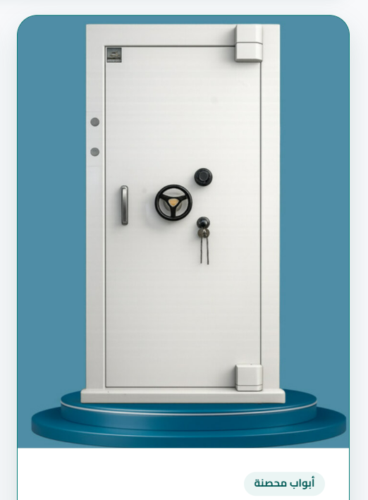

وضع هذه الصورة

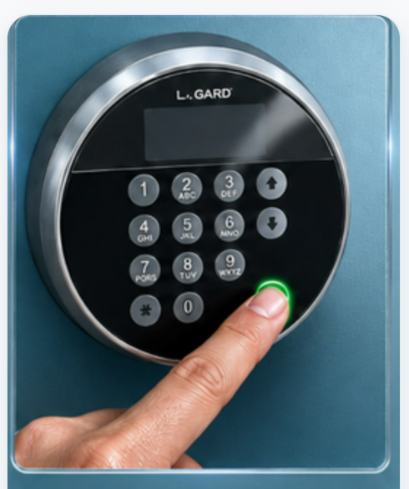
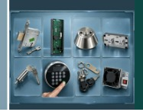
استبدال الصورة at home page

وضع هذه الصورة

بخصوص طريقة عرض مواصفات اعمد الامانات تكون بهذه الصورة
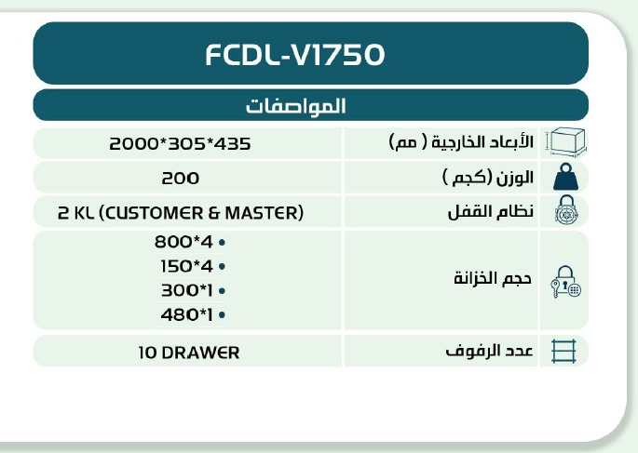

بخصوص ارقام التواصل:

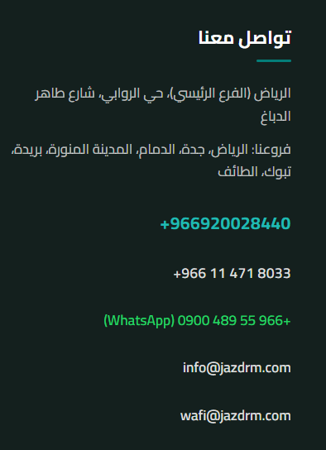
حذف رقم +966 ليصبح 920028440
حذف رقم +966114718033
حذف رقم الواتس اب
إضافة ايميل: jazdrm@jazdrm.com

إضافة خاصية ارفاق ملف بي دي اف للسيرة الزاتية

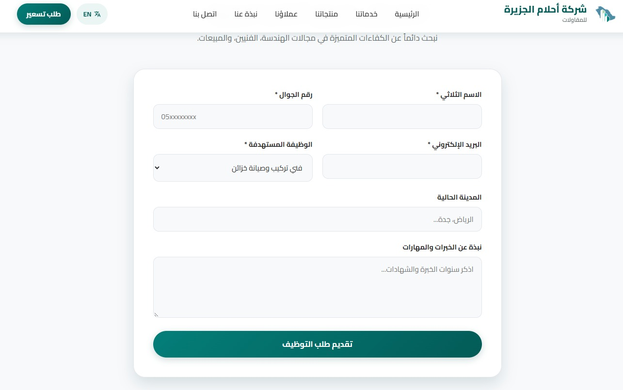
إضافة ايقونة بخصوص خدمة النقل و فتح وصيانة جميع أنواع الخزنة علي مدار 24 ساعة

