American University of Beirut
Maroun Semaan Faculty of Engineering and Architecture
EECE 435L Software Tools Laboratory

Security Incident Detection and Response Management System
  - Sprint 1 report
Implementation and execution evidence for Mohammad Kourani
Team: Mohammad Kourani, Anthony Feghali, Titia Saikali
Report date: 21 October 2026
Repository: https://github.com/mhmdko/MohammadKourani-AnthonyFeghali-TitiaSaikali-435L
Project name: MohammadKourani-AnthonyFeghali-TitiaSaikali-435L
This report explains the backend design and Mohammad Kourani's Users and Identity, Security Audit Logging, and Notifications services. It includes the team's shared architecture, relational schema, API catalogue, and division of responsibilities. Execution evidence is drawn from the existing Postman and database captures.
Source version documented: 0071594

2 Table of Contents (Mohammad Kourani)
Section | Responsible team member | Page
1 Title Page | Mohammad Kourani | 1
2 Table of Contents | Mohammad Kourani | 2
3 Introduction | Mohammad Kourani | 3
4 System Architecture | Titia Saikali | 4
5 Implementation Details | Mohammad Kourani | 7
6 Database Design | Anthony Feghali | 77
7 Error Handling and Validation | Anthony Feghali | 87
8 API Documentation | All three members | 88
9 Authentication and Authorization | Mohammad Kourani | 94
10 GitHub and Version Control | Titia Saikali | 95
11 References | Titia Saikali | 97

Section ownership follows the repository's contribution plan. The service explanations and execution evidence focus on Mohammad Kourani's contribution; the API catalogue also identifies the owners of the other services.

3 Introduction (Mohammad Kourani)

3.1 Project overview
Security teams need to connect incident reports with the affected assets, relevant threats, known vulnerabilities, and response actions. When these records are handled separately, assignments can be missed and it becomes difficult to reconstruct who changed a security record. The backend centralizes those relationships and preserves an audit trail.
The system provides REST endpoints that exchange JSON with Postman. It is implemented in Python with Flask and Flask-SQLAlchemy, uses SQLite for storage, and applies four roles: Security Administrator, Security Analyst, Regular Employee, and Auditor. The project scope is the backend; a browser frontend is outside Sprint 1.

3.2 Objectives and scope
The objectives are to persist consistent security records, authenticate active users, restrict operations by role and ownership, validate input before database changes, return predictable errors, and demonstrate operation with real requests. The nine services expose 54 service endpoints, with three services assigned to each member.
Member | Services | Shared responsibilities
Mohammad Kourani | Users and Identity; Audit Logging; Notifications | Application setup, authentication, validation, configuration, database initializer
Anthony Feghali | Assets; Threat Intelligence; Vulnerabilities | Network validation and database schema documentation
Titia Saikali | Incidents; Security Reports; Playbooks and Response | Architecture documentation and incident/playbook schema additions

3.3 Reproducing the project
Clone the repository, create a virtual environment, install requirements.txt, and create a private .env from .env.example. Configure the secrets locally, run python init_db.py to rebuild the sample database, then run python run.py. The development API listens at http://127.0.0.1:5000. Never include the private .env, virtual environment, or local database in Git.
For each Postman collection, rebuild the sample database before starting its scenario sequence, run Setup first, then execute the folders in numeric order. Setup stores login tokens in collection variables. Requests later in a collection depend on the records and identifiers created earlier in that collection.

4 System Architecture (Titia Saikali)
The application is a modular Flask backend. Each service is a Blueprint with its own routes, models, and README. The application factory discovers the service packages and registers their Blueprints. All services run in one process and share the same database connection configuration and response helpers [1, 2].
External clients communicate through HTTP REST APIs. Cooperation between services inside this implementation uses Python functions and ORM models: log_event() writes audit events, create_notification() creates alerts, and routes check related records through their models. The services are not deployed as independent HTTP servers.
Service | Owner | Responsibility
Users and Identity | Mohammad Kourani | Accounts, authentication, profiles, roles, and account status.
Asset Management | Anthony Feghali | Organizational assets, ownership, criticality, and related records.
Incident Management | Titia Saikali | Incident reporting, assignment, investigation notes, and lifecycle.
Threat Intelligence | Anthony Feghali | Validated and normalized threat indicators with duplicate prevention.
Security Audit Logging | Mohammad Kourani | Security activity records, searches, user history, and restricted deletion.
Security Reports | Titia Saikali | Current statistics aggregated from the other services' tables.
Vulnerability Management | Anthony Feghali | Asset vulnerabilities, CVE identifiers, CVSS scores, and remediation.
Notifications | Mohammad Kourani | User alerts, ownership checks, unread/read status, and read timestamps.
Playbooks and Response | Titia Saikali | Ordered response actions, assignment, status changes, and action history.

Figure 1. Titia Saikali - System architecture
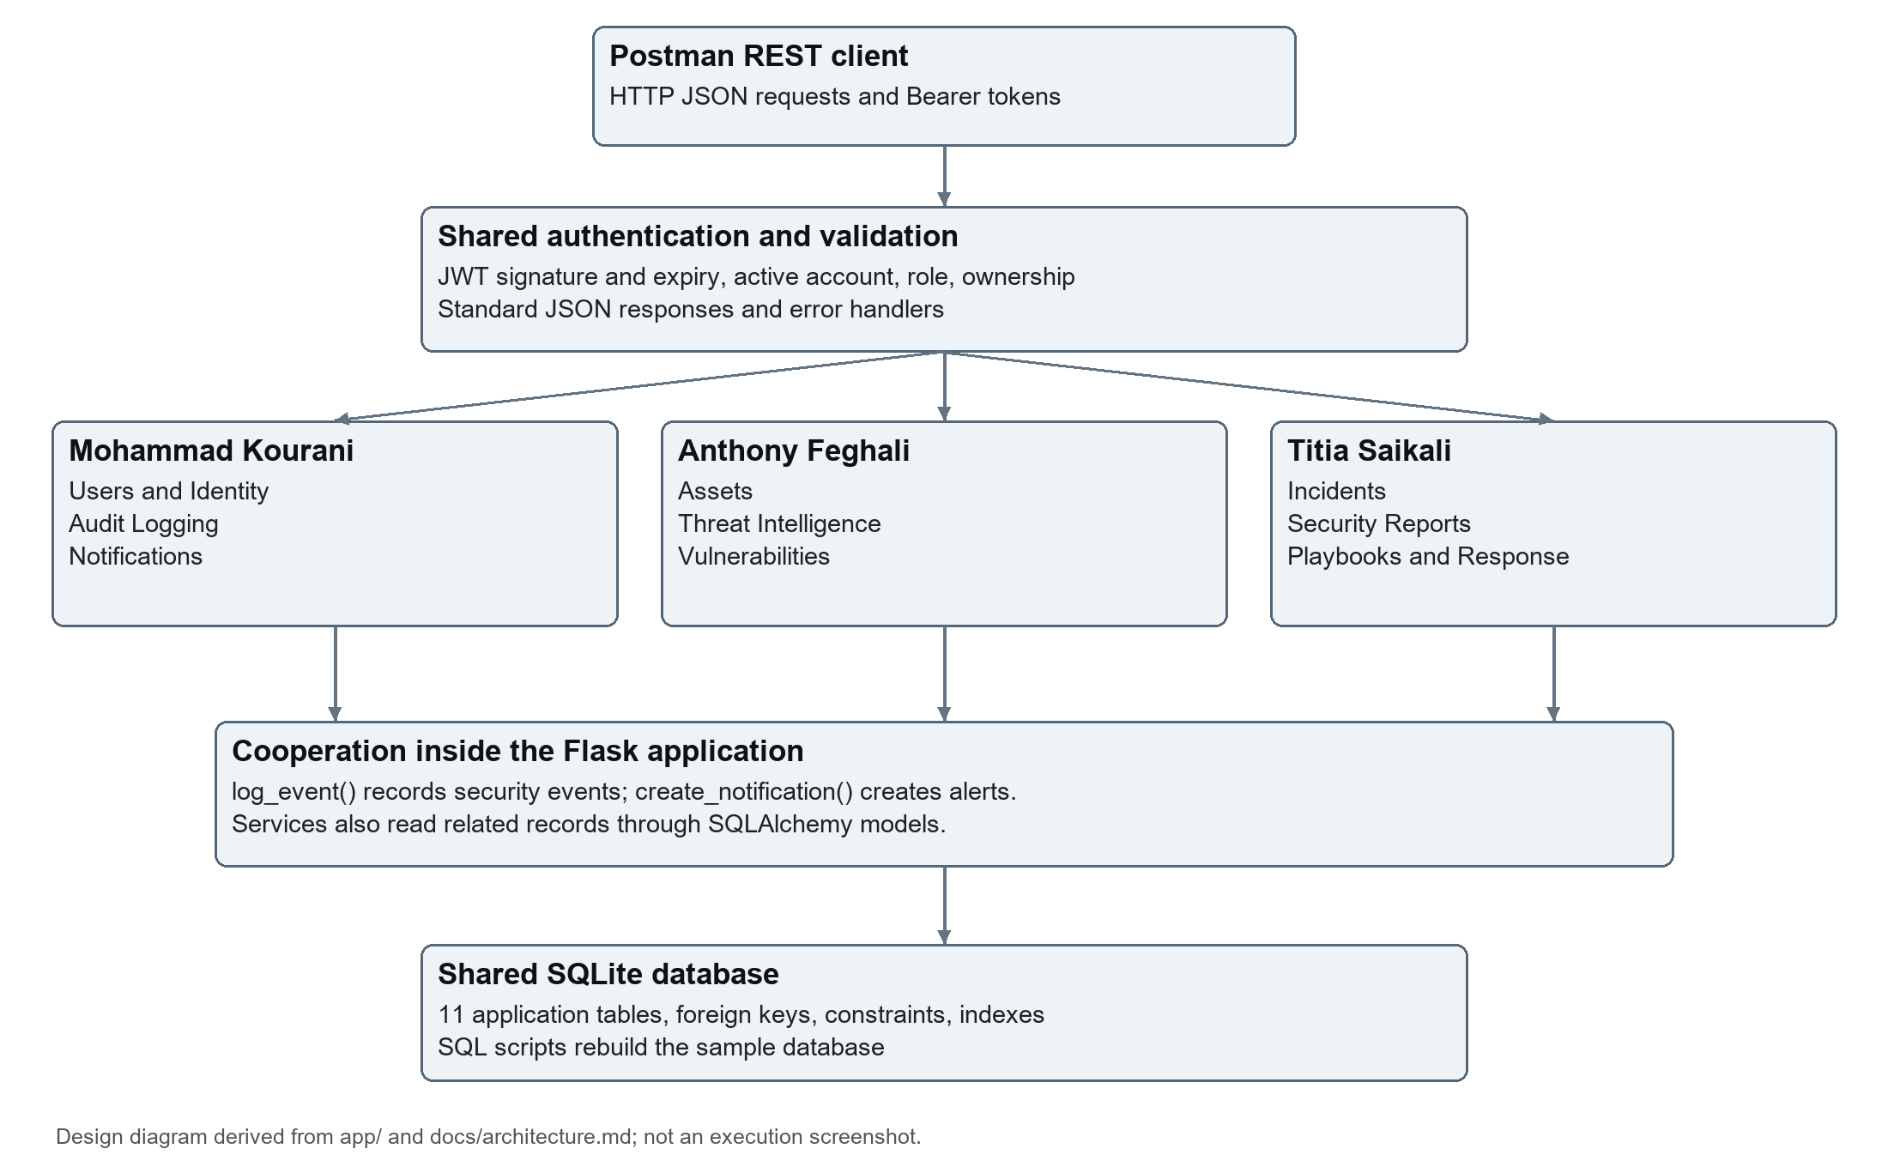
Design diagram based on the repository's application factory, common modules, and architecture documentation. It represents the current shared-function and shared-database implementation; it is not an execution screenshot.

4.1 Request flow and cooperation
Protected requests pass through roles_required(). It validates the token, reloads the current account, checks Active status and the permitted role, then makes the authenticated user available to the route. Routes add ownership and business-rule checks before writing records. Rejections use the common error format and are recorded as UNAUTHORIZED_ACCESS events.
Incident assignment creates a notification for the analyst. High or Critical threats alert active analysts, and High or Critical vulnerabilities alert the affected asset's owner. Playbook actions can notify their assignees. Security Reports reads the underlying models to calculate current counts, rather than storing a duplicate report table.
The incident lifecycle is Open to Under Investigation to Mitigated to Resolved to Closed. Vulnerabilities follow Open to Under Investigation to In Progress to Resolved to Closed. Playbook actions follow Pending to In Progress to Completed. The relevant services reject skipped or backward transitions.

5 Implementation Details (Mohammad Kourani)
Mohammad Kourani implemented the three services described in this section. Each route includes an author docstring, uses the common JSON response functions, and documents allowed callers. The following execution figures preserve the existing screenshots without changing their request or response content.

5.1 Users and Identity Management
The User model maps account and profile data to the users table. Registration validates the full name, username, email, password, department, and requested role. An unauthenticated caller may only create a Regular Employee. Administrators can create other roles. Passwords are hashed before insertion and password_hash is excluded from API serialization.
Username uniqueness is checked without regard to case, then enforced again by the database. A duplicate returns 409 rather than creating a second account. Profile updates permit employees to change only their own name, email, and department; role and account-status changes require an administrator. Self-demotion, self-deactivation, and self-deletion by an administrator are blocked.
Method | Endpoint | Allowed callers | Success
POST | /users/register | Anyone (as Regular Employee); Security Administrator (any role) | 201
POST | /users/login | Anyone with an Active account | 200
PUT | /users/{id} | Security Administrator (any user); Regular Employee (own account) | 200
DELETE | /users/{id} | Security Administrator | 200
GET | /users | Security Administrator, Auditor | 200
GET | /users/{username} | Security Administrator, Auditor; Regular Employee (own account) | 200

Registration inserts a user, login verifies the stored password hash and updates login activity, updates commit only validated changes, and deletion is rejected with 409 when required linked records still exist. All successful changes and authentication outcomes generate audit events. Figures below cover positive, negative, and ownership scenarios.

Figure 2. Mohammad Kourani - User Registration - employee self-registers
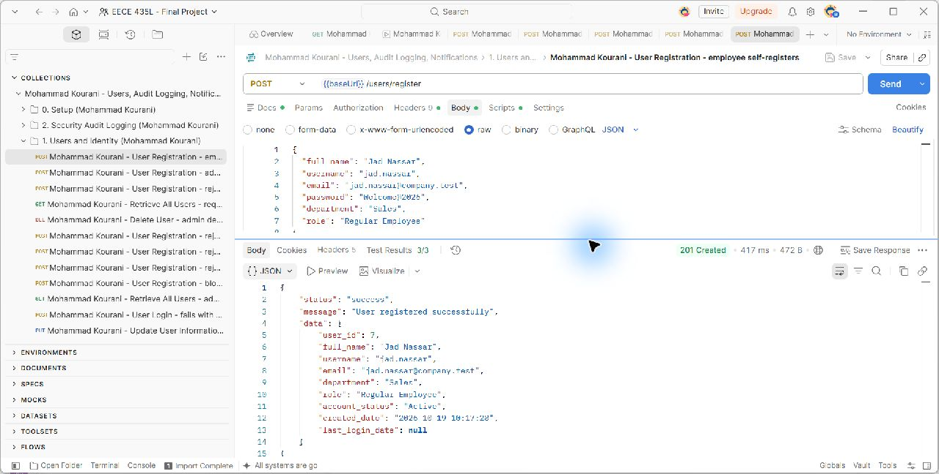
POST {{baseUrl}}/users/register. The captured scenario checks HTTP 201; the request and actual server response are shown in the unchanged screenshot. Source: docs/evidence/MohammadKourani/register-success.png.

Figure 3. Mohammad Kourani - Database - registered user jad.nassar
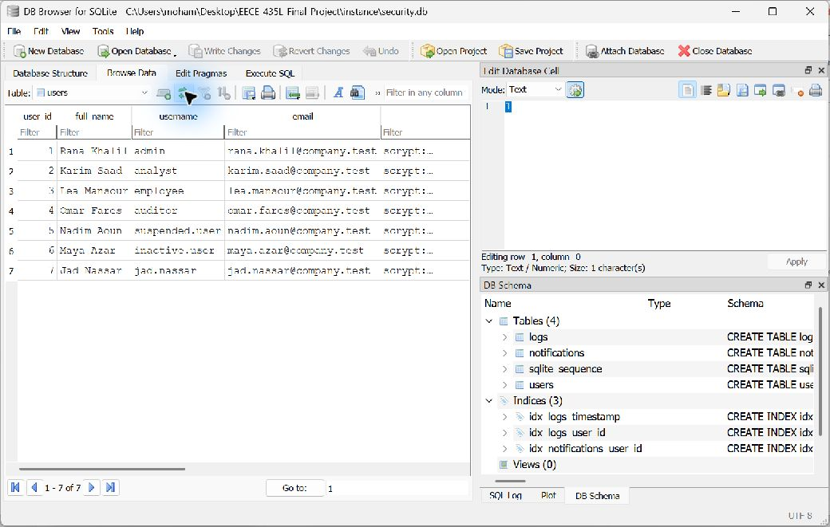
The users table contains the new jad.nassar row immediately after successful self-registration. Source: docs/evidence/MohammadKourani/register-db-record.png.

Figure 4. Mohammad Kourani - User Registration - admin creates an analyst account
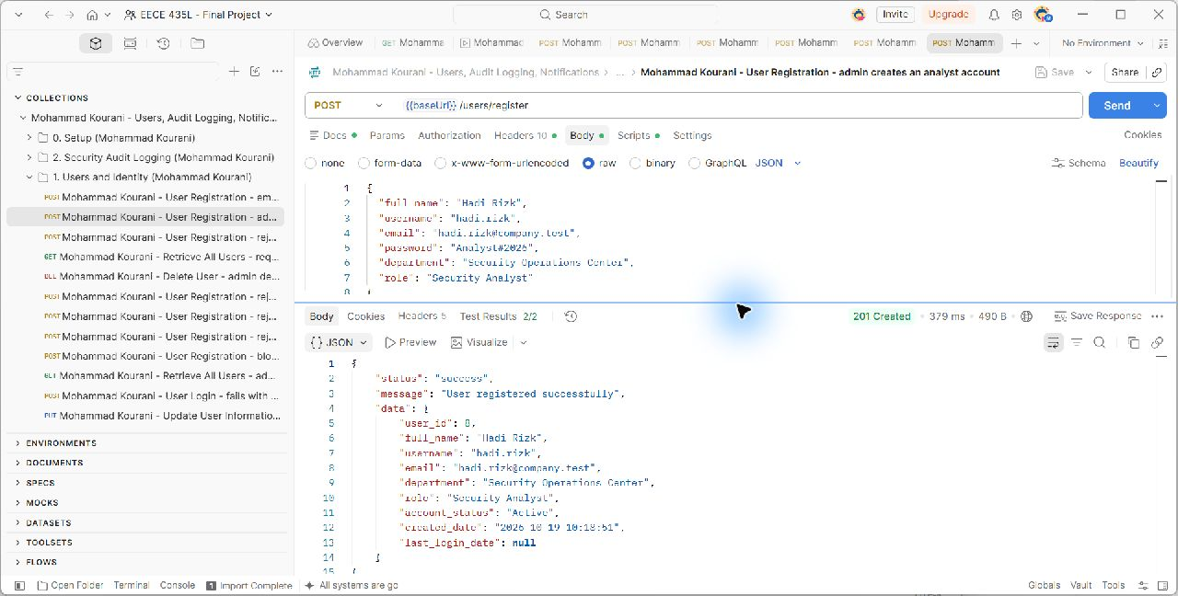
POST {{baseUrl}}/users/register. The captured scenario checks HTTP 201; the request and actual server response are shown in the unchanged screenshot. Source: docs/evidence/MohammadKourani/register-admin-analyst.png.

Figure 5. Mohammad Kourani - User Registration - rejects a duplicate username
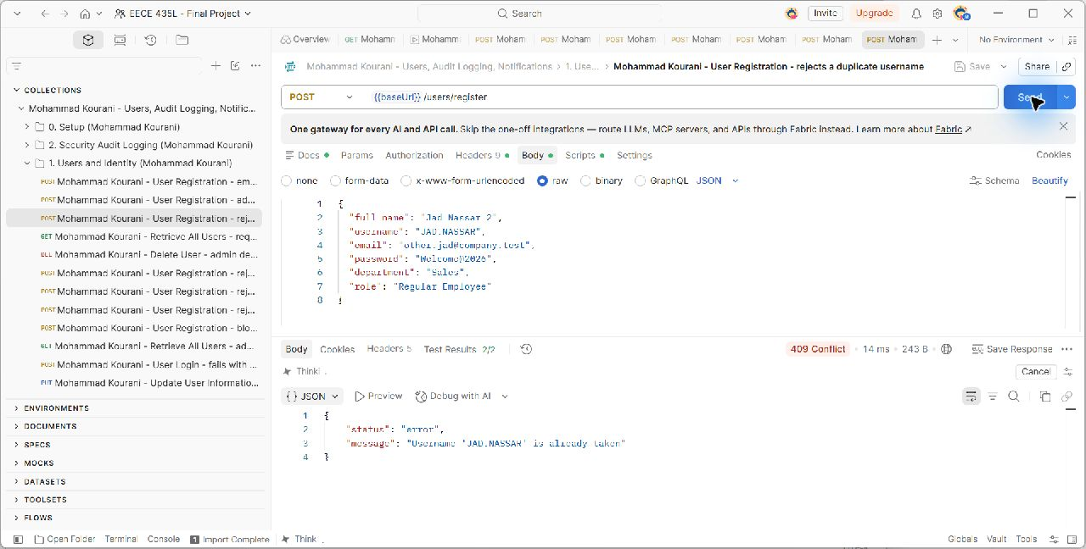
POST {{baseUrl}}/users/register. The captured scenario checks HTTP 409; the request and actual server response are shown in the unchanged screenshot. Source: docs/evidence/MohammadKourani/register-duplicate.png.

Figure 6. Mohammad Kourani - User Registration - rejects an invalid email
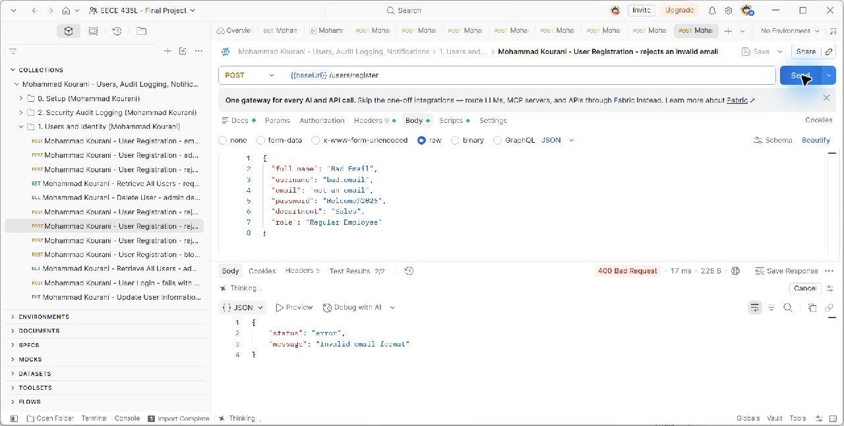
POST {{baseUrl}}/users/register. The captured scenario checks HTTP 400; the request and actual server response are shown in the unchanged screenshot. Source: docs/evidence/MohammadKourani/validation-invalid-email.png.

Figure 7. Mohammad Kourani - User Registration - rejects a weak password
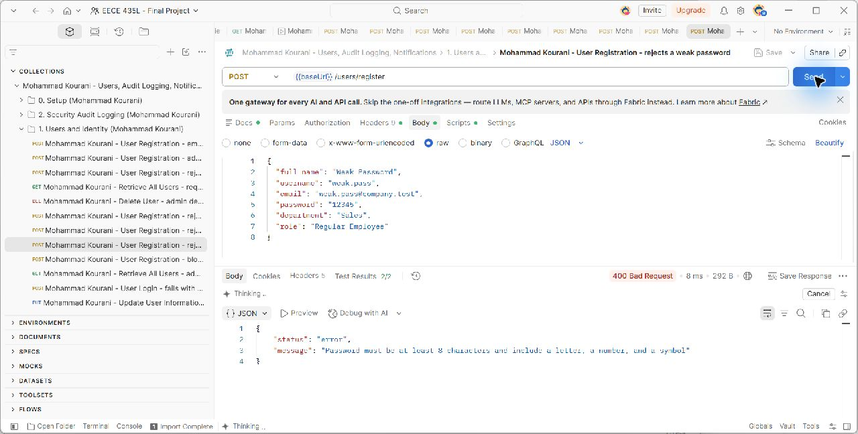
POST {{baseUrl}}/users/register. The captured scenario checks HTTP 400; the request and actual server response are shown in the unchanged screenshot. Source: docs/evidence/MohammadKourani/validation-weak-password.png.

Figure 8. Mohammad Kourani - User Registration - rejects missing fields
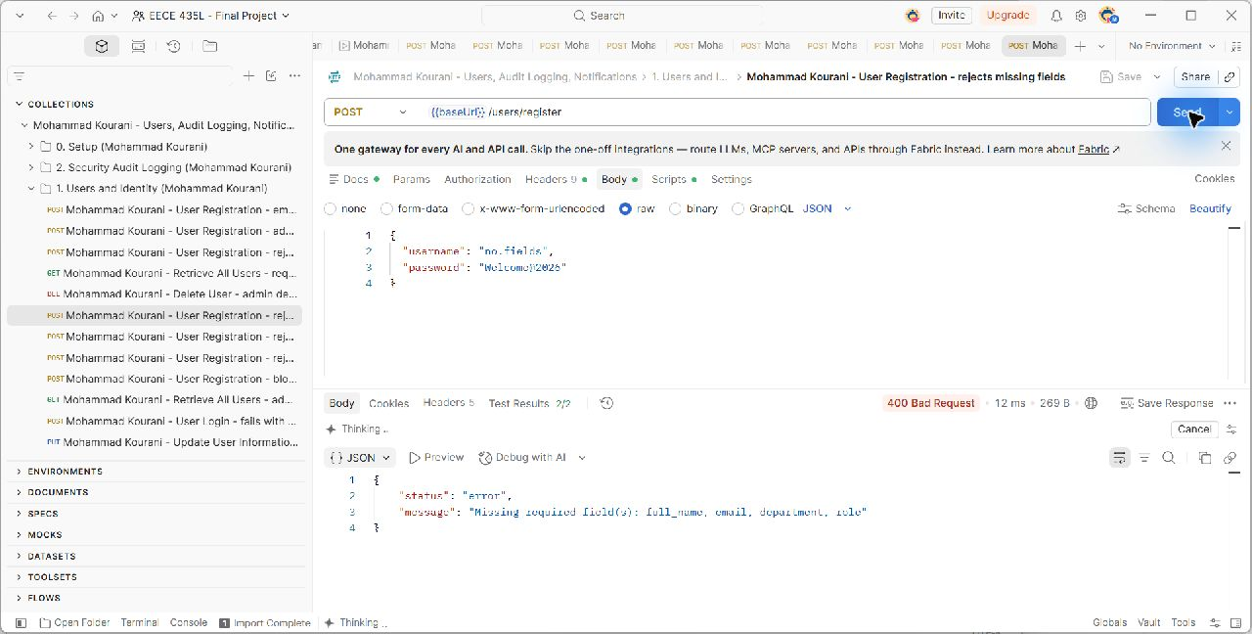
POST {{baseUrl}}/users/register. The captured scenario checks HTTP 400; the request and actual server response are shown in the unchanged screenshot. Source: docs/evidence/MohammadKourani/validation-missing-fields.png.

Figure 9. Mohammad Kourani - User Registration - blocks self-registration as administrator
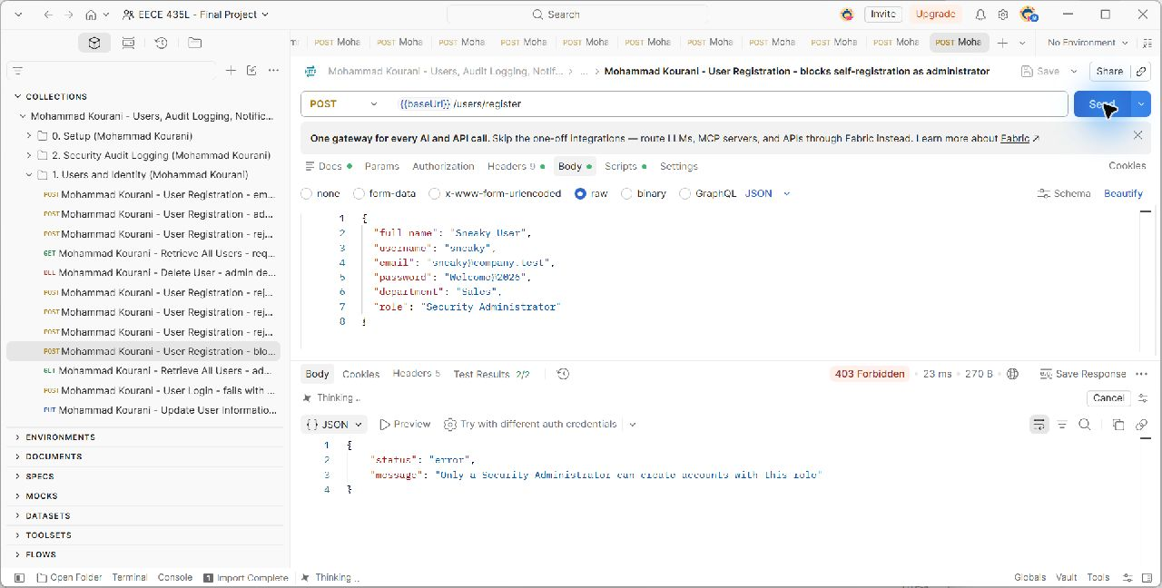
POST {{baseUrl}}/users/register. The captured scenario checks HTTP 403; the request and actual server response are shown in the unchanged screenshot. Source: docs/evidence/MohammadKourani/register-admin-self-denied.png.

Figure 10. Mohammad Kourani - User Login - new user logs in successfully
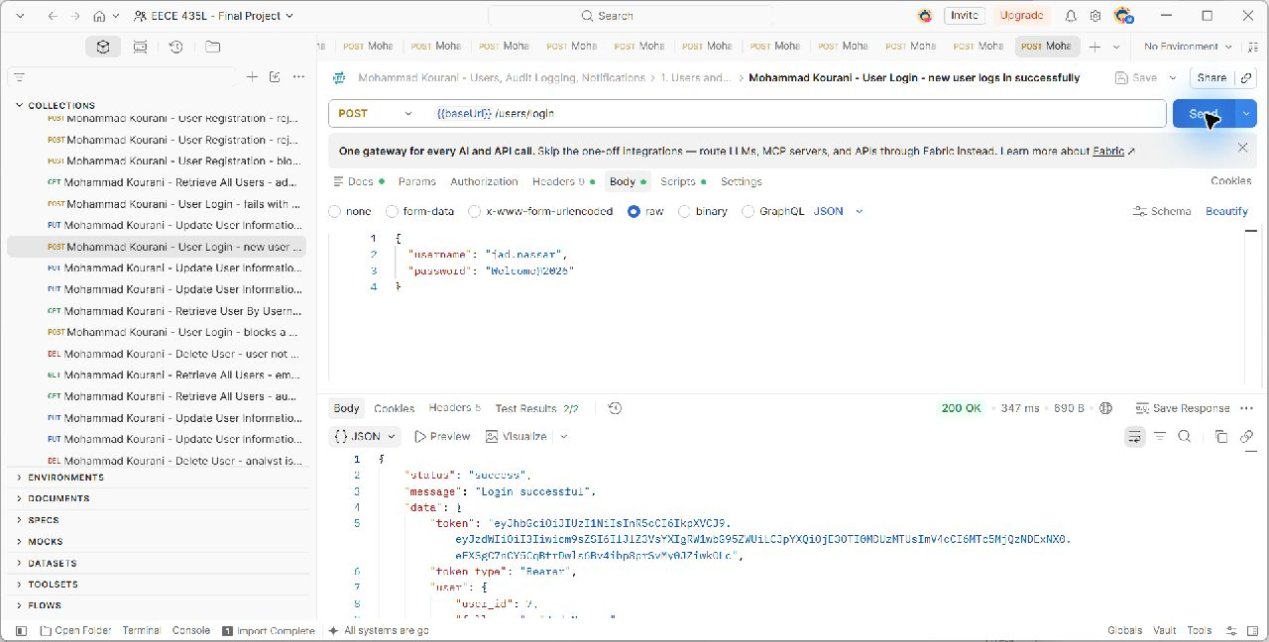
POST {{baseUrl}}/users/login. The captured scenario checks HTTP 200; the request and actual server response are shown in the unchanged screenshot. Source: docs/evidence/MohammadKourani/login-success.png.

Figure 11. Mohammad Kourani - User Login - fails with a wrong password
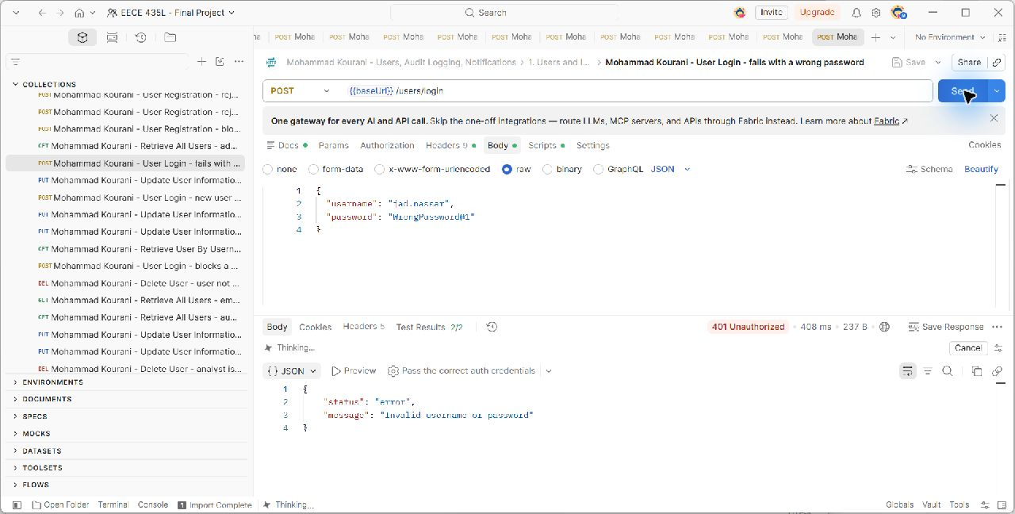
POST {{baseUrl}}/users/login. The captured scenario checks HTTP 401; the request and actual server response are shown in the unchanged screenshot. Source: docs/evidence/MohammadKourani/login-failed.png.

Figure 12. Mohammad Kourani - User Login - blocks a suspended account
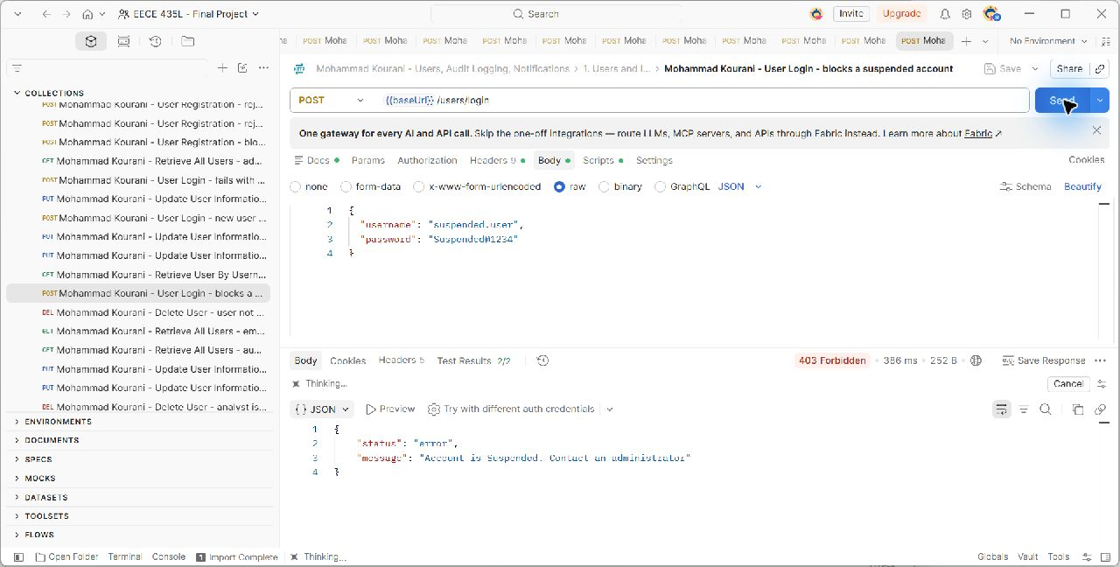
POST {{baseUrl}}/users/login. The captured scenario checks HTTP 403; the request and actual server response are shown in the unchanged screenshot. Source: docs/evidence/MohammadKourani/login-suspended.png.

Figure 13. Mohammad Kourani - Update User Information - employee updates own profile
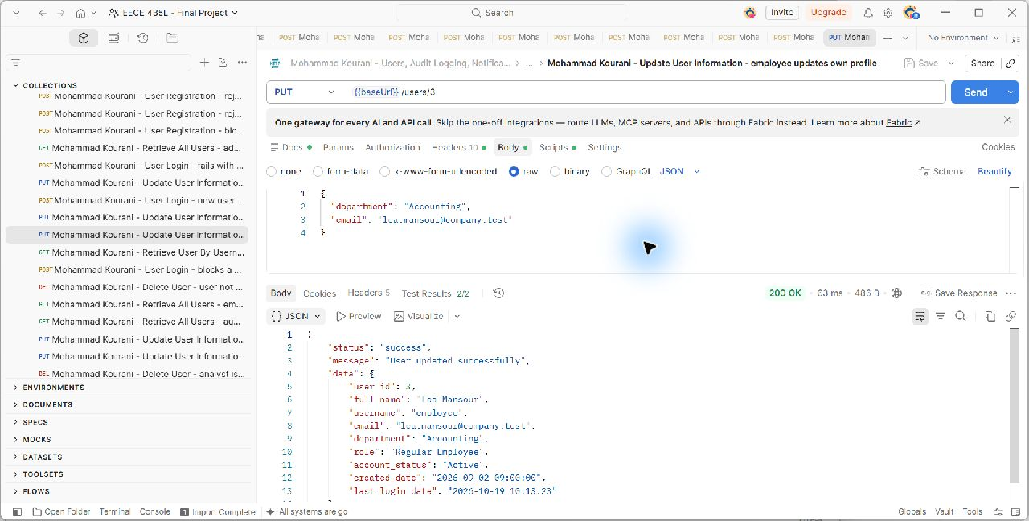
PUT {{baseUrl}}/users/3. The captured scenario checks HTTP 200; the request and actual server response are shown in the unchanged screenshot. Source: docs/evidence/MohammadKourani/update-user.png.

Figure 14. Mohammad Kourani - Database - employee department updated
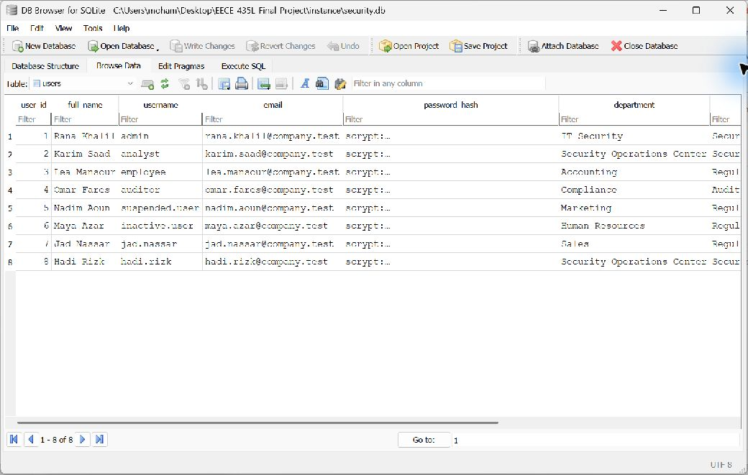
User 3 has department Accounting after the employee updates their own profile. Source: docs/evidence/MohammadKourani/update-user-db.png.

Figure 15. Mohammad Kourani - Update User Information - employee cannot edit another user
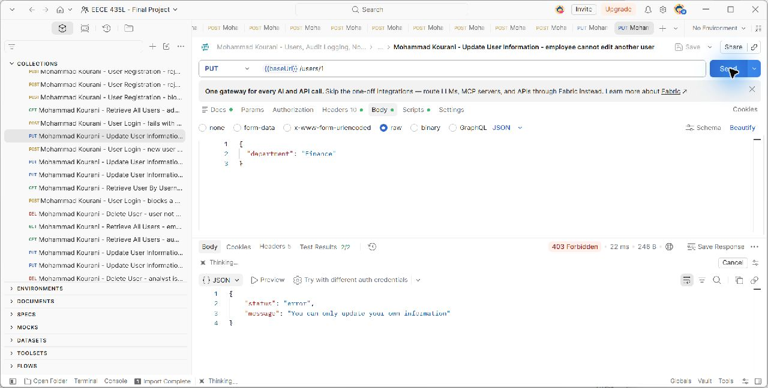
PUT {{baseUrl}}/users/1. The captured scenario checks HTTP 403; the request and actual server response are shown in the unchanged screenshot. Source: docs/evidence/MohammadKourani/update-other-user-denied.png.

Figure 16. Mohammad Kourani - Update User Information - employee cannot change own role
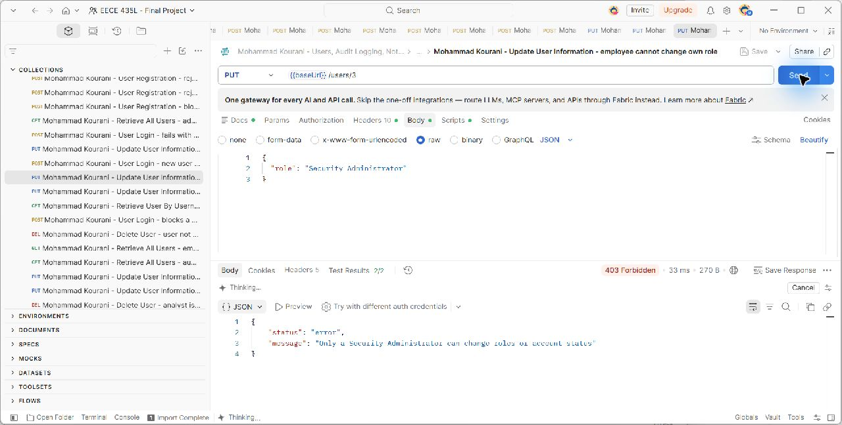
PUT {{baseUrl}}/users/3. The captured scenario checks HTTP 403; the request and actual server response are shown in the unchanged screenshot. Source: docs/evidence/MohammadKourani/update-own-role-denied.png.

Figure 17. Mohammad Kourani - Update User Information - admin promotes a user (role change)
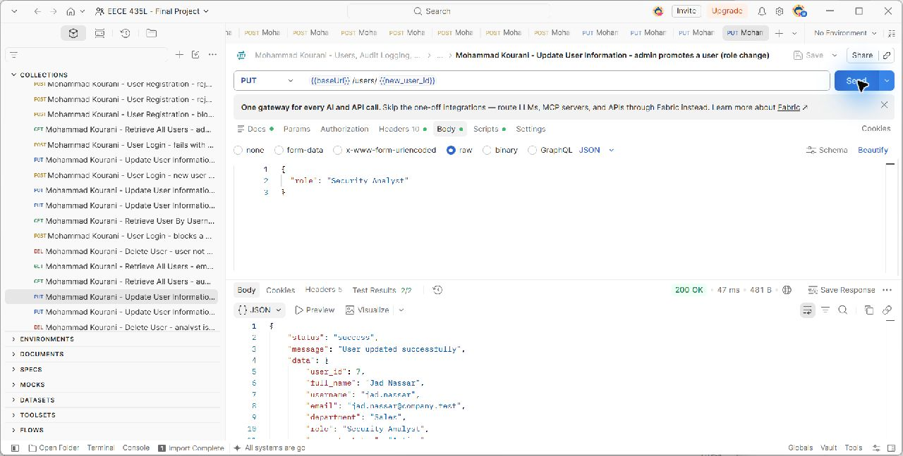
PUT {{baseUrl}}/users/{{new_user_id}}. The captured scenario checks HTTP 200; the request and actual server response are shown in the unchanged screenshot. Source: docs/evidence/MohammadKourani/update-user-role.png.

Figure 18. Mohammad Kourani - Update User Information - rejects an invalid email
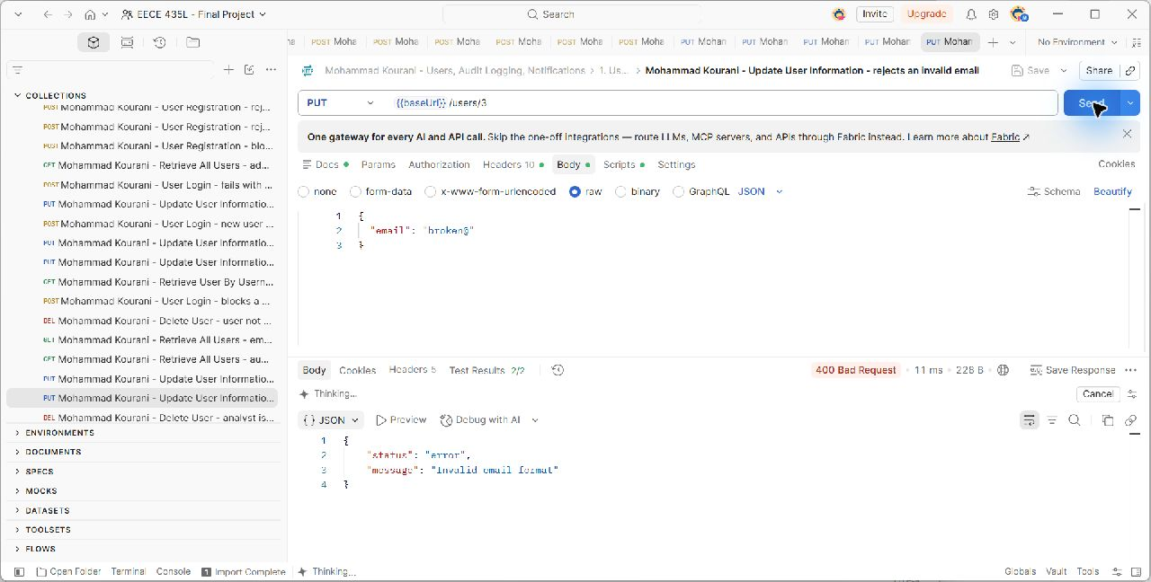
PUT {{baseUrl}}/users/3. The captured scenario checks HTTP 400; the request and actual server response are shown in the unchanged screenshot. Source: docs/evidence/MohammadKourani/update-user-invalid-email.png.

Figure 19. Mohammad Kourani - Retrieve All Users - admin lists all users
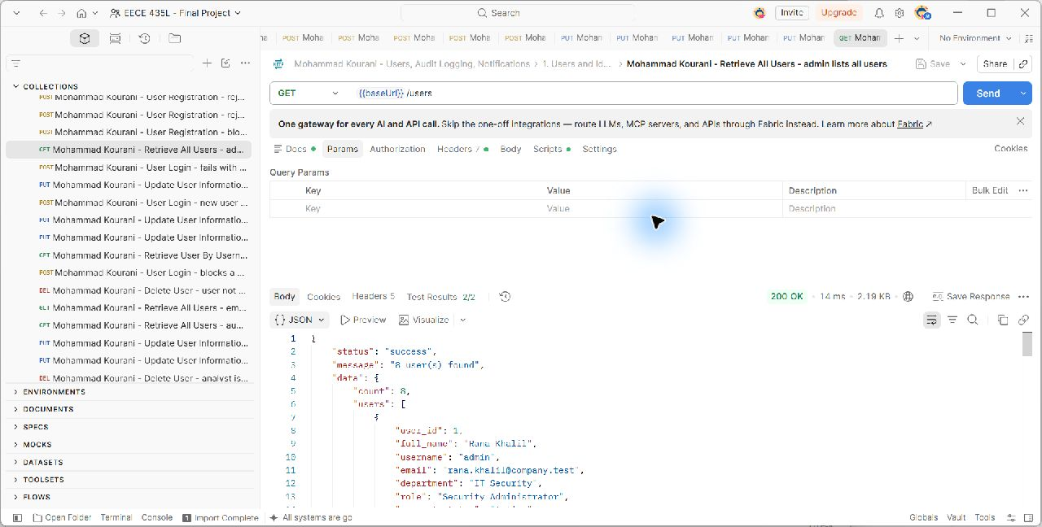
GET {{baseUrl}}/users. The captured scenario checks HTTP 200; the request and actual server response are shown in the unchanged screenshot. Source: docs/evidence/MohammadKourani/get-all-users.png.

Figure 20. Mohammad Kourani - Retrieve All Users - auditor lists all users
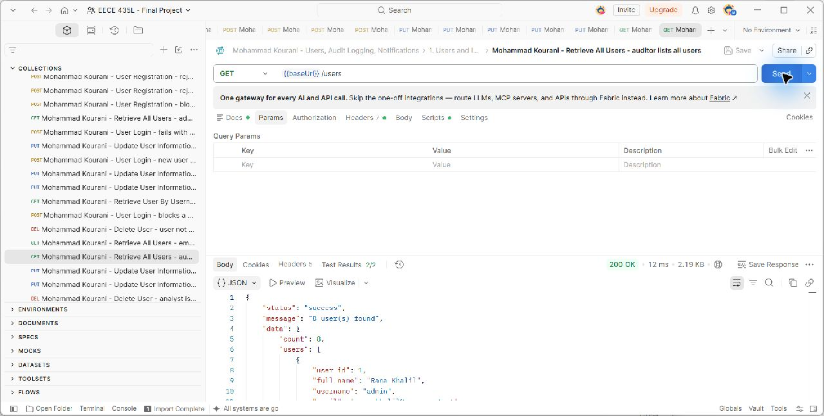
GET {{baseUrl}}/users. The captured scenario checks HTTP 200; the request and actual server response are shown in the unchanged screenshot. Source: docs/evidence/MohammadKourani/get-all-users-auditor.png.

Figure 21. Mohammad Kourani - Retrieve All Users - employee is denied
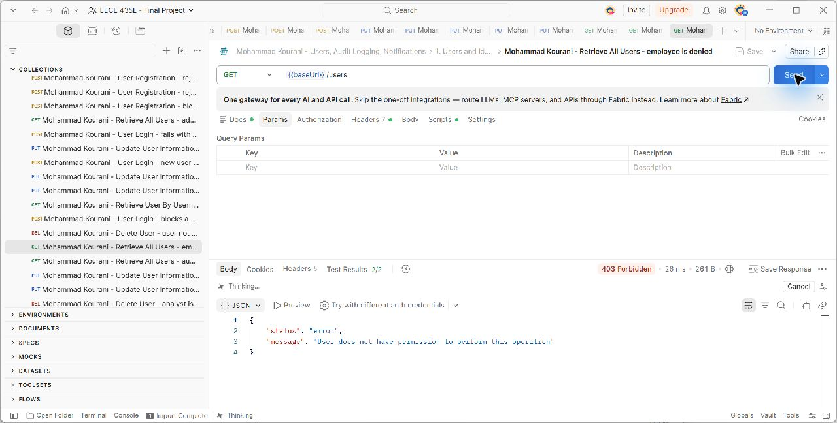
GET {{baseUrl}}/users. The captured scenario checks HTTP 403; the request and actual server response are shown in the unchanged screenshot. Source: docs/evidence/MohammadKourani/auth-insufficient.png.

Figure 22. Mohammad Kourani - Retrieve All Users - request without a token is rejected
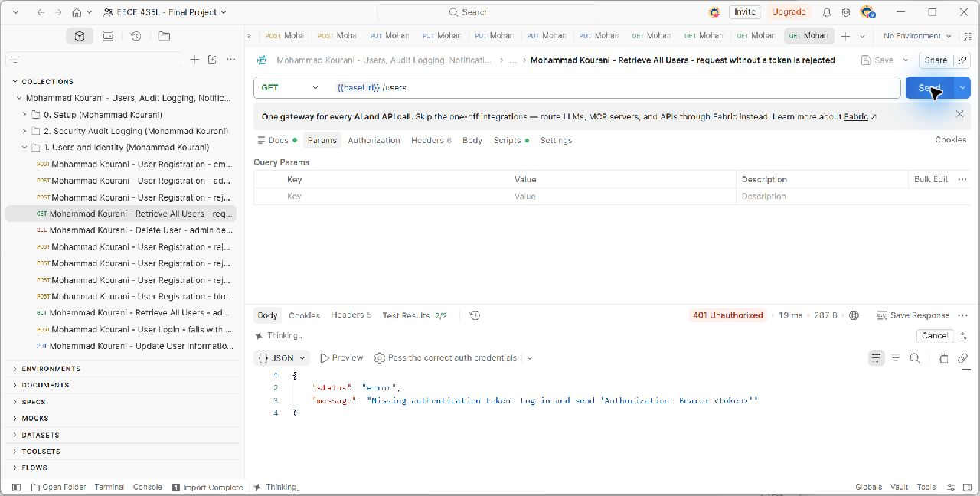
GET {{baseUrl}}/users. The captured scenario checks HTTP 401; the request and actual server response are shown in the unchanged screenshot. Source: docs/evidence/MohammadKourani/auth-no-token.png.

Figure 23. Mohammad Kourani - Retrieve User By Username - auditor finds an existing user
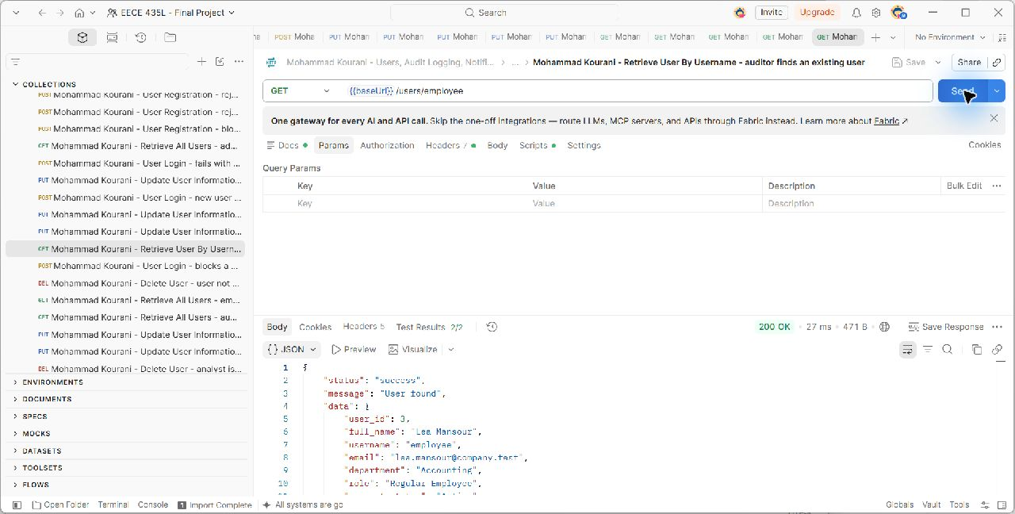
GET {{baseUrl}}/users/employee. The captured scenario checks HTTP 200; the request and actual server response are shown in the unchanged screenshot. Source: docs/evidence/MohammadKourani/get-user-found.png.

Figure 24. Mohammad Kourani - Retrieve User By Username - user does not exist
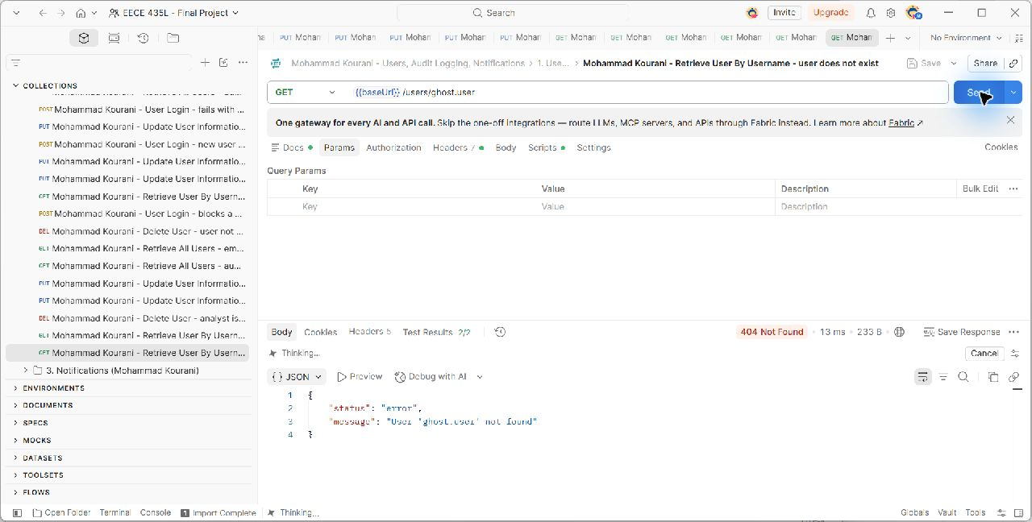
GET {{baseUrl}}/users/ghost.user. The captured scenario checks HTTP 404; the request and actual server response are shown in the unchanged screenshot. Source: docs/evidence/MohammadKourani/get-user-not-found.png.

Figure 25. Mohammad Kourani - Retrieve User By Username - employee views own profile
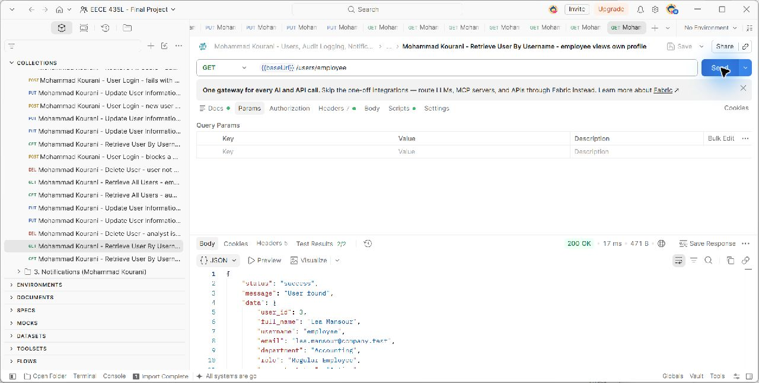
GET {{baseUrl}}/users/employee. The captured scenario checks HTTP 200; the request and actual server response are shown in the unchanged screenshot. Source: docs/evidence/MohammadKourani/get-user-own-profile.png.

Figure 26. Mohammad Kourani - Delete User - analyst is denied
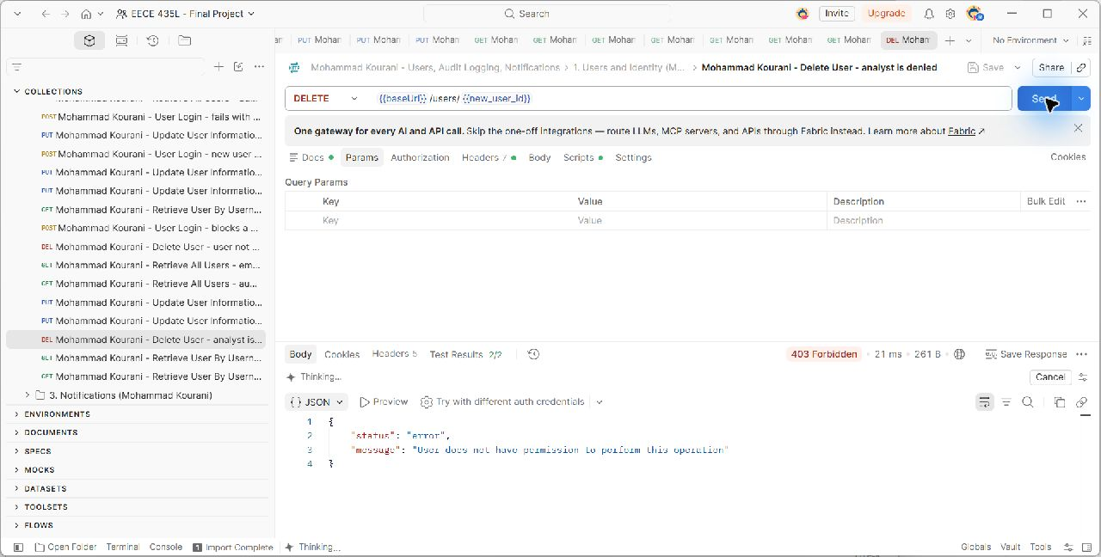
DELETE {{baseUrl}}/users/{{new_user_id}}. The captured scenario checks HTTP 403; the request and actual server response are shown in the unchanged screenshot. Source: docs/evidence/MohammadKourani/delete-user-denied.png.

Figure 27. Mohammad Kourani - Delete User - admin deletes a user
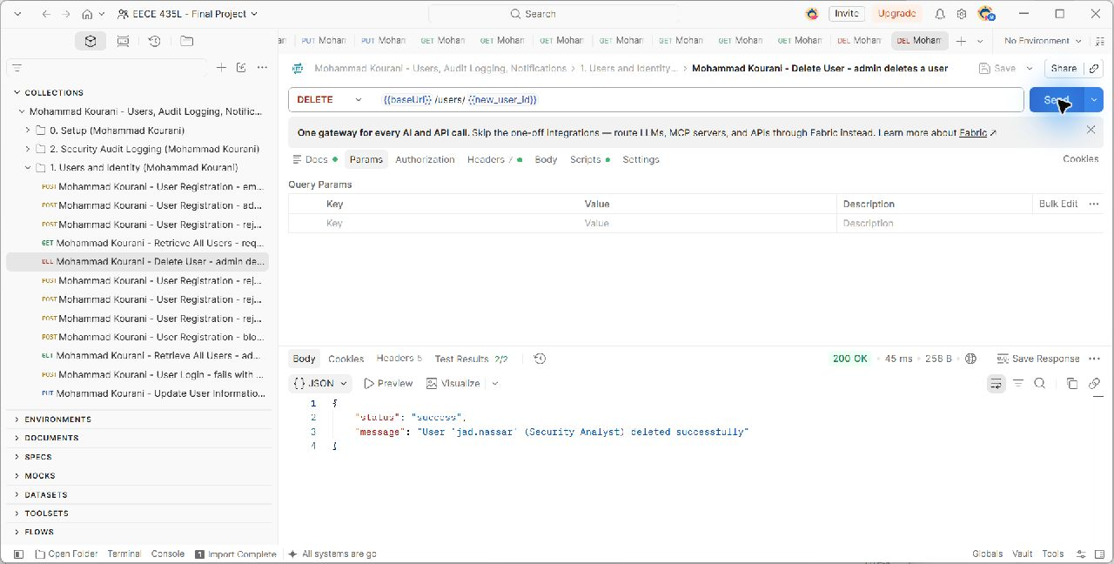
DELETE {{baseUrl}}/users/{{new_user_id}}. The captured scenario checks HTTP 200; the request and actual server response are shown in the unchanged screenshot. Source: docs/evidence/MohammadKourani/delete-user-success.png.

Figure 28. Mohammad Kourani - Delete User - user not found
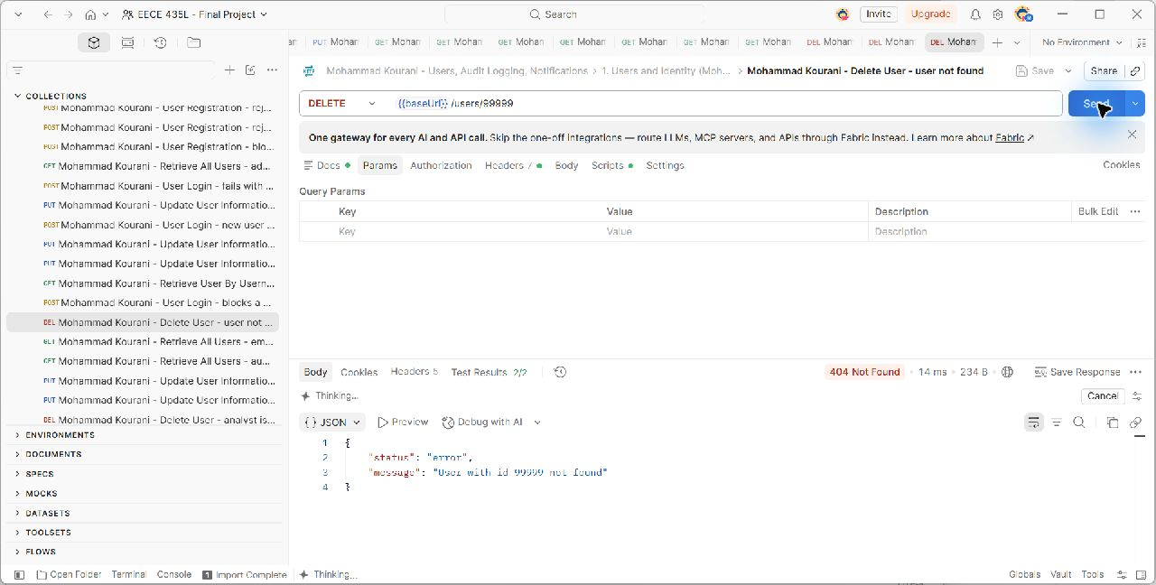
DELETE {{baseUrl}}/users/99999. The captured scenario checks HTTP 404; the request and actual server response are shown in the unchanged screenshot. Source: docs/evidence/MohammadKourani/delete-user-not-found.png.

5.2 Security Audit Logging
The Log model stores the actor, action, description, timestamp, severity, and related service. log_event() is a shared function called for logins, account changes, permission violations, and service mutations. Administrators may add manual entries; administrators and auditors can read the complete history. Analysts have narrower record and search access.
Search combines user, date, action, severity, and service filters. A date identifies a complete day, and an existing user with no activity receives a successful empty result. The API has no update operation, so PUT returns 405. The logs_block_updates SQLite trigger also blocks changes to recorded content while allowing the user link to become null. Administrator deletion is supported and creates a new Critical LOG_DELETED event.
Method | Endpoint | Allowed callers | Success
POST | /logs | Security Administrator | 201
GET | /logs | Security Administrator, Auditor | 200
GET | /logs/{id} | Security Administrator, Auditor, Security Analyst | 200
GET | /logs/search | Security Administrator, Auditor, Security Analyst | 200
DELETE | /logs/{id} | Security Administrator | 200
GET | /logs/user/{user_id} | Security Administrator, Auditor | 200

Figure 29. Mohammad Kourani - Create Log Record - admin adds a log manually
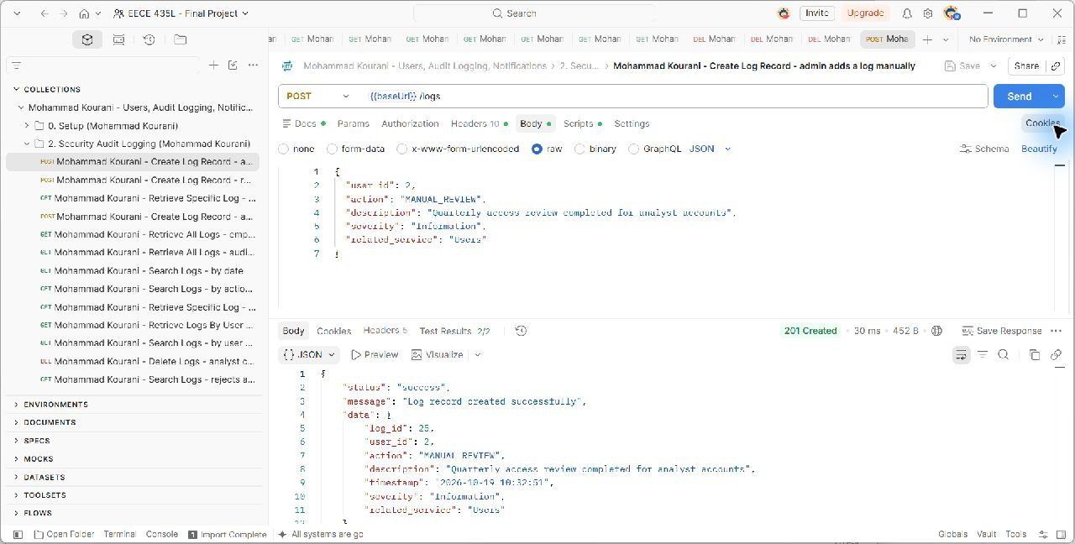
POST {{baseUrl}}/logs. The captured scenario checks HTTP 201; the request and actual server response are shown in the unchanged screenshot. Source: docs/evidence/MohammadKourani/logs-create.png.

Figure 30. Mohammad Kourani - Create Log Record - rejects an invalid severity
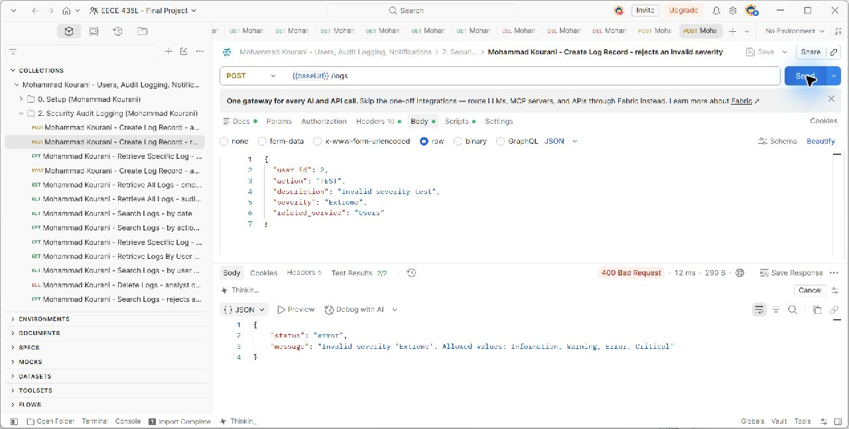
POST {{baseUrl}}/logs. The captured scenario checks HTTP 400; the request and actual server response are shown in the unchanged screenshot. Source: docs/evidence/MohammadKourani/validation-invalid-severity.png.

Figure 31. Mohammad Kourani - Create Log Record - auditor cannot create logs
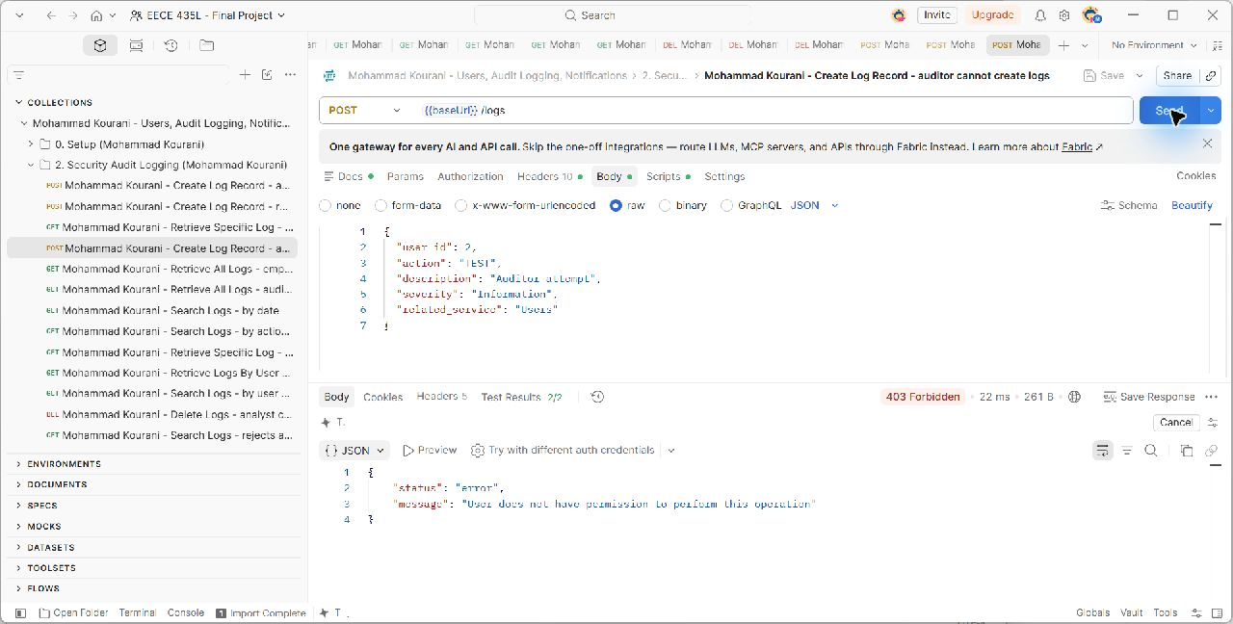
POST {{baseUrl}}/logs. The captured scenario checks HTTP 403; the request and actual server response are shown in the unchanged screenshot. Source: docs/evidence/MohammadKourani/logs-create-denied.png.

Figure 32. Mohammad Kourani - Retrieve All Logs - auditor lists every log
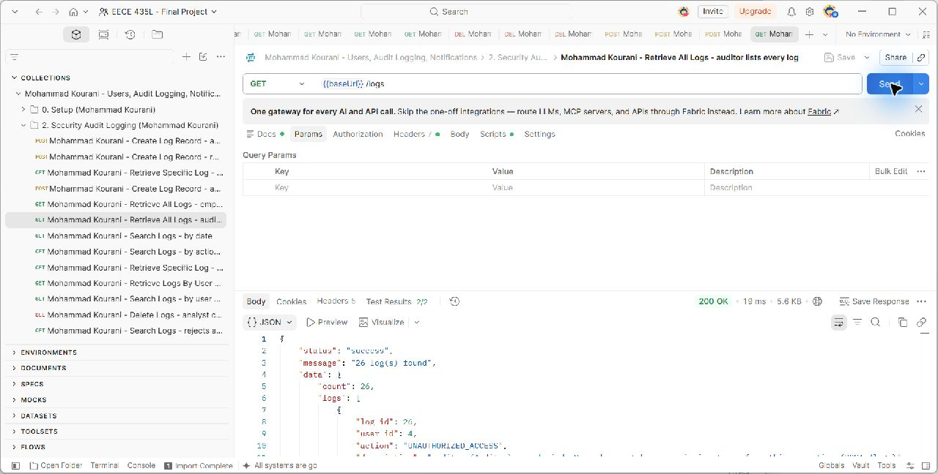
GET {{baseUrl}}/logs. The captured scenario checks HTTP 200; the request and actual server response are shown in the unchanged screenshot. Source: docs/evidence/MohammadKourani/logs-get-all.png.

Figure 33. Mohammad Kourani - Retrieve All Logs - employee is denied
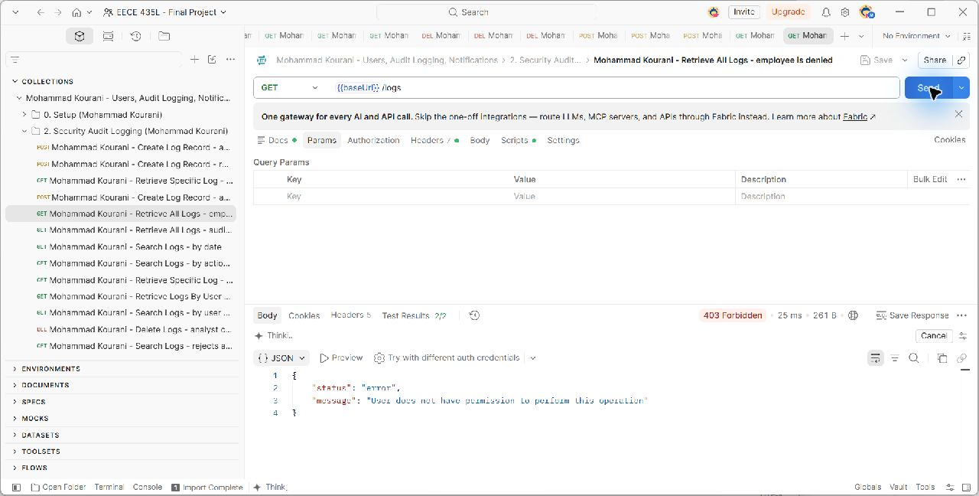
GET {{baseUrl}}/logs. The captured scenario checks HTTP 403; the request and actual server response are shown in the unchanged screenshot. Source: docs/evidence/MohammadKourani/logs-get-all-denied.png.

Figure 34. Mohammad Kourani - Retrieve Specific Log - analyst gets one log
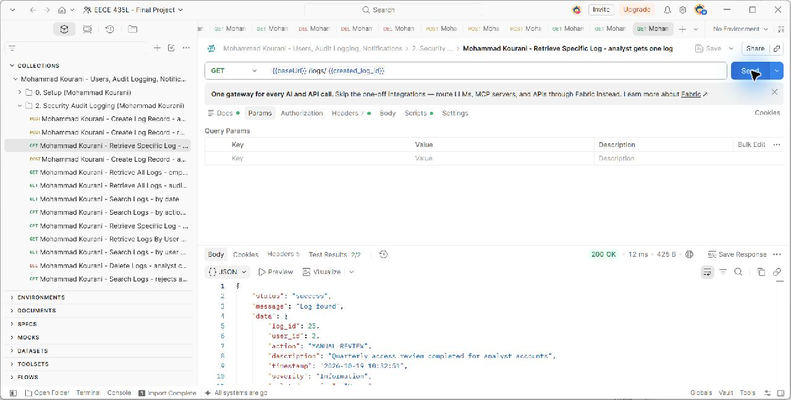
GET {{baseUrl}}/logs/{{created_log_id}}. The captured scenario checks HTTP 200; the request and actual server response are shown in the unchanged screenshot. Source: docs/evidence/MohammadKourani/logs-get-one.png.

Figure 35. Mohammad Kourani - Retrieve Specific Log - invalid log id
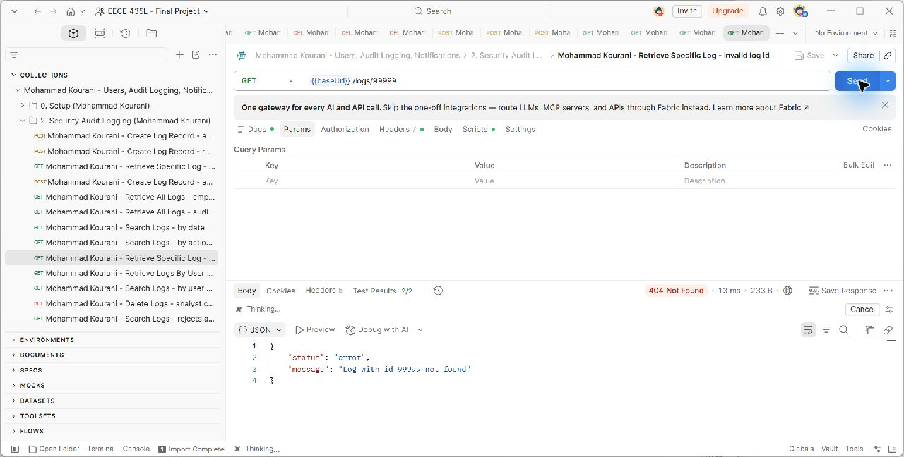
GET {{baseUrl}}/logs/99999. The captured scenario checks HTTP 404; the request and actual server response are shown in the unchanged screenshot. Source: docs/evidence/MohammadKourani/logs-get-invalid.png.

Figure 36. Mohammad Kourani - Search Logs - by action (failed logins)
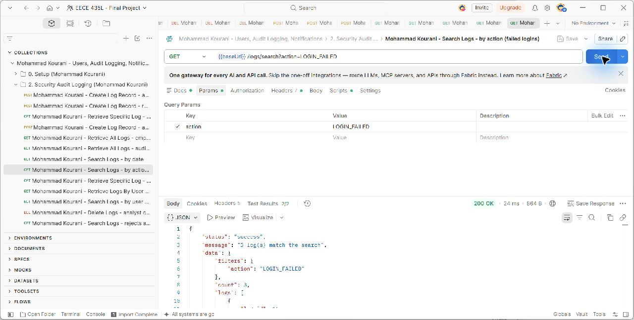
GET {{baseUrl}}/logs/search?action=LOGIN_FAILED. The captured scenario checks HTTP 200; the request and actual server response are shown in the unchanged screenshot. Source: docs/evidence/MohammadKourani/logs-search-action.png.

Figure 37. Mohammad Kourani - Search Logs - by severity
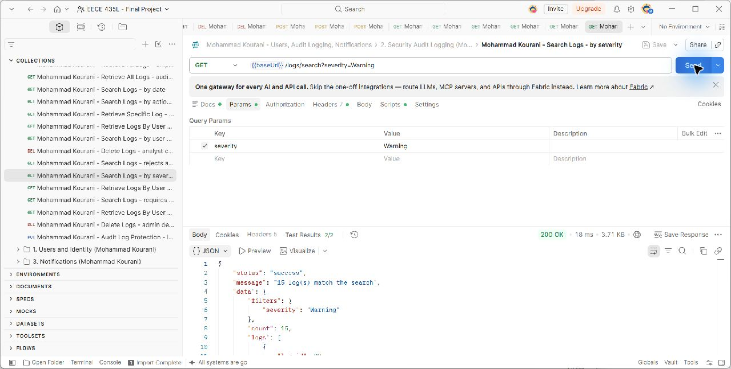
GET {{baseUrl}}/logs/search?severity=Warning. The captured scenario checks HTTP 200; the request and actual server response are shown in the unchanged screenshot. Source: docs/evidence/MohammadKourani/logs-search-severity.png.

Figure 38. Mohammad Kourani - Search Logs - by date
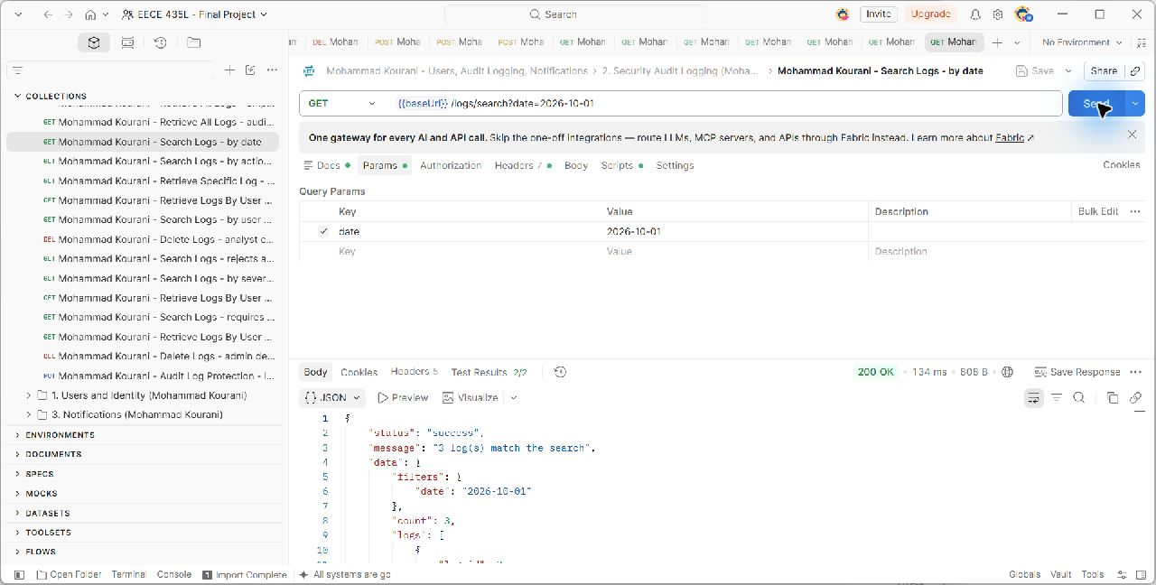
GET {{baseUrl}}/logs/search?date=2026-10-01. The captured scenario checks HTTP 200; the request and actual server response are shown in the unchanged screenshot. Source: docs/evidence/MohammadKourani/logs-search-date.png.

Figure 39. Mohammad Kourani - Search Logs - by user and service combined
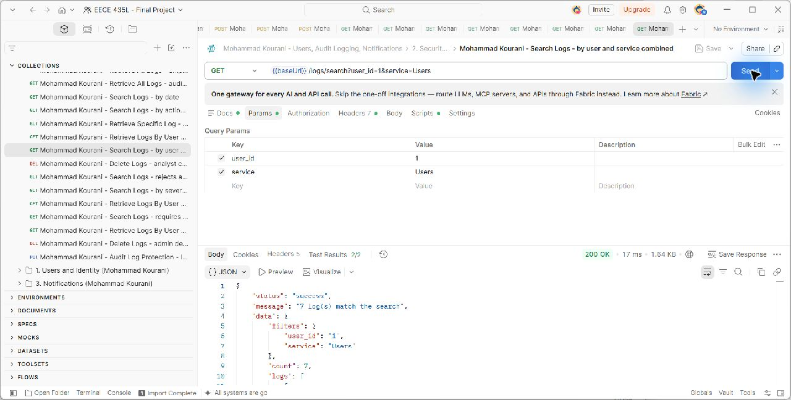
GET {{baseUrl}}/logs/search?user_id=1&service=Users. The captured scenario checks HTTP 200; the request and actual server response are shown in the unchanged screenshot. Source: docs/evidence/MohammadKourani/logs-search-combined.png.

Figure 40. Mohammad Kourani - Search Logs - rejects a badly formatted date
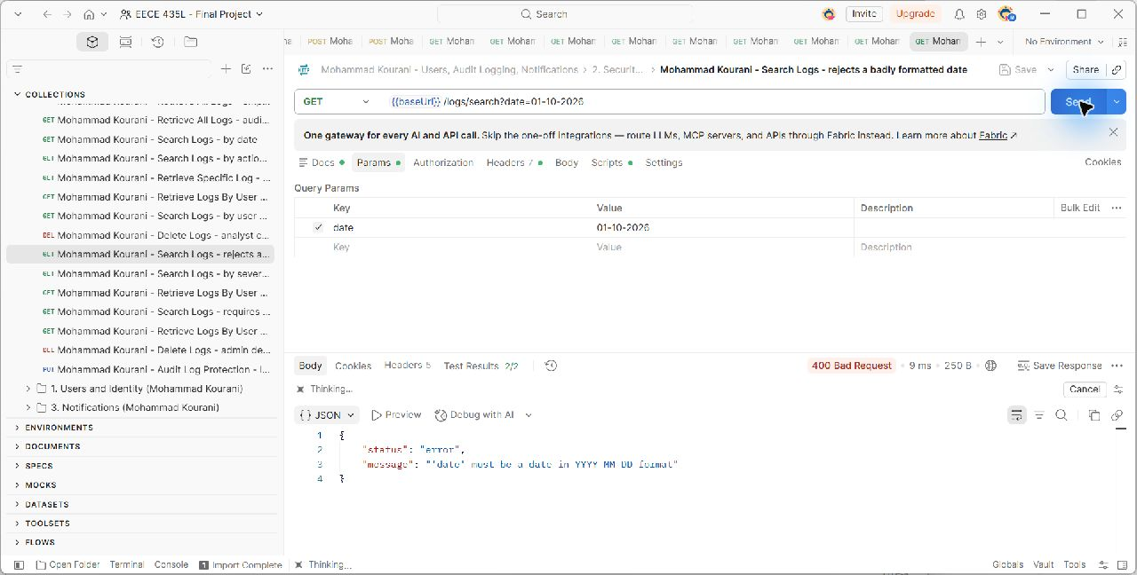
GET {{baseUrl}}/logs/search?date=01-10-2026. The captured scenario checks HTTP 400; the request and actual server response are shown in the unchanged screenshot. Source: docs/evidence/MohammadKourani/logs-search-invalid-date.png.

Figure 41. Mohammad Kourani - Search Logs - requires at least one filter
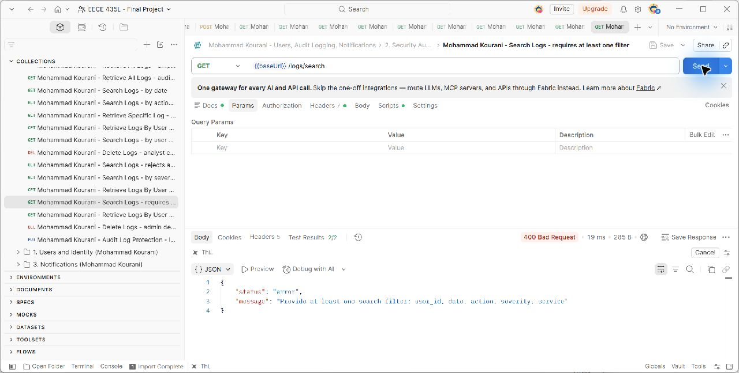
GET {{baseUrl}}/logs/search. The captured scenario checks HTTP 400; the request and actual server response are shown in the unchanged screenshot. Source: docs/evidence/MohammadKourani/logs-search-no-filter.png.

Figure 42. Mohammad Kourani - Retrieve Logs By User - all activity of the admin
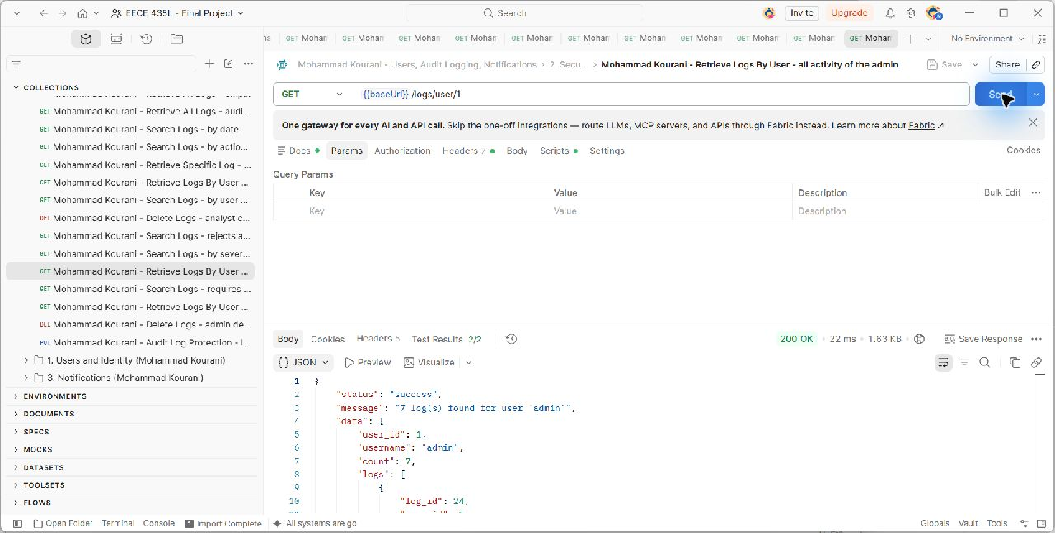
GET {{baseUrl}}/logs/user/1. The captured scenario checks HTTP 200; the request and actual server response are shown in the unchanged screenshot. Source: docs/evidence/MohammadKourani/logs-by-user.png.

Figure 43. Mohammad Kourani - Retrieve Logs By User - user with no logs
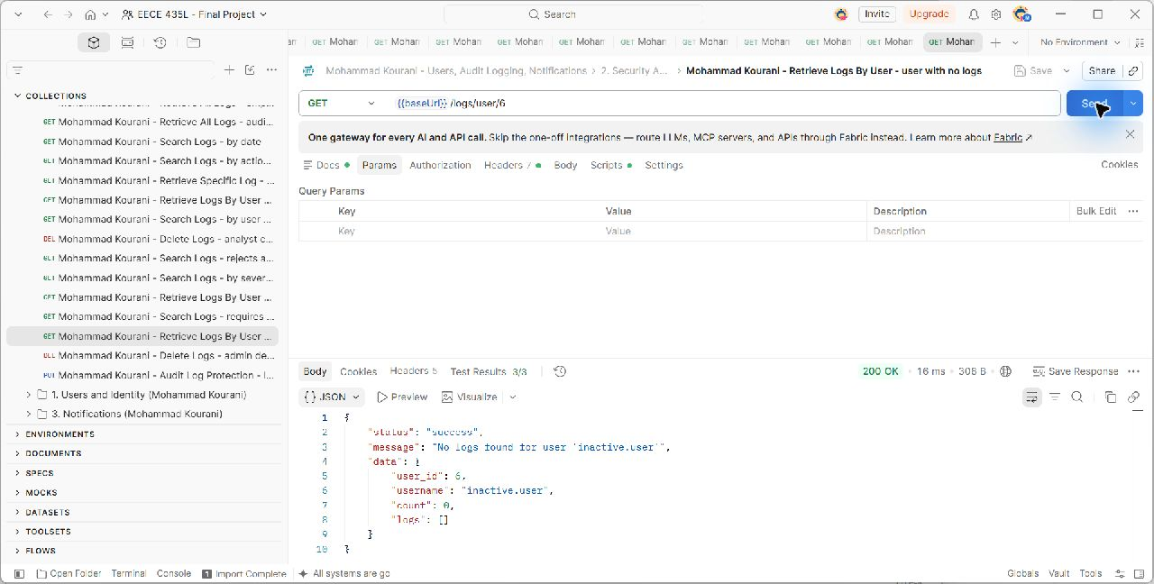
GET {{baseUrl}}/logs/user/6. The captured scenario checks HTTP 200; the request and actual server response are shown in the unchanged screenshot. Source: docs/evidence/MohammadKourani/logs-by-user-empty.png.

Figure 44. Mohammad Kourani - Retrieve Logs By User - user does not exist
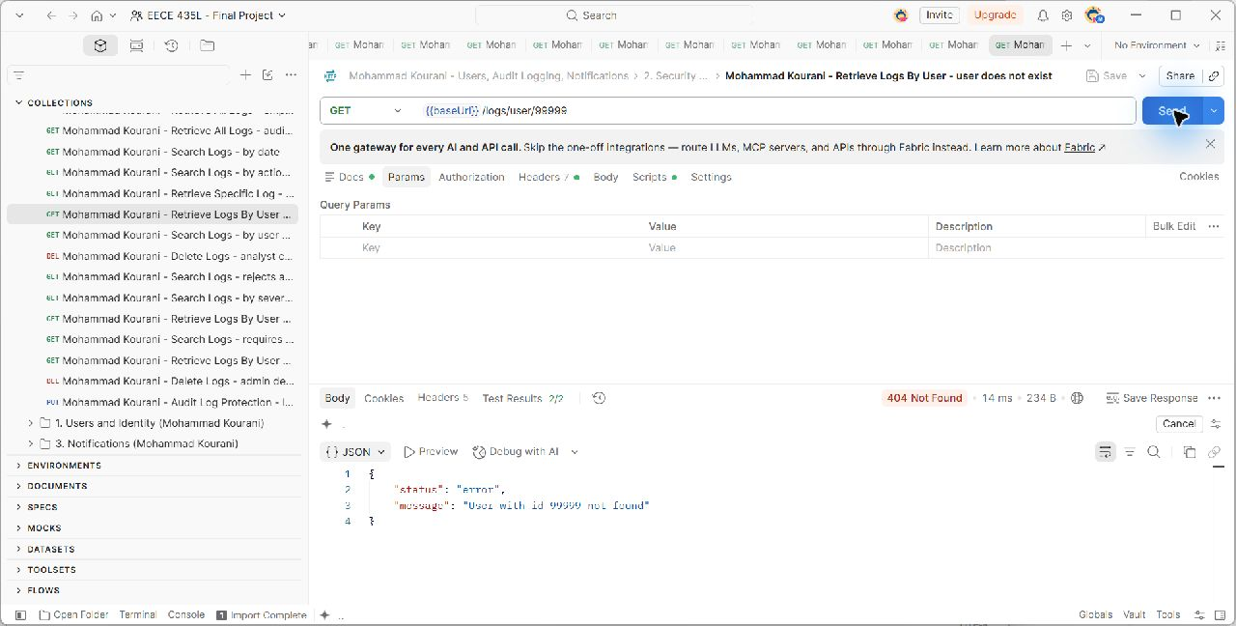
GET {{baseUrl}}/logs/user/99999. The captured scenario checks HTTP 404; the request and actual server response are shown in the unchanged screenshot. Source: docs/evidence/MohammadKourani/logs-by-user-not-found.png.

Figure 45. Mohammad Kourani - Delete Logs - analyst cannot delete logs
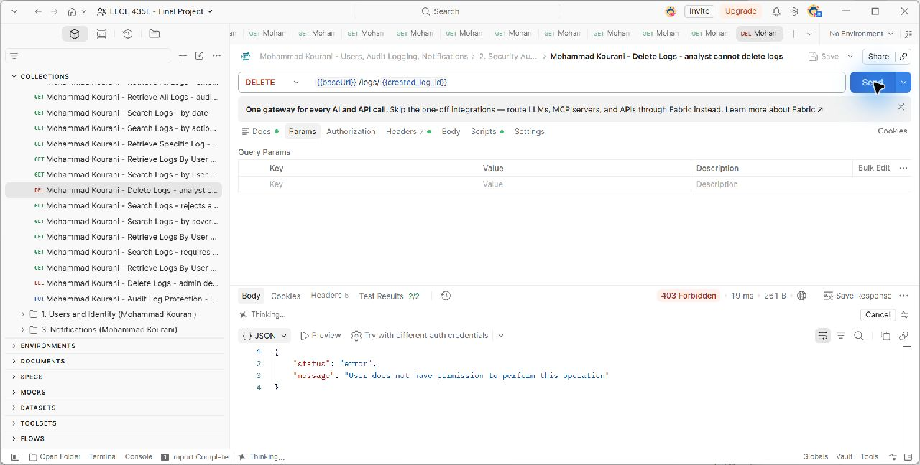
DELETE {{baseUrl}}/logs/{{created_log_id}}. The captured scenario checks HTTP 403; the request and actual server response are shown in the unchanged screenshot. Source: docs/evidence/MohammadKourani/logs-delete-denied.png.

Figure 46. Mohammad Kourani - Delete Logs - admin deletes a log
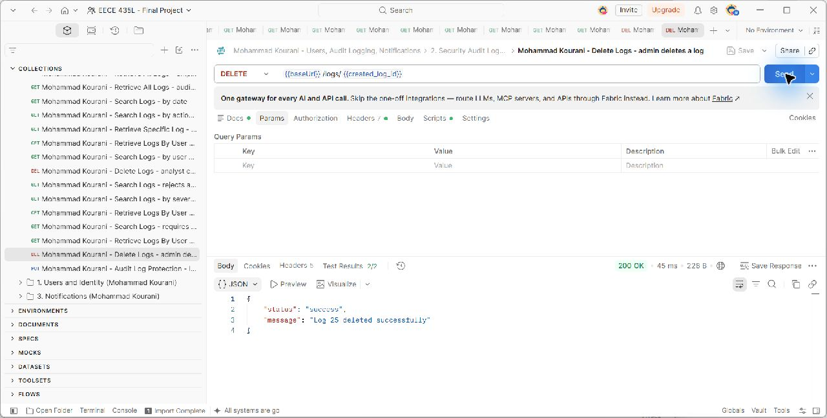
DELETE {{baseUrl}}/logs/{{created_log_id}}. The captured scenario checks HTTP 200; the request and actual server response are shown in the unchanged screenshot. Source: docs/evidence/MohammadKourani/logs-delete-success.png.

Figure 47. Mohammad Kourani - Audit Log Protection - logs cannot be modified
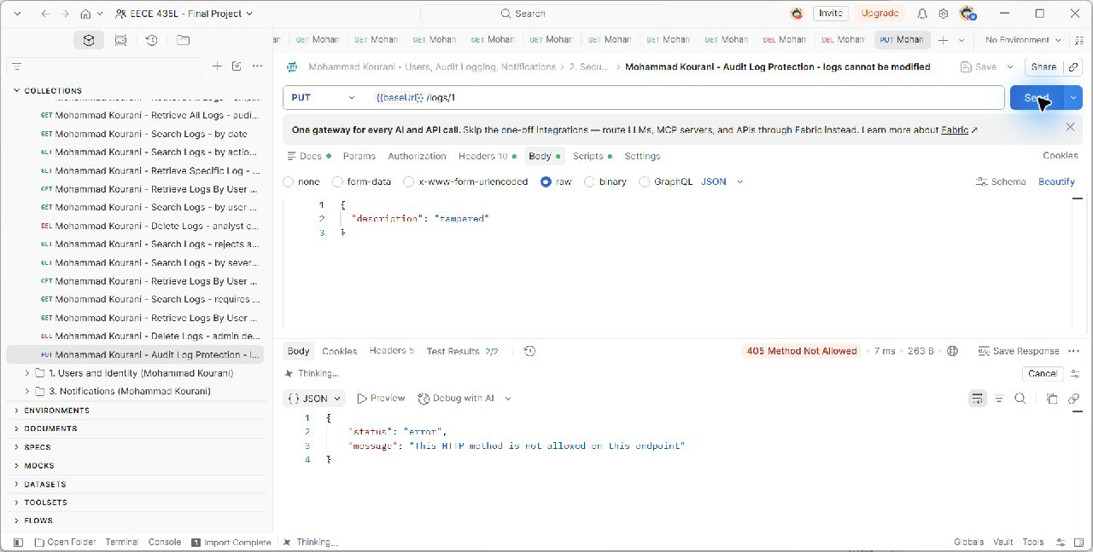
PUT {{baseUrl}}/logs/1. The captured scenario checks HTTP 405; the request and actual server response are shown in the unchanged screenshot. Source: docs/evidence/MohammadKourani/logs-cannot-modify.png.

Figure 48. Mohammad Kourani - Database - audit records after logging tests
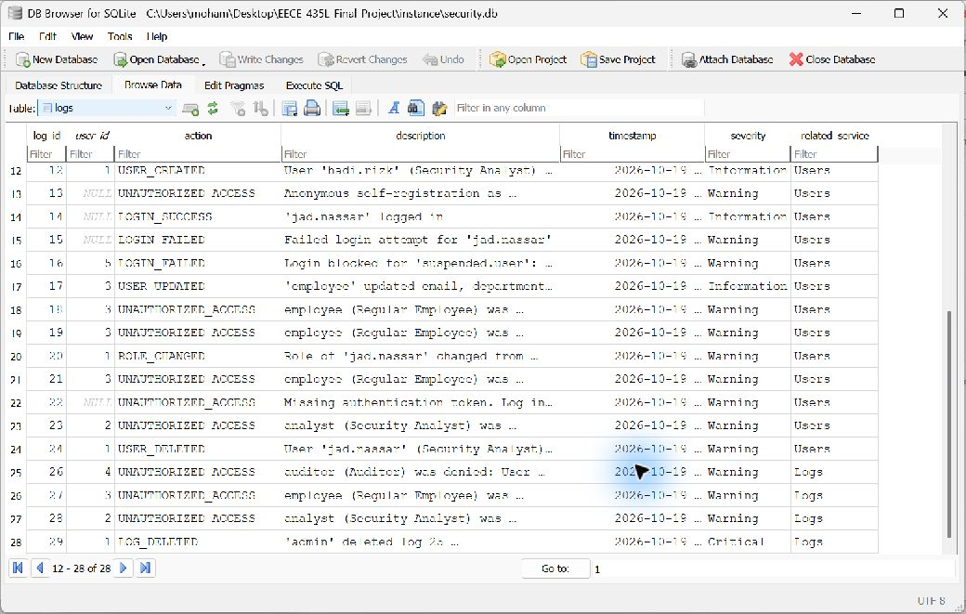
The logs table records the activity and denied operations produced during the audit collection. Source: docs/evidence/MohammadKourani/logs-db-records.png.

5.3 Notifications
The Notification model stores the recipient, title, message, type, severity, status, creation time, and read time. create_notification() validates the recipient and fields before committing an Unread notification. Administrators can create messages through the REST endpoint; other services use the shared function for automatic alerts.
Analysts and employees can access only their own notifications. Administrators and auditors can inspect other users' notifications, while auditors cannot mark messages as read or delete them. Marking an unread notification sets status to Read and records read_date. Repeating the request returns 200 without replacing the original read timestamp. Only administrators may delete notifications.
Method | Endpoint | Allowed callers | Success
POST | /notifications | Security Administrator | 201
GET | /notifications/user/{user_id} | All roles (Analyst and Employee: own only) | 200
GET | /notifications/{id} | All roles (Analyst and Employee: own only) | 200
PUT | /notifications/{id}/read | Security Administrator; Analyst and Employee (own only) | 200
GET | /notifications/search | Security Administrator, Auditor; Analyst (own only) | 200
DELETE | /notifications/{id} | Security Administrator | 200

Figure 49. Mohammad Kourani - Create Notification - admin alerts the employee
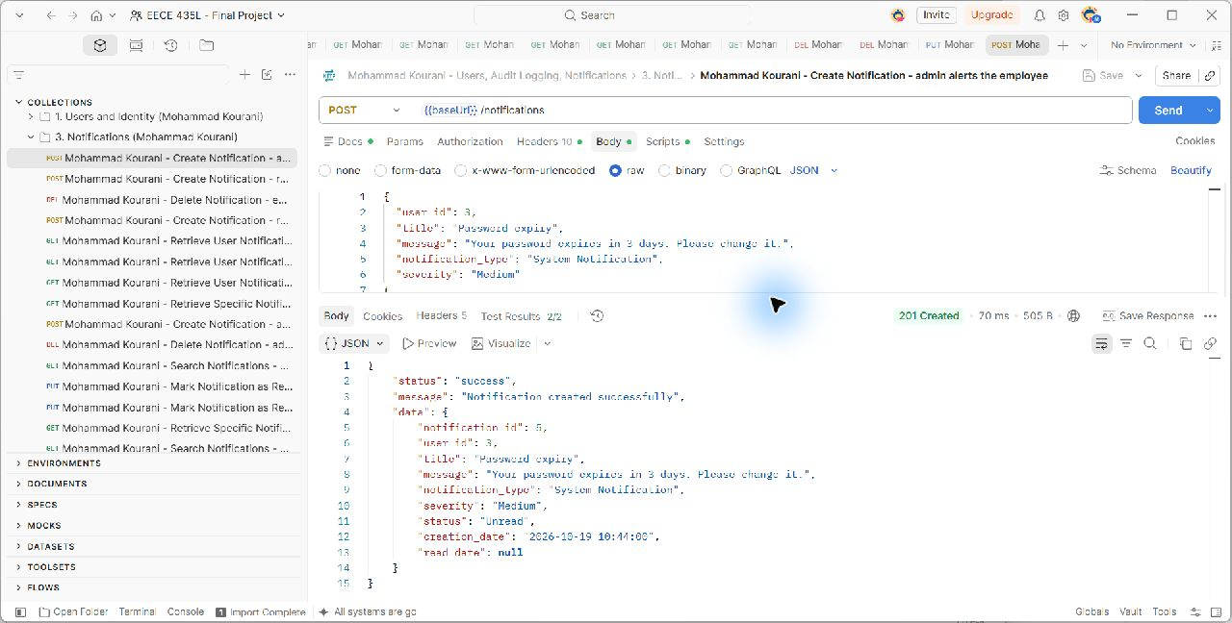
POST {{baseUrl}}/notifications. The captured scenario checks HTTP 201; the request and actual server response are shown in the unchanged screenshot. Source: docs/evidence/MohammadKourani/notif-create.png.

Figure 50. Mohammad Kourani - Database - new notification is Unread
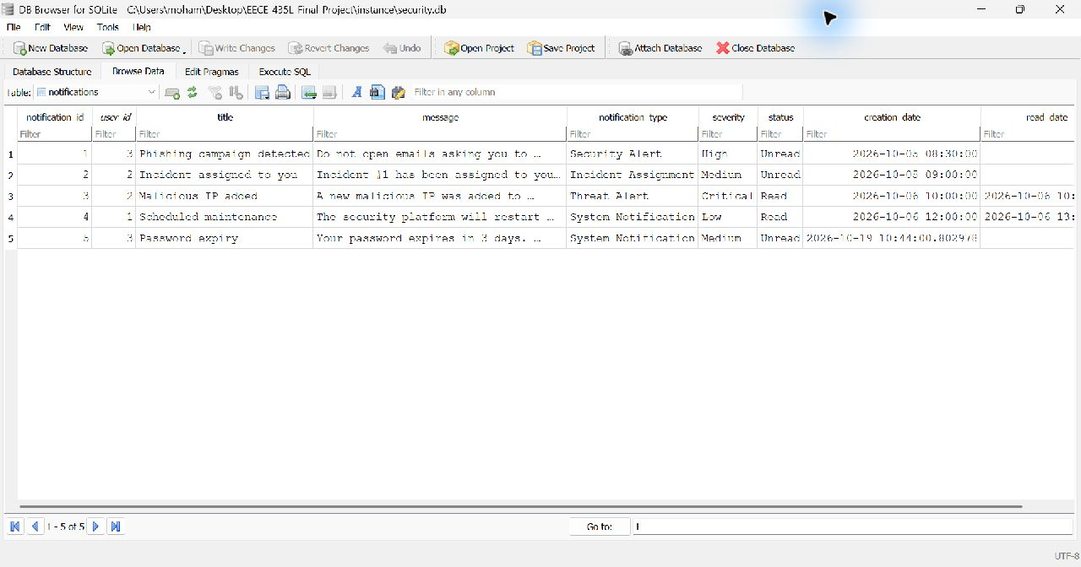
The new notification starts as Unread with no read_date. This is also the before-read checkpoint. Source: docs/evidence/MohammadKourani/notif-db-records.png.

Figure 51. Mohammad Kourani - Create Notification - rejects an invalid type
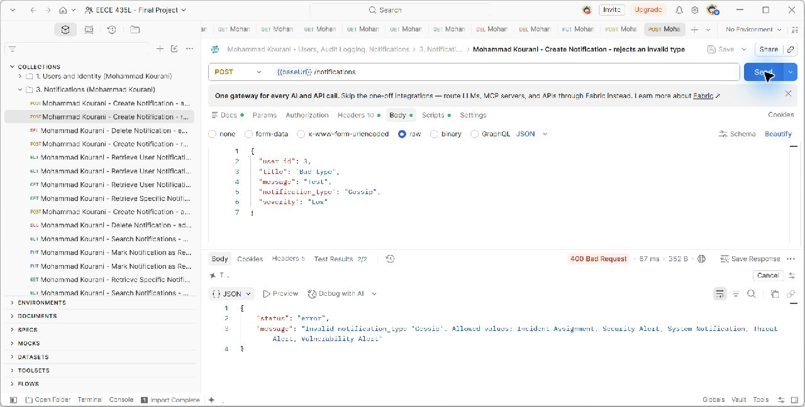
POST {{baseUrl}}/notifications. The captured scenario checks HTTP 400; the request and actual server response are shown in the unchanged screenshot. Source: docs/evidence/MohammadKourani/notif-create-invalid-type.png.

Figure 52. Mohammad Kourani - Create Notification - recipient does not exist
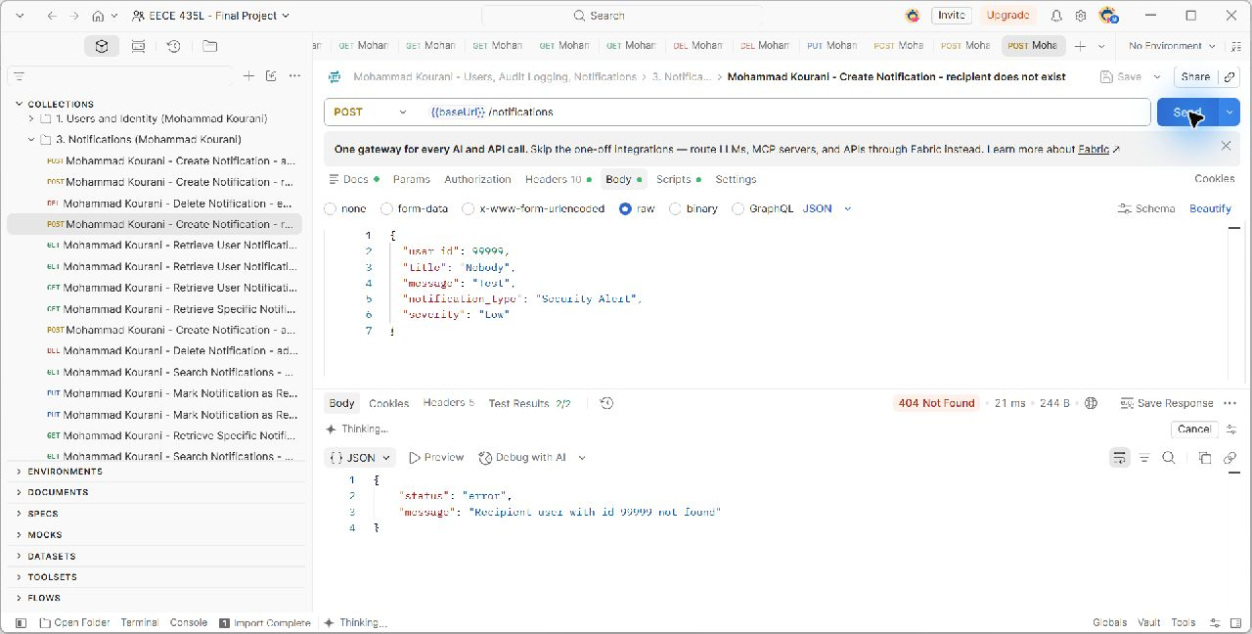
POST {{baseUrl}}/notifications. The captured scenario checks HTTP 404; the request and actual server response are shown in the unchanged screenshot. Source: docs/evidence/MohammadKourani/notif-create-recipient-not-found.png.

Figure 53. Mohammad Kourani - Create Notification - analyst cannot create notifications
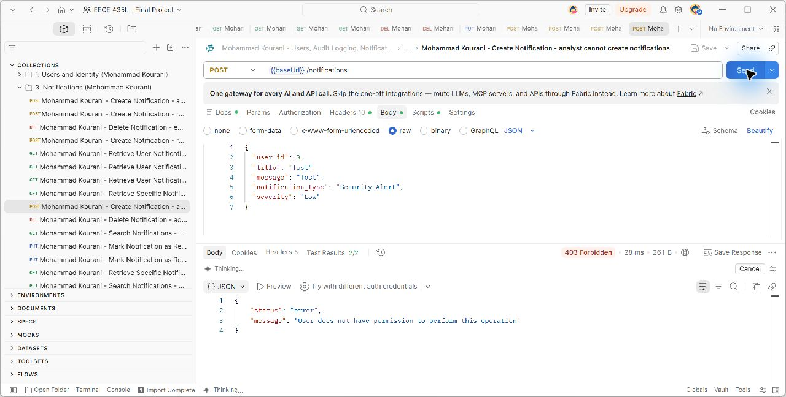
POST {{baseUrl}}/notifications. The captured scenario checks HTTP 403; the request and actual server response are shown in the unchanged screenshot. Source: docs/evidence/MohammadKourani/notif-create-denied.png.

Figure 54. Mohammad Kourani - Retrieve User Notifications - employee views own notifications
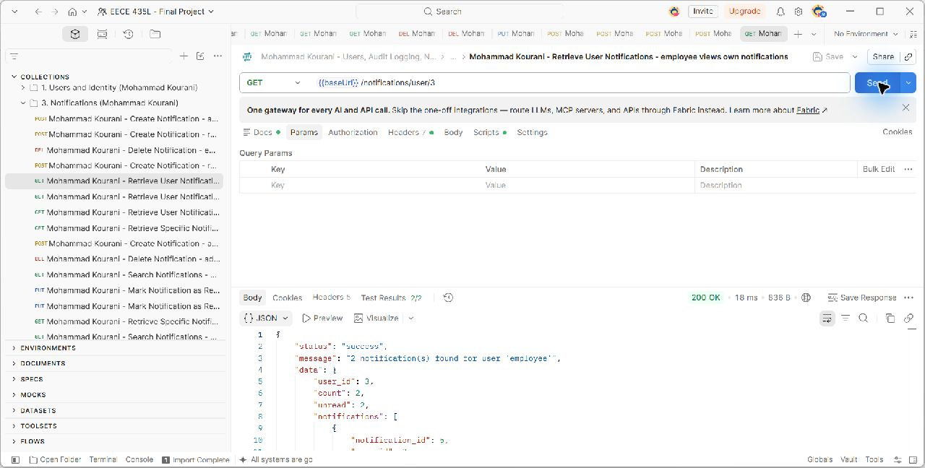
GET {{baseUrl}}/notifications/user/3. The captured scenario checks HTTP 200; the request and actual server response are shown in the unchanged screenshot. Source: docs/evidence/MohammadKourani/notif-user-list.png.

Figure 55. Mohammad Kourani - Retrieve User Notifications - user with no notifications
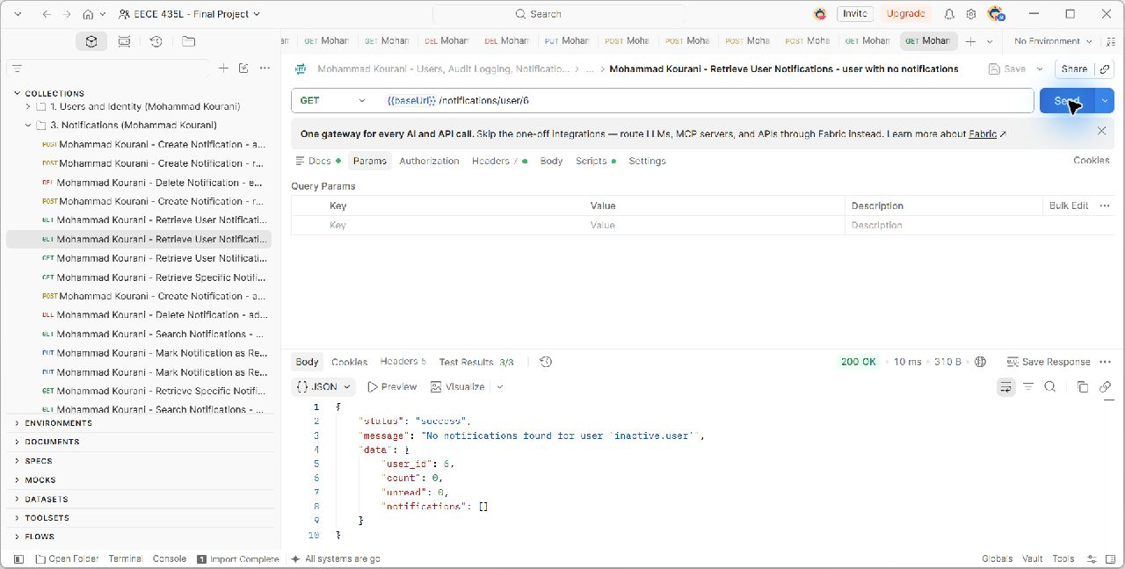
GET {{baseUrl}}/notifications/user/6. The captured scenario checks HTTP 200; the request and actual server response are shown in the unchanged screenshot. Source: docs/evidence/MohammadKourani/notif-user-empty.png.

Figure 56. Mohammad Kourani - Retrieve User Notifications - employee cannot view someone else's
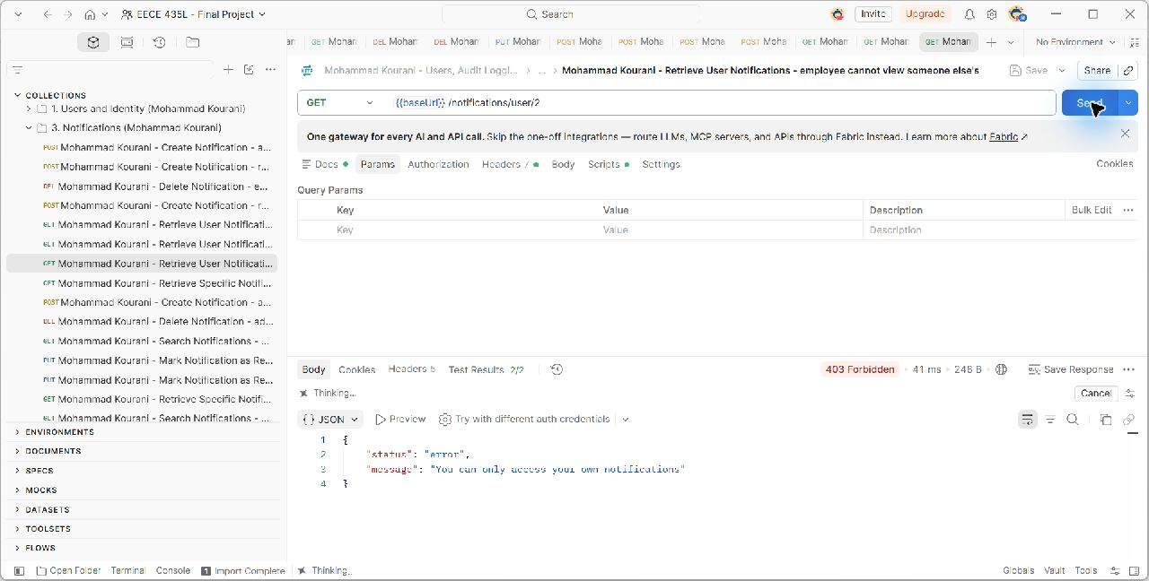
GET {{baseUrl}}/notifications/user/2. The captured scenario checks HTTP 403; the request and actual server response are shown in the unchanged screenshot. Source: docs/evidence/MohammadKourani/notif-user-other-denied.png.

Figure 57. Mohammad Kourani - Retrieve Specific Notification - employee opens one notification
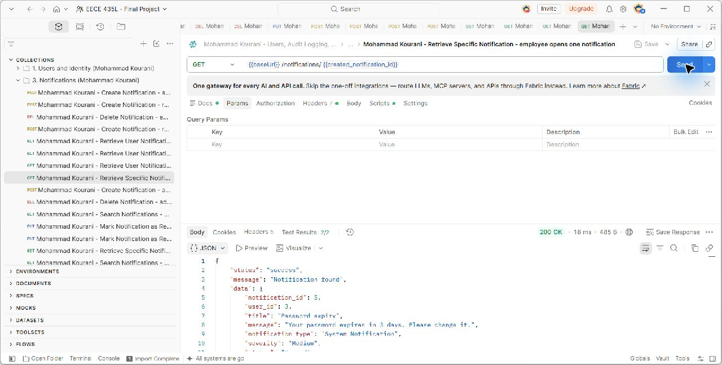
GET {{baseUrl}}/notifications/{{created_notification_id}}. The captured scenario checks HTTP 200; the request and actual server response are shown in the unchanged screenshot. Source: docs/evidence/MohammadKourani/notif-get-one.png.

Figure 58. Mohammad Kourani - Retrieve Specific Notification - invalid notification id
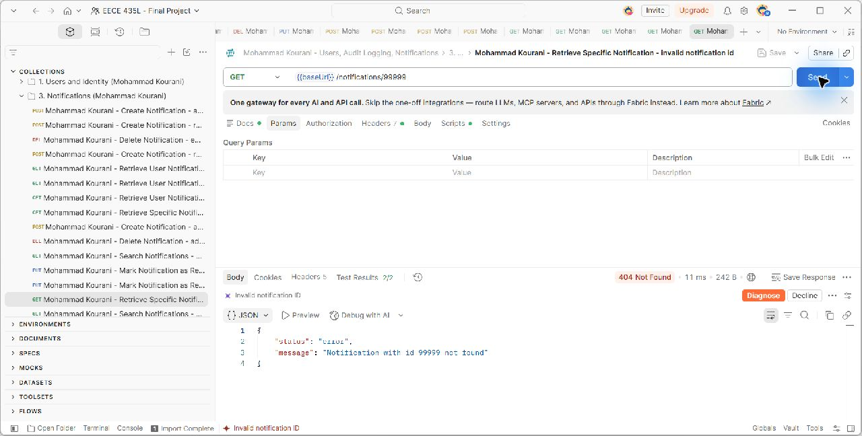
GET {{baseUrl}}/notifications/99999. The captured scenario checks HTTP 404; the request and actual server response are shown in the unchanged screenshot. Source: docs/evidence/MohammadKourani/notif-get-invalid.png.

Figure 59. Mohammad Kourani - Mark Notification as Read - employee marks it as read
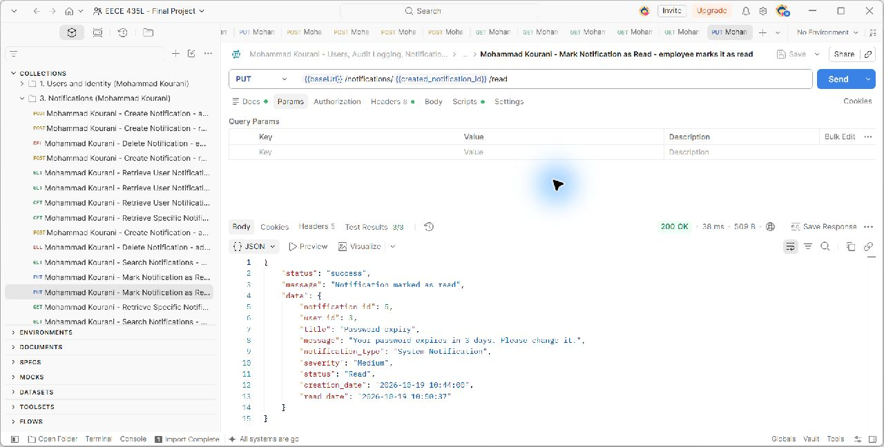
PUT {{baseUrl}}/notifications/{{created_notification_id}}/read. The captured scenario checks HTTP 200; the request and actual server response are shown in the unchanged screenshot. Source: docs/evidence/MohammadKourani/notif-mark-read.png.

Figure 60. Mohammad Kourani - Database - notification becomes Read
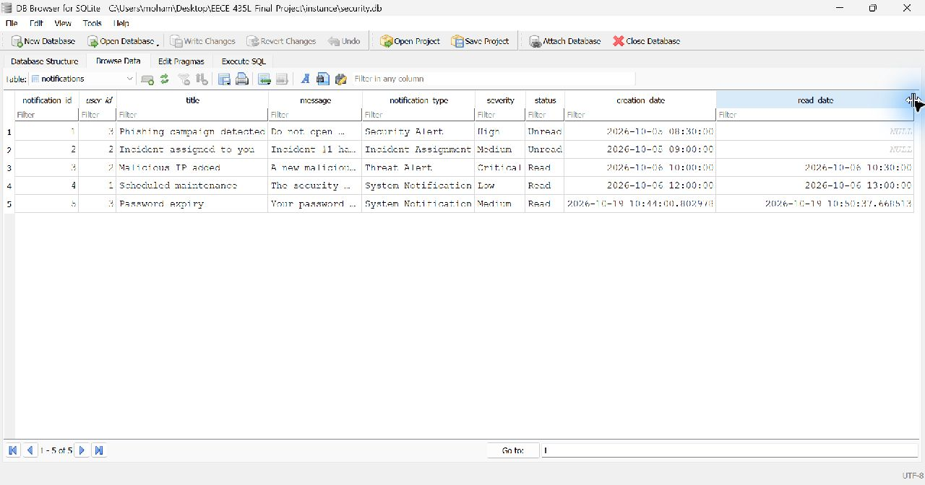
The same notification has status Read and a populated read_date after the mark-read request. Source: docs/evidence/MohammadKourani/notif-mark-read-db.png.

Figure 61. Mohammad Kourani - Mark Notification as Read - marking again changes nothing
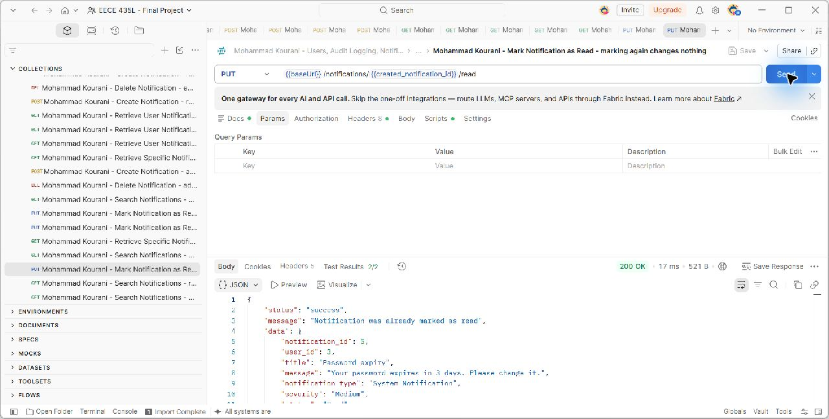
PUT {{baseUrl}}/notifications/{{created_notification_id}}/read. The captured scenario checks HTTP 200; the request and actual server response are shown in the unchanged screenshot. Source: docs/evidence/MohammadKourani/notif-mark-read-again.png.

Figure 62. Mohammad Kourani - Mark Notification as Read - auditor cannot mark as read
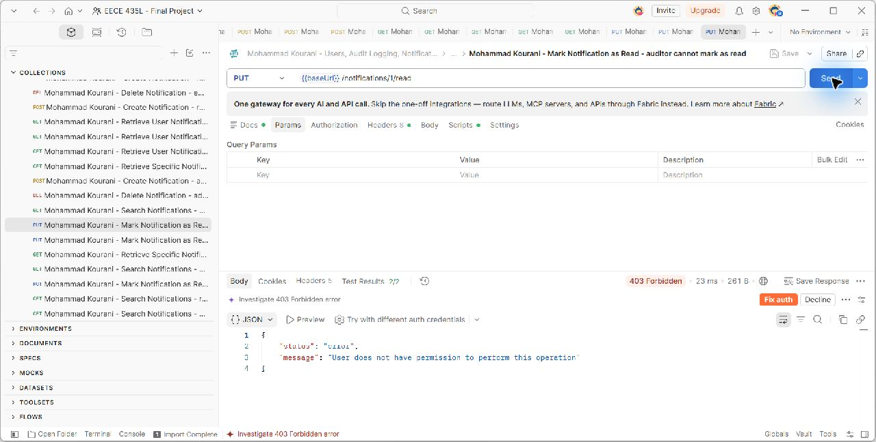
PUT {{baseUrl}}/notifications/1/read. The captured scenario checks HTTP 403; the request and actual server response are shown in the unchanged screenshot. Source: docs/evidence/MohammadKourani/notif-mark-read-denied.png.

Figure 63. Mohammad Kourani - Search Notifications - unread notifications
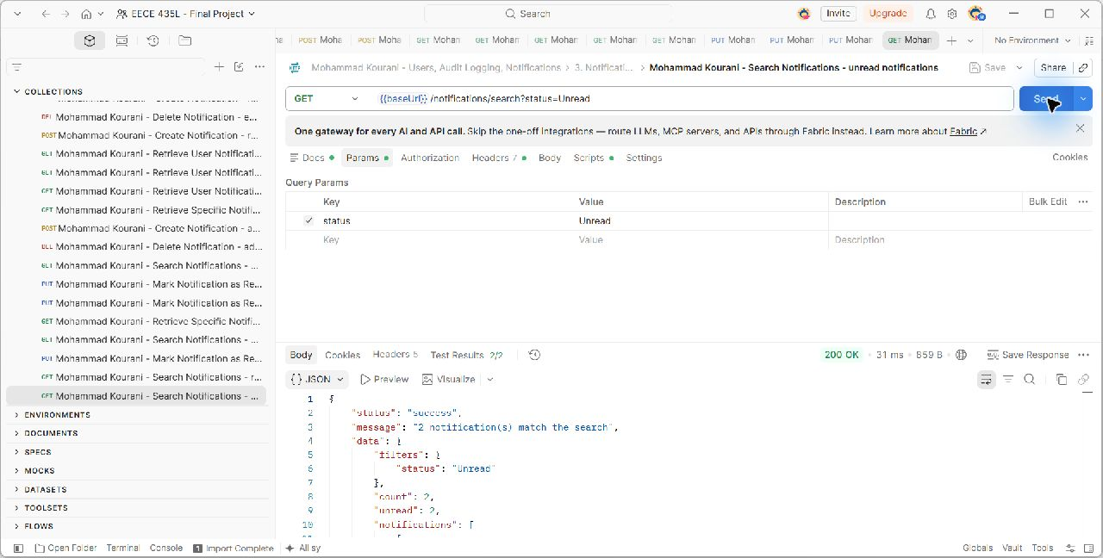
GET {{baseUrl}}/notifications/search?status=Unread. The captured scenario checks HTTP 200; the request and actual server response are shown in the unchanged screenshot. Source: docs/evidence/MohammadKourani/notif-search-status.png.

Figure 64. Mohammad Kourani - Search Notifications - by type
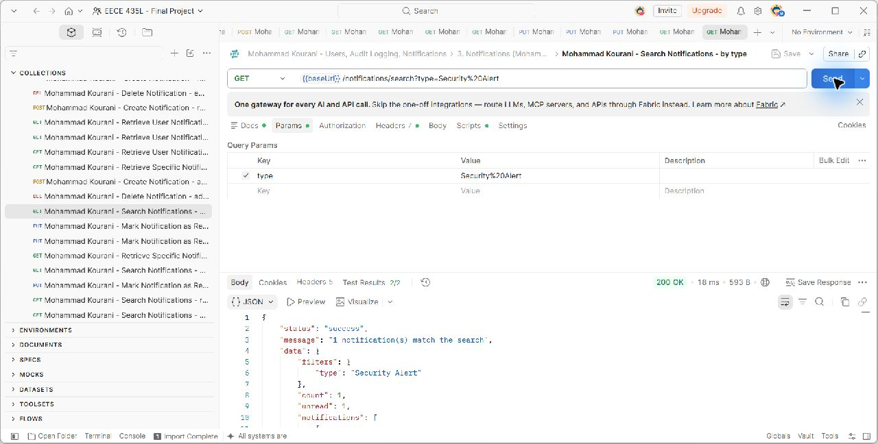
GET {{baseUrl}}/notifications/search?type=Security%20Alert. The captured scenario checks HTTP 200; the request and actual server response are shown in the unchanged screenshot. Source: docs/evidence/MohammadKourani/notif-search-type.png.

Figure 65. Mohammad Kourani - Search Notifications - analyst sees only own results
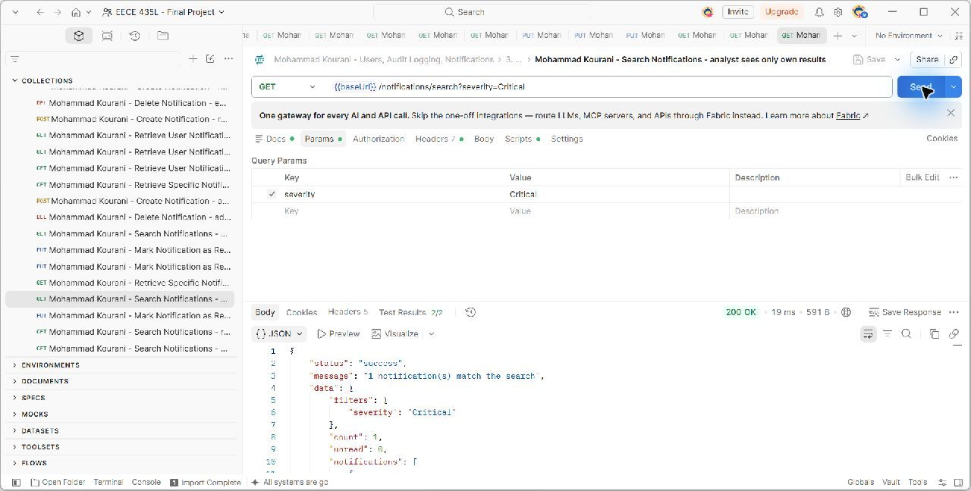
GET {{baseUrl}}/notifications/search?severity=Critical. The captured scenario checks HTTP 200; the request and actual server response are shown in the unchanged screenshot. Source: docs/evidence/MohammadKourani/notif-search-analyst-own.png.

Figure 66. Mohammad Kourani - Search Notifications - rejects an invalid status
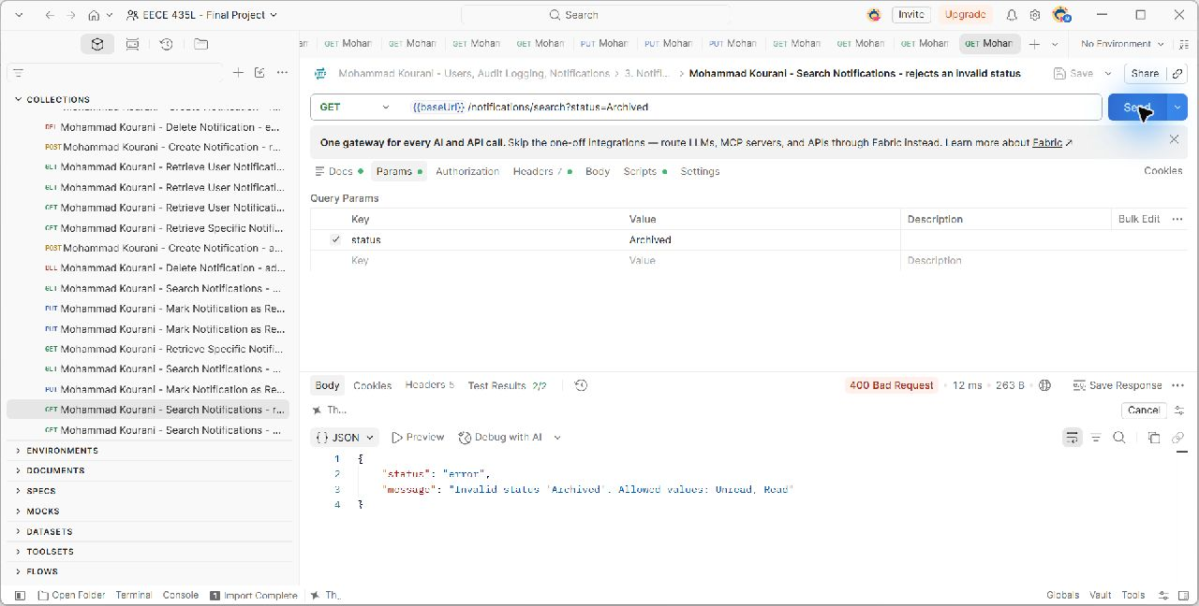
GET {{baseUrl}}/notifications/search?status=Archived. The captured scenario checks HTTP 400; the request and actual server response are shown in the unchanged screenshot. Source: docs/evidence/MohammadKourani/notif-search-invalid-status.png.

Figure 67. Mohammad Kourani - Delete Notification - employee cannot delete
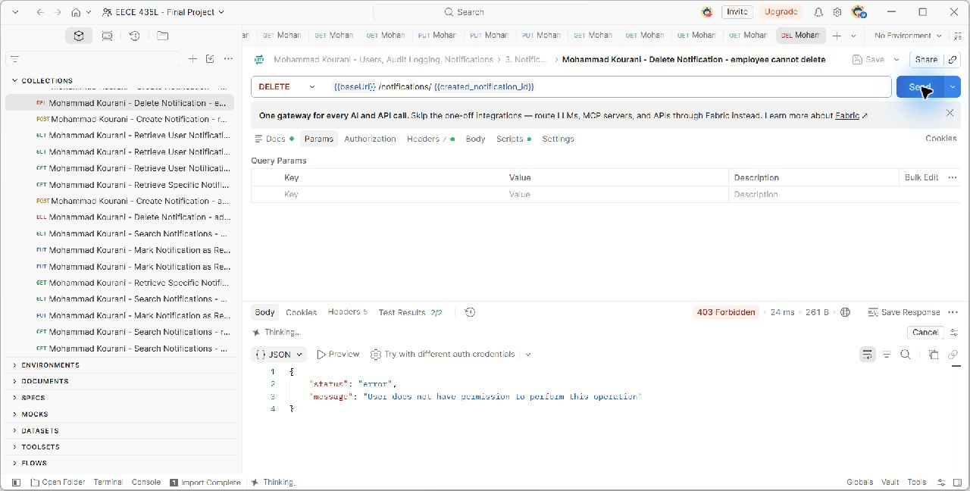
DELETE {{baseUrl}}/notifications/{{created_notification_id}}. The captured scenario checks HTTP 403; the request and actual server response are shown in the unchanged screenshot. Source: docs/evidence/MohammadKourani/notif-delete-denied.png.

Figure 68. Mohammad Kourani - Delete Notification - admin deletes it
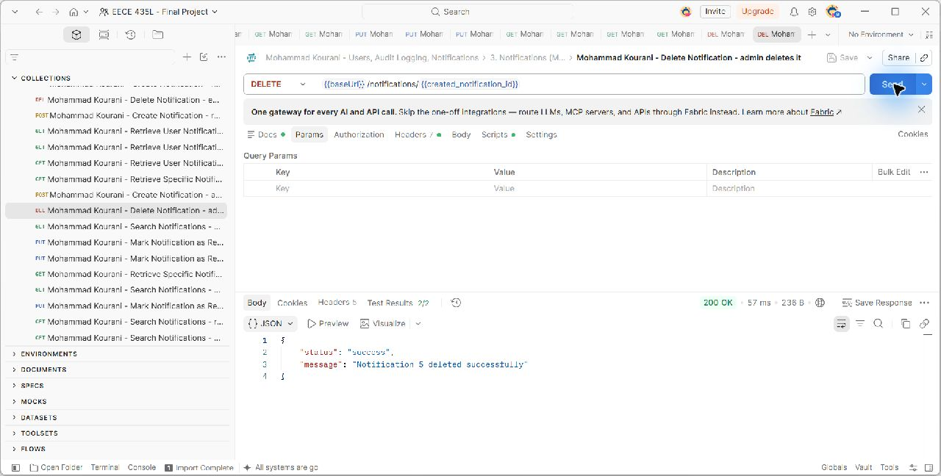
DELETE {{baseUrl}}/notifications/{{created_notification_id}}. The captured scenario checks HTTP 200; the request and actual server response are shown in the unchanged screenshot. Source: docs/evidence/MohammadKourani/notif-delete-success.png.

6 Database Design (Anthony Feghali)
Three ordered SQL scripts define the complete relational schema. Script 01 contains Mohammad Kourani's users, logs, and notifications tables. Script 02 contains Anthony Feghali's assets, threats, and vulnerabilities tables. Script 03 contains Titia Saikali's incidents, notes, playbooks, response actions, and action history. Reports are calculated from those tables and have no independent storage table.
Primary keys identify records, foreign keys prevent broken relationships, UNIQUE constraints prevent duplicate identifiers, and CHECK constraints restrict allowed states and values. SQLite foreign-key enforcement is enabled by the database integration and initializer [4]. The design diagram and dictionary below are derived from the SQL scripts; the original database screenshots show Mohammad Kourani's three tables at their capture checkpoints.

Figure 69. Anthony Feghali and Titia Saikali - Database schema
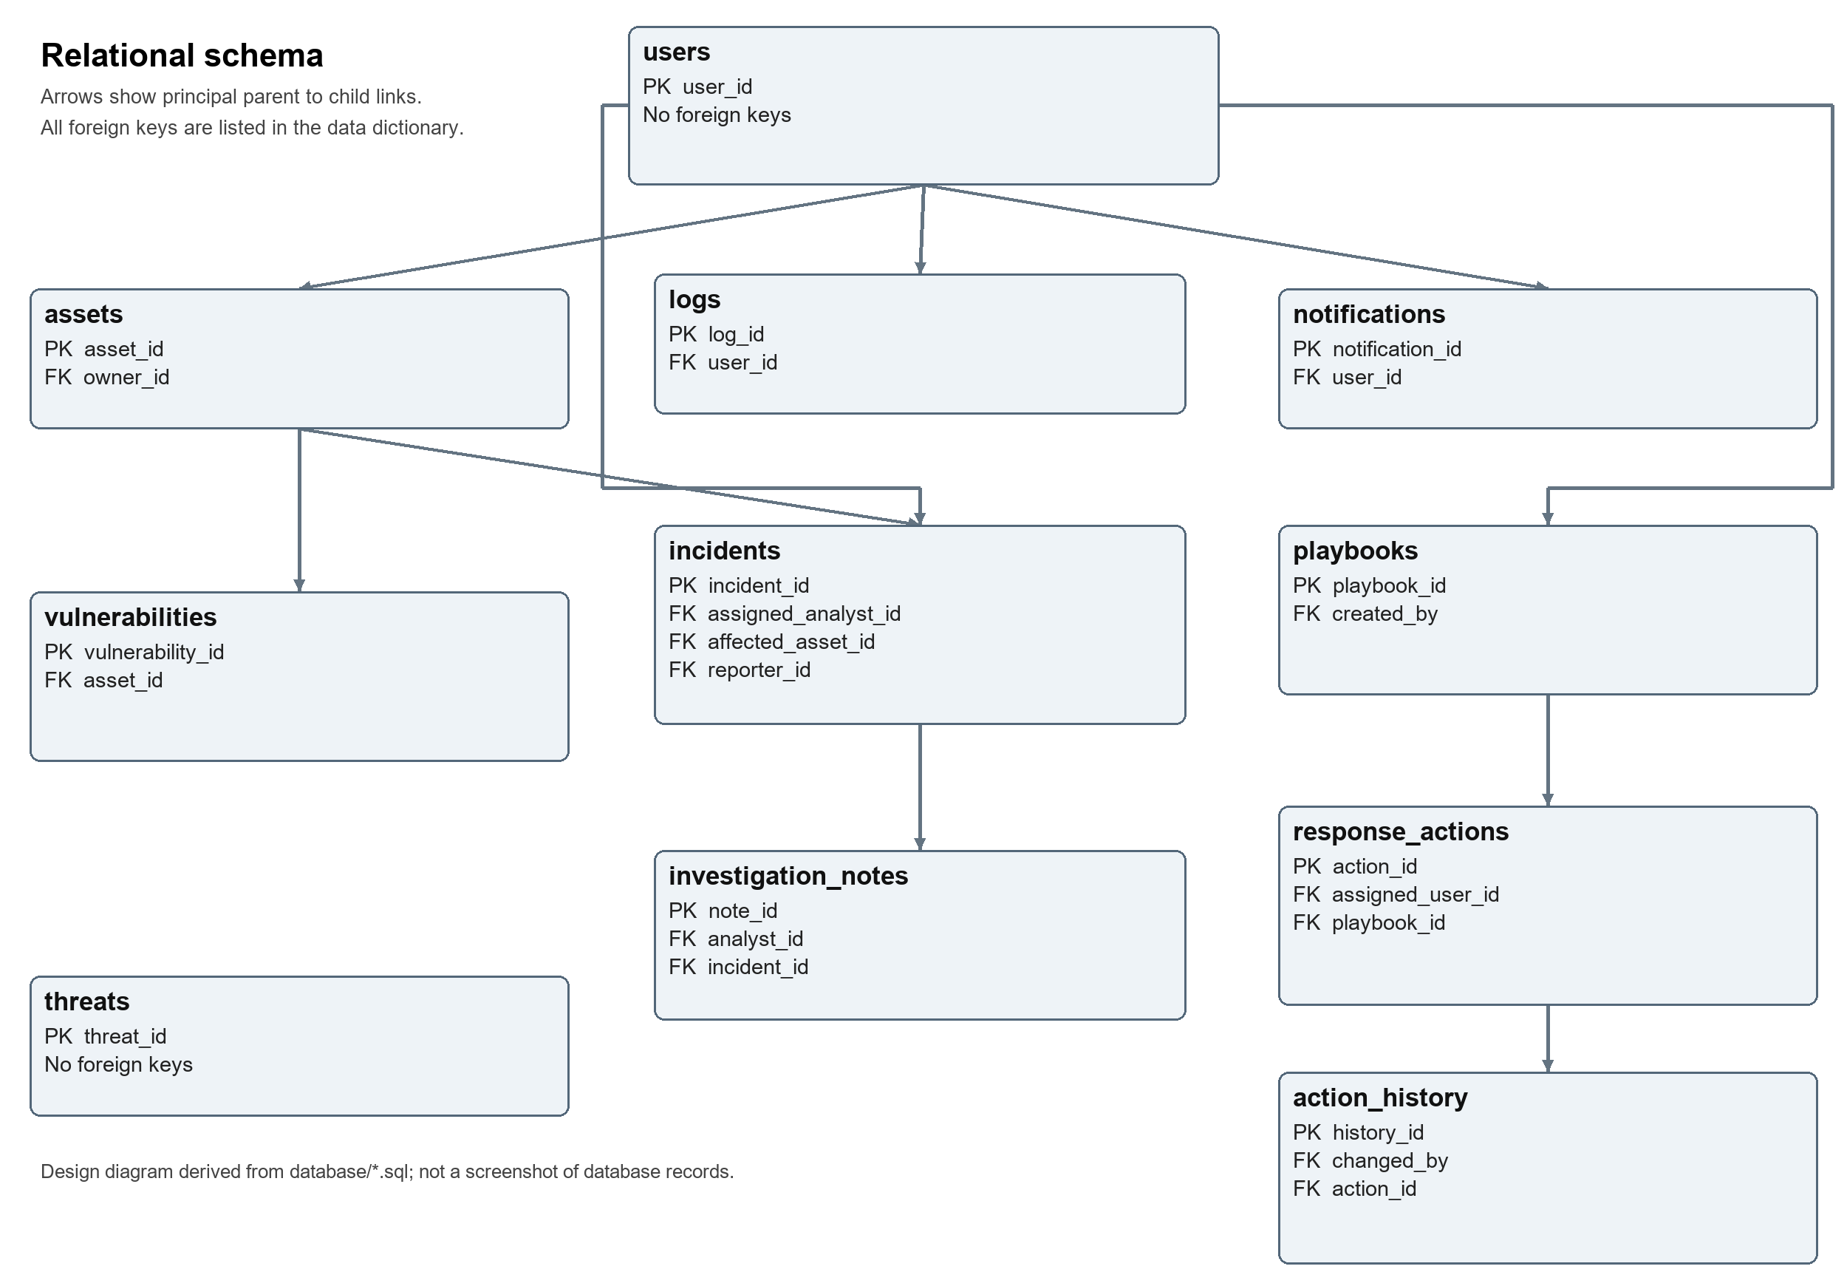
Principal parent-child relationships. Every foreign key, including the additional actor and assignee links, is specified in the following dictionary. The threats table is independent of asset and incident foreign keys.

6.1 Relationships and deletion rules
A user can own multiple assets, report multiple incidents, receive multiple notifications, and produce multiple logs. Assets may be linked to multiple vulnerabilities and incidents. An incident contains investigation notes. A playbook contains ordered response actions, and each action can have multiple history entries.
Optional actor or assignment links use SET NULL where defined; dependent records such as a user's notifications or a playbook's actions use CASCADE. Required asset ownership and linked records prevent destructive deletion. The log immutability trigger permits the narrow user_id-to-null change needed by ON DELETE SET NULL, provided the log id, action, description, timestamp, severity, and related service remain unchanged. This preserves the recorded event when its user account is deleted, while rejecting edits to its contents.
Table | Primary key | Foreign-key relationships
action_history | history_id | changed_by -> users.user_id (delete: SET NULL); action_id -> response_actions.action_id (delete: CASCADE)
assets | asset_id | owner_id -> users.user_id (delete: NO ACTION)
incidents | incident_id | assigned_analyst_id -> users.user_id (delete: SET NULL); affected_asset_id -> assets.asset_id (delete: NO ACTION); reporter_id -> users.user_id (delete: NO ACTION)
investigation_notes | note_id | analyst_id -> users.user_id (delete: NO ACTION); incident_id -> incidents.incident_id (delete: CASCADE)
logs | log_id | user_id -> users.user_id (delete: SET NULL)
notifications | notification_id | user_id -> users.user_id (delete: CASCADE)
playbooks | playbook_id | created_by -> users.user_id (delete: NO ACTION)
response_actions | action_id | assigned_user_id -> users.user_id (delete: SET NULL); playbook_id -> playbooks.playbook_id (delete: CASCADE)
threats | threat_id | None
users | user_id | None
vulnerabilities | vulnerability_id | asset_id -> assets.asset_id (delete: NO ACTION)

6.2 Data dictionary

Action History
Field | SQL type | Key and nullability
history_id | INTEGER | PK; Required primary key
action_id | INTEGER | FK -> response_actions.action_id; NOT NULL
old_status | TEXT | NOT NULL
new_status | TEXT | NOT NULL
changed_by | INTEGER | FK -> users.user_id; Nullable
changed_at | DATETIME | NOT NULL

Assets
Field | SQL type | Key and nullability
asset_id | INTEGER | PK; Required primary key
asset_name | TEXT | NOT NULL
asset_type | TEXT | NOT NULL
ip_address | TEXT | NOT NULL
operating_system | TEXT | Nullable
department | TEXT | NOT NULL
owner_id | INTEGER | FK -> users.user_id; NOT NULL
location | TEXT | Nullable
criticality | TEXT | NOT NULL
status | TEXT | NOT NULL
created_date | DATETIME | NOT NULL
updated_date | DATETIME | NOT NULL

Incidents
Field | SQL type | Key and nullability
incident_id | INTEGER | PK; Required primary key
title | TEXT | NOT NULL
description | TEXT | NOT NULL
category | TEXT | NOT NULL
severity | TEXT | NOT NULL
reporter_id | INTEGER | FK -> users.user_id; NOT NULL
affected_asset_id | INTEGER | FK -> assets.asset_id; Nullable
assigned_analyst_id | INTEGER | FK -> users.user_id; Nullable
status | TEXT | NOT NULL
created_date | DATETIME | NOT NULL
resolution_date | DATETIME | Nullable
updated_date | DATETIME | NOT NULL

Investigation Notes
Field | SQL type | Key and nullability
note_id | INTEGER | PK; Required primary key
incident_id | INTEGER | FK -> incidents.incident_id; NOT NULL
analyst_id | INTEGER | FK -> users.user_id; NOT NULL
note_content | TEXT | NOT NULL
created_timestamp | DATETIME | NOT NULL

Logs
Field | SQL type | Key and nullability
log_id | INTEGER | PK; Required primary key
user_id | INTEGER | FK -> users.user_id; Nullable
action | TEXT | NOT NULL
description | TEXT | Nullable
timestamp | DATETIME | NOT NULL
severity | TEXT | NOT NULL
related_service | TEXT | NOT NULL

Notifications
Field | SQL type | Key and nullability
notification_id | INTEGER | PK; Required primary key
user_id | INTEGER | FK -> users.user_id; NOT NULL
title | TEXT | NOT NULL
message | TEXT | NOT NULL
notification_type | TEXT | NOT NULL
severity | TEXT | NOT NULL
status | TEXT | NOT NULL
creation_date | DATETIME | NOT NULL
read_date | DATETIME | Nullable

Playbooks
Field | SQL type | Key and nullability
playbook_id | INTEGER | PK; Required primary key
name | TEXT | NOT NULL
description | TEXT | NOT NULL
incident_category | TEXT | NOT NULL
severity | TEXT | NOT NULL
created_by | INTEGER | FK -> users.user_id; NOT NULL
created_date | DATETIME | NOT NULL

Response Actions
Field | SQL type | Key and nullability
action_id | INTEGER | PK; Required primary key
playbook_id | INTEGER | FK -> playbooks.playbook_id; NOT NULL
action_description | TEXT | NOT NULL
step_number | INTEGER | NOT NULL
status | TEXT | NOT NULL
assigned_user_id | INTEGER | FK -> users.user_id; Nullable
completion_date | DATETIME | Nullable
created_date | DATETIME | NOT NULL
updated_date | DATETIME | NOT NULL

Threats
Field | SQL type | Key and nullability
threat_id | INTEGER | PK; Required primary key
threat_type | TEXT | NOT NULL
threat_value | TEXT | NOT NULL
description | TEXT | NOT NULL
severity | TEXT | NOT NULL
source | TEXT | NOT NULL
date_added | DATETIME | NOT NULL
updated_date | DATETIME | NOT NULL

Users
Field | SQL type | Key and nullability
user_id | INTEGER | PK; Required primary key
full_name | TEXT | NOT NULL
username | TEXT | NOT NULL
email | TEXT | NOT NULL
password_hash | TEXT | NOT NULL
department | TEXT | NOT NULL
role | TEXT | NOT NULL
account_status | TEXT | NOT NULL
created_date | DATETIME | NOT NULL
last_login_date | DATETIME | Nullable

Vulnerabilities
Field | SQL type | Key and nullability
vulnerability_id | INTEGER | PK; Required primary key
title | TEXT | NOT NULL
description | TEXT | NOT NULL
cve_id | TEXT | NOT NULL
cvss_score | REAL | NOT NULL
severity | TEXT | NOT NULL
asset_id | INTEGER | FK -> assets.asset_id; NOT NULL
discovery_source | TEXT | NOT NULL
status | TEXT | NOT NULL
created_date | DATETIME | NOT NULL
resolution_date | DATETIME | Nullable
updated_date | DATETIME | NOT NULL

Figure 70. Mohammad Kourani - Database structure - tables indexes and log trigger
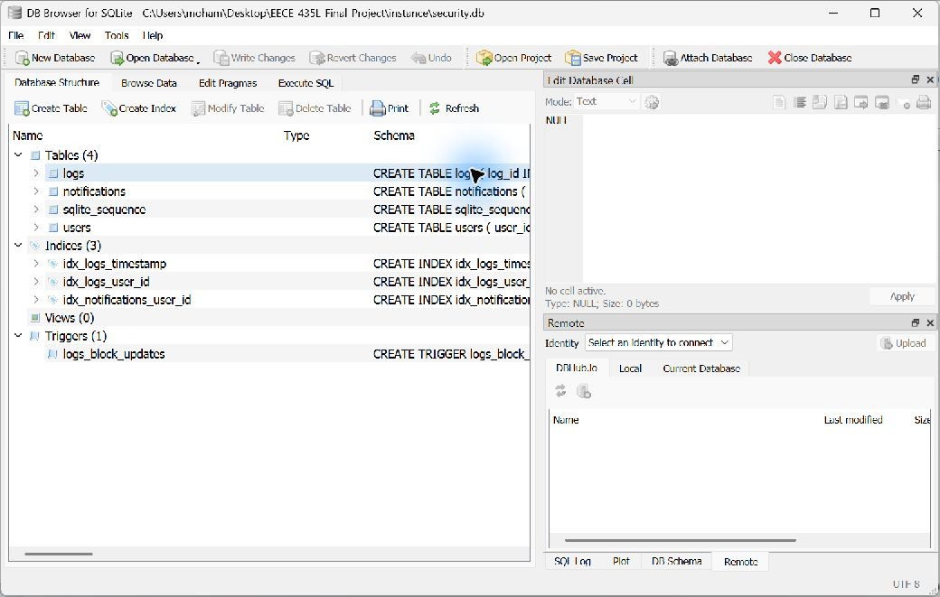
Original Database Structure view for Mohammad Kourani's users, logs, and notifications schema. Source: docs/evidence/MohammadKourani/db-structure.png.

Figure 71. Mohammad Kourani - Database - stored password hashes
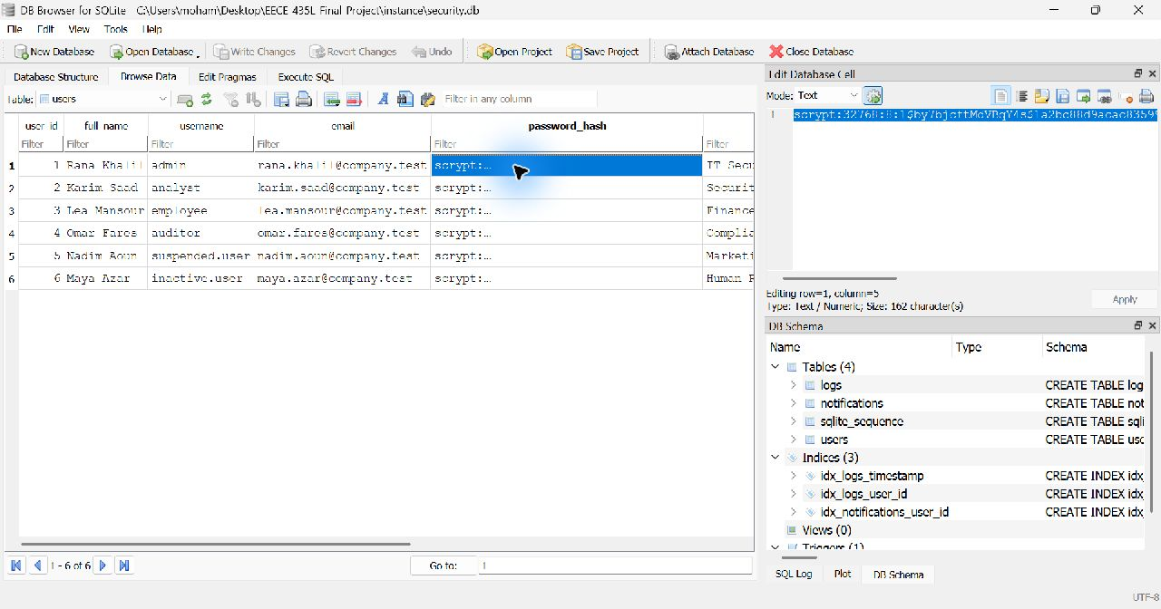
The original users table shows password_hash values rather than plain-text passwords. Source: docs/evidence/MohammadKourani/db-users.png.

7 Error Handling and Validation (Anthony Feghali)
The common validation functions require a JSON object, reject unsupported keys and missing required fields, trim text, enforce length limits, and validate choices, dates, identifiers, and email format. Services add their own business rules. SQLAlchemy binds values as query parameters instead of concatenating user input into SQL [2].
Case | Handling | Code
Missing or invalid values | ApiError explains the rejected field or rule | 400
Missing, invalid, or expired login token | Authentication gate refuses protected access | 401
Wrong role or owner | Request is refused and logged as UNAUTHORIZED_ACCESS | 403
Missing resource | Resource-specific not-found message | 404
Unsupported method | Common method-not-allowed handler | 405
Duplicate or linked-record conflict | Unique and foreign-key failures produce a conflict | 409
Unexpected server error | Rollback, server-side log, generic response without exception details | 500

The response envelope is consistent: status identifies success or error, message explains the result, and successful responses include data when applicable. The ApiError handler rolls back unsuccessful work; IntegrityError is mapped to 409. A missing record is distinguished from an existing user whose result list is empty.
Service | Representative validation
Users | Case-insensitive username uniqueness, email format, password strength, role and account status, own-profile restrictions
Logs | Allowed severity, valid date, supplied search filters, user existence, unsupported modification
Notifications | Existing recipient, valid type/severity/status, own-message access and immutable original read timestamp
Assets and threats | IP/domain/hash formats, allowed asset values, normalized duplicate threat indicators
Incidents and response | Active analyst assignment, sequential incident/action lifecycle, action order and ownership
Vulnerabilities | CVE format, CVSS 0 to 10, matching severity band, sequential lifecycle and valid resolution date

The validation evidence is embedded with the relevant service requests: invalid email (Figure 6), weak password (7), missing fields (8), and invalid log severity (30). Each figure shows the original request and rejection response near the implementation explanation.

8 API Documentation (Mohammad Kourani, Anthony Feghali, Titia Saikali)
The API base URL is http://127.0.0.1:5000. The resource paths below match the current source and original screenshots. Protected calls send Authorization: Bearer <token>; JSON bodies use Content-Type: application/json. Route docstrings identify the full student name responsible for each implementation. Names shown in Postman request titles identify the evidence owner.
Collection JSON | Owner | Requests
AnthonyFeghali.postman_collection.json | Anthony Feghali | 95
MohammadKourani.postman_collection.json | Mohammad Kourani | 67
TitiaSaikali.postman_collection.json | Titia Saikali | 97

These three exported collections are included under postman/ in the repository. They contain 259 scenario requests in total, including setup, successful operations, input errors, missing records, permission denials, and workflow checks. The execution screenshots in this report document Mohammad Kourani's 62 service requests following five Setup requests.

8.1 Team endpoint catalogue

Users and Identity (Mohammad Kourani)
Method | Endpoint | Allowed callers | Success
POST | /users/register | Anyone (as Regular Employee); Security Administrator (any role) | 201
POST | /users/login | Anyone with an Active account | 200
PUT | /users/{id} | Security Administrator (any user); Regular Employee (own account) | 200
DELETE | /users/{id} | Security Administrator | 200
GET | /users | Security Administrator, Auditor | 200
GET | /users/{username} | Security Administrator, Auditor; Regular Employee (own account) | 200

Asset Management (Anthony Feghali)
Method | Endpoint | Allowed callers | Success
POST | /assets | Security Administrator | 201
PUT | /assets/{id} | Security Administrator | 200
DELETE | /assets/{id} | Security Administrator | 200
GET | /assets | Security Administrator, Auditor | 200
GET | /assets/{id} | Security Administrator, Security Analyst, Auditor | 200
GET | /assets/search | Security Administrator, Security Analyst, Auditor | 200

Incident Management (Titia Saikali)
Method | Endpoint | Allowed callers | Success
POST | /incidents | Security Administrator, Regular Employee | 201
GET | /incidents | Security Administrator, Auditor | 200
GET | /incidents/{id} | Administrator, Analyst, Auditor; Regular Employee (own reports only) | 200
PUT | /incidents/{id}/assign | Security Administrator | 200
PUT | /incidents/{id}/status | Security Administrator; Security Analyst (incidents assigned to them) | 200
POST | /incidents/{id}/notes | Security Administrator; Security Analyst (incidents assigned to them) | 201

Threat Intelligence (Anthony Feghali)
Method | Endpoint | Allowed callers | Success
POST | /threats | Security Administrator | 201
GET | /threats | Security Administrator, Security Analyst, Auditor | 200
GET | /threats/{id} | Security Administrator, Security Analyst, Auditor | 200
GET | /threats/search | Security Administrator, Security Analyst | 200
PUT | /threats/{id} | Security Administrator | 200
DELETE | /threats/{id} | Security Administrator | 200

Security Audit Logging (Mohammad Kourani)
Method | Endpoint | Allowed callers | Success
POST | /logs | Security Administrator | 201
GET | /logs | Security Administrator, Auditor | 200
GET | /logs/{id} | Security Administrator, Auditor, Security Analyst | 200
GET | /logs/search | Security Administrator, Auditor, Security Analyst | 200
DELETE | /logs/{id} | Security Administrator | 200
GET | /logs/user/{user_id} | Security Administrator, Auditor | 200

Security Reports (Titia Saikali)
Method | Endpoint | Allowed callers | Success
GET | /reports/summary | Administrator, Auditor | 200
GET | /reports/incidents | Administrator, Auditor | 200
GET | /reports/assets | Administrator, Auditor | 200
GET | /reports/threats | Administrator, Auditor | 200
GET | /reports/vulnerabilities | Administrator, Auditor | 200
GET | /reports/activity | Administrator, Auditor | 200

Vulnerability Management (Anthony Feghali)
Method | Endpoint | Allowed callers | Success
POST | /vulnerabilities | Security Administrator | 201
GET | /vulnerabilities | Security Administrator, Security Analyst, Auditor | 200
GET | /vulnerabilities/{id} | Security Administrator, Security Analyst, Auditor | 200
PUT | /vulnerabilities/{id} | Security Administrator, Security Analyst | 200
GET | /vulnerabilities/search | Security Administrator, Security Analyst, Auditor | 200
DELETE | /vulnerabilities/{id} | Security Administrator | 200

Notifications (Mohammad Kourani)
Method | Endpoint | Allowed callers | Success
POST | /notifications | Security Administrator | 201
GET | /notifications/user/{user_id} | All roles (Analyst and Employee: own only) | 200
GET | /notifications/{id} | All roles (Analyst and Employee: own only) | 200
PUT | /notifications/{id}/read | Security Administrator; Analyst and Employee (own only) | 200
GET | /notifications/search | Security Administrator, Auditor; Analyst (own only) | 200
DELETE | /notifications/{id} | Security Administrator | 200

Playbooks and Response (Titia Saikali)
Method | Endpoint | Allowed callers | Success
POST | /playbooks | Security Administrator | 201
GET | /playbooks | Security Administrator, Security Analyst, Auditor | 200
GET | /playbooks/{id} | Security Administrator, Security Analyst, Auditor | 200
POST | /playbooks/{id}/actions | Security Administrator, Security Analyst | 201
PUT | /actions/{id}/status | Security Administrator; Security Analyst (actions assigned to them, or unassigned) | 200
DELETE | /playbooks/{id} | Security Administrator | 200

8.2 Request contracts (Mohammad Kourani)
Operation | Body or query parameters | Response and principal errors
Register | full_name, username, email, password, department, role | 201 user data without password_hash; 400 invalid input, 403 privileged self-registration, 409 duplicate
Login | password plus username or email | 200 token and user; 400 incomplete body, 401 wrong credentials, 403 inactive/suspended account
Update user | Path user id; at least one profile field; role/account_status are admin-only | 200 updated user; 400 validation, 403 owner/role, 404 missing user, 409 conflict
Delete or retrieve user | Path id for deletion or username for lookup; no JSON body | 200 success/user; 401/403 access, 404 missing user, 409 linked-record conflict on deletion
Create log | user_id, action, description, severity, related_service | 201 new log; 400 validation, 403 role, 404 missing user
Search logs | user_id, date YYYY-MM-DD, action, severity, service; filters combine | 200 count and logs; 400 invalid/missing filters; 401/403 access
Read or delete log | Path log id or user id; no JSON body | 200 record/list/deletion; 403 role, 404 missing record; PUT is 405
Create notification | user_id, title, message, notification_type, severity | 201 Unread notification; 400 invalid fields, 403 role, 404 missing recipient
Read, mark, or delete notification | Path notification id or recipient id; no JSON body for mark-read | 200 record/list/read state/deletion; 403 role or owner, 404 missing record
Search notifications | user_id, type, severity, status; analyst results are restricted to own user id | 200 count/unread/notifications; 400 invalid status/filter values, 403 role

8.3 Three worked API explanations
User registration (Figures 2 and 3): the request supplies profile information and the Regular Employee role. Validation runs before insertion, the password is hashed, a USER_CREATED event is written, and the response returns the serialized account without its password hash. The database checkpoint independently shows jad.nassar. The duplicate request returns 409, as shown in Figure 5.
Audit search (Figures 36 to 39): query parameters restrict the log result set. Combining action, severity, and date requires every filter to match. The response includes a count and an array of log records; a valid search with no matches is a successful empty list, while an invalid date returns 400.
Mark notification as read (Figures 59 and 60): the route loads the notification and checks that the actor is permitted to update it. It changes Unread to Read and sets read_date. Repeating the operation preserves the timestamp, making the state change idempotent. An auditor's update attempt is denied in Figure 62.

8.4 Request examples from the exported collection

Self registration
POST {{baseUrl}}/users/register
{
"full_name": "Jad Nassar",
"username": "jad.nassar",
"email": "jad.nassar@company.test",
"password": "Welcome@2026",
"department": "Sales",
"role": "Regular Employee"
}

Manual log creation
POST {{baseUrl}}/logs
{
"user_id": 2,
"action": "MANUAL_REVIEW",
"description": "Quarterly access review completed for analyst accounts",
"severity": "Information",
"related_service": "Users"
}

Notification creation
POST {{baseUrl}}/notifications
{
"user_id": 3,
"title": "Password expiry",
"message": "Your password expires in 3 days. Please change it.",
"notification_type": "System Notification",
"severity": "Medium"
}
These are request examples from the collection, not newly generated execution outputs. The exact observed responses appear in the corresponding embedded screenshots.

9 Authentication and Authorization (Mohammad Kourani)
A successful login verifies the supplied password with Werkzeug's password-checking function and returns a signed HS256 JSON Web Token. Its claims include the user id, role, issued-at time, and expiry. The default lifetime is eight hours. The server signs and verifies tokens with a private configured key; the report does not include that key [3, 5].
For every protected route, roles_required() validates the Bearer token and then reloads the user from the database. The current account must still exist and remain Active, and its current role must be allowed. Ownership checks then restrict employees' profiles and notifications and analysts' assigned work. This database lookup means changes to a role or account status affect future requests even before an existing token expires.
Role | Authority | Important restrictions
Security Administrator | User and operational management; report generation; notification and audit administration | Self-deletion/demotion/deactivation checks; linked-record constraints still apply
Security Analyst | Investigation and permitted asset/threat/vulnerability/playbook operations; own alerts | No user management; no destructive administrator operations; assigned-record and ownership checks
Regular Employee | Self-registration, own profile, incident reporting, own notifications | No organizational assets, threats, vulnerabilities, audit logs, reports, or playbooks
Auditor | Permitted read operations and report generation | Cannot create, modify, delete, change roles, or mark notifications read

The endpoint catalogue records the precise allowed callers for each operation. Authentication and authorization are separate: missing or invalid authentication returns 401; a valid identity that lacks access returns 403. Every authorization rejection invokes the audit logger.
Evidence | Observed scenario | Figure
Successful login | Active account receives a token with HTTP 200 | 10
Failed login | Wrong password is rejected with HTTP 401 | 11
Blocked account | Suspended account is rejected with HTTP 403 | 12
Insufficient permission | Employee requests all users and receives HTTP 403 | 21
Correct permission | Administrator requests the same users list and receives HTTP 200 | 19
Missing token | Protected call without a Bearer token receives HTTP 401 | 22

Passwords are stored using salted scrypt hashes. Verification uses the parameters and salt encoded in the stored hash; the application does not compare a newly generated random-salt hash by string equality. The API never serializes password_hash. Figure 71 shows the database column containing hashes.

10 GitHub and Version Control (Titia Saikali)
Repository: https://github.com/mhmdko/MohammadKourani-AnthonyFeghali-TitiaSaikali-435L
The project uses separate service directories and SQL scripts so each member can develop three services without replacing another member's implementation. The repository records commits by Mohammad Kourani (Git author mhmdko), Anthony Feghali, and Titia Saikali. The table below transcribes actual Git metadata at source version 0071594.
Commit | Date | Author | Recorded change
0071594 | 2026-10-20 | Titia Saikali | Added Postman collection, architecture diagrams, schema updates, README sections, and evidence checklist
f03c628 | 2026-10-20 | Titia Saikali | Implemented security reports service using data from all services
3b0cbdf | 2026-10-20 | Titia Saikali | Implemented playbooks and response actions with ordered steps and execution history
90073f8 | 2026-10-20 | Titia Saikali | Implemented incident management service with assignment, lifecycle, and investigation notes
2959b6f | 2026-10-19 | Anthony Feghali | Added Postman collection, database schema diagram, README sections, and evidence checklist
d7881d8 | 2026-10-19 | Anthony Feghali | Implemented vulnerability management service with CVSS checks and status lifecycle
cce6666 | 2026-10-19 | Anthony Feghali | Implemented threat intelligence service with duplicate prevention and analyst alerts
e721c20 | 2026-10-19 | Anthony Feghali | Implemented asset management service with validation and database script
a7f135b | 2026-10-19 | mhmdko | Added evidence screenshots for users, audit logging, and notifications
dd9fd91 | 2026-10-18 | mhmdko | Added Titia Saikali's full name to README
1976746 | 2026-10-18 | mhmdko | Added Flask app setup, configuration, and shared authentication and validation modules
65ebe36 | 2026-10-18 | mhmdko | Added Postman collection, README, and evidence checklist
ee0cbe8 | 2026-10-18 | mhmdko | Implemented notifications service
fcfd9dc | 2026-10-18 | mhmdko | Implemented security audit logging service
dd9e70a | 2026-10-18 | mhmdko | Implemented users and identity service with login and role checks
2322ddc | 2026-10-18 | mhmdko | Set up Flask project structure, configuration, and shared modules
9a75a9a | 2026-10-15 | Titia Saikali | Add Titia services
7452ba1 | 2026-10-15 | Anthony Feghali | Add service plans for Assets, Vulnerabilities, and Threat Intelligence
2d435ef | 2026-10-14 | mhmdko | Add service plans for Users, Audit Logging, and Notifications

10.1 Contribution attribution
Member | Implementation | Documentation and shared work
Mohammad Kourani | Services 1, 5, 8 | Shared setup/authentication/validation, SQL 01, Mohammad collection and 71 evidence PNG files
Anthony Feghali | Services 2, 4, 7 | Network validation, SQL 02, Anthony collection, database schema documentation
Titia Saikali | Services 3, 6, 9 | SQL 03, Titia collection, architecture diagrams and incident/playbook schema documentation

The .gitignore excludes .env, local database files, virtual environments, and exported Postman environments. Reproducibility comes from the source, requirements.txt, ordered SQL scripts, and exported collection JSON files. The report does not include private environment values or fabricate commit activity.

11 References (Titia Saikali)
[1] Pallets Projects. Flask documentation, Modular Applications with Blueprints. https://flask.palletsprojects.com/en/stable/blueprints/
[2] Pallets Projects. Flask-SQLAlchemy documentation. https://flask-sqlalchemy.palletsprojects.com/en/stable/
[3] PyJWT. Usage Examples. https://pyjwt.readthedocs.io/en/stable/usage.html
[4] SQLite. Foreign Key Support and CREATE TRIGGER. https://www.sqlite.org/foreignkeys.html and https://www.sqlite.org/lang_createtrigger.html
[5] Pallets Projects. Werkzeug security utilities. https://werkzeug.palletsprojects.com/en/stable/utils/#module-werkzeug.security
[6] Postman. Collection documentation. https://learning.postman.com/docs/collections/collections-overview/
[7] AUB EECE 435L. Final Project Fall 2026-2027 Sprint 1 assignment handout.
[8] Project source, SQL scripts, service READMEs, Postman collections, architecture.md, database-schema.md, and original evidence at Git commit 0071594. https://github.com/mhmdko/MohammadKourani-AnthonyFeghali-TitiaSaikali-435L

11.1 AI assistance disclosure
The repository credits Claude (Anthropic) for initial assistance with Mohammad Kourani's implementation and documentation, and Claude and Codex (OpenAI) for assistance with Anthony Feghali's and Titia Saikali's services, collections, testing, and design documentation. Codex also assisted with organizing this report, checking the source, creating design diagrams from the schema, and embedding the existing screenshots. No API responses, database records, screenshots, or Git activity were generated to stand in for real execution evidence.

11.2 Evidence provenance
The source folder contains 71 PNG files representing 69 distinct screenshots. auth-correct.png duplicates get-all-users.png, and notif-mark-read-db-before.png duplicates notif-db-records.png. Each distinct screenshot is embedded once in this report with a caption naming Mohammad Kourani and explaining the API operation or database checkpoint. Image content is preserved; the document scales images only for page layout.
All figures labelled as Postman or database execution are the original local-system captures. The two design diagrams are explanatory illustrations derived from the source, rather than screenshots of running output.

