EECE 503M - Software Security
Lab 3 - Broken Access Control and Command Injection
Meridian Service Desk
Mohammad Kourani
Prof. Khaled Dassouki - American University of Beirut
October 2026
Fixed code repository: https://github.com/mhmdko/EECE-503M---Lab-3---Mohammad-Kourani

Overview
This lab has two halves that meet at the end. Part A is about who is allowed to do what: Meridian scopes each agent to their own queues, gates an admin tool, and protects its forms, and each of those controls has a hole. Part B is about what the server runs: the ticket export builds a shell command out of a value the user supplies. The finale chains them, using an access-control hole to reach the export and command injection to turn it into a shell.
All testing was done through Burp Suite, driving requests from Repeater, against the local instance (127.0.0.1:5001). I signed in as the support agent rmasri, who is scoped to the Customer Support queue only.

Part A - Broken Access Control

A1 - IDOR across the queue boundary
The ticket view checks only the id in the URL, not whether the signed-in agent is allowed the ticket's queue. As rmasri (Customer Support only) I requested tickets outside my queue just by changing the number:
/tickets/4/ and /tickets/5/
Both opened. Ticket 4 ("Invoice 4471 charged twice") and ticket 5 ("Need a VAT receipt for March") are both in the Billing queue, assigned to tokafor, yet I could read their full billing detail. Two different Billing tickets reading cleanly shows the flaw is systematic, not a one-off. The id is the only thing between an agent and any record, and ids are guessable.
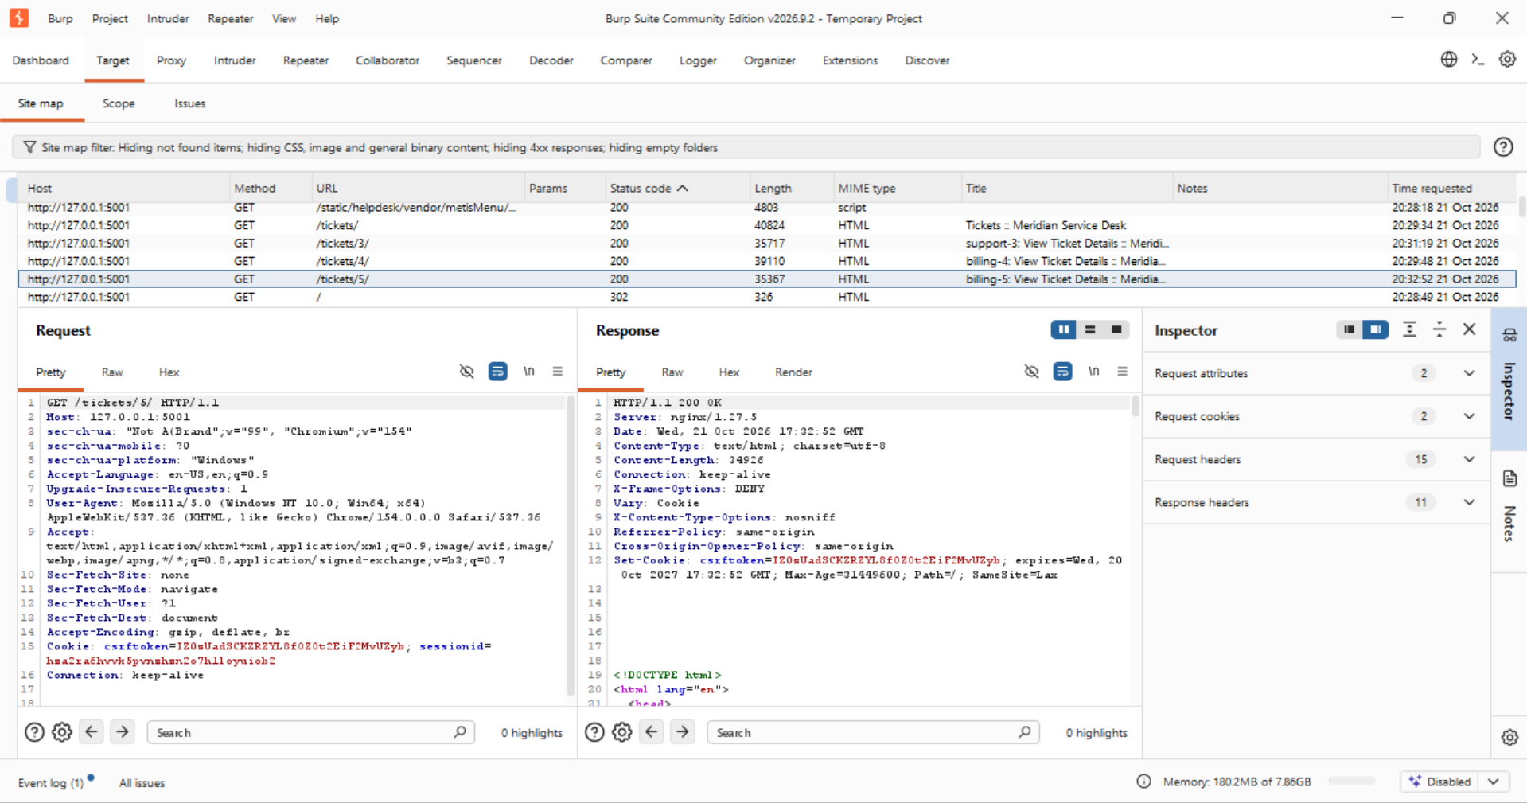
Figure 1. Burp site map: /tickets/3/, /tickets/4/ (billing-4) and /tickets/5/ (billing-5) all return 200 to the support agent.
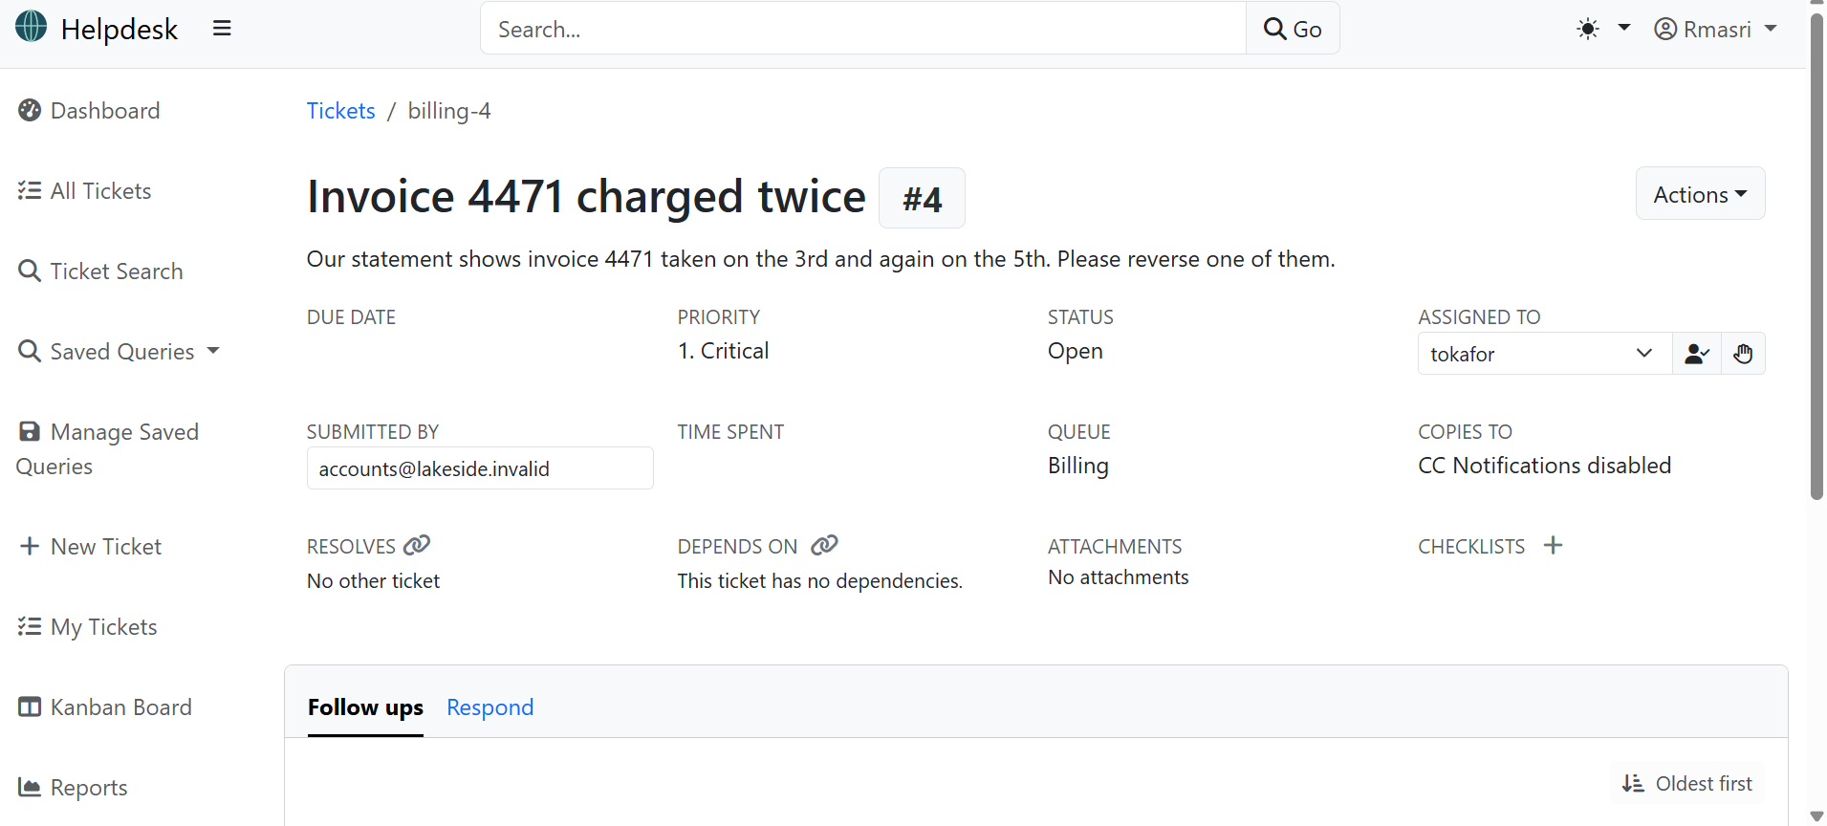
Figure 2. Ticket 4 opened as rmasri: a Billing-queue record the support agent has no permission to see.

A2 - Vertical privilege escalation
The admin tool at /admin-tools/promote/ grants a user administrator rights. It checks that the caller is signed-in staff, but not that the caller is an administrator, so any agent can call it. As rmasri I promoted another account:
/admin-tools/promote/?user=tokafor
The response confirmed the account is now a superuser. Pointing the same call at ?user=rmasri would hand the agent the keys to their own account.
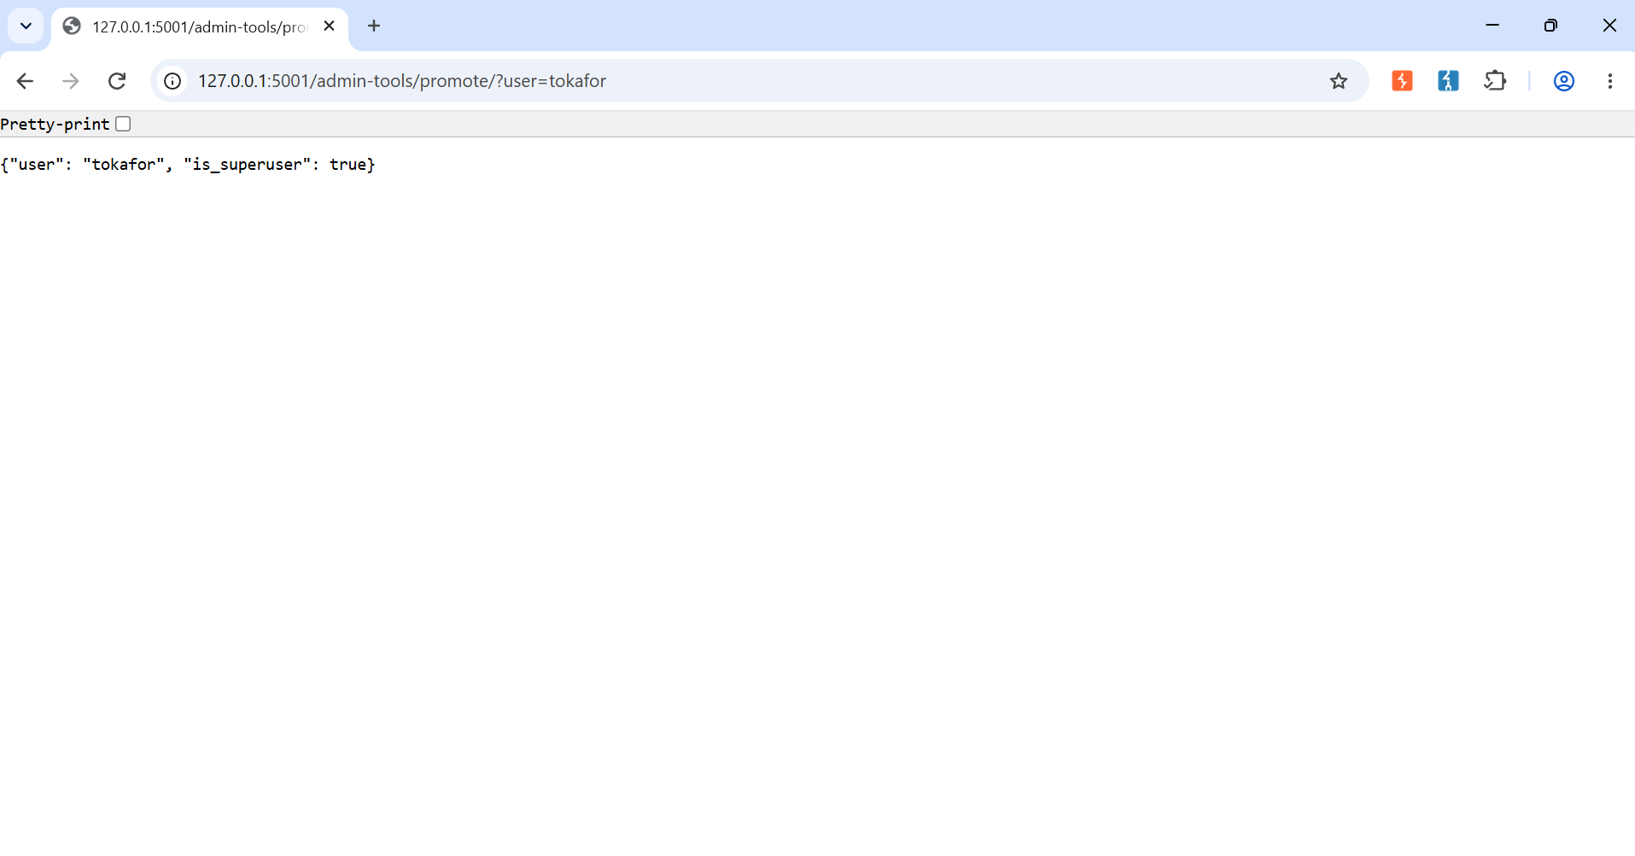
Figure 3. The promote tool returns {"user": "tokafor", "is_superuser": true} to a plain support agent.
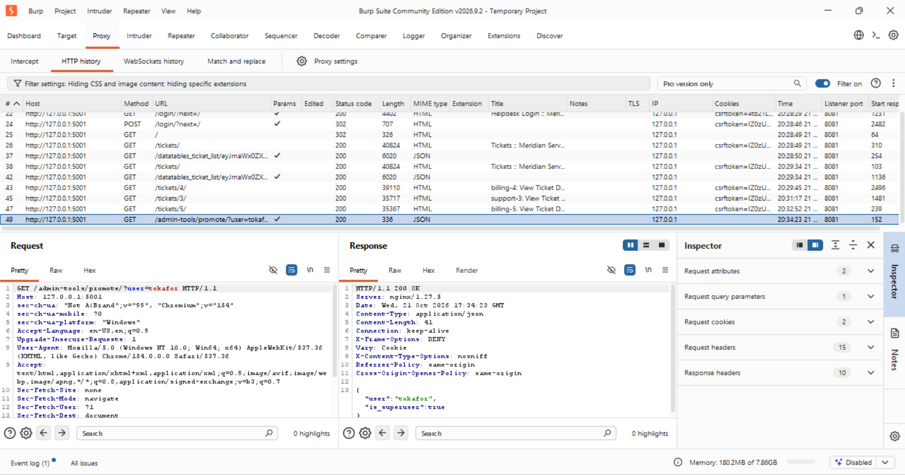
Figure 4. The same request captured in Burp: 200 OK, application/json, is_superuser true.

A3 - Cross-site request forgery (CSRF)
The "change my e-mail" action accepts a POST with no CSRF token. I crafted the request in Repeater with no csrfmiddlewaretoken in the body and no Referer or Origin header, keeping only the logged-in session cookie (as a victim's browser would have):
POST /profile/email/ body: email=attacker@evil.invalid
It succeeded. A properly protected Django form would reject this with 403 CSRF verification failed. Because the view is decorated @csrf_exempt, any page a logged-in victim visits could silently submit this and change their email.
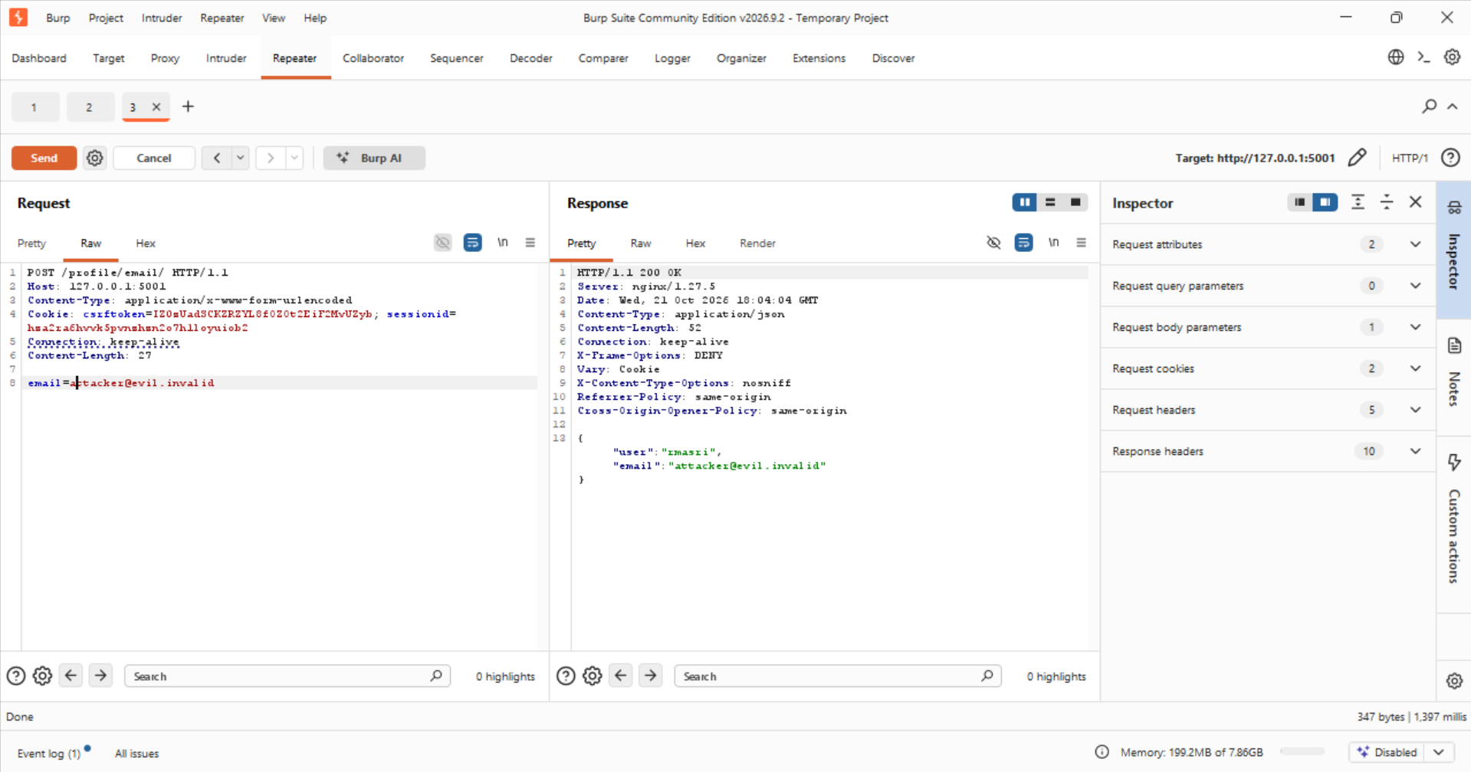
Figure 5. The tokenless POST is accepted: 200 OK with {"user": "rmasri", "email": "attacker@evil.invalid"}.

Part B - Command Injection
The export at /tickets/<id>/export/ takes a label and builds a shell command around it, then runs it with subprocess and shell=True. The label lands in the middle of this string, so shell metacharacters in the label execute as commands. The export appends .txt right after the label, so a trailing # (shell comment) is used to discard it, and the payload is URL-encoded so the shell characters survive the request.

B5 - Chain a command with a semicolon
The shell treats ; as "then run this". Label x; id # (URL-encoded):
/tickets/2/export/?label=x%3B+id+%23
The response returned uid=0(root) gid=0(root) groups=0(root). The injected id executed on the server, and notably as root, so every command runs with full privileges.
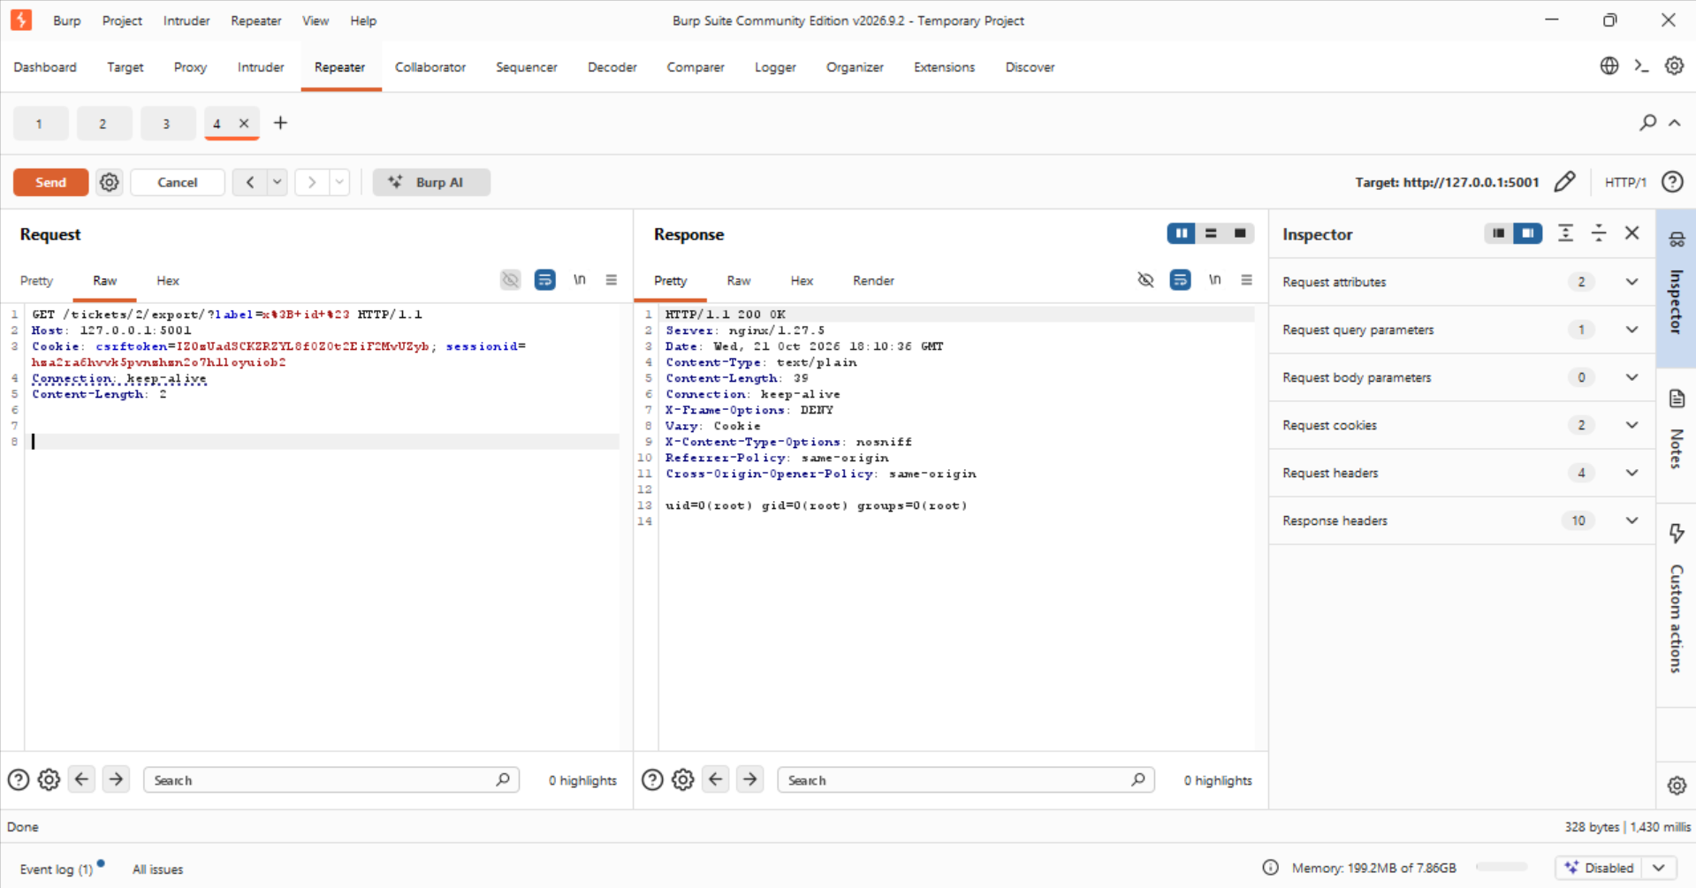
Figure 6. Command injection via semicolon: the export response contains uid=0(root).

B6 - Confirm with a second separator
Repeating with && ("run the next command if the first succeeded") gives the same result, proving a real shell is interpreting the label rather than one lucky character:
/tickets/2/export/?label=x+%26%26+id+%23
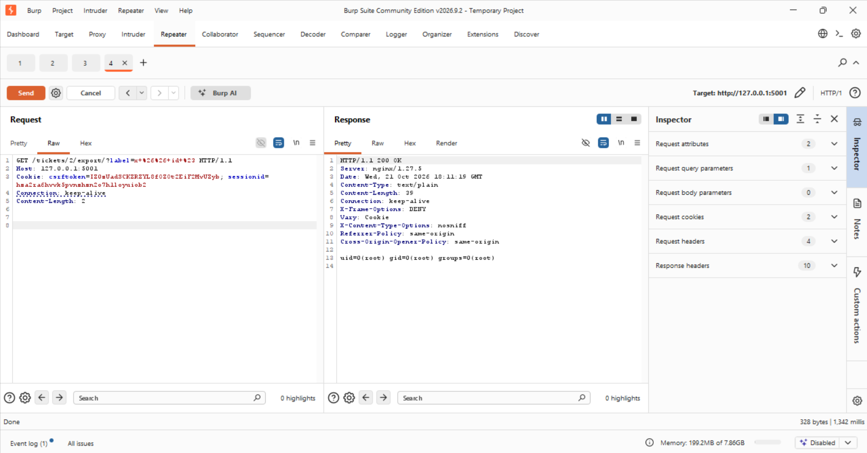
Figure 7. Same result with the && separator: uid=0(root).

B7 - Read a file to show impact
Reading a server file through the export demonstrates real impact (kept to a harmless read):
/tickets/2/export/?label=x%3B+cat+/etc/passwd+%23
The response returned the contents of /etc/passwd. Running as root, an attacker could read any file on the server.
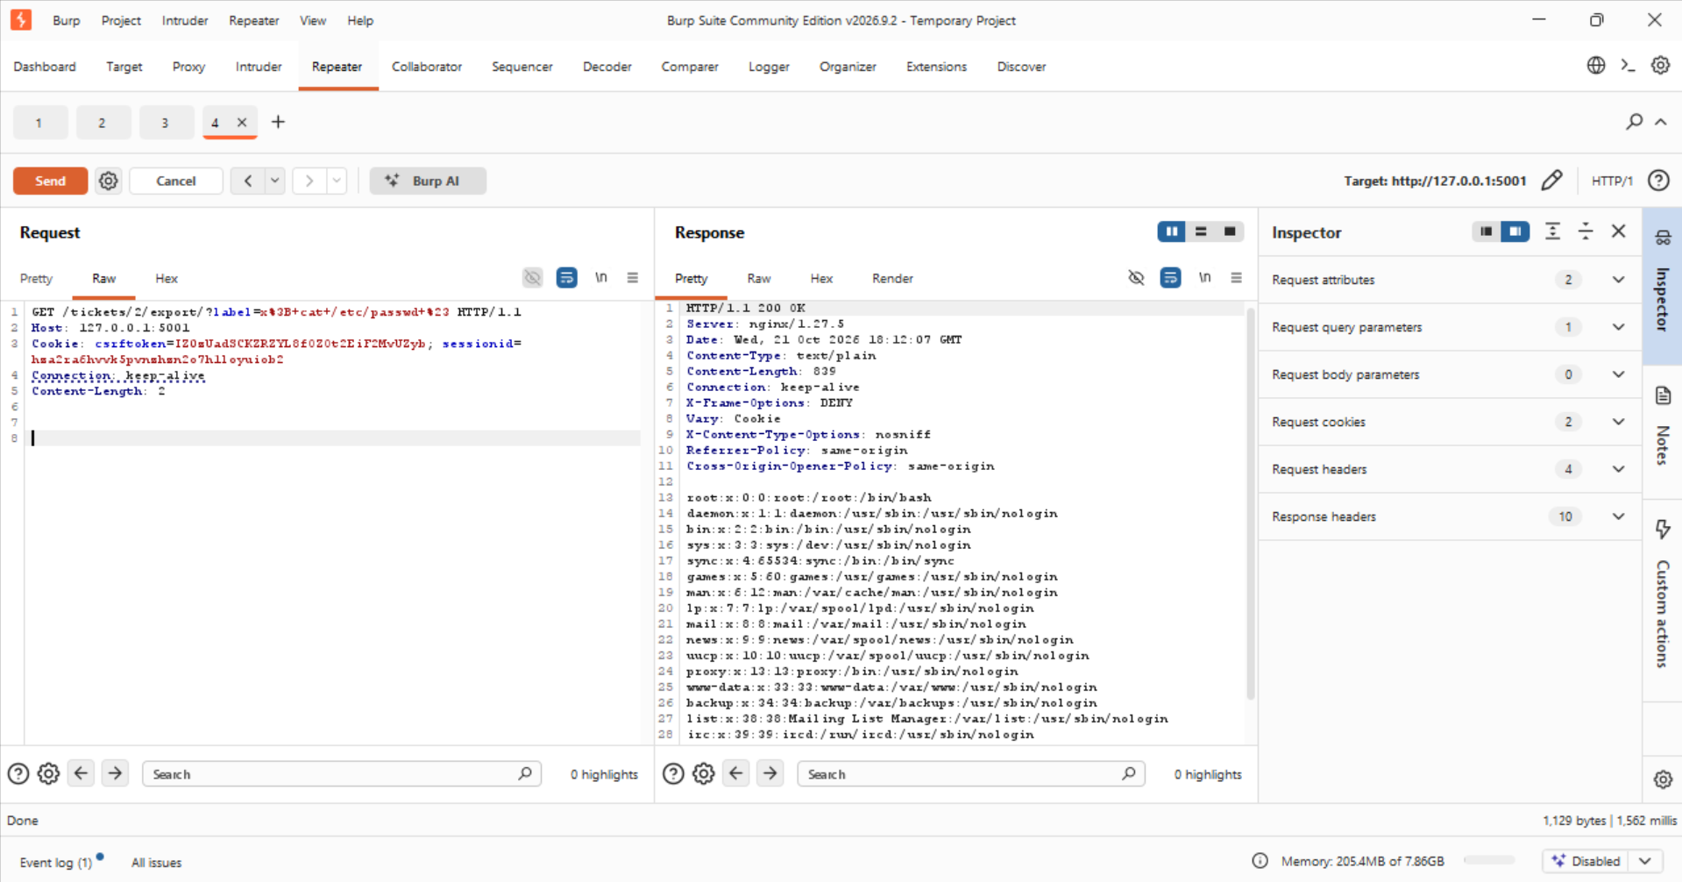
Figure 8. /etc/passwd read through the export's command injection.

Finale - Chaining the two
A support agent has no business exporting a Billing ticket, let alone running a command through it. Part A showed the export's object check is missing; Part B showed the label is a shell. Aiming the injection at a ticket outside my queue combines both in one request:
/tickets/4/export/?label=x%3B+id+%23
Ticket 4 is a Billing ticket outside rmasri's queue, and the response is uid=0(root). In a single request I crossed the queue boundary (broken access control) and executed a command as root behind it (command injection). One weak control let me reach a surface I should never have reached; the other let me abuse it. This is how real breaches read: not one flaw, but a path built from several.
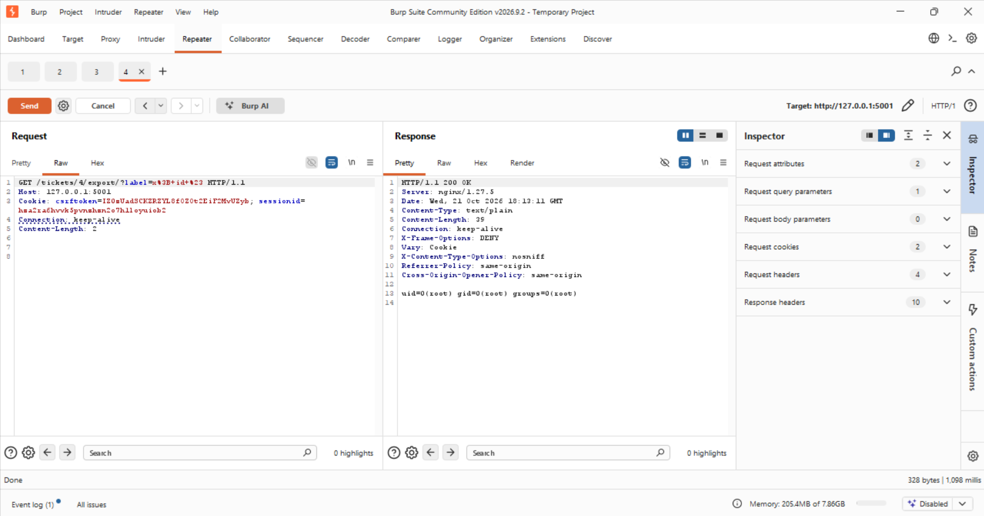
Figure 9. The chained attack: export of out-of-queue ticket 4 returns uid=0(root).

Remediation
All four holes live in src/helpdesk/views/staff.py. The fixed file is in the linked repository. Each fix and its verification follows.

Fix 1 - Access-control object check (closes A1 and the finale)
Added the application's own permission helper to both the ticket view and the export, so an agent can only see or export a ticket in a queue they are allowed:
def view_ticket(request, ticket_id):
ticket = get_object_or_404(Ticket, id=ticket_id)
ticket_perm_check(request, ticket) # added
...

def export_ticket(request, ticket_id):
ticket = get_object_or_404(Ticket, id=ticket_id)
ticket_perm_check(request, ticket) # added
Verification: as rmasri, /tickets/4/ now returns 403 Forbidden instead of the Billing record.
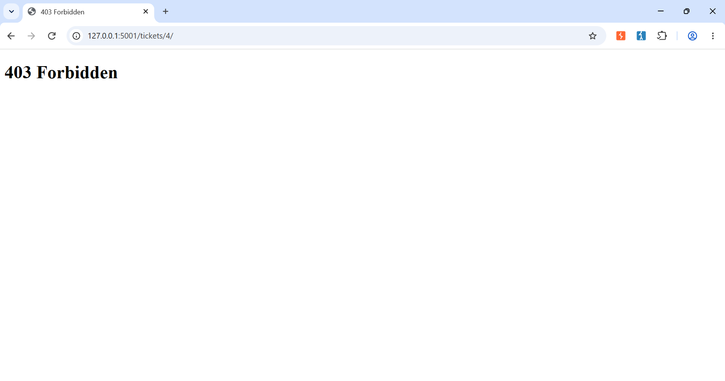
Figure 10. After the fix: ticket 4 returns 403 Forbidden to the support agent.

Fix 2 - Require administrator rights (closes A2)
Changed the promote view to require an administrator, not merely staff, by swapping its decorator to @helpdesk_superuser_required.
Verification: as rmasri, the promote call is refused (it redirects to login rather than returning the is_superuser success JSON). The account is not promoted.
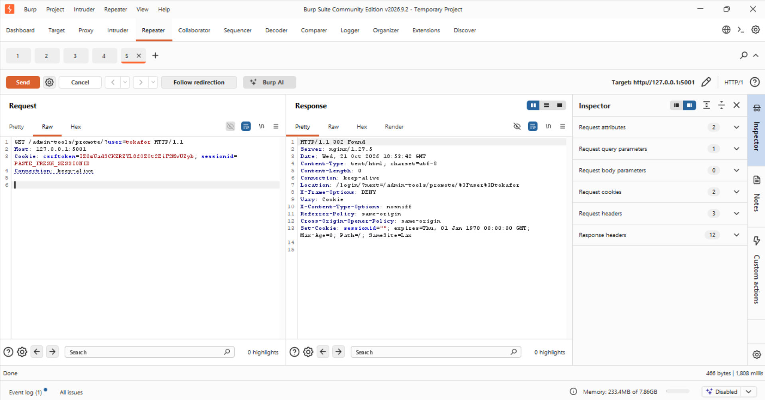
Figure 11. After the fix: the promote request is refused for a non-admin (302 to login, no success JSON).

Fix 3 - Restore CSRF protection (closes A3)
Removed the @csrf_exempt decorator from change_email so Django's token protection applies again.
Verification: the tokenless POST now returns 403 Forbidden.
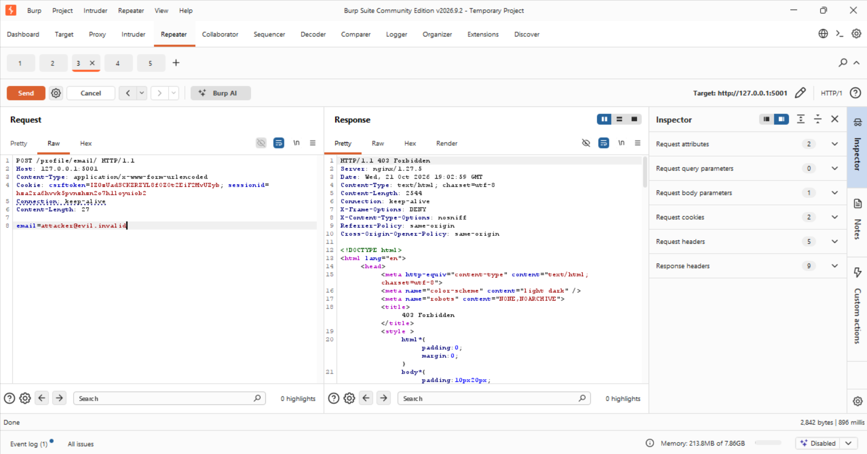
Figure 12. After the fix: the tokenless POST to /profile/email/ returns 403 Forbidden.

Fix 4 - No shell string in the export (closes Part B)
The export no longer builds a shell command. The label is stripped to a safe character set, and the file is written with plain Python (os.makedirs and open), with no subprocess and no shell, so the label can never be parsed as a command:
safe_label = re.sub(r"[^A-Za-z0-9_-]", "", label)
name = f"ticket-{ticket_id}" + (f"-{safe_label}" if safe_label else "")
os.makedirs(export_dir, exist_ok=True)
with open(out_path, "w") as handle:
handle.write(body)
Verification: the injection payload now returns the normal export text and never uid=.
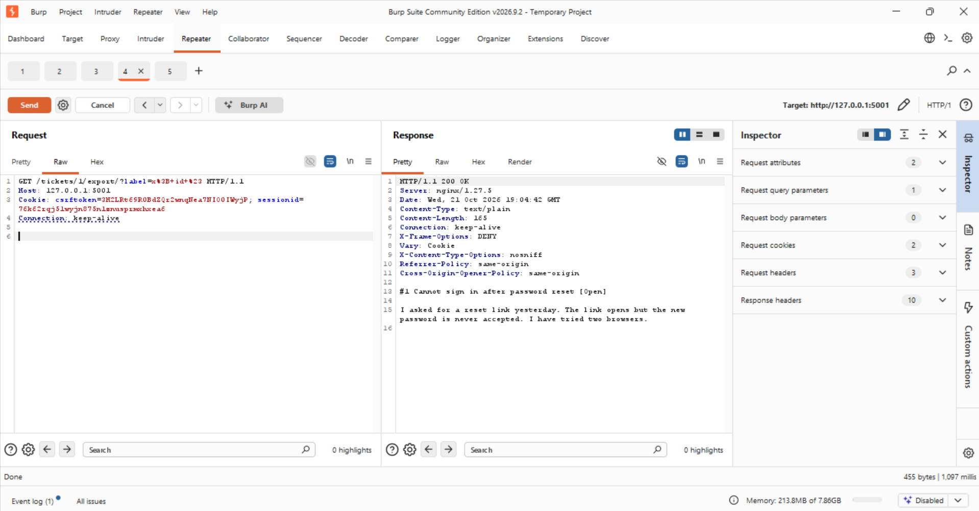
Figure 13. After the fix: /tickets/1/export/?label=x; id # returns the normal ticket text, with no uid= output.

Summary
Every attack from the lab now fails: ticket 4 is denied to rmasri, the promote tool refuses a non-admin, the tokenless POST is rejected, and the export label produces a file or a permission error but never the output of a command. The four fixes address broken object-level access control, missing function-level authorization, missing CSRF protection, and OS command injection respectively.

