

**Report: Water Scarcity in Lebanon**

**Scarcity to Abundance**

GNE301 – Professional Communication

Presented to: Professor Rachelle Askar

Presented on: Monday, 22 July 2024.

Presented by:

Maroun Eid

Mohammed Marchud

Jana Rima

Lynn Audi

Elie Charbel

Abstract

This report investigates the severe issue of water scarcity in Lebanon, emphasizing its primary causes, such as inadequate infrastructure, refugee influx, and environmental degradation, alongside its important societal impacts. Through a survey conducted at the Lebanese American University, it assesses the accessibility and quality of water, showing differences in water availability and increased health risks. The findings highlight an urgent need for infrastructural rehabilitation, stricter regulatory measures, and capacity building. Recommended solutions aim to render the water supply more stable and improve public health, ensuring a sustainable future for Lebanon's water resources.

Table of Contents

Introduction 3

Literature Review 4

Causes of Water Scarcity 5

Impacts of Water Scarcity 6

Methods 8

Results 9

Discussion 13

Conclusion 16

Solutions 16

Recommendations 17

References 17

List of Figures and Tables

Figure 1 – Percentage of respondents experiencing water shortages. 10

Figure 2 - Primary source of water of the respondents. 10

Figure 3 – Most effective solutions to address water scarcity in Lebanon. 11

Figure 4 - Effect of rise in refugees’ number on water scarcity. 11

Figure 5 - Increase in water related expenses. 12

Figure 6 - Impact of water scarcity and poor water quality on public health. 12

# Introduction

In November 2002, the Committee on Economic, Social and Cultural Rights adopted General Comment No. 15 on the right to water. Article I.1 states that: “The human right to water is indispensable for leading a life in human dignity. It is a prerequisite for the realization of other human rights.” This shows that the importance of water extends beyond just consumption and hygiene; it is also crucial for agricultural, health care, economic stability, and environmental sustainability. Although water scarcity in Lebanon was not pervasive until 2019, the problem started in 2010 due to many factors including the rise of refugee’s number which led to population growth, in addition to the significant increase in temperature caused by climate change. Moreover, industrial waste and agricultural runoff has intensified pollution therefore contaminating freshwater resources, all of which intensified the problem of water scarcity in Lebanon. Insufficient rainfall amounts, overuse of groundwater resources, poor maintenance of infrastructure combined with the economic crisis have all led to the escalation of this problem in 2019. This escalation created a significant water loss before it could even reach the citizens, which has weakened the water system and made it more fragile. Water scarcity harm agriculture and threatens food security, while contaminated water and unsafe water raise public health concerns. The lack of investments in water infrastructure and the government’s ineffective enforcement in water management laws have worsen the problem more putting Lebanon on a potential collapse in the water systems. This study primarily focuses on identifying the main causes and effects of water scarcity in Lebanon. It examines the effect of water scarcity on multiple sectors including agriculture, health, economy, and environment. In addition to presenting several solutions and recommendations to prevent the intensification of the problem in Lebanon.

# Literature Review

## Causes of Water Scarcity

Previous studies on Lebanese water scarcity have thoroughly examined its underlying causes. The aging water infrastructure, which causes continuous water loss, is at the center of the problem (UNICEF, 2021; Middle East Institute, 2022). For instance, the Middle East Institute (2022) estimated that the highest contributor to water scarcity is the infrastructure, where 40% of the water is lost before it reaches consumers due to poor maintenance since the civil war. Moreover, the influx of refugees exacerbates the issue and puts an extra burden on the already damaged infrastructure (Middle East Institute, 2022). In addition to these infrastructure issues, water scarcity is further intensified by the agricultural sector. According to Nouri et al. (2019), agriculture accounts for 92% of the global water consumption. Similarly, this sector is the largest consumer of water in Lebanon; with 85% of the water resources being allocated to irrigation and other agricultural services (Haddad et al., 2020). The region relies on traditional and ineffective irrigation techniques which drains the economic resources (Haddad et al., 2020). The overuse of water due to such inefficient practices and inadequate water management intensifies the problem of water scarcity in Lebanon (Nouri et al., 2019). Furthermore, water pollution, which makes it even harder to efficiently and sustainably benefit from Lebanon's vast resources, is a major contributor to water scarcity. Industrial discharge, agricultural runoff, and untreated sewage have contaminated many of the country's water sources, rendering them unsuitable for consumption or irrigation (Khatib et al., 2023). Pollution not only reduces the available clean water but also poses serious health risks to the population. Hence, previous studies have agreed that infrastructure challenges and agricultural practices have all led to the scarcity of water in Lebanon.

## Impacts of Water Scarcity

Previous studies on water scarcity in Lebanon have tackled the effects of this problem on public health, affordability of water, agriculture, and environment.

The UNICEF report on the water crisis in Lebanon emphasizes on the serious effect of water scarcity on public health. The failure of the water infrastructure in Lebanon coupled with the economic crisis and energy absences has negatively affected the population’s access to clean water. Families in Lebanon are relying on unsafe water sources, which might lead to the spread of diseases including waterborne diseases and cholera. Children under the age of five suffer from such illnesses as it remains one of the leading causes of their death. In addition, females are having difficulties to maintain personal hygiene due to the lack of access to adequate sanitation facilities.

The article “(Un)Affordability of Informal Water Systems: Disparities in a Comparative Case Study in Beirut, Lebanon” emphasizes on the costs and affordability of water in Beirut, Lebanon. Considering the water shortages in Beirut, accessibility to affordable and equitable water remains a challenge (Choueiri et al., 2022). The authors further state that households of low income in Beirut spend approximately 6% of their income on water which is more than the global average of 3% to 5%. Water is considered unaffordable for the entire population of Lebanon; however, lower income families might be the most affected by the prices of such services (Choueiri et al., 2022).

Research highlights that water scarcity in Lebanon has been a great issue affecting agriculture. Water scarcity in Lebanon has limited the access of water for crop irrigation which negatively affected their growth affecting the growing season (Yared, 2023). Furthermore, Yared (2023) mentions that the lack of water worsened the financial status of the farmers, limiting their purchase of seeds and equipment and resulting in food insecurity. Due to this shortage, Yared (2023) reveals that some farmers were forced to find alternative resources of water which has led to its overextraction, further complicating the situation of scarcity. Not only has water scarcity directly affected the crop production, but it has also indirectly affected it through having insufficient water for farm animals which need to be constantly hydrated, leading to the negative impact on livestock farming (Yared, 2023).

Additionally, water scarcity in Lebanon has affected the environment in general. The insufficiency of water has affected the daily household chores, according to Updated National Water Sector Strategy 2020 (n.d.). This scarcity has also led to the increase in pollution of water resources, which played a role in supplying poor water quality to the environment and reduction of clean water supply (“Updated National Water Sector Strategy 2020,” n.d.). However, one of the most dangerous concerns remains the outbreak of waterborne diseases, for as mentioned by Updated National Water Sector Strategy 2020 (n.d.), water scarcity has led to the distribution and use of unclean water causing many illnesses, with the highlight being the Cholera outbreak, where 65% of the population had no access to clean and well-managed water.

Therefore, researchers have agreed on the impacts of water scarcity in Lebanon on the economical, agricultural, environmental, and health sectors.

Previous research presents multiple gaps and limitations. The articles didn’t tackle the impacts of the economic crisis on water scarcity in Lebanon. Furthermore, Choueiri et al., (2022) mainly focused on the effects of water scarcity on the economic sector in Beirut city.

# Methods

The aim of this study is to collect data to acknowledge the issue Lebanon faces due to water scarcity to find solutions to this problem. The survey conducted aims to gather information about the current situation of water in Lebanon, to learn more about the situation of each participant regarding their water use and issues if there are any.

The current study was conducted at the Lebanese American University in Byblos, where a quantitative Google Sheets questionnaire composed of 15 questions was answered by a total of 49 participants. The questionnaire featured 12 multiple choice questions, 2 scale questions, and one yes or no question.

Participants were asked to answer the questionnaire. Through this, the questionnaire collected data about the availability of water, probable causes of its scarcity, its results on the Lebanese community through each participant’s current conditions, which assisted in better understanding the imposed issue. This survey also tried to suggest some solutions and recommendations, as each participant answered closed-ended questions about the possible ways to solve this problem. So, in brief, the survey covered the following aspects:

* Availability of water in the area
* Accessibility and costs of water in the area
* Effective solutions for water scarcity
* Effects of water scarcity on economic, social and health aspects

# Results

The survey focused on identifying the causes and consequences of water scarcity and propose potential solutions.

The first question addressed the water shortage problem, 33.3% stated that they suffer sometimes from shortages in their area and 17.8% experience shortages always.

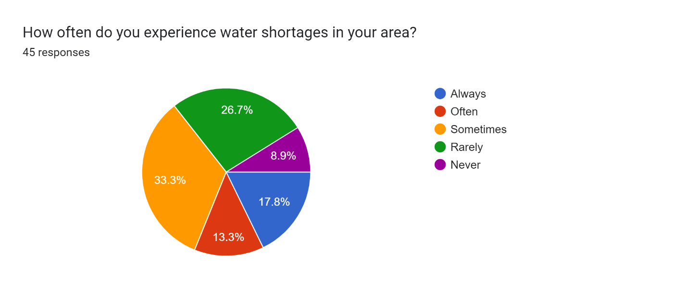

Figure 1 – Percentage of respondents experiencing water shortages.

The survey revealed that 37.8% of respondents depend on public water supply as a primary source of water in their homes.

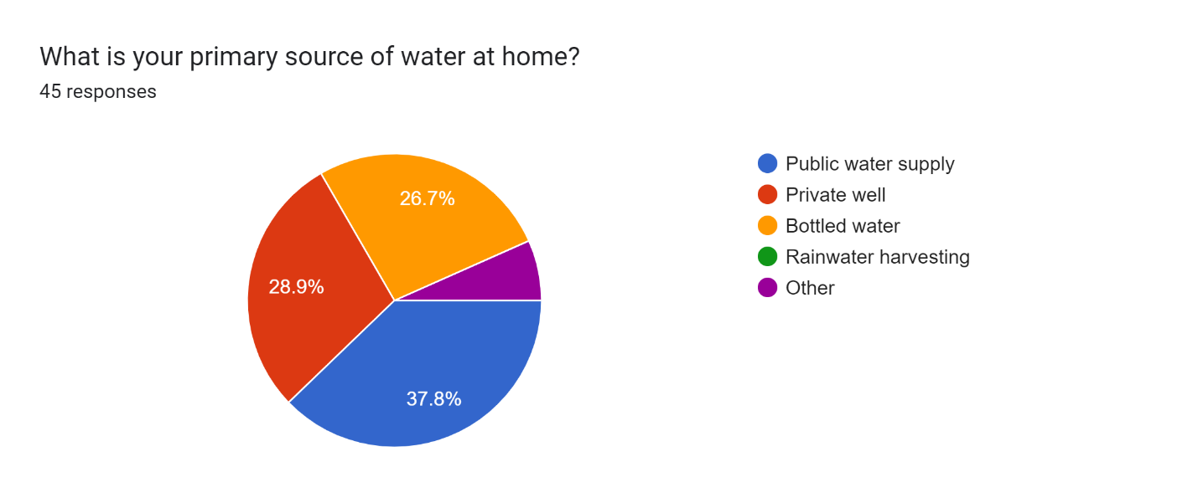

Figure 2 - Primary source of water of the respondents.

When asked about solutions, most respondents (68.9%) agree that improving the infrastructure and investing in water recycling technologies would be most effective in addressing water scarcity in Lebanon. Many responders (48.9%) believe that enforcing water conservation policies would be helpful as well.

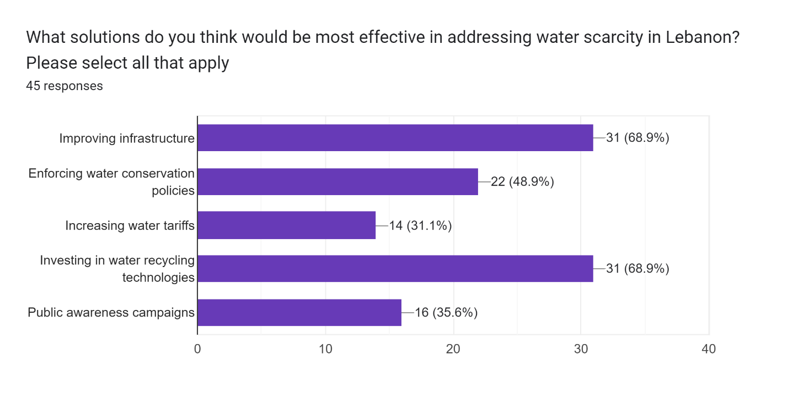

Figure 3 – Most effective solutions to address water scarcity in Lebanon.

As for the causes of this problem, 48.9% believe that the influx of refugees has significantly increased water scarcity in Lebanon, whereas 35.6% claim that it has moderately intensified the problem. However, only 4.4% believe that refugees have not impacted the situation of water scarcity at all.

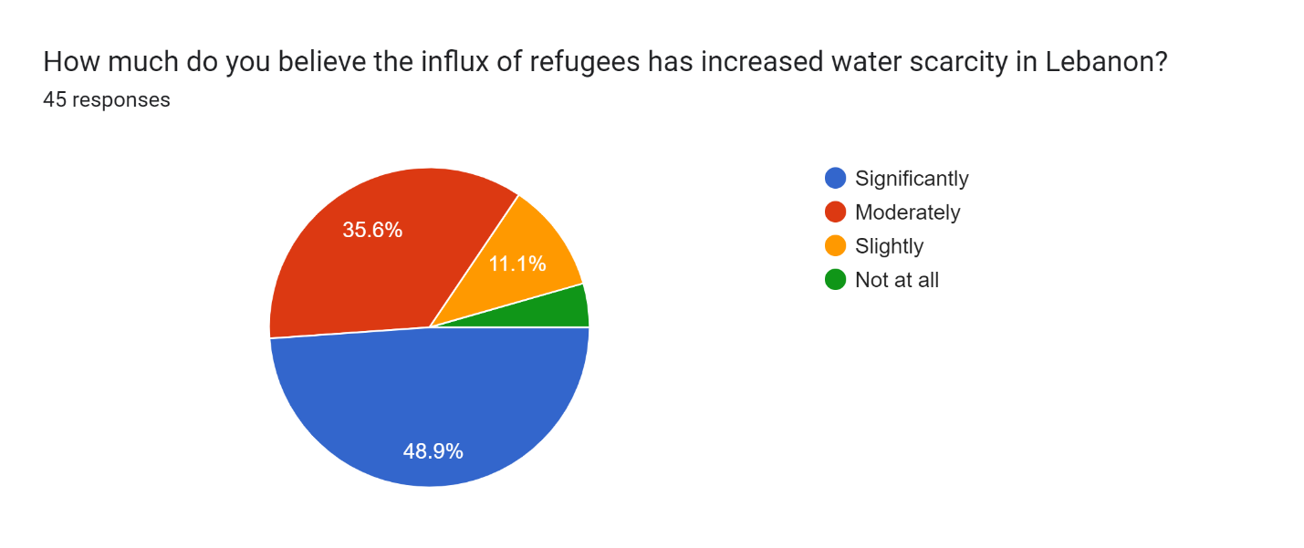

Figure 4 - Effect of rise in refugees’ number on water scarcity.

Moreover, a majority of 46.7% and 22.2% noticed a significant and moderate increase (respectively) in water-related expenses during summer due to scarcity.

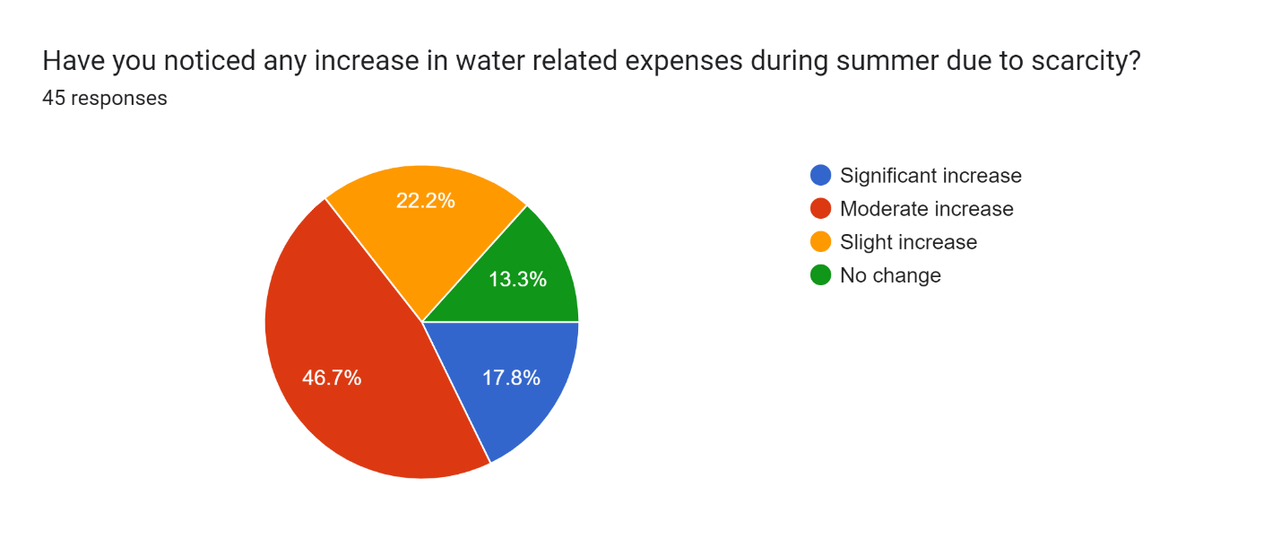

Figure 5 - Increase in water related expenses.

Regarding the impacts of water scarcity on health, 35.6% of respondents claim that they have experienced or have a family member that experienced health issues related to water scarcity or poor water quality.

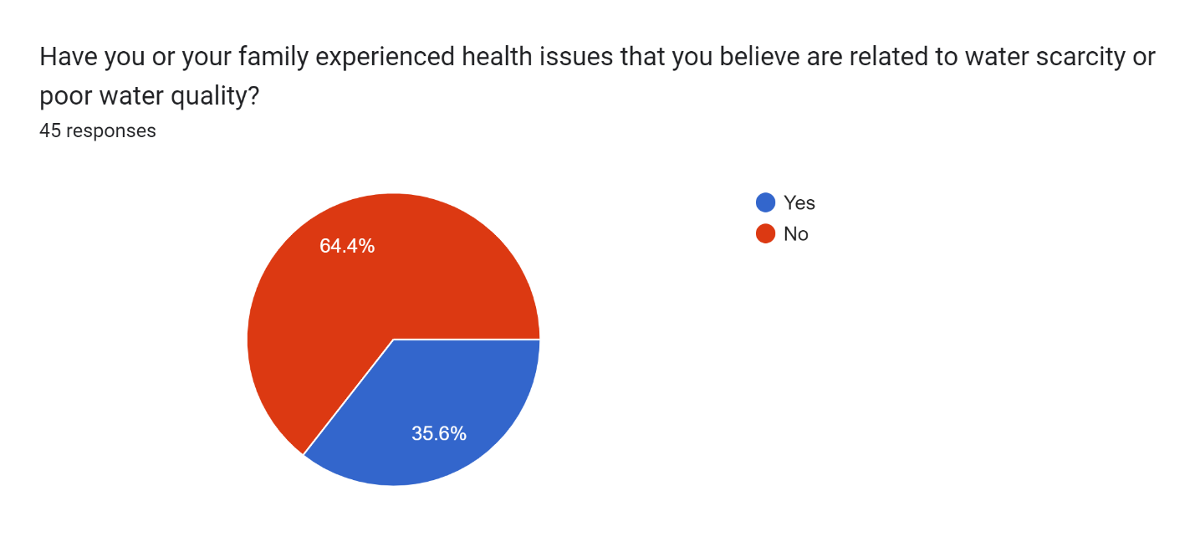

Figure 6 - Impact of water scarcity and poor water quality on public health.

# Discussion

The first question in the survey aimed to gather data on the frequency of water shortages. The wide distribution of responses indicates a variability in water scarcity among respondents. Knowing that the sampled students reside in different regions, this most reasonably suggests that different regions experience scarcity in varying degrees, depending on the local efforts to secure water in the absence of governmental action. This inference is supported by the answers to the question regarding student’s primary source of water, where private wells, bottled water, and other sources outweighed the reliance on public water supply, confirming the role of local efforts in securing water. These findings are in accord with Choueiri *et al.* (2022) which state that in areas where formal piped water supply is inadequate in either quantity or quality, informal water sources usually supply the remaining demands, although being more expensive.  
Another factor challenging water security is affordability. Variations also show in expenses, highlighting the diverse economic strain on the wide range of economic classes. Alarming expenses above 150USD show up in the responses, far exceeding the 3% of income threshold set by the UNDP. Also, as mentioned in Fayssal *et al. (2024)* water supply to the household declines during the summer, which explains the reported increase in water related expenses during summer by 83.2% of respondents. The additional expenditure most possibly channels towards informal sources such as those mentioned previously, and households may need to adapt strategies to cope with seasonal increases, both on the economic and domestic level.

According to Yared, Gregory B. (2023) public education is necessary to protect Lebanon’s water infrastructure for the future, and it must focus on water conservation. Participants’ responses underline a lack of awareness on the importance of saving water, as well as the effectiveness of water metering. On a scale of 1 to 5, the higher portion of participants (68.9%) lied in the range 1 to 3, when asked how informed they were about water management and conservation strategies. Most respondents (68.9%) described metering as “somewhat effective,” undermining the important role it plays in increasing revenue, decreasing supply scarcity, and providing better water to more people. (Yared, Gregory B., 2023). This lack of awareness is reflected in the lack of engagement regarding policy changes advocating water metering implementation and suggests a need in water education among the Lebanese. However, a promising propensity to invest in water-saving technologies (48.9% reported being “somewhat willing” and 28.9% “very willing”) could translate in a high adoption rate of water-saving technologies when provided. The willingness of respondents to invest in water-saving technologies may be affected by financial constraints, made worse by the economic crisis, but can still be leveraged to design campaigns and incentives encouraging investments in such technologies.

The majority belief in the potential for social conflicts due to water scarcity (73.3%) emphasizes the severity of the issue and the need to engage communities in water management, to relief the risks of conflicts. The potential for conflict escalates, as the refugee influx strains on the water resources of the country and amplifies impacts on accessibility and affordability of water sources (Choueiri *et al.,* 2022). 48.9% and 35.6% of respondents considered the refugee influx respectively “significantly” and “moderately” contributing to increased water scarcity. The perception of refugees as competitors for resources is likely to increase internal tensions and influence public opinion and policy.

Moreover, when asked which solutions were most effective in combatting water scarcity, the vast majority chose improving infrastructure, in addition to investing in water recycling technologies. In support of these choices, a survey by Fayssal *et al.* (2024) covering the past 5 years and 150 municipalities, showed that 25.3% of the municipal budget is allocated to issues related to the operation and maintenance of water resources and infrastructure. This indicates and confirms the importance of infrastructure in alleviating water scarcity. Other solutions such as public awareness campaigns seem equally relevant after the conclusions reached previously in this discussion. Finally, the need for quick action to resolve the water scarcity crisis in Lebanon is clear from the responses of the survey, and the solutions provided were approved by most respondents.

# Conclusion

## Solutions

In conclusion, the mismanagement of water, poor infrastructure, and lack of awareness have led to an alarming increase in water scarcity. The detrimental effects of water scarcity in Lebanon necessitate immediate solutions and actions to address them, which are:

1. Repairing leaks in the existing water distribution system to prevent water loss.
2. Implementing strict regulations on excessive water usage in agriculture, and penalizing those who exceed set limits.
3. Implementing water metering systems in households and increasing tariffs when consumption exceeds a certain threshold.
4. Enforcing water-efficient practices in all industries to effectively reduce overall water consumption.

If implemented, these solutions will ensure that Lebanon's water scarcity problem is addressed, leading to a more sustainable future.

## Recommendations

1. Assigning necessary funds and resources for water infrastructure projects.
2. Collaborating to share information, resources, and efficient strategies.
3. Encouraging farmers to adopt sustainable methods of irrigation and other practices.
4. Funding research and development of advanced technologies on managing and preserving water resources.
5. Renewing plans based on latest data, research, and technological innovations.

Applying these recommendations might help Lebanon transition from water scarcity to abundance, safeguarding a sustainable and secure water future for its residents.

# References

Choueiri, Y., Lund, J., London, J. K., & Spang, E. S. (2022). (Un)Affordability of informal water

systems: Disparities in a comparative case study in Beirut, Lebanon. *Water*, *14*(17), 2713. <https://doi.org/10.3390/w14172713>

Fayssal, N., Tawil, L. A., Danageuzian, H., Sabat, M., ElMerehbi, H., Darazi, D., Sabat, M.,

Roukos, R., Dargham, S. A., & Romanos, J. (2024). Navigating the water–energy nexus amidst the Lebanese economic crisis. *Aqua*. <https://doi.org/10.2166/aqua.2024.329>

Human right to water and sanitation | International Decade for Action “Water for Life” 2005-

2015. (n.d.). <https://www.un.org/waterforlifedecade/human_right_to_water.shtml#:~:text=Water%2C%20and%20water%20facilities%20and,per%20cent%20of%20household%20income>.

Khatib, M., Daoud, M., WahibArairo, Saba, M., &Mortada, H. (2023). Evaluation of water quality in the South of Lebanon: Case study. Water Air and Soil Pollution, 234(7). <https://doi.org/10.1007/s11270-023-06453-y>

Middle East Institute. (2022). Amid Lebanon’s perfect storm of crises, water demands attention. Middle East Institute.

<https://www.mei.edu/publications/amid-lebanons-perfect-storm-crises-water-demands-attention>

UNICEF. (2021). Water supply systems on the verge of collapse in Lebanon: over 71 per cent of people risk losing access to water. UNICEF.

<https://www.unicef.org/press-releases/water-supply-systems-verge-collapse-lebanon-over-71-cent-people-risk-losing-access>

UNICEF Lebanon. (2021). *Water crisis in Lebanon, July 2021*. UNICEF Lebanon. Retrieved from <https://www.unicef.org/lebanon/media/6711/file/UNICEF_Lebanon_Water_Crisis_July_2021_EN.pdf>

Yared, Gregory B., "Water Scarcity in Lebanon: The Edge Of Collapse" (2023). Student Theses

2015-Present. 144.

<https://research.library.fordham.edu/environ_2015/144>

Appendix

Questionnaire

https://forms.gle/gwcJXx1mwyoyB66v7

Results

