Bhasha institute spell checker Testing Report

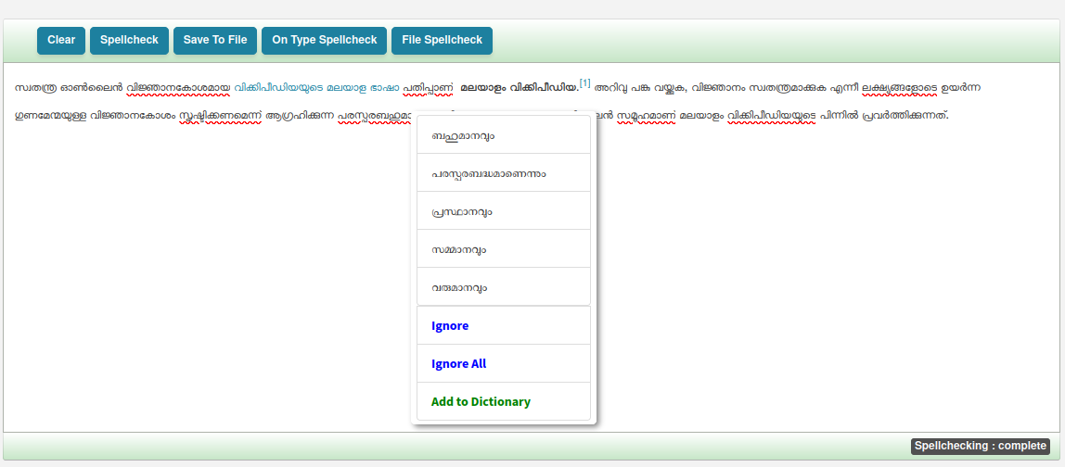
1)

