### **Application based on Vehicle-to-Cloud (V2C)**

**Concept:**

Vehicle-to-cloud (V2C) communication is a wireless technology that allows vehicles to communicate with the cloud. This means that vehicles can send and receive data with remote servers, such as those owned by automakers, insurance companies, or navigation providers.

V2C communication is enabled by a variety of technologies, including cellular networks, Wi-Fi hotspots, and Dedicated V2C. Once connected, vehicles can send and receive data in real time. This data can include vehicle diagnostics, performance data, location data, and driver behavior data.

V2C communication can be used for a variety of purposes, including:

* Over-the-air (OTA) software updates: V2C communication can be used to deliver software updates to vehicles without the need to take them to a dealership. This can help to improve vehicle safety and performance.

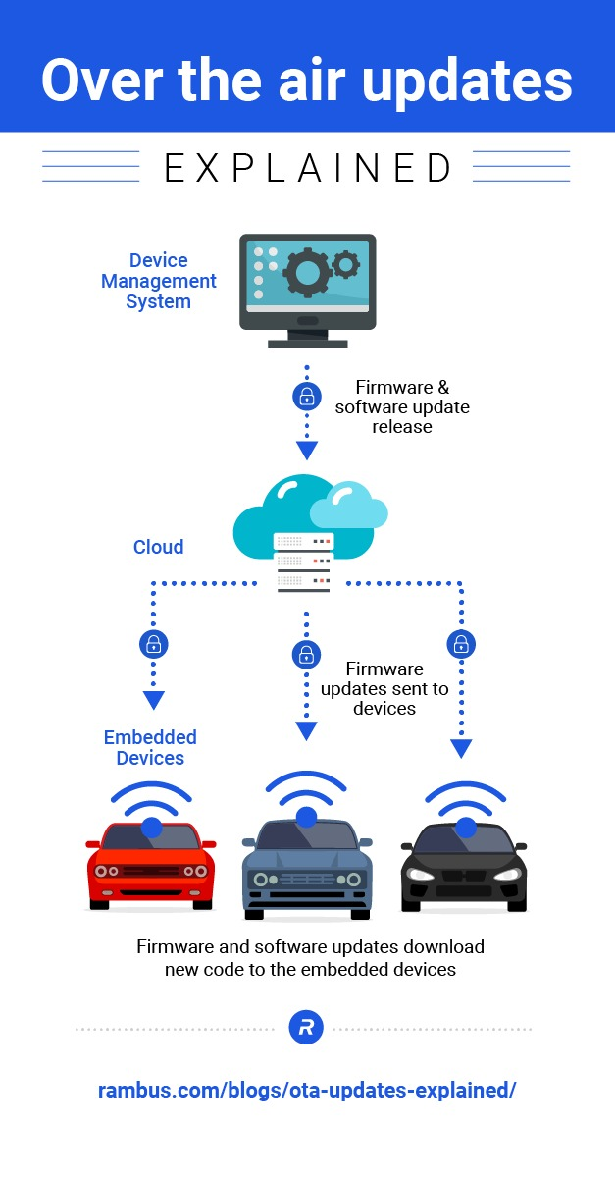

* Remote diagnostics: V2C communication can be used to diagnose vehicle problems remotely. This can help to reduce the time and cost of vehicle repairs.

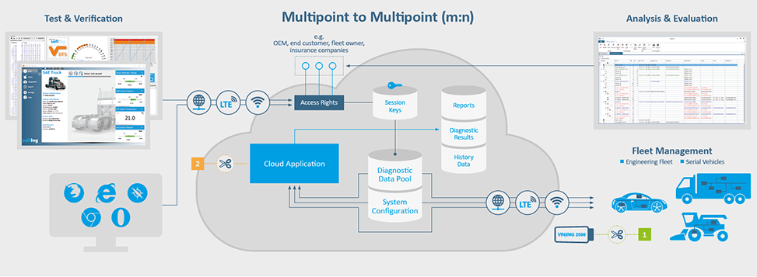

* Predictive maintenance: V2C communication can be used to collect data about vehicle performance and identify potential problems before they cause breakdowns. This can help to reduce vehicle downtime and save money on repairs.
* Usage-based insurance: V2C communication can be used to collect data about driver behavior, such as braking and acceleration patterns. This data can be used by insurance companies to calculate premiums based on individual driving habits.
* Connected car services: V2C communication can be used to power a variety of connected car services, such as real-time traffic information, navigation, and infotainment.

**Details:**

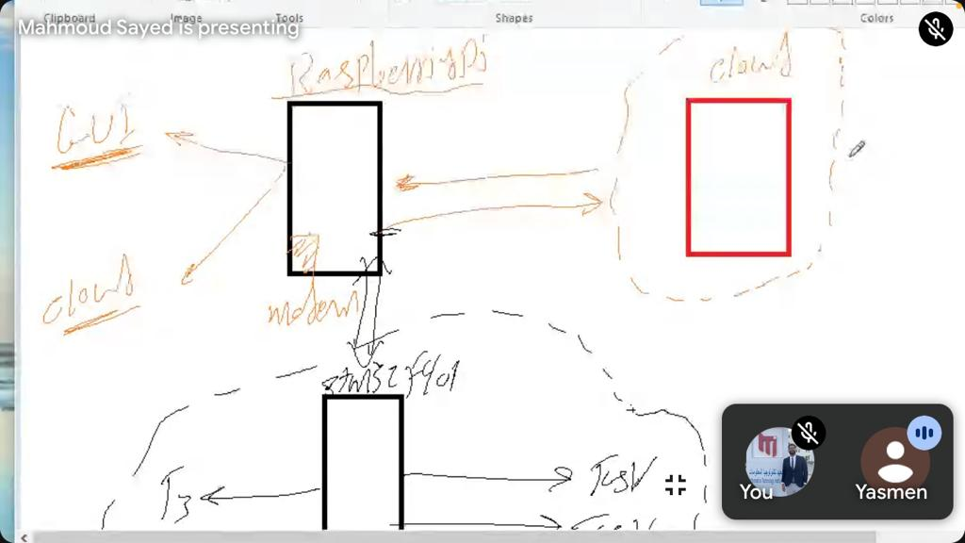

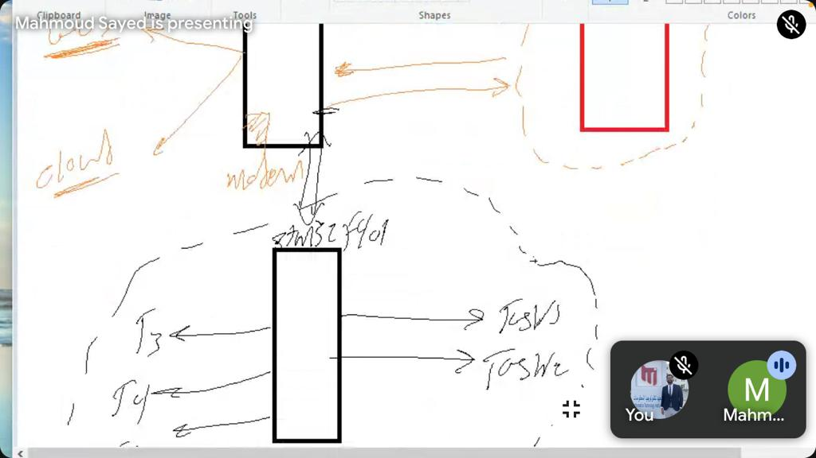

1. Design the system: The first step is to design the system. This includes selecting the appropriate hardware and software components and designing the overall system architecture.
2. Build the hardware: Once the system has been designed, the next step is to build the hardware. This includes assembling the Raspberry Pi board and the STM32 microcontroller board.
3. Install the software: Once the hardware has been built, the next step is to install the necessary software. This includes the Raspberry Pi operating system, the STM32 firmware, the V2C communication software, and the GUI software.
4. Configure the system: Once the software has been installed, the next step is to configure the system. This includes configuring the V2C communication link, the GUI software, and the Raspberry Pi and STM32 microcontroller boards.
5. Test the system: Once the system has been configured, it is important to test it thoroughly to ensure that it is working as expected. This includes testing the V2C communication link, the GUI software, and the Raspberry Pi and STM32 microcontroller boards.
6. Deploy the system: Once the system has been tested and verified, it can be deployed to production. This involves making the system available to users and providing support for the system.

**Challenges:**

1. Choose the right cloud platform for your needs.
2. Use a Raspberry Pi with a GUI.
3. Use an STM32 microcontroller board to connect to the vehicle's CAN bus.
4. Use a V2C communication library to simplify the development of your V2C application.
5. Use a GUI library to develop the user interface for your application.

**Conclusion:**

* V2C communication has the potential to revolutionize the automotive industry. By connecting vehicles to the cloud, V2C communication can help to improve vehicle safety, performance, and efficiency.
* V2C communication is still in its early stages of development, but a number of automakers and other companies are investing in the development of V2C technologies and services. As V2C technology continues to mature, we can expect to see more and more vehicles become connected to the cloud.