Mohamad Chmaitilly
202300209
EECE 435L - Lab 10

Modified Jenkins File:
pipeline {
agent any
environment {
VIRTUAL_ENV = 'venv'
}
stages {
stage('Setup') {
steps {
script {
if (!fileExists("${env.WORKSPACE}/${VIRTUAL_ENV}")) {
bat "\"C:\\Users\\LENOVO\\AppData\\Local\\Programs\\Python\\Python313\\python.exe\" -m venv ${VIRTUAL_ENV}"
}
bat "call ${VIRTUAL_ENV}\\Scripts\\activate.bat && pip install -r requirements.txt"
}
}
}
stage('Lint') {
steps {
script {
bat "call ${VIRTUAL_ENV}\\Scripts\\activate.bat && flake8 app.py"
}
}
}
stage('Test') {
steps {
script {
bat "call ${VIRTUAL_ENV}\\Scripts\\activate.bat && set PYTHONPATH=%CD% && pytest"
}
}
}
stage('Coverage') {
steps {
script {
bat """
call ${VIRTUAL_ENV}\\Scripts\\activate.bat && \
set PYTHONPATH=%CD% && \
coverage run -m pytest && \
coverage report && \
coverage html
"""
}
}
post {
always {
archiveArtifacts artifacts: 'htmlcov/**', allowEmptyArchive: true
}
}
}
stage('Security Scan') {
steps {
script {
bat """
call ${VIRTUAL_ENV}\\Scripts\\activate.bat && bandit -r . -f json -o bandit-report.json || (echo Bandit scan completed with warnings or errors & ver > nul) && bandit -r . -f txt -o bandit-report.txt || (echo Bandit scan completed with warnings or errors & ver > nul)
"""
}
}
post {
always {
archiveArtifacts artifacts: 'bandit-report.*', allowEmptyArchive: true
}
}
}
stage('Deploy') {
steps {
script {
bat """
call ${VIRTUAL_ENV}\\Scripts\\activate.bat && \
echo Deploying application... && \
if not exist deploy (mkdir deploy) && \
copy app.py deploy\\ && \
copy requirements.txt deploy\\ && \
echo Application files copied to deploy directory
"""
// For remote deployment, uncomment and configure:
// bat """
// scp -r deploy\\* user@remote-server:/path/to/deployment/
// ssh user@remote-server "cd /path/to/deployment && pip install -r requirements.txt"
// """
echo "Deployment completed successfully!"
}
}
}
}
post {
always {
cleanWs()
}
}
}

Changes Made
- Added Coverage Stage
  - Integrated coverage.py to run tests and generate coverage reports in both text and HTML formats.
  - Used coverage run -m pytest, coverage report, and coverage html.
  - Archived the HTML coverage report using:
  - archiveArtifacts artifacts: 'htmlcov/**', allowEmptyArchive: true
- Added Security Scan Stage
  - Integrated the bandit security scanning tool.
  - Generated both JSON and text reports:
  - bandit -r . -f json -o bandit-report.json
  - bandit -r . -f txt -o bandit-report.txt
  - Archived the generated reports for review.
- Added Deploy Stage
  - Implemented a simple deployment step that copies application files to a deploy folder.
  - Included commented-out SSH/SCP commands for future remote deployment configuration.
- Maintained Existing Lint and Test Stages
  - Retained flake8 linting for code style enforcement.
  - Retained pytest for unit testing.
- Ensured Workspace Cleanup
  - Added cleanWs() in the post block to ensure a clean workspace after each build.

Build output:
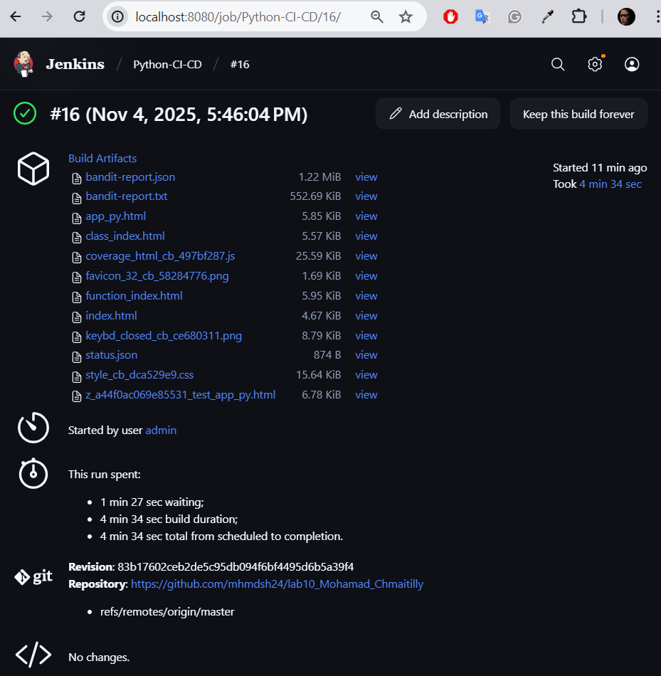
Console output:
Started by user admin

Obtained Jenkinsfile from git https://github.com/mhmdsh24/lab10_Mohamad_Chmaitilly
[Pipeline] Start of Pipeline
[Pipeline] node
Still waiting to schedule task
Waiting for next available executor
Running on Jenkins
in C:\ProgramData\Jenkins\.jenkins\workspace\Python-CI-CD
[Pipeline] {
[Pipeline] stage
[Pipeline] { (Declarative: Checkout SCM)
[Pipeline] checkout
Selected Git installation does not exist. Using Default
The recommended git tool is: NONE
No credentials specified
Cloning the remote Git repository
Cloning repository https://github.com/mhmdsh24/lab10_Mohamad_Chmaitilly
> C:\Program Files\Git\cmd\git.exe init C:\ProgramData\Jenkins\.jenkins\workspace\Python-CI-CD # timeout=10
Fetching upstream changes from https://github.com/mhmdsh24/lab10_Mohamad_Chmaitilly
> C:\Program Files\Git\cmd\git.exe --version # timeout=10
> git --version # 'git version 2.47.1.windows.1'
> C:\Program Files\Git\cmd\git.exe fetch --tags --force --progress -- https://github.com/mhmdsh24/lab10_Mohamad_Chmaitilly +refs/heads/*:refs/remotes/origin/* # timeout=10
> C:\Program Files\Git\cmd\git.exe config remote.origin.url https://github.com/mhmdsh24/lab10_Mohamad_Chmaitilly # timeout=10
> C:\Program Files\Git\cmd\git.exe config --add remote.origin.fetch +refs/heads/*:refs/remotes/origin/* # timeout=10
Avoid second fetch
> C:\Program Files\Git\cmd\git.exe rev-parse "refs/remotes/origin/master^{commit}" # timeout=10
Checking out Revision 83b17602ceb2de5c95db094f6bf4495d6b5a39f4 (refs/remotes/origin/master)
> C:\Program Files\Git\cmd\git.exe config core.sparsecheckout # timeout=10
> C:\Program Files\Git\cmd\git.exe checkout -f 83b17602ceb2de5c95db094f6bf4495d6b5a39f4 # timeout=10
Commit message: "fix url"
> C:\Program Files\Git\cmd\git.exe rev-list --no-walk 83b17602ceb2de5c95db094f6bf4495d6b5a39f4 # timeout=10
[Pipeline] }
[Pipeline] // stage
[Pipeline] withEnv
[Pipeline] {
[Pipeline] withEnv
[Pipeline] {
[Pipeline] stage
[Pipeline] { (Setup)
[Pipeline] script
[Pipeline] {
[Pipeline] fileExists
[Pipeline] bat

C:\ProgramData\Jenkins\.jenkins\workspace\Python-CI-CD>"C:\Users\LENOVO\AppData\Local\Programs\Python\Python313\python.exe" -m venv venv
[Pipeline] bat

C:\ProgramData\Jenkins\.jenkins\workspace\Python-CI-CD>call venv\Scripts\activate.bat && pip install -r requirements.txt
Collecting flake8 (from -r requirements.txt (line 1))
Using cached flake8-7.3.0-py2.py3-none-any.whl.metadata (3.8 kB)
Collecting pytest (from -r requirements.txt (line 2))
Using cached pytest-8.4.2-py3-none-any.whl.metadata (7.7 kB)
Collecting coverage (from -r requirements.txt (line 3))
Using cached coverage-7.11.0-cp313-cp313-win_amd64.whl.metadata (9.2 kB)
Collecting bandit (from -r requirements.txt (line 4))
Using cached bandit-1.8.6-py3-none-any.whl.metadata (6.9 kB)
Collecting mccabe<0.8.0,>=0.7.0 (from flake8->-r requirements.txt (line 1))
Using cached mccabe-0.7.0-py2.py3-none-any.whl.metadata (5.0 kB)
Collecting pycodestyle<2.15.0,>=2.14.0 (from flake8->-r requirements.txt (line 1))
Using cached pycodestyle-2.14.0-py2.py3-none-any.whl.metadata (4.5 kB)
Collecting pyflakes<3.5.0,>=3.4.0 (from flake8->-r requirements.txt (line 1))
Using cached pyflakes-3.4.0-py2.py3-none-any.whl.metadata (3.5 kB)
Collecting colorama>=0.4 (from pytest->-r requirements.txt (line 2))
Using cached colorama-0.4.6-py2.py3-none-any.whl.metadata (17 kB)
Collecting iniconfig>=1 (from pytest->-r requirements.txt (line 2))
Using cached iniconfig-2.3.0-py3-none-any.whl.metadata (2.5 kB)
Collecting packaging>=20 (from pytest->-r requirements.txt (line 2))
Using cached packaging-25.0-py3-none-any.whl.metadata (3.3 kB)
Collecting pluggy<2,>=1.5 (from pytest->-r requirements.txt (line 2))
Using cached pluggy-1.6.0-py3-none-any.whl.metadata (4.8 kB)
Collecting pygments>=2.7.2 (from pytest->-r requirements.txt (line 2))
Using cached pygments-2.19.2-py3-none-any.whl.metadata (2.5 kB)
Collecting PyYAML>=5.3.1 (from bandit->-r requirements.txt (line 4))
Using cached pyyaml-6.0.3-cp313-cp313-win_amd64.whl.metadata (2.4 kB)
Collecting stevedore>=1.20.0 (from bandit->-r requirements.txt (line 4))
Using cached stevedore-5.5.0-py3-none-any.whl.metadata (2.2 kB)
Collecting rich (from bandit->-r requirements.txt (line 4))
Using cached rich-14.2.0-py3-none-any.whl.metadata (18 kB)
Collecting markdown-it-py>=2.2.0 (from rich->bandit->-r requirements.txt (line 4))
Using cached markdown_it_py-4.0.0-py3-none-any.whl.metadata (7.3 kB)
Collecting mdurl~=0.1 (from markdown-it-py>=2.2.0->rich->bandit->-r requirements.txt (line 4))
Using cached mdurl-0.1.2-py3-none-any.whl.metadata (1.6 kB)
Using cached flake8-7.3.0-py2.py3-none-any.whl (57 kB)
Using cached mccabe-0.7.0-py2.py3-none-any.whl (7.3 kB)
Using cached pycodestyle-2.14.0-py2.py3-none-any.whl (31 kB)
Using cached pyflakes-3.4.0-py2.py3-none-any.whl (63 kB)
Using cached pytest-8.4.2-py3-none-any.whl (365 kB)
Using cached pluggy-1.6.0-py3-none-any.whl (20 kB)
Using cached coverage-7.11.0-cp313-cp313-win_amd64.whl (219 kB)
Using cached bandit-1.8.6-py3-none-any.whl (133 kB)
Using cached colorama-0.4.6-py2.py3-none-any.whl (25 kB)
Using cached iniconfig-2.3.0-py3-none-any.whl (7.5 kB)
Using cached packaging-25.0-py3-none-any.whl (66 kB)
Using cached pygments-2.19.2-py3-none-any.whl (1.2 MB)
Using cached pyyaml-6.0.3-cp313-cp313-win_amd64.whl (154 kB)
Using cached stevedore-5.5.0-py3-none-any.whl (49 kB)
Using cached rich-14.2.0-py3-none-any.whl (243 kB)
Using cached markdown_it_py-4.0.0-py3-none-any.whl (87 kB)
Using cached mdurl-0.1.2-py3-none-any.whl (10.0 kB)
Installing collected packages: stevedore, PyYAML, pygments, pyflakes, pycodestyle, pluggy, packaging, mdurl, mccabe, iniconfig, coverage, colorama, pytest, markdown-it-py, flake8, rich, bandit

Successfully installed PyYAML-6.0.3 bandit-1.8.6 colorama-0.4.6 coverage-7.11.0 flake8-7.3.0 iniconfig-2.3.0 markdown-it-py-4.0.0 mccabe-0.7.0 mdurl-0.1.2 packaging-25.0 pluggy-1.6.0 pycodestyle-2.14.0 pyflakes-3.4.0 pygments-2.19.2 pytest-8.4.2 rich-14.2.0 stevedore-5.5.0

[notice] A new release of pip is available: 25.2 -> 25.3
[notice] To update, run: python.exe -m pip install --upgrade pip
[Pipeline] }
[Pipeline] // script
[Pipeline] }
[Pipeline] // stage
[Pipeline] stage
[Pipeline] { (Lint)
[Pipeline] script
[Pipeline] {
[Pipeline] bat

C:\ProgramData\Jenkins\.jenkins\workspace\Python-CI-CD>call venv\Scripts\activate.bat && flake8 app.py
[Pipeline] }
[Pipeline] // script
[Pipeline] }
[Pipeline] // stage
[Pipeline] stage
[Pipeline] { (Test)
[Pipeline] script
[Pipeline] {
[Pipeline] bat

C:\ProgramData\Jenkins\.jenkins\workspace\Python-CI-CD>call venv\Scripts\activate.bat && set PYTHONPATH=C:\ProgramData\Jenkins\.jenkins\workspace\Python-CI-CD && pytest
============================= test session starts =============================
platform win32 -- Python 3.13.7, pytest-8.4.2, pluggy-1.6.0
rootdir: C:\ProgramData\Jenkins\.jenkins\workspace\Python-CI-CD
collected 1 item

tests\test_app.py . [100%]

============================== 1 passed in 0.02s ==============================
[Pipeline] }
[Pipeline] // script
[Pipeline] }
[Pipeline] // stage
[Pipeline] stage
[Pipeline] { (Coverage)
[Pipeline] script
[Pipeline] {
[Pipeline] bat

C:\ProgramData\Jenkins\.jenkins\workspace\Python-CI-CD>call venv\Scripts\activate.bat && set PYTHONPATH=C:\ProgramData\Jenkins\.jenkins\workspace\Python-CI-CD && coverage run -m pytest && coverage report && coverage html
============================= test session starts =============================
platform win32 -- Python 3.13.7, pytest-8.4.2, pluggy-1.6.0
rootdir: C:\ProgramData\Jenkins\.jenkins\workspace\Python-CI-CD
collected 1 item

tests\test_app.py . [100%]

============================== 1 passed in 0.02s ==============================
Name Stmts Miss Cover
---------------------------------------
app.py 4 1 75%
tests\test_app.py 7 1 86%
---------------------------------------
TOTAL 11 2 82%
Wrote HTML report to htmlcov\index.html
[Pipeline] }
[Pipeline] // script
Post stage
[Pipeline] archiveArtifacts
Archiving artifacts
[Pipeline] }
[Pipeline] // stage
[Pipeline] stage
[Pipeline] { (Security Scan)
[Pipeline] script
[Pipeline] {
[Pipeline] bat

C:\ProgramData\Jenkins\.jenkins\workspace\Python-CI-CD>call venv\Scripts\activate.bat && bandit -r . -f json -o bandit-report.json || (echo Bandit scan completed with warnings or errors & ver 1>nul ) && bandit -r . -f txt -o bandit-report.txt || (echo Bandit scan completed with warnings or errors & ver 1>nul )
[main] INFO profile include tests: None
[main] INFO profile exclude tests: None
[main] INFO cli include tests: None
[main] INFO cli exclude tests: None
[manager] WARNING Test in comment: _lines is not a test name or id, ignoring
[manager] WARNING Test in comment: is is not a test name or id, ignoring
[manager] WARNING Test in comment: a is not a test name or id, ignoring
[manager] WARNING Test in comment: dict is not a test name or id, ignoring
[manager] WARNING Test in comment: of is not a test name or id, ignoring
[manager] WARNING Test in comment: line is not a test name or id, ignoring
[manager] WARNING Test in comment: number is not a test name or id, ignoring
[manager] WARNING Test in comment: set is not a test name or id, ignoring
[manager] WARNING Test in comment: of is not a test name or id, ignoring
[manager] WARNING Test in comment: tests is not a test name or id, ignoring
[manager] WARNING Test in comment: to is not a test name or id, ignoring
[manager] WARNING Test in comment: ignore is not a test name or id, ignoring
[manager] WARNING Test in comment: tkelsey is not a test name or id, ignoring
[manager] WARNING Test in comment: catching is not a test name or id, ignoring
[manager] WARNING Test in comment: expected is not a test name or id, ignoring
[manager] WARNING Test in comment: exception is not a test name or id, ignoring
[tester] WARNING nosec encountered (B108), but no failed test on line 61
Working... ---------------------------------------- 100% 0:01:07
[json] INFO JSON output written to file: bandit-report.json
Bandit scan completed with warnings or errors
[main] INFO profile include tests: None
[main] INFO profile exclude tests: None
[main] INFO cli include tests: None
[main] INFO cli exclude tests: None
[main] INFO running on Python 3.13.7
[manager] WARNING Test in comment: _lines is not a test name or id, ignoring
[manager] WARNING Test in comment: is is not a test name or id, ignoring
[manager] WARNING Test in comment: a is not a test name or id, ignoring
[manager] WARNING Test in comment: dict is not a test name or id, ignoring
[manager] WARNING Test in comment: of is not a test name or id, ignoring
[manager] WARNING Test in comment: line is not a test name or id, ignoring
[manager] WARNING Test in comment: number is not a test name or id, ignoring
[manager] WARNING Test in comment: set is not a test name or id, ignoring
[manager] WARNING Test in comment: of is not a test name or id, ignoring
[manager] WARNING Test in comment: tests is not a test name or id, ignoring
[manager] WARNING Test in comment: to is not a test name or id, ignoring
[manager] WARNING Test in comment: ignore is not a test name or id, ignoring
[manager] WARNING Test in comment: tkelsey is not a test name or id, ignoring
[manager] WARNING Test in comment: catching is not a test name or id, ignoring
[manager] WARNING Test in comment: expected is not a test name or id, ignoring
[manager] WARNING Test in comment: exception is not a test name or id, ignoring
[tester] WARNING nosec encountered (B108), but no failed test on line 61
Working... ---------------------------------------- 100% 0:01:03
[text] INFO Text output written to file: bandit-report.txt
Bandit scan completed with warnings or errors
[Pipeline] }
[Pipeline] // script
Post stage
[Pipeline] archiveArtifacts
Archiving artifacts
[Pipeline] }
[Pipeline] // stage
[Pipeline] stage
[Pipeline] { (Deploy)
[Pipeline] script
[Pipeline] {
[Pipeline] bat

C:\ProgramData\Jenkins\.jenkins\workspace\Python-CI-CD>call venv\Scripts\activate.bat && echo Deploying application... && if not exist deploy (mkdir deploy ) && copy app.py deploy\ && copy requirements.txt deploy\ && echo Application files copied to deploy directory
Deploying application...
1 file(s) copied.
1 file(s) copied.
Application files copied to deploy directory
[Pipeline] echo
Deployment completed successfully!
[Pipeline] }
[Pipeline] // script
[Pipeline] }
[Pipeline] // stage
[Pipeline] stage
[Pipeline] { (Declarative: Post Actions)
[Pipeline] cleanWs
[WS-CLEANUP] Deleting project workspace...
[WS-CLEANUP] Deferred wipeout is used...
[WS-CLEANUP] done
[Pipeline] }
[Pipeline] // stage
[Pipeline] }
[Pipeline] // withEnv
[Pipeline] }
[Pipeline] // withEnv
[Pipeline] }
[Pipeline] // node
[Pipeline] End of Pipeline
Finished: SUCCESS

Output Explanation:
The Jenkins pipeline executed successfully from start to finish. The process began by cloning the GitHub repository and checking out the latest commit from the master branch. During the Setup stage, a Python virtual environment was created, and all required dependencies were installed from the requirements.txt file without any errors. The Lint stage used flake8 to verify code quality and style compliance, and no issues were detected. In the Test stage, pytest was executed, and all tests passed successfully, confirming that the application’s functionality was correct. The Coverage stage generated both console and HTML reports, achieving an overall test coverage of 82%, which were archived for review. The Security Scan stage employed bandit to detect potential vulnerabilities; while minor warnings appeared, no critical security issues were identified, and both JSON and text reports were archived. The Deploy stage completed successfully, creating a deployment directory and copying the necessary application files (app.py and requirements.txt). Finally, post-build actions archived all artifacts and cleaned the workspace to maintain an organized environment. The build concluded with the message “Finished: SUCCESS,” indicating that all stages executed correctly and the continuous integration pipeline ran as intended.

