Lesson:

Typescript is a programming language as well as compiler which compile its code to JS (Older version). So almost all the browsers support it.

1. Built by MS
2. Allow static strict typing
3. Errors during compiling.
4. Interfaces, enums, tuples, generics
5. Support modern features (Arrow functions, let, const)
6. Based on the .NET harmony specification
7. Compiles to JS, so run everywhere.
8. Familiar OOP programming.

Why TypeScript not JS?

1. Not suitable for larger applications.
2. Lack strong typing.
3. Weird inheritance and unfamiliar syntax.
4. Only errors during runtime.
5. Suffers type coercion. (Undefined, null, can be join string with int etc.)

Installing:

1. Install Node.js
2. npm i -g typescript

Project Setup:

1. tsc –init
2. go to tscconfig.json file and uncomment rootDir and outDir.
3. after that, for compiling only hit “tsc” command.
4. if face any problem, watch the project setup.html file.
5. “tsc -w” for auto reload.

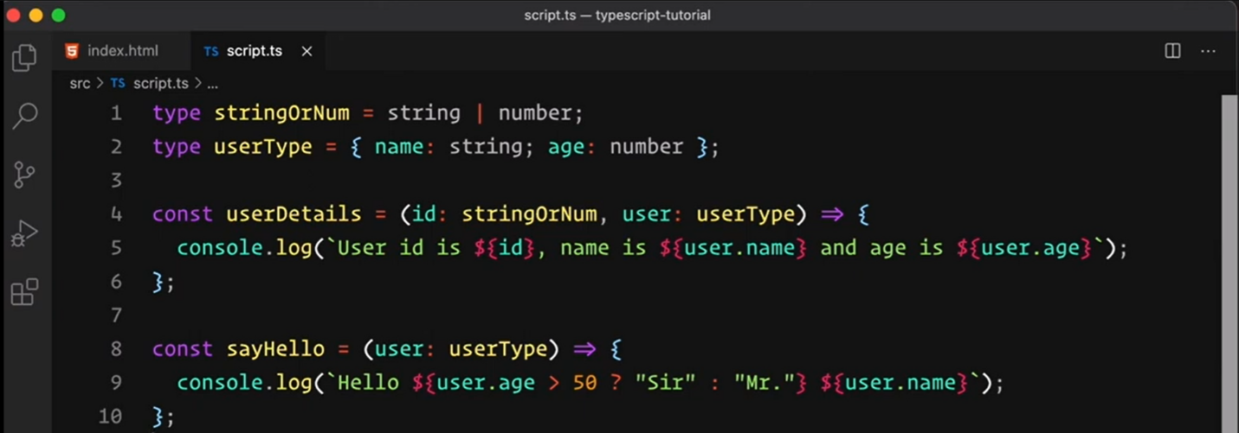Type Aliases:

Module Setup: learn with sumit video 11.

drawback: typescript doesn’t help in bundling.. should use webpack.