Title of the paper. This is primarily from the APA style. LODJ apparently does not have a specific format for the title

This is where the abstract will be.

# level 1 heading

Paragraph one of normal text. This text is indented even though it’s the first paragraph after a heading. Am yet unable to figure out how to make just the first paragraph unindented.

This is the second paragraph. Notice that the spacing between this paragraph and the previous one is the same as the spacing between two lines.

# Level 1 heading again

As the primary purpose of our work is to explore the dimensions of transformational leadership, the dimensional conceptualization of Rafferty and Griffin (2004) is useful as theoretically it should discriminate between the various dimensions.

Further some initial empirical evidence is also provided (Rafferty and Griffin 2004).

# Psychological Empowerment

Psychological empowerment is defined as a set of motivational cognitions shaped by a work environment and reflecting an individual's active orientation to his or her work role (Spreitzer 1995).

The concept of psychological empowerment has gained wide acceptance in both management theory and practice as it is related with a variety of organizationally valued outcomes (Guangping Wang and Lee 2009).

# Hypotheses

## Level 2 Heading

In support of these arguments, Kirkpatrick and Locke (1996) demonstrated through an experiment that a vision positively affected followers’ perception of importance of the task.

**H1**: *Block quote. The bold of H1 is from the underlying markdown would be positively related to meaning.*

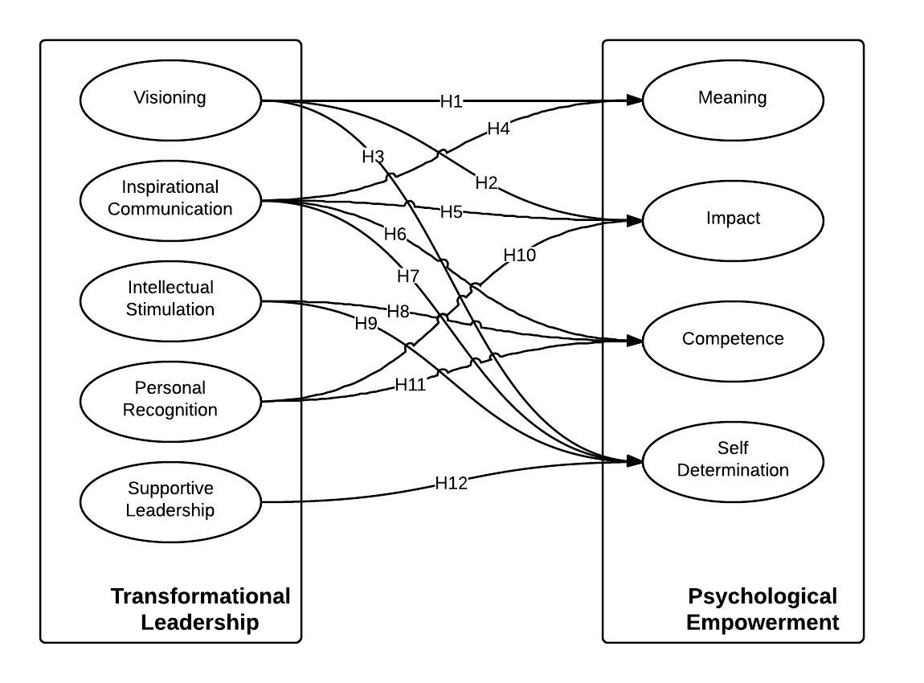

Image and Table Captions are Small Caps

# Method

## Sample and Procedures

We approached a large Indian IT services organization that operates in a B2B services environment.

## Measures

### Psychological Empowerment

Psychological empowerment was measured using the twelve-item scale by Spreitzer (1995). It is a four-dimensional scale with three items measuring each dimension.

### Control Variables

Higher levels of individual human capital should be positively associated with one’s ability to take action and have a positive impact in the workplace (Seibert, Wang, and Courtright 2011).

# Results

To begin with our measurement model test, we specified a one-factor model (Model 1) in which all the 27 items loaded on a single factor. Model 2 did not fit the data well in absolute sense (Table 1). However, a significant value of chi-square in a chi-square difference test suggested that Model 2 was

Results of the Measurement Model Tests

|  |  |  |  |  |  |  |
| --- | --- | --- | --- | --- | --- | --- |
| Model | χ2 | df | RMSEA | SRMR | NNFI | CFI |
| One-factor Model | 2121.81 | 324 | 0.13 | 0.11 | 0.43 | 0.47 |
| Two-factor Model | 1840.66 | 323 | 0.12 | 0.10 | 0.51 | 0.55 |
| Nine-factor Model | 444.78 | 288 | 0.04 | 0.04 | 0.94 | 0.95 |

Results of the Model Tests

|  |  |  |  |  |  |  |
| --- | --- | --- | --- | --- | --- | --- |
| Model | χ2 | df | RMSEA | SRMR | NNFI | CFI |
| Hypothesized Model | 12.16 | 9 | 0.03 | 0.02 | 0.98 | 0.99 |
| Insignificant paths removed | 15.58 | 11 | 0.03 | 0.02 | 0.98 | 0.99 |

# References

Avolio, Bruce J., and William L. Gardner. 2005. “Authentic Leadership Development: Getting to the Root of Positive Forms of Leadership.” *The Leadership Quarterly* 16 (3): 315–38. The only thing important is the hanging indent. The rest of the formatting is due to csl file