install ubuntu 20.04.6

# ---------------------------------------------------------------------------------------------

Topic: nvidia driver

Cmd: sudo add-apt-repository ppa:graphics-drivers/ppa

In software&update > additonal drivers install nvidia driver as shown below

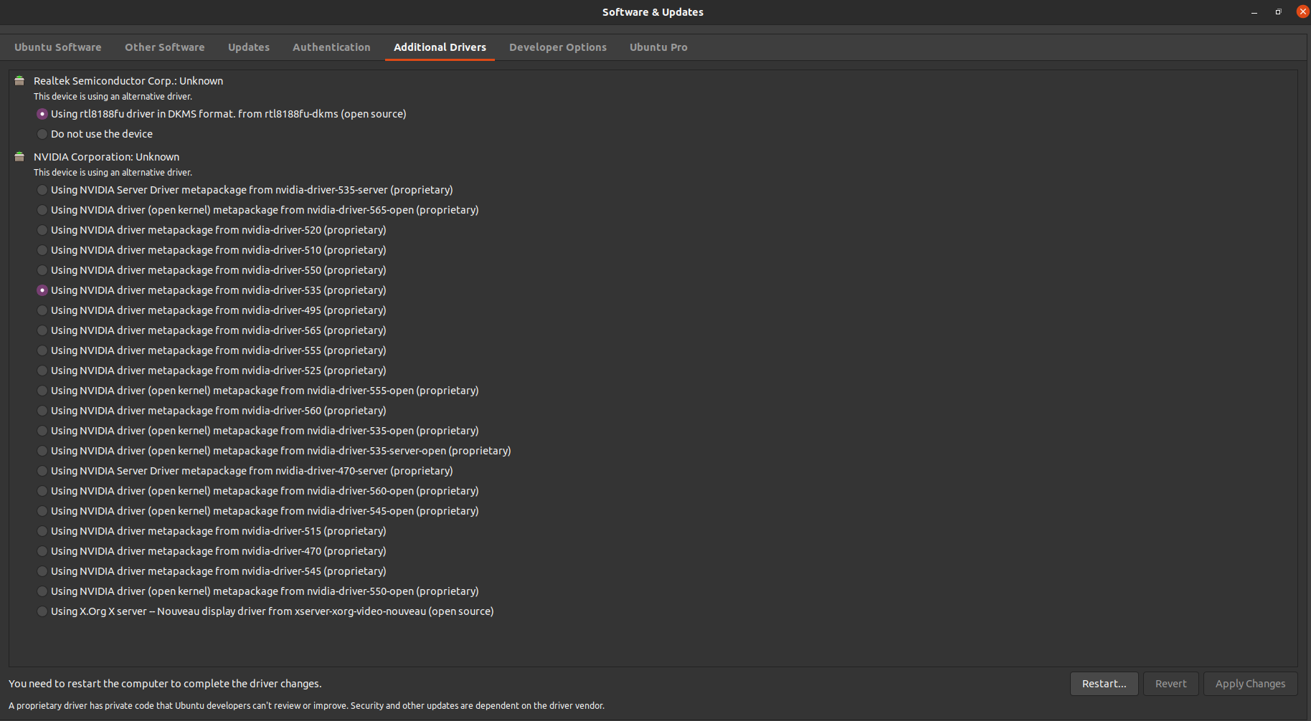

Cmd: reboot (Reboot the system so the new driver takes effect.)

Cmd: nvidia-smi

Output:

+---------------------------------------------------------------------------------------+

| NVIDIA-SMI 535.183.01 Driver Version: 535.183.01 CUDA Version: 12.2 |

|-----------------------------------------+----------------------+----------------------+

| GPU Name Persistence-M | Bus-Id Disp.A | Volatile Uncorr. ECC |

| Fan Temp Perf Pwr:Usage/Cap | Memory-Usage | GPU-Util Compute M. |

| | | MIG M. |

|=========================================+======================+======================|

| 0 NVIDIA GeForce RTX 3060 Off | 00000000:07:00.0 On | N/A |

| 0% 31C P8 19W / 170W | 307MiB / 12288MiB | 9% Default |

| | | N/A |

+-----------------------------------------+----------------------+----------------------+

Note:

* Driver Version: 535.183.01 -> the currently installed nvidia driver version
* CUDA Version: 12.2 -> the highest version of cuda that this nvidia driver could support is 12.2

# ---------------------------------------------------------------------------------------------

Topic: gcc

Ref: <https://github.com/espressomd/espresso/issues/3654#issuecomment-723140670>

Cmd: sudo apt -y install gcc-9

Cmd: sudo update-alternatives --install /usr/bin/gcc gcc /usr/bin/gcc-9 9

Cmd: sudo update-alternatives --install /usr/bin/gcc gcc /usr/bin/gcc-11 11

Note: select gcc-9 as compiler (version) -- press the number that points to gcc-9

Cmd: sudo update-alternatives --config gcc

# ---------------------------------------------------------------------------------------------

Topic: cuda

Cmd: nvcc –V [not working here]

Note: You can install CUDA 11.1 and cuDNN 8.1 for for GPU support with TensorFlow 2.11 as mentioned here

Ref: <https://www.tensorflow.org/install/source#gpu>

Note: Now, download the CUDA 11.1.0 .run file from NVIDIA:

Ref: <https://developer.nvidia.com/cuda-11.1.0-download-archive?target_os=Linux&target_arch=x86_64&target_distro=Ubuntu&target_version=2004&target_type=runfilelocal>

Cmd: wget -c <https://developer.download.nvidia.com/compute/cuda/11.1.0/local_installers/cuda_11.1.0_455.23.05_linux.run>

Cmd: chmod +x cuda_11.1.0_455.23.05_linux.run

Cmd: sudo sh cuda_11.1.0_455.23.05_linux.run

Note: The cuda toolkit comes with its nvidia driver. But I don't recommend installing the NVIDIA drivers that come with CUDA as they do not contain the dkms drivers that carry over into new kernel upgrades. So don’t forget to uncheck it as shown below

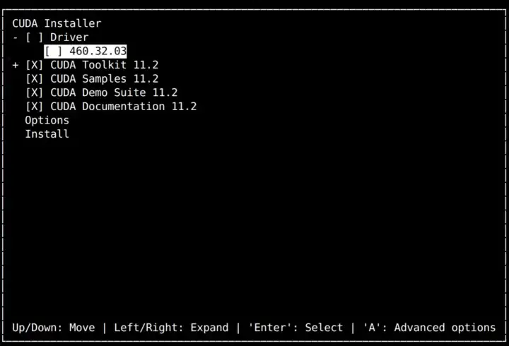

Cmd: gedit ~/.bashrc

Note: A file will open, add the following lines to it

export CUDA_HOME=/usr/local/cuda-11.1

export PATH=/usr/local/cuda-11.1/bin:$PATH

export CPATH=/usr/local/cuda-11.1/include:$CPATH

export LIBRARY_PATH=/usr/local/cuda-11.1/lib64:$LIBRARY_PATH

export LD_LIBRARY_PATH=/usr/local/cuda-11.1/lib64:/usr/local/cuda-11.1/extras/CUPTI/lib64:$LD_LIBRARY_PATH

export LD_LIBRARY_PATH=/usr/local/cuda-11.1/lib64:$LD_LIBRARY_PATH

Note: save and close the file

Cmd: source ~/.bashrc

Cmd: nvcc –V [working here]

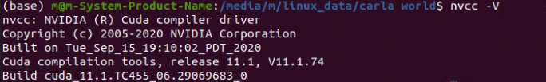

Note: in /usr/local/

You should find these folders cuda/ and cuda11.1/

# ---------------------------------------------------------------------------------------------

Topic: cudnn

Ref: <https://stackoverflow.com/questions/66977227/could-not-load-dynamic-library-libcudnn-so-8-when-running-tensorflow-on-ubun>

Cmd: wget https://developer.download.nvidia.com/compute/cuda/repos/ubuntu2004/x86_64/cuda-ubuntu2004.pin

Cmd: sudo mv cuda-ubuntu2004.pin /etc/apt/preferences.d/cuda-repository-pin-600

Cmd: sudo apt-key adv --fetch-keys https://developer.download.nvidia.com/compute/cuda/repos/ubuntu2004/x86_64/3bf863cc.pub

Cmd: sudo add-apt-repository "deb https://developer.download.nvidia.com/compute/cuda/repos/ubuntu2004/x86_64/ /"

Cmd: sudo apt-get update

Cmd: sudo apt-get install libcudnn8

Cmd: sudo apt-get install libcudnn8-dev

Cmd: cat /usr/include/x86_64-linux-gnu/cudnn_v*.h | grep CUDNN_MAJOR -A 2

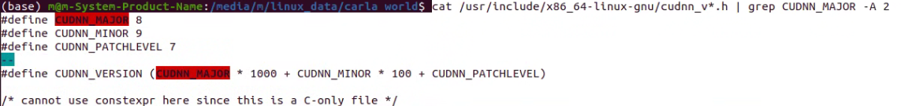The picture indicates that cudnn version 8.9.7 is installed