* Login page:
  + If first time login chrome will be opened for you to login.

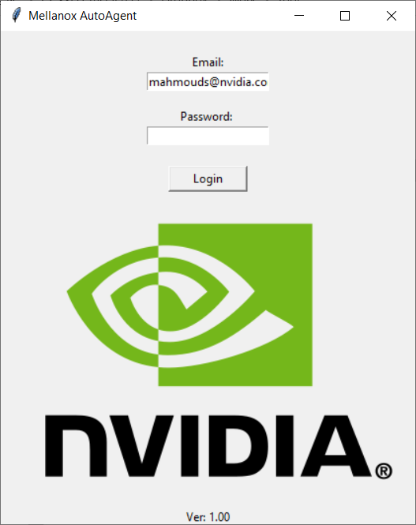

* Main methods:
  + RMA
  + SN to GUID

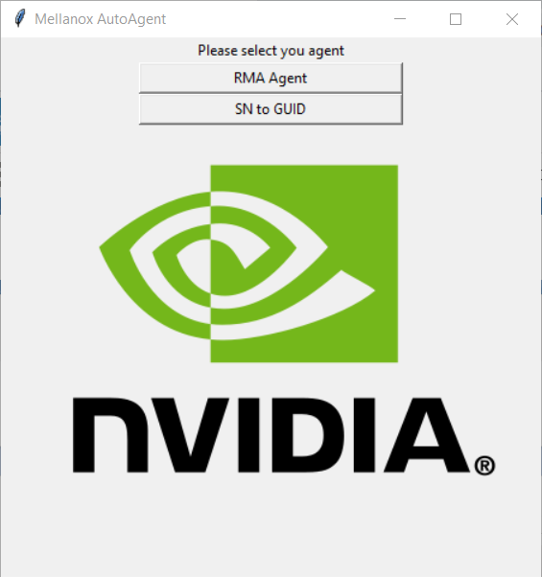

SN to GUID:

* Need to browse the serials TXT (each line 1 SN)
* Check on convert file
  + Output file (result.txt) in the same location as serials file

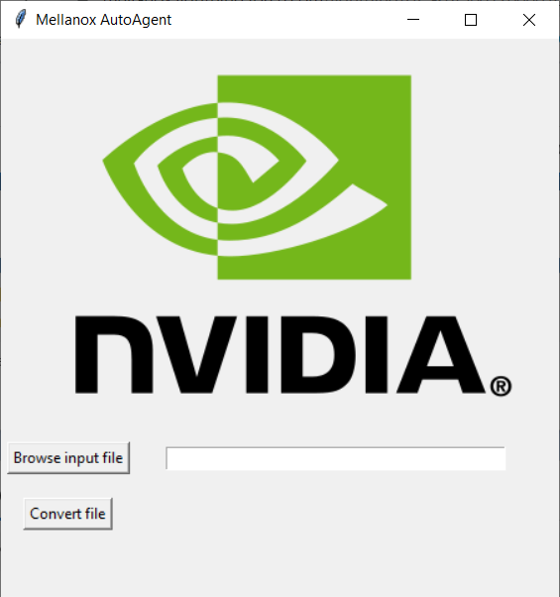

Result file includes the SN and the GUID:

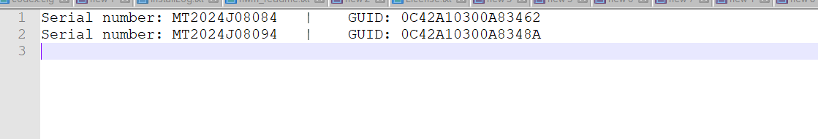

RMA:

Enter the RMA # to dequeue and add RMA summery:

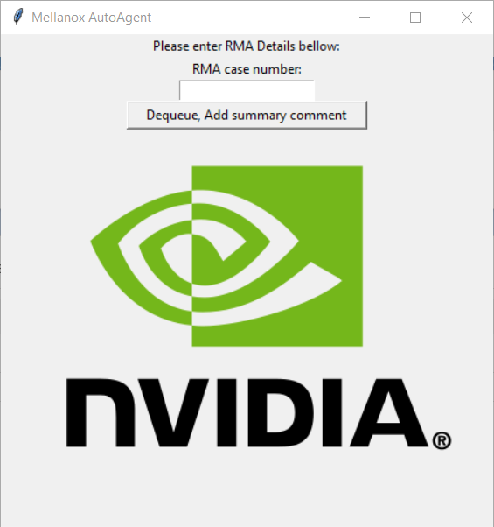

Results:

* Check if account OEM (Wikinox site search).
* Check if any of the SN was approved in previews RMA.
* If there is related case was not mention in the RMA.
* If FA requested.
* Number of assets
* 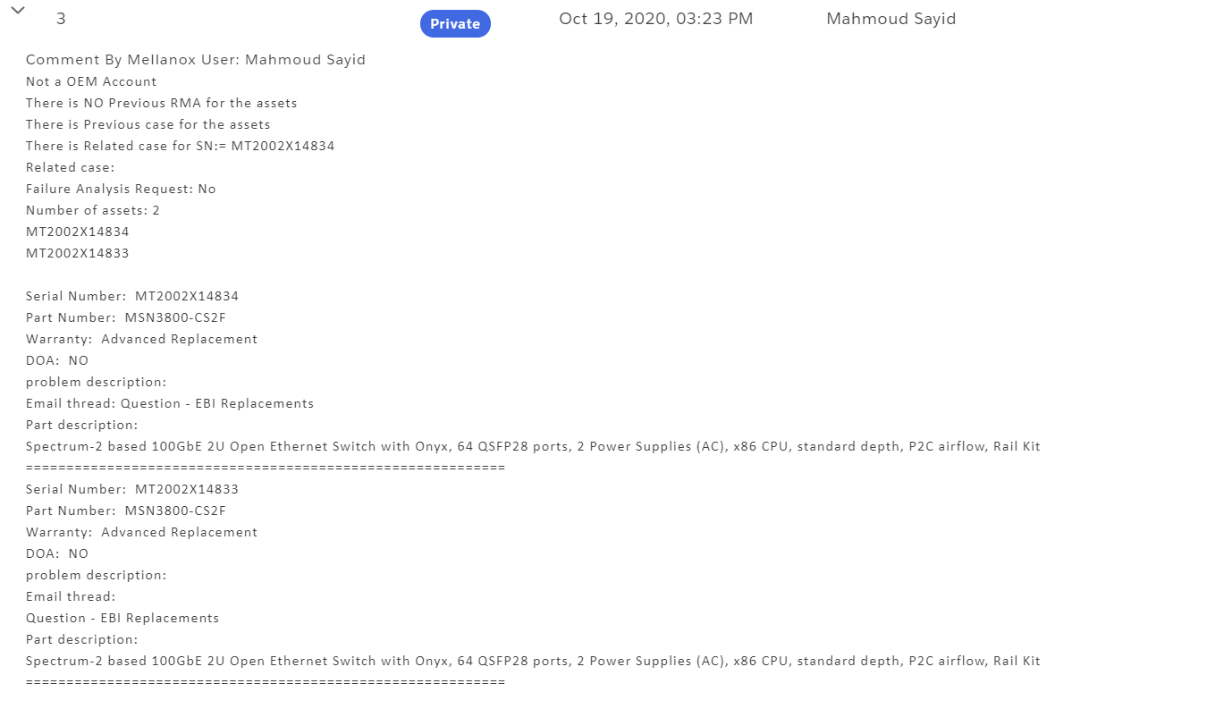Assets summery

Wikinox page for the scripts:

If there is new procedure or request you can add row to the table (will be added SOON).

* Field:
  + The search field (SN, PN, Account)
* Key:
  + What is the requested SN or PN or the account name you need.
* Procedure:
  + Will add this note to the RMA summary
    - For example:
      * SN ends with MEZZ need to move to OEM
      * 40gb to 56gb cable in the PD finisar recall issue need to approve as AR.
      * Can sent email if RMA from account was open

