# **Appendices- B: Testing**

## **Intention of Software Application testing:**

Testing is required for an effective performance of software application or product. It’s important to ensure that application works properly without any kind of failure. The reason of testing is to make sure that the end of the system or product meet all the requirements which it’s have. Appropriate testing provide the best quality of the product and stay in the business market.

## **Principles of testing:**

There are seven types of principles testing. The description of those principles are given below:

* **Presence of Defects:** Testing ensure the defects of the application or product. Even after testing we can’t say that the product is full free of defect. It reduces the number of unseen defects in the software.
* **Impossible Exhaustive testing:** Testing the whole thing containing all combinations of input and preconditions is not possible. For accessing and managing risk it is must needed.
* **Early Testing:** In software testing lifecycle early testing is must be started as soon as possible and also should attention on well-defined intents.
* **Defect Clustering:** Few modules contains a large portion of the imperfections found in pre-discharge testing. It indicates the effective failure.
* **Pesticide Paradox:** For overcoming Pesticide Paradox, needs to analysis the test cases often and different tests need to written to exercise different parts of application to catch more faults.
* **Context Dependent:** Testing is mainly context depending. Different sites tested differently.
* **Absence of errors Fallacy:** Built useless system and does not please the client's and not fulfill the all requirements then finding and fixing errors are useless.

<http://istqbexamcertification.com/what-are-the-principles-of-testing/>

## **Key Test Assumptions:**

There are some test assumptions that must be focused while the testing is running on. Those assumptions are described below:

* Appropriate data should be used during the relevant testing processes.
* Testing processes will be gradually checked by the tester and tester can choose a well-suited person to carry out processes as an alternative.
* All types of suggestions, queries, helps and doc file of the system will be given by the tester during the testing processes.

## **List of Testing:**

1. Integration Testing
2. Security Testing
3. Crows Browser Testing
4. Validation Testing
5. Responsive Testing
6. Performance Testing
7. Functionality Testing
8. Compatibility Testing
9. Usability Testing
10. Database Testing
11. Block unauthorized Testing
12. SQL Injection Testing
13. Crowd Testing

## **Attempting Testing:**

Those testing are attempting for the application which are given below:

**Security Testing:**

Security testing is a process to determine that an information system protects data and maintain functionality as intended. It confirms that the program is restricted access to authorize. Security testing of the this system is given below –

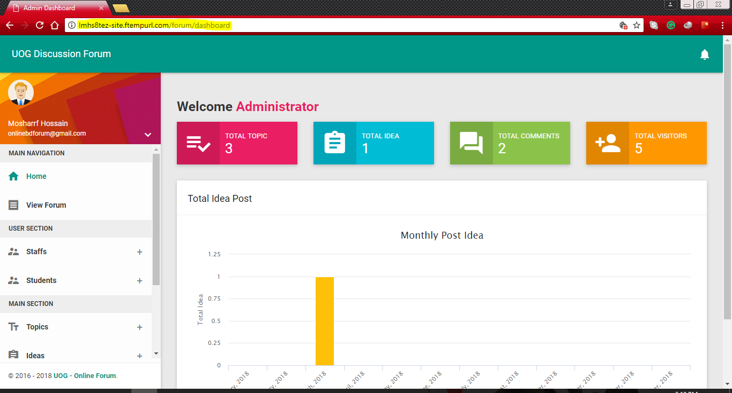

**Figure 18: Admin Dashboard after login**

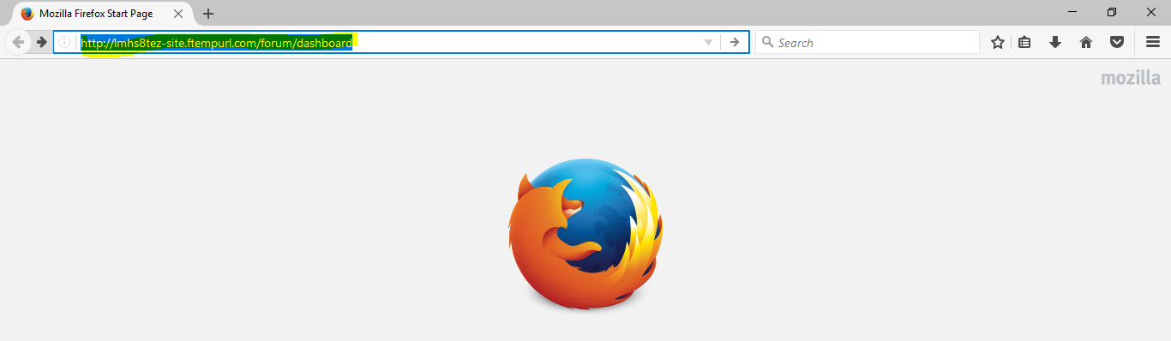

**Figure 19: Copy URL and paste it Mozilla Browser**

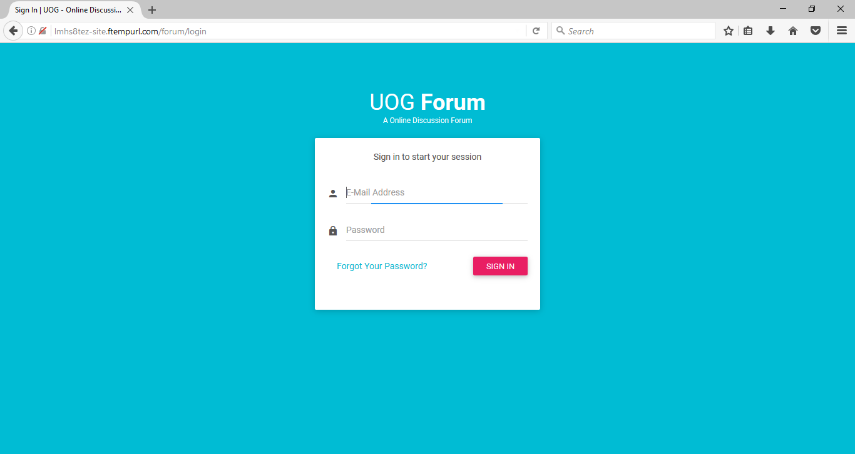

**Figure 20: Showing Login page**

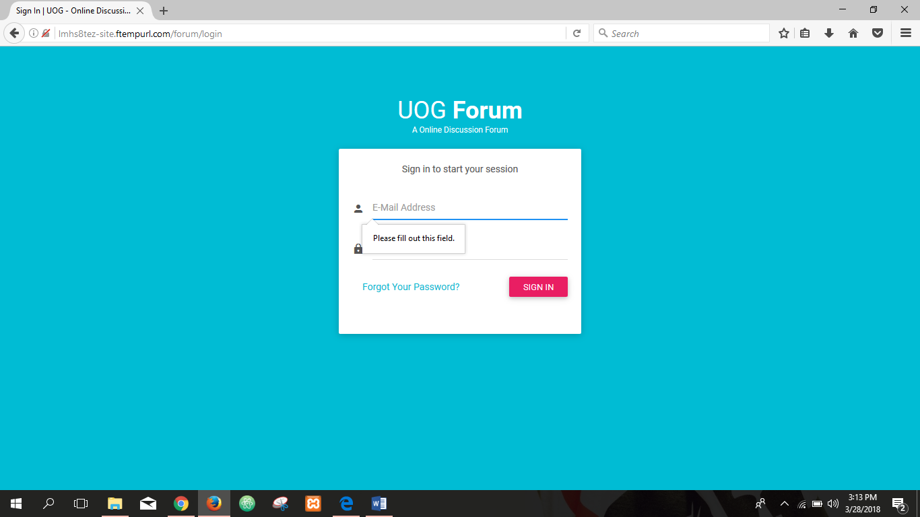

**Figure 21: Field can't be blanked**

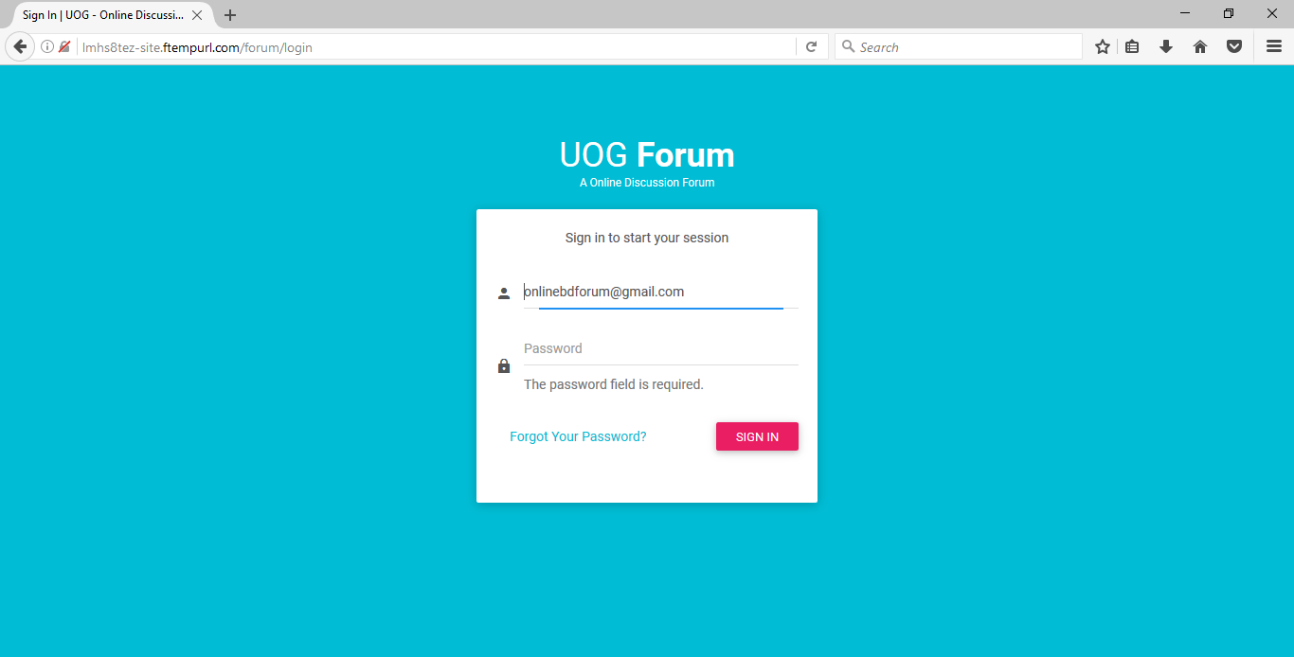

**Figure 22: Password can't be blanked**

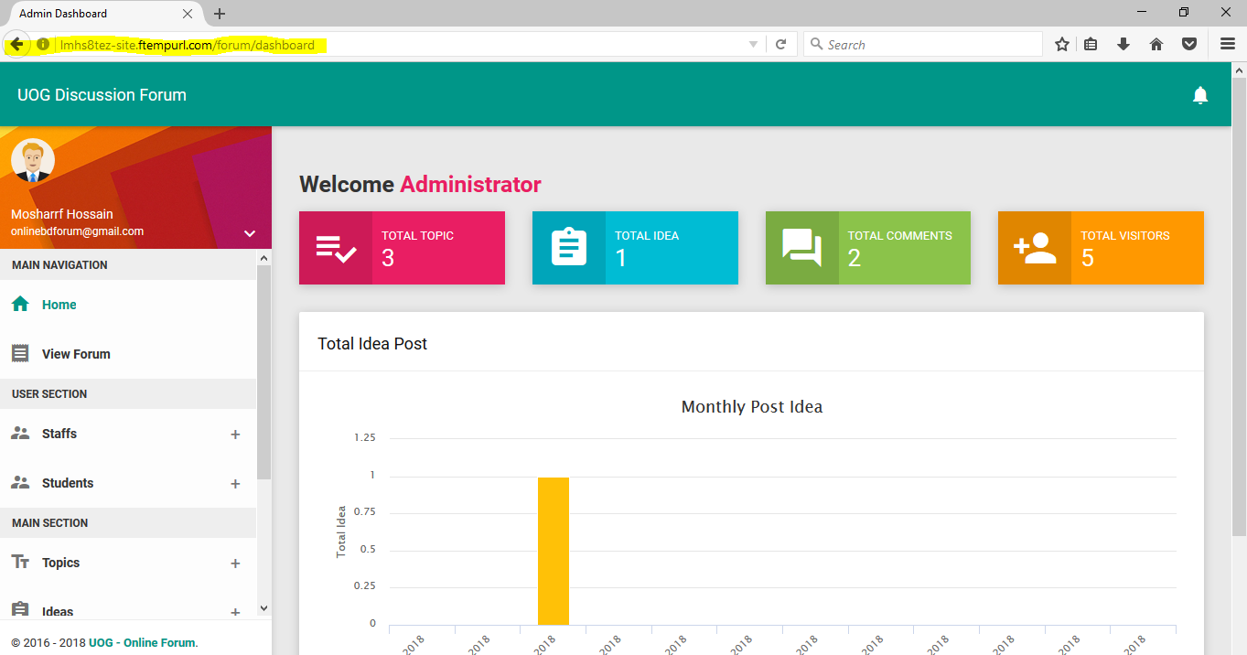

**Figure 23: Successfully Login after giving all correct information**

**Cross Browser Testing:**

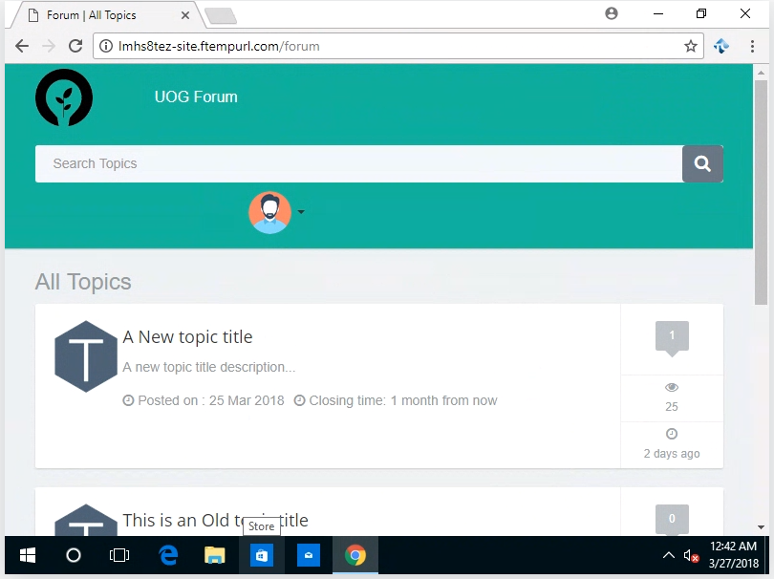Cross Browser testing is a process to test web applications across multiple browser. It checking compatibility and ensure that web application works correctly across the different web browser. Some web browser testing of my application is given below:

**Figure 24: Google Chrome**

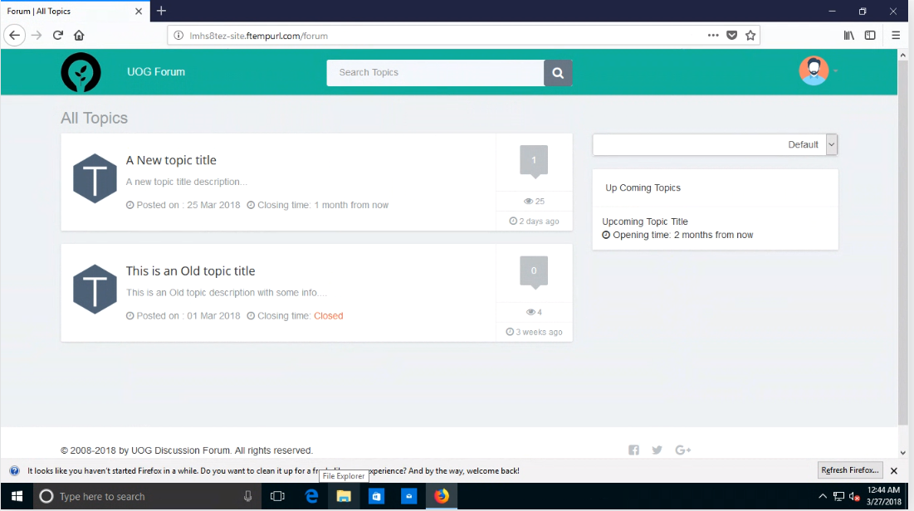

**Figure 25: Mozilla Firefox browser**

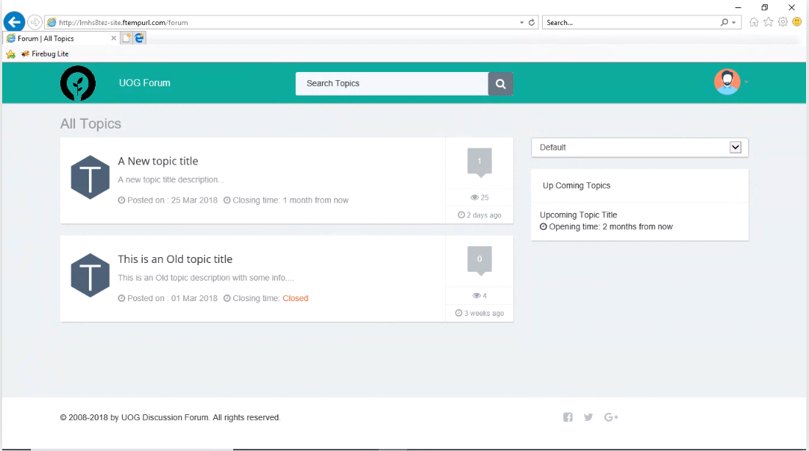

**Figure 26: Internet Explorer browser**

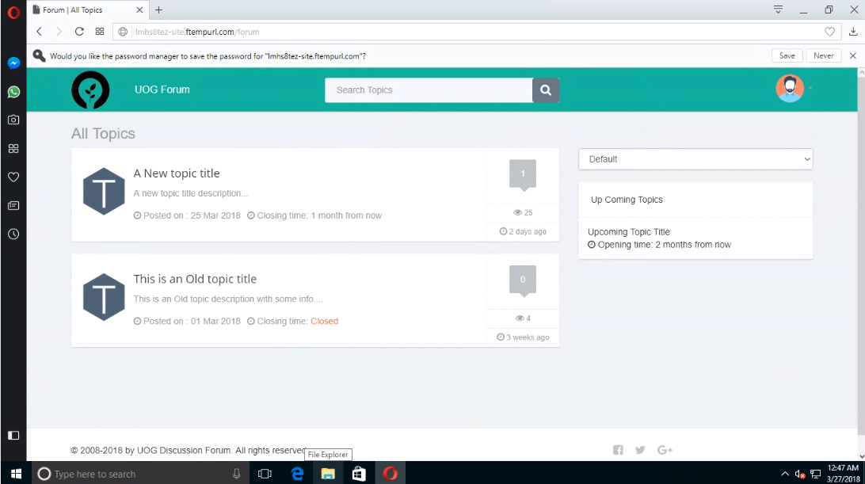

**Figure 27: Opera browser**

**Validation Testing:**

The Process of evaluating software during the development process or after the completing all the processes. It ensure that the product meet the requirements which is required and accomplishes functional purposes. Validation testing is must needed for testing for an application. Major validation test of the program is given below –

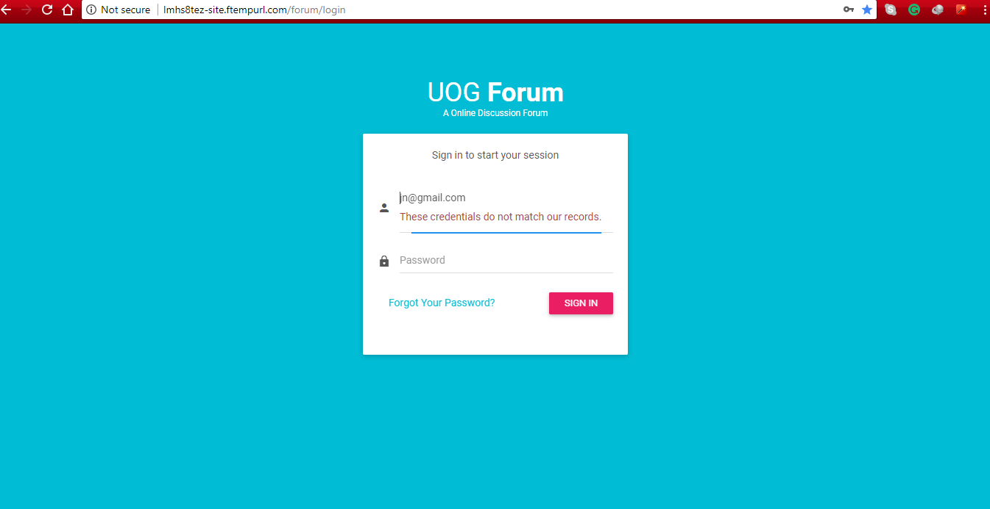

**Figure 28: Not valid Email Address check**

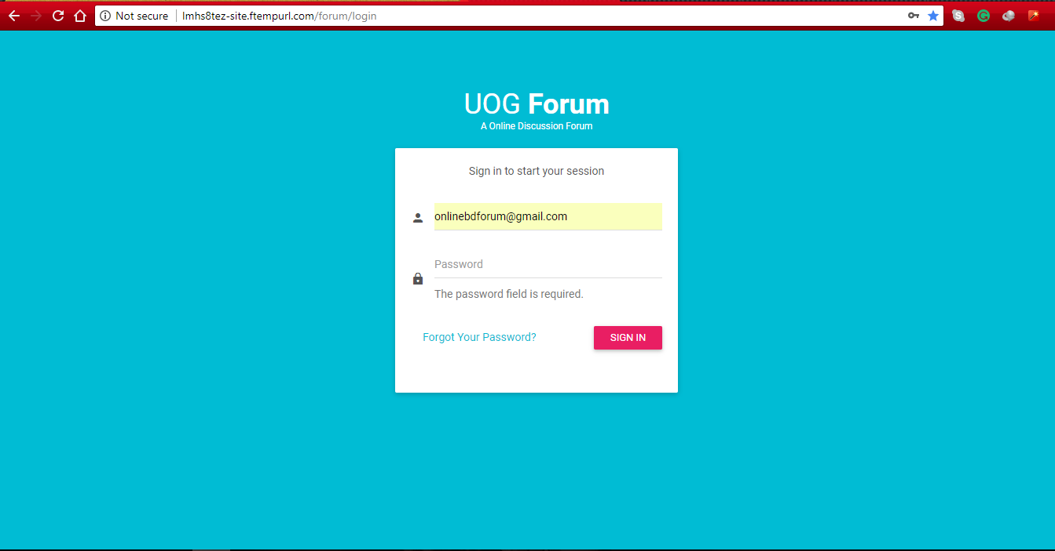

**Figure 29: Password Field can't be blank**

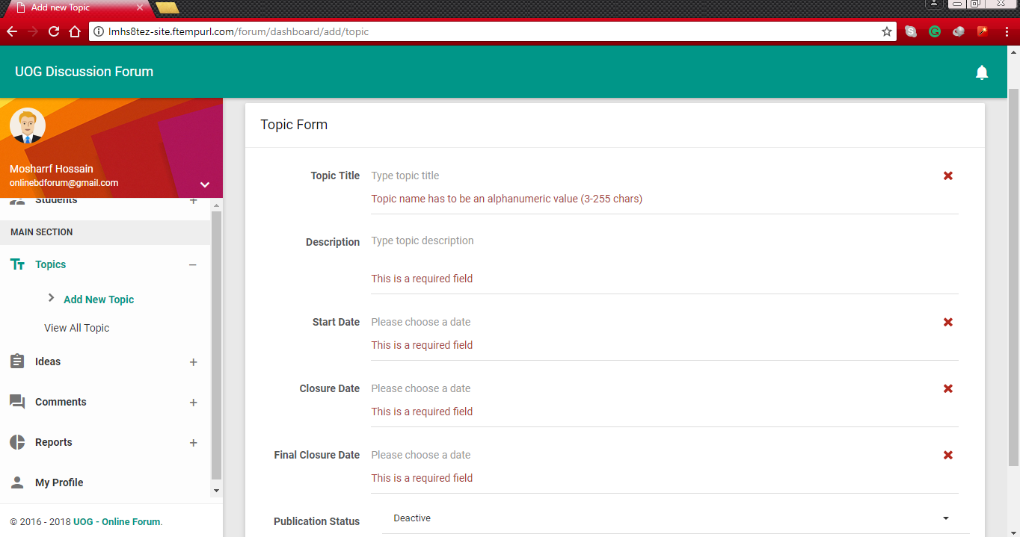

**Figure 30: If field is blanked then validation message will show**

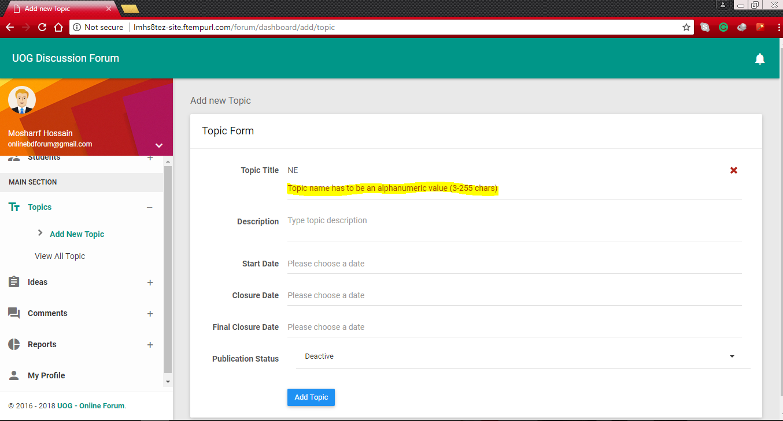

**Figure 31: Topic Title must be in 3 Words**

**Responsive Testing:**

It is an approach to design intended at creating sites to provide a best viewing experience like easily reading and navigation with a minimum of resizing, planning and scrolling across a wide range of devices. This system is tested on various devices like computer, laptop, pc, mobile, tablet with the different screened devices and it passed all the tested and run efficiently. In the below a figure is given for this testing-

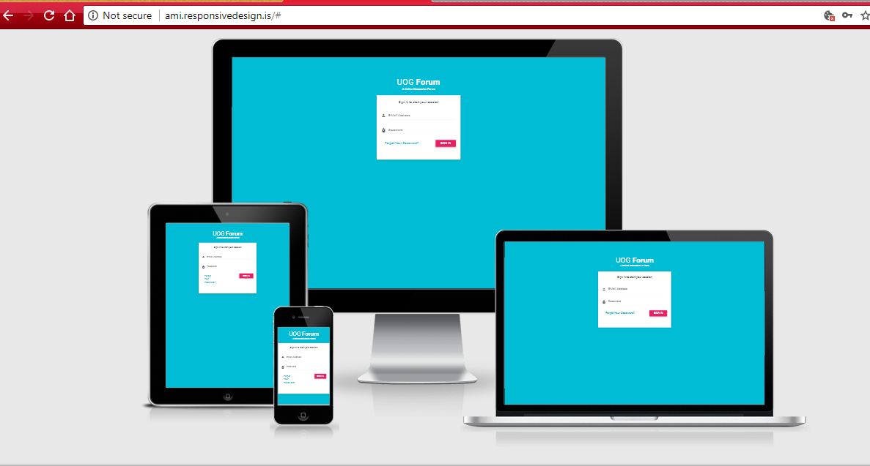  
[http://ami.responsivedesign.is/#](http://ami.responsivedesign.is/)

**Figure 32: The system show properly all type of display**

**Performance Testing:**

This testing evaluate the response time or speed. Throughput and utilization of the system to execute its required functions in comparison with different versions of the same product which is called as a Performance testing. In the below there is given of my application performance-

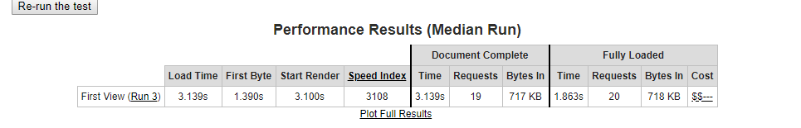

**Figure 33: Performance Testing**

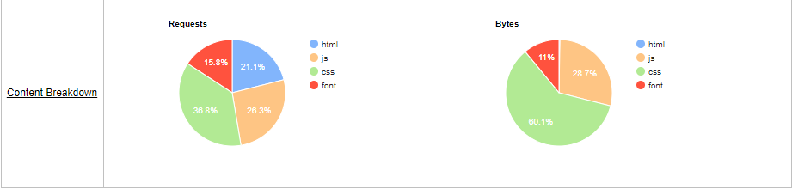

**Figure 34: Performance Testing PIE Chart**

**Functionality Testing:**

It’s a process used within software development in which software is tested to ensure that it confirms with all requirements. It’s a way off checking software to ensure that it has all the required functionality that specified within its functional requirements. Some of the functional testing of the system is given below –

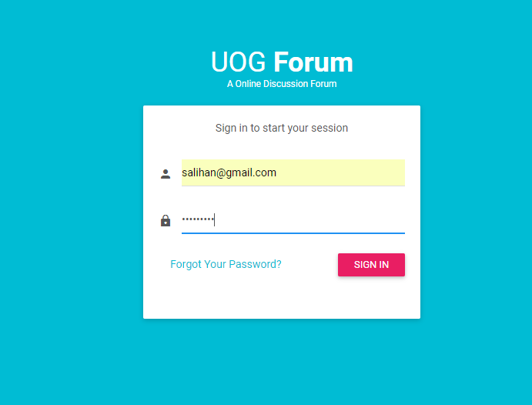

**Figure 35: Student user name and password entered**

**Figure 36: Login Successful in student user Interface**

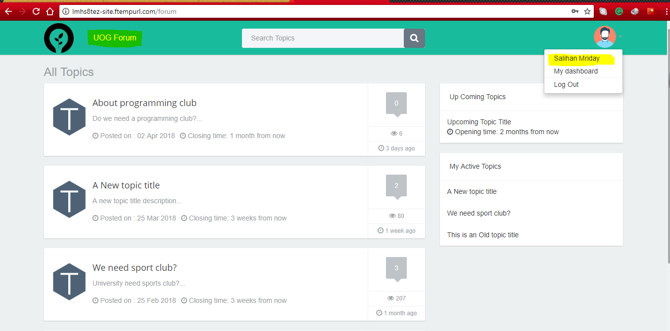

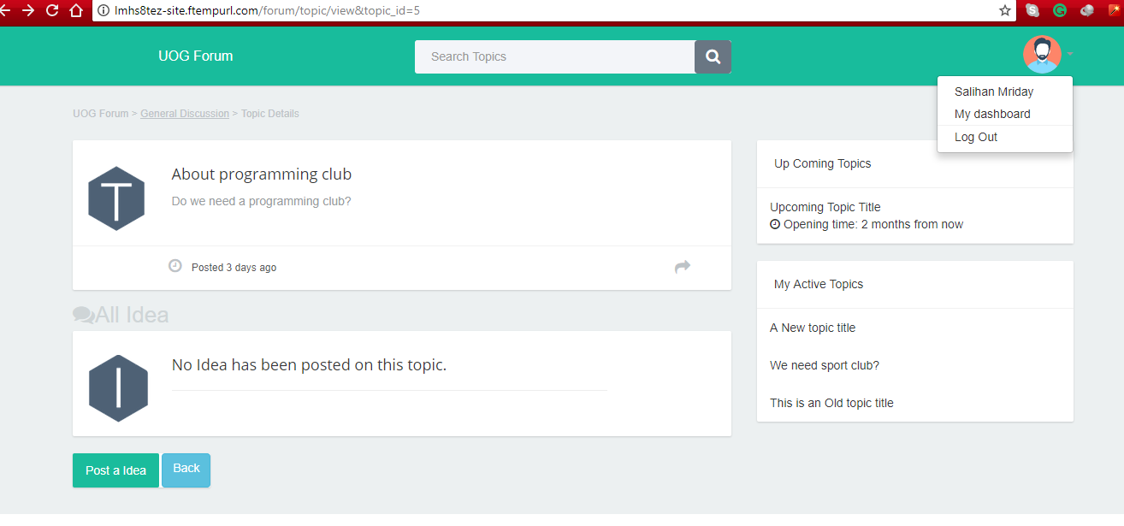

Post Idea as a student

**Figure 37: Select idea button for posting idea under a topic**

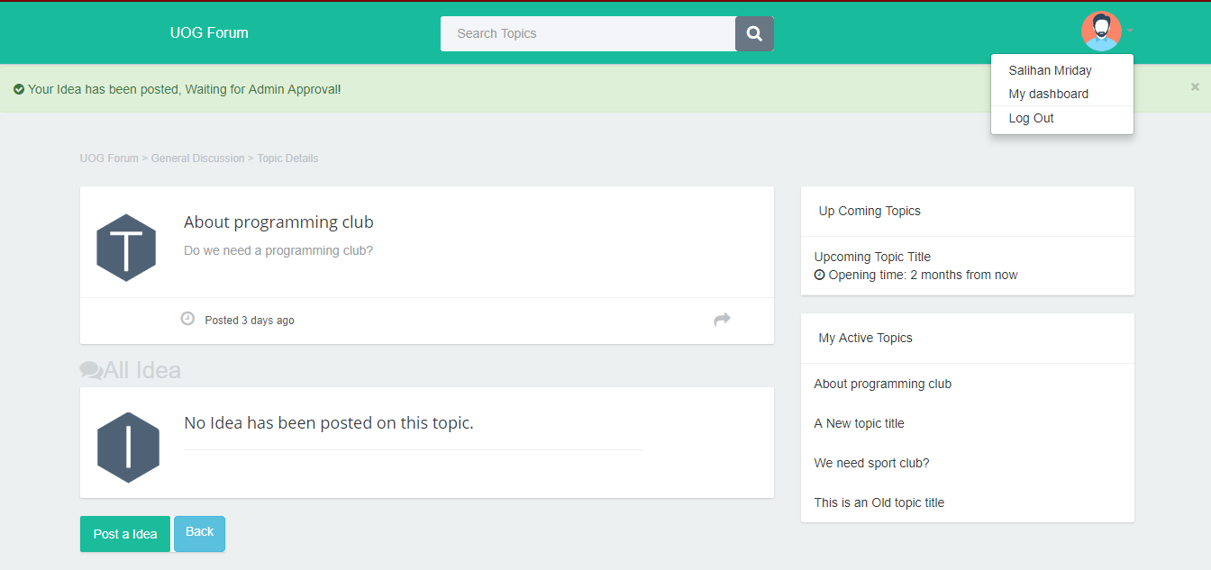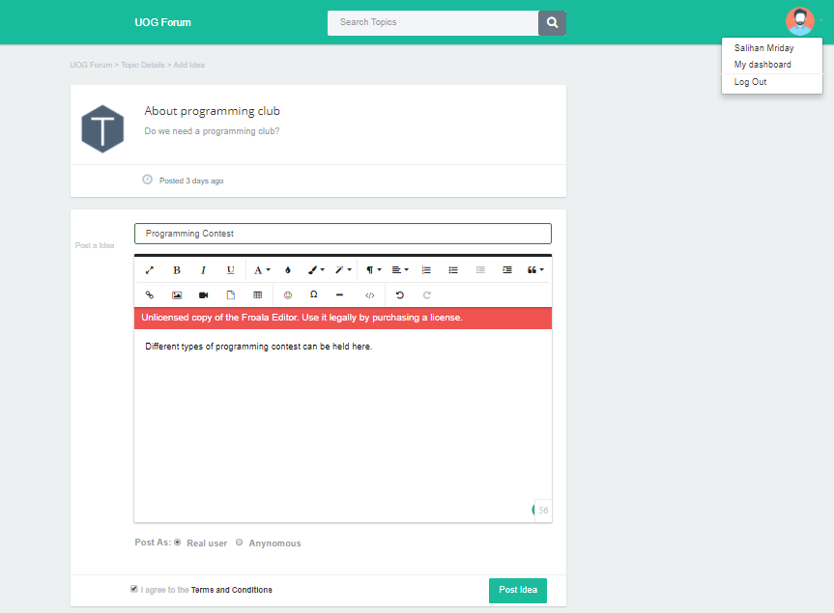

**Figure 38: Idea will be posted after admin approval**

**Figure 39: Insert Idea Title, description, real name or anonymous**

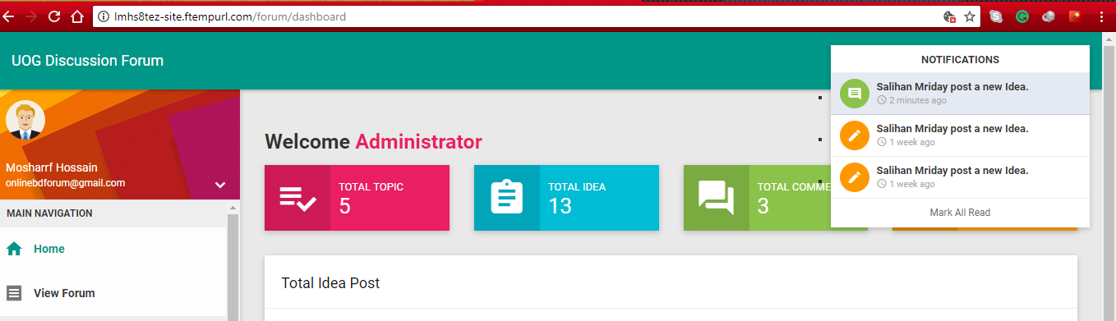

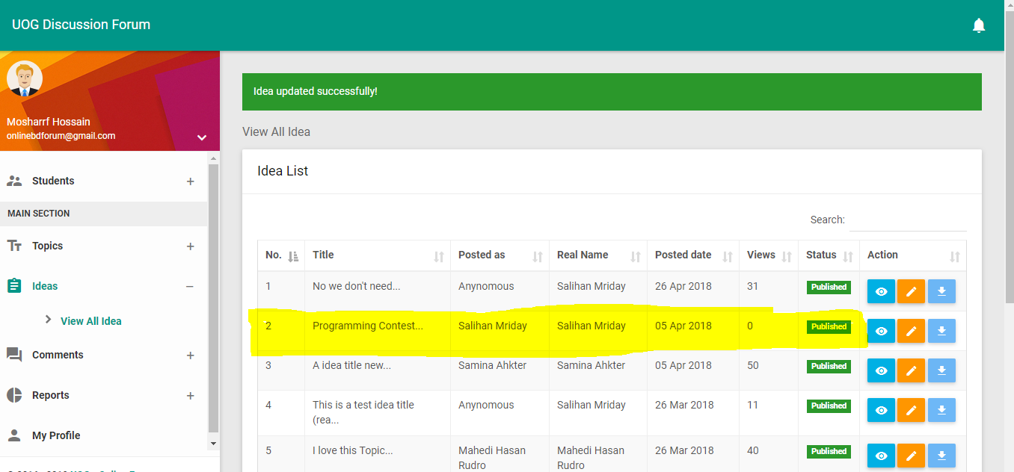

**Figure 40: Admin get notification for new idea**

**Figure 41: Admin Approve the Idea**

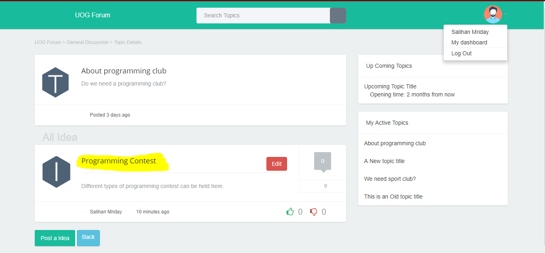

**Figure 42: Idea Successfully Posted**

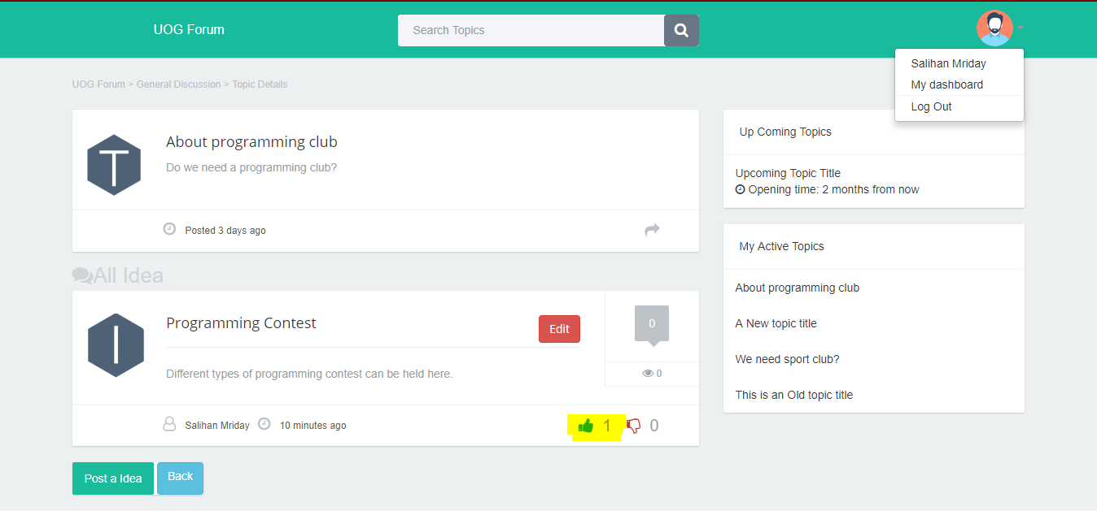

**Figure 43: Give Thumbs Up for the Idea**

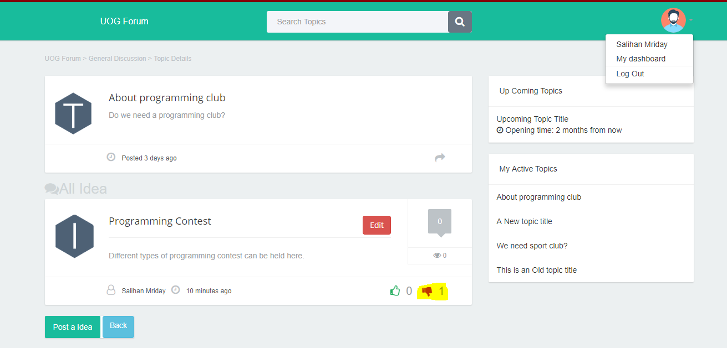

**Figure 44: Can give Thumbs Down for Idea**

**Compatibility Testing:**

This software testing is used to ensure compatibility of the system built with carious objects such as other web browser, hardware platforms, and user’s requirements.

**Usability Testing:**

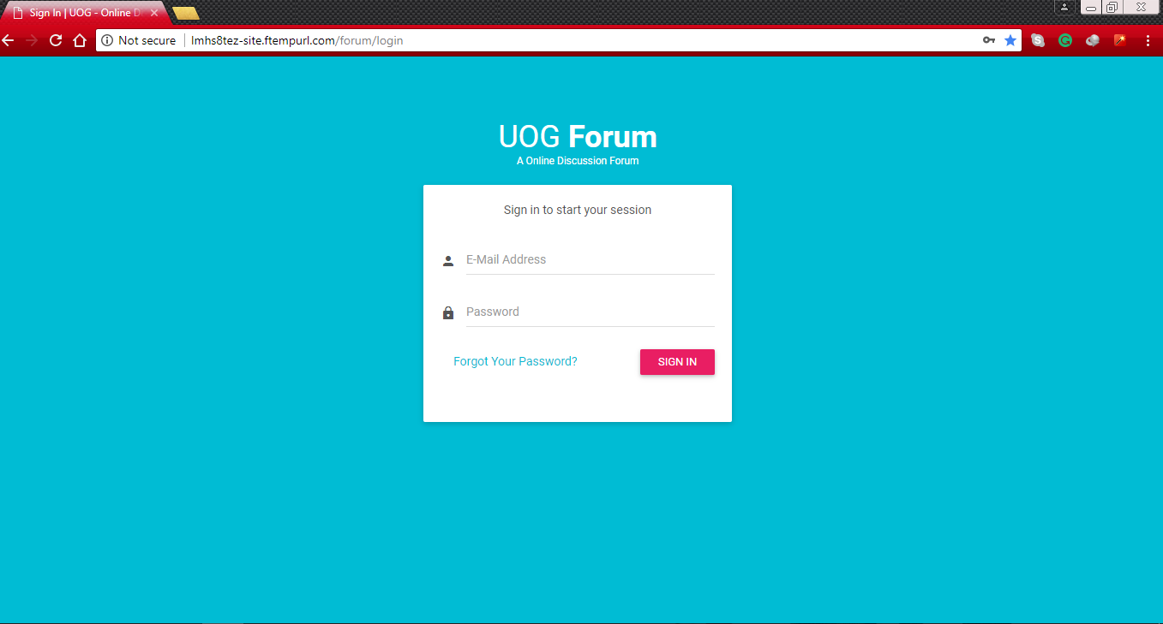It’s a technique used in user-centered interaction design to evaluate a product by testing it on user. This can be seen as an irreplaceable usability practice when it gives direct input on how real users use the system. Particular testing of usability is given below –

**Figure 45: Manager and Student Login**

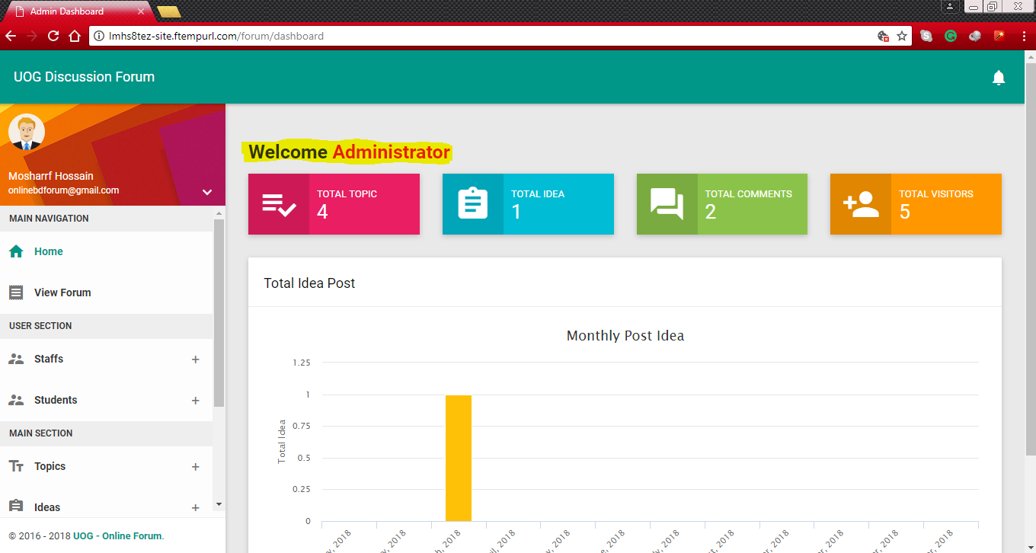

Instruction for Admin

PIE chart for Posting Idea

Admin Navigation Bar

**Figure 46: All Functions are available here for Admin to manage**

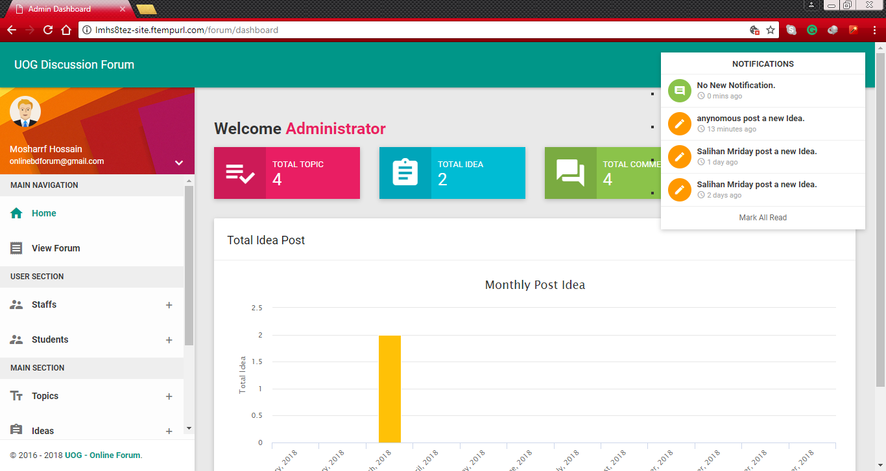

Notification Bar for Admin

**Figure 47: Notification bar for Admin**

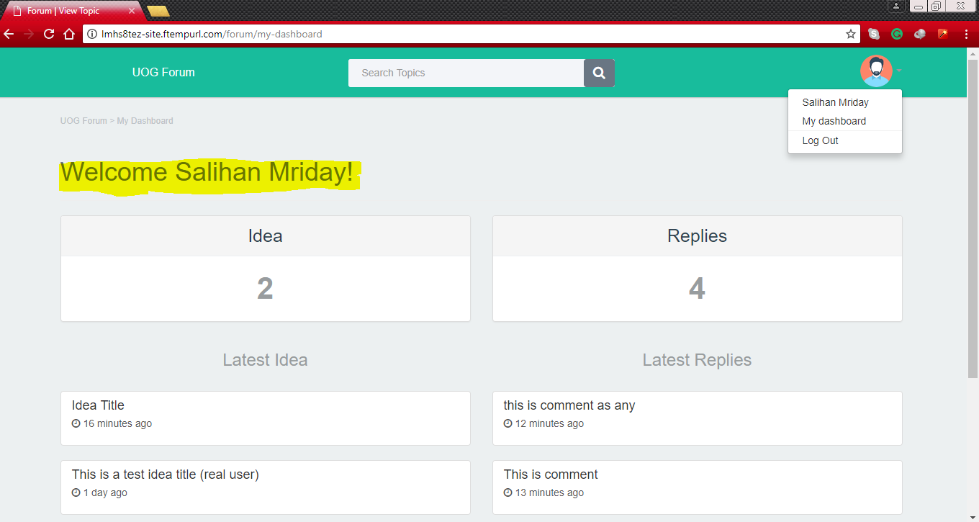

Can Search Ideas

Can see Replies of Idea

Can see Posted Idea

Student Navigation Bar

As a Student Login

**Figure 48: Correct Student Managing functional are available here**

**Database Testing:**

This testing involves the database connect successfully to the system. It performs module testing of database functions, triggers, views, SQL queries. It validated database tables, data models, database schema etc. Determining system by CRUD which more efficient database. Particular database testing of the system is shown here –

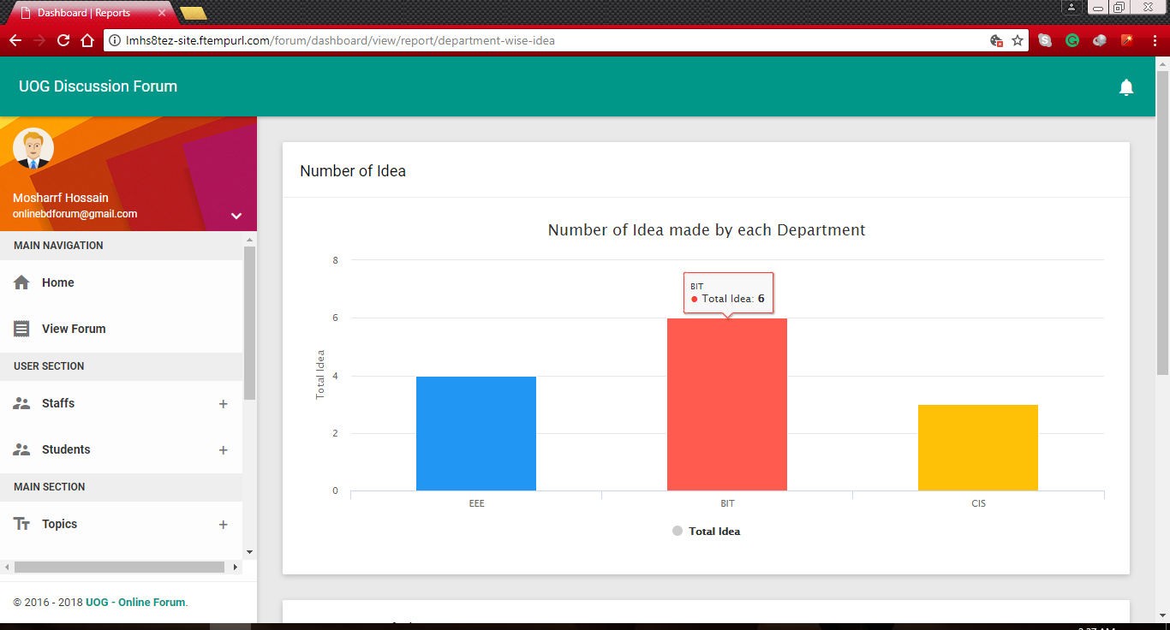

**Figure 49: Successfully connected to the system**

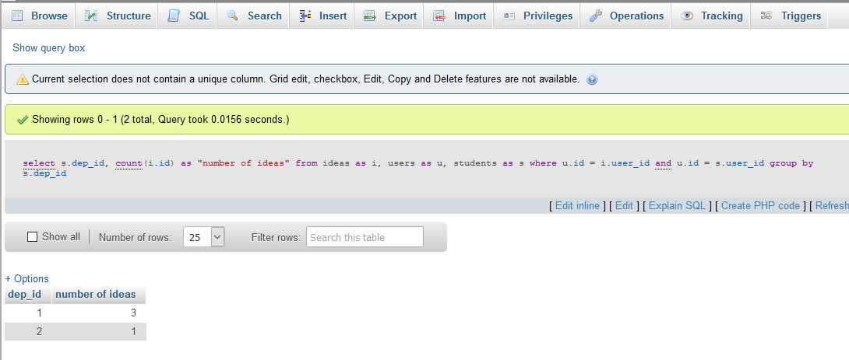

**Figure 50: Query run successfully in the database**

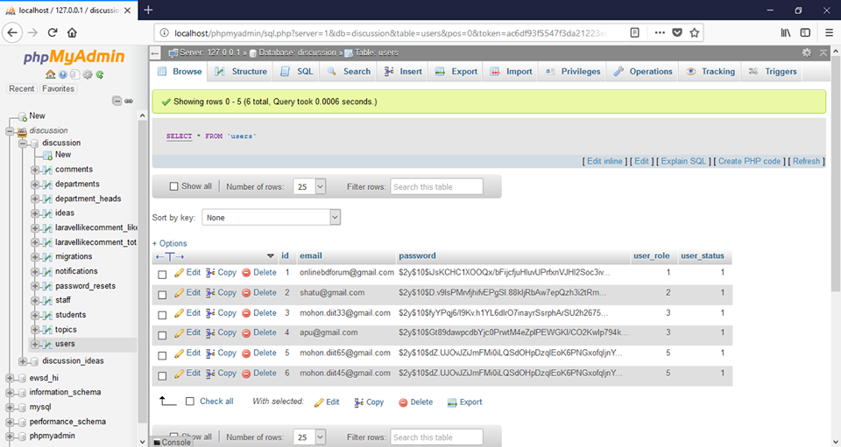

Password Encrypted

**Figure 51: Encrypted password in Database**

**Block unauthorized testing:**

It means if any one tried with wrong information can’t access in the system as well as uncertainty a person input wrong information at least 5 times then system will block this unauthorized person for 18 second. Here few testing of it is shown –

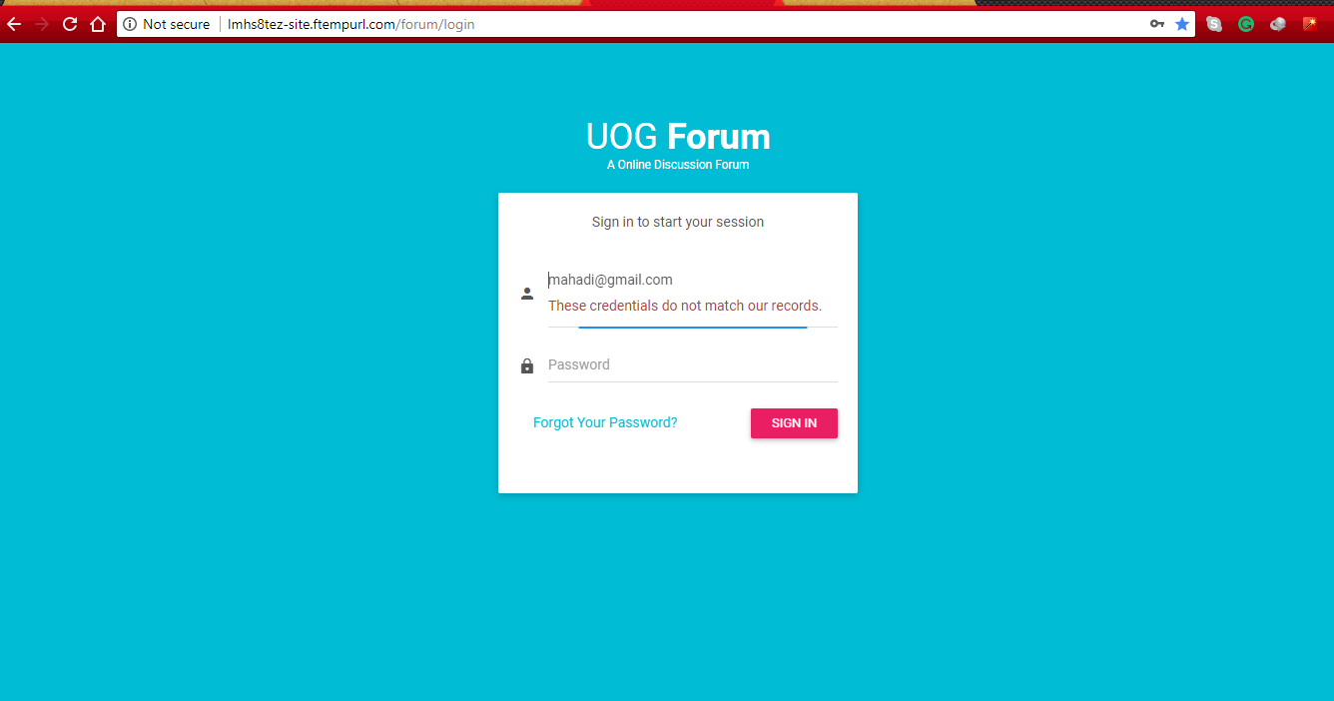

**Figure 52: Information doesn't match**

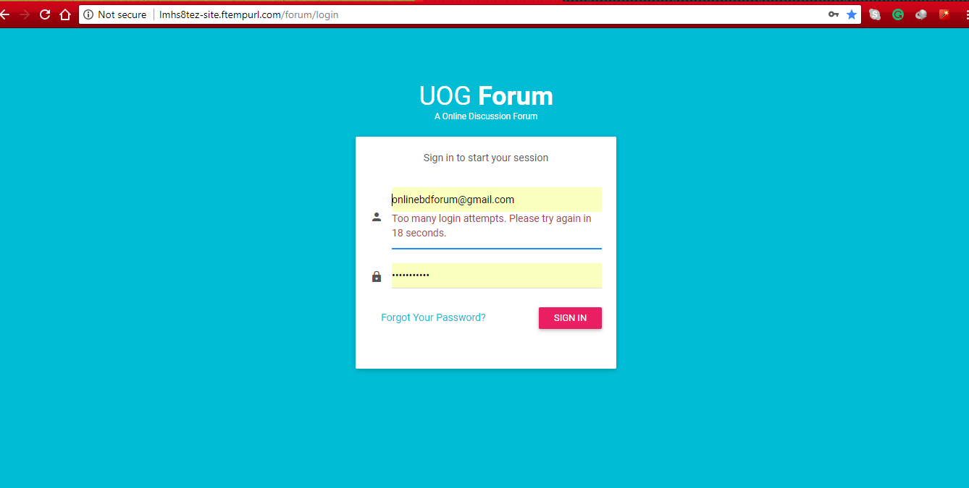

**Figure 53: Block Unauthorized users for few time**

**SQL Injection testing:**

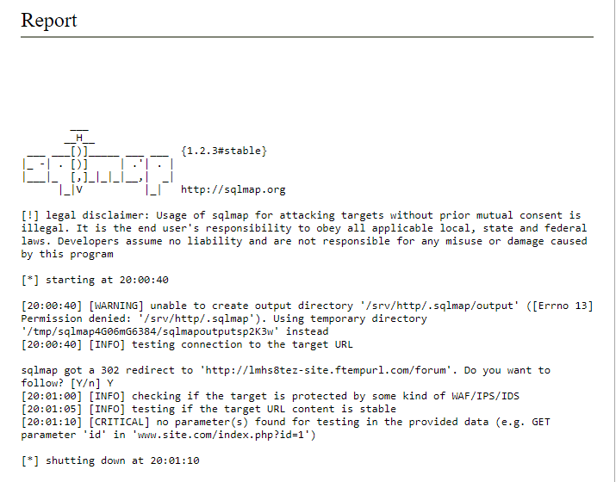This is consists of insertion or injection of a SQL query via the input data from the client to the application. This testing is need for seeing how much my database is strong enough to protect attack.

**Figure 54: SQL Injection Test Report**

**Crowd Testing:**

This testing is directed by analyzer in related with a gathering of non-specialized individual. This follows how the gathering tell about the item and their input about your product. Additionally guarantee the execution, convenience of the framework from their point of view on the off chance that they can rest easy