Name: Mahamudul Hasan
ID: 1000060317 ,Course code: CSE729
Github Repo link:

Experiment 1 — Effect of Miner Count
Task 1

Question: What happens to the percentage of mined blocks of an individual miner as the total miner count increases?
Answer: As the total miner count increases, the percentage of blocks mined by Miner 0 decreases. This happens because Miner 0 has a fixed hash power (e.g., 50). As new miners are added to the network, the total computational power (hash rate) of the entire network grows. Consequently, Miner 0's computational power represents a smaller and smaller fraction of the total network, lowering their probability of solving the next block.

Question: What will probably happen to the profit of that miner if the miner count remains the same over time?
Answer: If the total miner count and the network's overall hash power remain the same over time, the miner's relative share of the network's computational power stays constant. Because their probability of mining a block does not change, their expected profit over a given timeframe will remain stable and consistent. However, in a real-world Bitcoin scenario, even if the miner count remains exactly the same, the miner's overall profit will eventually drop in the long term due to the block reward halving mechanism.

Experiment 2 — Effect of Block Interval
Task 2

B.
The Question: What happens to the stale rate as Binterval increases?
The Answer: As the block interval increases, the stale rate strictly decreases. This occurs because network latency (the time it takes for a newly mined block to propagate to all other nodes) becomes a much smaller fraction of the total block creation time. With a very short interval (e.g., 10 seconds), miners are frequently solving blocks at the exact same time before they have a chance to hear about each other's blocks, leading to high collisions and 'orphan' or stale blocks. With a longer interval (e.g., 320 seconds), the network has more than enough time to synchronize, ensuring all miners are building on the same updated chain, which drastically reduces the stale rate.

Experiment 3 — Implementing FIFO Transaction Ordering
Task 3
A.
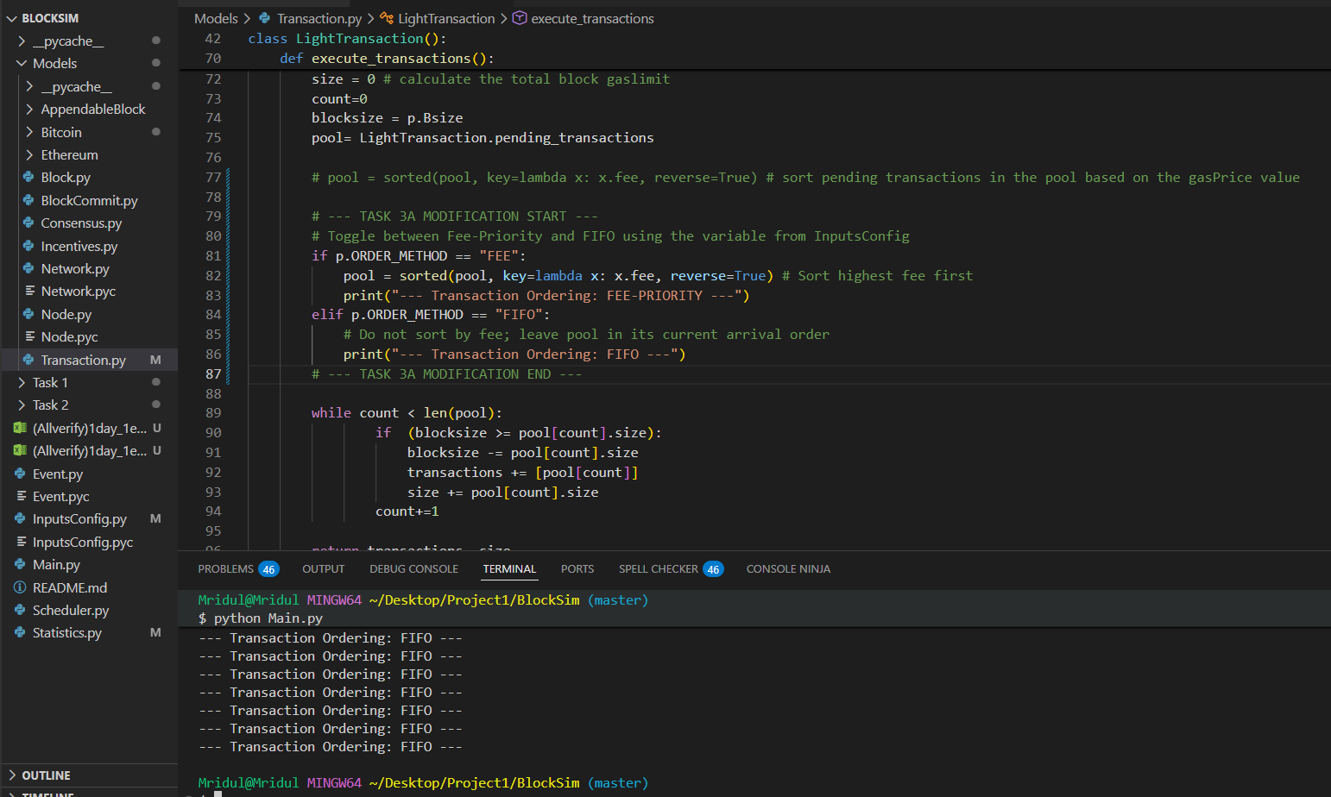
B.

1. Fairness to Users (The "Pros" of FIFO)
Under the default fee-priority model, blockchains act like a bidding war. Users who attach higher fees to their transactions get processed first, while those who attach lower fees get pushed to the back of the queue.
- Predictability and Equality: FIFO ordering completely removes this bidding war. The primary advantage of FIFO is strict egalitarian fairness—every transaction is processed in the exact order it arrives in the mempool (pending pool), regardless of the user's financial status.
- Protection for Average Users: In a fee-priority model, during times of high network congestion, the cost to transact can skyrocket. This prices out average users who are trying to send small amounts. FIFO ensures that small, everyday transactions are treated with the exact same priority as massive institutional transfers.

2. Miner Incentives (The "Cons" of FIFO)
Miners are rational, profit-seeking entities. They expend massive amounts of electricity and hardware costs to secure the network, and they rely on block rewards and transaction fees to stay profitable.
- Loss of Revenue Optimization: The default fee-priority model is a profit-maximizing strategy for miners. By allowing them to cherry-pick the most lucrative transactions, they maximize their return on investment. FIFO entirely strips away this ability, forcing miners to process whatever is next in line, which drastically lowers their potential fee revenue.
- Threat to Network Security: If mining becomes less profitable because miners can no longer prioritize high-fee transactions, some miners may be forced to shut down their operations. A drop in the total number of miners (and overall hash rate) makes the entire blockchain less secure and more vulnerable to attacks.

3. Systemic Vulnerability (The "Hidden" Con of FIFO)
While the assignment specifically asks about fairness and incentives, adding this point will show a deep understanding of blockchain mechanics:
- Spam and DDoS Attacks: Fee-priority naturally protects the network from spam. If a malicious actor wants to flood the network with millions of fake transactions to clog it up, a fee-priority system forces them to pay exorbitant fees to do so, making the attack financially unsustainable. If the network uses FIFO, an attacker could flood the mempool with zero-fee or micro-fee transactions, and miners would be forced to process them, effectively halting legitimate network traffic.

Experiment 4 — Implementing Block Reward Halving
Task 4

B.
The Question: Based on your simulation results and the reward formula above, what happens to a miner's block reward as the number of halvings increases? What does this imply for Bitcoin once the block reward eventually rounds down to zero — where would miner revenue have to come from instead? Does a transaction ordering model such as FIFO or fee-based (fee-priority) ordering help address this situation? Explain your reasoning, referring back to what you observed in Experiment 3.

The Answer:
1. The Effect of Halvings on Block Rewards As the number of halvings increases, the block reward awarded to the miner decreases exponentially. Because the reward is divided by 2 at every predefined interval, the newly minted Bitcoin injected into the network gets smaller over time, enforcing a disinflationary supply schedule.
2. The Shift in Miner Revenue When the block reward eventually drops so low that it rounds down to zero, miners will no longer receive any newly created Bitcoin for finding a block. At this point, miner revenue must come entirely from transaction fees paid by users to have their transactions included in the ledger.
3. The Role of Transaction Ordering (Connecting to Experiment 3) A fee-based (fee-priority) ordering model is absolutely vital for the blockchain's survival once the block reward hits zero.
- If the network used the FIFO model observed in Experiment 3, users would have no incentive to attach fees to their transactions, because paying a fee would not get their transaction processed any faster. Without a block reward and without fee competition, miner revenue would drop to zero. Miners would shut down their hardware, destroying the network's security.
- The fee-priority model solves this situation by creating a competitive fee market. Users bid for block space, ensuring that even when the halving mechanism reduces the block reward to zero, miners are still highly incentivized to secure the network using the collected transaction fees.

