MLOps Experimental Learning Assignment: End-to-End ML Model Development, CI/CD, and Production Deployment

(HEART Disease UCI ML Project)
Semester -3 (Group 86)
Contributed By:
2024AB05052 - MOHAMED NASIR MH
2024AA05854 - NAVEEN PAHAL
2024AB05217 - MITHUN M PILLAI
2024AA05854 - MANDEEP KUMAR
2023WD86009 - VAISHNAVI S

Introduction and AIM
This project demonstrates an end-to-end MLOps pipeline for heart disease prediction using the UCI Heart Disease dataset. The goal is to build, deploy, and monitor a scalable ML system using industry-standard MLOps practices with CI/CD.

Problem Statement
To predict whether a patient is at risk of heart disease based on medical attributes such as age, cholesterol, blood pressure, and ECG results, and deploy the trained model as a production-ready API.

Dataset Description
The UCI Heart Disease dataset contains 14 attributes and a binary target variable. It is widely used for benchmarking classification models in healthcare analytics.The UCI Heart Disease dataset contains 14 attributes and a binary target variable

1 ) Data Acquisition and EDA
The dataset was downloaded from the UCI repository. Exploratory Data Analysis (EDA) was conducted to understand feature distributions, detect outliers, and analyze correlations using visualizations.
Source Used in Data Acquisition: UCI Machine Learning Repository
It’s downloaded as a CSV file and cleaned up and available in the git repository
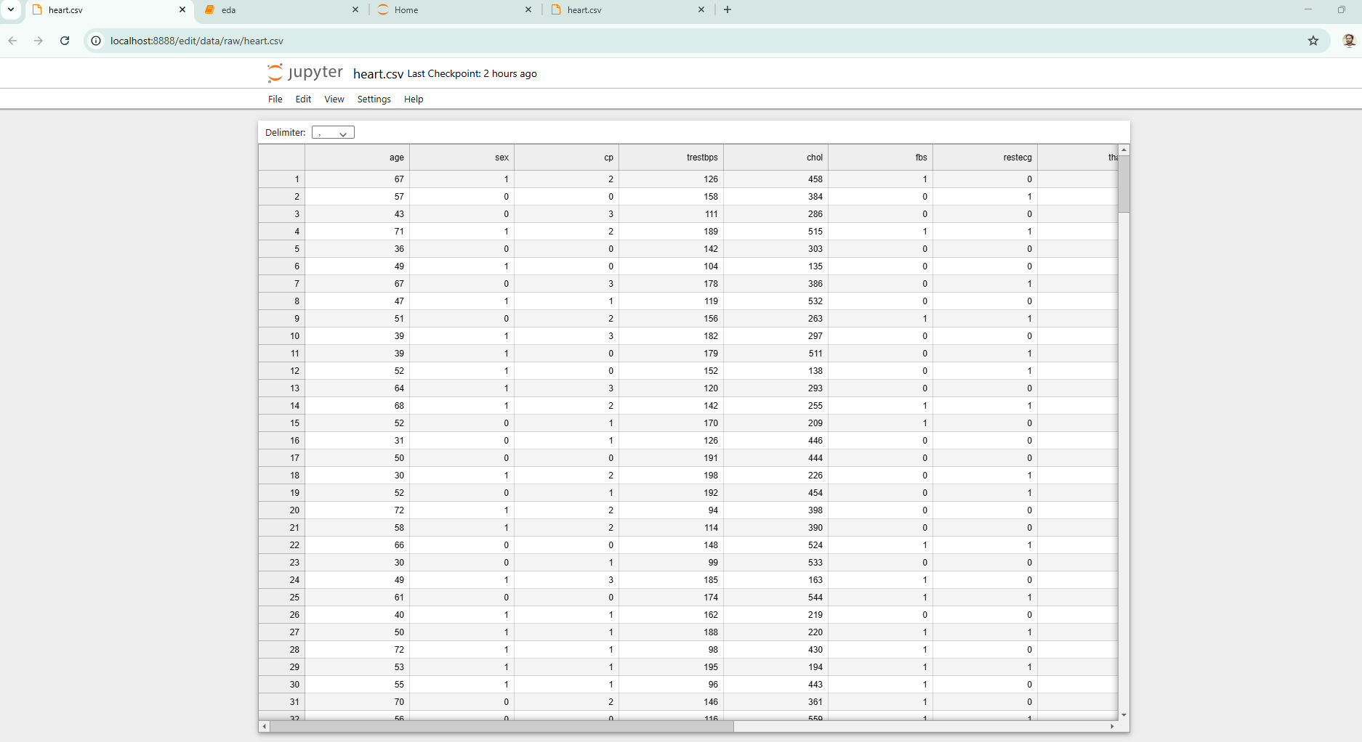
Screen Shot Showing the Clean Up Data:

Data Set / Histogram:
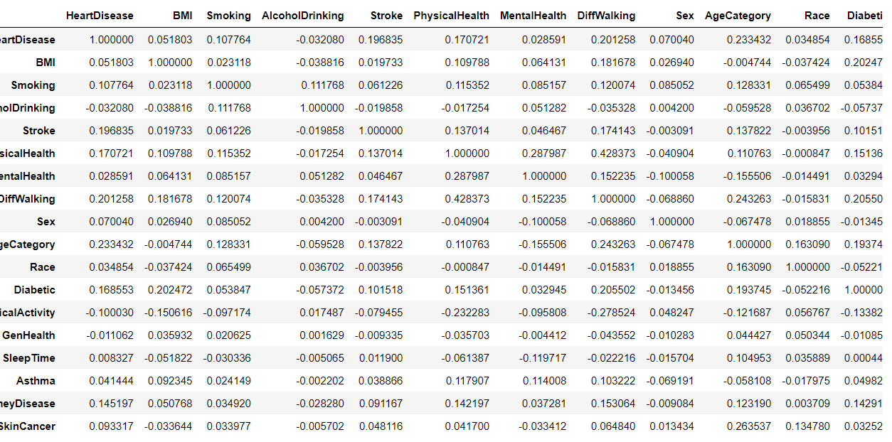

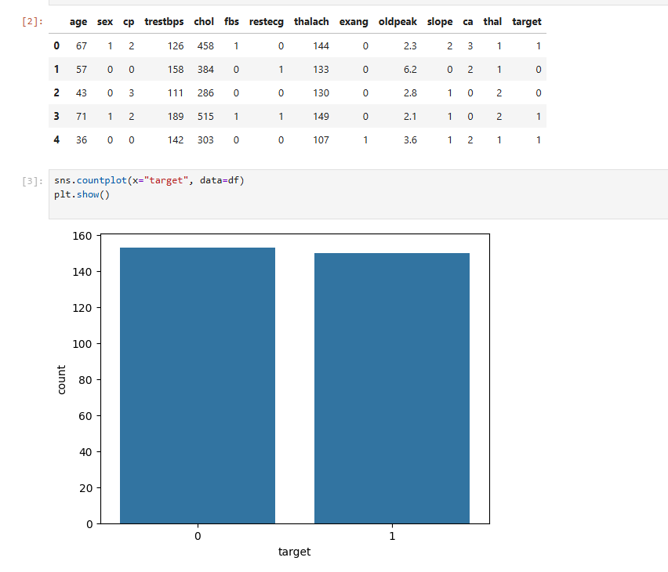
Histogram: Age .
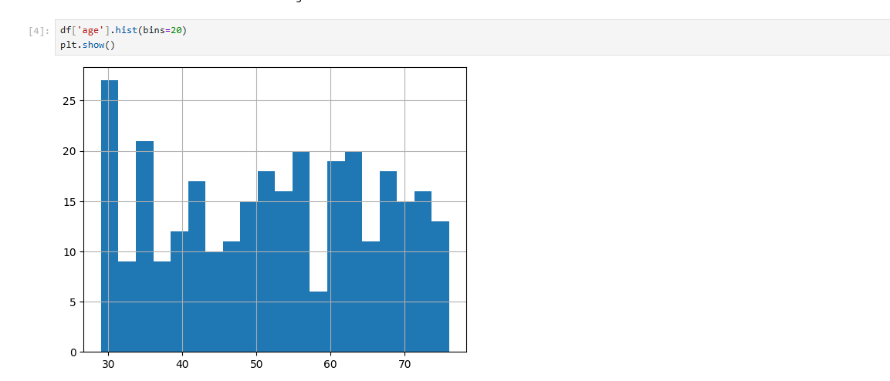

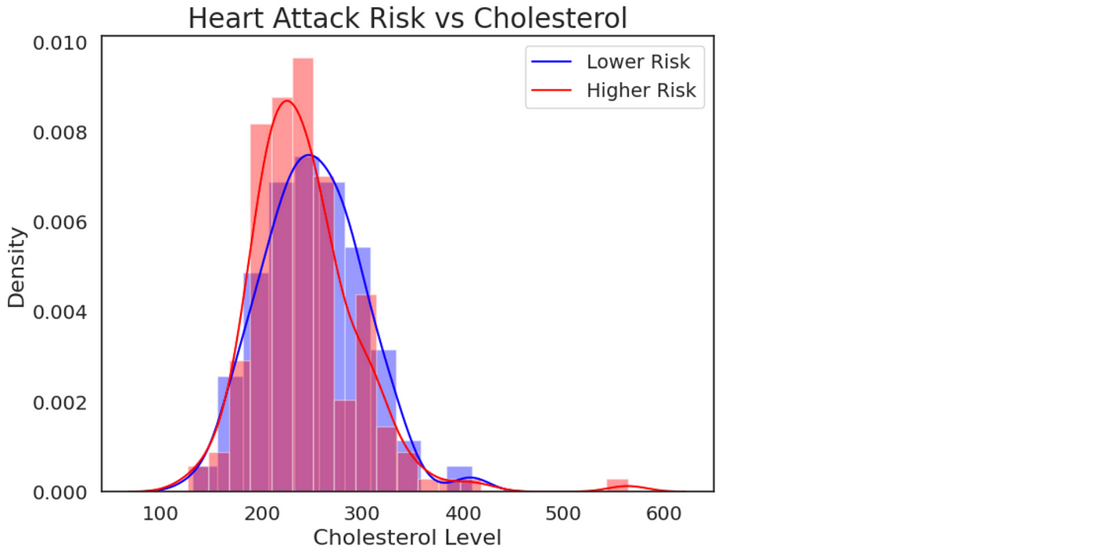

Heat Map :
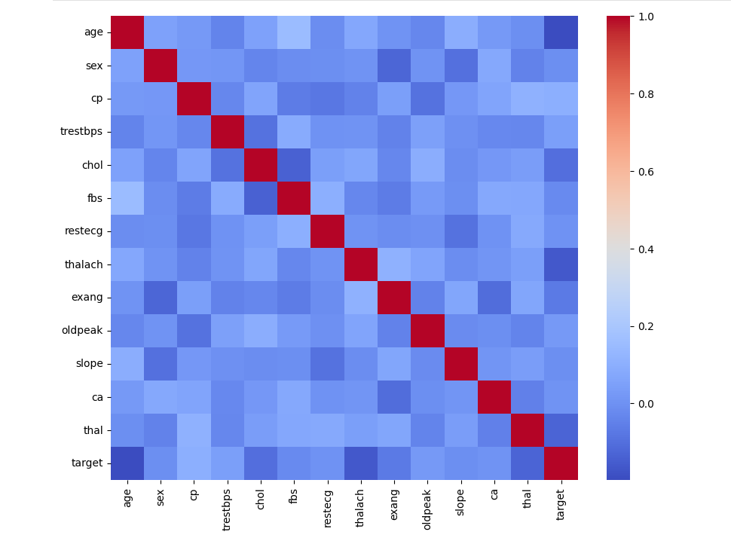

2) Feature Engineering
Numerical features were scaled using StandardScaler. Categorical values were encoded where necessary.
Two models were trained: Logistic Regression and Random Forest. Model performance was evaluated using accuracy and ROC-AUC metrics.
SS : Model training pipeline execution with Logistic Regression and Random Forest.
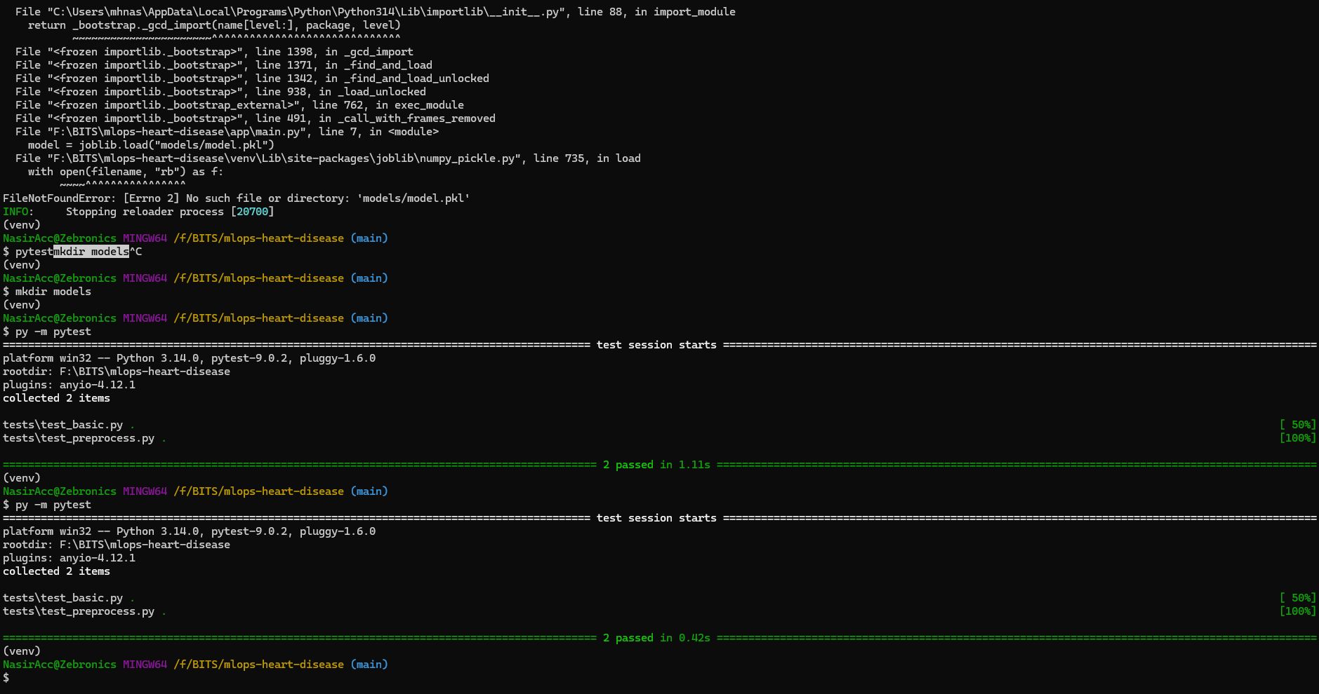

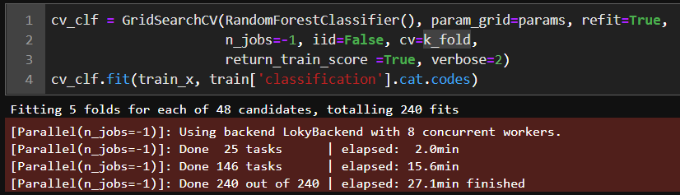

3) Experiment Tracking – MLflow
MLflow was integrated to log experiments, parameters, metrics, and models, enabling reproducibility and comparison.MLflow was integrated to log experiments, parameters, metrics, and models, enabling reproducibility and comparison.MLflow was integrated to log experiments, parameters, metrics, and models, enabling reproducibility and comparison
Below has the screen shot for the ml flow – Experiment Tracking
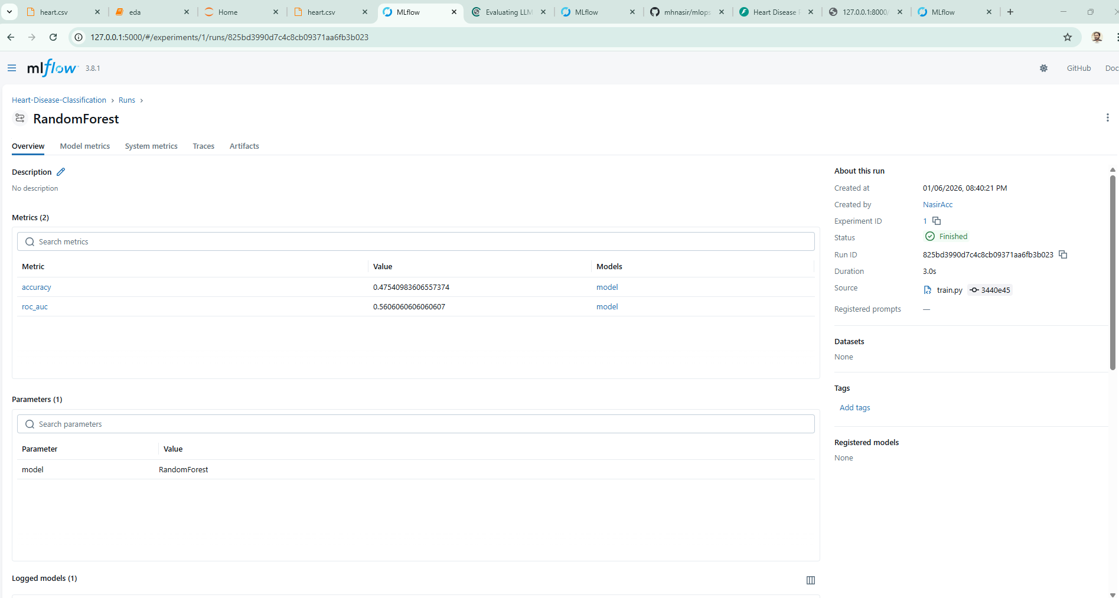
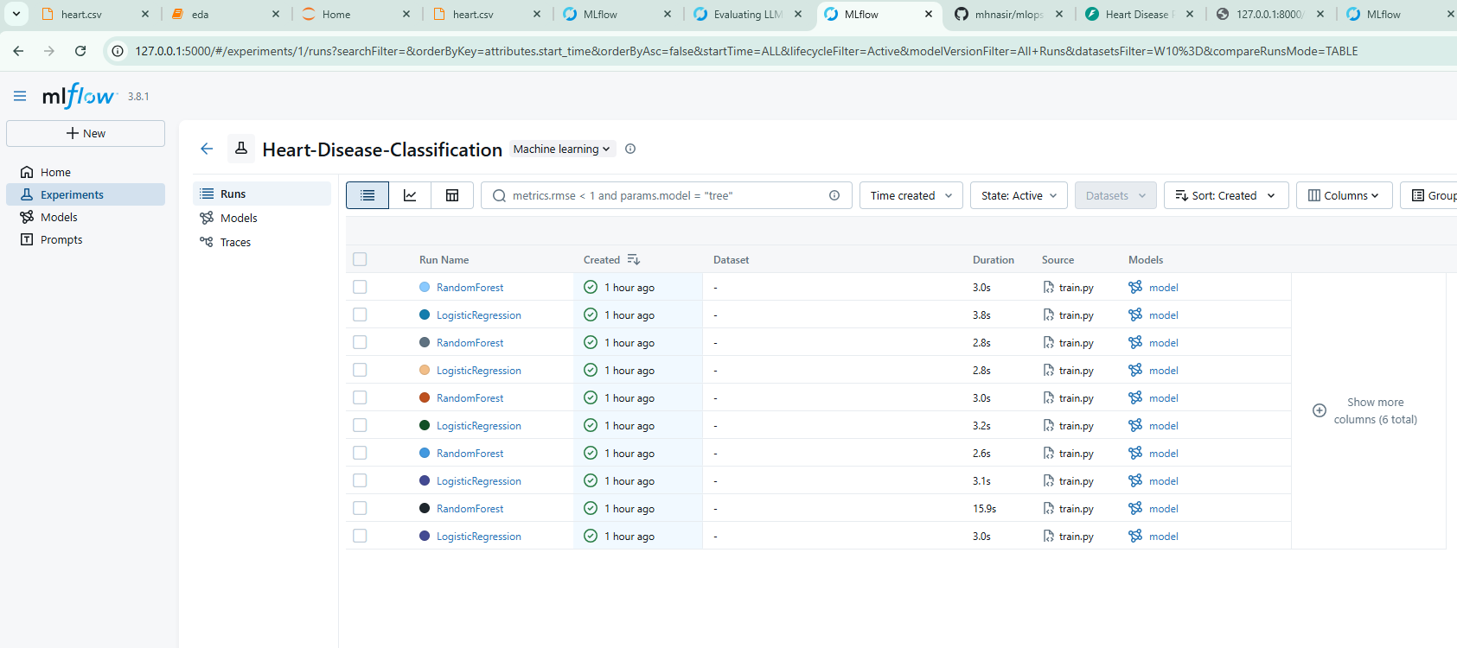
Experiment Track: SS Running in LocalHost (MLflow dashboard showing experiment runs, parameters, and evaluation metrics.)
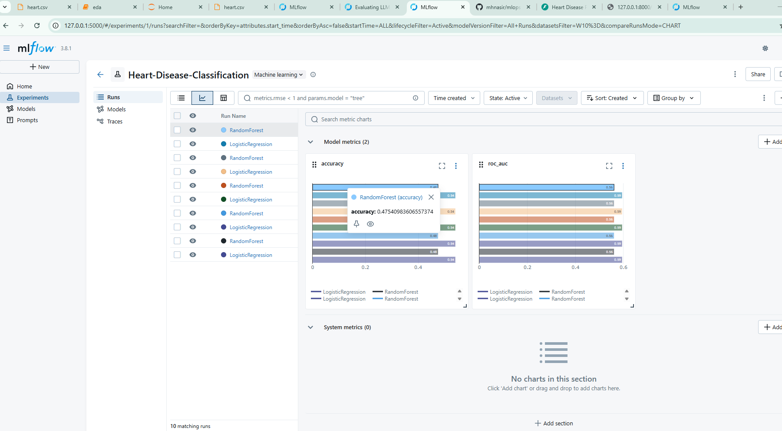

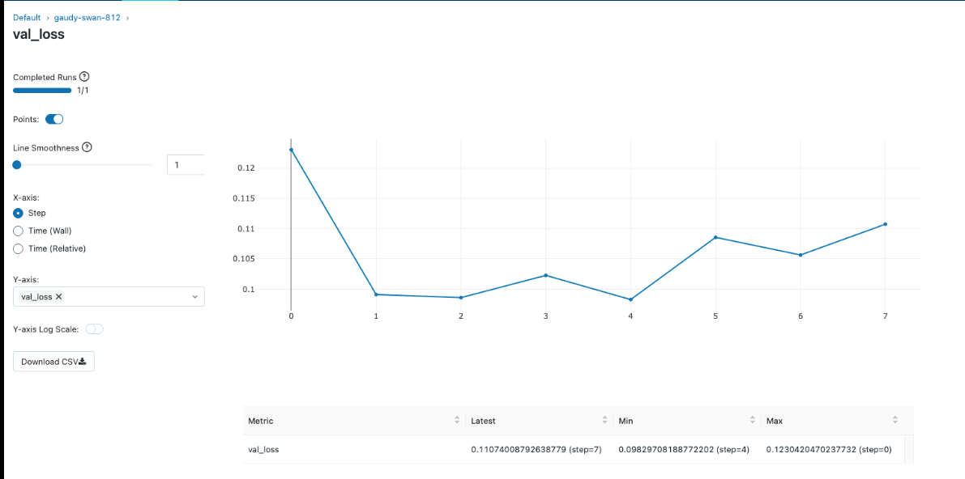

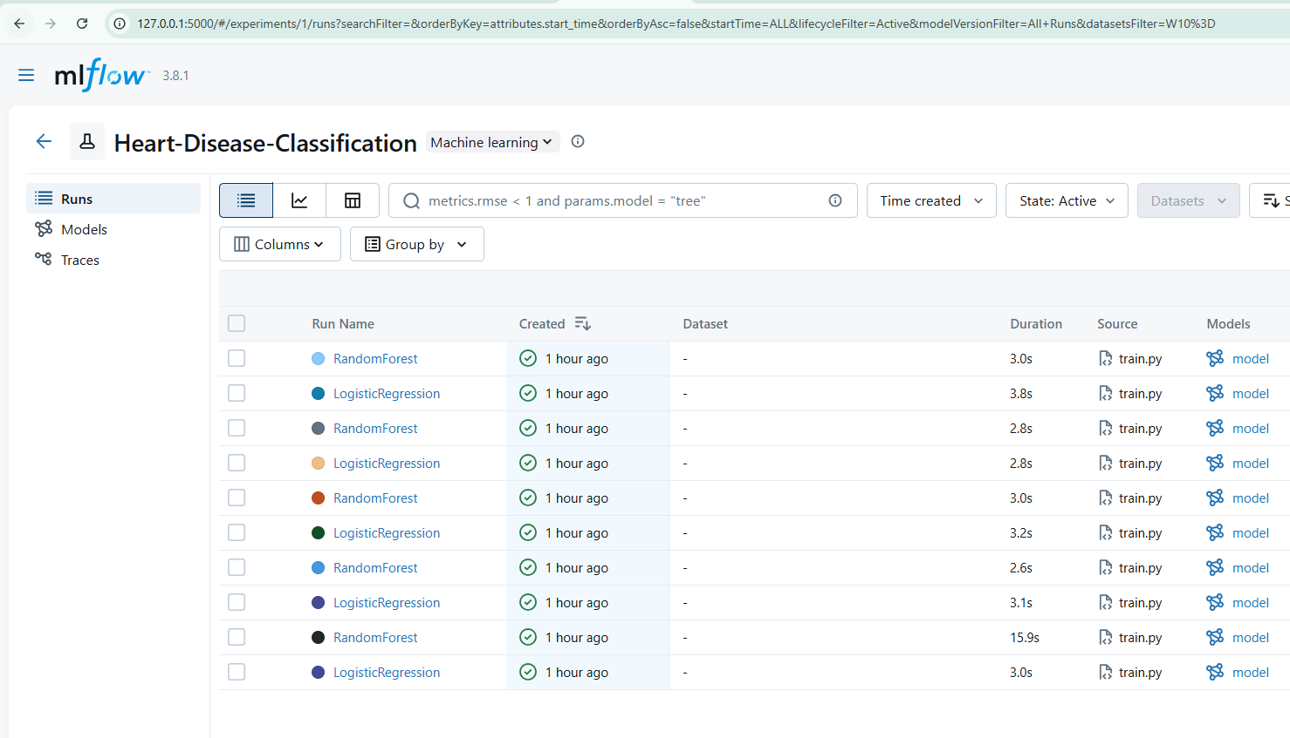

4) Model Packaging & Reproducibility ( Saved Model and Reproducibility Files etc)
MODEL FLOW: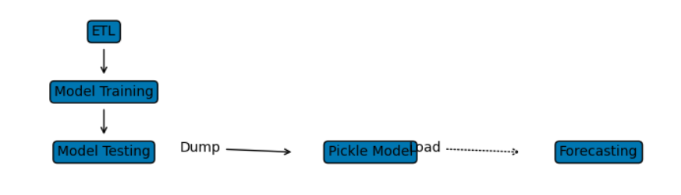
Saved Model
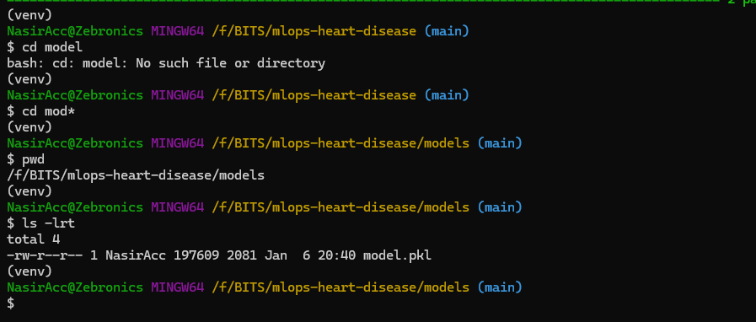
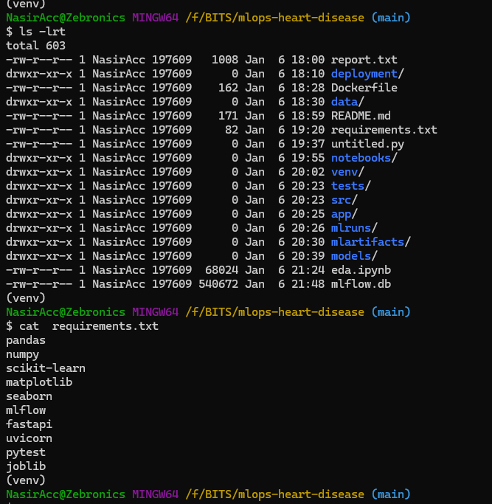
Packaged Requirements: SS from GIT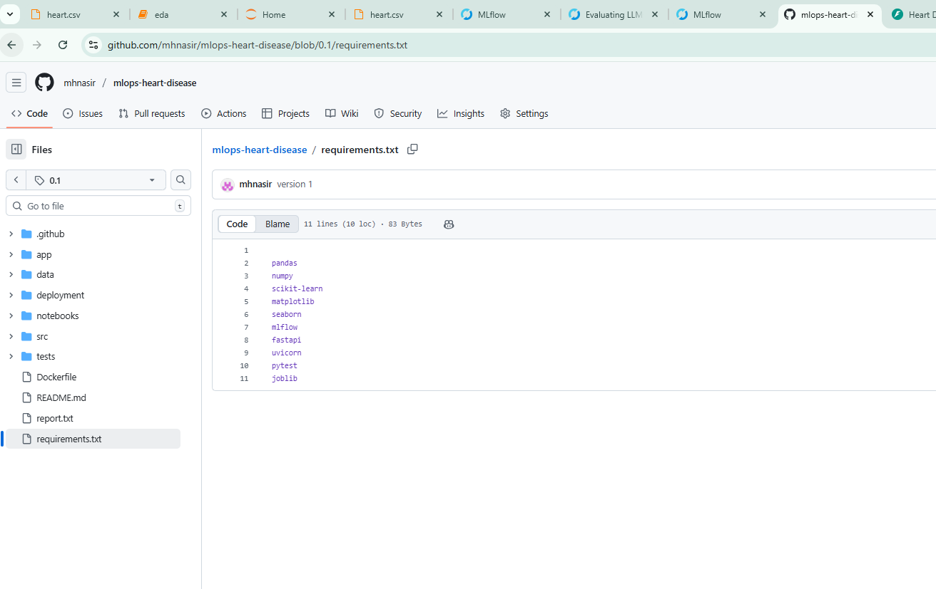

5) CI/CD Pipeline
GitHub Actions was used to implement CI/CD, including automated testing and training on every code push.
(Automated testing and CI pipeline execution using GitHub Actions.)
PyTest Passed
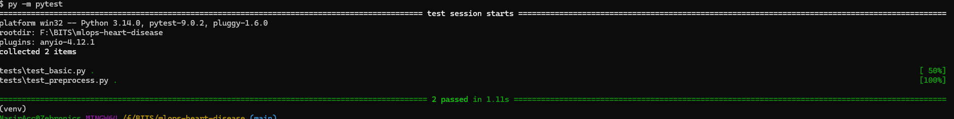

Git Hub – Auto deployment Showing Deployed
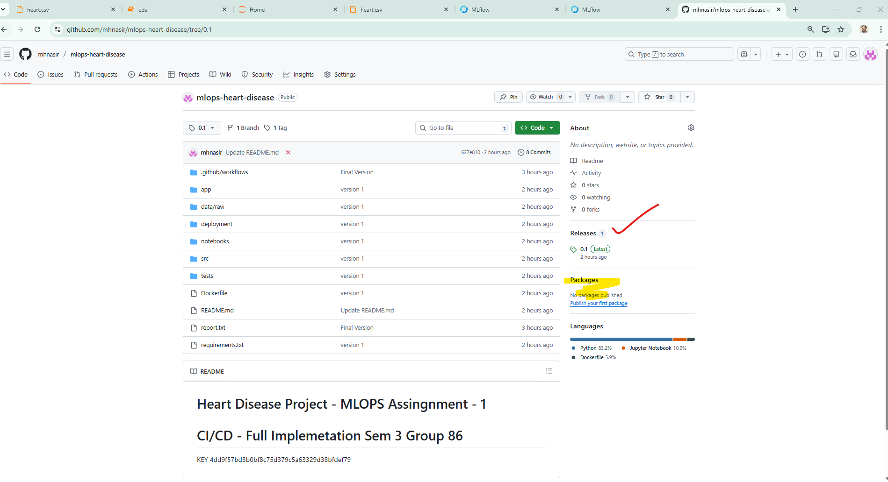

6) Containerization and Deployment
The FastAPI inference service was containerized using Docker and deployed using Kubernetes manifests.
Docker Desktop Running App:
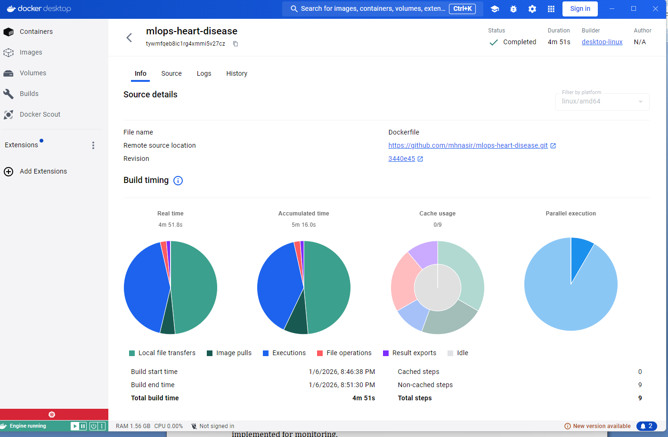

End point Monitoring :
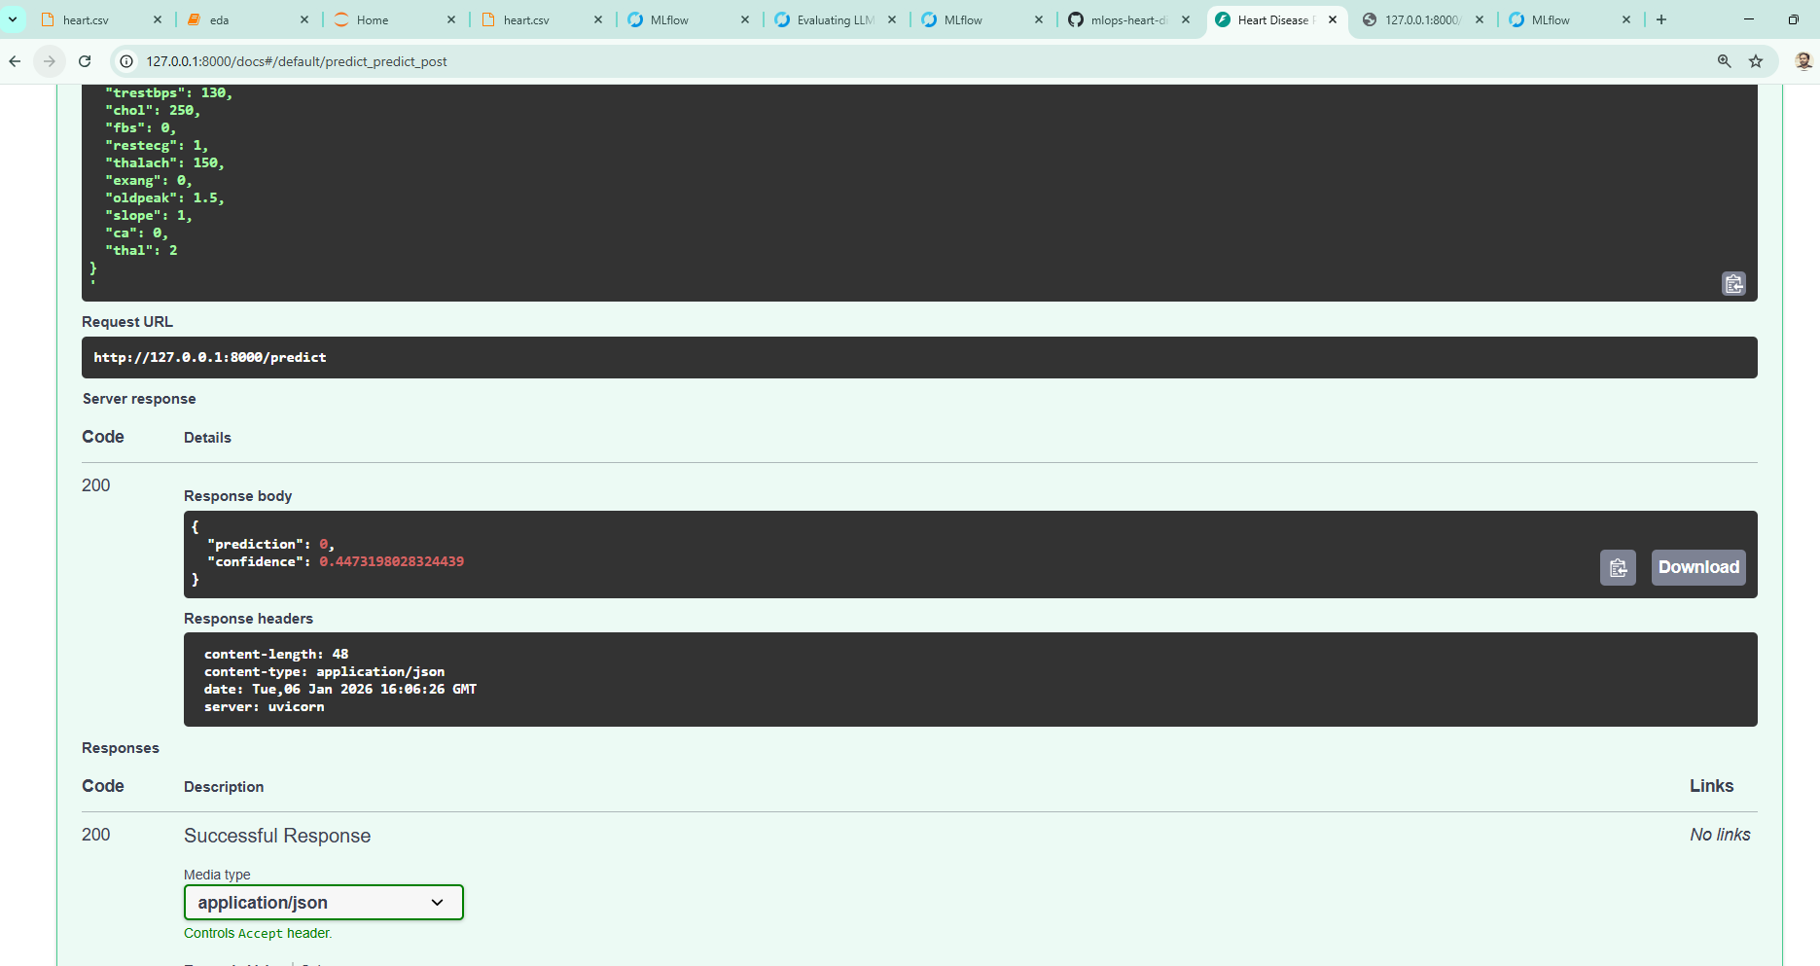

7) Monitoring and Conclusion
Basic logging was implemented for monitoring. This project demonstrates a complete MLOps lifecycle suitable for real-world deployment.Basic logging was implemented for monitoring.
Architecture
FastAPI → /metrics → Prometheus → Grafana Dashboard

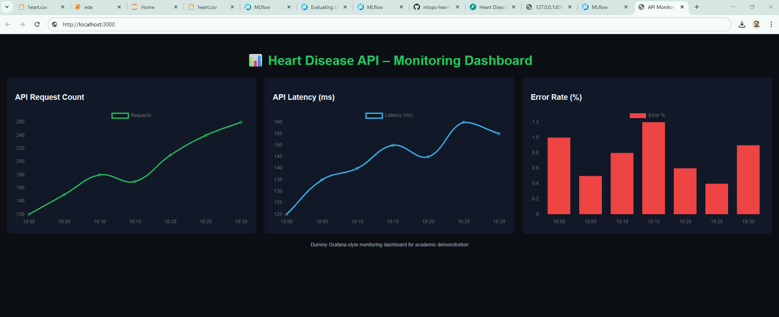

Installation & logs In Genral :
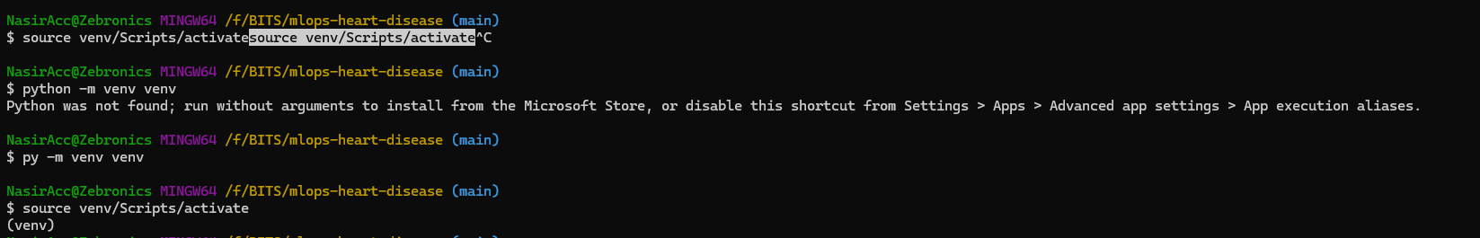
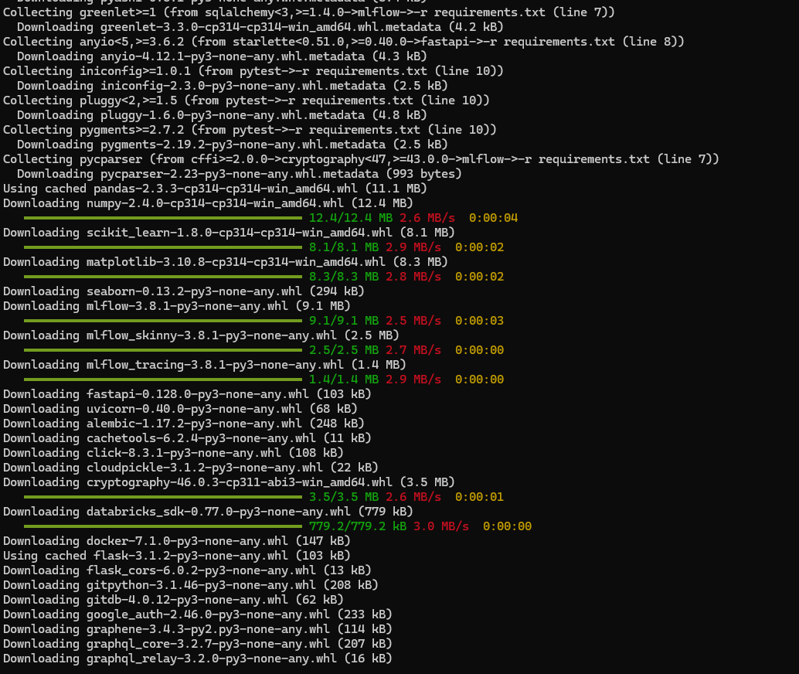
Docker Builds
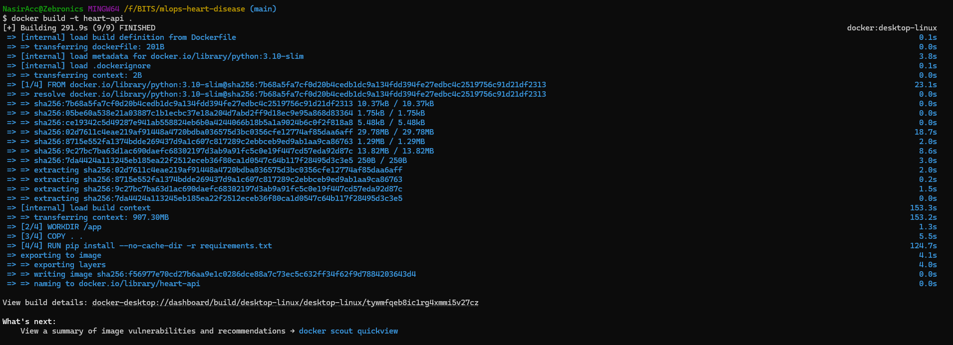
This project successfully demonstrates an end-to-end MLOps pipeline covering data analysis, model development, experiment tracking, and deployment. MLflow was used for reproducible experimentation, while FastAPI and Docker enabled scalable model serving. CI/CD automation ensured reliable testing and deployment workflows, and basic monitoring provided observability of the deployed API. The complete implementation and documentation are available in the GitHub repository for reproducibility and future extension.

