MLOps Experimental Learning Assignment: End-to-End ML Model Development, CI/CD, and Production Deployment
(HEART Disease UCI ML Project)
Semester -3 (Group 86)
Contributed By:
2024AB05052 - MOHAMED NASIR MH
2024AA05854 - NAVEEN PAHAL
2024AB05217 - MITHUN M PILLAI
2024AA05854 - MANDEEP KUMAR
2023WD86009 - VAISHNAVI S

Additional 10 Report Document in Git with reports has details in depth:

1. Setup and Installation Instructions
This project was implemented and tested locally to demonstrate an end-to-end MLOps workflow.
Steps:
1. Clone the GitHub repository.
2. Create and activate a Python virtual environment.
3. Install dependencies using requirements.txt.
4. Train the model using python src/train.py.
5. Run the FastAPI application locally using Uvicorn.

2. EDA and Modelling Choices
Exploratory Data Analysis (EDA) was performed to understand data distribution, correlations, and class balance.
Two machine learning models were trained:
- Logistic Regression as a baseline model.
- Random Forest Classifier to capture non-linear relationships.
Model performance was evaluated using accuracy and ROC-AUC metrics.
Detailed into the report document

3. Experiment Tracking Summary
MLflow was used for experiment tracking. Parameters, metrics, and trained models were logged for each run, ensuring reproducibility and easy comparison between experiments.

4. Architecture Diagram
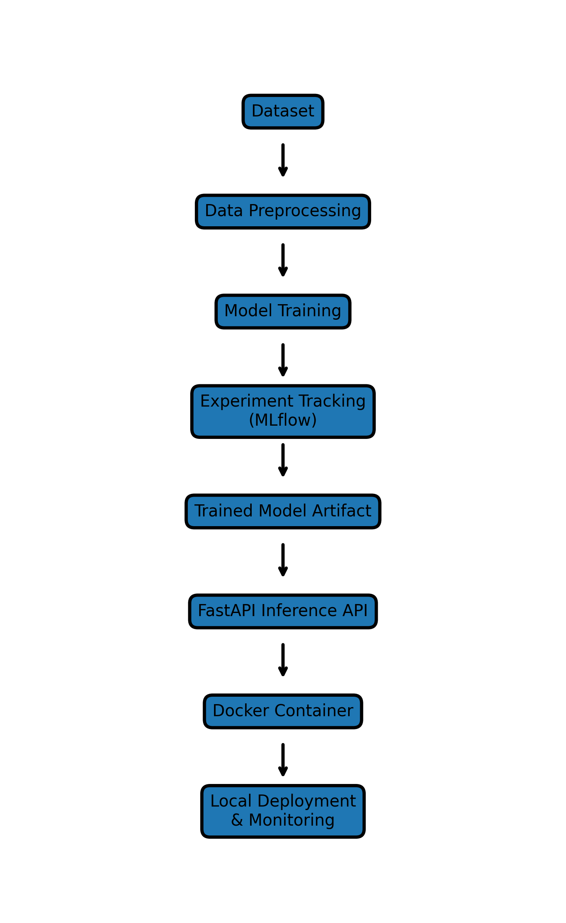
Dataset → Data Preprocessing → Model Training → Experiment Tracking (MLflow) → Trained Model Artifact → FastAPI Inference API → Docker Container → Local Deployment & Monitoring

5. CI/CD and Deployment Workflow
CI/CD automation was implemented using GitHub Actions to run unit tests and model training on every code push.
The trained model was deployed using FastAPI and containerized using Docker. Screenshots of successful CI/CD runs and deployment are included.

6. Link to Code Repository
GitHub Repository:
https://github.com/mhnasir/mlops-heart-disease

Conclusion
This project demonstrates a complete MLOps pipeline including data analysis, model development, experiment tracking, automated testing, deployment, and monitoring in a local environment.

Instructions :
# MLOps Assignment
1. Setup and Installation Instructions
# Prerequisites
- Python 3.10 or higher
- Git
- Docker Desktop
- Web browser (Chrome / Edge)
# Project Setup
bash
git clone https://github.com/mhnasir/mlops-heart-disease.git
cd mlops-heart-disease
python -m venv venv
source venv/Scripts/activate # Windows
pip install -r requirements.txt
Steps for running Locally
python -m uvicorn app.main:app --host 127.0.0.1 --port 8000
URLS where to see locally.
http://127.0.0.1:8000
http://127.0.0.1:8000/docs
Available Endpoints
- POST /predict – Accepts JSON input and returns heart disease prediction with confidence score
- GET /metrics – Exposes monitoring metrics for API performance

