Minh Nguyen
HW4 – Direct Mailing to Airline Customers
MIS 4560

1. Remove Id
/* Importing TTaykoSoftware.csv */
/* DO NOT FORGET to change the file directory */
FILENAME REFFILE '/export/viya/homes/mhnguyen@oakland.edu/MIS-4560/TaykoSoftware.csv';

PROC IMPORT DATAFILE=REFFILE
DBMS=CSV
OUT=WORK.TaykoSoftware
replace;
GETNAMES=YES;
RUN;
PROC CONTENTS DATA=WORK.TaykoSoftware;
RUN;

/******************************************/
/********** 01. Data Preparation *********/
/******************************************/
/* Drop ID variable */
data WORK.TaykoSoftware_final;
set WORK.TaykoSoftware;
drop id;
run;
proc contents data=work.TaykoSoftware_final;
run;
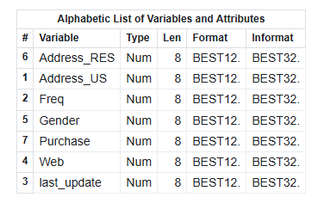
2. Partition the Data
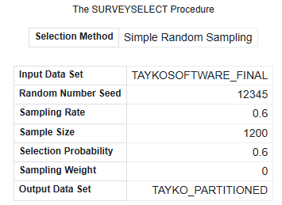
3. Logistic Regression
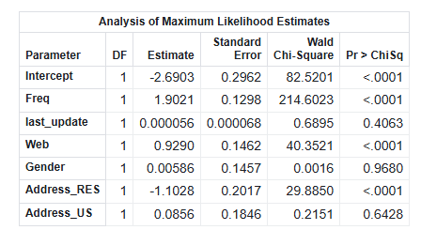
Target variable: Purchase
(From the dataset description: “predicting whether a new customer will make a purchase when they receive the new catalog.”)
Logit (Purchase) = -2.6903 + 1.9021(Freq) + 0.000056(last_update) + 0.9290(Web) + 0.00586(Gender) - 1.1028(Address_RES) + 0.0856(Address_US)
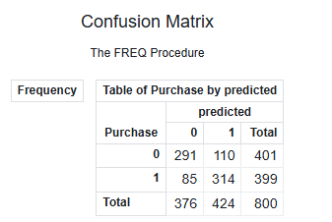
Confusion Matrix (Validation Set)
• True Negatives (TN): 291
• False Positives (FP): 110
• False Negatives (FN): 85
• True Positives (TP): 314
• Accuracy: (291 + 314) / 800 = 75.62 %
• Sensitivity (Recall for Purchase=1): 314 / (314 + 85) = 78.69 %
• Specificity: 291 / (291 + 110) = 72.56 %
From the confusion matrix provided above, the overall accuracy of the model is found to be 75.62%, which means the model can classify three-quarters of the customers in the validation set. The sensitivity (recall for Purchase = 1) is 78.69%, indicating the model correctly identifies most customers who made a purchase. The specificity is found to be 72.56%, which shows the model is performing well in predicting customers who did not purchase.
4. Neural Network
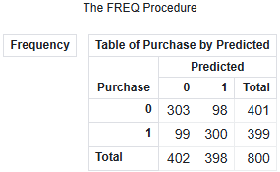
• True Negatives (TN): 303
• False Positives (FP): 98
• False Negatives (FN): 99
• True Positives (TP): 300
• Accuracy: (303 + 300) / 800 = 75.37 %
• Sensitivity (Recall for Purchase=1): 300 / (300+ 99) = 75.18 %
• Specificity: 303 / (303 + 98) = 75.56 %
From the confusion matrix above, the neural network model achieves an overall accuracy of 75.37%, meaning it correctly classifies roughly three‑quarters of customers in the validation set. The sensitivity (recall for Purchase = 1) is 75.18%, indicating the model correctly identifies most customers who made a purchase. The specificity is 75.56%, showing the model performs similarly well at identifying customers who did not purchase.
5. Compare the two model performances
The overall performance of both the logistic regression model and the neural network model is similar, with an accuracy rate of 75-76% on the validation dataset. Nevertheless, it is not the accuracy rate that will help determine which model is better for Tayko’s marketing purpose. Tayko will only send its catalog to those customers it predicts will purchase, so it is interested in the precision rate.
Logistic Regression
Precision: 314 / (110 + 314) = 74.05
If Tayko mails 100 catalogs to customers predicted as purchasers, about 74 will purchase.
Neural Network
Precision: 300 / (98 + 300) = 75.37
If Tayko mails 100 catalogs to customers predicted as purchasers, about 75 will purchase.
Even though the overall accuracy for logistic regression is slightly higher, the neural network model shows greater precision for identifying the purchasers, which is relevant for Tayko’s catalog mailings. Thus, slightly more success will be attained for customer purchases using the neural network model.

