Lecture 3: Basics of probability
  - BIOS 600 - Summer Session II 2026

Reading
- OpenIntro Statistics: Section 3.1.1-3.1.6
- Pagano and Gavreau: Sections 6.2, 6.3
- OpenIntro Statistics: Section 3.2

Announcements
- HW 2 Due tonight, Jun 23 at 11:59pm

Last Class
- Skewed distributions can be right or left skewed depending on which side the “tail” is on.
- Example of right skew (tail is on the right)
set.seed(123)
# Simulate data from a normal distribution
normal_data <- rnorm(400, mean = 0, sd = 1)
# Transform the data to make it right-skewed
right_skewed_data <- exp(normal_data)
# Create a histogram
hist(right_skewed_data, breaks = 30,
col = "darkgoldenrod3", main = " ",
xlab = "Value")
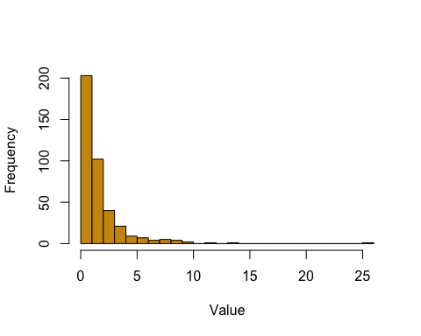

Last Class
- Data has Mean of 12, Median of 10
set.seed(123)
# Many typical values
x <- rnorm(100, mean = 10, sd = 1)
# One extreme outlier
x_with_outlier <- c(x, 200)
hist(x_with_outlier, breaks = 30, col = "gray",
main = "Servings of Fruits and Vegetables",
ylab= "# of Participants",
xlab = "# of Servings")
abline(v = mean(x_with_outlier), col = "red", lwd = 2)
abline(v = median(x_with_outlier), col = "blue", lwd = 2)
legend("topright",
legend = c("Mean", "Median"),
col = c("red", "blue"),
lwd = 2)
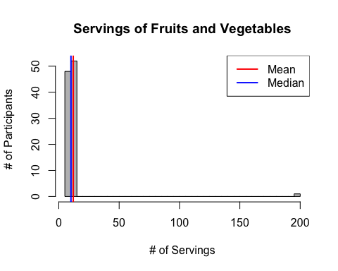

Last Class
- Mean is higher than the median but data is not skewed
# Many typical values
hist(x, breaks = 30, col = "gray",
main = "Servings of Fruits and Vegetables",
ylab= "# of Participants",
xlab = "# of Servings")
abline(v = mean(x_with_outlier), col = "red", lwd = 2)
abline(v = median(x_with_outlier), col = "blue", lwd = 2)
legend("topright",
legend = c("Mean", "Median"),
col = c("red", "blue"),
lwd = 2)
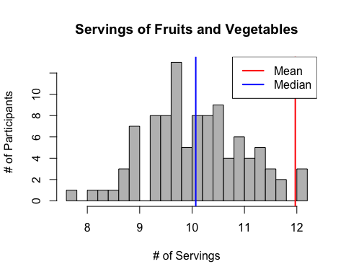

Last Class
- Categorical Data
  - Nominal - includes binary or dictotomous
  - Ordinal
- Continuous Data
  - Count or rank data
  - Continuous data
    - Can be discrete (having gaps)

Probability basics

What’s the use of probability?
- Last time: how to visualize data, how descriptive statistics are used to describe data
- Goal: Make inferences about a population based on a sample
  - Inference: making conclusions about a population based on a sample of data drawn from that population
- To do this, we need a solid foundation of probability theory

Probabilities come up all the time
- There is a moderate chance of drought in North Carolina during the next year
- The surgery has a 50-50 probability of success
- The ten-year survival probability of invasive breast cancer among US women is 83%.
How do we come up with these probabilities?
Before we answer that question, a little bit of history…

Probabilities
- Frequentist (classical) and Bayesian schools of thought
- Historical analogy: Imagine a medieval coin maker who wants to prove that his coin is fair. He flips the coin thousands of times. If it lands on heads about half the time, he concludes it’s a fair coin.
- This approach reflects long-run frequencies—the probability is defined by the frequency of an event (heads) occurring in many repeated trials.

Historical analogy (continued)
- Now, consider a knight deciding whether to trust the coin maker’s fairness. Even after seeing just a few flips, the knight forms a degree of belief about the coin’s fairness, adjusting this belief with more evidence.
- This reflects the Bayesian interpretation—probability as a measure of belief or certainty about an event, updated as new information becomes available.

Which approach is more useful?
- Each one is useful, just depends on context
- Frequentist: Most helpful when you have large sample sizes and repeated trials. Typically used in settings where you rely on long-run frequencies, such as in hypothesis testing and confidence intervals (more on these later).
- Bayesian: More useful when prior information or expert opinion is available, or when working with smaller sample sizes. Often applied in settings where you need to update probabilities as new data becomes available.

Example: clinical trial
Setting: Consider a clinical trial for a new drug.
- In large-scale randomized controlled trials (RCTs) to test a new drug’s efficacy, a frequentist approach is often more suitable.
- This is because you rely on the law of large numbers (more on this in a few lectures!), where results become more reliable with repeated trials.
- Frequentist methods like hypothesis testing and confidence intervals help establish the drug’s effectiveness based purely on the data without incorporating prior beliefs.

Example: diagnostic testing
Setting: Diagnostic testing with prior information
- When evaluating a rare disease using diagnostic tests, a Bayesian approach might be more useful.
- If prior knowledge or expert opinion suggests a very low prevalence of the disease, this information can be incorporated into the analysis.
- As new test results come in, the Bayesian method allows you to update the probability of a patient having the disease, leading to more nuanced decision-making, especially with small sample sizes or uncertain data.

Probability spaces
Mathematical objects that model random experiments, real-world processes involving states that occur randomly
A probability space consists of three components:
- A sample space, the set of all possible outcomes
- Subsets of the sample space, called events, which comprise any number of possible outcomes (including none of them!)
- A function that assigns probabilities to events
An event occurs if the outcome of the random experiment is contained in that event.

Sample spaces
Sample spaces depend on the random experiment in question
- Tossing a single fair coin
- Tossing two fair coins
- Sum of rolling two fair six-sided dice
- Survival (years) after cancer diagnosis
 Exercise
- What are the sample spaces for each of the experiments above?

Events
Events: Subsets of the sample space that comprise possible outcomes. Essentially, these are all the ‘plausibly reasonable’ events we’re interested in calculating probabilities for*:
- Tossing a single fair coin
  - A head
- Tossing two fair coins
  - At least one head
- Sum of rolling two fair six-sided dice
  - An odd number
- Survival (years) after cancer diagnosis*
  - More than 1 year
*Note: there is some complicated math involved in calculating this. Don’t worry about it for now!

Probabilities
A number describing the likelihood of each event’s occurrence. This maps events to a number between 0 and 1, inclusive:
- Tossing a single fair coin
  - A head
- Tossing two fair coins
  - At least one head
- Sum of rolling two fair six-sided dice
  - An odd number
- Survival (years) after cancer diagnosis
  - greater than one year

How did we come up with those answers?
- For the first three, you would probably intuit your way through using a discrete probability distribution (more on this in a few lectures)
- For the last one, by making some assumptions on the survival process, we can use similar probability tools to arrive at an answer. (But it’s still complicated!)

Events as (sub)sets
Remember, events are subsets of the entire sample space. Let’s take for now the example of tossing a single fair coin and recording the outcome.
There are only two elements in the outcome space:
- $A$: getting a head
- $B$: getting a tail
We can define the simple events of just $A$ or $B$ occurring, but are there “other” events we can define?

Set operations
Sets can be related to each other in different ways. For two sets (or events) $A$ and $B$, the most common relationships are:
- Intersection ($A∩B$): $A$ and $B$ both occur
- Union ($A∪B$): $A$ or $B$ occur (including when both occur)
- Complement ($A^{C}$): $A$ does not occur
- Difference ($A∖B$): $A$ occurs, but $B$ does not occur; equivalent to ($A∩B^{C}$) (why?)
Two sets $A$ and $B$ are said to be disjoint if $A∩B=∅$

Those “other” events
What are the intersection, union, complement, and difference of events $A$ (getting a head) and $B$ (a tail) as applied to our coin-toss example? Are the two events $A$ and $B$ disjoint?
What are the probabilities assigned to those events:
- $P(A∩B)=$?
- $P(A∪B)=$?
- …etc.

How do probabilities “work”?
Komolgorov axioms
- The probability of any event in the sample space is a non-negative real number (could be zero!)
- The probability of the entire sample space is 1
- If $A$ and $B$ are disjoint events (mutually exclusive), then the probability of $A$ or $B$ occurring is the sum of the individual probabilities that they occur

How to probabilities “work”?
For two events $A$ and $B$ with probabilities $P(A)$ and $P(B)$ of occurring, the Kolmogorov axioms give us two important rules:
- Complement Rule: $P(A^{C})=1−P(A)$
- Inclusion-Exclusion: $P(A∪B)=P(A)+P(B)−P(A∩B)$
 Question
How do we extend inclusion-exclusion to more than two events?

DeMorgan’s laws
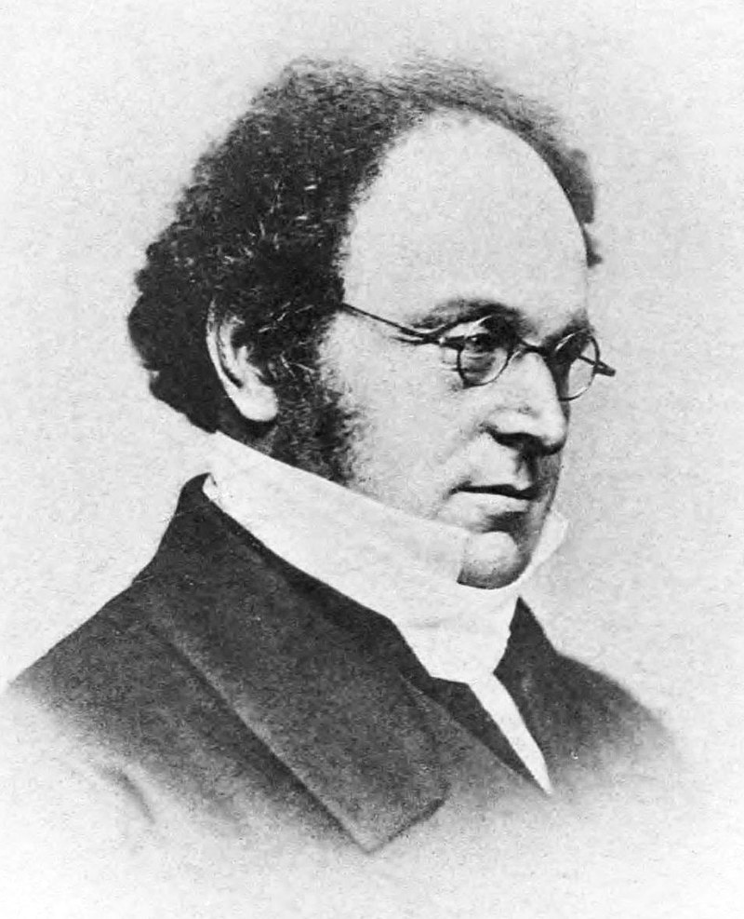
- Complement of union: $(A∪B)^{C}=A^{C}∩B^{C}$
- Complement of intersection: $(A∩B)^{C}=A^{C}∪B^{C}$
 Questions
How do we interpret these in plain English?

Gunter et al. study (2017)
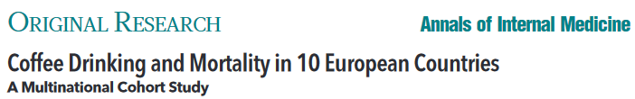
Coffee drinking | Died? Yes | Died? No | Total
None | 1039 | 5438 | 6477
Med-Low | 4440 | 29712 | 29809
High | 3601 | 24934 | 28535
Total | 9080 | 60084 | 64821
What was the probability that a randomly selected person in the trial..
- … did not drink coffee?
- … died during the study or did not drink coffee?
- …did not die during the study and was a high coffee drinker?

Conditional probability
- Conditional probability is the probability an event will occur when another event has already occurred. The conditional probability of event $A$ given event $B$ is
$$P(A|B)=\frac{P(A∩B)}{P(B)}$$
- How can we represent this visually? (Drawing)

Examples
Examples come up all the time in the real world:
- Given that a mammogram comes back positive, what is the probability that a woman has breast cancer?
- Given that a 68-year old man has suffered four previous heart attacks, what is the probability he dies in the next five years?
- Given that a patient has a mutation in the CFTR gene, what is the probability their offspring will have cystic fibrosis?
- Given the storm doesn’t shift north, we have a 60% change of snow

Independence and the multiplicative rule
We can rewrite the definition of conditional probability:
$$P(A|B)=\frac{P(A∩B)}{P(B)}⟹\underset{\text{Multiplicative Rule}}{\underset{⏟}{P(A∩B)=P(A|B)×P(B)}}$$
 Question
What does the multiplicative rule mean in plain English?

- The probability that A and B both happen is the probability that B happened, multiplied by the probability of A happened (given B already happened).

The multiplicative rule
Events $A$ and $B$ are said to be independent when
$$P(A∩B)=P(A)×P(B)$$
or equivalently, $P(A|B)=P(A)$ or $P(B|A)=P(B)$
- In other words, if A and B are independent, then the probability of both happening is simply the probability of A happening times the probability of B happening. (Since B happening has nothing to do with A later happening, or vice-versa).

Example
- Experiment: Toss a fair 6-sided dice two times. We assume the two tosses are independent from each other.
- Let $A$ = getting a 1 on the first toss. Let $B$ = getting a 1 on the second toss.
- What is $P(A)$?
- What is $P(B)$?
- What is the $P(A∩B)$?
- What is $P(A|B)$ ?
- What is $P(B|A)$ ?

Examples
- Example #1: Randomized Clinical Trial
  - Let $A$ = Participant is on a new treatment
  - Let $B$ = Participant is Older than 50
- Example #2: Electronic Health Records
  - Let $A$ = Participant is taking GLP-1
  - Let $B$ = Participant has health insurance

Recall: disjoint events
- Definition: Two outcomes are disjoint or mutually exclusive if they cannot both happen.
- For example: If we roll a die, the outcomes 1 and 2 are disjoint since they cannot both occur.
- On the other hand, the outcomes 1 and “rolling an odd number” are not disjoint since both occur if the outcome of the roll is a 1.

Disjoint vs. independent events
- Flipping one coin
- Let $A$ = heads, $B$ = tails
- Are these two outcomes disjoint?
- Are these two outcomes independent?

Conditional probabilities and independence
Coffee drinking | Died? Yes | Died? No | Total
None | 1039 | 5438 | 6477
Med-Low | 4440 | 29712 | 29809
High | 3601 | 24934 | 28535
Total | 9080 | 60084 | 64821
What was the probability a randomly selected person in the study…
- …died?
- …died, given they were a non-coffee drinker?
 Question
In this study, were dying and coffee drinking independent events?

Recap
- Probabilities come up all the time!
- Bayesian vs. frequentist approaches
- Probability spaces, sample spaces, events
- Set operations
- How do probabilities work? (Set operations, DeMorgan’s Laws)
- Conditional probability, the multiplicative rule, and Bayes’ theorem
- Disjoint vs. independent events

