All in the console:
dir.create(Sys.getenv("R_LIBS_USER"), recursive = TRUE, showWarnings = FALSE)
.libPaths(c(Sys.getenv("R_LIBS_USER"), .libPaths()))
.libPaths()
install.packages("tidymodels")

This will open a file (new tab in R studio)
In that r studio file – copy and paste
.libPaths(c(Sys.getenv("R_LIBS_USER"), .libPaths()))

Restart R (close it down and open it back up)
Hopefully library(tidymodels) will work now

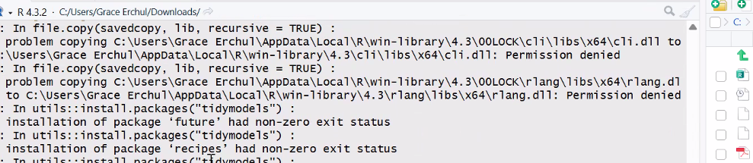

We found proteins overlapping between integrative proteincs and diffenrtial abunchce, these including known established prorteins such as LEP< however the invertageitve analysis showend edifvce o fan asscoiateion between LEP with genes ushc as CDAP and TMEME140, which overlapped in the transfctiptomics and ingertagive omcis analysis.

